UNIT–I: COMPUTATIONAL THINKING AND PYTHON FUNDAMENTALS
Tutorial Task 1: Hello World Program
1.Problem Statement: Write a Python program to display the message "Hello World" on the screen.
2.Algorithm:
- Start
- Display the message "Hello World" by using print statement
- Stop
3.Flowchart:
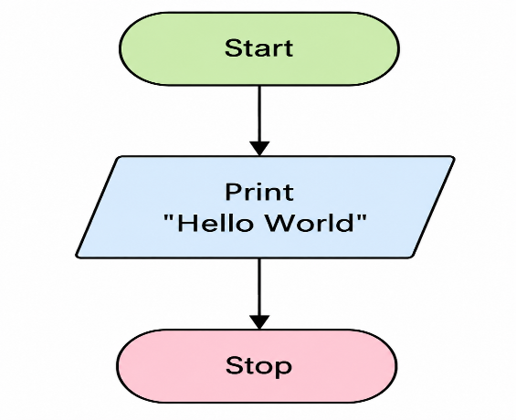
- Python Source Code:
print("Hello World")
- sample input/output:

Input:
No input required.
Output:
Hello World
- screenshot:
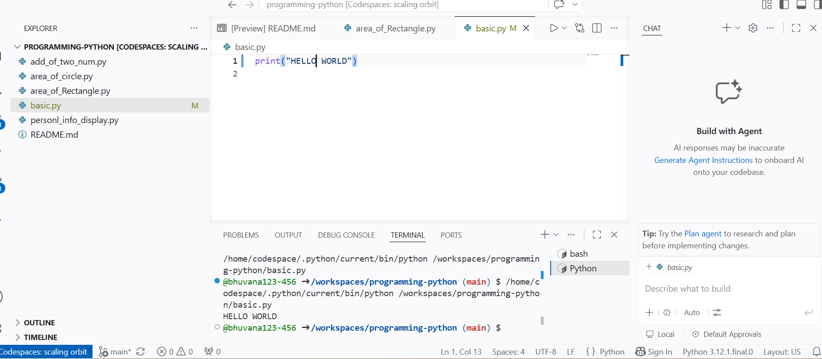

Tutorial Task 2: Personal Information Display
1.Problem Statement: Write a Python program to display a student's personal information including name, roll number, branch, and college name.
2.Algorithm:
  - Start
  - Assign values to name, designation, and employee_id
  - Display the heading "Personal Details" by using print statement.
  - Display the employee name by using print statement
  - Display the designation by using print()
  - Display the employee ID by using print().
  - Stop
3. Flowchart:
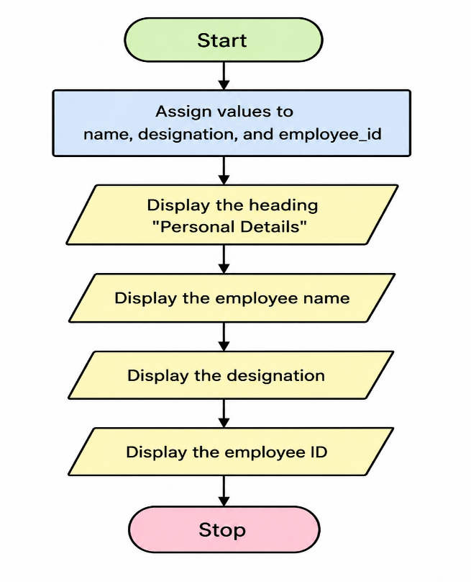

4. Python Source Code:
name="bhuvana"
designation="SoftwareIntern"
employee_id=1234
print("______personal Details________")
print("name:"+name)
print("designation:"+designation)
print("employee_id:",employee_id)

5. sample input/output:
Input:
Enter Name: Bhuvana
Enter Designation: Software Intern
Enter Employee ID: 1234
Output:
______ Personal Details ______
Name: Bhuvana
Designation: Software Intern
Employee ID: 1234
6. screenshot:
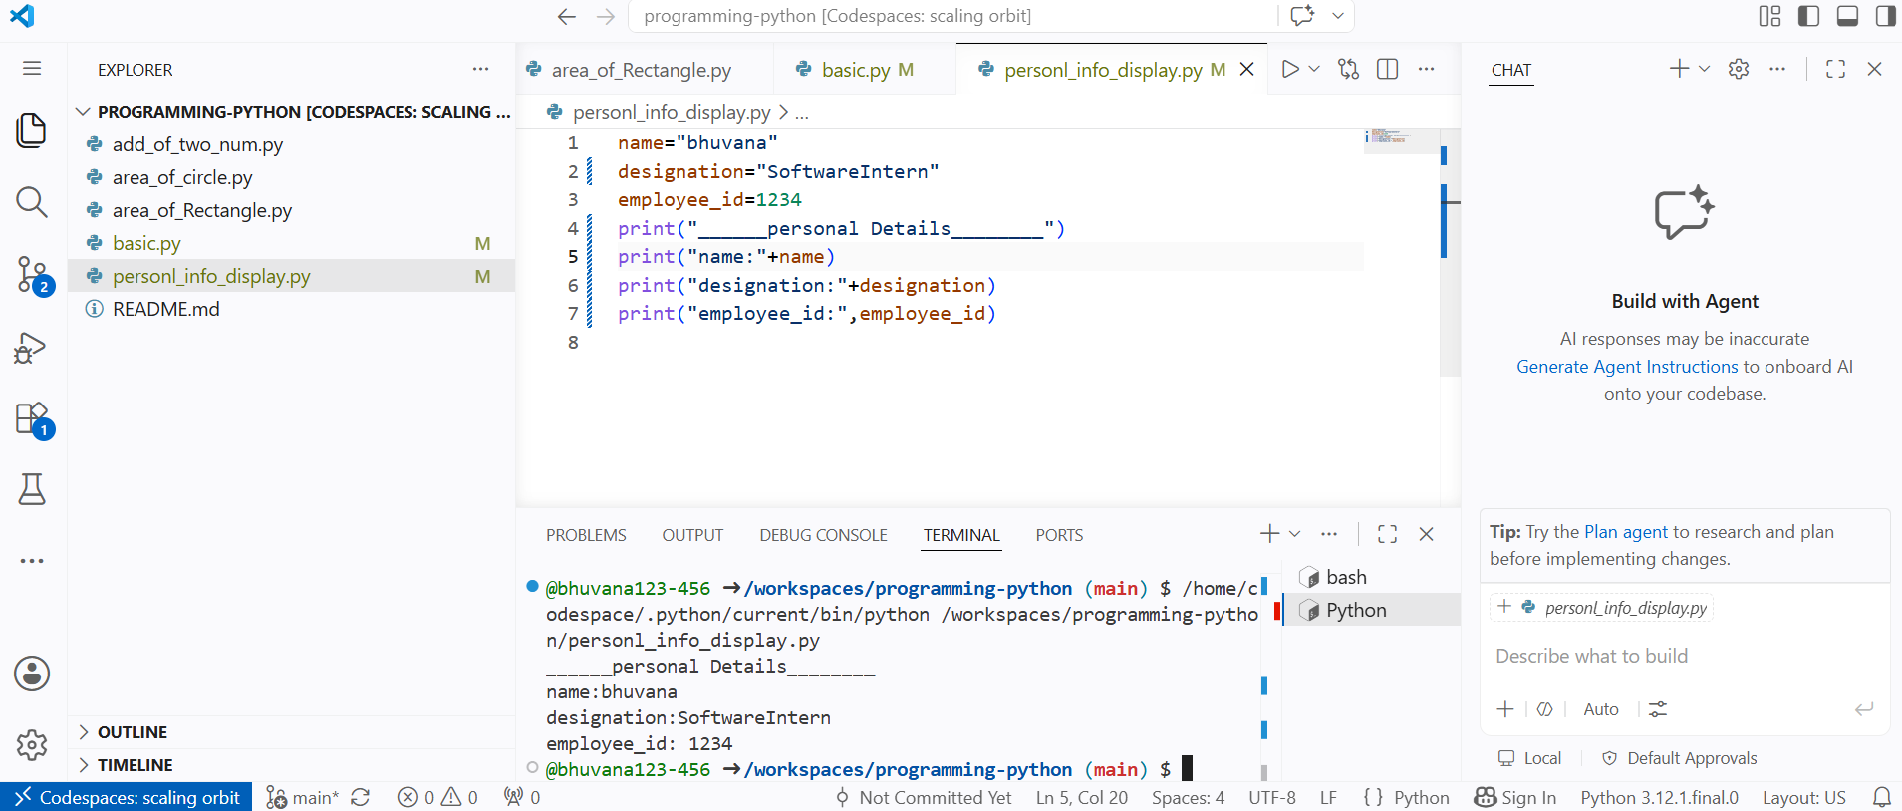

Tutorial Task 3: Addition of Two Numbers
1.Problem Statement: Write a Python program to read two numbers and display their sum.
2.Algorithm:
- Start
- Take the input from users for num1 and num2 by using input().
- Calculate sum =num1+num2.
- Display sum
- Stop
3. Flowchart:
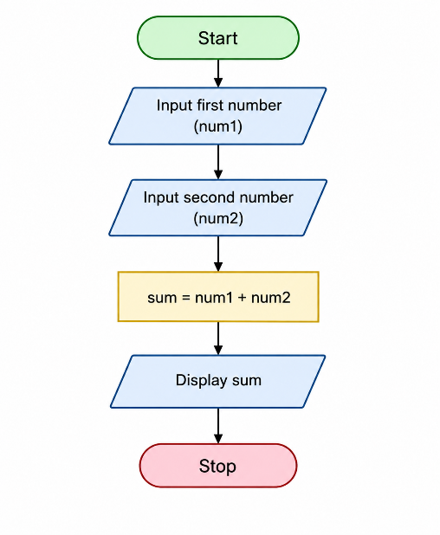
4. Python Source Code:
num1 = int(input("Enter first number: "))
num2 = int(input("Enter second number: "))
sum = num1 + num2
print("Sum =", sum)
5. sample input/output:
Input:
Enter first number: 10
Enter second number: 20
Output:
Sum = 30

6.screenshot:
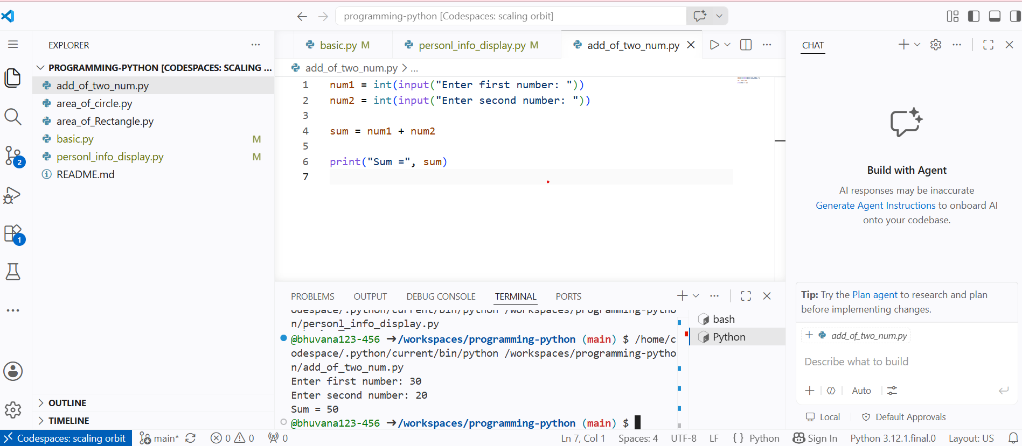
Tutorial Task 4: Area of Circle Calculation
1.Problem Statement: Write a Python program to calculate the area of a circle for a given radius.
2.Algorithm:
Step 1: Start
Step 2: Declare variables radius, pie, and area_of_circle
Step 3: Assign the value 3.14 to pie
Step 4: Read the value of radius from the user
Step 5: Calculate the area using the formula:
area_of_circle=pie*radius*radius
Step 6: Store the result in area_of_circle
Step 7: Display area_of_circle
Step 8: Stop

3. Flowchart:
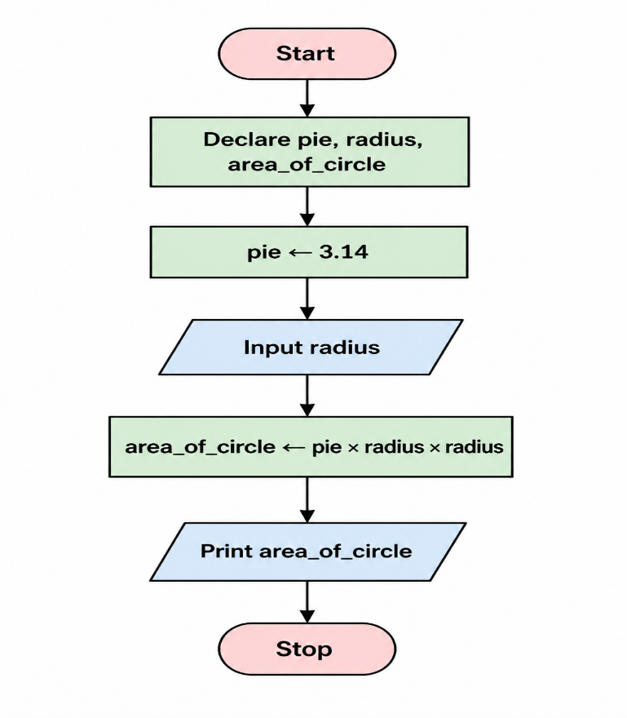

4. Python Source Code:
pie = 3.14
radius = int(input("Enter the radius: "))
area_of_circle = pie * radius * radius
print(area_of_circle)
5. sample input/output:
Input:
Enter the radius: 5
Output:
78.5

6. screenshot:

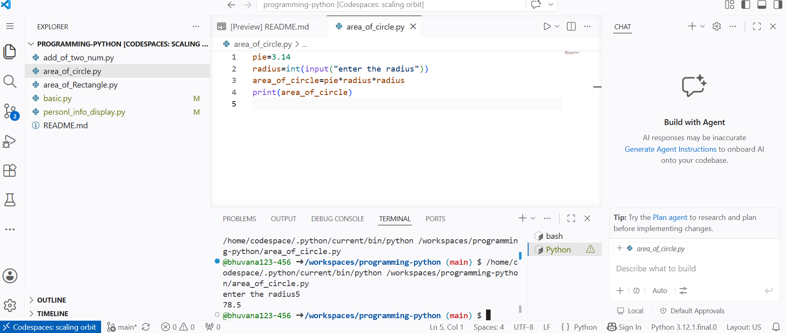
Tutorial Task 5: Area of Rectangle Calculation
1.Problem Statement: Write a Python program to calculate the area of a rectangle using length and breadth.
2.Algorithm:
Step 1: Start
Step 2: Declare variables l, b, and area_of_rectangle
Step 3: Read the value of length (l) from the user by using input().
Step 4: Read the value of breadth (b) from the user
Step 5: Calculate the area using the formula:
Area of Rectangle = Length × Breadth
Step 6: Store the result in area_of_rectangle
Step 7: Display area_of_rectangle
Step 8: Stop

3. Flowchart:
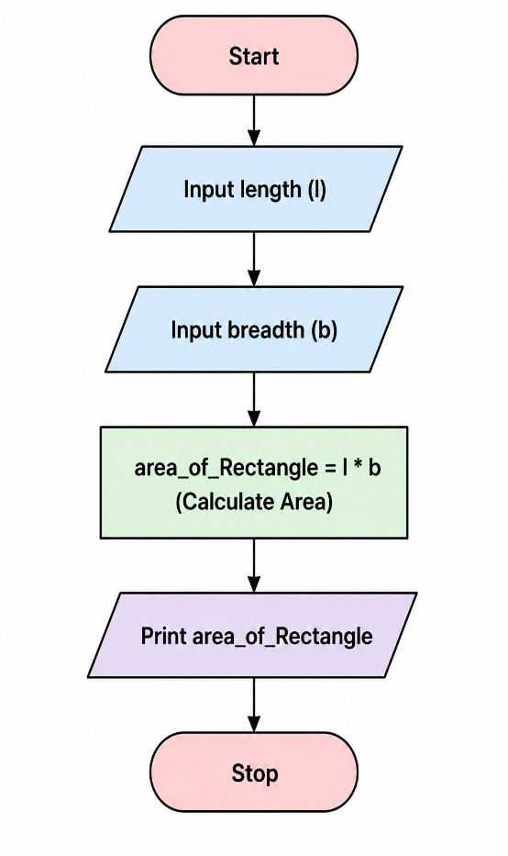

4. Python Source Code:
l = int(input("Enter the length: "))
b = int(input("Enter the breadth: "))
area_of_rectangle = l * b
print(area_of_rectangle)
5. sample input/output:
Input:
Enter the length: 10
Enter the breadth: 5
Output:
50

- screenshot:
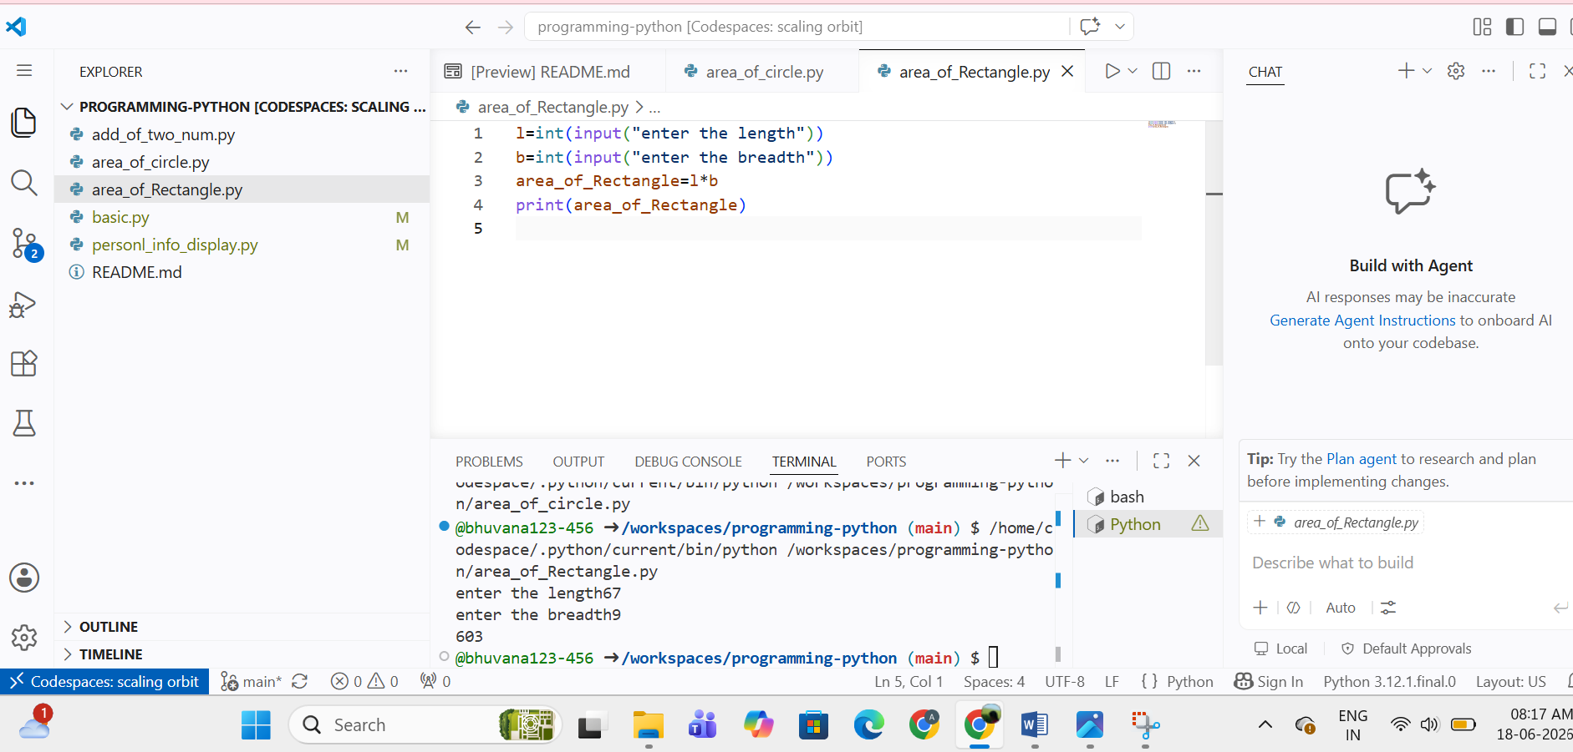

Tutorial Task 6: Temperature Conversion
Problem Statement: Write a Python program to convert temperature from Celsius to Fahrenheit.
Python Source Code:
celsius = float(input("Enter Temperature in Celsius: "))
fahrenheit = (celsius * 9/5) + 32
print("Temperature in Fahrenheit =", fahrenheit)

Sample Input/Output
Input:
25
Output:
Temperature in Fahrenheit = 77.0

Tutorial Task 7: Unit Conversion Program
1.Problem Statement: Write a Python program to convert kilometers to meters, meters to centimeters, and kilograms to grams.

Python Source Code:
km = float(input("Enter Kilometers: "))
m = float(input("Enter Meters: "))
kg = float(input("Enter Kilograms: "))
print("Meters =", km * 1000)
print("Centimeters =", m * 100)
print("Grams =", kg * 1000)

Sample Input/Output
Input
Enter Kilometers: 5
Enter Meters: 10
Enter Kilograms: 2
Output
Meters = 5000.0
Centimeters = 1000.0
Grams = 2000.0

Tutorial Task 8: Swap Two Variables
Problem Statement: Write a Python program to interchange the values of two variables and display the result.
Python Source Code:
a = input("Enter First Value: ")
b = input("Enter Second Value: ")
a, b = b, a
print("After Swapping")
print("a =", a)
print("b =", b)

Sample Input/Output
Input:
Enter First Value: 10
Enter Second Value: 20
Output
After Swapping
a = 20
b = 10

Tutorial Task 9: Student Marks Calculator
Problem Statement: Write a Python program to calculate the total marks obtained by a student in five subjects.
Python Source Code:
s1 = float(input("Subject 1 Marks: "))
s2 = float(input("Subject 2 Marks: "))
s3 = float(input("Subject 3 Marks: "))
s4 = float(input("Subject 4 Marks: "))
s5 = float(input("Subject 5 Marks: "))
total = s1 + s2 + s3 + s4 + s5
print("Total Marks =", total)

Sample Input/Output
Input
80
85
90
75
88
Output
Total Marks = 418.0

Tutorial Task 10: Percentage Calculator
Problem Statement: Write a Python program to calculate the percentage of marks obtained in an examination.
Python Source Code:
obtained = float(input("Enter Obtained Marks: "))
maximum = float(input("Enter Maximum Marks: "))
percentage = (obtained / maximum) * 100
print("Percentage =", percentage, "%")

Sample Input/Output
Input
418
500
Output
Percentage = 83.6 %

Tutorial Task 11: Age Calculator
Problem Statement: Write a Python program to calculate the age of a person using the year of birth and current year.
Python Source Code:
birth_year = int(input("Enter Birth Year: "))
current_year = int(input("Enter Current Year: "))
age = current_year - birth_year
print("Age =", age)

Sample Input
Enter Birth Year: 2002
Enter Current Year: 2026

Sample Output
Age = 24

Tutorial Task 12: BMI Calculator
Problem Statement: Write a Python program to calculate the Body Mass Index (BMI) using weight and height.
Python Source Code:
weight = float(input("Enter Weight (kg): "))
height = float(input("Enter Height (m): "))
bmi = weight / (height * height)
print("BMI =", bmi)

Sample Input
Enter Weight (kg): 60
Enter Height (m): 1.65

Sample Output
BMI = 22.03856749311295

Tutorial Task 13: Salary Calculator
Problem Statement: Write a Python program to calculate gross salary based on basic salary and allowances.
Python Source Code:
basic_salary = float(input("Enter Basic Salary: "))
allowances = float(input("Enter Allowances: "))
gross_salary = basic_salary + allowances
print("Gross Salary =", gross_salary)

Sample Input
Enter Basic Salary: 30000
Enter Allowances: 5000

Sample Output
Gross Salary = 35000.0

Tutorial Task 14: Electricity Bill Calculator
Problem Statement: Write a Python program to calculate the electricity bill amount based on units consumed.
Python Source Code:
units = float(input("Enter Units Consumed: "))
rate = float(input("Enter Rate per Unit: "))
bill = units * rate
print("Electricity Bill =", bill)

Sample Input
Enter Units Consumed: 250
Enter Rate per Unit: 6

Sample Output
Electricity Bill = 1500.0

Tutorial Task 15: Water Bill Calculator
Problem Statement: Write a Python program to calculate the monthly water bill based on water consumption.
Python Source Code:
consumption = float(input("Enter Water Consumption: "))
rate = float(input("Enter Rate per Unit: "))
bill = consumption * rate
print("Water Bill =", bill)

Sample Input
Enter Water Consumption: 500
Enter Rate per Unit: 2

Sample Output
Water Bill = 1000.0

Tutorial Task 16: Currency Converter
Problem Statement: Write a Python program to convert an amount from Indian Rupees to another currency using a fixed exchange rate.
Python Source Code:
inr = float(input("Enter Amount in INR: "))
exchange_rate = float(input("Enter Exchange Rate: "))
converted = inr / exchange_rate
print("Converted Amount =", converted)

Sample Input
Enter Amount in INR: 8500
Enter Exchange Rate: 85

Sample Output
Converted Amount = 100.0

Tutorial Task 17: Simple Interest Calculator
Problem Statement: Write a Python program to calculate simple interest and total amount payable.
Python Source Code:
principal = float(input("Enter Principal Amount: "))
rate = float(input("Enter Rate of Interest: "))
time = float(input("Enter Time (Years): "))
si = (principal * rate * time) / 100
amount = principal + si
print("Simple Interest =", si)
print("Total Amount =", amount)

Sample Input
Enter Principal Amount: 10000
Enter Rate of Interest: 10
Enter Time (Years): 2

Sample Output
Simple Interest = 2000.0
Total Amount = 12000.0

Tutorial Task 18: Compound Interest Calculator
Problem Statement: Write a Python program to calculate compound interest and maturity amount.
Python Source Code:
principal = float(input("Enter Principal Amount: "))
rate = float(input("Enter Rate of Interest: "))
time = float(input("Enter Time (Years): "))
amount = principal * ((1 + rate / 100) ** time)
ci = amount - principal
print("Compound Interest =", ci)
print("Maturity Amount =", amount)

Sample Input
Enter Principal Amount: 10000
Enter Rate of Interest: 10
Enter Time (Years): 2

Sample Output
Compound Interest = 2100.0
Maturity Amount = 12100.0

Tutorial Task 19: Profit and Loss Calculator
Problem Statement: Write a Python program to determine profit or loss based on cost price and selling price.
Python Source Code:
cp = float(input("Enter Cost Price: "))
sp = float(input("Enter Selling Price: "))
if sp > cp:
profit = sp - cp
print("Profit =", profit)
elif cp > sp:
loss = cp - sp
print("Loss =", loss)
else:
print("No Profit No Loss")

Sample Input
Enter Cost Price: 5000
Enter Selling Price: 6500

Sample Output
Profit = 1500.0

Tutorial Task 20: Fuel Cost Calculator
Problem Statement: Write a Python program to estimate fuel cost based on travel distance, mileage, and fuel price.
Python Source Code:
distance = float(input("Enter Distance (km): "))
mileage = float(input("Enter Mileage (km/l): "))
fuel_price = float(input("Enter Fuel Price per Liter: "))
fuel_required = distance / mileage
fuel_cost = fuel_required * fuel_price
print("Fuel Cost =", fuel_cost)

Sample Input
Enter Distance (km): 200
Enter Mileage (km/l): 20
Enter Fuel Price per Liter: 105

Sample Output
Fuel Cost = 1050.0

