July 26, 2020

**General**

1. Will follow the look, quality, typography, cleanness, responsiveness of [Advanced Wishlist](https://apps.shopify.com/my-wishlist-share-remind) by HulkApps

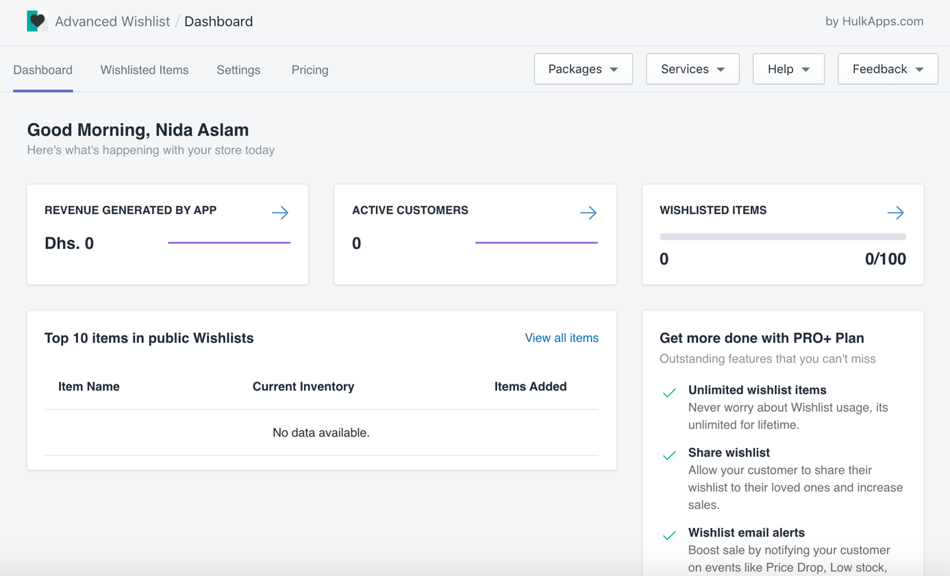

1. Will also follow their other details: sub-tabs, toggle styles, columns layout, etc.

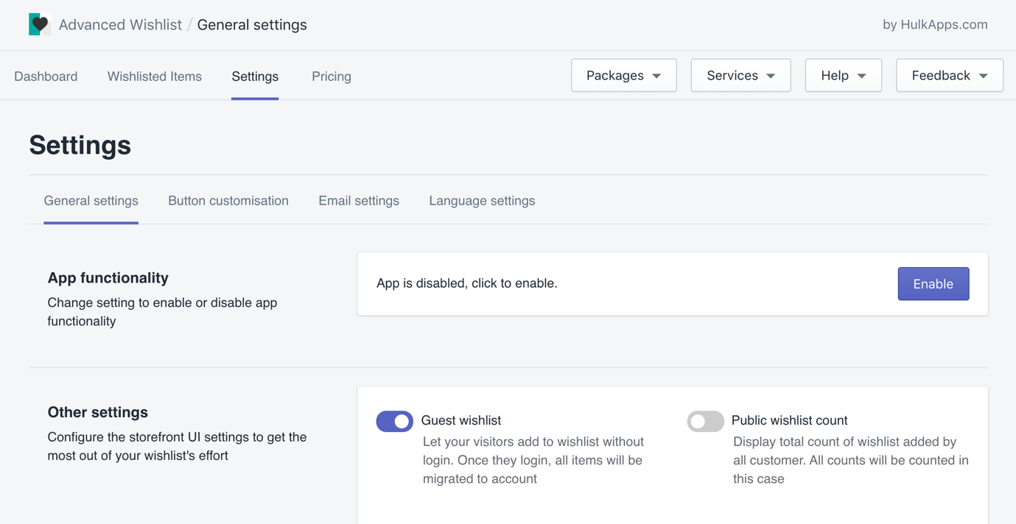

**Main Menu**

1. On the left, we can have the following tabs:
   1. Dashboard
   2. Country Price Settings
   3. Country Redirect Settings
   4. Announcement Bar Settings
2. On the right, we can have the following menus:
   1. Help
      1. Install Instructions (if needed)
      2. Setup Instructions (if needed)
      3. FAQ
      4. Submit a Ticket
   2. Feedback
      1. Feature Request
      2. Write a Review
      3. Share Feedback
   3. More
      1. Website Design & Development (would just link to chaostheoryhq.com)
      2. Changelog
      3. Terms & Conditions
      4. Privacy Policy

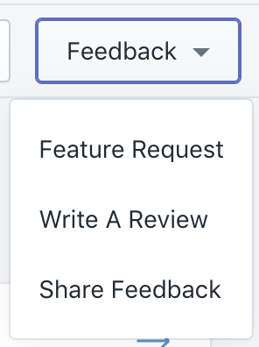

**Dashboard**

1. If there are steps to get the app up and running, we can add something like this in the main dashboard from [Advanced Wishlist](https://apps.shopify.com/my-wishlist-share-remind) dashboard

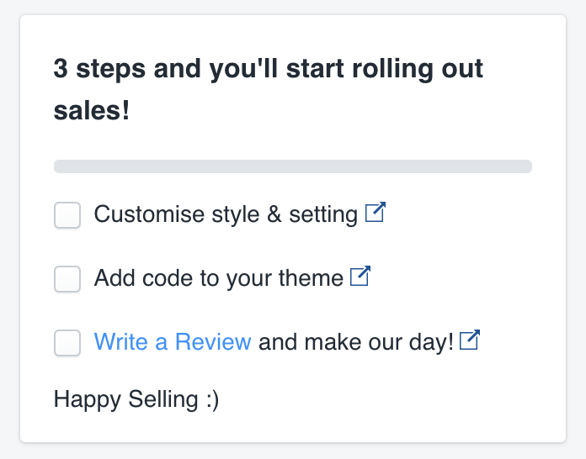

1. Customer can select which theme to install the app in like this from [Master Motivator](https://apps.shopify.com/master-motivator-promos-bar) – this can be in the main dashboard or wherever you feel it will fit better during the app installation process:

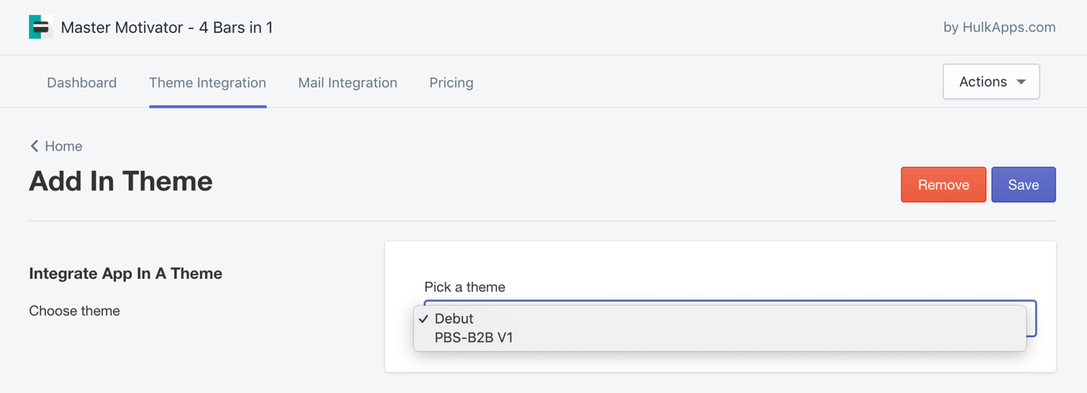

1. Option to enable / disable app
2. Google Analytics section can go here, something like this:

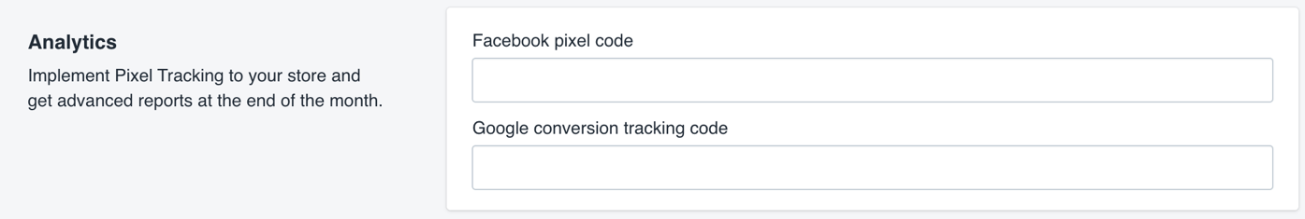

**Country Price Settings**

1. Sub-tabs in this tab would be:
   1. Country Management
      1. Here customers manage the areas of the world and what currency is used
      2. Add area / change currency for that area / delete area
      3. Default currency, rest of the world, etc.
      4. Default currency cannot be deleted
   2. Product Management
      1. Here customers manage what products have what prices in what areas
      2. Search for product
   3. Currency Menu Customization
      1. Here customers
2. Save button at the top of the page and at the bottom of the page

**Country Redirect Settings**

1. Sub-tabs in this tab would be:
   1. Internal redirection
      1. “Create rule” layout should be easy to use and manage
         1. Countries selection
         2. Redirection URL field with any instructions
      2. Create / edit / delete
   2. External redirection
      1. “Create rule” layout should be easy to use and manage
         1. Countries selection
         2. Redirection URL field with any instructions
      2. Create / edit / delete
   3. Both sections would have the settings we had discussed like:
      1. Preserving URL: <https://blog.addons.business/cozy-country-redirect/how-preserve-relative-url-works/#preserving-relative-url>
      2. And any other settings discussed

**Announcement Bar Settings**

1. Need to have a layout that allows for easy management of the announcement bars for different world areas
2. Will follow look of [Master Motivator](https://apps.shopify.com/master-motivator-promos-bar) “Create Bar” layout
3. Will follow section divisions / organization of [Master Motivator](https://apps.shopify.com/master-motivator-promos-bar) “Create Bar” layout where applicable
   1. Font family
   2. Font size
   3. Close button:
      1. Yes / no
   4. Bar position:
      1. Top / top sticky / bottom sticky
   5. Display bar on:
      1. Desktop + mobile
      2. Desktop only
      3. Mobile only
   6. Select which areas / countries to display bar for
   7. Display bar on page:
      1. All pages
      2. Homepage only
      3. Only on page with URL
4. Announcement bar sticky preview

