# Chapter 2: analysis

QR code generator analysis section is divided into subsections and them are:

# 2.1 introduction

A well-ordered breakdown of the periods of a procedure used to pass on the data sources, yields, and tasks that happen during each stage. A procedure examination can be utilized to improve comprehension of how the procedure works and to decide potential focuses on procedure improvement through evacuating waste and expanding proficiency.

To give the better outcome at firsts we had to understand all the functional and non-functional requirements of our project which is collected in the following analysis stage. and for it we had to follow a methodologies and techniques which helps to manage analysis process.

Analysis is an important phase of development it is done to gain better understating of complex topics, to make strategy, to calculate the output, for requirement gathering etc. So, And in my project I am going to used SWOT analysis.

Swot analysis: SWOT analysis (strengths, weaknesses, opportunities and threats analysis) is a framework for identifying and analyzing the internal and external factors that can have an impact on the viability of a project, product, place or person. Swot analysis focus on:

**Strengths**: what does your organization do better than your competition?

**Weaknesses**: what does your organization need to improve upon?

**Opportunities**: what market trends could lead to increased sales?

**Threads**: what are the advantages competitors have over your organization?

Swot analysis in my project used to help an entity whether it is an organization or an individual, to gain insight into its current and future position in the market.

# 2.2 feasibility study

A feasibility study is an analysis that takes all of a project's relevant factors into account—including economic, technical, legal, and scheduling considerations—to ascertain the likelihood of completing the project successfully. The goal of a feasibility study is to thoroughly understand all aspects of a project, concept, or plan; become aware of any potential problems that could occur while implementing the project; and determine if, after considering all significant factors, the project is viable—that is, worth undertaking.

Feasibility studies are important to business development. Feasibility studies also can lead to marketing strategies that could help convince investors or banks that investing in a particular project or business is a wise choice. For my project also I have done some of feasibility studies and they are:

1. **Financial feasibility:** A financial feasibility study projects how much start-up capital is needed, sources of capital, returns on investment, and other financial considerations. The study considers how much cash is needed, where it will come from, and how it will be spent. Which will leads not to be any financial problem while developing my system.
2. **Technical feasibility:** does the company have the technology resources to undertake the project? I .e , hardware. My final project will be ready in web app which can be accessed using laptop, mobile devices supporting the internet services can easily used it through browser. And I will be using some design of web to make to good interactive of user and interface.

**Programming languages:** in my project I’m going to use PHP, Javascript, HTML and bootstrap because it is being most commonly used in the development of todays web app development and the framework available in this are supportable in all devices and more responsive as compared to other one.

Reasons for project being technically feasible:

1. Using internet, the user wishing to access this website or web app can easily access from anywhere and anytime.
2. Mostly used common devices are computer laptop and mobiles phones and my project is compatible for all of them threes and can easily use this app.
3. Mostly all the companies are trying for their growth with the means of advertisement and for it my project is the best one among.
4. And I found in my analyzing process all most all people uses internet for their day to day work.
5. **Social feasibility:** Social feasibility is one of the feasibility study where the acceptance of the people is considered regarding the product to be launched. And my project is not differentiating any cultural of society nor promoting any political agendas or cultural part.

Thus, as result we are on the right way not insulting any of social cultural.

1. **Schedule feasibility**: schedule feasibility is the degree to which a deadline for a strategy, plan, project or process is realistic and achievable. Our project will not be completed/successful if it is not completed on time. So for my project also I had done some time estimation and it is shown in Gantt chart:
2. **Operational feasibility:** Operational feasibility alludes to the proportion of taking care of issues with the assistance of another proposed framework. It helps in exploiting the chances and satisfies the prerequisites as distinguished during the advancement of the undertaking. It takes care that the administration and the clients bolster the venture. I have implemented SWOT analysis for the QR code generator system the analysis will identify all the strength, weakness, threats etc which will help the operational feasibility.

# 2.3 Information Gathering Methodology

Analyzing the various aspect of the project we have to use some information gathering methodologies and the gathered data or information during this process is also used for feasibility study of the mentioned project and the used methodologies in my project are detailed below with descriptions:

## 2.3.1 Interview

An interview is a conversation where questions are asked and answers are given. In common parlance, the word "interview" refers to a one-on-one conversation between an interviewer and an interviewee. Which makes the very east and fastest way to collect the required data and information for my project. In the course of interview I had made some questions before to ask the individual going to be enrolled in my project in future time.

As my project is not based for any individual company or organization it is for all the one in required field. So, for the interview regarding my project I have choose two person one working on NGO and the other one is college student.

* **Interview with NGO’s employee**

Some of the questions were made for the interviewee for the calculation of success of my project and the details of the interview are as follows:

Interview Details:

Interview taken date: July 18, 2019

NGO’s employee name: Aditya Sharma

Questions asked in interview:

1. How frequently they organize program?
2. What they do to promote any awareness?
3. Are they having any issues while communicating with people?
4. How many people are available during their visit?
5. In what way they takes persons view and store them?
6. What are the features they using in their system?
7. In what way they are connect to the internet?
8. Does, they require any external entities?
9. How frequently they uses social media and any links?

* **Interview with college student**

After interviewing the NGO’s employee I was prepared for the interviewing the college student and the question asked with him are:

Interview taken date: July 19, 2019

Student name: Ashish Sharma

Question asked in interview:

1. How he uses the internet?
2. How he shares the study link to any one?
3. How he pays for the stuffs in the market?
4. Whether he visits the campaign field or access it through the internet?
5. How he stores the information?
6. What does he like to prefer in scanning code in single step or just go through the old process?

The above question with student helps me to clarify that my project is going to useful in coming days.

## 2.3.2 Questionnaires

Questionnaires is the another method that I have choose for the information gathering methodology. Questionnaires is useful for taking the overall view on the system and here the questions are all most the same for the all.

In this section I have distributed set of questions among 100 random peoples involving some on teacher profession some on tech company, some were parents and their children studying in higher level.

**Questions used are listed below:**

1. **What is your name?**

**……………………………………………………………………**

1. **What is your age?**

**……………………………………………………………………**

1. **What is contact number?**

**……………………………………………………………………..**

1. **What is your address?**

**…………………………………………………………………….**

1. **What is your qualification?**

**……………………………………………………………………..**

1. **What you use frequently-**

**Desktop [ ] Mobile [ ] laptop [ ] other[ ]**

1. **How longer you use device choose in no.5?**

**High[ ] Medium[ ] Less[ ]**

1. **Have you heard about QR code before?**

**Yes [ ] No [ ]**

1. **Does you have basic knowledge of computer and internet?**

**Yes [ ] No [ ]**

1. **What do you suffer more over the internet?**

**………………………………………………………**

1. **Do you think that internet is best way to promote business?**

**Yes [ ] No [ ]**

# 2.4 system architecture and database architecture

As I am deciding to make a web application so my system should be faster and also support asynchronous technique I will be using MVC software architecture in software development process.

Model–View–Controller (usually known as MVC) is an architectural pattern commonly used for developing user interfaces that divides an application into three interconnected parts. This is done to separate internal representations of information from the ways information is presented to and accepted from the user. The MVC design pattern decouples these major components allowing for code reuse and parallel development.

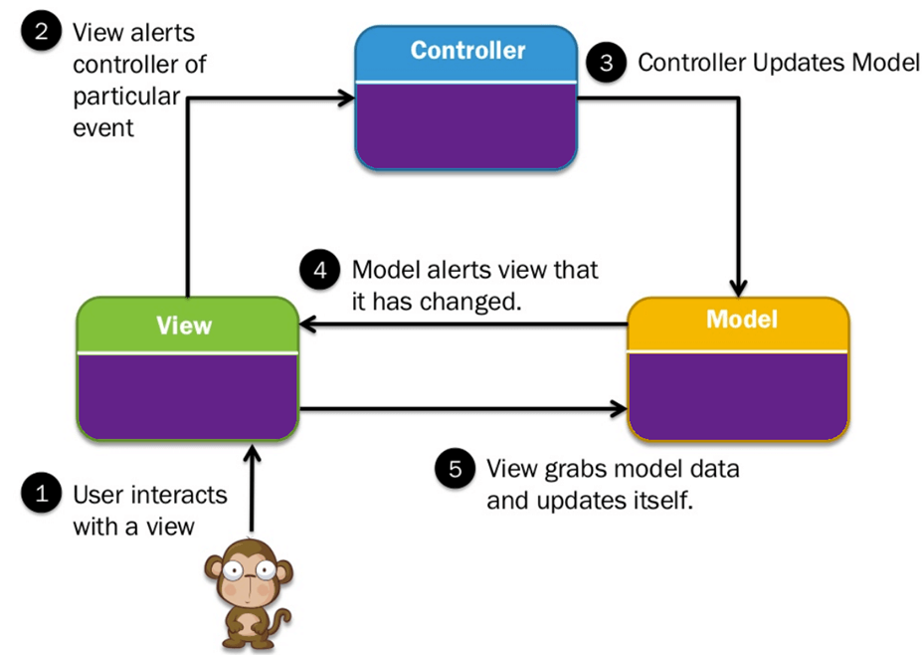

Fig: MVC design pattern

Models for handling data and business logic

Controllers for handling the user interface and application

Views for handling graphical user interface objects and presentation

Thus the results in user request being processed as follows:

1. The browser(on the client) sends a request for a page to the controller on the server.
2. The controller retrieves the data it needs from the model in order to respond to the request.
3. The controller gives the retrieved data to the view.
4. The view is rendered and sent back to the client for the browser to display.

**Benefits of MVC pattern:**

1. Faster web application development process.
2. MVC web application supports Asynchronous Technique.
3. Offers the multiple views.
4. Ideal for developing large size web application.
5. MVC model returns the data without the need of formatting.
6. The modification never affects the entire model.

## 2.4.2 Database architecture (client server architecture)

The project that I am developing is based on client-server system so for the development of my system I am using three-tier architecture for the database system. A three-tier architecture is a client-server architecture in which the functional process logic, data access, computer data storage and user interface are developed and maintained as independent modules on separate platforms. Three-tier architecture is a software design pattern and a well-established software architecture.

Benefits of three-tier architecture:

Performance: Because the Presentation tier can cache requests, network utilization is minimized, and the load is reduced on the Application and Data tiers. If needed, you can load-balance any tier.

Scalability—Each tier can scale horizontally. For example, you can load-balance the Presentation tier among three servers to satisfy more Web requests without adding servers to the Application and Data tiers.

Availability—If the Application tier server is down and caching is sufficient, the Presentation tier can process Web requests using the cache.

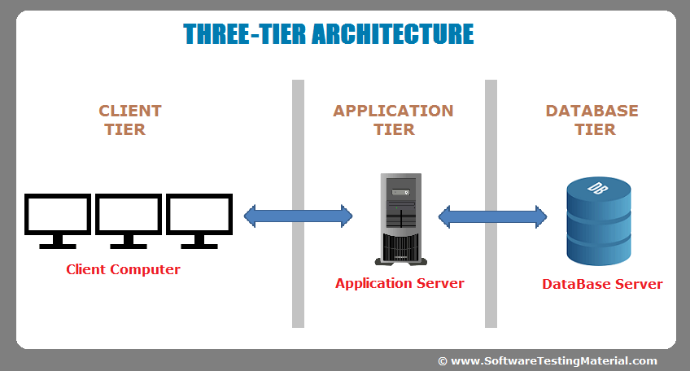

Fig: three-tier architecture

**Presentation Tier:** Occupies the top level and displays information related to services available on a website. This tier communicates with other tiers by sending results to the browser and other tiers in the network.

**Application Tier:** Also called the middle tier, logic tier, business logic or logic tier, this tier is pulled from the presentation tier. It controls application functionality by performing detailed processing.

**Data Tier:** Houses database servers where information is stored and retrieved. Data in this tier is kept independent of application servers or business logic.

# 2.5 SRS document:

A software requirements specification (SRS) is a document that describes what the software will do and how it will be expected to perform. Using the SRS helps to ensure requirements are fulfilled. And it can also help you make decisions about your product’s lifecycle — for instance, when to retire a feature.

There are two types of requirement related to SRS document and they are explained in related term to the project being developed:

1. **Functional requirement**

a functional requirement defines a system or its component. It describes the functions a software must perform. A function is nothing but inputs, its behavior, and outputs. It can be a calculation, data manipulation, business process, user interaction, or any other specific functionality which defines what function a system is likely to perform.

Functional software requirements help you to capture the intended behavior of the system. This behavior may be expressed as functions, services or tasks or which system is required to perform.

Advantage of functional requirement is it helps to check whether the application developed is providing all the functionalities that were mentioned in the functional requirement of that application.

1. **Sign in**

In our system we have developed the function where user can sign in or log in to the system with the registered account and view the details about how and where to create the code and used it. For the login or sign in process user should have the email and password associated or registered in our database.

1. **Sign** up

Where the our system provides login functionality it should also have the sign up function for new user who visited our site and can have access to it. And for this process user should provide a genium email and strong password for their account security.

1. **Update profile**

After the completion of sign up process user can have access to their account or if the user is already registered they can simply login and access it or edit the profile as their need and can see the resulted or create QR code in their account details.

1. **View QR code uses**

QR code can be uses for different purposes such as for marketing or promoting apps or events and in many ways. If the condition such as user are not aware about its uses in todays world then they can simply have information on it through the website and uses according to their needs and required field.

1. **Select QR code type for**

QR code are uses for different purposes and have many advantages on it and knowing the its uses where and where user can choose according to their uses and used it on required place.

1. **Create QR code**

After finalizing the area to uses such as for marketing or promoting user can create the QR code for their uses and applied it to the work.

1. **Track campaign performance**

After the campaign starts, you can track the scan statistics - how many times, when, where and with what devices the Codes have been scanned. So you can notice any changes in performance immediately. All information is presented in the form of easy-to-understand graphs and charts.

1. **High quality print format**

After the creating or generating the QR code user can download the codes in several pixel and vector file formats such as JPEG, PNG, EPS and SVG. Generated files are high-resolution as well as user can select best option for printing QRR codes in any size, color and on any medium, with the no compromises on quality.

1. **Sending and viewing messages**

In our system user can encode the message they want to share and shared them among the interested candidate and the user who gets it can decode easily and have it on. For the decoding user can use mobile and scan it through the related app.

1. **Decode generated QR code**

Some of the user also want to decode the already generated code which they have been suggested by some one or been shared or found in some product and they might want to explore it and wants to decode. For this I have developed the feature to decode the already generated code which made they easy to explore the external fields.

1. **Read manual**

All the user directly associated or in directly some of them may not have the knowledge on how to use it then they can simply visit the help sector and read the manual illustrate for the uses.

1. **Non-functional requirement**

A non-functional requirement defines the quality attribute of a software system. They represent a set of standards used to judge the specific operation of a system. Example, how fast does the website load?

A non-functional requirement is essential to ensure the usability and effectiveness of the entire software system. Failing to meet non-functional requirements can result in systems that fail to satisfy user needs.

Advantages of non-functional requirement is it ensure the software system follow legal and compliance rules as well as ensure the reliability, availability, and performance of the software system.

For the better performance and effective functionality, the developer should identify the quality attributes, considering this some of the non-functional requirement are carried out are:

1. **Security:**

Security requirements ensure that the software is protected from unauthorized access to the system and its stored data. It considers different levels of authorization and authentication across different users roles.

Some of the things needed for the maintaining security are:

Always keeping the software and firmware up-to-date.

Constantly creating new passwords.

Using the multi-factor authentication when need or possible incase.

Examples: Access permissions for the particular system information may only be changed by the system’s data administrator.

1. **Reliability:**

Reliability defines how likely it is for the software to work without failure for a given period of time. Reliability decreases because of bugs in the code, hardware failures, or problems with other system components.

Measurement of the software reliability can be count on the percentage of operations that are completed correctly.

Example: the database update process must roll back all related updates when any update fails.

1. **Performance:**

Performance is a quality attribute that describes the responsiveness of the system to various user interactions with it. Poor performance leads to negative user experience. It also jeopardizes system safety when it’s is overloaded.

Things for maintaining performance:

Achieving high web application performance and low page load speeds.

Combining CSS and JavaScript files to reduce HTTP requests.

Example: the front-page load time must be no more that 2seconds for users that access the website using an LTE connection.

1. **Availability:**

Availability is gauged by the period of time that the system’s functionality and services are available for use with all operations. So, scheduled maintenance periods directly influence this parameter. And it’s important to define how the impact of maintenance can be minimized.

Things for maintaining availability:

The team has to define the most critical components of the system that must be available at all time.

Well prepared for user notifications in case the system or one of its parts becomes unavailable.

Example: New module deployment must’nt impact front page, product pages, and check out pages availability and mustn’t take longer than one hour. The rest of the pages that may experience problems must display a notification with a timer showing when the system is going to be up again.

1. **Scalability:**

Scalability requirements describe how the system must grow without negative influence on its performance. This means serving more users, processing more data, and doing more transactions.

Scalability for databases requires that the database system be able to perform additional work given greater hardware resources, such as additional servers, processors, memory and storage. Workloads have continued to grow and demands on databases have followed suit.

Things for maintaining scalability:

Increase scalability by adding memory, servers, or disk space.

Compressing data or using optimizing algorithms, etc.

Example: The website attendency limit must be scalable enough to support 200,000 users at a time.

## 2.6 MoSCoW prioritization:

The MoSCoW method is a prioritization technique used in management, business analysis, project management, and software development to reach a common understanding with stakeholders on the importance they place on the delivery of each requirement.

When managing a project, it is important to develop a clear understanding of the customers' requirements and their priority.

The MoSCoW method can help. MoSCoW stands for must, should, could and would:

M - Must have this requirement to meet the business needs

S - Should have this requirement if possible, but project success does not rely on it

C - Could have this requirement if it does not affect anything else on the project

W - Would liketo have this requirement later, but delivery won't be this time

MoSCoW prioritization for functional requirement.

|  |  |  |  |
| --- | --- | --- | --- |
| No. | Requirement name | Requirement title | Prioritization |
| 1 | FR1 | Sign in | Must have |
| 2 | FR2 | Sign up | Must have |
| 3 | FR3 | Update profile |  |
| 4 | FR4 | View QR code uses | Should have |
| 5 | FR5 | Select QR code for | Must have |
| 6 | FR6 | Create QR code | Must have |
| 7 | FR7 | Track campaign performance | Should have |
| 8 | FR8 | High quality print format | Could have |
| 9 | FR9 | Sending and viewing messages | Would have |
| 10 | FR10 | Decode generated QR code | Must have |
| 11 | FR11 | Read manual | Could have |

MoSCoW prioritization for Non-functional requirement.

|  |  |  |  |  |
| --- | --- | --- | --- | --- |
| No. | Requirement name | Requirement title | Prioritization | Description |
| 1 | NFR1 | Performance | Must have | The more good performance in system, the more useful output can get. |
| 2 | NFR2 | Security | Should have | Data security is one of the any system as important data of code is being used here. |
| 3 | NFR3 | Scalability | Must have | For the scalability with increase of data and new technology, system also have to change. |
| 4 | NFR4 | Maintainability | Must have | To response upcoming errors and bugs maintain is required. |
| 5 | NFR5 | Usability | Must have | In order to archieve business need every system should be useable. |
| 6 | NFR6 | User-friendly | Must have | User friendly system can improve users satisfaction and performance. |
| 7 | NFR7 | Serviceability | Could have | Developed system should be designed in a way to solve errors and problems itself. |
| 8 | NFR8 | Data integrity and GUI consistency | Must have | Work in system should be without confusion and ambiguity. |

# 2.7 Use case

A use case is a methodology used in system analysis to identify, clarify, and organize system requirements. The use case is made up of a set of possible sequences of interactions between systems and users in a particular environment and related to a particular goal. It consists of a group of elements (for example, classes and interfaces) that can be used together in a way that will have an effect larger than the sum of the separate elements combined.

The use case for my project is:

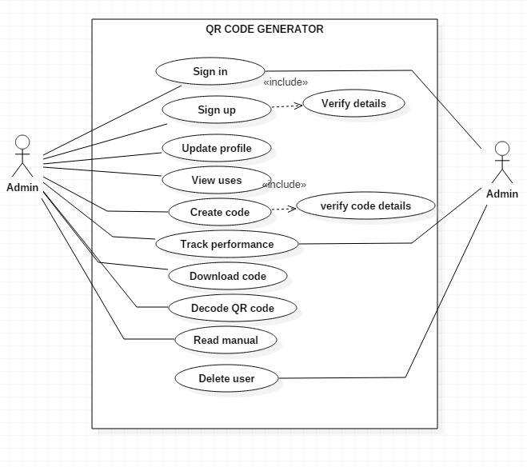

Fig: Use case diagram

# 2.8 Class diagram:

A class diagram is an illustration of the relationships and source code dependencies among classes in the Unified Modeling Language (UML). In this context, a class defines the methods and variables in an object, which is a specific entity in a program or the unit of code representing that entity. Class diagrams are useful in all forms of object-oriented programming (OOP).

UML Class Diagram gives an overview of a software system by displaying classes, attributes, operations, and their relationships. This Diagram includes the class name, attributes, and operation in separate designated compartments.

Class Diagram helps construct the code for the software application development.

**Natural Languages Analysis (NLA):**

Natural language analysis is the process of identifying verbs, adjectives and nouns in a piece of description text. Natural language understanding is enabling computers to derive meaning from human or natural language input, and others involve natural language generation.

* Nouns relate to potential classes
* Adjectives relate to potential attributes
* Verbs relate to potential functionality that must be represented.

For the identification of NLA there is a scenario and the scenario for the project is:

**SCENARIO:**

Todays world is of internet and all the things along with the human being are in dependent upon mostly on internet or the technology. As the technology and the internet is growing the day by day the uses of it in different area is growing rapidly. The world is being advanced and advanced.

Now days most of the business are successful through use of internet. They use internet for the advertisement purposes, learning, teaching, and many more. Considering its growth and making the day to day work easy we thought to develop a system where a user can compress a data and use for it work with the help of quick response code generator. Which would facilizes the user to generate the code or scan the code easily from accessing browser and can easily scan from the mobile phones with supportive apps.

A QR code (quick response code) is a type of 2D bar code that is used to provide easy access to information through a smartphone. The system should be Web API show it should be developed in PHP it is widely used and compatible one and many framework are also available. The user being registered in system must provide the details such as: Full name, Address, Mobile number, Email etc.

And the functions needed to be implemented in the system are:

* User can create an account, edit profile, view details.
* User should be provided with manual in the system to create the code.
* User can create the QR code for social media channels
* User can create the code for vCard
* User can create a code for the website links
* User could be able to create code for messages
* User should be able to download the generated code
* Users should be able to share generated code through social media.
* User can also delete generated code from their account.
* Users should also be provided with the uses of QR code.

**NLA identification from the scenario:**

|  |  |
| --- | --- |
| **Nouns** | **Verbs** |
| Users, Admin, QR code | Update profile, view profile, create QR code, Decode generated code, Download code, Add or delete QR code, uses of QR code |

**Candidate class:**

1. Users
2. Admin
3. QR code

**Methods:**

1. Update profile
2. View profile
3. Create QR code
4. Decode generated code
5. Download code
6. Add QR code
7. Delete code
8. View uses of QR code

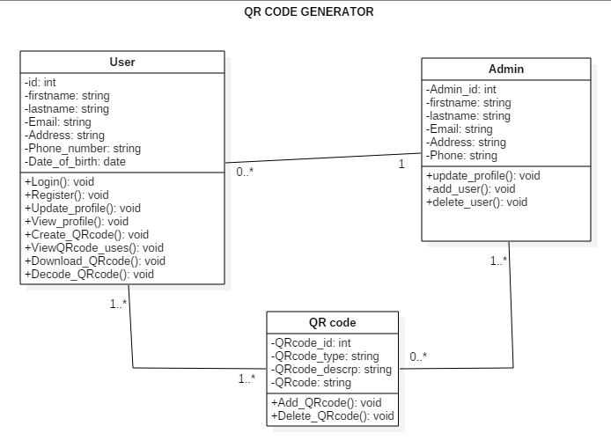

Fig: Class diagram