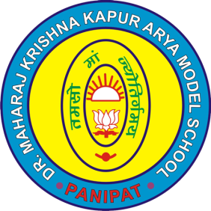

**Dr. M. K. K. Arya Model School**

**Model Town, PANIPAT**

**(Affiliated to C.B.S.E., New Delhi)**

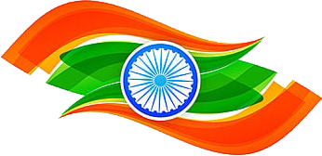

**Certificate of Appreciation**

This is to certify that Miss / Master................................. Class/ Sec............is being awarded for her/ his commendable performance in the **Poster Designing Competition** on the occasion of Independence Day held on Aug 15, 2021.

**Heartiest Congratulations!**



Principal