1. **Create a database music_artist**

Login into CouchDB using the credientials you set up while installing couchDB.

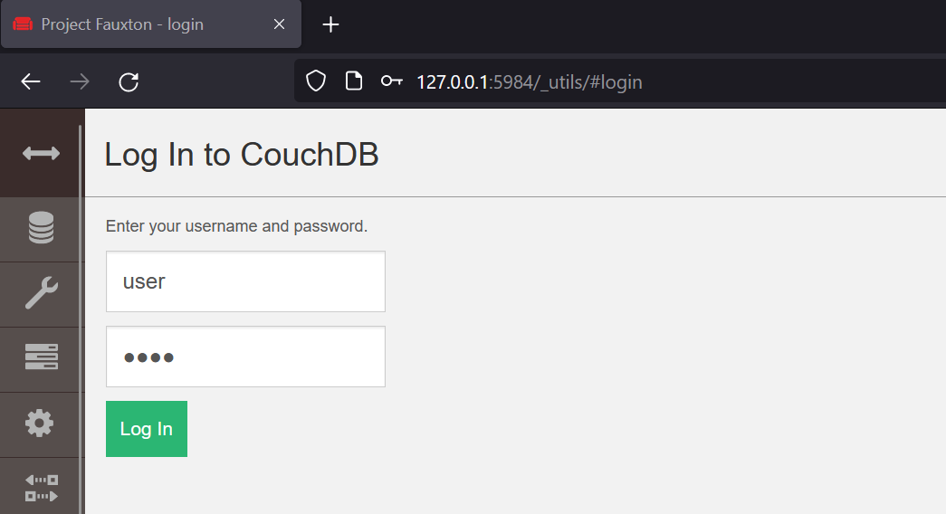

Create Database in CouchDB by clicking on Databases tab in the left menu and then click on Create Database.

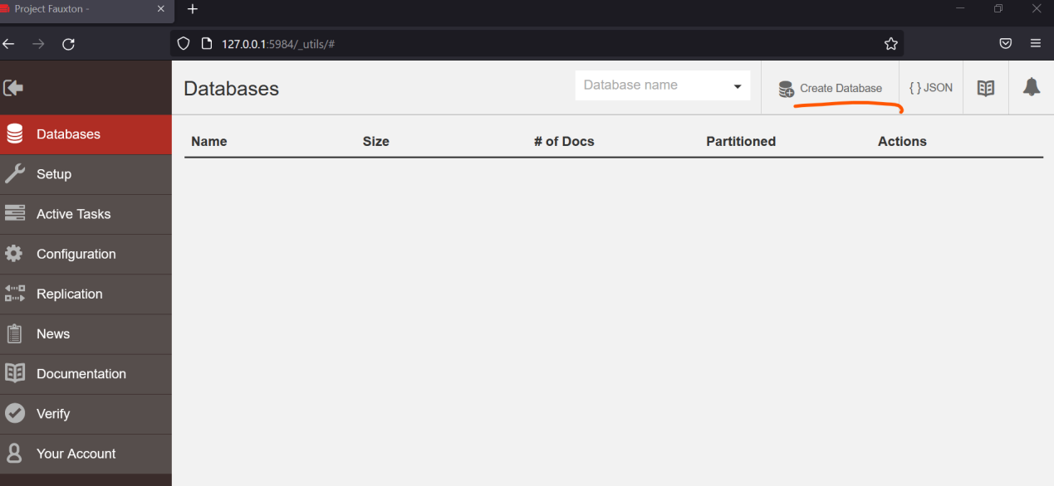

Create Database named Music_Artist

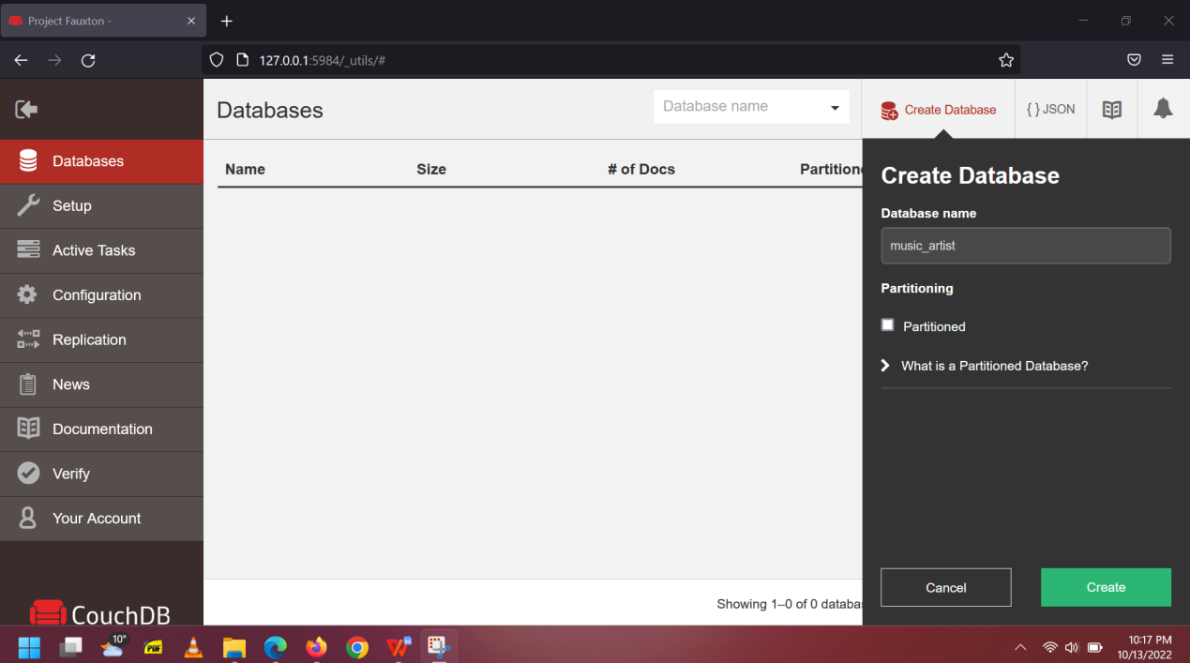

Successful database creation can be viewed by clicking the databases in the left side.

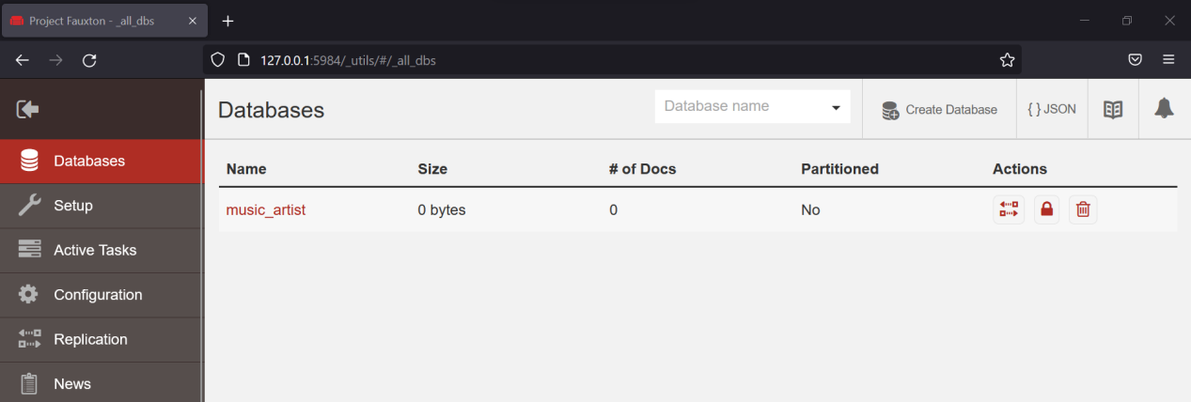

1. **Import the data from MuseRelatedArtist.json file into the new database**

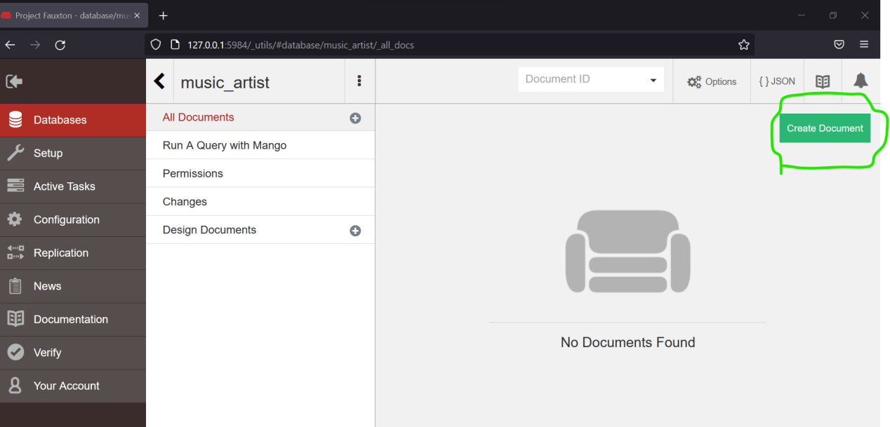

We have empty documents now.

For importing the Document MuseRelatedArtist.json in CouchDB Database Run the following command from CMD in downloads folder.

*curl -d @MuseRelatedArtist.json -H "Content-type: application/json" -X POST http://127.0.0.1:5984/music_artist/_bulk_docs -u user:pass*

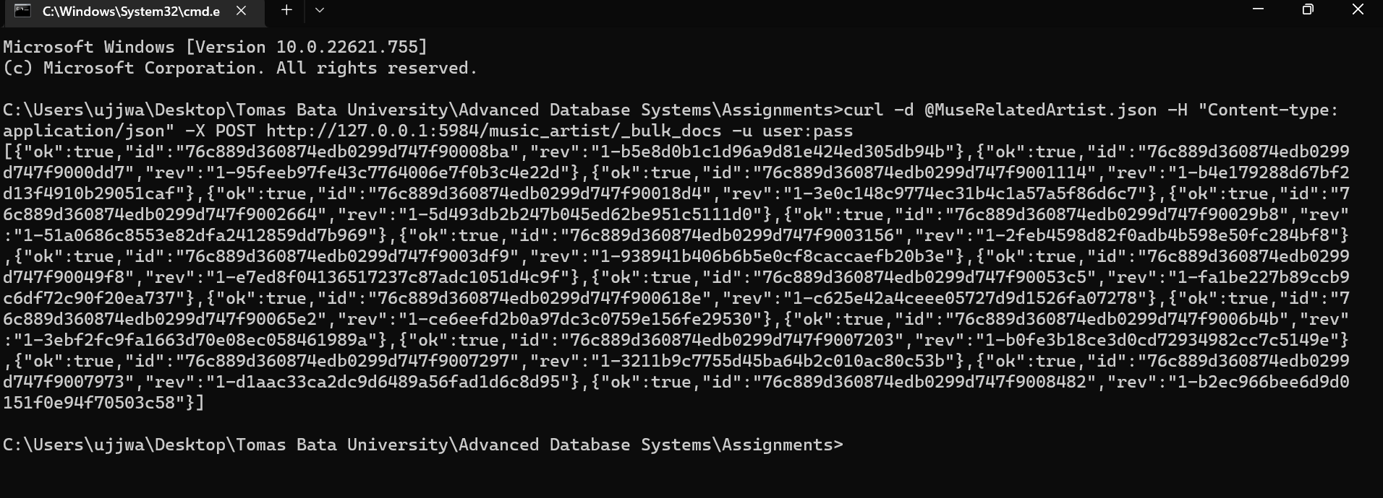

Location of the JSON file

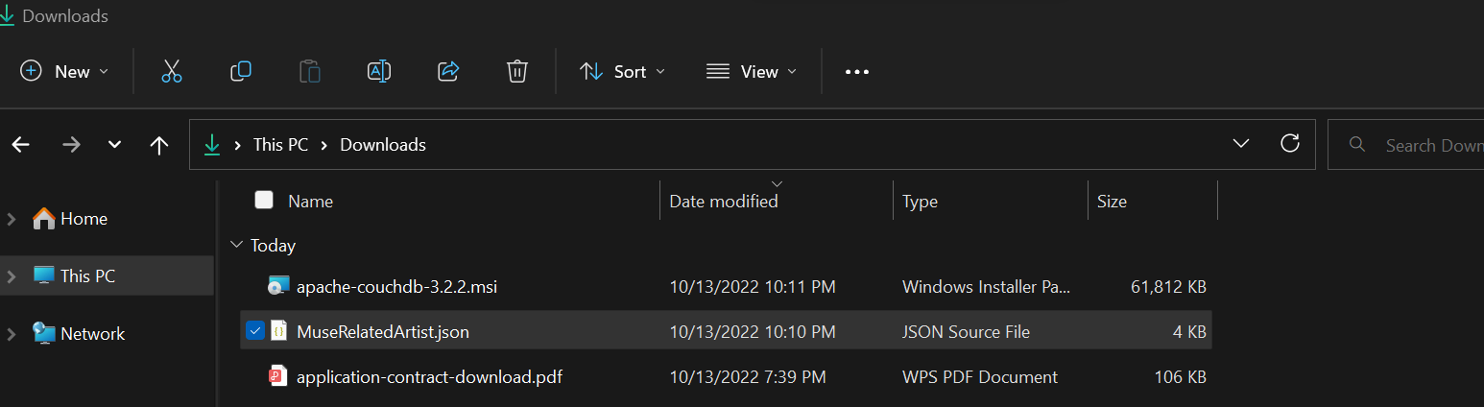

View the imported json file in the couchdb in various formats like metadata, table and json format.

Metadata view

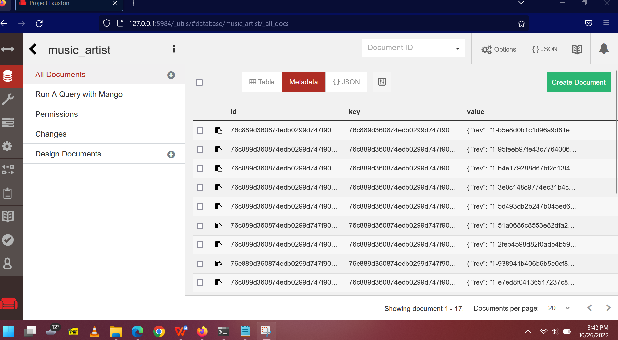

Table View

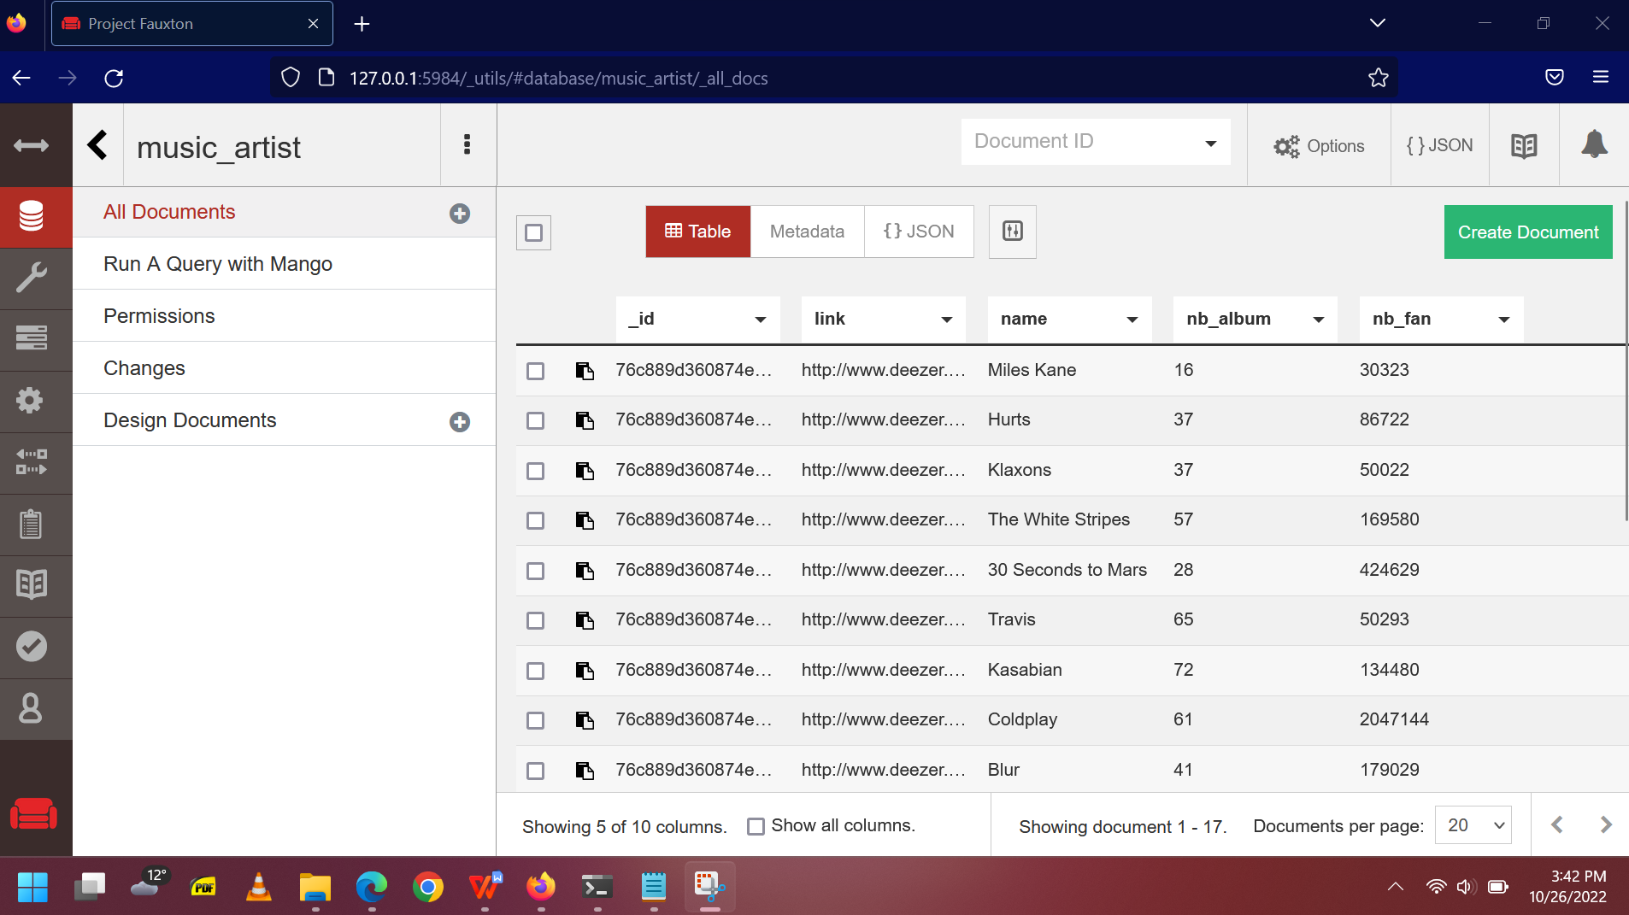

JSON View

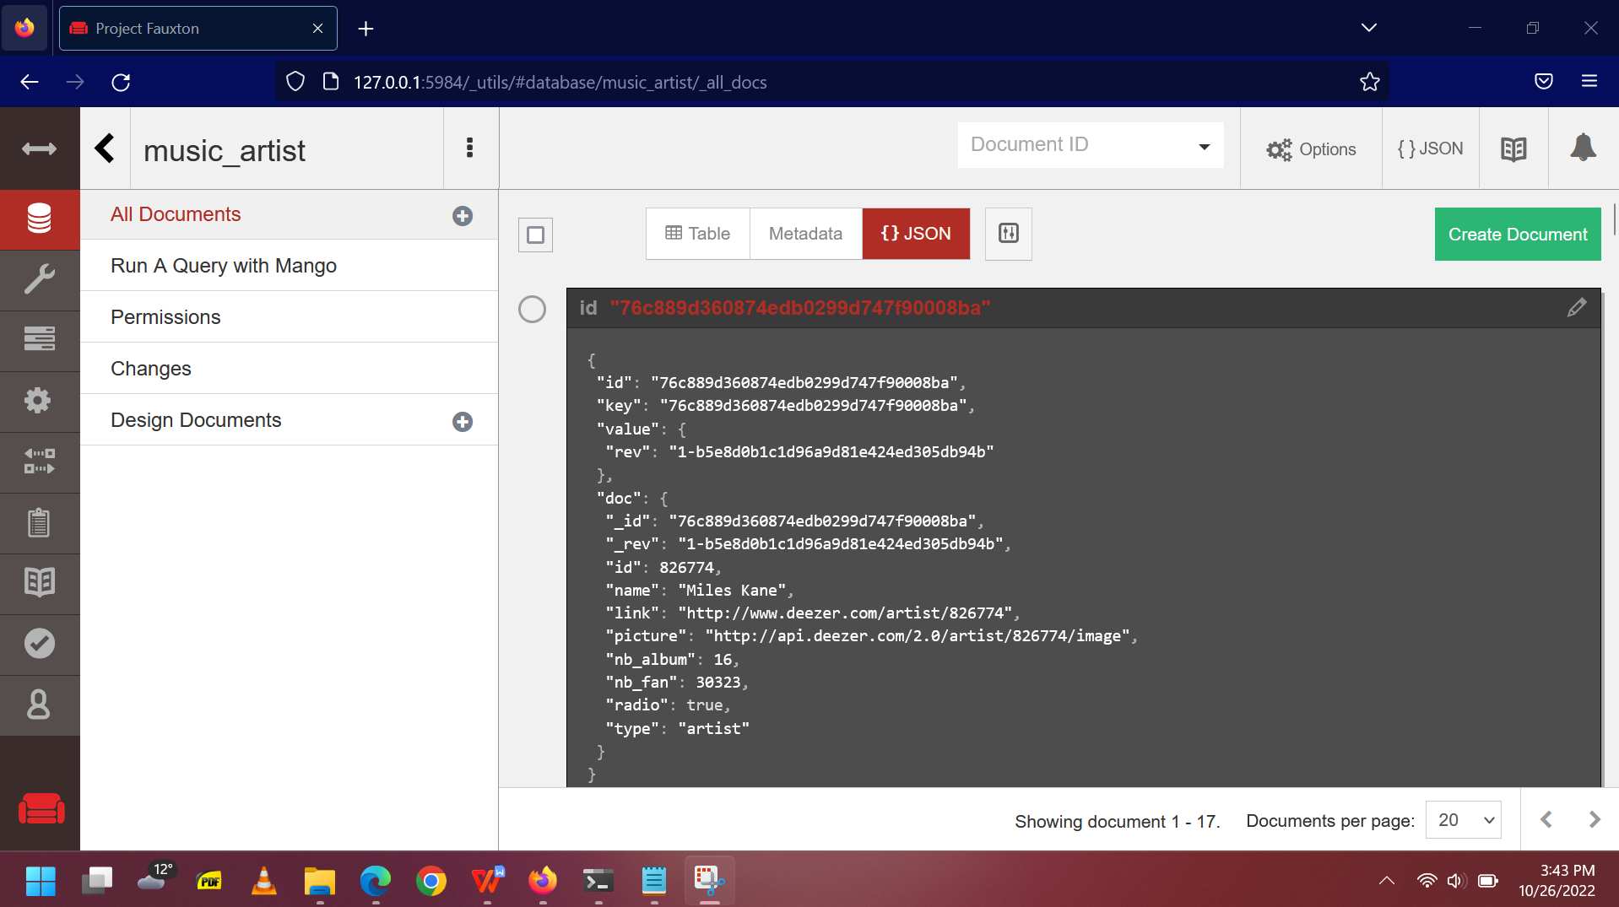

1. **Create a view that groups the information by the nb_album field and counts the number of rows per album.**

Create new View by clicking the new view as shown in the picture below.

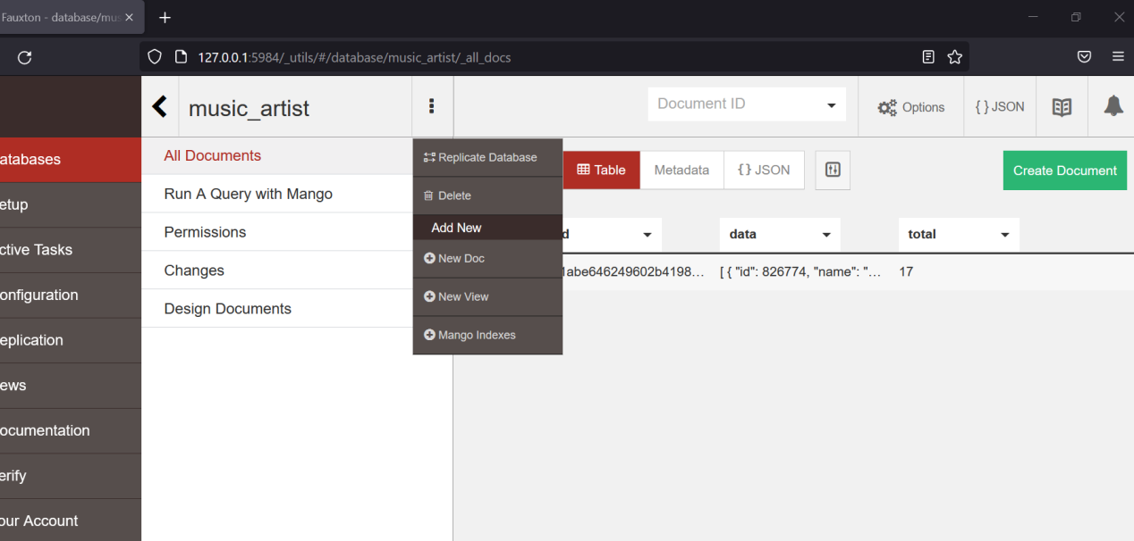

Create a view that groups the information by the nb_album field and counts the number of rows per album.

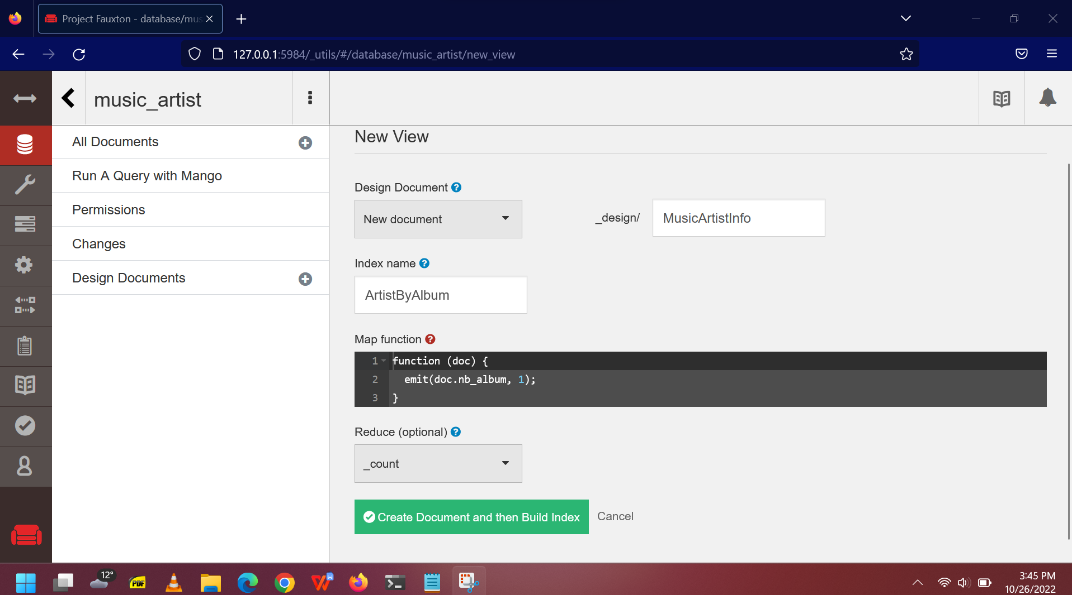

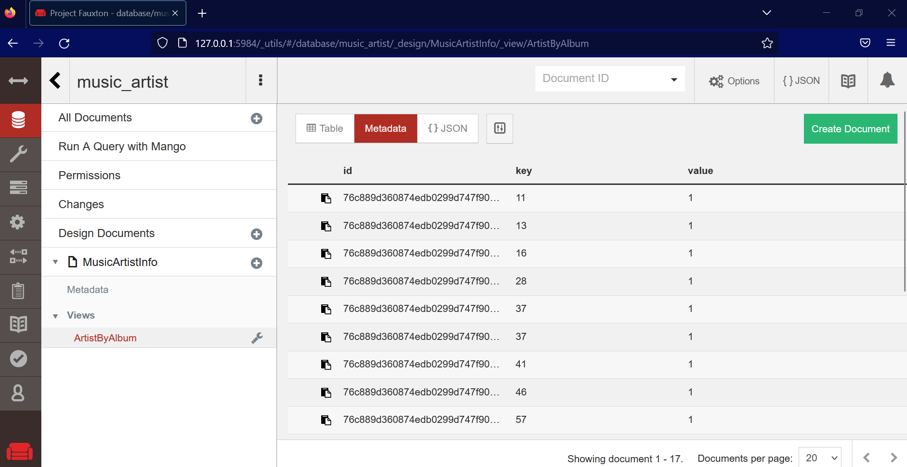

Then run the following command in the command prompt

*curl http://127.0.0.1:5984/music_artist/_design/MusicArtistInfo/_view/ArtistByAlbum?group=true -u user:pass*

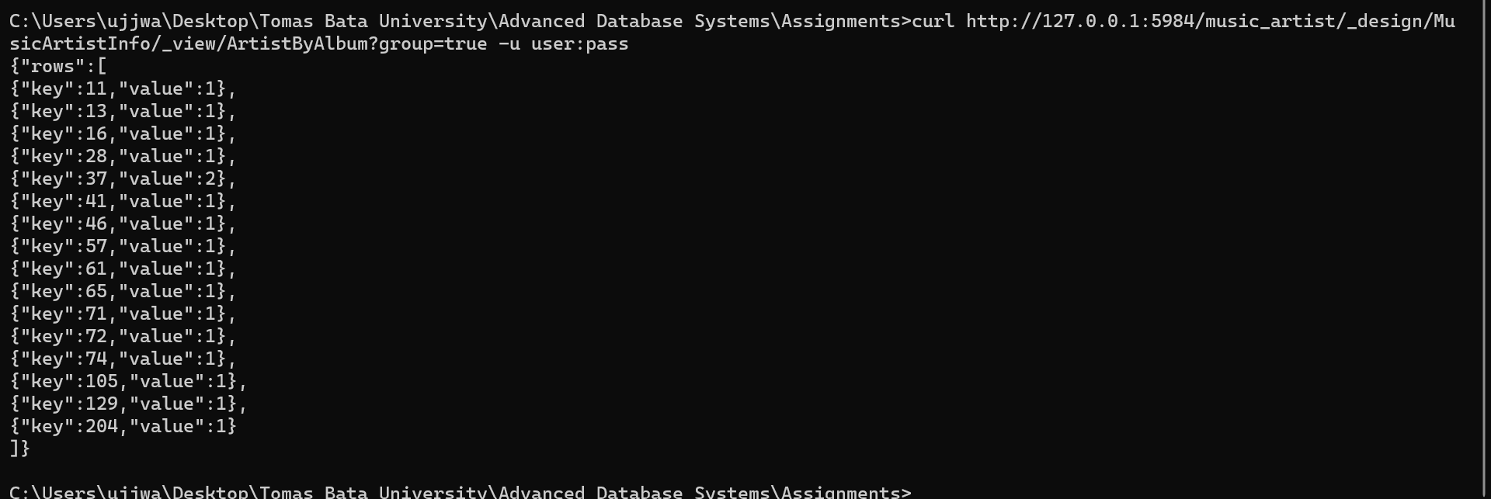

1. **Create another view that groups the information by the nb_album field and gets the total number of fans (nb_fan field) per album.**

Enter the details as shown in the picture when creating view.

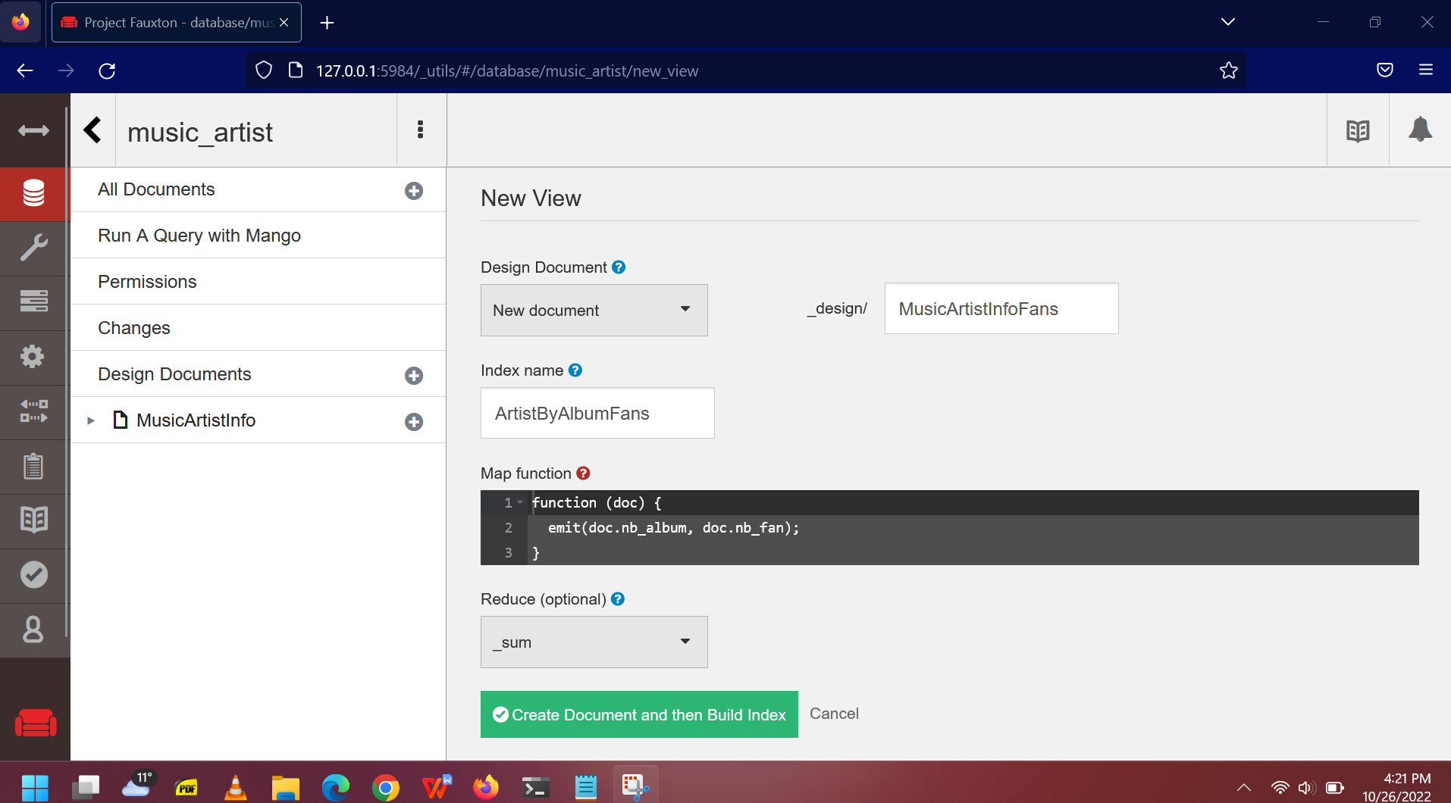

Then we have created two views views as shown below

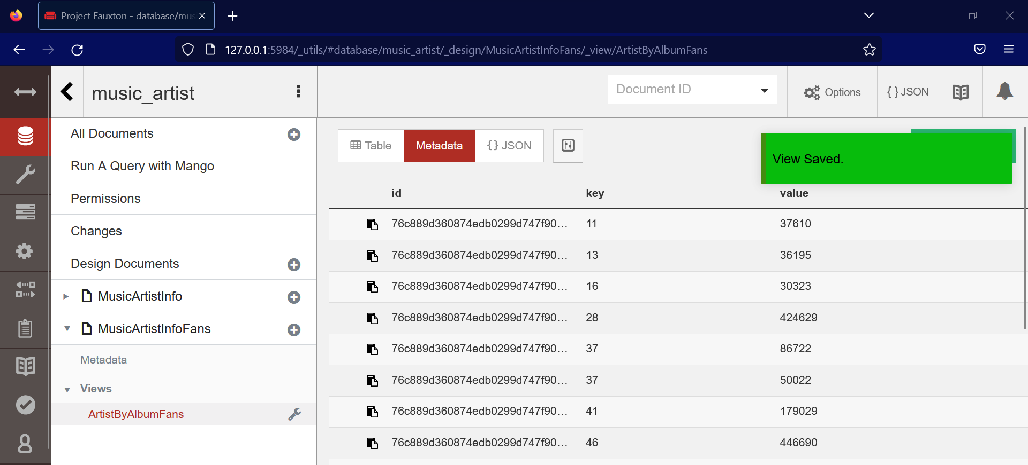

Then check in the command prompt the following code

curl http://127.0.0.1:5984/music_artist/_design/MusicArtistInfoFans/_view/ArtistByAlbumFans?group=true -u user:pass

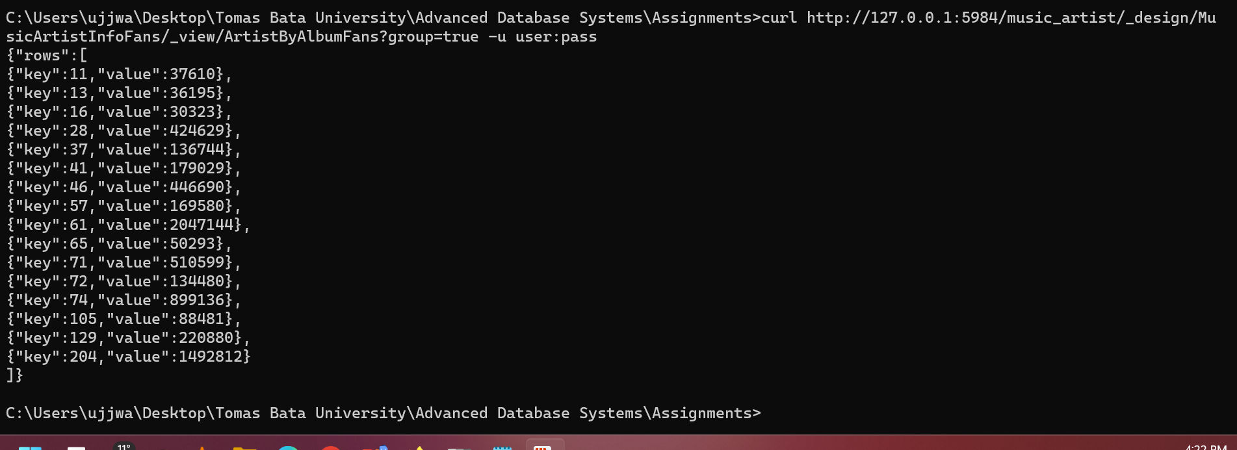

1. **Replicate the database in a new one: music_artist_replica. Demonstrate that it works by adding a new artist in the original database and displaying it in the replica.**

Click the Replicate icon as shown in the image below.

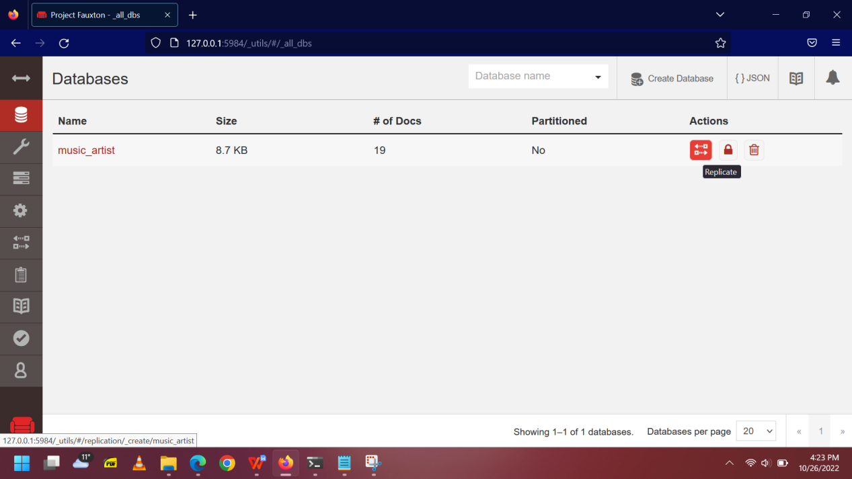

Fill the source details

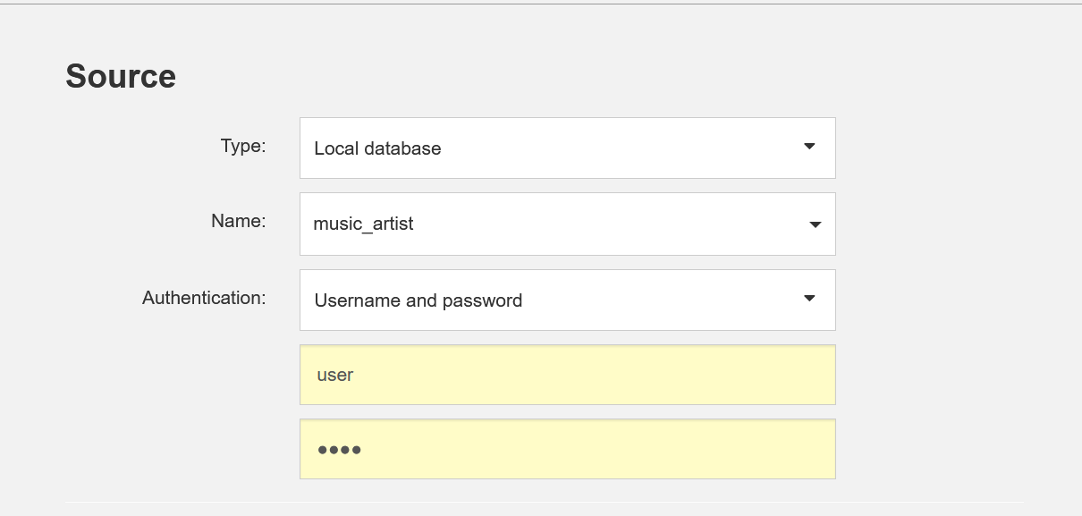

Fill the target details

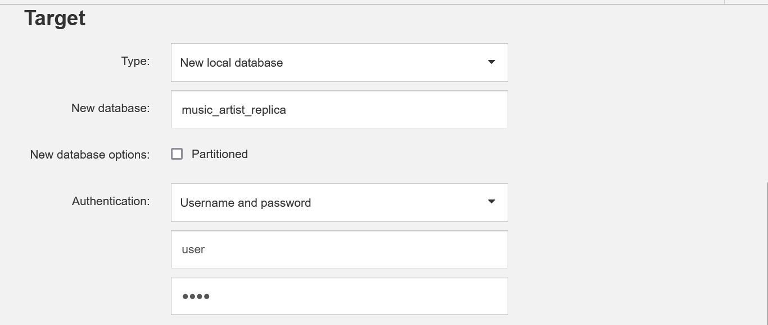

Select the replication type as continuous and start replication.

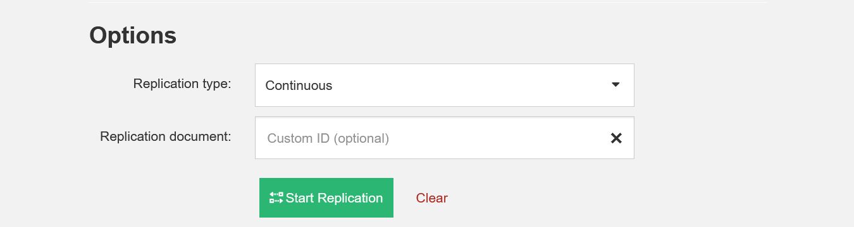

Replication done

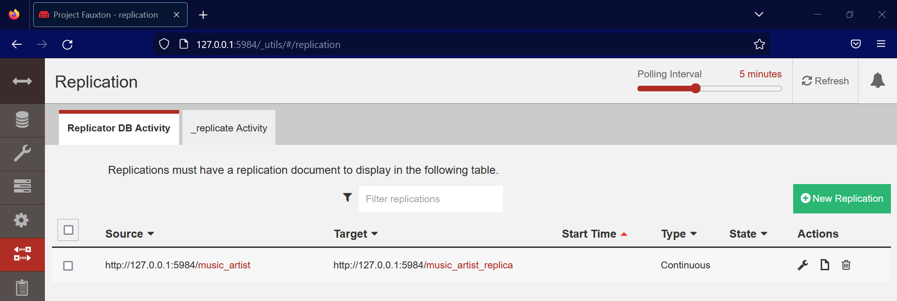

Number of documents is same for both databases after replication.

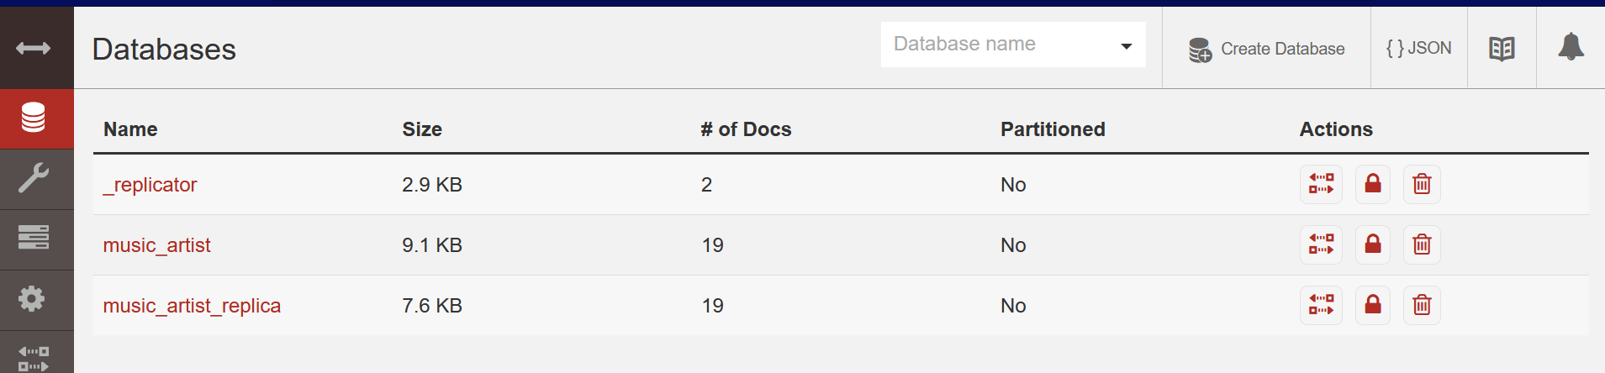

Create new document in the original database

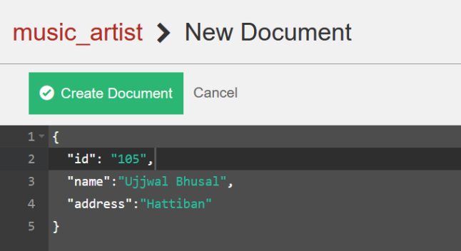

New document is created now

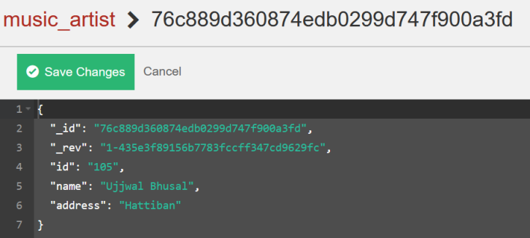

The number for document has changed in the replica and is present in the replica database.

