Complete the assignments that are included in Assignment 5 document by submitting a document with all required commands (you can include screenshots of the result of each task as well).

**Assignment #1: Create a courses collection**

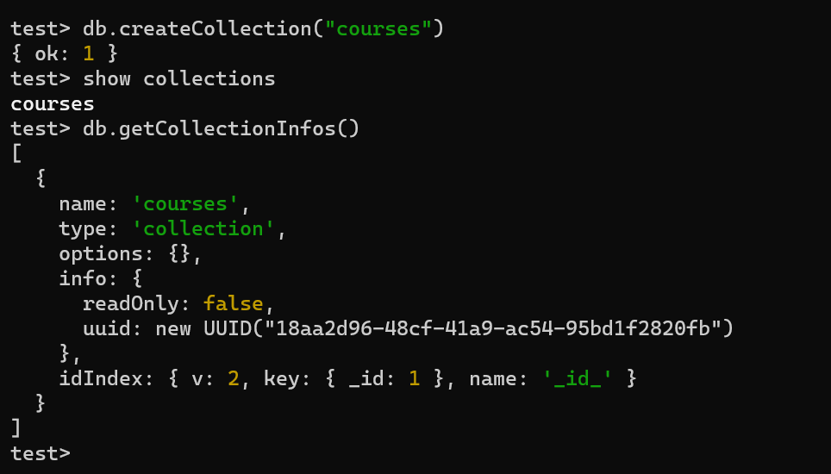

**Assignment #2: Insert 3 documents in the courses collection**

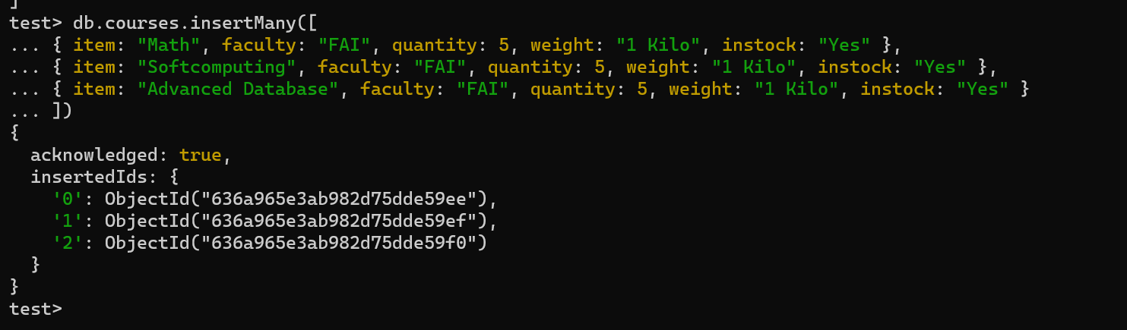

**Assignment #3: Query the following data**

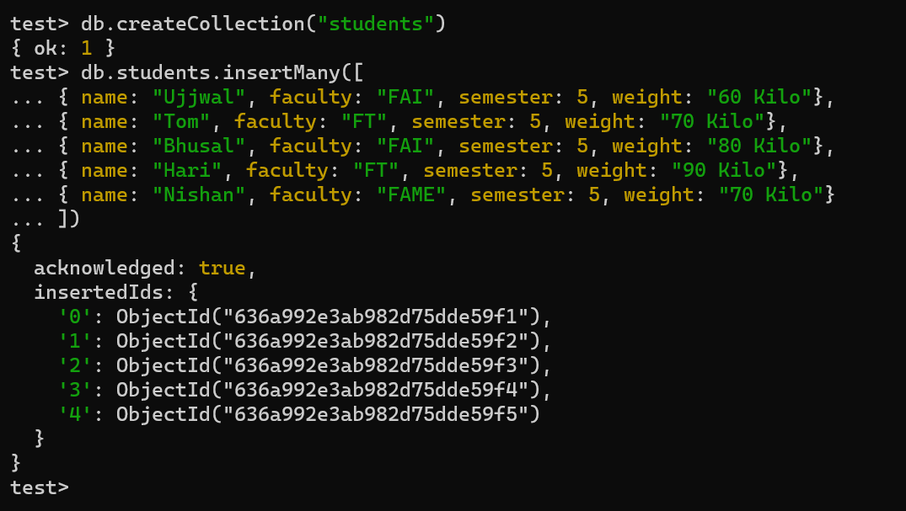

• Students from all faculties but FT

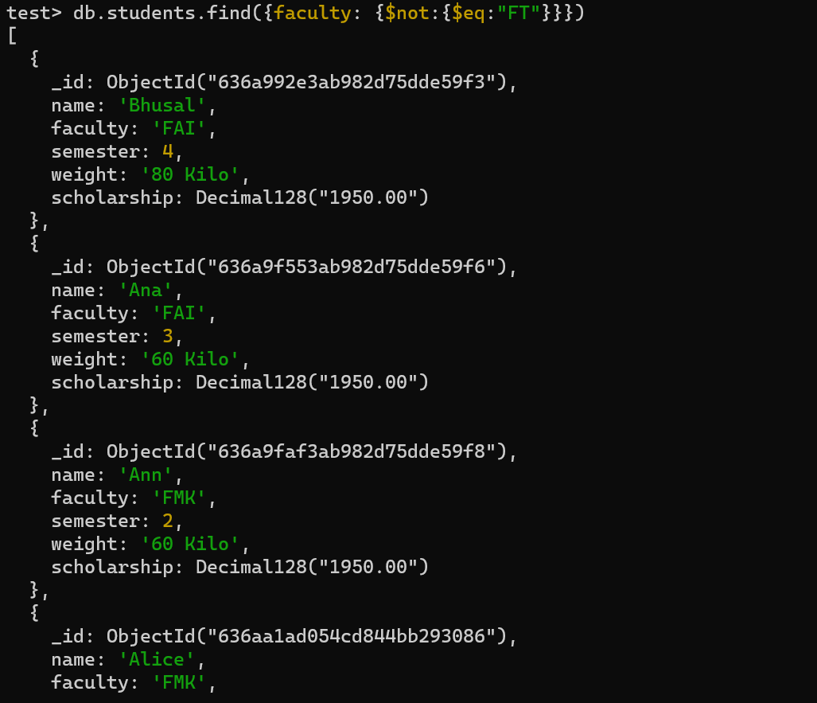

• Students Tom or Sara

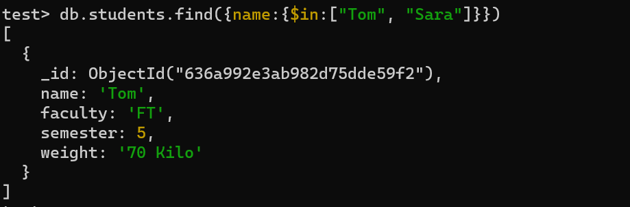

• Students from FT faculty and sixth semester

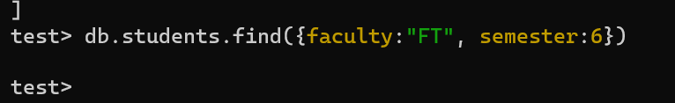

• Students between 3rd and 6th semester (including them)

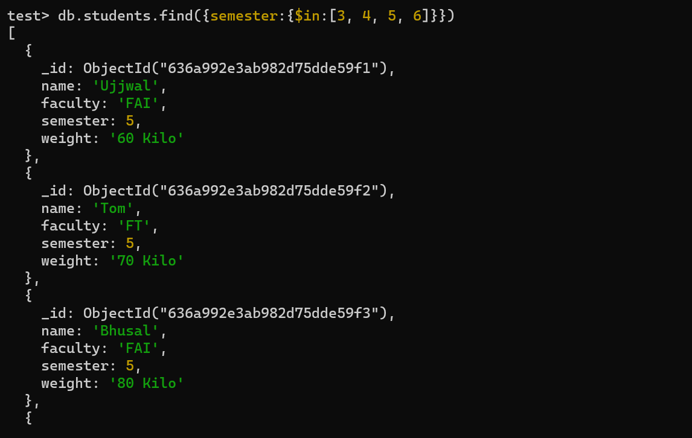

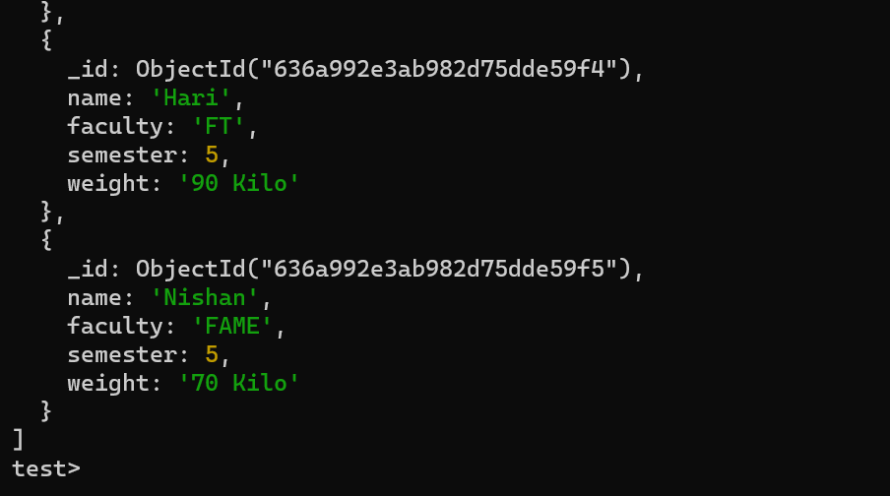

**Assignment #4: Update the following documents:**

• Ann’s new faculty is FMK

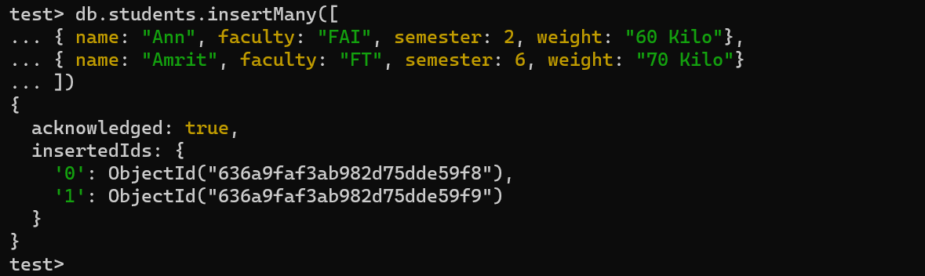

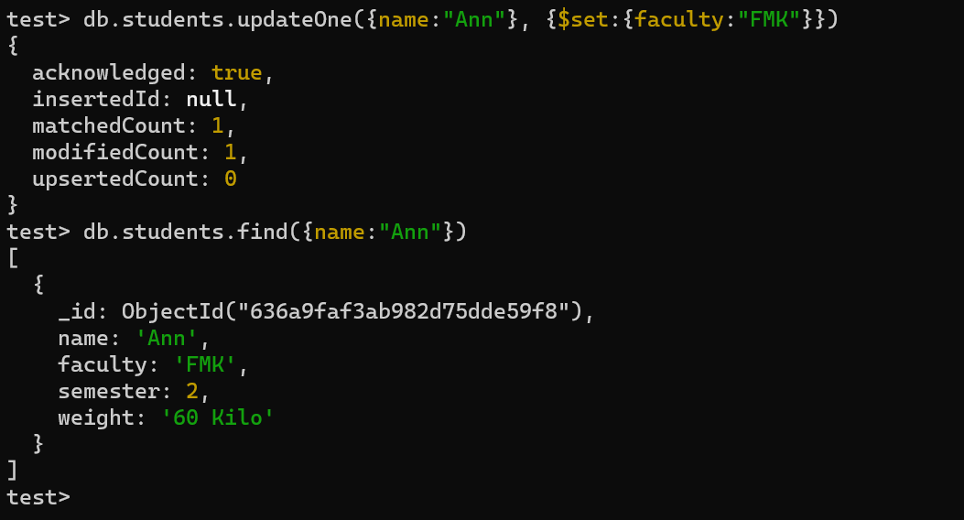

• Replace the information of a student named Alice. If it does not exist, insert a new document with the information.

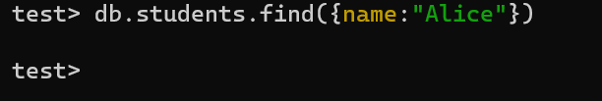

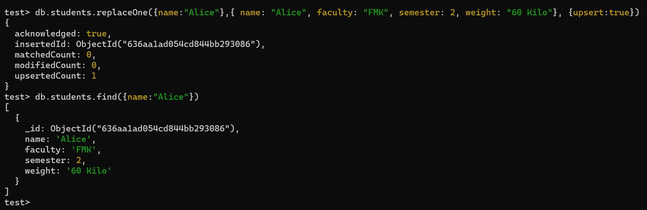

• Reduce by one the semester of all students from FAI faculty

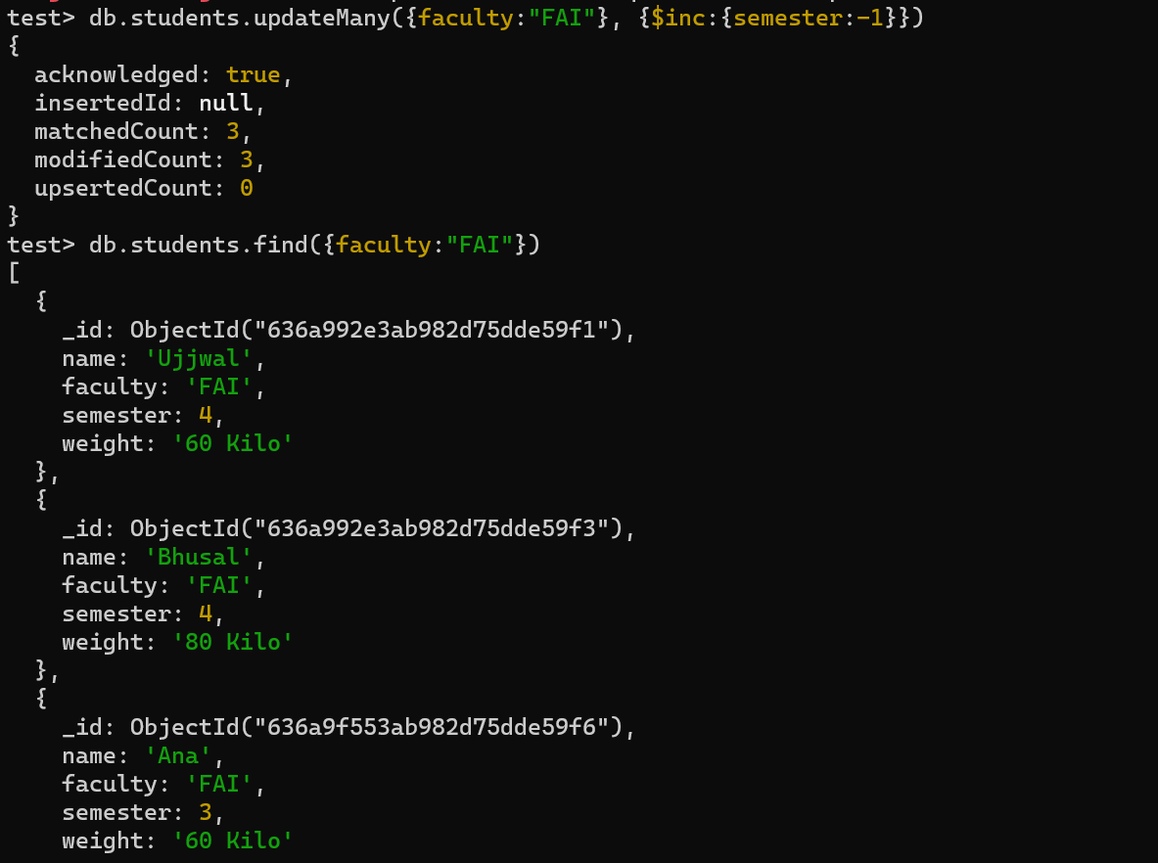

• All scholarships will be increased by 30%

Update scholarship

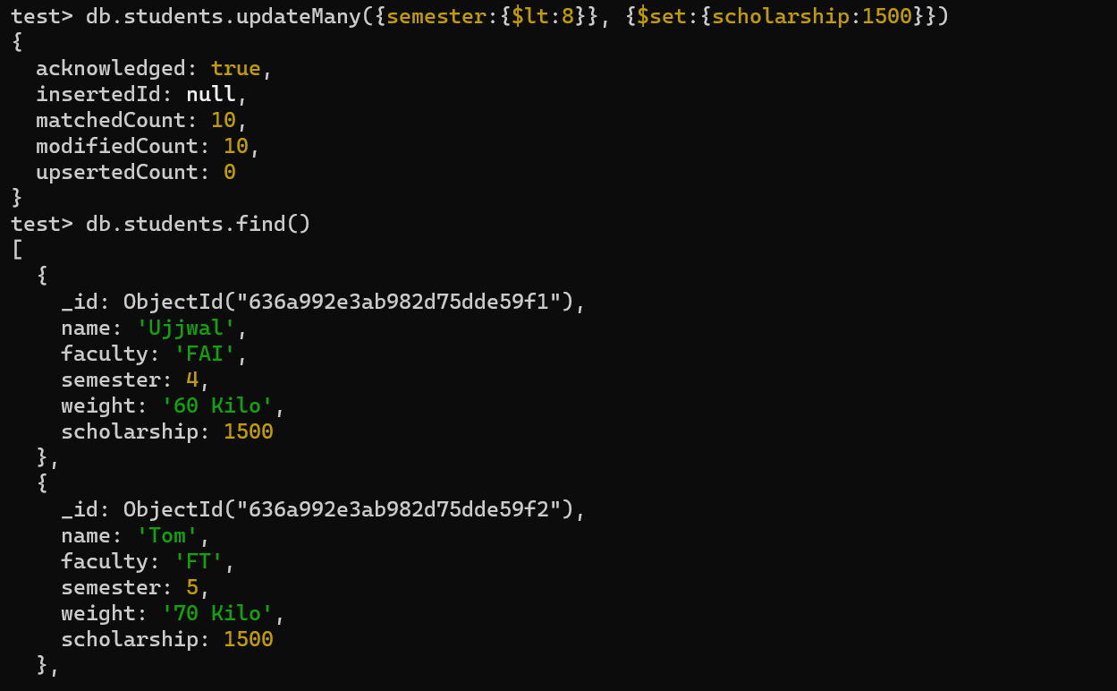

Increase scholarship by 30%

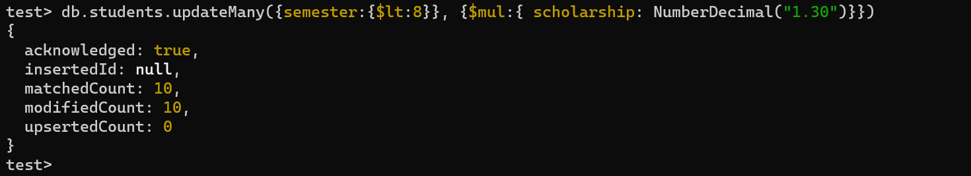

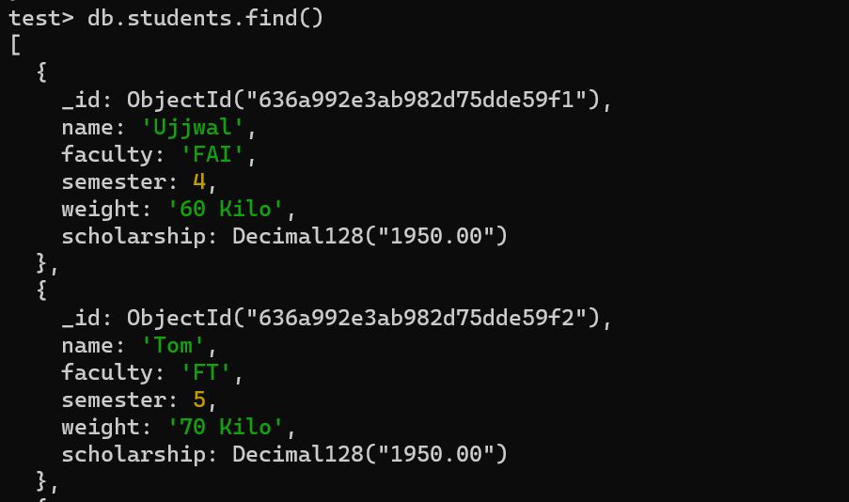

**Assignment #5: Remove the following documents:**

• All documents from FAME faculty

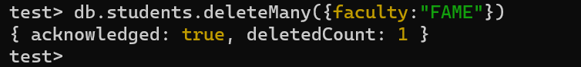

• One student with scholarship lower than 5000

