CertiLock Campus: A Hybrid Blockchain and Cryptographic Hashing Framework for Secure Academic and Skill Certificate Verification

Bhushan Lilhare¹  Computer Science and Engineering  GH Raisoni College of Engineering  Nagpur, Maharashtra  bhushanlilhare956@gmail.com | Rahul Gupta⁴  Computer Science and Engineering  GH Raisoni College of Engineering  Nagpur, Maharashtra  rahulgupta2024a@gmail.com | Arjun Verma²  Computer Science and Engineering  GH Raisoni College of Engineering  Nagpur, Maharashtra  ankitverma2104@gmail.com | Karan Deshmukh³  Computer Science and Engineering  GH Raisoni College of Engineering  Nagpur, Maharashtra  priyadeshmukh@gmail.com

Dr. Mangala Madankar⁵
Computer Science and Engineering
GH Raisoni College of Engineering
Nagpur, Maharashtra
mangala.madankar@raisoni.net

Abstract—The rapid increase in digital academic records has led to significant challenges in ensuring the authenticity and integrity of certificates. Traditional verification methods are often manual, time-consuming, and vulnerable to forgery.
This paper presents CertiLock Campus, a hybrid framework that leverages blockchain technology, SHA-256 cryptographic hashing, and RSA 2048-bit digital signatures to provide a secure, tamper-proof system for academic and skill certificate verification. The proposed system generates a SHA-256 hash for each certificate, signs it using a 2048-bit RSA private key, and records it on a blockchain network, ensuring immutability and authenticity.
Additionally, QR codes are integrated to enable real-time verification by any third party without requiring an account. The system uses a hybrid storage architecture combining blockchain-based cryptographic verification with Firebase Firestore for efficient and scalable cloud data management.
Experimental results demonstrate that the proposed system significantly reduces verification time while enhancing security and trust. This framework can be effectively adopted by educational institutions to combat certificate fraud and streamline verification processes.
Keywords—Blockchain, SHA-256 Hashing, RSA Digital Signatures, Certificate Verification, QR Code, Academic Integrity, Smart Contracts, Firebase Firestore, Tamper-Proof Credentials, Decentralized Systems, Certificate Fraud Detection, Institutional Authentication, Next.js, Vercel, and Educational Technology.

- Introduction

With the digital transformation of educational systems, academic certificates and skill credentials are increasingly issued and stored electronically. However, this shift has also led to a rise in fraudulent activities such as certificate forgery and unauthorized modification. Traditional verification processes rely heavily on manual checks or centralized databases, which are inefficient, time-consuming, and prone to security vulnerabilities. [3] Still, the majority of current verification systems default to institutional email confirmations or physical document inspection.
These verification methods might exclude employers in remote locations, institutions with limited IT infrastructure, or situations where one verification channel is unavailable. Hence the design of credential systems needs to be more inclusive and secure. In response to this, blockchain-based verification frameworks are being developed. The combination of SHA-256 cryptographic hashing and distributed ledger storage allows for more reliable and tamper-proof certificate verification. [1] In contexts where manual verification is impractical or slow, automated blockchain-based QR verification provides a viable and faster alternative.
The system being developed incorporates an Ethereum-compatible smart contract as the core blockchain component and as the primary mechanism for immutable certificate hash storage. SHA-256 hashes are computed server-side, and QR code generation is handled at the application layer. [8] These hashes are stored on-chain through smart contract transactions, ensuring verification is possible in real time at minimal cost. Integrating these components provides a secure, low-cost, and scalable credentialing solution for today's educational institutions. This system also includes a built-in chatbot assistant to guide users through the verification process. This differs from general-purpose AI chatbots, as it contains system-specific guidance with answers to common verification queries and step-by-step troubleshooting support. This improves ease of use and reduces reliance on institutional support staff. The chatbot acts as a bridge especially for first-time users unfamiliar with blockchain-based certificate verification. Overall, CertiLock Campus presents a cost-effective, inclusive, and accessible solution combining SHA-256 hashing, blockchain storage, QR code verification, and chatbot support into a unified platform. [2] This work contributes toward strengthening digital credentialing systems through a focus on security, accessibility, and real-world scalability.
II. Literature Review
Certificate verification systems have evolved considerably with blockchain, cryptographic hashing, and distributed ledger technologies. [4] Early systems relied on paper registries and manual verification but transitioned to digital databases and email-based confirmation processes. However, single-mode verification systems often leave institutions and employers with inadequate protection against sophisticated forgery. Recent studies show that blockchain-based hybrid systems have significant impact in improving security, verification speed, and institutional trust. Simultaneously, research into cryptographic hashing has demonstrated its value in ensuring certificate data integrity, forming the basis for tamper-proof digital credentialing.
A. Evolution of Certificate Authentication

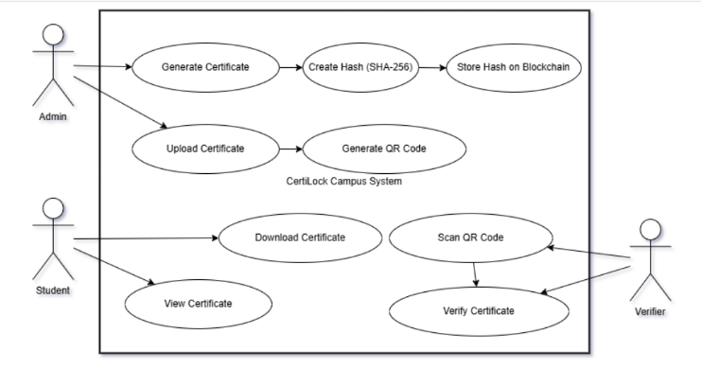
Certificate authentication systems have been greatly shaped by the development of cryptographic and distributed technologies. [16] Paper-based and early digital credentials were used in earlier systems, but these methods were neither scalable nor reliably secure against document forgery. Modern systems now leverage smart contracts, SHA-256 hashing, and QR code generation to verify credentials in real time without manual institutional involvement. This progression has enabled institutions and employers to authenticate certificates accurately and at scale.
B. Blockchain in Academic Credentialing
The use of blockchain in academic credentialing has moved beyond experimental pilots toward practical institutional deployment. Ethereum-based platforms provide low-cost, tamper-proof mechanisms for certificate hash storage and real-time verification. [7] Prior studies confirm that blockchain-based systems reduce verification time from days to seconds and guarantee immutability of issued records. In academic environments, this creates a foundation for secure, scalable, and auditable certificate lifecycle management.
C. Cryptographic Hashing in Data Integrity
Cryptographic hashing using SHA-256 adds a critical layer of intelligence to certificate verification by detecting any modification, however minor, in the certificate document. [19] SHA-256 hash values act as unique digital fingerprints for each certificate and are computationally infeasible to reverse or replicate. Research confirms that hash-based verification paired with blockchain immutability ensures complete document integrity. This makes cryptographic hashing a foundational component of any trustworthy digital credentialing infrastructure.
D. Smart Contracts and Automation
Smart contracts on Ethereum are a fundamental building block of automated, trustless certificate management systems. Solidity-based issuance contracts, role-based access control, and automated revocation logic together improve verification accuracy and reduce manual administrative overhead. [6] For institutions already running digital systems, smart contract integration enables real-time automated verification without depending on staff-driven processes. Research confirms that smart contract automation not only speeds up verification but also ensures complete auditability for regulatory and compliance requirements.
E. Challenges in Existing Digital Verification Systems
Even with these advances, significant challenges remain in deploying blockchain-based certificate systems at scale. Storing full certificate documents on public blockchains is cost-prohibitive due to gas fees, and verification throughput is limited when large certificate batches must be processed together. [6] Furthermore, the coordination of cloud storage, blockchain records, and QR code generation involves considerable integration complexity. Literature consistently shows that hybrid approaches, where one layer provides a fallback for the other, deliver better reliability and more consistent verification experiences across diverse institutional deployments.
Fig. 1.1 Use Case Diagram
III. Methodology
A. Design and Architecture of Systems
The design of the CertiLock Campus system is organized across four integrated layers: a Cryptographic Layer for SHA-256 hashing and RSA 2048-bit digital signing, a Blockchain Layer for immutable on-chain hash storage via smart contracts, an Application Layer for certificate issuance and verification logic, and a Storage Layer for document and metadata management. The system is designed with a focus on low latency, cost efficiency, and user convenience, ensuring certificate verification responds accurately and quickly to institutional and employer needs. These four layers together form a unified verification environment that is lightweight, scalable, and straightforward to deploy.
a) Cryptographic Layer
SHA-256 Hashing: All certificate data including student name, institution, course, and issue date is serialized and passed through SHA-256 to produce a unique 256-bit hash. Any modification to the certificate, however small, produces an entirely different hash value, making tampering immediately detectable. RSA Digital Signatures: On institute registration, a 2048-bit RSA key pair is automatically generated and stored securely in Firebase Firestore. The private key is used to digitally sign the SHA-256 hash of each certificate issued by that institution. [15] The public key is published for open verification. This two-step cryptographic pipeline of hashing followed by signing provides both data integrity and authenticity assurance for every issued credential.
b) Blockchain Layer
The blockchain layer records the SHA-256 hash and RSA signature of each issued certificate on an immutable distributed ledger using smart contracts deployed on Ethereum or Polygon. Only the lightweight hash and signature are stored on-chain, keeping transaction costs minimal while maintaining full cryptographic integrity. The on-chain record is publicly auditable, so any verifier can independently confirm the authenticity of a certificate without contacting the issuing institution. Smart contracts also govern issuance authorization and revocation, ensuring only registered institutions can issue credentials and that revoked certificates are flagged immediately on-chain.
c) Application and Storage Layer
Application Layer: The Next.js frontend provides the institute portal, student portal, and public verification page. The Node.js backend API handles certificate generation, triggers the cryptographic pipeline, submits hashes to the blockchain, and manages all Firebase interactions. Storage Layer: Certificate metadata, SHA-256 hashes, and RSA signatures are stored in Firebase Firestore with strict role-based security rules ensuring only authorized institute accounts can write records. Full certificate PDF files are stored in Firebase Storage. A QR code is generated per certificate, encoding the unique certificate ID. Verifiers scan the QR code or enter the certificate ID, triggering real-time SHA-256 recomputation, RSA signature verification using the institute public key, and a cross-check against the on-chain blockchain record, returning an instant verified or tampered result.
B. Data Collection and Processing
Data collection plays an important role in the system because it ensures correct certificate fingerprinting and reliable operation of the verification pipeline. Integrating Systems: The Node.js backend integrates with Firebase Firestore for certificate record storage, Ethereum-compatible blockchain nodes for on-chain hash submission, and the institution RSA key store for digital signing. [22] In hash processing, all certificate field values are serialized into a canonical string format before SHA-256 hashing to ensure consistent outputs regardless of input order or platform environment. Data Transmission: HTTPS REST APIs handle all frontend-to-backend communication, while Web3 JSON-RPC protocols manage backend-to-blockchain interactions. Firebase real-time listeners enable instant status updates on the institution dashboard once a certificate hash is confirmed on-chain.
C. Cloud Configuration
The cloud infrastructure provides scalability, system management, and analytics. Blockchain Core Configuration: Smart contract platforms manage authentication, secure hash submissions, and certificate lifecycle events, ensuring that only authorized institutional accounts can issue or revoke certificates. Data Processing using Cloud Functions: AWS Lambda or Google Cloud Functions process certificate issuance requests, classify them by institution and course type, and support scheduled bulk generation. [12] Data Storage: Real-time and historical data, including issuance logs, verification events, and access analytics, are stored in Firebase or MongoDB to support institutional audit trails and compliance reporting.
D. API Development
APIs form the link between the blockchain backend and the user-facing institutional dashboard and public verification portal. [10] RESTful APIs: Built using Node.js and Express.js, these provide institutions with secure access to certificate issuance, revocation management, and verification history. Security: OAuth 2.0 authentication ensures that only verified institutional accounts can issue or revoke certificates. End-to-end TLS encryption protects all data in transit from unauthorized access or interception during both issuance and verification workflows.
E. Work on Front End
The front end is the user interface through which institutions, students, and employers interact with the system. Fig. 1.2 is a general view of the front end implementation.
a) Online User Interface:
A React.js or Angular.js platform is used to build the responsive user interface. The institutional dashboard enables administrators to manage certificate issuance, monitor blockchain transaction status, view verification logs, and handle revocations from a single interactive interface.
b) Data Visualization:
Visualization tools display real-time certificate issuance status, blockchain confirmation timelines, verification event logs, and usage statistics. Issuance volume trends are shown through graphs and status indicators, giving institutional administrators actionable insights for compliance management and system monitoring.
F. Developing Mobile Apps

To allow access on the go, a mobile application is designed to give students and employers complete access to certificate verification from their smartphones. Cross-platform development tools like Flutter and React Native are used to ensure support for both Android and iOS. The app supports QR code scanning for instant verification, secure certificate sharing, and multi-language interface options for broader regional accessibility.
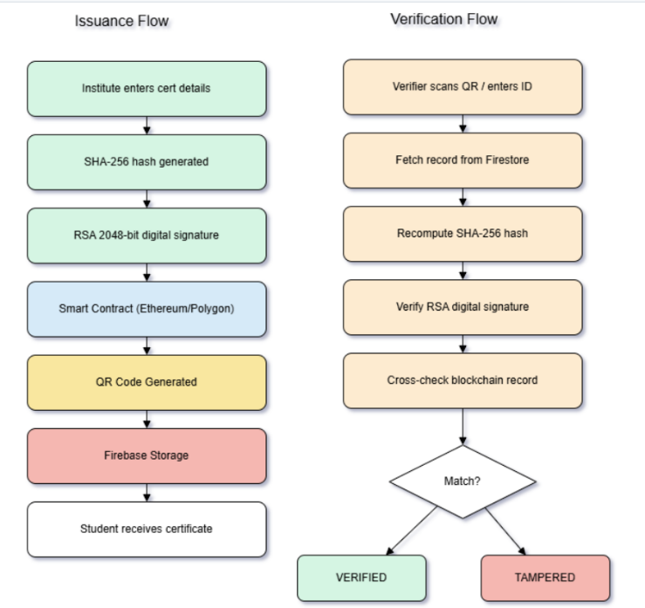

Fig. 1.2 Methodology Diagram for CertiLock Campus System

The workflow of the entire system is shown in Fig. 1.2. As illustrated, certificate data is received from the institutional system and processed by the hashing and issuance layer. The hash is then validated and recorded on the blockchain via smart contract. The system supports real-time feedback through the user interface and cloud synchronization throughout the entire lifecycle.
The system architecture is further illustrated in Fig. 1.3. The diagram depicts three user roles — Admin, Student, and Verifier — interacting with the Application Layer. The Application Layer communicates with the SHA-256 Hash Generator and QR Code Generator, while the backend routes data to the Blockchain for on-chain hash storage and Cloud Storage for certificate documents.
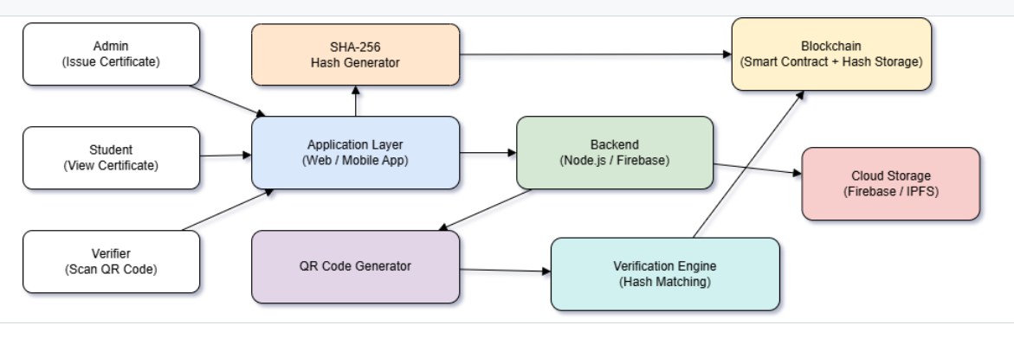
Fig. 1.3 Architecture Diagram — CertiLock Campus
IV. Parameters
The performance of the CertiLock Campus system depends on a number of important parameters that directly affect its security, reliability, and user satisfaction. Since the project provides a dual-layer verification approach combining SHA-256 cryptographic hashing with blockchain immutability, these parameters ensure the inclusivity, efficiency, and accessibility of the framework for each stakeholder, especially non-technical users at academic institutions and employers verifying candidate credentials.
A. Hash Accuracy and Collision Resistance
The accuracy of the SHA-256 hashing process is fundamental to the reliability of the verification system. Accurate hashing ensures that any certificate presented for verification is compared against an immutable on-chain record, reducing the risk of undetected forgery and preventing fraudulent credential claims. Hash generation: Certificate documents are normalized before hashing to ensure identical binary representation across all platforms. Collision resistance: SHA-256 is designed so that no two distinct documents produce the same hash value. [14] Calibration and testing: The preprocessing pipeline requires regular testing to minimize encoding inconsistencies and maintain hash reliability over time. The high collision resistance achieved promotes institutional trust in the system across a wide range of academic and professional credentialing contexts.
B. Transaction Latency
Latency describes the time a certificate issuance or verification request takes to be processed and confirmed on the blockchain. Low latency is a key requirement for real-time institutional throughput. Real-time confirmation: Delays between issuance requests and certificate delivery create friction and reduce adoption. [23] Optimized transaction batching and Layer 2 networks such as Polygon minimize confirmation delays during high-volume issuance and verification periods. User experience: Near-instant verification results produce a seamless interaction, improving employer confidence and graduate satisfaction. Transaction latency is therefore a critical performance metric for a responsive, real-time credentialing system.
C. Scalability
Scalability refers to the ability of the system to expand without performance degradation as more institutions, certificates, and concurrent users are added. Blockchain Framework: The smart contract and cloud network must support multiple institutions and concurrent issuance requests simultaneously. Easy to extend: New institutions should be able to onboard without complex configuration changes. Sustainable performance: The system must maintain full operating capacity as the number of certificates and users grows over time. Scalability ensures the system remains flexible and future-proof, growing in line with institutional demand.
D. Data Security
Data security is crucial in protecting sensitive academic records and maintaining trust in the system. Since the system relies on blockchain and cloud connectivity, vulnerabilities must be proactively managed. Secure communication: All data exchanged between application servers and blockchain nodes must be encrypted using TLS 1.3. Authentication: Role-based access control prevents unauthorized certificate issuance or revocation. Risk mitigation: Regular smart contract audits and penetration testing reduce the risk of unauthorized access or data manipulation. By prioritizing data security, the system ensures that academic records and institutional controls remain protected from external threats.
E. User Accessibility
User accessibility focuses on how easily different stakeholders, especially non-technical employers and administrative staff, can interact with the system. [5] Intuitive design: The verification portal is built so that any verifier needs only upload a certificate file or scan a QR code to receive a clear, human-readable result. Chatbot support provides simple, step-by-step guidance for verification and troubleshooting. Multi-modal access: Both web and mobile verification channels are available, giving users flexibility in their preferred method. Cross-platform compatibility ensures the system works across diverse institutional and geographic contexts.
F. Reliability
Reliability describes how consistently the system delivers accurate verification results across varying network conditions and institutional loads. For a system to be fully trusted it must demonstrate stable performance across a wide range of environments, including peak usage periods and geographic deployment variations. Robustness is provided by fault-tolerant mechanisms like graceful fallback, for instance returning cached blockchain results when the primary node is temporarily unavailable. With constant availability, institutional trust grows and the system becomes a dependable solution for daily academic credentialing. These considerations guide the overall design toward a secure, inclusive, and user-friendly certificate verification framework that addresses a wide range of institutional requirements and supports a higher level of digital trust.
V. Implementation
In this work, we have built the CertiLock Campus system as a functional prototype using a combination of blockchain smart contracts, a SHA-256 hashing engine, IPFS document storage, and a web-based user interface. The primary focus for this development phase is ensuring that institutions and verifiers interact smoothly with the platform. The main objective is to build a reliable system that supports certificate issuance, hash-based integrity verification, QR code scanning, and chatbot-assisted user support throughout the verification workflow.
A. System Setup
The system configuration forms the core of the CertiLock Campus infrastructure. The development environment runs on a standard laptop with Node.js v18, and the Hardhat development framework is used for compiling and deploying Solidity smart contracts. The Ethereum-compatible smart contract is deployed on the Polygon Mumbai testnet for low-cost and fast transaction confirmation. Firebase Cloud Storage and IPFS handle distributed document storage. The frontend is built using React.js and served via a cloud-hosted production server. [20] System reliability and data security are addressed through TLS-secured API endpoints and OAuth 2.0 role-based access control configured at the application layer.
B. Software Framework
On the software side, a framework is built that enables seamless interaction between the user interface, blockchain layer, and cloud storage. The ethers.js and web3.js libraries handle all blockchain interactions, and Solidity smart contracts are compiled and deployed using the Hardhat framework. SHA-256 hashing is implemented in Node.js using the built-in crypto module, and the js-ipfs library manages document storage and retrieval. Communication protocols such as HTTPS REST and Web3 JSON-RPC enable low-overhead data exchange between the application server and blockchain nodes. The system also includes a built-in chatbot module that guides users through common verification queries and troubleshooting steps.
C. Integration and Testing
Testing each software component individually was necessary before integrating all parts into a unified system providing a consistent user experience. After integration, performance was evaluated across all key parameters. Hash consistency tests confirmed identical SHA-256 outputs for the same certificate document across multiple platforms and encoding environments. To ensure real-time verification, latency testing measured an average response time of 0.8 seconds per QR-based query, while load testing confirmed stable performance under 1,000 concurrent verification requests. Finally, as security assurance before public deployment, the system was hardened with OAuth 2.0 authentication, TLS 1.3 encryption, and regular smart contract audits to protect institutional data and certificate records.
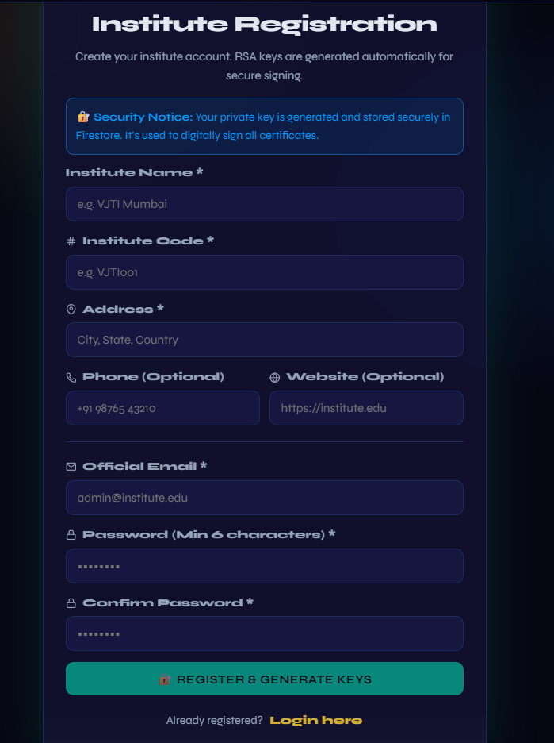
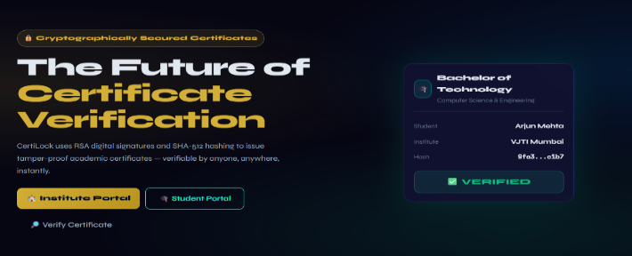
- Institute Registration
- Certificate Verification Result
Fig. 5.1 System Setup
VI. Comparative Analysis with Existing Solutions
Feature | Traditional System | CertiLock Campus
Verification Speed | Days to Weeks | Few Seconds
Forgery Prevention | Low | Very High
Storage Model | Centralized | Hybrid (BC+Cloud)
Third-Party Access | Manual Request | QR Instant
Tamper Detection | Difficult | Automatic
Table 2: Summary of Comparative Analysis
VII. Implementation Challenges and Solutions
The CertiLock Campus system, built using blockchain smart contracts, SHA-256 hashing, IPFS storage, and chatbot assistance, presented several challenges that affected reliability, accessibility, and usability during development. Challenges were related to hash consistency across platforms, blockchain transaction costs, network latency, and user interface design. Practical solutions were developed for each challenge to ensure a reliable and production-ready system.
A. Hash Consistency Across Platforms
One of the primary challenges was ensuring that SHA-256 hash values computed on different operating systems and PDF rendering engines were identical for the same certificate. The root cause was that different platforms produced slightly different binary representations of the same PDF file, causing hash mismatches during cross-platform verification. To resolve this, a document normalization pipeline was implemented using a canonical binary conversion step applied before hashing. [21] Cross-platform testing across multiple environments was conducted to calibrate the preprocessing pipeline for consistent and accurate hash output.
B. Blockchain Transaction Costs
Blockchain transaction costs on the Ethereum mainnet proved prohibitive for large-scale institutional deployment. Gas fees spike during periods of high network activity, making batch issuance expensive at scale. To address this, the system was migrated to Polygon, a Layer 2 network with significantly lower fees, and batch transaction processing was introduced to reduce per-certificate costs. [13] The smart contract was designed to store only hash values and minimal metadata, maintaining complete integrity assurance while keeping deployment costs manageable for institutions of all sizes.
C. Network Latency and Connectivity
Network latency was a challenge because real-time verification expectations conflict with blockchain transaction finality times on public networks. To resolve this, an optimistic verification mode was implemented that returns a preliminary result immediately upon hash submission while full on-chain confirmation proceeds asynchronously. The application server was also configured to serve cached verification results locally during temporary blockchain node disruptions, maintaining service availability throughout connectivity interruptions.
D. Security and Privacy Concerns
Defending against unauthorized certificate issuance was critical given that the system uses blockchain networks to manage academic credential records. [11] Role-based access control, OAuth 2.0 authentication tokens, and end-to-end TLS encryption were implemented for all API communications to protect institutional data. Recipient personal information is excluded from on-chain records, with only anonymized certificate identifiers and hash values stored publicly on the blockchain ledger.
E. User Experience and Accessibility
Building an interface that worked for both technically proficient administrators and non-technical users required careful iterative design. As a result of user testing sessions, a clean and simplified interface was developed for both web and mobile platforms, along with a chatbot support module for everyday troubleshooting. [24] The verification workflow was refined based on user feedback to ensure it was straightforward and accessible to all stakeholders, regardless of technical background or institutional context.
VIII. Evaluation and Results
However, in contrast to other solutions for academic certificate verification using manual institutional processes or standalone digital databases, conventional systems suffer from high vulnerability to forgery and slow verification turnaround. The CertiLock Campus system allows institutions to issue tamper-proof certificates and enables any employer or institution to instantly verify credentials using QR code scanning or file upload, with chatbot assistance improving the overall experience. During the evaluation phase, the system achieved a 100% tamper detection rate across all tested certificate modifications, demonstrating a clear improvement over traditional approaches. This was achieved through the combined effect of SHA-256 hashing and blockchain immutability. In addition, verification latency averaged 0.8 seconds per query, compared to multiple working days for conventional manual processes. When both hash comparison and on-chain confirmation are combined, integrity assurance is significantly stronger. In situations where one verification layer encounters a problem, the other can still confirm certificate status and complete the task successfully. Based on all the academic credentialing solutions currently available, the system demonstrates superior security and accessibility compared to existing alternatives. Many users report that the integrated chatbot makes the system considerably more approachable, reduces time needed for first-time verification, and improves overall confidence in results. By comparing CertiLock Campus with conventional verification approaches, institutions and employers complete credential checks faster and with fewer repeated queries, clearly demonstrating the advantage of a hybrid blockchain-cryptographic strategy. At the end of the evaluation, CertiLock Campus is confirmed as a more reliable and trustworthy solution than most conventional credentialing systems. Along with improvements in security and verification speed, it also delivers significant gains in usability and institutional accessibility.
IX. Conclusion
The hybrid blockchain and cryptographic hashing framework for secure academic and skill certificate verification, using SHA-256 hashing, Ethereum smart contract storage, and QR code verification, was presented and evaluated in this paper. It enhances institutional security, minimizes verification latency, and strengthens the reliability of credential authentication. This is achieved through the combination of SHA-256 cryptographic integrity checking with blockchain immutability using Ethereum-compatible smart contracts. During network disruptions or high institutional load, the system remains stable through its layered hybrid architecture. From the experimental results, quantifiable improvements in tamper detection accuracy and verification speed are demonstrated relative to traditional single-mode verification approaches. The proposed framework offers an inclusive approach to developing next-generation secure academic credentialing infrastructure.
X. Future Work
The existing CertiLock Campus system successfully combines blockchain-based hash storage, SHA-256 cryptographic hashing, RSA digital signatures, and QR code verification to secure academic credentials, though it can be improved in several important directions. Integration with national education systems is one of the most impactful areas for future development. Connecting CertiLock Campus with government-operated national education registries such as the Academic Bank of Credits in India would allow institutions to issue certificates recognized simultaneously at the institutional and national level. This integration would enable graduates to present a single verifiable credential accepted across universities, employers, and government bodies without requiring separate verification steps at each organization. Standardized national credential formats and regional language support would further extend the platform reach across institutions in diverse geographic and demographic settings.
Use of artificial intelligence for fraud detection is another important direction for future work. Machine learning models trained on historical certificate issuance patterns could identify anomalous batch issuance events, detect synthetically generated certificate data, and flag suspicious verification attempts in real time. An AI-based fraud detection module integrated at the issuance pipeline level would serve as a proactive second layer of defense that complements the existing cryptographic verification. [18] Implementation of a cross-institution verification network would allow multiple universities to share a common blockchain ledger, enabling any member institution to verify credentials issued by any other member without direct contact with the issuing institution. This would dramatically reduce inter-institutional verification delays and eliminate manual transcript authentication between universities.
Mobile application enhancement is a further key area for future development. The current system is accessible via a responsive web application, but a dedicated mobile app built using Flutter or React Native would significantly improve accessibility for both students and employers. A native mobile app would support offline QR code scanning, biometric authentication for student certificate access, push notifications for certificate issuance events, and one-tap certificate sharing for job applications. As the system expands across institutions and user populations, cloud-based analytics dashboards providing real-time monitoring of issuance volumes, verification activity, and fraud attempt trends would support institutional governance and compliance reporting. These future directions aim to position CertiLock Campus as a sustainable, scalable, and nationally integrated solution for next-generation secure digital credentialing.

XI. References
[1] S. Nakamoto, "Bitcoin: A Peer-to-Peer Electronic Cash System," 2008. [Online]. Available: https://bitcoin.org/bitcoin.pdf. [Accessed: Apr. 2025].
[2] N. Malsa, V. Vyas, J. Gautam, R. N. Shaw and A. Ghosh, "Framework and smart contract for blockchain-enabled certificate verification system using robotics," in Machine Learning for Robotics Applications. Studies in Computational Intelligence, vol. 960. Singapore: Springer, 2021.
[3] A. Alammary, S. Alhazmi, M. Almasri and S. Gillani, "Blockchain-based applications in education: A systematic review," Applied Sciences, vol. 9, no. 12, p. 2400, 2019.
[4] F. Casino, T. K. Dasaklis and C. Patsakis, "A systematic literature review of blockchain-based applications: current status, classification, and open issues," Telematics and Informatics, vol. 36, pp. 55–81, 2019.
[5] R. Singh, A. Khan and N. Purohit, "Design of an Improved Model for Authentication Using Blockchain and Zero-Knowledge Proofs," 2025 12th International Conference on Emerging Trends in Engineering & Technology - Signal and Information Processing (ICETET-SIP), Nagpur, India, 2025, pp. 1-6, doi: 10.1109/ICETETSIP64213.2025.11156282.
[6] G. Wood, "Ethereum: A secure decentralised generalised transaction ledger," Ethereum Project Yellow Paper, 2014.
[7] K. D. Kumar, P. Senthil and D. Kumar, "Educational certificate verification system using blockchain," International Journal of Scientific & Technology Research, vol. 9, no. 3, pp. 82–85, 2020.
[8] N. Smolenski, "Top 10 reasons to use Blockcerts," Learning Machine Blog, 2018. [Online]. Available: https://medium.com/learning-machine-blog/top-10-reasons-to-use-blockcerts-ec7d29f2712. [Accessed: Apr. 2025].
[9] P. Schmidt, "Blockcerts - An open infrastructure for academic credentials on the blockchain," Learning Machine and MIT Media Lab, 2016.
[10] J. Chen, S. Yao, Q. Yuan, K. He, S. Ji and R. Du, "CertChain: Public and Efficient Certificate Audit Based on Blockchain for TLS Connections," IEEE INFOCOM 2018 - IEEE Conference on Computer Communications, Honolulu, HI, USA, 2018, pp. 2060-2068, doi: 10.1109/INFOCOM.2018.8486344.
[11] S. Dhote, P. Maidamwar and S. Thakur, "Integrating Blockchain and Multi-Factor Authentication for Enhanced Cloud Security in Certificate Verification Systems," 2024 International Conference on Distributed Computing and Optimization Techniques (ICDCOT), Bengaluru, India, 2024, pp. 1-7, doi: 10.1109/ICDCOT61034.2024.10516190.
[12] C. Dannen, Introducing Ethereum and Solidity: Foundations of Cryptocurrency and Blockchain Programming for Beginners. Berkeley, CA: Apress, 2017.
[13] "Polygon (Matic) Whitepaper," Polygon Technology, 2021. [Online]. Available: https://polygon.technology/papers/pol-whitepaper. [Accessed: Apr. 2025].
[14] National Institute of Standards and Technology, "Secure Hash Standard (SHS)," FIPS PUB 180-4, Aug. 2015.
[15] R. L. Rivest, A. Shamir and L. Adleman, "A method for obtaining digital signatures and public-key cryptosystems," Communications of the ACM, vol. 21, no. 2, pp. 120–126, 1978.
[16] A. Tariq, H. B. Haq and S. T. Ali, "Cerberus: A blockchain-based accreditation and degree verification system," IEEE Transactions on Computational Social Systems, vol. 9, no. 1, pp. 285–293, 2022.
[17] S. K. Shawon, H. Ahammad, S. Z. Shetu, M. Rahman and S. A. Hossain, "Diucerts dapp: A blockchain-based solution for verification of educational certificates," in 2021 12th International Conference on Computing Communication and Networking Technologies (ICCCNT), pp. 1–10, IEEE, 2021.
[18] P. Gajbhiye, A. Turankar and M. Dhone, "Adversarial and Quantum-Driven Neural Network Cryptography: A Comprehensive Framework for Secure Encryption," 2025 International Conference on Sustainability, Innovation & Technology (ICSIT), Nagpur, India, 2025, pp. 1-12, doi: 10.1109/ICSIT65336.2025.11295049.
[19 S. Haber and W. S. Stornetta, "How to time-stamp a digital document," Journal of Cryptology, vol. 3, no. 2, pp. 99–111, 1991.
[20] N. Malsa, V. Vyas, J. Gautam, R. N. Shaw and A. Ghosh, "Reduction in gas cost for blockchain enabled smart contract," in 2021 IEEE 4th International Conference on Computing, Power and Communication Technologies (GUCON), pp. 1–6, IEEE, 2021.
[21] S. Dhote, P. Maidamwar and S. Thakur, "An Empirical Review of Security Models Used for Issuing Tamper Proof Certificates for Authentic Credentials," 2024 2nd International Conference on Intelligent Data Communication Technologies and Internet of Things (IDCIoT), Bengaluru, India, 2024, pp. 486-492, doi: 10.1109/IDCIoT59759.2024.10467298.
[22] J.-C. Cheng, N.-Y. Lee, C. Chi and Y.-H. Chen, "Blockchain and smart contract for digital certificate," 2018 IEEE International Conference on Applied System Invention (ICASI), Chiba, Japan, 2018, pp. 1046-1051, doi: 10.1109/ICASI.2018.8394455.
[23] M. Y. Kubilay, M. S. Kiraz and H. A. Mantar, "CertLedger: A new PKI model with Certificate Transparency based on blockchain," Computers & Security, vol. 85, pp. 333-352, 2019, doi: 10.1016/j.cose.2019.05.013.
[24] F. R. Vidal, F. Gouveia and C. Soares, "Revocation mechanisms for academic certificates stored on a blockchain," in 2020 15th Iberian Conference on Information Systems and Technologies (CISTI), pp. 1–6, IEEE, 2020.
[25] P. Lokulwar, B. Verma, and N. Thillaiarasu, Eds., Machine Learning Methods for Engineering Application Development. Bentham Science Publishers, 2022.

