Report on Tracking Page Faults for a Process

I have observe page faults for 3 different applications which are as follows

1. compute and I/O intensive: a program which takes input from text file of 50 mb[more than 100 thousands lines] and perform complex computation over it ran on Host:

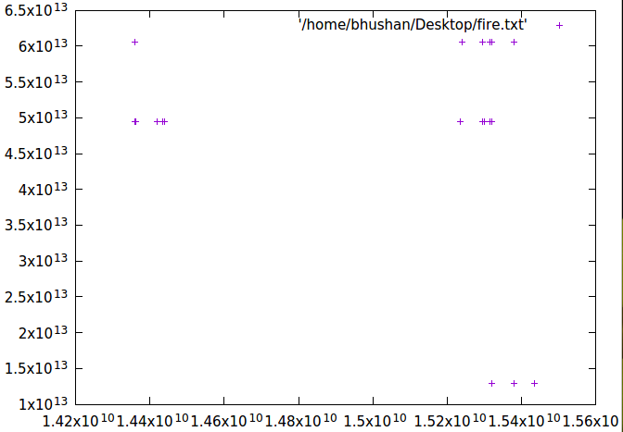
a.
as I found out that while taking input: reading from file column wise there will be many page-faults,
compared to when you read row wise, the above graph shows page faults for column wise readings.

b.
the next observations is about page faults as numbers becoming larger and larger , after 1.52*10**10 nsec number of page faults increased till program is running.

c.
computation is responsible for more page faults than I/O tasks

d.
out of 3 tasks , the number of page faults on this task are largest there were around 500 page faults came

e.
time is on x-axis, time unit is nano second, virtual addresses are converted to decimal for graph.

f.
to conclude: computing needs more memory access than I/O in above example,

2. compute intensive: tried sys-bench in terminal with prime max=2000 on Host
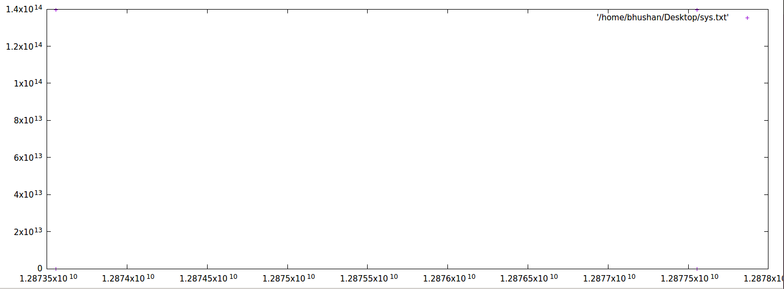
a.
total page faults came were 72,

b.
time is on x-axis, time unit is nano second, virtual addresses are converted to decimal for graph.

c. all the page faults came at the top when o/p came on console, there was not a single page faults on virtual addresses below 1.2*10**14

d.
observations are of around 15 seconds

e.
as you can see all the page faults came on virtual address are linear at various time

f.
page faults came on at the starting of the process and at the end but virtual address remain linear

g. lots of page faults came on the same time (at same nano seconds) thats why all 72 page faults are not visible on graph.

i.
number of page faults are less than tasks 1 and grater than task 3

3. network I/O intensive: tried iperf -s command on VM
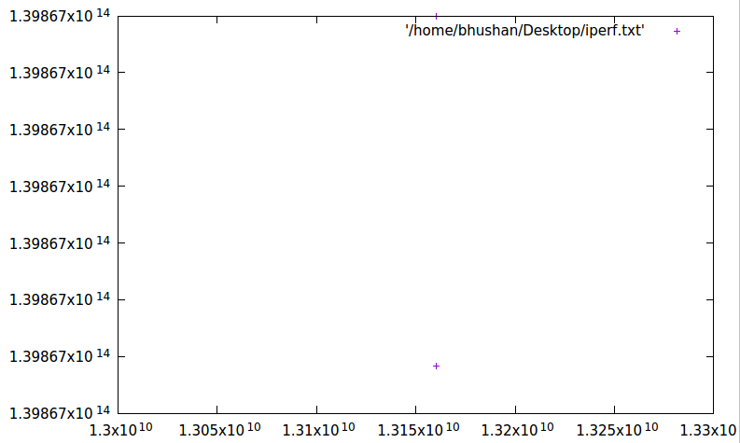
a.
total page faults came were 2,

b.
time is on x-axis, time unit is nano second, virtual addresses are converted to decimal for graph.

c.
pattern I found is curve wrt to time and virtual address, as time increases virtual address also increased which shows direct relation between virtual address and time.

d.
observations is for around 15 seconds.

e.
as there are only 2 page faults in the entire execution which shoes task 3 is lightest among all .

To conclude:

1. compute and I/O intensive tasks have largest page faults and scattered
2. compute intensive tasks shows page faults linear virtual address over time
3. network I/O intensive tasks shows curve patterns between time and virtual addresses which shows direct relation between time and virtual addresses

