Contents

1. Background 2

2. Scope of document: 2

3. Technical design 2

3.1 Assumptions: 2

3.2 Message and security details 3

3.2.1 Security Controls: 3

4. Web Service and Services 3

4.1 getEIA service 3

4.2 Request Message 3

4.3 Response Message 5

# Background

As per Clause 59 of the Revised Guidelines on Insurance Repositories and electronic issuance of Insurance policies mentions that ‘Every insurer and every IR shall necessarily use iTrex to transmit messages related to the electronic policy requests/responses.’ Thus all data shared between an Insurer and Insurance Repository is exchanged through iTrex. Insurance companies facilitate individuals to open eIA and send data for eIA opening in xml format to Insurance Repository via iTrex. There is a demand from the Insurance Companies to have a web service which can be used real-time for opening of eIA. The document details the web services between iTrex and Insurance Repository.

# Scope of document:

The technical design section of this document has the following

* Message structure details between iTrex and Insurance repositories .(The same message can be leveraged for the integration between Insurance Carriers and iTrex
* Transaction level security – In order to exchange business message in secured manner, the document proposes security controls such as IP whitelisting, Encrypted username/ password etc.
* The same can be leverage for the integration between Insurance Carriers and iTrex.

# Technical design

In the proposed new process, insurance carriers will send policy holder details along with the preferred IR in a XML message format. ITrex will log, de-dupe, validate and route the details of eIA request details to specific IR based on IR option of policy holder. Each repository will capture policy holder details in respective IR systems, generates and share eIA # in XML message format to iTrex system which in turn returns the generate eIA details to Insurance carrier.

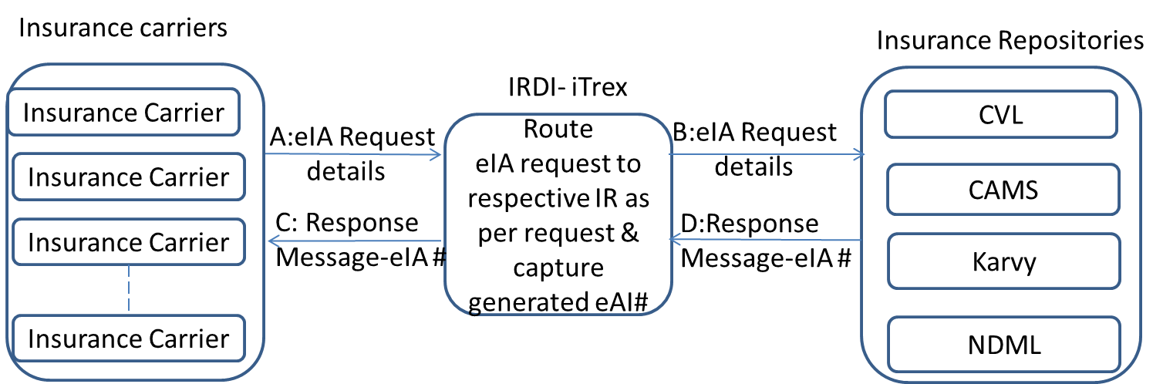

## Assumptions:

The following assumptions are needs to validated to validate the message format and validation

* Each repository is expected to generate unique eIA# that will not result in eIA# duplicates between IR systems.
* Each Insurance carrier and IR will have pre-allocated code at iTrex end so as to route the messages accordingly between Insurance carrier and Insurance repositories.
* iTrex will leverage/implement the same message structures for the integration with Insurance carriers and Insurance repositories as per the current SOAP XML Process.
* iTrex will send an individual request message for each eIA # generation and bulk eIA number generation can be achieved by existing services from iTrex.

## Message and security details

The following messages are planned between Insurance carriers-iTrex –IRs.

**Message A & B:** eIA generation detailed message - This message will be generated at Insurance carrier end and will reach respective IR through iTrex.

**Message C & D:** generated eIA details message - This message will be generated at IR end and will be shared to Insurance carrier through iTrex.

### Security Controls:

The following security controls has been proposed for secure business transaction between iTrex and various IRs. The same controls can be extended between iTrex and Insurance carriers.

* IPs will be whitelisted at both ends
* ID and Password will be maintained at both ends
* The communication will be in https mode
* Encrypted Username and password should be used while invoking the services.

# Web Service and Services

Each IR will host a Web Service Method (e.g geteIA) with the following service

## getEIA service

<Request header>: will consists of UserID, Encrypted Password with AuthenticatedToken as per current iTrex process

<Body>: The xml has to send in the body tag.

The request and response message structures are as follows.

## Request Message

<soap:Envelope xmlns:soap="http://www.w3.org/2003/05/soap-envelope"

xmlns:tem="http://tempuri.org/">

<soap:Header>

<SecuredWebServiceHeader>

<UserID>UserID</UserID>

<Password>Encrypted Password</Password>

<AuthenticatedToken></AuthenticatedToken> </SecuredWebServiceHeader>

</soap:Header>

<soap:Body> >**//zip file containing xml file should be encoded in byte64) This is the process followed currently.**



<eIA_Acc_Details>

<File_Header>

<File_id>4</File_id>

<From/>

<Date_Of_Generation>20151130</Date_Of_Generation>

<Num_Of_eIA_Acc_Details>1</Num_Of_eIA_Acc_Details></File_Header>

<Person_eIA_Detail>

<Id/>

<eIADetails>

<AccCategory>1</AccCategory>

<TypeOfAcc>1</TypeOfAcc>

<AppNo>123456785</AppNo>

<Insurance_Cmpny_Cd>10</Insurance_Cmpny_Cd>

<Date_Of_Receipt>20220914</Date_Of_Receipt>

</eIADetails>

<Applicant_Detail>

<No_Of_Applicant>1</No_Of_Applicant>

<Applicant Name="Sole/First Proposer">

<First_Name>Srinivas</First_Name>

<Middle_Name/>

<Last_Name>Sethi </Last_Name>

<Father_Husband_Name/>

<Gender>M</Gender>

<DOB>19811112</DOB>

<PAN>CQNPS7215J</PAN>

<UID/>

<Address Name="Permanent">

<AddLine1>NIRAVATHUPARAMPIL</AddLine1>

<AddLine2>KOLANI P O</AddLine2>

<AddLine3>VENGALLOOR</AddLine3>

<Land_Mark/>

<City>THODUPUZHA</City>

<State>32</State>

<Country>4</Country>

<PIN_Code>685608</PIN_Code>

</Address>

<Address Name="Correspondence">

<AddLine1>NIRAVATHUPARAMPIL</AddLine1>

<AddLine2>KOLANI P O</AddLine2>

<AddLine3>VENGALLOOR</AddLine3>

<Land_Mark/>

<City>THODUPUZHA</City>

<State>32</State>

<Country>4</Country>

<PIN_Code>685608</PIN_Code>

</Address>

<Communication_Detail>

<Telephone_Number/>

<Alt_Telephone_Number/>

<Mob_Number>9032723168</Mob_Number>

<FAX/>

<Primary_email>srinivassethi@iib.gov.in</Primary_email>

<Alternate_email/>

</Communication_Detail>

</Applicant>

<Bank_Details>

<Bank_Name>36</Bank_Name>

<Other_Bank_Name/>

<Branch>G G ROAD</Branch>

<City>KOCHI</City>

<Bank_Account_Number>543534553</Bank_Account_Number>

<Bank_Account_Type>1</Bank_Account_Type>

<Bank_MICR_Code/>

<Bank_IFSC_Code>IBKL0000014</Bank_IFSC_Code>

<Cancelled_Cheque>y</Cancelled_Cheque>

</Bank_Details>

<Authorized_Representative>

<First_Name>SSS</First_Name>

<Middle_Name/>

<Last_Name/>

<Gender/>

<DOB/>

<PAN/>

<UID/>

<Address Name="Permanent">

<AddLine1>SFYRTYT</AddLine1>

<AddLine2>KOLANI P O</AddLine2>

<AddLine3>VENGALLOOR</AddLine3>

<Land_Mark/>

<City>THODUPUZHA</City>

<State>32</State>

<Country>4</Country>

<PIN_Code>685608</PIN_Code>

</Address>

<Communication_Detail>

<Telephone_Number/>

<Mob_Number>9032723168</Mob_Number>

<Relationship>7</Relationship>

<Relationship_Other/>

<Primary_email>Srinivassethi@iib.gov.in</Primary_email>

</Communication_Detail>

<Communication_Flag>Y</Communication_Flag>

</Authorized_Representative>

<Other_Detail>

<ID_Proof>1</ID_Proof>

<Address_Proof>5</Address_Proof>

<Correspondence_Address_Proof>5</Correspondence_Address_Proof>

<DOB_Proof>1</DOB_Proof>

</Other_Detail>

</Applicant_Detail>

</Person_eIA_Detail>

</eIA_Acc_Details>

## Response Message

**Success Message**

<?xml version="1.0" encoding="UTF-8"?>

<eIA_Acc_Details>

<Response_TimeStamp>DDMMYY:HHMMSS</Response_Timestamp>

<STATUS>S</STATUS>

<EIA_NO>510108292929</EIA_NO>

<ERROR_DESC></ERROR_DESC> // This will be Blank<eIA_Acc_Details>

**Failure Message**

<eIA_Acc_Details>

<Response_TimeStamp>DDMMYY:HHMMSS</Response_Timestamp>

<STATUS>E </STATUS>

<EIA_NO></EIA_NO> // This will be Blank

<ERROR_DESC>Errorcode _Error Message </ERROR_DESC>

<eIA_Acc_Details>