CSE 505 – Midterm Exam 1 Sample Version 1

Name: First Last

Student ID # _________________________________

Question # | Points Available | Points Earned
1 | 10
2 | 10
3 | 10
4 | 10
5 | 10
6 | 10
7 | 10
8 | 10
9 | 10
10 | 10
Total: | 100

Directions: You have 80 minutes to complete this exam. Write all answers neatly in the space provided. Please do not separate exam sheets.

Individual closed book exam. You are not allowed to use the textbook, lecture notes, cheat sheets or anything else beside your brain during the exam.

Note: You can use Prolog helper methods as long as you define them and you cannot use predefined predicates.

Note: If you leave a problem completely empty or you cross the answer with a big X and write "EMPTY" on the page, then you get 20% of the points for that problem.
Question 1
Write the greatest common divisor (GCD) program in Prolog. The greatest common divisor of two or more non-zero integers, is the largest positive integer that divides the numbers without a remainder. For example, the GCD of 8 and 12 is 4.

The oldest written algorithm:
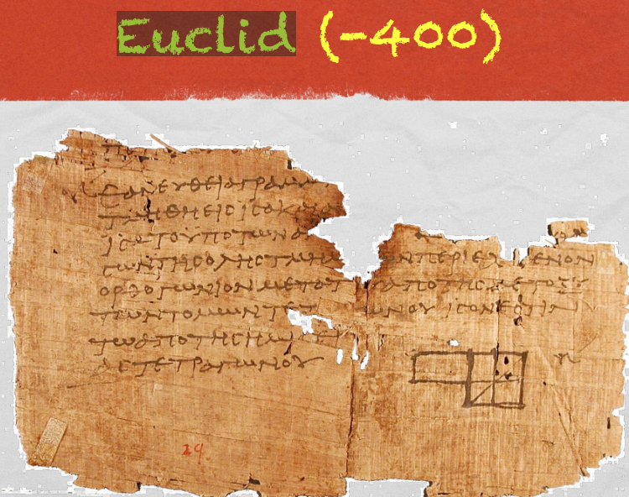

Question 2
Write the following programs in Prolog.
a. Find the last element of a list of int. If the list is empty, then we return 0.

b. Find the K'th element of a list of int. If there is no K'th element, then we return 0.

Question 3
Write the following programs in Prolog.
a. Flatten a nested list structure. Transform a list, possibly holding lists as elements into a 'flat' list by replacing each list with its elements (recursively).
Example: flatten([[1,2],[3,4]], L). returns L=[1,2,3,4].

b. Eliminate consecutive duplicates of list elements. If a list contains repeated consecutive elements they should be replaced with a single copy of the element. The order of the elements should not be changed.
Example: compress([a,a,a,a,b,c,c,a,a,d,e,e,e,e], L). returns L=[a,b,c,a,d,e]

Question 4
Write the following programs in Prolog.
a. Reverse a list.

b. Find out whether a list is a palindrome. A palindrome can be read forward or backward; e.g. [r,a,c,e,c,a,r].

Question 5
Write the following programs in Prolog.
a. Pack consecutive duplicates of list elements into sublists. If a list contains repeated elements they should be placed in separate sublists.
Example: pack([a,a,a,a,b,c,c,a,a,d,e,e,e,e], L). returns L=[[a,a,a,a],[b],[c,c],[a,a],[d],[e,e,e,e]].

b. Run-length encoding of a list. Consecutive duplicates of elements are encoded as terms [N,E] where N is the number of duplicates of the element E.
Example: encode([a,a,a,a,b,c,c,a,a,d,e,e,e,e], L). returns [(4,a),(1,b),(2,c),(2,a),(1,d),(4,e)]

Question 6
Write the following programs in Prolog.
a. Decode a run-length encoded list. Given a run-length code list, construct its uncompressed version.
Example: decode([(4,a),(1,b),(2,c),(2,a),(1,d),(4,e)], L). returns [a,a,a,a,b,c,c,a,a,d,e,e,e,e].

b. Create a list containing all integers within a given range.
Example: range(4,9,L). returns L=[4,5,6,7,8,9]

Question 7
For all the problems below consider the Graph a term graph(ListNodes,ListEdges), like in this example: Graph=graph([a, b, c, d, e, f, g, h, i, j, k], [e(b,c), e(b,f), e(c,f), e(f,k), e(g,h)]).
Write a predicate degree(Graph, Node, Degree) that determines the degree of a given node.

Question 8
Write a predicate that generates a list of all nodes of a graph sorted according to decreasing degree.

Question 9
Assume you have a binary tree, represented by
- node/3 facts: for internal nodes: node(a,b,c) means that a has b and c as children.
- leaf/1 facts: for leaves: leaf(a) means that a is a leaf.
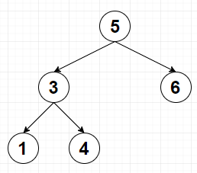
Example:
node(5, 3, 6).
node(3, 1, 4).
leaf(1).
leaf(4).
leaf(6).
Write predicates preorder/2, inorder/2 and postorder/2 that traverse the tree (starting from a given node) and returns the list of nodes in pre/in/post-order.

Question 10
Goldbach's conjecture says that every positive even number greater than 2 is the sum of two prime numbers. Example: 28 = 5 + 23. Write a predicate goldbach(N,L) that returns L as a list of the two prime numbers that sum up to the given N (which must be even).

