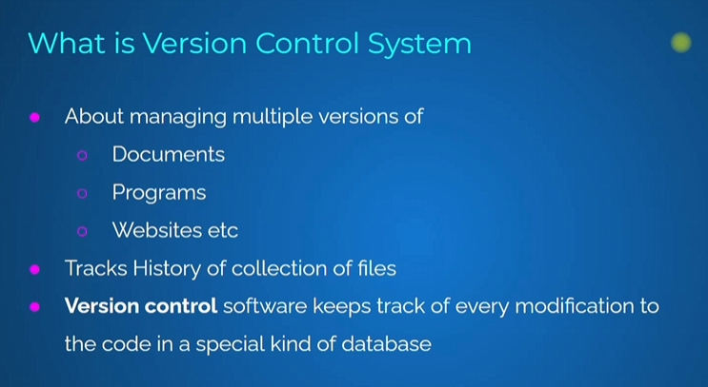

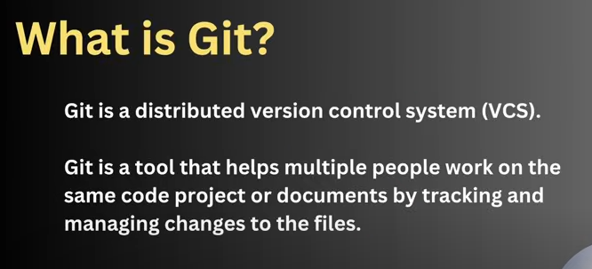

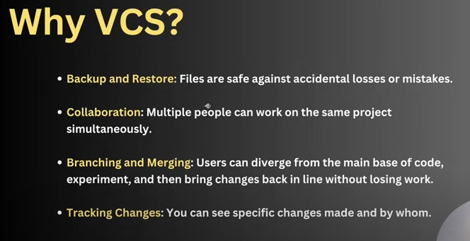

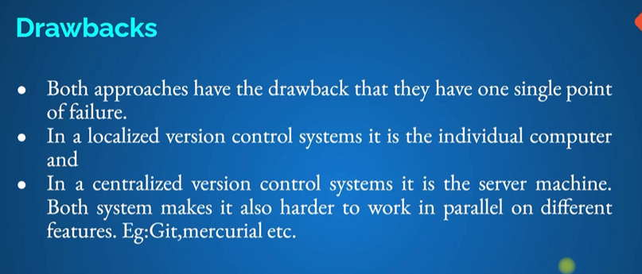

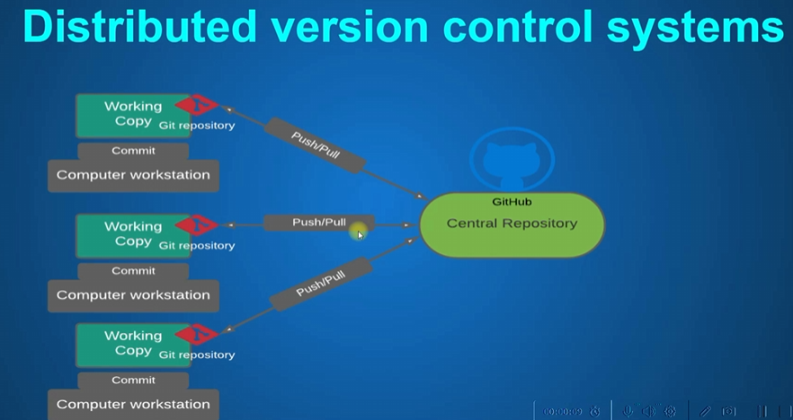

Git status – show the status of local repository

Git add index.html – start the track file or add the file in staging area

Git add \* - add all file

git commit -m ""First V1 of Index.html

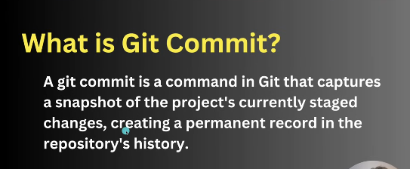

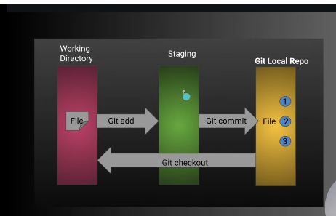

Stagin area means preparation before the commit

Git log – to check the log

Git log –oneline – show the commit id in small line

Git diff – command shows the what changes we did between present file and old file

Git diff –cached – command shows the what changes in stage area we did between present file and old file

Git diff previous commit..currnt commit

View files from old commit –

Git show commit id:filename  
git show 620ac53c7335af67b16fffdf83629dd36e22cc2d:index.html

Get Old Version file with GIt Checkout –

Git checkout gitcommit id of latest version -- \* -> get old version of all files with this commit id

Git checkout gitcommit id of latest version – index.html -> get old version of this files with this commit id.

Again get latest verion

Gi checkout master -- \*

Working wit GIT restore ->

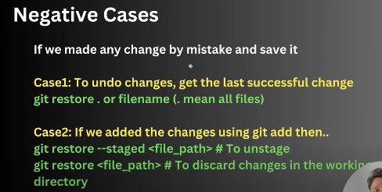

Git diff in statging area

git diff –cached

git restore --staged . – restore staged file

git restore . –restore untracked file

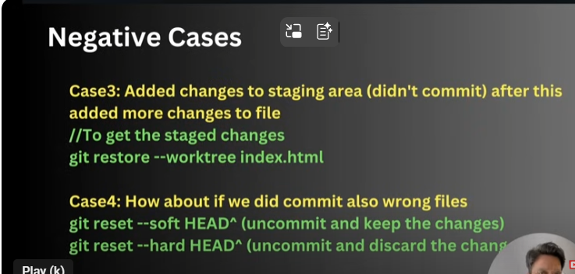

If we add file in staging are and after that we did changes mistakly for undo wrong changes use below command

git restore --worktree .

Working wit Git reset =>

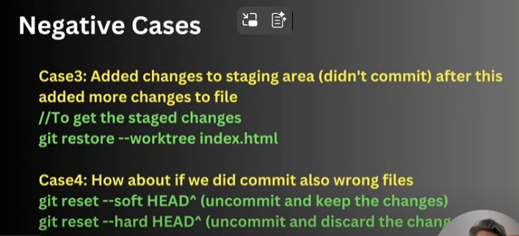

git reset --hard HEAD^

Git Log 🡺

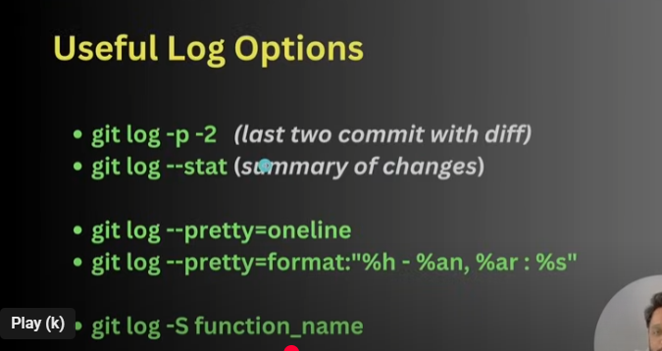

git log -p -1

git log --pretty=oneline – show in online description

git log -S "h1" – when we add h1 tag

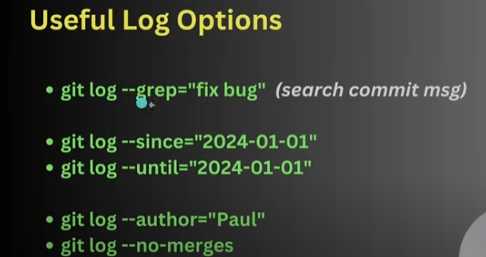

Remote Repository🡺

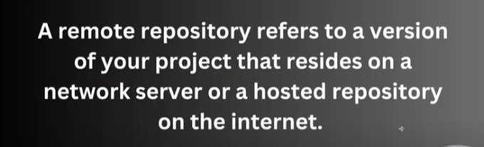

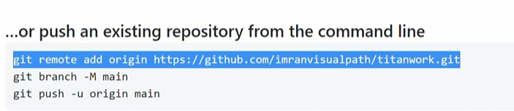

To push the file remote repository.  
git push origin name

GIT CLONE🡺

Is used to pull repository from git hub

Git clone <https://github.com/bhushan3490/Git-Repo.git>

Git Branch and Merge 🡺

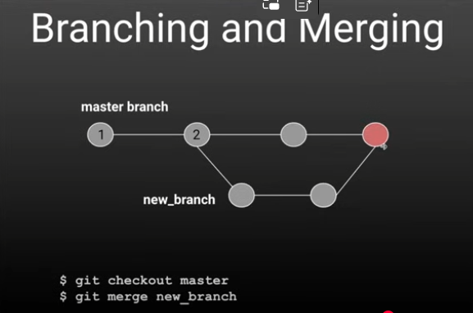

Git brach to check branches

Git brach New branch name or Git brach -c New branch name

git checkout Design – change the branch or git switch Branch name

git merge Design – merge Design brach file into main branch

git push origin Design – to push changes one branch to new brach in git hub or git push –all origin Bracnchname

Merge conflict🡺

Git forking and pull Request🡺

Take the code from other account repo and we fork and do changes

After changes we can send pull request to original user contribute – pull request

Git Ignore🡺

To ignore unnecessary or important files , add file names into .gitignore file

Git Clean🡺

Git clean -n – show untracked file for clean

Git clean -f - delete untracked files

Versioning🡺

Git Tags🡺

git tag -a V1 -m "This is tag" – this tag for latest commit

git tag – show the tag

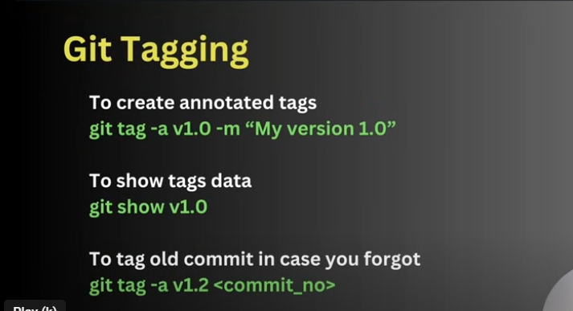

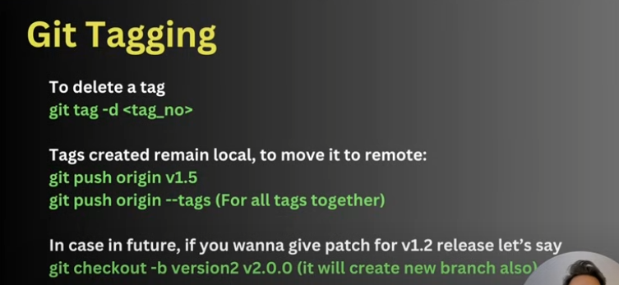

Pull the repository from git hub using Login through SSH🡺

Ssh-keygen.exe

Ls .ssh/

Copy the key

Go to account -setting-ssh – newadd – paste the key

Then

Git clone sshpath