**DPF analysis (Workflow):**

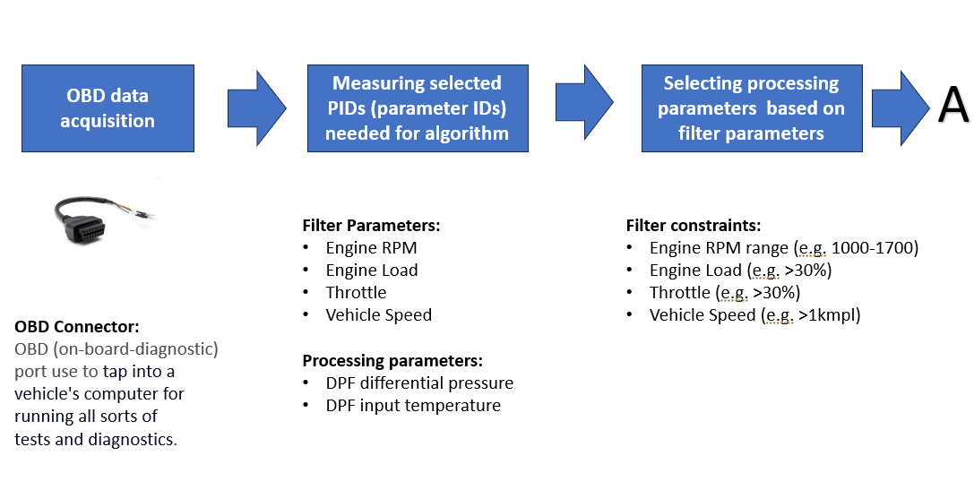

**Pre-processing:**

PIDs are captured at one sample per 8 second rate, which is down sampled by 10 for further processing.

Algorithm needs differential pressure PID for processing, but the differential pressure measurement is affected by driving conditions (e.g. value of differential pressure across DPF can vary based on RPM/Engine Load/Throttle etc).

To avoid the variability in pressure measurement we restrict the measurement conditions,

1. Fixed RPM range outside which measured differential pressure value is discarded.
2. Minimum engine load below which measured differential pressure value is discarded.
3. Minimum throttle below which measured differential pressure value is discarded.
4. Minimum vehicle speed below which measured differential pressure value is discarded.

**Threshold selection:**

Vehicle Threshold selection is done based on Engine specifications, Active regeneration sufficient conditions and range of differential pressure observed across DFP.

**Thresholds independent of engine specifications**

Minimum Throttle (THROTTLE_CUTOFF): 30%

Minimum Engine load (ENGINE_LOAD_CUTOFF): 30%

Minimum vehicle speed (ENGINE_IDLE_SWITCH): 1 Kmpl

Pre and post buffer size: 25 samples

**Thresholds dependent of engine specifications**

**Note:** Upper threshold of the differential pressure should be,

DP_Level_4 >= DP at which active regeneration is initiated by ECU (Can be found out by plotting DP and DPF input temperature graph, point where temperature is raised more than 500 degree, corresponding pressure)

**Engine CC: 2000-6000**

RPM : 800 -2200

DP_Level_1: 2 , DP_Level_2: 2.66, DP_Level_3: 3.32 ,DP_Level_4: 4

**Engine CC: 6000-8000**

RPM : 1000 -2200

DP_Level_1: 2 , DP_Level_2: 3, DP_Level_3: 4 ,DP_Level_4: 5

**Engine CC: 8000-10000**

RPM : 1000 -2200

DP_Level_1: 3 , DP_Level_2: 4, DP_Level_3: 5 ,DP_Level_4: 6

**Engine CC: 10000-12000**

RPM : 1000 -2200

DP_Level_1: 4 , DP_Level_2: 5, DP_Level_3: 6 ,DP_Level_4: 7

**Engine CC: 12000-15000**

RPM : 1000 -2200

DP_Level_1: 5, DP_Level_2: 6, DP_Level_3: 7 ,DP_Level_4: 8

**Algorithm Logic:**

**Soot burn quality**

1. Remove the values more than 95th percentile and below 5th percentile form pre and post buffer to removed outlier (this takes care of noisy data/saturated values).
2. Calculate the mean values (Pre_mean, Post_mean) of pre and post buffer (after outlier removal).
3. Take care of mathematical corner cases (divide by zero)
4. Calculate the *Relative fall in differential pressure* = (Pre_mean-Post_mean)/Pre_mean.
5. Soot burn quality is given as,

* If relative fall in differential pressure is less than -0.5 irrespective of pre regeneration pressure (which means post regeneration pressure is doble than pre regeneration pressure), we assign soot burn as fail.
* If pre generation pressure is above the lower pressure threshold (DP_Level_1) and relative fall in differential pressure is less than 0, we assign soot burn as fail.
* Other than above two conditions, Soot burn quality = 1 - np.exp(-5*( *Relative fall in differential pressure*))

**Why exponential scaling:**

1. Post_mean can never practically be zero, as newly install DPF has non zero pressure drop for optimal filtering.
2. There is upper limit for Pre_mean, as beyond that active regeneration starts and in normal case Pre_mean can not have values more than limit (4Kpa for 2000 to 8000 cc engine).
3. Above two condition limits the Relative fall in differential pressure range.
4. To compensate we wrap the calculated relative fall in differential pressure value in 0-1 range.

**Alert logic.**

First two conditions are purely based on current differential pressure across DPF (Post_mean). Next two conditions modulate the alert set in first two conditions, based on burn quality (if burn quality fails then alerts are raised even at low differential pressure).

1. Set the alert values to -1 by default, which means hold on previous sate unless below logic changes any state.
2. At algorithm entry level, if Post_mean is greater than high threshold (DP_Level_4) set Major alert.
3. At algorithm entry level, if Post_mean is greater than medium threshold (DP_Level_3) and less than high threshold (DP_Level_4) set Minor alert.
4. If burn quality is failed and if Post_mean is greater than medium threshold (DP_Level_2) and less than high threshold (DP_Level_3) set Minor alert.
5. If burn quality is fail and Post_mean is greater than medium threshold (DP_Level_3) set Major alert.
6. If Post_mean is less than low threshold (DP_Level_1) remove alert (if any).

**API interface:**

BURN_Quality,ALERT,ALERT_SAMPLE = soot_burn_quantification(DP,AR_status,Thresholds)

**Inputs**:

**DP**: differential pressure sample buffer of length 50 (0:24- Pre buffer and 25:49- Post buffer)

Datatype: float32 buffer of size 50.

**AR_status**: Active regeneration FLAG corresponds to 25th sample in the buffer. (if 25th samples is mesure while active regeneration then FLAG is 1 else 0)

Datatype: int8 value (0 or 1)

**Thresholds**: Config structure containing pressure thresholds.

Datatype: structure

**Outputs**:

**BURN_Quality** : soot burn quality (0-1 in case of successful burn and 2 if burn is fail)

Datatype: float32 value (0 to 1 range).

**ALERT**: Alert state (-1: Hold previous state, 1: Minor, 2: Major, 0: Remove Existing alert)

Datatype: float32 value (-1/0 /1/2).

**ALERT_SAMPLE** : Time stamp of 25th sample.

Datatype: int32 value.