**Hack-n-Code 2.0 PROJECT**

Title of solution/project

**By**

**Bhushan B. Patil**

**Sameer Pusegaonkar**

**Neha Parab**

October 7, 2018

**Project Details**

**Institution: Rajiv Gandhi Institute of Technology**

**Duration: 12hr**

**Start Time: 9:00am**

**Submission Time:**

**Title of the project: AASRA Suicide prevention and Depression AID**

**Team members: Bhushan B. Patil**

**Sameer Pusegaonkar**

**Neha Parab**

**Key words: Help, Suicide, Depression, AID, Die, Sad.**

**Project Areas:**

The areas of the project are as follows:

Project development:

Frontend: HTML, CSS

Backend: JAVASCRIPT, PHP, MYSQL

**AASRA Suicide prevention & Depression AID**

|  |  |
| --- | --- |
| **SNo.** | **Title** |
|  |  |
| ***I*** | ***Abstract*** |
|  |  |
| **1** | **Project Development** |
| 1.1 | Front End |
| 1.2 | BackEnd |
| 1.3 | Features |
| **2.** | **Setting Up The Project** |
| 2.1 | Dependencies |
| 2.2 | Instructions |
| 2.3 | Snippets |
|  |  |
| **3.** | **Future scope** |
| ***II*** | ***Conclusions*** |
| ***III*** | ***References*** |

1. **ABSTRACT:**

Suicide is a very big problem especially in a developing country like India, where education is given the utmost priority and talking about mental health is a taboo. People are often shy to talk about mental heath with their family as they think that they won’t understand.

Our web application helps such people in need to talk to professionals and also with people who have similar experience. The user is anonymous and hence it becomes easier for them to let their emotions out without the fear of being judged. Therapy is not very common in India and hence this web appication encourages one’s in need to take therapy or atleast to talk to one of the voluteers about what they feel.

You can also help others in need by signing up as a volunteer on our website and gain point. The more you volunteering you do, the more points you earn. Top volunteers are of the week ae displayed on the main page of the website.

1. **Project Development:**

This is a basic web application made to help people facing depression and suicide tendencies. This application respects the user’s privacy and at no stage it is compulsory for the user to input their personal information.

**1.1 Front End:**

**HTML/CSS:** For designing the website html and css is use. Bright color scheme is selected to make the website pop and less depressing. The website is made easy to use by making most of the important elements for the user on the first page itself.

**1.2 Backend:**

**mySQL:** Having a database is the most important feature of this website as it maintain the list of volunteers and therapist in the system.

Volunteers: volunteers a awarded points for volunteering. These points are stored in the database and a top volunteers with the most volunteering points are saluted by displaying their names on the main page. The volunteers have to login or sign up to help others. They are asked to read a document which teaches them the basics of dealing with someone with depression. People can also share the stories and the best stories are also displayed on the main page.

**PHP:** It is used to communicate and take informations from forms. It is also used to communicate with the data base,

**Javascript:** It is used to make logical operations. It is used to create the slide show and the motivation quotes bloack on the main page. Javascript is also used to configure the google maps API that is used to display all the nearby therapists. It asks for the location from the user and searches for therapist in the users area.

**1.3 Features:**

**Story of the day:**

This feature is displayed on the front page of the website. Top pick are selected and displayed. These are stories from people who are or used to face depression. This features is added so that the user can relate and not feel alone.

**Motivational Quotes:**

You can scroll throught multiple motional quotes related to depression, Quotes from around the world are selected for this section.

**Consult a therapist:**

Clicking on consult a therapist displays list of therapist that do therapy for free or minimal cost.

**Map:**

If you allow the website to access your location it will show you all the therapists in your area. The map is at the bottom of the website.

**Help Others:**

Help others option is on the navigation bar. It is to volunteer to help others. Volunteers can sign up from here and also login if already signed up. Therapist can also sign up to be listed in the list of therapist who are willing to help other for minimal cost.

**ChatBox:**

A chatbox lies in the lower corner of the website so that uses can chat with volunteers. The chatcox use tawk.to service to chat with the volunteers that are online.

**Donate:**

Donate page is to accept donations which are put to good use to reach more people and save more lives.

**Dependencies:**

* **Google Maps API**
* **twat.co chat service**

**Instructions:**

Open index.html to see the website. Since the database could not transferred some functions of the website may not work.

**Snippets:**

**FRONT PAGE:**

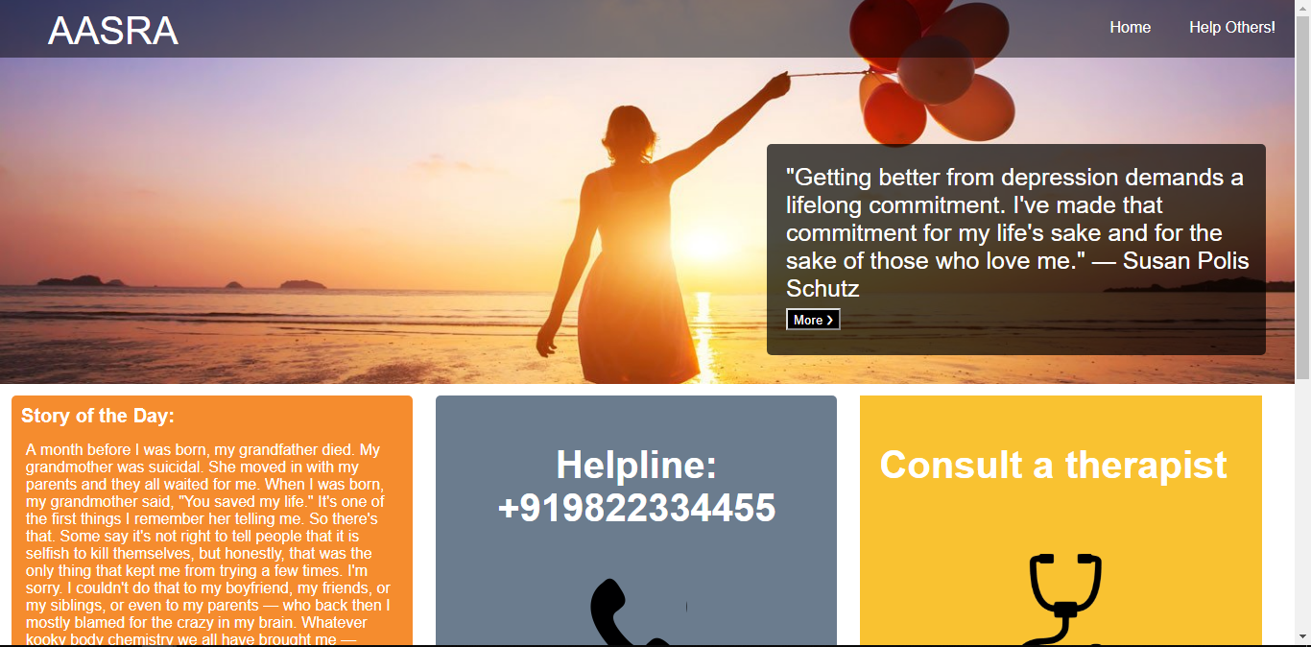

**MAP:**

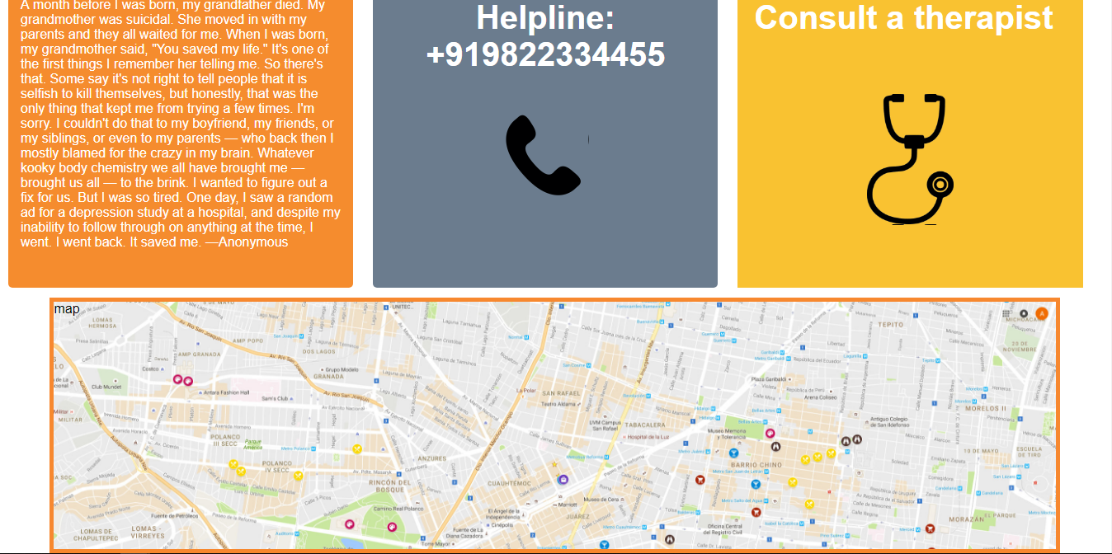

**HELP OTHERS OPTIONS:**

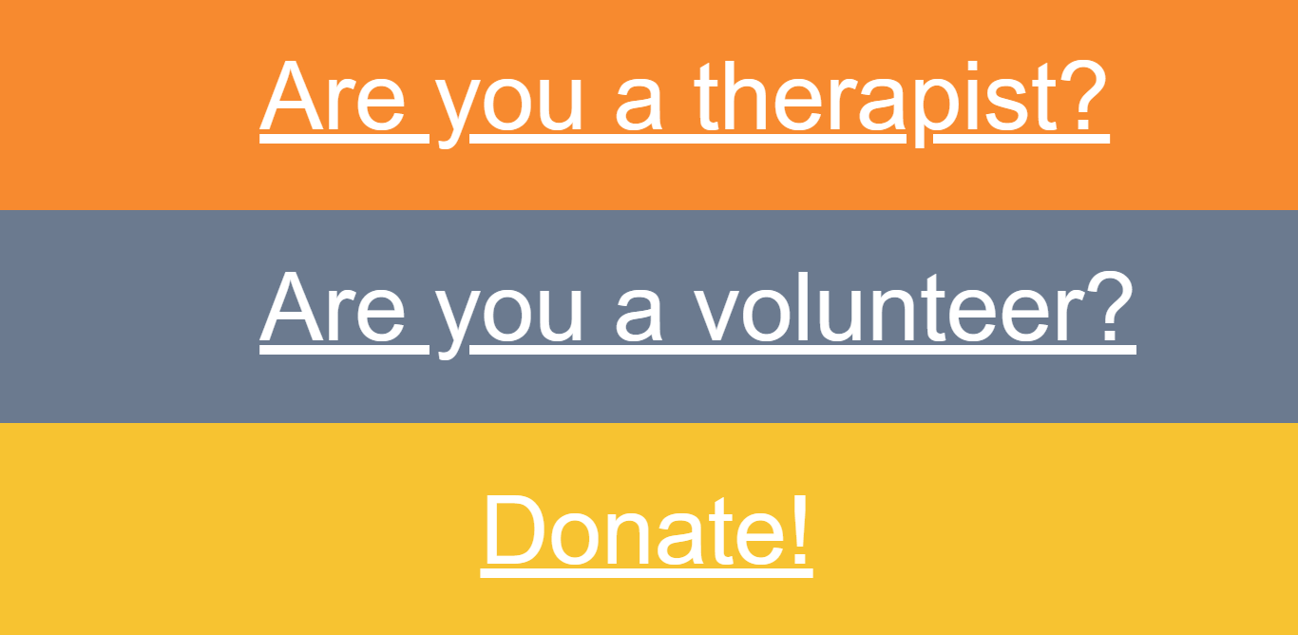

**LOGIN PAGE:**

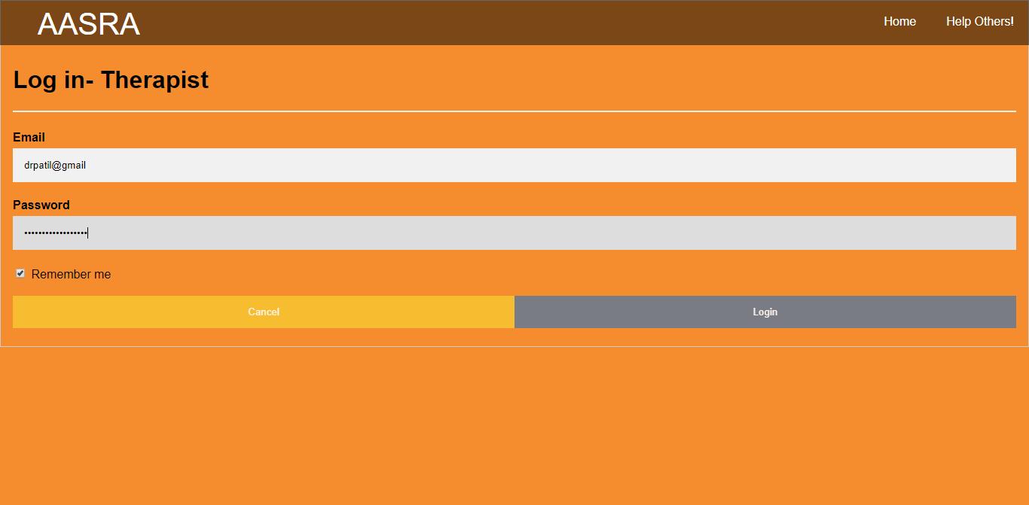

**DONATE PAGE OPTION:**



**CHATBOX:**

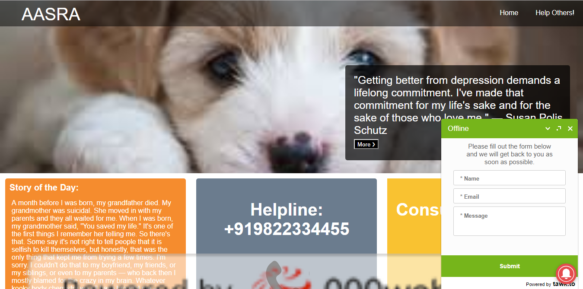

**DATABASE:**

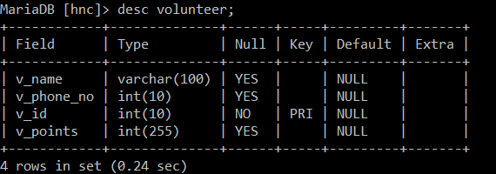

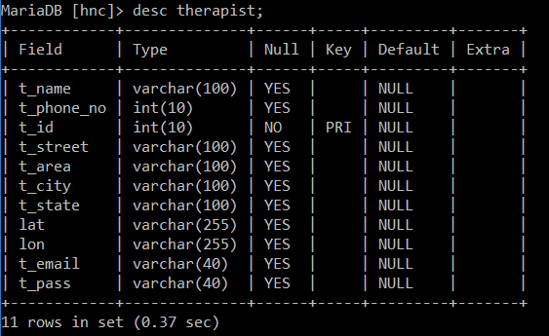

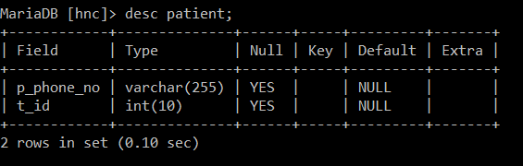

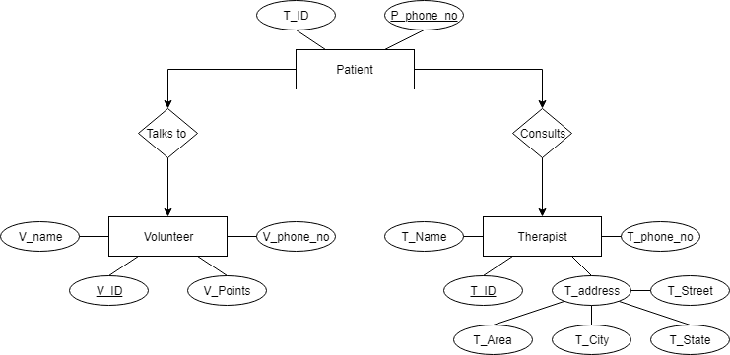

**Future Scope:**

Suicide rates are on a rise by 1.2% every year. And getting therapy is not feasible and affordable for everyone. Doctors should move towards online therapy where they can serve more people by means for text, phone and videochat.

This webite can become a community in the future to help those in need and encourage people to help and understand depression.

**References:**

[www.w3schools.com](http://www.w3schools.com)

[www.stackoverflow.com](http://www.stackoverflow.com)

[www.tawk.co](http://www.tawk.co)