

March13,2019

RID:YVrBM4H-5

TO WHOM IT MAY CONCERN

INTERNSHIP COMPLETION LETTER

WearegladtoinformyouthatMr. Bansuri J Sanganal fromMS Ramaiah Institute of Technology, has successfullycompletedhisinternshipatFoxmula byInversionConsultancyLLP(EducationalBrand) from
20th​ JANUARY, 2019 — 05th​ MARCH, 2019.

Duringhisinternship,hewasexposedtothevariousactivitiesintheMachineLearningdomain, implementingClustering,Regressionandmoreskills.

WefoundhimextremelyInquisitiveanddedicated.Hewasverymuchinterestedingettingintothedepth ofthesubjecttounderstanditbetter.

Hisassociationwithuswasfruitfulandwewishhimallthebestinhisfutureendeavors.

WithRegards

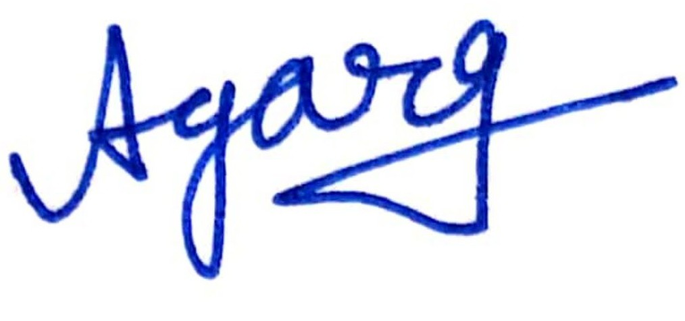

Ayush Garg

VPofMarketing:Inversion Consultancy LLP

Director:FOXMULA

support@​foxmula.com​ www.​foxmula.com​ +91-8448444619, 6350694526



