$ mkdir git-dvcs

$ cd git-dvcs/

$ git config --global user.name "bhushan"

$ git config --global user.email "bhushan,jadhav1@gmail.com"

$ git config --global --list

user.name=bhushan

user.email=bhushan.jadhav1@gmail.com

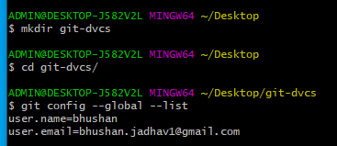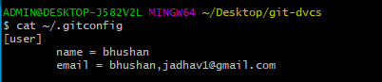

$ mkdir git-demo-project

$ cd git-demo-project/

$ git init



For existing files and directories

$ rm -rf .git/