Chatbot POC Architecture & Flow
MCP-Orchestrated Multi-Agent Chatbot using Static JSON Data
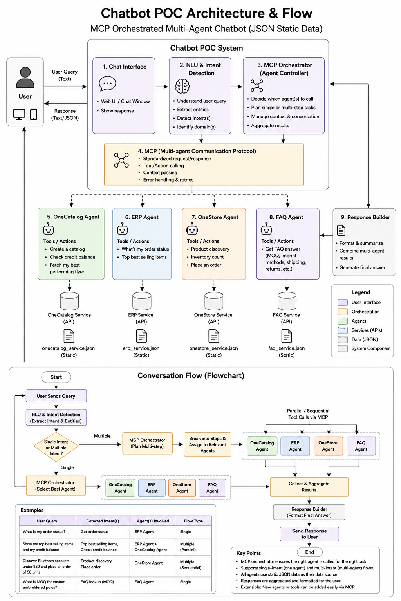

1. Purpose of the Chatbot POC
This Proof of Concept (POC) demonstrates how a chatbot can use multiple specialized agents and MCP (Model Context Protocol) to decide which agent should handle a user's request. The system uses static JSON data instead of live databases or external business APIs.
The main idea is simple: the user asks a question in normal language, the system understands what the user wants, the MCP Orchestrator decides which agent or agents are needed, the agents perform their specific tasks using JSON data, and the final results are combined into one response.

2. High-Level Architecture
The architecture has three major layers:
- User and Chatbot Layer – receives the user's message and displays the answer.
- Orchestration Layer – understands the request and controls which agents need to be called.
- Agent and Data Layer – contains the specialized agents and their static JSON data, including a dedicated FAQ Agent and FAQ Service.
MCP acts as the communication and tool-calling protocol between the orchestrator and the agents. The orchestrator does not need to know the internal implementation of every agent. It sends a standardized request, the correct agent performs the required action, and the result is returned.

3. System Components Explained

1. Chat Interface
This is the part the user sees. It can be a web chat window or another UI.
- Accepts the user's text query.
- Sends the query to the backend chatbot system.
- Displays the final text or JSON response to the user.

2. NLU & Intent Detection
NLU means Natural Language Understanding. This component reads the user's message and identifies what the user is asking for.
- Understands the meaning of the query.
- Extracts useful entities such as product name, order information, quantity, customer information, etc.
- Detects one or more intents.
- Passes the detected intent information to the MCP Orchestrator.

3. MCP Orchestrator (Agent Controller)
This is the main decision-making component. It decides which agent or agents are required.
- Selects the best agent for a single task.
- Creates a multi-step plan when the query contains multiple tasks.
- Decides whether agents should run sequentially or in parallel.
- Passes the required context and parameters.
- Collects the results returned by agents.
- Handles the overall conversation flow.

4. MCP (Multi-Agent Communication Protocol)
MCP provides a standardized way for the orchestrator to communicate with agents and call their tools/actions.
- Defines a consistent request and response structure.
- Supports tool/action calling.
- Allows context and parameters to be passed to an agent.
- Provides a clear place for error handling and retry logic.
- Makes it easier to add more agents later.

5. OneCatalog Agent
This agent handles catalog-related operations.
- Create a catalog.
- Check credit balance.
- Fetch the best-performing flyer.

6. ERP Agent
This agent handles ERP-related operational information.
- Check order status.
- Find top-selling items.

7. OneStore Agent
This agent handles store and product-related operations only.
- Product discovery.
- Inventory count.
- Place an order.
- Do not handle FAQ/knowledge questions; those are owned by the dedicated FAQ Agent.

8. FAQ Agent
This agent is a separate service responsible for FAQ and product-knowledge questions. It is not part of the OneStore Agent.
- Answer FAQ questions.
- Provide MOQ information.
- Provide imprint method information.
- Provide shipping, returns, and other approved FAQ information.
- Read only from the dedicated FAQ Service / faq_service.json data source.
Service boundary: OneStore owns product discovery, inventory, and ordering. FAQ owns FAQ/knowledge retrieval. The OneStore Agent must never answer FAQ questions by reading faq_service.json.

8.1 FAQ Agent Flow
Example: "What is the MOQ and imprint method for this product?"
- NLU detects an FAQ / product-knowledge intent.
- MCP Orchestrator routes the request to the FAQ Agent.
- FAQ Agent calls the dedicated FAQ Service and reads faq_service.json.
- FAQ Agent returns the relevant answer to the orchestrator.
- Response Builder formats the final answer.
- OneStore Agent is not called unless the same user request also contains a separate OneStore task such as inventory or ordering.

9. Response Builder
This component turns one or more agent results into a clean answer for the user.
- Formats the results.
- Summarizes information.
- Combines results from multiple agents.
- Generates the final response sent to the chat interface.

4. Static JSON Data Layer
For this POC, there is no requirement to connect to live OneCatalog, ERP, OneStore, or FAQ systems. Each agent reads from its own separate static JSON data source. This keeps the POC simple and makes it easy to test the orchestration logic.
Agent | Data Source | Example Data
OneCatalog Agent | OneCatalog JSON | Catalogs, credit balance, flyer performance
ERP Agent | ERP JSON | Orders, order status, sales/top-selling items
OneStore Agent | OneStore JSON | Products, inventory, ordering information (no FAQs)
FAQ Agent | FAQ JSON / FAQ Service | MOQ, imprint methods, shipping, returns, approved FAQ knowledge
The JSON files should be treated as mock service data sources for the POC. Later, the same agent interfaces can be connected to real APIs or databases without changing the overall orchestration concept.

5. How MCP Orchestration Works
MCP is used as the standard communication layer between the orchestrator and the agents. The orchestrator is responsible for deciding what should happen; the agents are responsible for executing their own specialized actions.
- The user sends a natural-language question.
- NLU/intent detection identifies the task or tasks in the question.
- The MCP Orchestrator determines which agent is best suited for each task.
- The orchestrator creates the required execution plan.
- The orchestrator calls the selected agent tools through MCP.
- The selected agent reads the required static JSON data for its own service.
- The agent returns a structured result.
- The orchestrator collects all results.
- The Response Builder formats and summarizes the results.
- The chatbot sends the final response to the user.

6. Single-Intent Flow
A single-intent request means the user is asking for one main task. In this case, the orchestrator normally needs only one specialized agent.
Example: "What is my order status?"
- User sends the query.
- NLU detects the intent: Get Order Status.
- MCP Orchestrator identifies the ERP Agent as the correct agent.
- ERP Agent receives the request through MCP.
- ERP Agent checks the ERP JSON data.
- ERP Agent returns the order status.
- Response Builder formats the result.
- The final answer is displayed to the user.
Simple flow:
User → NLU → MCP Orchestrator → ERP Agent → JSON Data → Response Builder → User

7. Multi-Intent Flow
A multi-intent request contains two or more tasks. The orchestrator breaks the request into smaller tasks and assigns each task to the appropriate agent.
Example: "Show me the top best-selling items and check my credit balance."
- NLU identifies two intents: Top Best-Selling Items and Check Credit Balance.
- The orchestrator maps Top Best-Selling Items to the ERP Agent.
- The orchestrator maps Check Credit Balance to the OneCatalog Agent.
- Because the two tasks do not depend on each other, they can be executed in parallel.
- ERP Agent reads its JSON data and returns the best-selling items.
- OneCatalog Agent reads its JSON data and returns the credit balance.
- The orchestrator collects both results.
- Response Builder combines the results into one clear response.
User → NLU → Orchestrator → [ERP Agent + OneCatalog Agent] → Aggregate → Response Builder → User

8. Sequential Multi-Agent Flow
Some requests require one task to happen before another task. This is called a sequential flow.
Example: "Discover Bluetooth speakers under $30 and place an order of 50 units."
- NLU detects Product Discovery and Place an Order.
- The orchestrator identifies that product discovery must happen first.
- OneStore Agent searches the OneStore JSON data for suitable Bluetooth speakers.
- The product information is returned to the orchestrator.
- The orchestrator uses the result as context for the next step.
- OneStore Agent performs the order-related action using the selected product and quantity.
- The results are collected and passed to the Response Builder.
- The final response is sent to the user.
User → NLU → Plan → Product Discovery → Context → Place Order → Aggregate → Response → User

9. Parallel vs. Sequential Agent Calls
Flow Type | When to Use | Example
Parallel | Tasks are independent and do not need each other's output. | Top-selling items + credit balance
Sequential | The next task depends on the result of the previous task. | Discover product → place order

10. Complete End-to-End Conversation Flow
Start: The chatbot system is ready to receive a user query.
User Sends Query: The user enters a question in the chat interface.
NLU & Intent Detection: The system understands the question and extracts intent(s) and important entities.
Single or Multiple Intent?: The system determines whether the request contains one task or multiple tasks.
Single Intent: The orchestrator selects the most suitable agent.
Multiple Intent: The orchestrator creates a plan, breaks the request into steps, and assigns tasks to the relevant agents.
MCP Tool Calls: The orchestrator calls the selected agent actions using MCP.
Agent Execution: Each agent performs its assigned task using its static JSON data.
Collect & Aggregate Results: The orchestrator collects all returned results.
Response Builder: Results are formatted, summarized, and combined into a user-friendly response.
Send Response: The final answer is returned to the chat interface.
End: The current request is complete.

11. Example Queries and Agent Mapping
User Query | Detected Intent(s) | Agent(s) Involved | Flow
What is my order status? | Get order status | ERP Agent | Single
Show me the top best-selling items and check my credit balance. | Top best-selling items; Check credit balance | ERP + OneCatalog | Multiple / Parallel
Discover Bluetooth speakers under $30 and place an order of 50 units. | Product discovery; Place order | OneStore Agent | Multiple / Sequential
Create a catalog for my latest products. | Create catalog | OneCatalog Agent | Single
How many units are available for this product? | Inventory count | OneStore Agent | Single
What is the MOQ and imprint method for this product? | FAQ / MOQ / imprint method | FAQ Agent | Single
What are the shipping and return options for this product? | FAQ / shipping / returns | FAQ Agent | Single

12. Agent Responsibilities
Each agent should have a clear responsibility. An agent should not try to perform another agent's business function.
Agent | Owns | Does Not Own
OneCatalog Agent | Catalog, credit balance, flyer performance | ERP order status or OneStore inventory
ERP Agent | Orders, sales and operational ERP information | Catalog creation or product ordering
OneStore Agent | Product discovery, inventory, orders | FAQ/knowledge retrieval and ERP-specific operational reporting
FAQ Agent | FAQ, MOQ, imprint methods, shipping, returns and approved product knowledge | Product inventory, ordering, and ERP-specific operational reporting

13. Response Builder
The Response Builder is important when more than one agent is involved. It prevents the user from receiving multiple disconnected technical responses.
- Receives structured results from the orchestrator.
- Combines related information.
- Removes unnecessary technical details.
- Produces a clear natural-language response.
- Can return text, JSON, or both depending on the UI requirement.
Example combined response:
Your credit balance is 1,250 credits. The top-selling item this month is the Bluetooth Speaker Pro, with 430 units sold.

14. Error Handling and Retries
The MCP layer and orchestrator should handle failures in a controlled way. For the POC, this can be simple, but the design should allow more robust behavior later.
- If an agent is not available, return a clear error instead of silently failing.
- If JSON data is missing, report that the required information is unavailable.
- If a tool/action fails temporarily, the orchestrator can retry according to a defined retry limit.
- If one task in a multi-agent request fails, the response should clearly identify which task failed and which tasks succeeded.
- The system should avoid repeatedly calling an agent when the same request has already failed.

15. Context and Conversation Management
The orchestrator manages the conversation context. This is useful when the user refers to information from an earlier step.
Example:
- User: "Find Bluetooth speakers under $30."
- System: Returns a suitable product.
- User: "Order 50 of those."
- The orchestrator uses the previous result to understand what "those" refers to and sends the required information to the OneStore Agent.
For the POC, this context can be kept in application memory or a simple session structure. A production system can later use a dedicated conversation store.

16. Adding New Agents
One of the main benefits of the architecture is that new agents can be added without redesigning the entire chatbot.
- Create the new agent with a clearly defined business responsibility.
- Define its tools/actions and input/output format.
- Register the agent with the MCP layer.
- Provide the required JSON data for the POC.
- Teach the orchestrator which intents should map to the new agent.
- Test single-agent and multi-agent scenarios.
For example, a future Pricing Agent could handle pricing, discounts and customer-specific price rules.

17. Suggested POC Implementation Mapping
Architecture Part | Possible POC Implementation | Purpose
Chat Interface | Next.js / React chat UI | Collect and display messages
NLU & Intent Detection | LLM + structured output | Identify intents and entities
MCP Orchestrator | LangGraph/LangChain orchestration layer + MCP client | Plan and coordinate agent calls
Agents | Four specialized agent services/modules | Execute business-specific actions
Agent Tools | Typed functions over static JSON | Perform POC operations
Data | Static JSON files | Mock OneCatalog, ERP, OneStore and FAQ systems
Response Builder | LLM or deterministic formatter | Create the final answer

18. Architecture in Very Simple Terms
Think of the chatbot as a manager and the agents as specialists:
- The User is the person asking for help.
- The Chat Interface is the front desk where the question is received.
- NLU is the receptionist who understands what the user is asking.
- The MCP Orchestrator is the manager who decides who should do the work.
- MCP is the standard communication method used to send work to the specialists.
- OneCatalog Agent is the catalog specialist.
- ERP Agent is the ERP/order specialist.
- OneStore Agent is the product/store specialist; FAQ Agent is the FAQ/knowledge specialist.
- JSON files are the mock data sources used by the specialists, with faq_service.json owned exclusively by the FAQ Service.
- Response Builder is the person who combines everything into one final answer.

19. Key Design Principles
- The MCP Orchestrator decides which agent should be called.
- Agents should have clear and separate responsibilities.
- Agents communicate through the orchestrator rather than directly calling other agents.
- Single-intent requests should use the simplest possible path.
- Independent tasks can run in parallel.
- Dependent tasks should run sequentially.
- Agent results should be structured so they can be combined reliably.
- Static JSON is sufficient for the initial POC.
- The design should allow new agents and tools to be added later.
- Errors should be visible and understandable to the user.
- Conversation context should be managed centrally by the orchestration layer.

20. Final End-to-End Summary
The complete system follows one central principle: the chatbot should call the right specialist for the right task.
User Query → Understand Intent → Orchestrate → Select Agent(s) → MCP Tool Calls → Read JSON Data → Collect Results → Build Response → User
For one task, the flow can be very short: the orchestrator identifies the correct agent and returns its result. For multiple tasks, the orchestrator breaks the request into smaller pieces, assigns each piece to the correct agent, executes independent tasks in parallel or dependent tasks sequentially, and finally combines everything into one response.
This architecture provides a clean foundation for the POC while keeping the system extensible. The static JSON data can later be replaced with real OneCatalog, ERP, OneStore and FAQ APIs/services without changing the fundamental chatbot and orchestration flow.

