***#Assignment A6-SQL#***

**Problem Statement:** Cursors: (All types: Implicit, Explicit, Cursor FOR Loop, Parameterized Cursor)

Write a PL/SQL block of code using parameterized Cursor, that will merge the data available in the newly created table N_RollCall with the data available in the table O_RollCall. If the data in the first table already exist in the second table then that data should be skipped.

Frame the separate problem statement for writing PL/SQL block to implement all types of Cursors inline with above statement. The problem statement should clearly state the requirements.

**Source Code:**

-- Create the new_class_1 table

CREATE TABLE new_class_1 (

roll NUMBER(10),

name VARCHAR(10)

);

SELECT * FROM NEW_CLASS_1;

DROP TABLE NEW_CLASS_1;

INSERT INTO new_class_1 (roll, name) VALUES (1, 'Aarav');

INSERT INTO new_class_1 (roll, name) VALUES (2, 'Vivaan');

INSERT INTO new_class_1 (roll, name) VALUES (3, 'Aditya');

INSERT INTO new_class_1 (roll, name) VALUES (4, 'Sai');

INSERT INTO new_class_1 (roll, name) VALUES (5, 'Ishaan');

INSERT INTO new_class_1 (roll, name) VALUES (6, 'Reyansh');

INSERT INTO new_class_1 (roll, name) VALUES (7, 'Anaya');

INSERT INTO new_class_1 (roll, name) VALUES (8, 'Kiara');

INSERT INTO new_class_1 (roll, name) VALUES (9, 'Tara');

INSERT INTO new_class_1 (roll, name) VALUES (10, 'Nisha');

-- Create the old_class_1 table

CREATE TABLE old_class_1 (

roll NUMBER(10),

name VARCHAR(10)

);

SELECT * FROM OLD_ClASS_1;

DROP TABLE OLD_CLASS_1;

DECLARE

CURSOR c_new_class IS

SELECT roll, name FROM new_class_1;

CURSOR c_exists(roll_num NUMBER) IS

SELECT COUNT(*) FROM old_class_1 WHERE roll = roll_num;

v_roll NUMBER(10);

v_name VARCHAR(10);

v_count NUMBER;

BEGIN

OPEN c_new_class;

LOOP

FETCH c_new_class INTO v_roll, v_name;

EXIT WHEN c_new_class%NOTFOUND;

OPEN c_exists(v_roll);

FETCH c_exists INTO v_count;

IF v_count = 0 THEN

INSERT INTO old_class_1 (roll, name)

VALUES (v_roll, v_name);

END IF;

CLOSE c_exists;

END LOOP;

CLOSE c_new_class;

COMMIT;

DBMS_OUTPUT.PUT_LINE('Data merged successfully!');

EXCEPTION

WHEN OTHERS THEN

ROLLBACK;

DBMS_OUTPUT.PUT_LINE('Error occurred: ' || SQLERRM);

END;

/

**Output:**

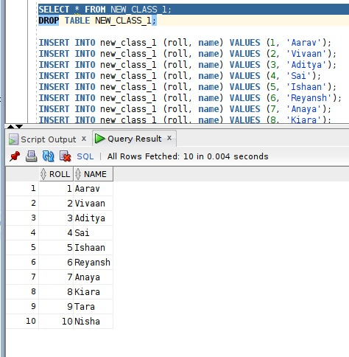

New Class

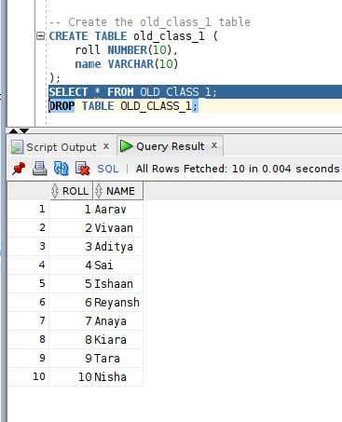

After Execution of Cursor