**1. Continuous Allocation Method**

-In contiguous allocation, files are assigned to contiguous area of secondary storage. A linear ordering of disk addresses is seen on the disk.

-The advantage of this approach is that successive logical records are physically adjacent and require no head movement. So disk seek time is minimal and speeds up access of records. Also, this scheme is relatively simple to implement. The technique, in which the operating system provides units of file space on demand by user running processes, is known as dynamic allocation of disk space.

-Contiguous allocation merely retains the disk address (start of file) and length (in block units) of the first block. If a file is n blocks long and it begins with location b (blocks), then it occupies b, b+1, b+2,…, b+n -1 blocks. First-fit and best-fit strategies can be used to select a free hole from the available ones. But the major problem here is searching for sufficient space for a new file.

-The below diagram depicts a contiguous allocation method.

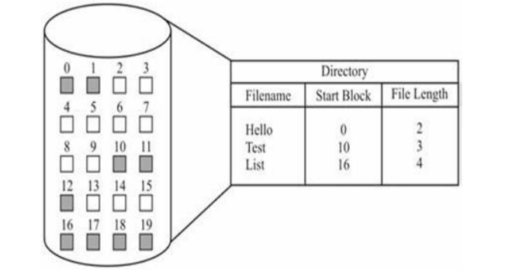

-As shown in the above example, ‘Hello’ file is stored on disk and the starting block from where the file begins is block number 0 (zero) and the length of the file is 2 blocks long. So, block number 0 and 1 are allocated for the file ‘Hello’. Same way allocation for ‘Test’ and ‘List’ file will be done.

-This diagram exhibits similar fragmentation problems as in variable memory partitioning. This is because the allocation and deal location could result in regions of free disk space broken into chunks (pieces) within active space, which is called external fragmentation.

-A user specifies in advance the size of the area needed to hold a file to be created. If the desired amount of contiguous space is not available, the file cannot be created. But it supports both sequential and direct accessing. For sequential access almost no seeks are required. Even direct access to seek and read is fast. Also, calculation of blocks holding data is quick and easy as we need just offset from the start of the file.