**Indexed Allocation Method**

-Index allocation addresses many of the problems of contiguous and chained allocation. In this case, the file allocation table contains a separate one-level index for each file; the index has one entry for each portion allocated to file.

-Typically, the file indexes are not physically stored as part of the file allocation table. Rather, the index for a file is kept in a separate block, and entry for the file in the allocation table points to that block.

-The allocation may be on the basis of either fixed size blocks or variable size portions.

-The indexed allocation scheme is diagrammatically shown in below.

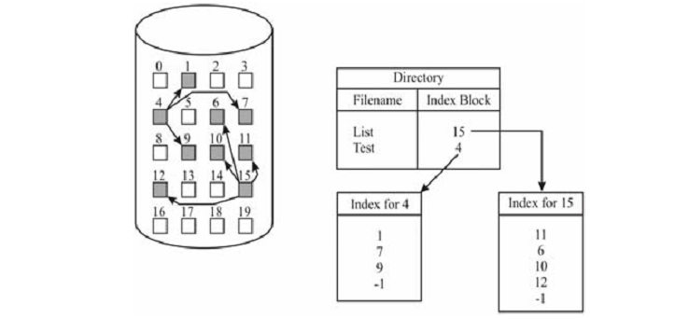

The advantage of this scheme is that it supports both sequential and random access. The searching may take place in index blocks themselves.

The index blocks may be kept close together in secondary storage to minimize seek time. Also space is wasted only on the index which is not very large and there’s no external fragmentation.