**Linked Allocation Method**

-Linked allocation is essentially a disk-based version of the linked list. The disk blocks may be scattered anywhere on the disk. The directory contains a pointer to the first and last block of the file. Also each block contains pointers to the next block, which are not made available to the user.

-It can be used effectively for sequential access only but there also it may generate long seeks between blocks. Another issue is the extra storage space required for pointers. Yet the reliability problem is also there due to loss/damage of any pointer.

-The below diagram depicts linked /chained allocation where each block contains the information about the next block.

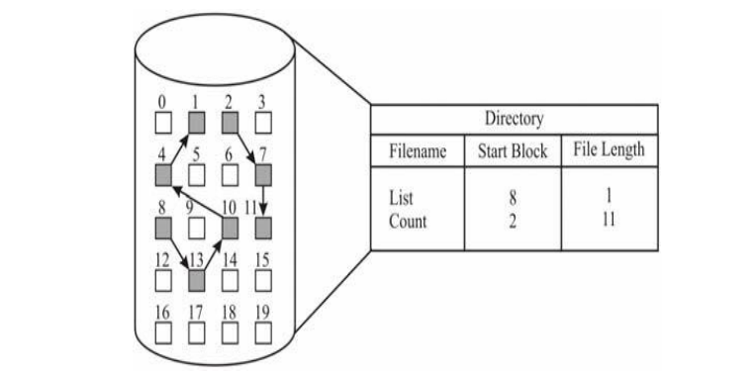

-MS-DOS and OS/2 use another variation on linked list called FAT (File Allocation Table). The beginning of each partition contains a table having one entry for each disk block and is indexed by the block number.

-The directory entry contains the block number of the first block of the file. The table entry indexed by block number contains the block number of the next block in the file.

-The Table pointer of the last block in the file has an EOF pointer value. This chain continues until EOF (end of file) table entry is encountered.