

MAHARASHTRA STATE BOARD OF TECHNIACL EDUCATION.

“Industrial Training Report”

Submitted in Partial Fulfilment of the Requirement

for the
Diploma in Information Technology
Academic Year
2026-27

Maharashtra State Board Of Technical Education, Thane



Certificate of Completion
This is to certify that Bhushan Bhau Pansare with Enrollment No. 24110220426 has successfully completed Industrial Training (315004) at WiseInvoice Software Company. From 25 may 2025 to 16 August 2025 for partial fulfillment towards completion of Diploma in Computer Engineering from Government Polytechnic Thane Institute code 0116.

Date:

Place: Thane.

Mr. Drashan Khapekar | DR.V.A.Khandekar | Prof. J.R. Nikhade
Industry Supervisor | Faculty-Mentor | Head of Department

Internal Examiner External Examiner

Dr. D.R. Mahajan
Principal, G.P. Thane

Name of Student: Bhushan Bhau Pansare
Enrollment no.: 24110220426
Name of Program: Information Technology.
Semester: Fifth (IF5K)
Course Title: Industrial Training
Code: 315004
Name of Industry : WiseInvoice Software Company

Course Outcomes (COs):

- CO1 – Observe time/resource management and industrial safety aspects.
- CO2 – Acquire professional experience of industry environment.

- CO3 – Establish effective communication in working environment.
- CO4 – Prepare report of assigned activities and accomplishments.

Enrollment | Tasks | Overall | Creativity | Knowledge | Speech | Body | Presentations | Diary , | Total
No. | undertaken (20) | Understanding (20) | /Innovatioon demonstrated (10) | acquired (10) | Clarity (10) | Language (10) | (10) | Report  writing and | (100)
 |  |  |  |  |  |  |  | /
 |  |  |  |  |  |  |  | Product
 |  |  |  |  |  |  |  | (10)

Prof D. P. Sapkal Industry Supervisor
Faculty-Mentor



PROGRAMME- INFORMATION TECHNOLOGY



Institute Code 0116

Institute Vision
To create competent technical manpower to cater Industrial and societal needs.

Institute Mission

We are committed to
- Provide an environment that values and encourages knowledge acquisition with effective curriculum implementation.
- Maintain the well-equipped laboratories to develop industrial competencies among the students.
- Empower and motivate faculties towards building their domain expertise in technology and management.
- Groom all round personality of students towards leadership, self-employability, and lifelong learning.
- Promote Industry Institute Interaction through training and placement services, continuing education programs, consultancy & Technical services, etc. for socio- economic development.

Our Core Values are-
Ethics, Equity, Women Empowerment, safety and Eco-friendly practices.
Government Polytechnic Thane



PROGRAMME- INFORMATION TECHNOLOGY



Institute Code 0116

Program Vision
To develop technical manpower in Information Technology by adapting rapid technological advancement.

Program Mission
M1. Provide hands on skills with well-equipped laboratories.
M2. Train faculty & staff to adapt changing technology.
M3. Develop IT professionals with entrepreneurial skills.
M4. Inculcate ethical values, honesty, equity, women empowerment and safety.

Program Outcomes (POs)

PO1. Basic and Discipline specific knowledge: Apply knowledge of basic mathematics, science and engineering fundamentals and engineering specialization to solve the engineeringproblems.
PO2. Problem analysis: Identify and analyze well-defined engineering problems using codified standard methods.
PO3. Design/ development of solutions: Design solutions for well-defined technical problems and assist with the design of systems components or processes to meet specified needs.
PO4. Engineering Tools, Experimentation and Testing: Apply modern engineering tools and appropriate technique to conduct standard tests and measurements.
PO5. Engineering practices for society, sustainability and environment: Apply appropriate technology in context of society, sustainability, environment and ethical practices.
PO6. Project Management: Use engineering management principles individually, as a team member or a leader to manage projects and effectively communicate about well-defined engineering activities.
PO7. Life-long learning: Ability to analyses individual needs and engage in updating in the context of technological changes.

Programme Educational Objectives (PEOs)
(What s/he will continue to do even after 3-5 years of working in the industry)

PEO-1: Provide socially responsible, environment friendly solutions to Information Technology related broad-based problems adapting professional ethics.
PEO-2: Adapt state-of-the-art of Information Technology techniques to work in multi-disciplinary work environments.
PEO-3: Solve broad-based problems individually and as a team member communicating effectively in the world of work.

Program Specific Outcomes (PSOs)
(What s/he will be able to do in the Information Technology specific industry soon after the diploma programme)

PSO 1: Modern Information Technology: Use latest technologies for operation and application of information.
PSO 2: Information Technology Process: Maintain the information processes using modern information and communication technologies.

Certificate page:

ABSTRACT:

The industrial training was undertaken at WiseInvoice Software Company with the objective of gaining practical exposure to Python Programming, Data Analytics, Data Visualization, Machine Learning, and related technologies. The training provided a structured learning environment that covered both theoretical concepts and hands-on implementation using real-world datasets.
In the initial phase, I learned the fundamentals of Python programming, including variables, data types, operators, conditional statements, loops, functions, lists, and other basic programming concepts. Gradually, the focus shifted towards Data Analytics, where I learned to work with datasets using Pandas and NumPy. I performed operations such as data loading, data cleaning, handling missing values, preprocessing, filtering, and analyzing data.
The training further involved Exploratory Data Analysis (EDA) and Data Visualization using libraries such as Matplotlib and Seaborn. I created different charts and visualizations to identify patterns, trends, relationships, and useful insights from datasets. I also gained practical experience in developing interactive dashboards using Streamlit, which helped in presenting analytical results in a user-friendly manner.
In the final phase, I worked on a major project – Gym Membership Recommendation System, where I analyzed gym membership-related data and used relevant member attributes to recommend suitable membership options. The project involved data cleaning, preprocessing, exploratory data analysis, feature selection, model training, and membership recommendation. This project enabled me to apply my knowledge of Python, Data Analytics, and Machine Learning to a practical dataset and generate personalized membership recommendations.
Overall, the industrial training provided valuable insights into the complete data analytics and recommendation system lifecycle, from data collection and cleaning to analysis, model development, recommendation generation, and dashboard presentation, while strengthening my technical, analytical, problem-solving, machine learning, and data interpretation skills.

ACKNOWLEDGEMENT:

I express my sincere gratitude to WiseInvoice Software Company for providing me with the opportunity to undergo industrial training in the field of Python Programming, Data Analytics, Data Visualization, and Machine Learning. The training has been a highly valuable experience that enhanced my practical knowledge, analytical abilities, and professional skills.
I am deeply thankful to my industry mentor, Dr. Varsha A. Khandekar, for her valuable guidance, encouragement, and continuous support throughout the training period. Her guidance helped me understand various concepts related to Python Programming, Data Analytics, Data Visualization, Machine Learning, and project development.
I would like to express my heartfelt thanks to my faculty mentor for providing valuable academic guidance and support, which motivated me to complete the training and Gym Membership Recommendation System project successfully.
I am also extremely grateful to our Head of Department, Prof. J. R. Nikhade, for his encouragement and support, and to our Principal, Dr. D. R. Mahajan, for providing me with this valuable opportunity to gain industry exposure through internship training.
Finally, I would like to thank everyone who directly or indirectly supported me throughout the training and helped me successfully complete my internship and project.

INDEX

Sr. No. | Description | Page No.
1 | Abstract | 11
2 | Acknowledgement | 12
3 | Chapter 1 – Organization Structure of Industry and General Layout | 14
4 | Chapter 2 – Introduction to Industry / Organization (history, type of products and services, turnover, number of employees, etc.) | 15
5 | Chapter 3 – Major Hardware and Software Used in Industry with their specifications, approximate cost, specific use and routine maintenance | 17
6 | Chapter 4 – Data Analytics Processes, Techniques, Methodologies and Data Handling Procedures | 19
7 | Chapter 5 – Testing of Software, Dataset, Data Analysis and Recommendation System with testing and data handling procedures | 21
8 | Chapter 6 – Safety Procedures and Security Measures Followed in the Industry | 22
9 | Chapter 7 – Particulars of Practical Experiences in Industry / Organization including Python Programming, Data Analysis, Visualization and Recommendation System Development | 23
10 | Chapter 8 – Detailed Report of the Tasks Undertaken During the Training: Gym Membership Recommendation System Project | 24
11 | Chapter 9 – Special / Challenging Experiences Encountered During Training | 35
12 | Chapter 10 – Conclusion | 37
13 | Chapter 11 – References / Sources of Information | 38

Chapter - 1

Name of the Organization:
WiseInvoice Software Company

Address of the Organization:

Contact Information:
● Phone:
● Email:
● Website:

Nature of the Organization:
WiseInvoice Software Company is a software-oriented organization that focuses on providing technology-based solutions and practical exposure to software and data-related technologies. The organization provides an environment where students and trainees can develop their technical knowledge and gain practical experience through industry-oriented training and project work.
During my industrial training, I gained practical exposure to Python Programming, Data Analytics, Data Visualization, and Dashboard Development. The training helped me understand how programming and analytical techniques can be applied to real-world datasets.
The organization focuses on:
● Providing practical, industry-oriented technical training.
● Developing programming and analytical skills.
● Providing hands-on experience with software and data-related technologies.
● Encouraging students to work on practical projects and real-world datasets.
● Developing problem-solving and technical skills through project-based learning.

Vision and Mission of the Organization:
Vision:
To provide practical technical knowledge and industry-oriented training that helps students develop the skills required to work with modern software and data technologies.
Mission:
● To provide quality technical training through practical learning methodologies.
● To develop programming, analytical, and problem-solving skills among trainees.
● To provide hands-on experience through real-world projects and datasets.
● To encourage continuous learning and adoption of modern technologies.
● To bridge the gap between academic knowledge and practical industry requirements.
Top of Form

Bottom of Form
- .

Chapter - 2

Overview
The success of any organization depends largely on its internal structure and the way responsibilities are distributed. WiseInvoice Software Company follows a structured working environment that enables effective coordination, supervision, and smooth execution of technical and training activities.
The structure ensures:
● Clear responsibilities and effective communication between different levels.
● Proper guidance and supervision during training and project activities.
● A balance between theoretical knowledge and practical implementation.
● Systematic completion of assigned tasks and projects.

Hierarchical Structure:
At WiseInvoice Software Company, the working structure can be broadly divided into four major levels:

1. Leadership Level (Management)
• Responsible for the overall vision, objectives, and functioning of the organization.
• Oversees organizational activities, projects, and technical initiatives.
• Ensures effective utilization of available resources.

2. Supervisory Level (Industry Mentors & Supervisors)
• Acts as a bridge between management and trainees.
• Provides guidance for training activities and project development.
• Assigns tasks and monitors the progress of trainees.
• Provides feedback and technical support whenever required.

3. Execution Level (Technical / Training Team)
• Guides trainees in practical implementation of technical concepts.
• Helps connect theoretical knowledge with real-world applications.
• Supports activities related to Python Programming, Data Analytics, Data Visualization, and Dashboard Development.
• Reviews the work performed by trainees and provides necessary corrections.

4. Learning Level (Intern Students)
• Actively participate in training sessions, assignments, and projects.
• Develop practical knowledge through hands-on activities.
• Work with datasets and analytical tools to solve real-world problems.
• Develop technical, analytical, communication, and problem-solving skills..

Chapter – 3
Major Equipments / Hardware & Software Used in Industry:
During the internship at WiseInvoice Software Company, the primary focus was on Python Programming, Data Analytics, Data Visualization, and Dashboard Development. Hence, the industry setup mainly required laptops/computers, internet connectivity, and software development and data analytics tools rather than physical manufacturing equipment or hardware instruments. The details of the equipment and tools used are as follows:

Hardware Components:

Sr.no | Equipment | Specification | Specific Use
1. | Laptop | Intel i5, 16 GB RAM, 512 GB SSD, Windows 10 OS | Main development environment for Android Studio and coding.
2. | Smartphone (Testing Device) | Android 10+, 4–6 GB  RAM, 64–128 GB  Storage | Testing and debugging Android apps on real devices.
3. | Wi-Fi Router & Internet Connection | Broadband, 50–100 Mbps | Required for API integration, Firebase, GitHub, and online tools

Software Components:

Sr.no | Software | Specification | Specific Use
1. | Android Studio (IDE) | Official IDE for Android, Gradle build system, Emulator support | Designing, coding, debugging, and testing Android apps
2. | Firebase | Google Cloud Platform for authentication, real-time DB | User authentication, cloud storage, real-time data sync.
3. | Git & GitHub | Version control system & repository hosting. | Code versioning, collaborative development, backup

Routine Maintenance Practices:
● Keeping Python, Jupyter Notebook, VS Code, and required libraries updated.
● Maintaining laptop performance with antivirus protection, regular cleanup, and operating system updates.
● Regularly checking and validating datasets to ensure data accuracy and consistency during analysis.
● Maintaining regular backups of project files, datasets, and analysis work to prevent data loss.
● Ensuring stable internet connectivity for downloading datasets, installing libraries, accessing online resources, and developing the Streamlit dashboard.

Chapter- 4

Introduction:

Unlike traditional industries that focus on manufacturing physical products, the software and data analytics industry follows systematic processes and methodologies to collect, clean, analyze, visualize, and interpret data. During my internship at WiseInvoice Software Company, the training emphasized Python Programming, Data Analytics, Data Visualization, Machine Learning, and Recommendation System Development using practical and project-based learning.

Data Analytics Process Followed:

The general process adopted during the internship consisted of the following phases:

1. Requirement Gathering

• Understanding the problem statement and objectives of the recommendation system.
• Identifying the type of data required for the project.
• Defining the important parameters required to recommend suitable gym memberships.
• Example: Identifying requirements for the Gym Membership Recommendation System, such as analyzing member information, fitness-related attributes, membership preferences, and other relevant factors.

2. Data Collection

• Collecting the required dataset in CSV format.
• Understanding the different columns and attributes available in the dataset.
• Checking whether the collected data is suitable for developing the recommendation system.
• Understanding the relationship between member attributes and suitable membership options.

3. Data Cleaning & Preprocessing

• Loading the dataset using Pandas.
• Identifying and handling missing or incorrect values.
• Removing unnecessary or duplicate records where required.
• Converting data into suitable formats for analysis and model training.
• Preparing clean and structured data for further processing.

4. Exploratory Data Analysis (EDA)

• Examining the dataset to understand patterns and relationships.
• Calculating summary statistics and analyzing important variables.
• Comparing different member attributes and membership-related factors.
• Identifying trends and useful patterns from the dataset.
• Using EDA results to understand the factors that can influence membership recommendations.

5. Data Visualization

• Creating graphical representations of analyzed data using Matplotlib and Seaborn.
• Using suitable charts such as bar charts, pie charts, histograms, and other visualizations.
• Presenting complex information in an easy-to-understand visual format.
• Using visualizations to understand membership patterns and customer-related data.

6. Model Training & Recommendation

• Selecting relevant features from the preprocessed dataset.
• Preparing the data for model training.
• Training the recommendation model using the selected features.
• Generating suitable gym membership recommendations based on user/member information.
• Evaluating the recommendation results and making necessary improvements.

7. Testing & Validation

• Checking the accuracy and consistency of the recommendation results.
• Testing the model with different input values.
• Verifying that the system provides suitable membership recommendations.
• Identifying and correcting errors in the Python program and recommendation process.

8. Final Presentation

• Organizing project files, dataset, Python code, model, and results.
• Presenting the completed Gym Membership Recommendation System.
• Demonstrating the recommendation process and final results.

Methodologies Used:

1. Agile Methodology

• Work was divided into smaller tasks and completed systematically.
• Regular feedback was used to improve the project.
• Changes and corrections were incorporated during project development.

2. Project-Based Learning (PBL)

• Practical assignments and projects were used to apply theoretical concepts.
• Python, Pandas, data visualization, and machine learning concepts were implemented through practical activities.
• Final major project: Gym Membership Recommendation System.

3. Iterative Development

• The project was developed in multiple stages.
• Initially, the dataset was loaded and explored.
• Later, data cleaning, preprocessing, analysis, feature selection, and model training were performed step-by-step.
• The recommendation system was improved based on testing and corrections.

Data Handling Procedures:

In software and data analytics industries, the primary resources include digital files, datasets, source code, trained models, and analytical results. Proper handling was ensured through:

➢ Dataset Management

• Storing the gym membership dataset in an organized manner.
• Checking the dataset for missing, duplicate, or incorrect values.
• Maintaining the original dataset separately from the cleaned dataset.

➢ Source Code Management

• Maintaining Python programs and project files in an organized structure.
• Regularly saving updated versions of the analysis and recommendation code.
• Keeping project files properly organized.

➢ Data Analysis

• Using Pandas and NumPy for data processing and analysis.
• Using appropriate statistical and analytical methods to understand the dataset.
• Validating analytical results before using them for model development.

➢ Model Management

• Maintaining the trained recommendation model and related files properly.
• Using appropriate input features for generating recommendations.
• Testing the model with different inputs to check the consistency of recommendations.

➢ Documentation & Reports

• Maintaining internship activities and project documentation.
• Recording important observations, analytical findings, and recommendation results.
• Preparing project reports and documentation using appropriate tools.

Outcome of Processes & Methodologies:

By following these processes and methodologies:

● Data analysis became systematic and organized.
● Dataset quality was improved through cleaning and preprocessing.
● Important patterns and relationships were identified through EDA and visualization.
● Relevant features were selected for developing the recommendation system.
● A Gym Membership Recommendation System was developed to generate suitable membership recommendations.
● The project provided practical exposure to the complete data analytics and machine learning workflow, from data collection and preprocessing to model training and final recommendation.

Chapter – 5

Hardware Testing:

• Laptop / PC: Tested for performance, operating system stability, storage capacity, and antivirus protection to ensure smooth execution of Python, Jupyter Notebook, VS Code, and required machine learning libraries.

• Internet & Router: Checked for speed and stability to support dataset downloads, installation of Python libraries, accessing online resources, and project development.

• Storage Devices: Checked for sufficient storage space and proper functioning to safely store gym membership datasets, Python programs, project files, trained model files, and reports.

Software Testing:

● Unit Testing:

Verified individual Python programs, functions, data-processing operations, preprocessing steps, and recommendation components.

● Data Validation Testing:

Checked the dataset for missing values, duplicate records, incorrect data types, and inconsistent values before performing analysis and model training.

● Integration Testing:

Ensured smooth integration between the CSV dataset, Pandas data-processing operations, preprocessing techniques, trained model, and recommendation system.

● System Testing:

Tested the complete Gym Membership Recommendation System to verify that data processing, model execution, input handling, and membership recommendations worked correctly.

● User Acceptance Testing (UAT):

Performed final validation of the recommendation system based on testing, observations, feedback, and corrections provided during the training.

Material Handling Procedures:

● Dataset:

The Gym Membership CSV dataset was stored and handled systematically during the cleaning, preprocessing, and analysis process.

● Source Code:

Python programs and recommendation system files were maintained in an organized project folder with regular backups.

● Model Files:

The trained recommendation model and related files were stored properly and tested to ensure they could be used for generating recommendations.

● Documentation:

Internship diaries, project documentation, analysis results, recommendation results, and report files were maintained properly.

● Project Files:

Datasets, Python scripts, preprocessing files, model files, and project documentation were organized and maintained to prevent accidental loss or duplication.

Outcome:

Testing and proper handling procedures ensured data accuracy, reliable model performance, consistent recommendations, proper data processing, and successful completion of the Gym Membership Recommendation System project.

Chapter – 6

Importance of Safety in Training:

During industrial training, following proper safety measures is essential to ensure a secure and disciplined learning environment. At WiseInvoice Software Company, safety guidelines are not limited to physical well-being but also extend to data safety, digital security, system protection, and professional conduct. These measures create a safe environment for students to focus on their learning, data analysis activities, and project development without unnecessary risks.

Safety Procedures Implemented:

1. Digital & Cybersecurity Measures

• Use of authorized software and trusted Python libraries for programming and data analysis.
• Avoiding downloads from unverified sources to prevent malware and security threats.
• Safe handling of login credentials and project-related information.
• Using strong passwords and avoiding sharing sensitive project files or account information.
• Ensuring that datasets and project files are accessed only through trusted sources.

2. Data Backup & Protection

• Regular backups of datasets, Python programs, dashboard files, and project documents.
• Maintaining separate copies of important project files to prevent accidental data loss.
• Using appropriate version control and backup practices for project development.
• Storing project-related documents securely on local or cloud storage.

3. System and Equipment Safety

• Proper handling of laptops, chargers, storage devices, and other computer equipment.
• Ensuring that systems are connected to a stable power supply to prevent data loss or hardware damage.
• Keeping operating systems and security software updated.
• Using antivirus protection to safeguard systems against malware and other threats.

4. Workplace Safety & Professional Conduct

• Maintaining discipline and professionalism in the workplace and training environment.
• Following proper ergonomics while working for long periods on computers.
• Taking appropriate breaks to avoid excessive physical strain during computer work.
• Respecting intellectual property rights by avoiding plagiarism and providing references for information and resources used.
• Maintaining confidentiality of organization and project-related information.

5. Data Privacy & Responsible Data Handling

• Using datasets only for the intended training and project analysis purposes.
• Avoiding unnecessary sharing or modification of project data.
• Maintaining the accuracy and integrity of the dataset during preprocessing and analysis.
• Ensuring that analytical results and project information are presented responsibly.

Safety Outcome:

Following these safety procedures helped maintain a secure, disciplined, and productive working environment throughout the training. It also developed awareness about cybersecurity, data protection, responsible data handling, equipment safety, and professional conduct during data analytics project development.

Chapter – 7

During my industrial training at WiseInvoice Software Company, I gained hands-on exposure to various phases of the Data Analytics and Machine Learning lifecycle. This included data collection, data cleaning, preprocessing, analysis, feature selection, model training, testing, and recommendation generation. Each stage provided me with valuable practical experience and improved my technical, analytical, machine learning, and problem-solving skills.
Practical Experiences:
a) Data Collection & Preparation
• Learned how to work with CSV datasets and understand different data attributes.
• Collected and examined the Gym Membership dataset for analysis and recommendation system development.
• Learned to identify important attributes related to gym members, their preferences, fitness-related information, and membership requirements.
• Gained practical experience in preparing raw data for further analysis and model development.
b) Data Cleaning & Preprocessing
• Used Pandas to load, inspect, clean, and preprocess the Gym Membership dataset.
• Identified and handled missing values, duplicate records, and inconsistent data.
• Converted data into appropriate formats wherever required.
• Removed unnecessary data and prepared a clean dataset for Exploratory Data Analysis and model training.
c) Exploratory Data Analysis & Visualization
• Performed Exploratory Data Analysis (EDA) to understand patterns and relationships in the dataset.
• Analyzed member-related attributes and membership preferences to identify useful patterns.
• Created charts and graphs using Matplotlib and Seaborn.
• Used visualizations to understand trends and relationships that could help in generating suitable membership recommendations.
d) Model Development & Recommendation
• Selected relevant features from the preprocessed dataset for developing the recommendation system.
• Prepared the data for model training.
• Trained the recommendation model using the selected features.
• Tested the model with different input values to generate suitable gym membership recommendations.
• Improved the recommendation process based on testing, observations, and mentor feedback.
e) Project Maintenance & Improvements
• Updated Python code to correct errors and improve project performance.
• Organized datasets, Python programs, preprocessing files, model files, and project documentation properly.
• Maintained backups of important project files to prevent data loss.
• Improved the recommendation system based on testing and feedback.
• Learned how continuous improvements can make a machine learning-based recommendation system more accurate, organized, and user-friendly.

Chapter – 8
During my internship at WiseInvoice Software Company, I began by setting up the required development environment for Python Programming, Data Analytics, and Machine Learning. I learned Python fundamentals through practical exercises and gradually moved towards working with datasets using Pandas and NumPy. I then gained hands-on experience in data cleaning, preprocessing, Exploratory Data Analysis (EDA), and data visualization using Matplotlib and Seaborn. In the later stages, I worked on Machine Learning and recommendation system development and applied the concepts learned during the training to my major project, Gym Membership Recommendation System.
List of Tasks and Projects Undertaken During Training:
Python Programming & Basic Tasks:
⮚ Python installation and environment setup
⮚ Understanding Python features and basic syntax
⮚ Variables, constants and data types
⮚ Type conversion and type checking
⮚ Operators and expressions
⮚ Conditional statements
⮚ For and while loops
⮚ Lists, tuples, sets and dictionaries
⮚ Indexing and slicing
⮚ Functions and basic programming exercises
⮚ Basic problem-solving programs
Python Practical Exercises:
⮚ Student Grading System
⮚ Personal Information Program
⮚ Data Type Explorer
⮚ Odd Number Printing Program
⮚ Number Sequence Programs using range()
⮚ While Loop Programs
⮚ List Operations and Manipulation
⮚ List indexing and slicing exercises
⮚ Append, insert and remove operations
Pandas & NumPy:
⮚ Introduction to NumPy
⮚ Creating and manipulating NumPy arrays
⮚ Introduction to Pandas
⮚ Creating Pandas Series and DataFrames
⮚ Reading CSV datasets
⮚ Using head() and tail() functions
⮚ Understanding dataset structure using info() and describe()
⮚ Selecting and filtering data
⮚ Handling missing values
⮚ Removing duplicate records
⮚ Data cleaning and preprocessing
⮚ Converting non-numeric data into numeric data
⮚ Creating dummy variables using Pandas
Data Visualization:
⮚ Introduction to Matplotlib
⮚ Creating bar charts
⮚ Creating line charts
⮚ Creating pie charts
⮚ Creating histograms
⮚ Introduction to Seaborn
⮚ Creating statistical visualizations
⮚ Creating heatmaps
⮚ Comparing different categories using charts
⮚ Presenting analytical results through visualizations
Data Analytics & EDA:
⮚ Understanding Exploratory Data Analysis (EDA)
⮚ Identifying patterns and trends in datasets
⮚ Calculating summary statistics
⮚ Analysing relationships between different variables
⮚ Identifying missing and inconsistent data
⮚ Performing data filtering and grouping
⮚ Extracting meaningful insights from datasets
Machine Learning & Recommendation System:
⮚ Introduction to Machine Learning concepts
⮚ Understanding supervised learning and recommendation systems
⮚ Selecting relevant features from the dataset
⮚ Preparing data for model training
⮚ Training the recommendation model
⮚ Testing the model with different inputs
⮚ Generating suitable gym membership recommendations
⮚ Evaluating and improving recommendation results
Gym Membership Recommendation System:
⮚ Loading and understanding the Gym Membership dataset
⮚ Cleaning and preprocessing the dataset
⮚ Performing Exploratory Data Analysis
⮚ Selecting relevant member and membership attributes
⮚ Preparing the dataset for model training
⮚ Training the recommendation model
⮚ Generating membership recommendations based on user/member information
⮚ Testing the recommendation system
⮚ Displaying and interpreting recommendation results
⮚ Improving the recommendation system based on testing and feedback

Major Project:

Gym Membership Recommendation System

The major project undertaken during the internship was Gym Membership Recommendation System.

The project focuses on analyzing gym membership and member-related data to identify useful patterns and provide suitable membership recommendations based on relevant user/member attributes.

Main Features of the Project:

⮚ Analysis of gym member-related data

⮚ Analysis of membership-related attributes

⮚ Identification of relevant features for recommendation

⮚ Data cleaning and preprocessing

⮚ Exploratory Data Analysis (EDA)

⮚ Analysis of patterns and relationships in the dataset

⮚ Feature selection for the recommendation model

⮚ Preparation of data for model training

⮚ Training of the recommendation model

⮚ Generation of suitable gym membership recommendations

⮚ Testing the recommendation system with different inputs

⮚ Evaluation and improvement of recommendation results

⮚ Presentation and interpretation of the recommendation results

Project Workflow:

Gym Membership Dataset (CSV)
↓
Data Cleaning
↓
Data Preprocessing
↓
Exploratory Data Analysis (EDA)
↓
Feature Selection
↓
Model Training
↓
Membership Recommendation
↓
Recommendation Results

This project helped me apply the concepts learned during the internship to a practical dataset and provided hands-on experience in the complete Data Analytics and Machine Learning workflow, from raw data processing and analysis to model training and final membership recommendation.

Major Projects:

⮚ Gym Membership Recommendation System – Data analysis and machine-learning-based recommendation of suitable gym memberships.

⮚ Zomato Restaurant Analysis – Analysis of restaurant data using Python, data visualization, and an interactive dashboard.

Final Project: GYM membership Recommandation System

Basic Details along with Features:

The Gym Membership Recommendation System is a data analytics and machine learning project designed to analyze gym member-related information and generate suitable membership recommendations based on relevant user attributes. The project involves data cleaning, data preprocessing, Exploratory Data Analysis (EDA), feature selection, model training, and recommendation generation.
The project analyzes important member and membership-related attributes available in the dataset. The data is processed using Python, Pandas, and NumPy, while Matplotlib and Seaborn are used to create visualizations and identify patterns and relationships in the dataset. Relevant features are selected and used for developing the recommendation model.
The final system generates suitable gym membership recommendations based on the provided member information and selected features. The project helps in understanding member patterns and preferences and demonstrates how data analytics and machine learning can be used to support personalized membership recommendations.
Why This Project Is Different from Other Projects:
• Uses a data-driven recommendation approach for suggesting suitable gym memberships.
• Analyzes multiple member and membership-related attributes to generate recommendations.
• Uses data preprocessing and feature selection before model training.
• Combines Data Analytics, Exploratory Data Analysis, Machine Learning, and Recommendation System Development in a single project.
• Uses data visualizations to understand patterns and relationships within the dataset.
• Generates personalized gym membership recommendations based on user/member information.
• Provides practical experience in applying machine learning techniques to a real-world recommendation problem.

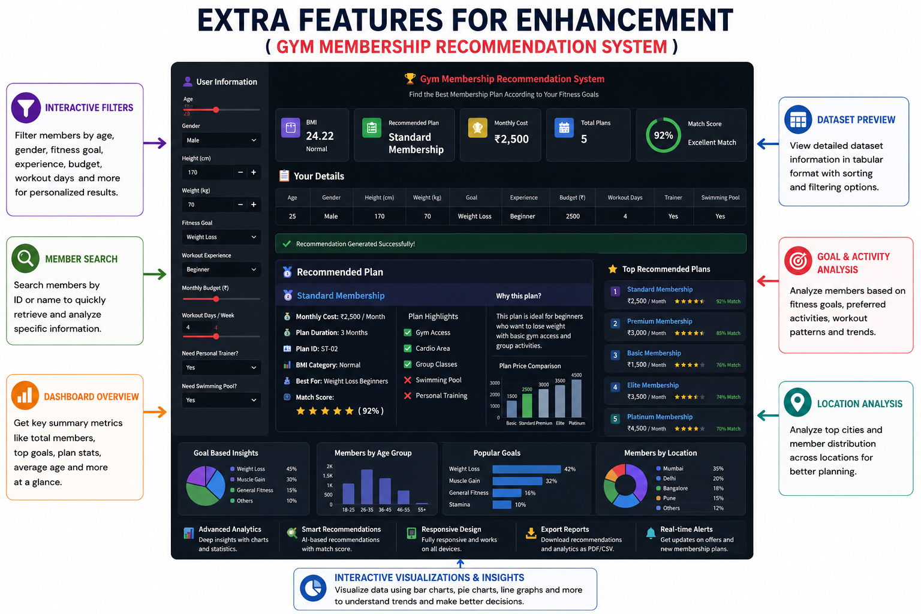

Flow of the project:
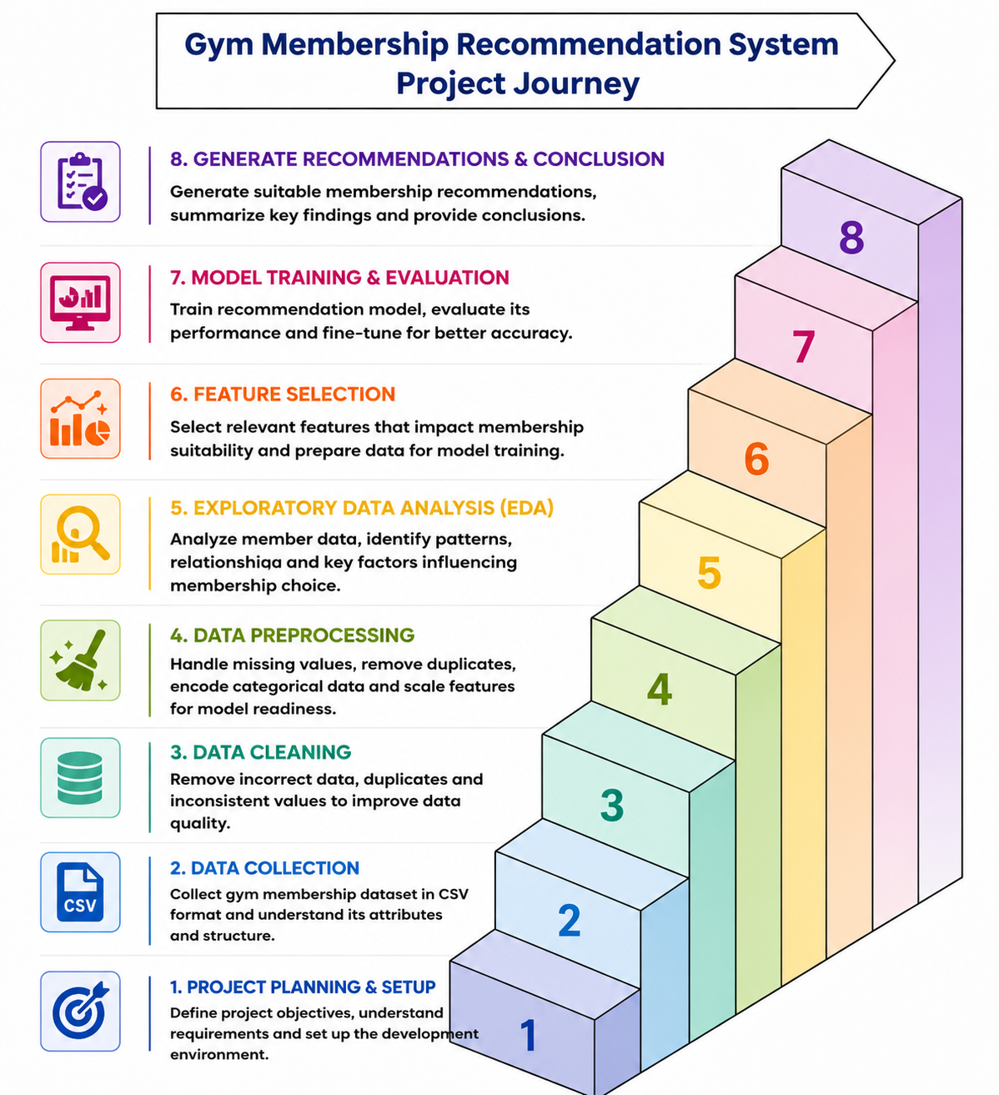
Code Files:

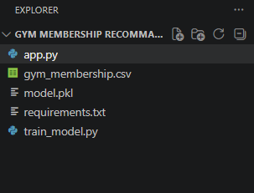
^{Output of the Project:}
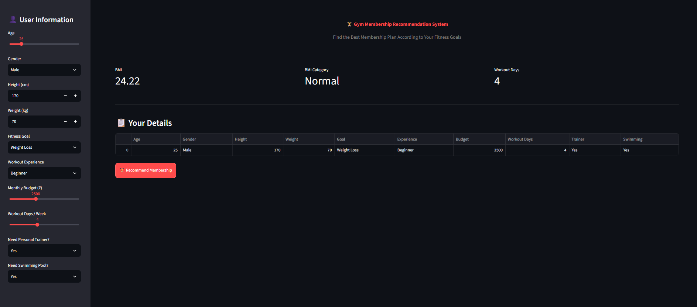
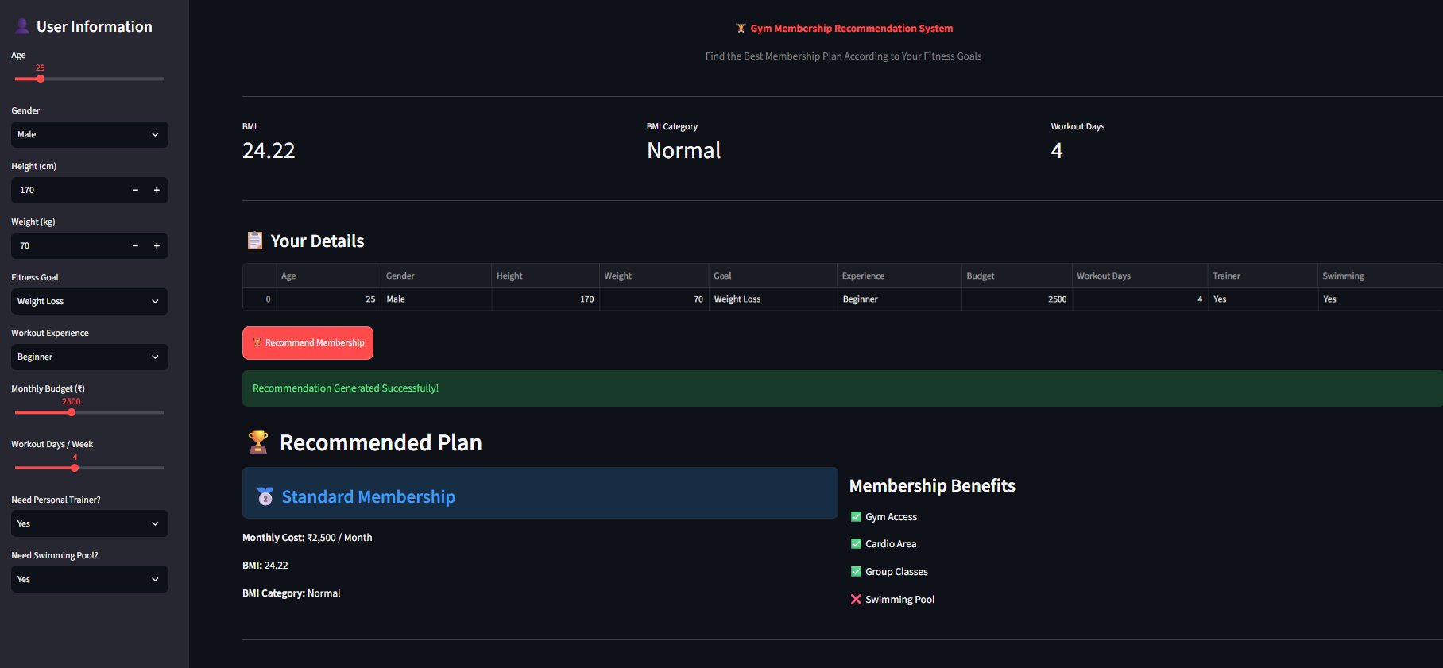
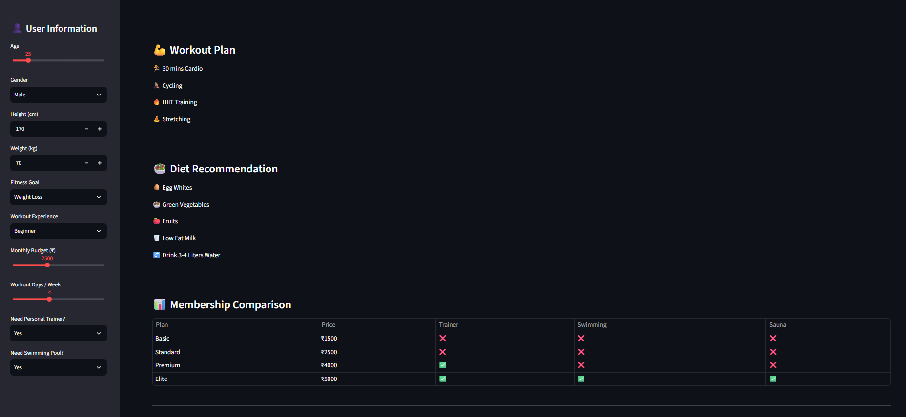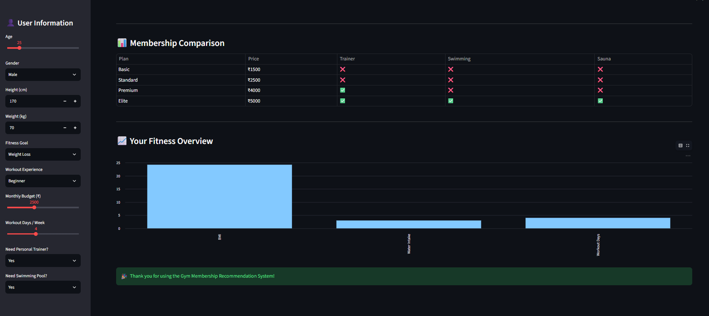

Chapter – 9

Special / Challenging Experiences Encountered During Training

Every industrial training program comes with its own set of challenges and learning opportunities. During my internship at WiseInvoice Software Company, I encountered situations that tested my technical abilities, analytical thinking, problem-solving skills, and adaptability. Overcoming these challenges provided me with valuable insights into practical data analytics and machine learning and improved my professional skills.

Challenges Faced:

1. Initial Adaptation to Python and Data Analytics Tools

● At the beginning, understanding the Python environment, Jupyter Notebook, VS Code, Pandas, and NumPy was challenging. Working with datasets and learning different functions required regular practice.

● Learning Outcome: With continuous practice and guidance, I became more comfortable with Python programming and learned how to work efficiently with data analytics tools.

2. Data Cleaning and Preprocessing

● While working with the Gym Membership dataset, I faced challenges related to missing values, duplicate records, inconsistent data, and different data formats. Preparing the raw data for analysis and model training required careful checking.

● Learning Outcome: This improved my understanding of data cleaning and taught me the importance of maintaining data quality and consistency before performing analysis and developing the recommendation system.

3. Data Analysis and Feature Selection

● Initially, identifying the important attributes and understanding relationships between different member and membership-related factors was challenging.

● Learning Outcome: I learned how to perform Exploratory Data Analysis (EDA) and select relevant features that could be useful for generating suitable gym membership recommendations.

4. Model Training and Recommendation Development

● Developing the recommendation system was challenging because I had to prepare the data, select appropriate features, train the model, and test the recommendations with different inputs.

● Learning Outcome: I gained practical experience in model training, testing, debugging, and generating membership recommendations based on user/member information.

5. Time Management

● Balancing internship assignments, data analytics exercises, documentation, and the final Gym Membership Recommendation System project within the given deadlines was sometimes difficult.

● Learning Outcome: I learned to plan my work, divide the project into smaller tasks, prioritize important activities, and complete work in a systematic manner.

Special Experiences:

⮚ Positive Experiences:

• Enjoyed working with a practical Gym Membership dataset and discovering useful patterns from the data.

• Practical assignments helped me understand how theoretical concepts of Python, Data Analytics, and Machine Learning are applied in real projects.

• Developing the Gym Membership Recommendation System was an engaging experience because I could apply data analysis and machine learning concepts to generate membership recommendations.

• Guidance and feedback during training helped me improve my technical, analytical, and problem-solving skills.

• Learned the importance of data cleaning, feature selection, model testing, and systematic project development.

⮚ Negative Experiences:

• Working with inconsistent or incomplete dataset values was initially time-consuming.

• Debugging Python code and correcting model or recommendation errors could sometimes be frustrating.

• Initially, I had limited confidence while independently performing data analysis and developing the recommendation system.

• Understanding the relationship between different input features and recommendation results required additional practice.

• Managing multiple internship activities and project documentation within deadlines was challenging.

Overall Learning Experience:

The challenges encountered during the training helped me become more confident in working with Python, Pandas, NumPy, data visualization, EDA, feature selection, and machine learning techniques. The experience also taught me that careful data preparation, systematic testing, proper feature selection, and continuous improvement are important for developing a successful Gym Membership Recommendation System.

Chapter – 10

The industrial training at WiseInvoice Software Company provided me with valuable practical exposure to the field of Python Programming, Data Analytics, and Machine Learning. Through systematic guidance and practical activities, I was able to strengthen my knowledge of Python, NumPy, Pandas, Data Cleaning, Data Preprocessing, Exploratory Data Analysis, Matplotlib, Seaborn, and Machine Learning.

The training not only enhanced my technical knowledge but also developed my analytical thinking, problem-solving skills, time management, and professional discipline. Working on practical assignments and the major Gym Membership Recommendation System project helped me understand the complete data analytics and machine learning process, from handling raw data to preprocessing, feature selection, model training, and generating suitable membership recommendations.

The internship also helped bridge the gap between theoretical knowledge and practical application. By working with a practical gym membership dataset, I gained a better understanding of how data can be cleaned, analyzed, processed, and used to develop a recommendation system that provides suitable membership suggestions.

Overall Learning Outcome

This training has given me:

● Technical Competence – Strong foundation in Python programming, Pandas, NumPy, data visualization, and machine learning concepts.

● Practical Experience – Hands-on experience in data cleaning, preprocessing, EDA, feature selection, model training, and recommendation generation.

● Analytical Skills – Improved ability to identify patterns, relationships, and meaningful information from datasets.

● Professional Growth – Improved problem-solving, time management, documentation, and systematic working abilities.

● Project Experience – Practical experience in developing and presenting the Gym Membership Recommendation System.

● Career Readiness – Increased confidence to work on real-world Data Analytics, Machine Learning, and recommendation system projects and pursue future professional opportunities.

Chapter – 11

References Used:
- Kaggle – Gym Membership Dataset.
- Python Official Documentation – https://docs.python.org/
- Pandas Official Documentation – https://pandas.pydata.org/docs/
- NumPy Official Documentation – https://numpy.org/doc/
- Matplotlib Official Documentation – https://matplotlib.org/stable/
- Seaborn Documentation – https://seaborn.pydata.org/
- Scikit-learn Official Documentation – https://scikit-learn.org/stable/
- Internship training notes and practical exercises provided during the training at WiseInvoice Software Company.
- Gym Membership Recommendation System project files, dataset, and analysis work developed during the internship.

