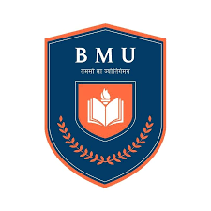**Bhagwan Mahavir University**

**Bhagwan Mahavir College of Management**

**Subject Code: 3050302102**

**Subject Name: Relational Database Management System**

**Question Bank**

**For**

**Theory MID-TERM Exam**

**Q.1 Definition Database. Characteristics of DBMS with example.**

**Q.2 What is Database Users. Explain various users and Its role.**

**Q.3 What is DBMS Architecture?**

**Q.4 What is File System? Do the Comparison File Systems v/s. DBMS**

**Q.5 Define Database Languages with Examples**

**Q.6 Explain Relational Model with Examples**

**Q.7 Explain Relational Algebra with proper signature (symbols) with examples**

**Q.8 What is Joins in SQL? Define with SQL queries and proper diagrams.**

**Q.9 What is PL/SQL? Define its Key Features and Structure.**

# **Q.10 Difference Between SQL and PL/SQL.**

**Q.11 Explain pros and cons of PL/SQL.**

**Q.12 Write SQL query using Relational Algebra notation.**

**Q.13 Write SQL quey using group by and order by clause with aggregate function.**

**Q.14 Write PL/SQL blocks using control structure statements.**

**Q.15 Explain Oracle Date/Time function with proper format.**

**Exam Syllabus:**

**UNIT-1 : FULL**

**UNIT-2 : FULL**

**UNIT-3 : PL/SQL Introduction**

**Control Structures in PL/SQL**

**Exception Handling**