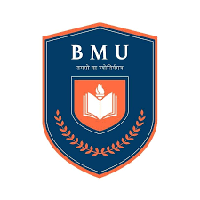**Bhagwan Mahavir University**

**Bhagwan Mahavir College of Management**

**Subject Code: 3050302102**

**Subject Name: Relational Database Management System**

**Question Bank**

**For**

**Theory MID-TERM Exam**

Q.1 Definition Database. Characteristics of DBMS with example.

Q.2 What is Database Users. Explain various users and Its role.

Q.3 What is DBMS Architecture?

Q.4 What is File System? Do the Comparison File Systems v/s. DBMS

Q.5 Define Database Languages with Examples

**Q.6 Explain Relational Model with Examples**

Q.7 Explain Relational Algebra with proper signature (symbols) with examples

Q.8 What is Joins in SQL? Define with SQL queries and proper diagrams.

Q.9 What is PL/SQL? Define its Key Features and Structure.

# Q.10 Difference Between SQL and PL/SQL.

Q.11 Explain pros and cons of PL/SQL.

Q.12 Write SQL query using Relational Algebra notation.

Q.13 Write SQL quey using group by and order by clause with aggregate function.

Q.14 Write PL/SQL blocks using control structure statements.

**Q.15 Explain Oracle Date/Time function with proper format.**

**Exam Syllabus:**

**UNIT-1 : FULL**

**UNIT-2 : FULL**

**UNIT-3 : PL/SQL Introduction**

**Control Structures in PL/SQL**

**Exception Handling**