Case : activationFails``` the activation itself fails after `activationProcessingTime` (see below) has passed

Start Page : http://localhost:3000/

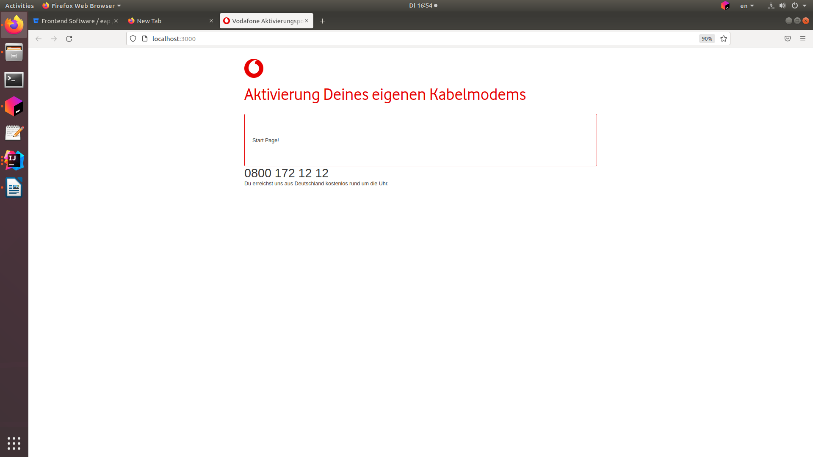
Login Page: http://localhost:3000/v2/login

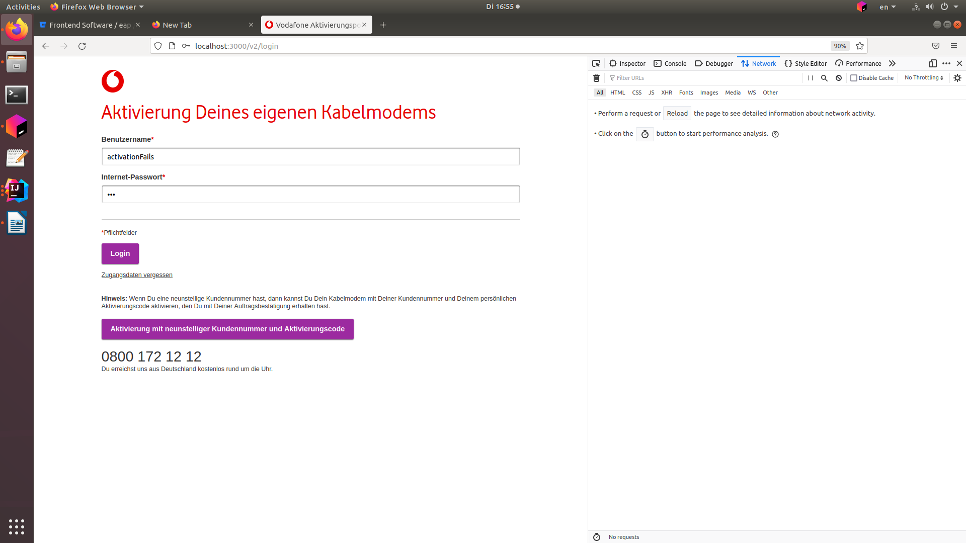

Activation Page:

http://localhost:3000/v2/activation

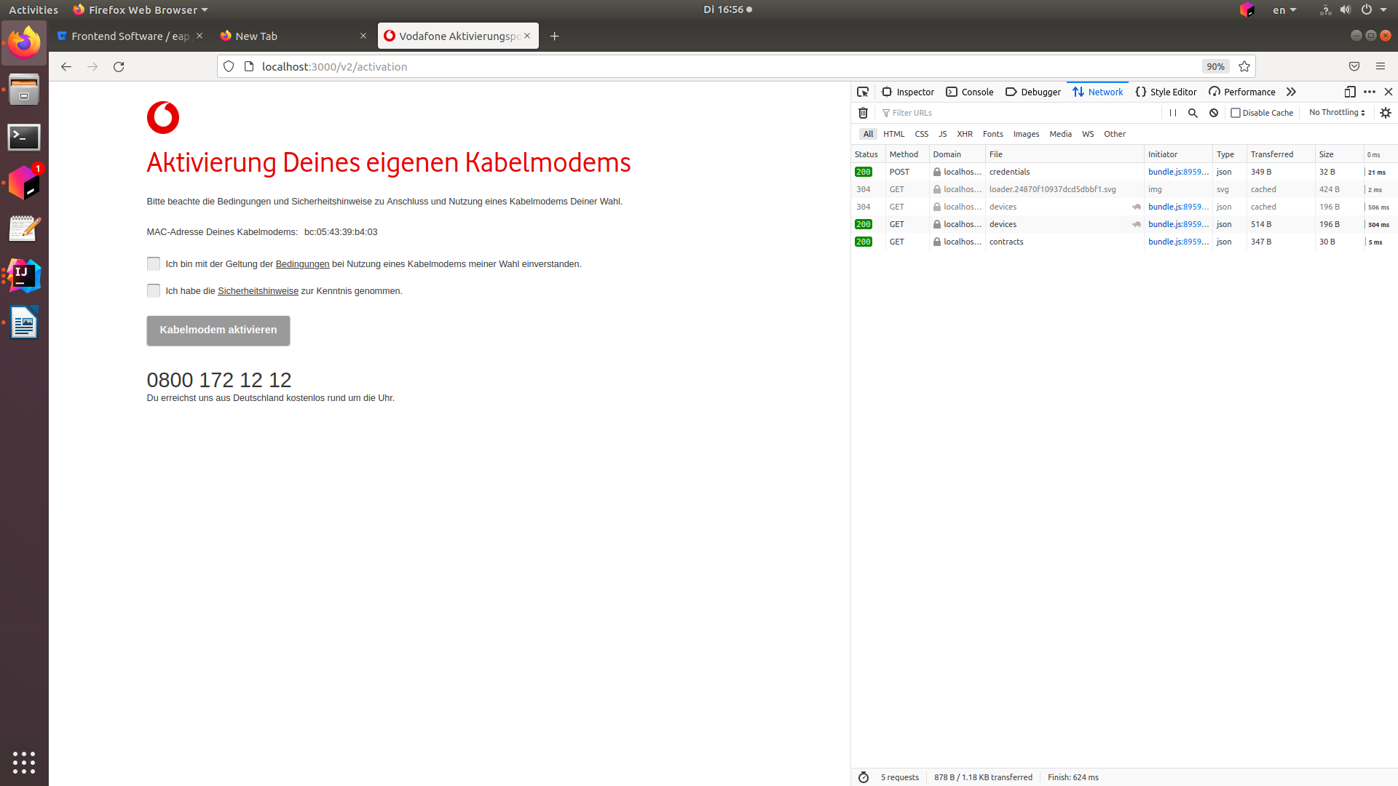

PDF link works:
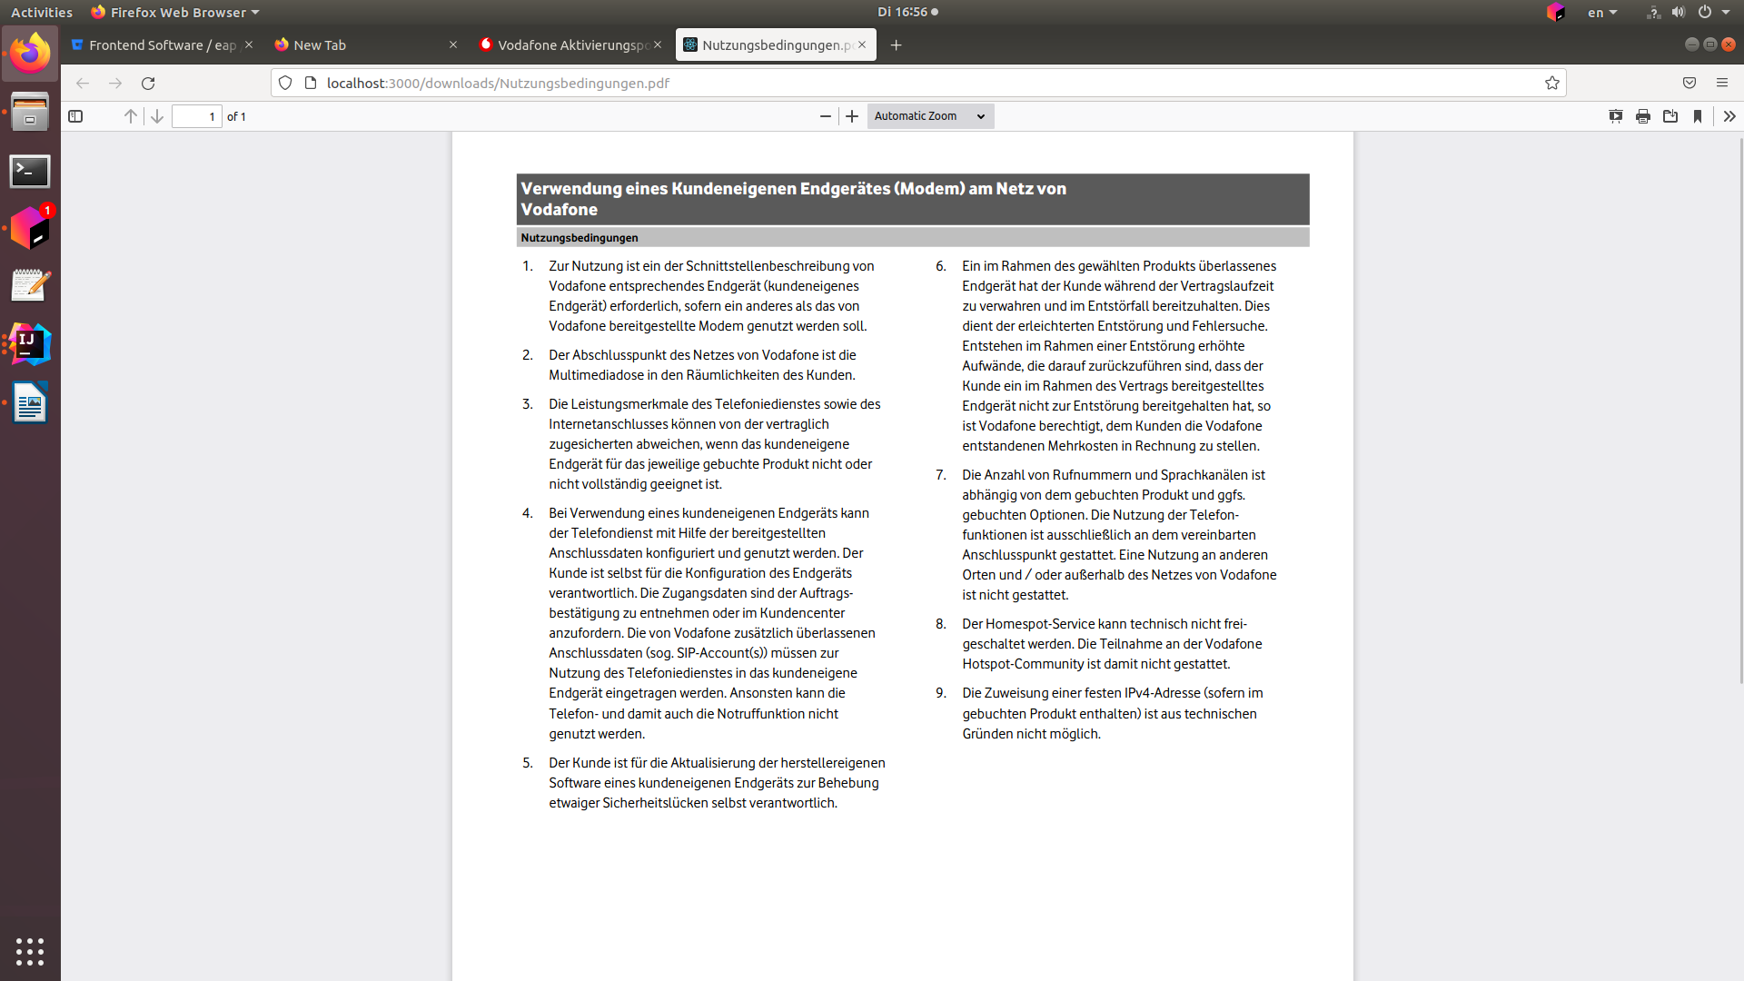

Question dialog box also appears:
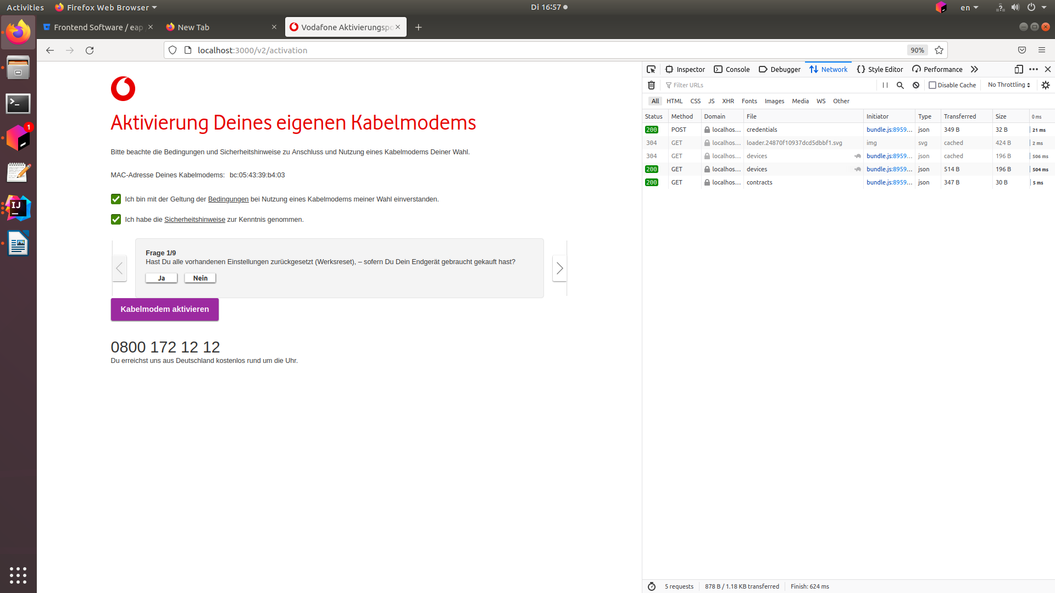

Device activation fails:

http://localhost:3000/v2/activation-state

