Case : multipleContracts``` customer has multiple contracts (fails as of Solution 0)

Start Page : http://localhost:3000/

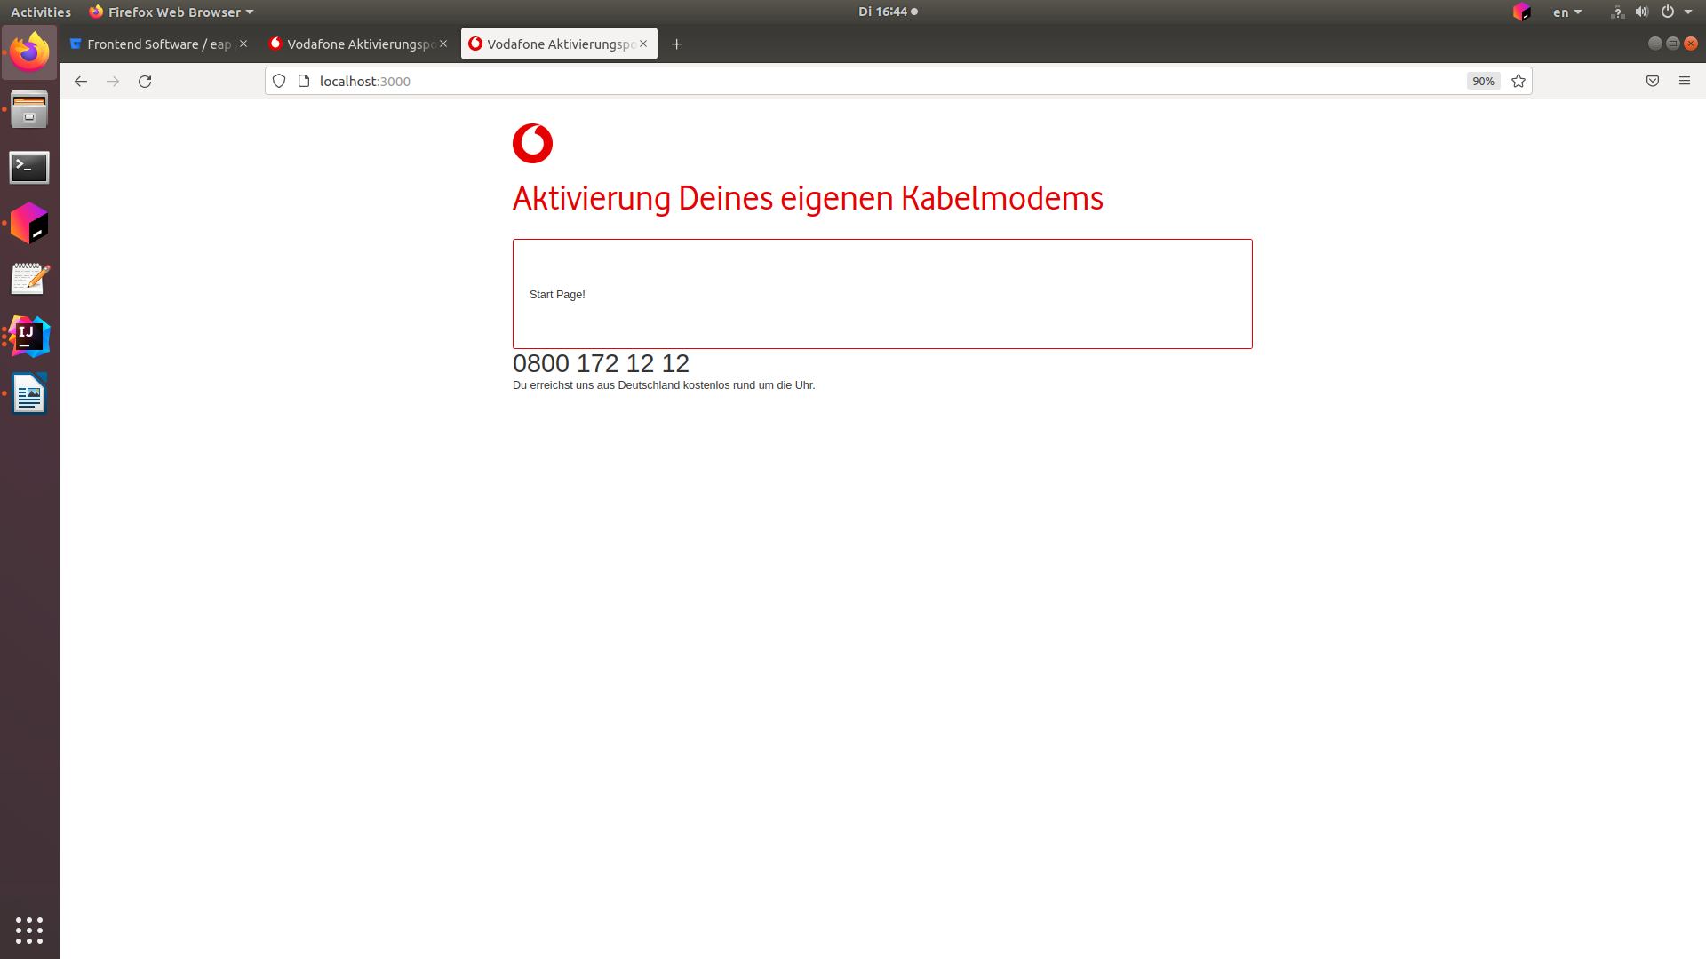
Login Page: http://localhost:3000/v2/login

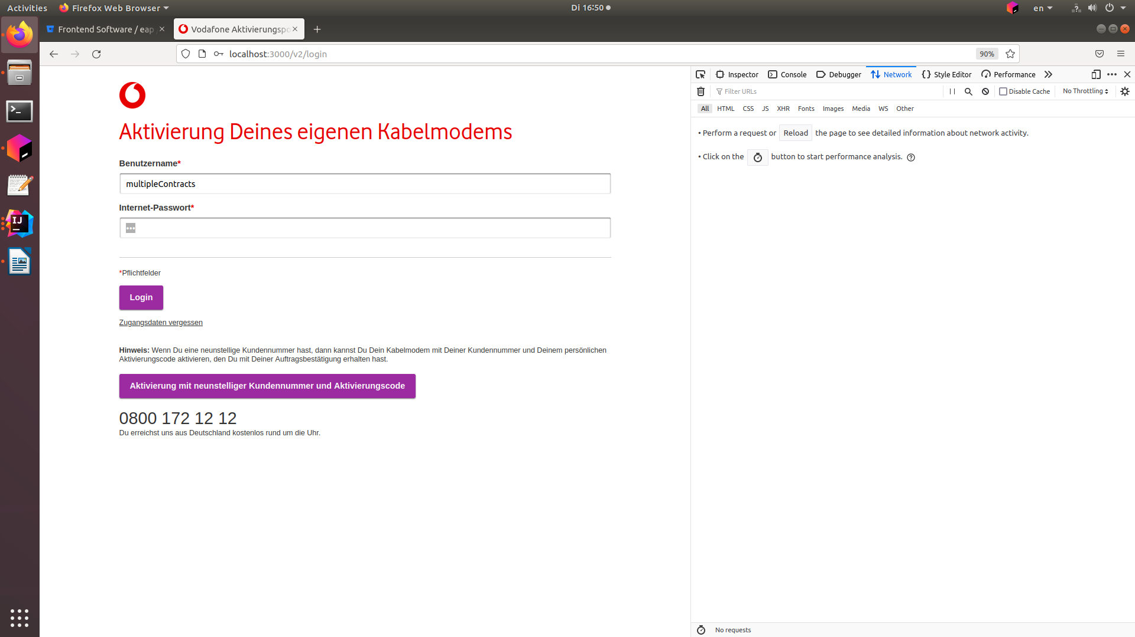

http://localhost:3000/v2/contract-selection:

