Case 2: noContract``` no contracts found for customer

Start Page : http://localhost:3000/

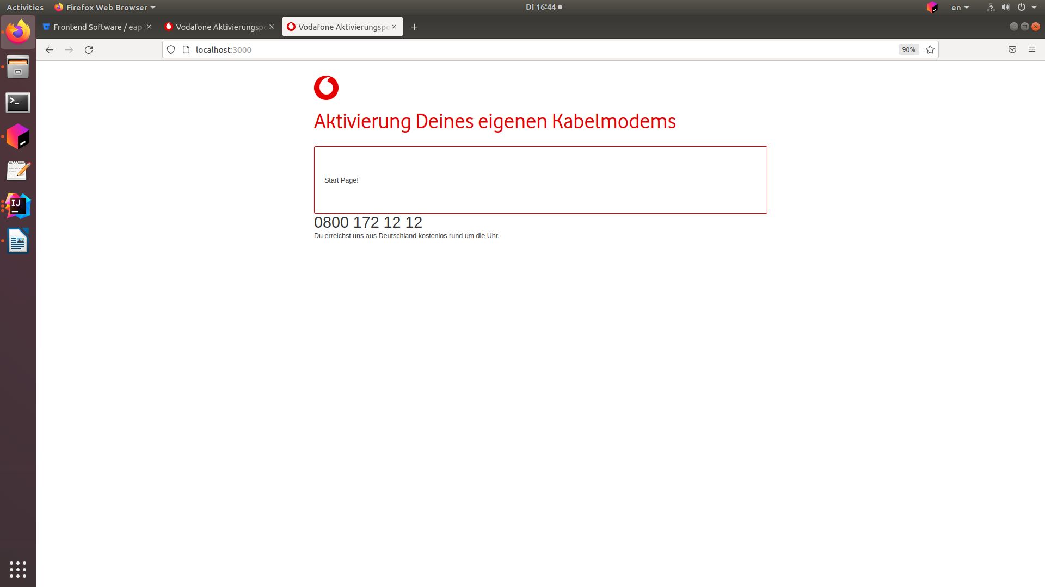
Login Page: http://localhost:3000/v2/login

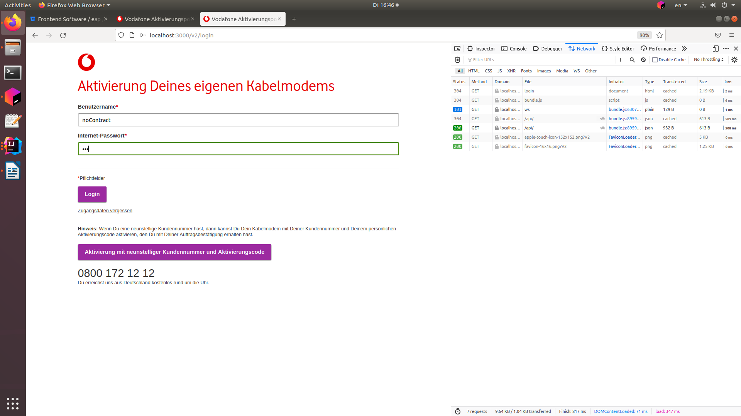

No contract error page:

http://localhost:3000/v2/contract-selection

