Analysis of the data of

Agricultural Production of India

Wireframe Documentation

Homepage

According to the analysis, I have made a few reports and dashboards.

* **Yield and cost of production by Crops**

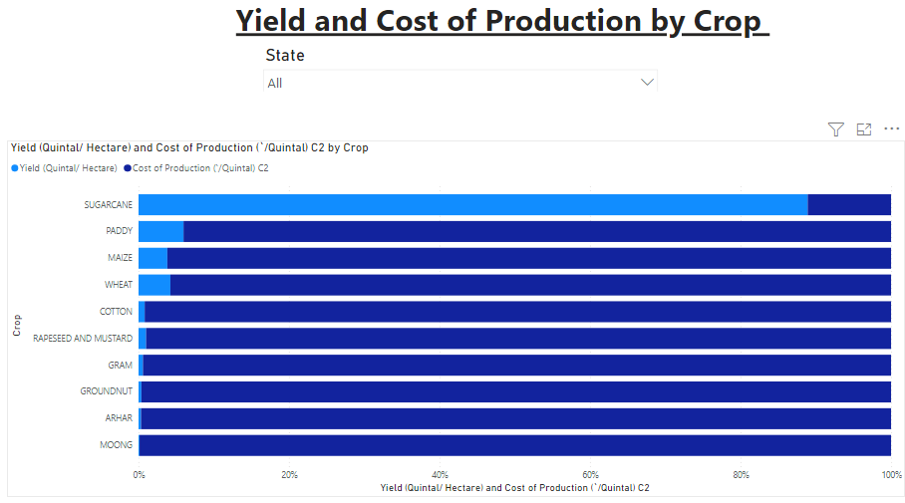

* **Cost of Cultivation in States**

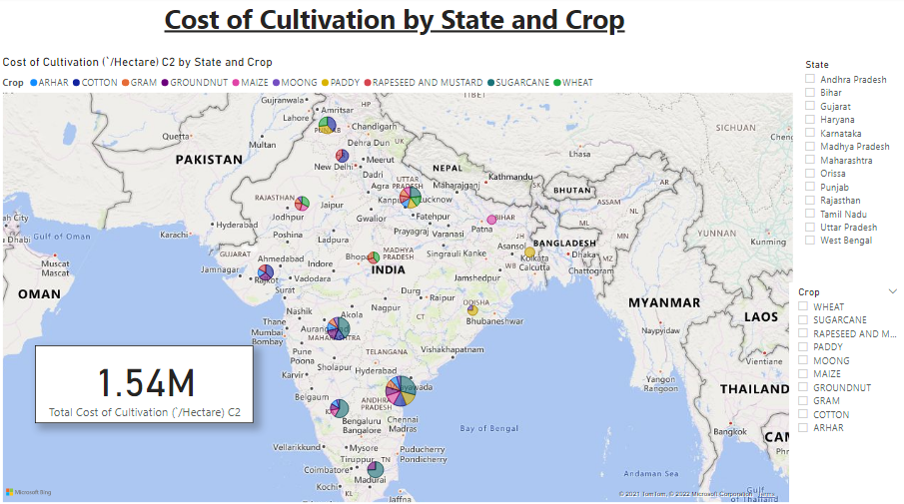

* **Cost of productions as per State**

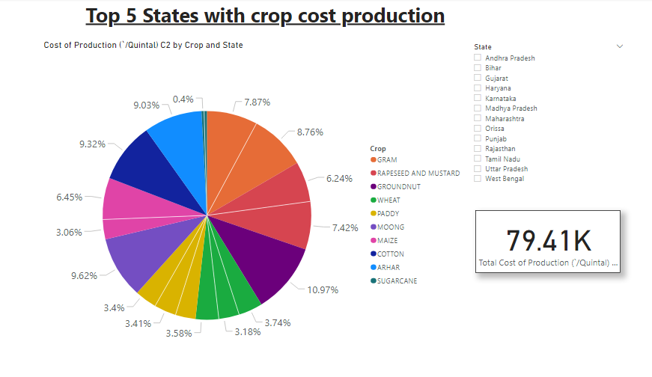

* **Yearly production VS Area.**

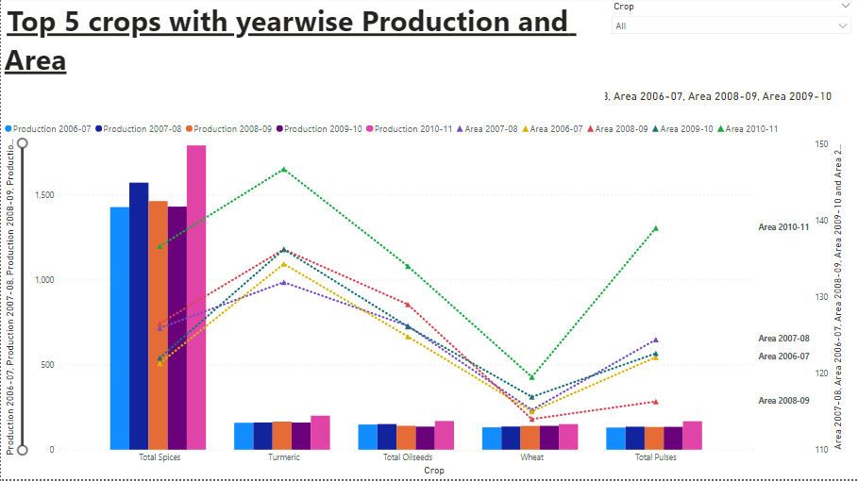

* **Yield vs Area.**

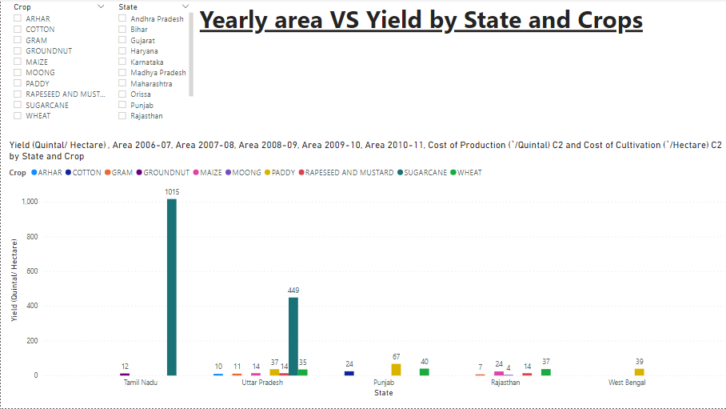

.

* **Yearly value.**

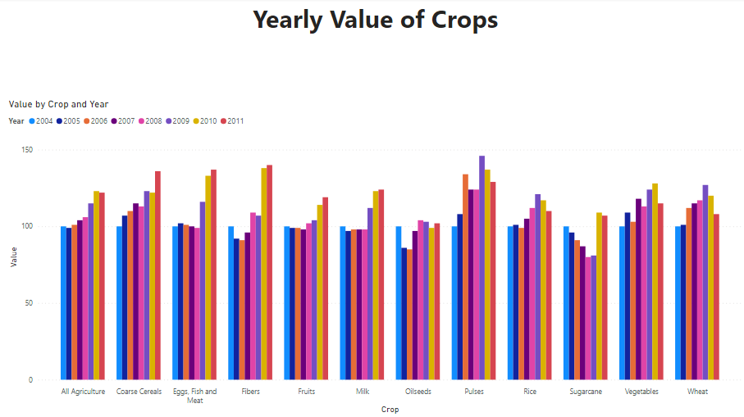

* **Area prod. of Cereals.**

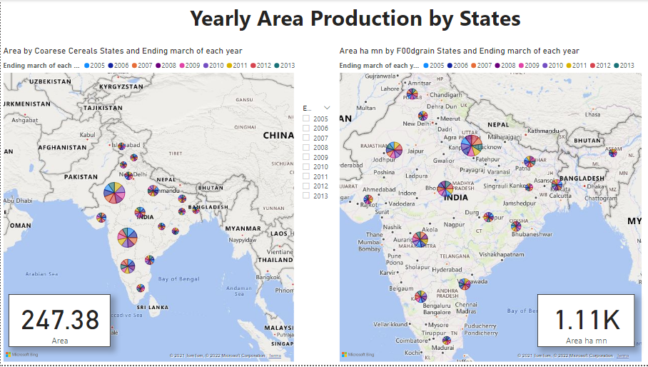

* **Major crops Achieved.**

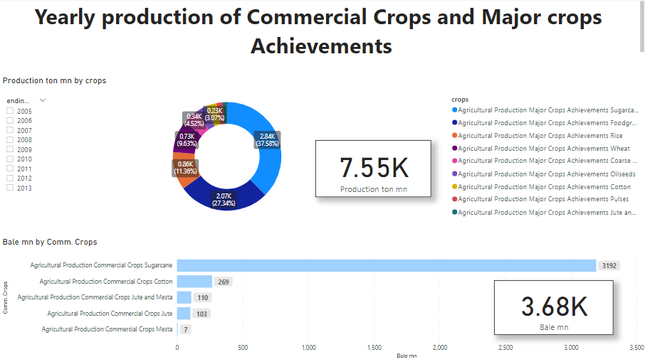

* **Seasonal Production of Foodgrains and Oilseeds.**

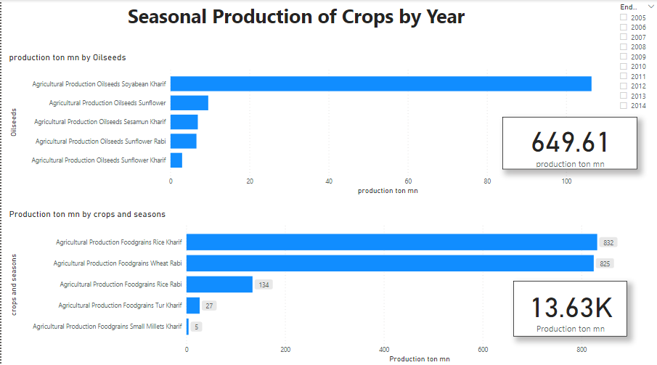

* **Recommendation system.**

