****

**Angular Minds Pvt. Ltd**

# CERTIFICATE

This is to certify that the undersigned have assesses and evaluated the project **Tracking Hours** submitted by **Bhushan Janardan Shirude.** The project report has been accepted for the partial fulfillment of the degree of **MSc(Computer Science)** from Fergusson College pune 2017-2018.

**Place**: Pune

**Date**: 24/ 04 /2018

**Industrial Expert**

**Name : \_\_\_\_\_\_\_\_\_\_\_\_\_\_\_\_\_\_\_\_\_\_\_\_\_\_\_\_\_\_**

**Signature: \_\_\_\_\_\_\_\_\_\_\_\_\_\_\_\_\_\_\_\_\_\_\_\_\_\_\_\_\_\_**

**Examiners Name Signature**

**1.\_\_\_\_\_\_\_\_\_\_\_\_\_\_\_\_\_\_\_\_\_\_\_\_\_\_\_\_\_\_\_\_\_\_ \_\_\_\_\_\_\_\_\_\_\_\_\_\_\_\_\_**

**2.\_\_\_\_\_\_\_\_\_\_\_\_\_\_\_\_\_\_\_\_\_\_\_\_\_\_\_\_\_\_\_\_\_\_ \_\_\_\_\_\_\_\_\_\_\_\_\_\_\_\_\_**

# fergusson3_header_03

Deccan Education Society’s

Fergusson College (Autonomous), Pune

**Department Of Computer Science**

# CERTIFICATE

This is to certify that the project entitled  **Tracking Hours** submitted by **Bhushan Janardan Shirude** in partial fulfillment of the requirement of the completion of M.Sc.(C.S)-II [Semester-IV] has been carried out by them under our guidance satisfactorily during the academic year 2017-2018.

**Place**: Pune

**Date:**24 /04 /2018 **Head of Department**

**Department Of Computer Science**

**Fergusson College, Pune**

**Project Guide:**

**Name : \_\_\_\_\_\_\_\_\_\_\_\_\_\_\_\_\_\_\_\_\_\_\_\_\_\_\_\_\_**

**Signature : \_\_\_\_\_\_\_\_\_\_\_\_\_\_\_\_\_\_\_\_\_\_\_\_\_\_**

**Examiners Name Signature**

**1. \_\_\_\_\_\_\_\_\_\_\_\_\_\_\_\_\_\_\_\_\_\_\_\_\_\_\_ \_\_\_\_\_\_\_\_\_\_\_\_\_\_\_\_\_\_\_\_\_**

**2. \_\_\_\_\_\_\_\_\_\_\_\_\_\_\_\_\_\_\_\_\_\_\_\_\_\_\_** \_\_\_\_\_\_\_\_\_\_\_\_\_\_\_\_\_\_\_\_\_\_

**Preface**

This document gives a brief description of different development activities followed in the course of the project.

**What is this document about?**

This document talks about my contribution to the project during my industrial training period. At the start it contains a brief overview of the Angular Minds, company’s product information. It has brief introduction to **“Web Technologies”**. During my tenure at Angular Minds, I have worked on this project as a part of industrial training program.

**Acknowledgement**

It has been a great honor and privilege to undergo Industrial Training at**Angular Minds Pvt Ltd.** Through this acknowledgement I take opportunity to express my profound gratitude and deep regards to **Sagar Mahajan and Virendra Shivgunde** our guide **AbhijeetBorade and SachinWagh** for their exemplary guidance, monitoring and constant encouragement throughout the Industrial Training **Angular Minds** of this project. The blessing, help and guidance given by them time to time shall carry me a long way in the journey of life on which I am about to embark.

I am obliged to staff members of **Angular Minds Pvt. Ltd** , for the valuable information provided by them in their respective fields. I am grateful for their cooperation during the period of my assignment.

Last but not the least I would like to thank my teachers **Prof. Irfan Khatik** (Project Guide), **Prof. Anjali Naik** (Placement co-coordinator) and all teaching, non-teaching staff of Department of Computer science, Fergusson College Pune .

**Bhushan Janardan Shirude**

**Index**

|  |  |  |
| --- | --- | --- |
| **Sr. No.** | **Title** | **Page No** |
| **1** | **Introduction**   * Company Profile |  |
| **2** | **Problem Definition**   * Introduction * Existing System * Proposed System |  |
| **3** | **System Requirement - Hardware & software** |  |
| **4** | **Software Project Scope** |  |
| **5** | **Analysis and Designs**   * Use Case Diagram * Activity Diagram * Sequence Diagram * Component Diagram * Deployment Diagram |  |
| **6** | **Testing** |  |
| **7** | **Drawbacks and limitations** |  |
| **8** | **Future Enhancement** |  |
| **9** | **Bibliography** |  |

**Introduction**

**Company profile:**

Angular Minds is much broader and agile in terms of kinds of innovative solutions and services we bring to the market. We want our clients to understand that our brand is about client satisfaction that we are passionate about finding efficient and better solutions that help our client connect to their business strategy. So to stay relevant our brand has to be one that's passionate, that's collaborative, that's innovative and most importantly that's confident.

We work closely with our customers, discussing their business goals, expectations of the website, technology and process involved in building the website. Leveraging a development idea to maximum benefit is what we aimed for. Angular Minds is an offshore website design & development company in India offering responsive web design solution and has a team of experts who can design responsive websites even for complex solutions.

**Problem Definition**

**Introduction:**

**Tracking Hours** software typically has two broad parts the graphical user interface that is the front-end and the database that is the back-end. The graphical user interface is for accepting input from the user and displaying output to the user. It is typically coded in Angular JS, HTML, CSS and the JavaScript. I have done the Front end of the project and some part of server side.

Today to track the number of hours, an employee working on a project we do not have any system.

The Main idea of this system is to provide a track of the working hours of the employees within the organization and to maintain the report of the working hours spent on a project.

Tracking ours also generates reports related to a project and the employees working on it and these reports can be generated for a specific time period or a particular day.

These information may be used for payroll, [client billing](http://www.apptivo.com/answers/questions/10623/what-are-the-billing-methods-available-in-projects-app) and increasingly for project costing, estimation, [tracking and management.](http://www.apptivo.com/blog/projects-time-tracking-billing-bundle-quick-start-guide/)

**Existing System**

The application was a mix of spreadsheets, Excel, manual forms, and email. Two files were completed by each employee and archived by the personnel department. The forms contained working hours, holidays and sick time, and overtime for each day of the month, as well as a project log of activities during the month.

Both users and administrators that didn’t have checks and balances in place for the form made errors or did not complete the form, which created inaccuracy when preparing effort estimates and comparing actual costs. This process was painful, time-consuming, and costly. Additionally, the internally-created time tracking solution wasn’t scalable, so it could not fulfill the company’s growing needs.

**Proposed System**

* The proposed system will provide Timesheet.
* [Submit /Resubmit number](http://www.apptivo.com/answers/questions/10558/how-do-i-resubmit-the-timesheet) of working hours for record.
* Add comments on work progress.
* Project based Access control.
* [Track and analyze hours](http://www.apptivo.com/answers/questions/10647/how-can-i-convert-the-project) by developers and project.
* [Create Invoices,](http://www.apptivo.com/answers/questions/10360/what-happens-if-my-timesheet-is-approved) email to clients, etc...,
* [Give administration the access](http://www.apptivo.com/answers/questions/10556/what-is-role-based-access-control)to see the time spent on different projects.

**System Requirements**

**1) Hardware Details:**

* A minimum of 256 MB RAM.
* A Flash with minimum 64 MB.
* Dual cores, at least 850MHz or more.

**2) Software Details:**

* A system running one of the following operating systems:
* Windows 7(32 or 64 bit)
* Windows 8 (32 or 64 bit)
* Windows 10(32 or 64 bit)
* Linux.
* Macintosh.
* Sublime Text.
* Visual Studio Code
* Web Browser.
* Mongo booster.
* Postman.

**2) Technology used:**

* JavaScript.
* HTML.
* CSS.
* Angular JS.
* Node JS.
* Mongo DB.

**Project Scope**

1. **Usage of the Product:**

* **Time Tracking for Marketing, Sales, or Development Teams.**
* **Time Tracking for Project Managers.**
* **Time Tracking for HR/Payroll.**
* **Track of records for the Administration to analyze.**

1. **Functions within the Tracking Hours:**

* Time Track.
* Comments.
* Reports.
* Admin Panel.
* Projects and Client Record.

# Requirement Analysis

If you work with several clients on a variety of projects, then a system with [project portfolio management](http://technologyadvice.com/project-portfolio-management-software/) is important. For project managers, the ability to accurately measure task time and use it to forecast future project estimates is an important feature. Since you work with multiple contractors and consultants, a system that tracks time in myriad ways is essential. Look for an end-to-end project management solution with strong time tracking capabilities, or a standalone time tracking software that integrates with your existing PM systems.

**Feasibility Study**

A feasibility study’s main goal is to access the economic viability of the proposed system. The study should provide a thorough analysis of the business opportunity, including a look at all the possible roadblocks that may stand in the way of the organization’s success.

The outcome of the feasibility study will indicate whether or not to proceed with the proposed venture. If the results of the feasibility study are positive, then the organization can proceed to develop a business plan. If the results show that the project is not a sound business idea, then the project should not be pursued.  Although it is difficult to accept a feasibility study that shows these results, it is much better to find this out sooner rather than later, when more time and money would have been invested and lost.

Feasibility study is an evaluation of a proposal designed to determine the difficult in carrying out a designed task. Generally, a feasibility study precedes technical development and project implementation. The feasibility study provides one with objective information to evaluate existing services and strengths. The major areas to consider while determining the feasibility of a system are:-

* Technical Feasibility
* Operational Feasibility
* Economical Feasibility

It serves for…

1. To estimate rough cost to each possible solution.
2. To develop rough cost of possible benefits and drawbacks.
3. To develop the online of project to be carried out.

**Technical Feasibility**

This area concerns with the internal set-up of the organization.  It is the study of the type of technology the business will need to implement this system and the costs that are involved for the same. Technical Feasibility plays an important role in feasibility study. This study reveals all the technical aspects and its corresponding results.

For the proposed system, this is as follows:

The system will be developed by using open source software and also GUI is developed using Angular JS which make it to run on any platform.

**Operational Feasibility**

This system provide a track of the working hours of the employees within the organization and to maintain the report of the working hours spent on a project and generates reports related to a project and the employees working on it and these reports can be generated for a specific time period or a particular day.So that these information may be used for payroll, [client billing](http://www.apptivo.com/answers/questions/10623/what-are-the-billing-methods-available-in-projects-app) and increasingly for project costing, estimation, [tracking and management.](http://www.apptivo.com/blog/projects-time-tracking-billing-bundle-quick-start-guide/)

**Economical Feasibility**

The proposed system uses most of the open source software and the device contains 256MB of RAM, 64MB of Flash. Therefore, the project is economically feasible.

**UML Diagrams**

1. **Use case diagram**

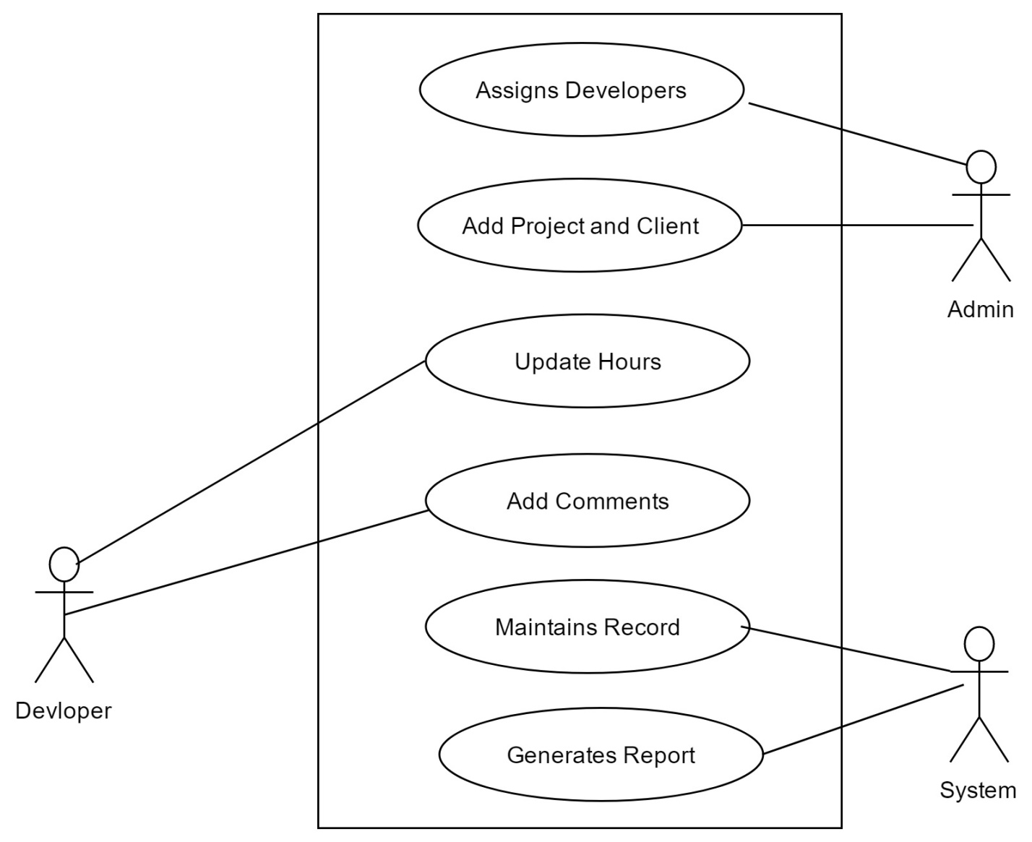

1. **Activity Diagram**

**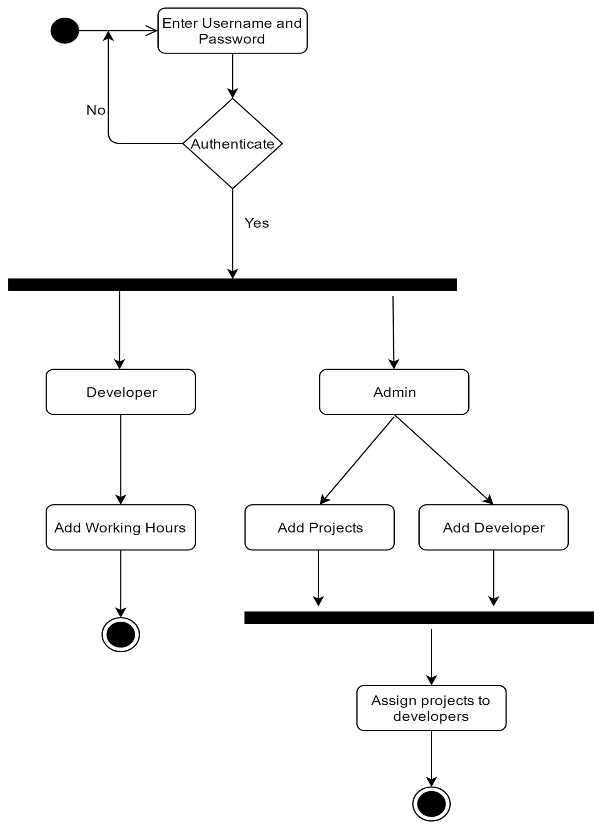**

**3) Sequence Diagram**

**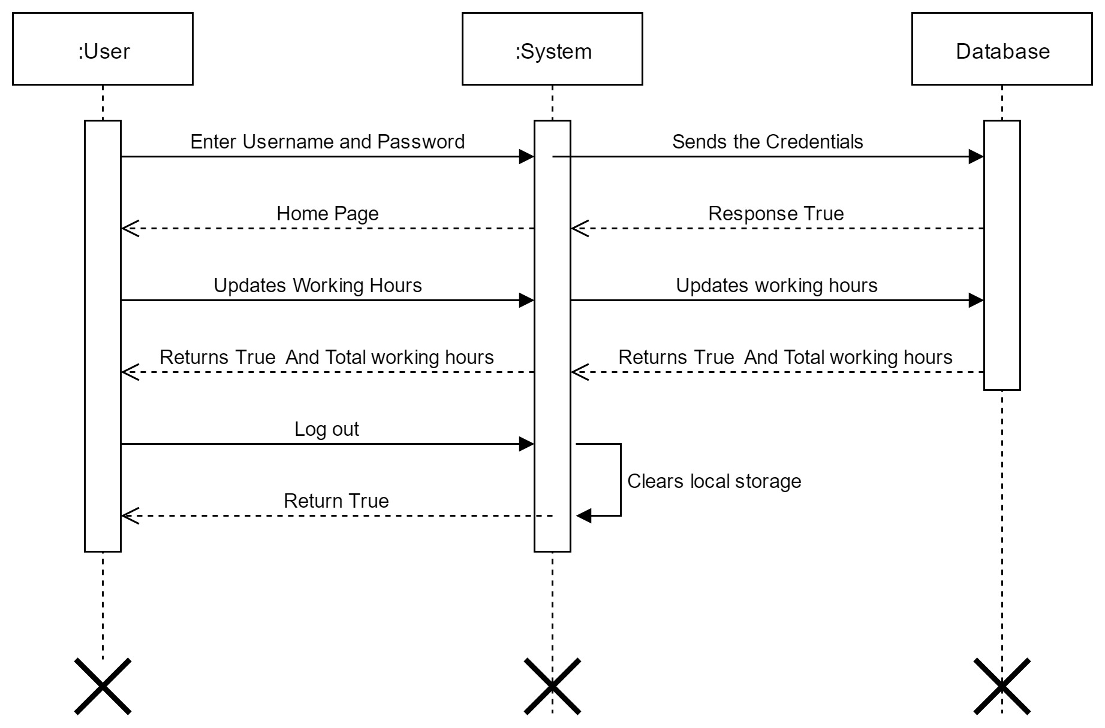**

1. **Component Diagram**

**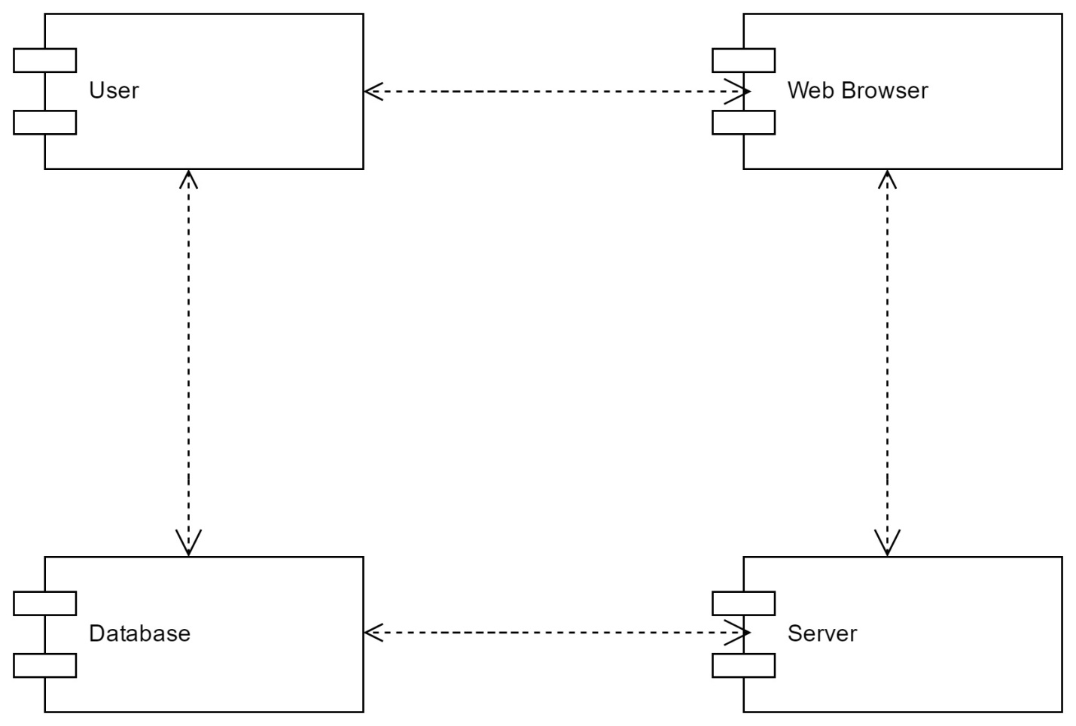**

1. **Deployment Diagram**

**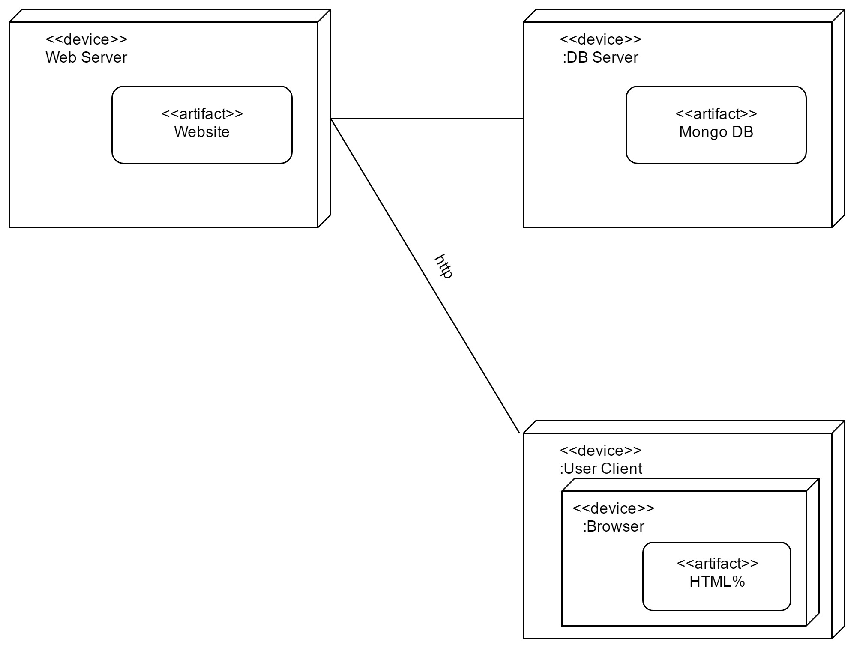**

**Testing**

Software Testing is necessary because we all make mistakes. Some of those mistakes are unimportant, but some of them are expensive or dangerous. We need to check everything and anything we produce because things can always go wrong.

**TYPES OF TESTING PERFORMED**

* **UNIT TESTING :**

Each individual web page is tested, whether they are working correctly or not and giving us the desired output.

* **REGRESSION TESTING:**

We made changes to data and checked whether they are reflected in the reports or not.

* **SYSTEM TESTING:**

The whole framework is tested in order to check all the modules. All functions from creating a requisition to Report generation is tested.

**Drawbacks and limitations of our project**

* We do not keep a work log of task.
* We do not provide approval for maintaining hour details.
* We do not generate bills for the working hours in the system.

**Future Enhancement and Conclusion**

* To keep a work log of task.
* To provide approval for maintaining hour details.
* To generate bills for the working hours in the system.
* To increase the performance of the system.
* To increase the scalability of the system.
* Code optimization.
* Mobile Application for this Project

**Bibliography**

* <https://www.angularminds.com/>
* <https://www.w3schools.com/>
* <https://www.shellscript.sh/>
* <https://docs.angularjs.org/guide/concepts>
* <https://docs.mongodb.com/>
* https://nodejs.org/en/docs/