1. Names of Group 4 members:

* Braden Huttash
* Austin Jensen
* Lee Williamson

2. Theme Description:

* This theme is based off of Japanese rock gardens. It uses greys and browns to represent rocks and sand, with green for foliage.

3. Wireframes:

* **Small:**

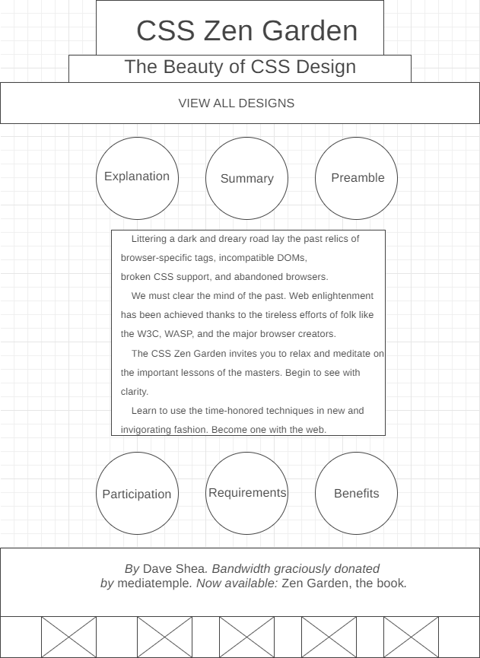

* **Large:**

