CS423 – CSC15003 – Software Testing (AI-augmented · 2026)
HOMEWORK – AI-FIRST EDITION (2026 v1.0)
KCPM-23KTPM2
23127121 – Bùi Hữu Thịnh

HW01 – QA/QC Jobs · 20 Defects · Test a Physical Product

Requirement 1 – QA/QC Job Market 2026+ (40 pts)
- Automation QA Engineer - Nakivo
- Link: https://itviec.com/it-jobs/automation-qa-engineer-qa-qc-tester-automation-test-nakivo-0115
- Screenshot:
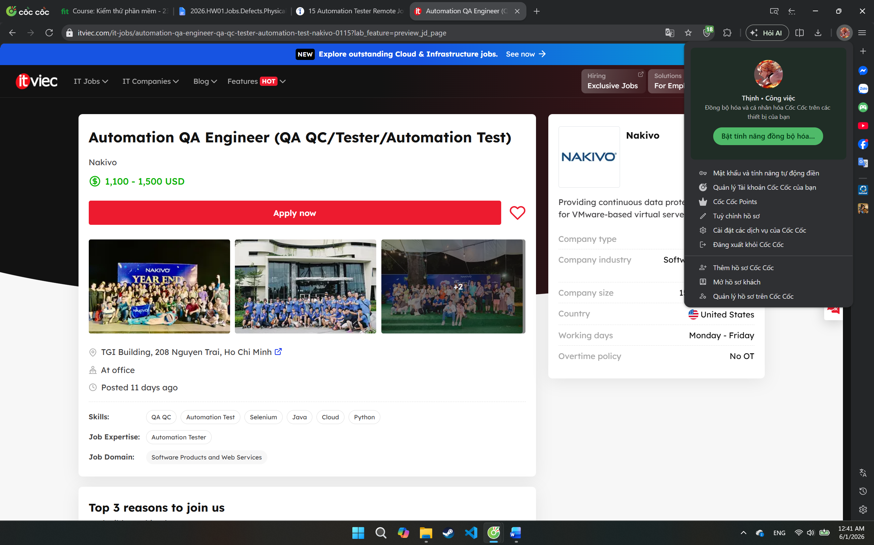
- Job description:
  - Collaborate with software developers and quality assurance teams to understand project requirements and functionality
  - Design, develop, and execute automated test scripts using industry-standard automation tools
  - Identify and report software defects in a clear and concise manner
  - Work closely with cross-functional teams to analyze test results and troubleshoot issues
  - Contribute to the continuous improvement of the automation testing process
  - Design, create, and manage automation test cases using AI technologies
- Required skill:
  - You properly are a potential candidate for this position, if you have:
    - Bachelor degree in Computer Science, Engineering, or related field
    - Strong understanding of software development life cycle and testing
    - Methodologies
    - 3 years of experience or more in relevant positions
    - Proficient in at least one programming language (e.g., Java, Python, C#)
    - Familiarity with automation testing tools such as Selenium, Appium, or similar
    - Basic knowledge of version control systems (e.g., Git)
    - Excellent problem-solving and analytical skills
    - Strong communication and collaboration skills
    - Experience with AI-automation testing (e.g., Copilot, Cursor, Perplexity)
  - You will be a strong candidate if you have
    - Experience in working with test automation frameworks (e.g. JUnit, TestNG,
    - Selenium WebDriver)
    - Understanding of web technologies (HTML, CSS, JavaScript)
    - Knowledge of API testing and tools (e.g., Postman, RestAssured)
    - Experience with performance testing concepts and tools
    - Experience with VMware, Hyper-V, Aws and Cloud storage
    - Hands-on experience working with AI Technologies
- Salary: 1,100 - 1,500 USD
- AI Impact Analysis: This position reflects the growing demand for automation-focused QA engineers who can build and maintain testing frameworks rather than only execute manual test cases. AI tools can assist in generating test scripts, analyzing defects, and improving regression testing efficiency. However, human engineers are still required to design testing strategies, validate business requirements, investigate complex failures, and ensure software quality in real-world scenarios.
- Senior QC – PNJ
- Link: https://itviec.com/it-jobs/senior-qc-automation-tester-qa-qc-pnj-5542
- Screenshot:
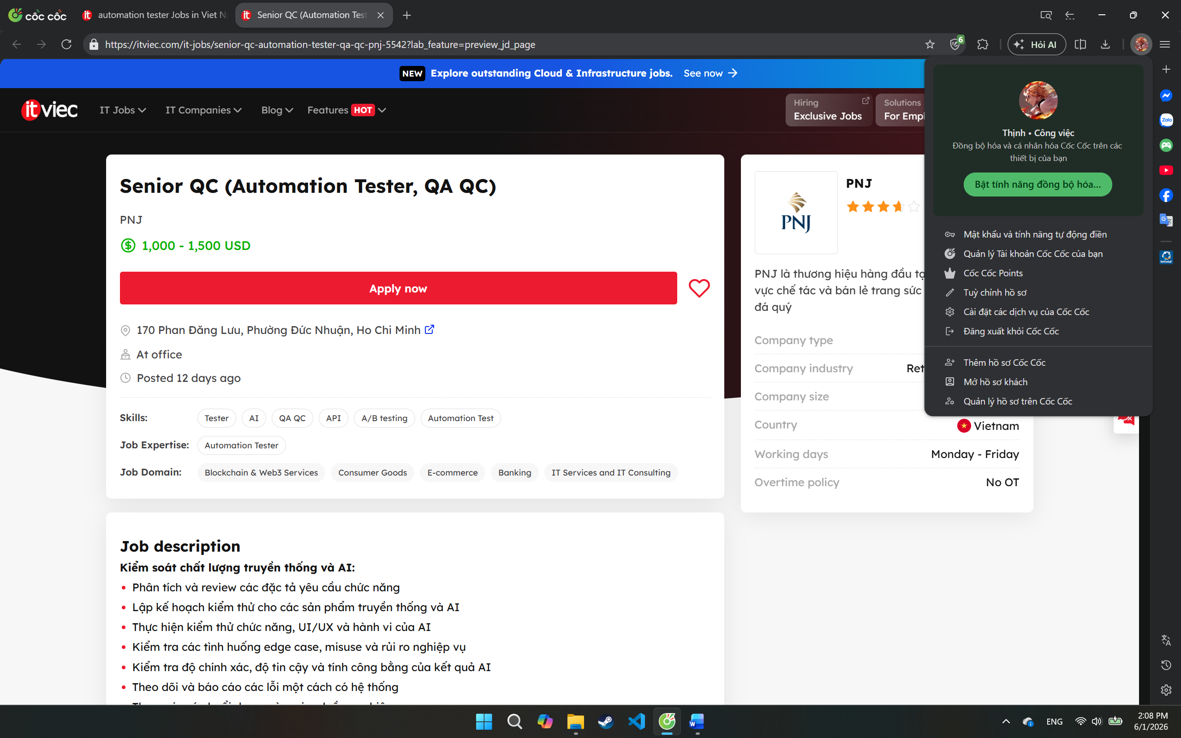
- Job description:
  - Kiểm soát chất lượng truyền thống và AI:
    - Phân tích và review các đặc tả yêu cầu chức năng
    - Lập kế hoạch kiểm thử cho các sản phẩm truyền thống và AI
    - Thực hiện kiểm thử chức năng, UI/UX và hành vi của AI
    - Kiểm tra các tình huống edge case, misuse và rủi ro nghiệp vụ
    - Kiểm tra độ chính xác, độ tin cậy và tính công bằng của kết quả AI
    - Theo dõi và báo cáo các lỗi một cách có hệ thống
    - Tham gia các buổi demo và review luồng nghiệp vụ
  - ​Kiểm thử tự động và công cụ AI:
    - Phát triển các kịch bản kiểm thử tự động
    - Áp dụng các công cụ kiểm thử AI (LLM evaluation, synthetic data)
    - Thiết lập và duy trì hệ thống CI/CD cho kiểm thử
    - Sử dụng công cụ giả lập người dùng để kiểm thử tự động
    - Phát triển các công cụ nội bộ hỗ trợ kiểm thử AI
  - ​Đảm bảo chất lượng dữ liệu cho AI:
    - Kiểm tra tính đầy đủ và chính xác của dữ liệu huấn luyện AI
    - Đánh giá tính đa dạng và cân bằng của dữ liệu
    - Kiểm tra việc xử lý dữ liệu cá nhân và tuân thủ bảo mật
    - Theo dõi hiệu suất mô hình AI theo thời gian
  - Học hỏi và phát triển:
    - Nghiên cứu các xu hướng, công cụ và phương pháp kiểm thử AI mới
    - Chủ động nâng cao tư duy kiểm thử manual + automation, tư duy phân tích rủi ro và tư duy end user
    - Tham gia các khóa học và hoạt động nâng cao kỹ năng
    - Chia sẻ kiến thức với đồng nghiệp
- Required skill:
  - Bằng cấp: Cử Nhân trở lên các chuyên ngành CNTT & Phần mềm
  - Chuyên ngành: Khoa Học Máy Tính, Công Nghệ Thông Tin, hoặc các ngành có liên quan
  - Must-have:
    - Tối thiểu 04 năm kinh nghiệm trong lĩnh vực Software Testing Automation ứng dụng AI trong testing
    - Chủ động, năng động, trách nhiệm cao, kiên định bám mục tiêu
    - Có khả năng xử lý nhiều dự án song song, biết sắp xếp ưu tiên theo tiến độ công việc
    - Có tư duy end-user, cẩn thận trong công việc
    - Giao tiếp tốt, phối hợp hiệu quả với các team liên quan.
    - Có khả năng phân tích các rủi ro hệ thống
  - Should-have:
    - Có chứng chỉ ISTQB, Agile hoặc các chứng chỉ tương đương là điểm cộng.
- Salary: 1,000 - 1,500 USD
- AI Impact Analysis: This position shows how QA roles are evolving from traditional software testing to AI-augmented quality engineering. Besides automation testing, the company requires skills in AI evaluation, fairness testing, LLM validation, and synthetic data testing. AI is changing the responsibilities of QA engineers, but human testers are still necessary for risk analysis, business validation, and edge-case discovery.
- QA Engineer (Manual/ Automation) - Ingenico Vietnam
- Link: https://itviec.com/it-jobs/qa-engineer-manual-automation-upto-3000-ingenico-vietnam-5116
- Screenshot: 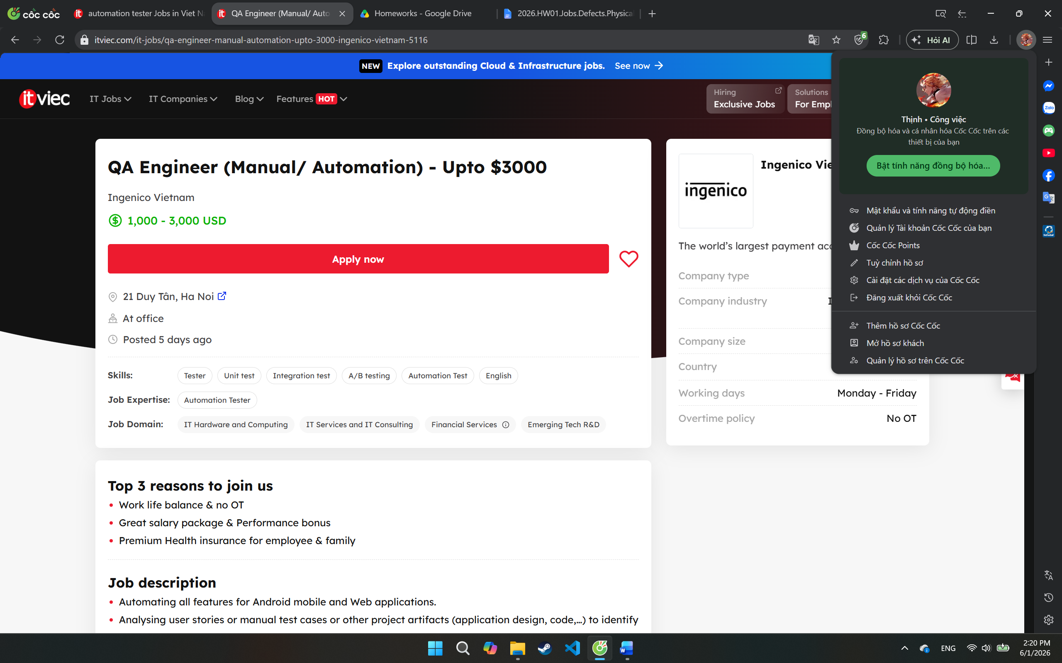
- Job description:
  - Automating all features for Android mobile and Web applications.
  - Analysing user stories or manual test cases or other project artifacts (application design, code,…) to identify areas where automation can be applied.
  - Developing tests cases, test plans, test scripts, test data sets, or test procedures based on business requirements
  - Reporting results of automated tests to development team so that defects can be addressed before production release
  - Developing automation frameworks and reusable code libraries for future automation projects
  - Performing manual testing on applications to identify bugs or defects in functionality
  - Coordinating with the stakeholders (Project Manager/Scrum Master, Manual QA Engineer, Developer team, Business Analyst) to understand targets, software requirements, plan and establish test strategy and test approach for automation team.
  - Using programming language: Python with OOP/OOP design patterns to build the automation framework.
  - Mentoring and supporting other members
  - Working well with other persons in other countries and regions.
- Required skill:
  - At least 5+ years of experience as a Test Manual/ Automation Engineer
  - Great communication in English (verbal and written)
  - Experience in building at least one manual/ automation framework from scratch for WebUI or Mobile UI (Android)
  - Experience in some built-in frameworks: Robot framework, Serenity, Katalon, QuickTestPro, CodeceptJs, Cypress…
  - Experience about some automation libraries: Appium, UI Automator2, Selenium Webdriver.
  - Experience to use automation approaches, such as BDD, TDD, Page Object Model, Project Objects Management (POM), Keyword driven, Data driven, ...
  - Ability to automate manual test cases using Python
  - Excellent knowledge base of OOP and OOP Design patterns
  - Excellent knowledge base of Quality Control & Quality Assurance
  - Familiarity with version control systems (e.g., Bitbucket) and CI/CD pipelines
  - Be able to self-study & investigate technical issues in a certain period of time
- Salary: 1,000 – 3,000 USD
- AI Impact Analysis: This position demonstrates the transition from traditional manual testing toward automation-driven quality engineering. Many repetitive QA activities such as test script generation, regression testing, and defect analysis can now be assisted by AI tools. However, the role still requires human expertise in framework architecture, test strategy design, stakeholder communication, and quality risk assessment, which AI cannot fully replace.
- Software QA Engineer
- Link: https://itviec.com/it-jobs/software-qa-engineer-ai-first-mindset-zen8labs-5907
- Screenshot:
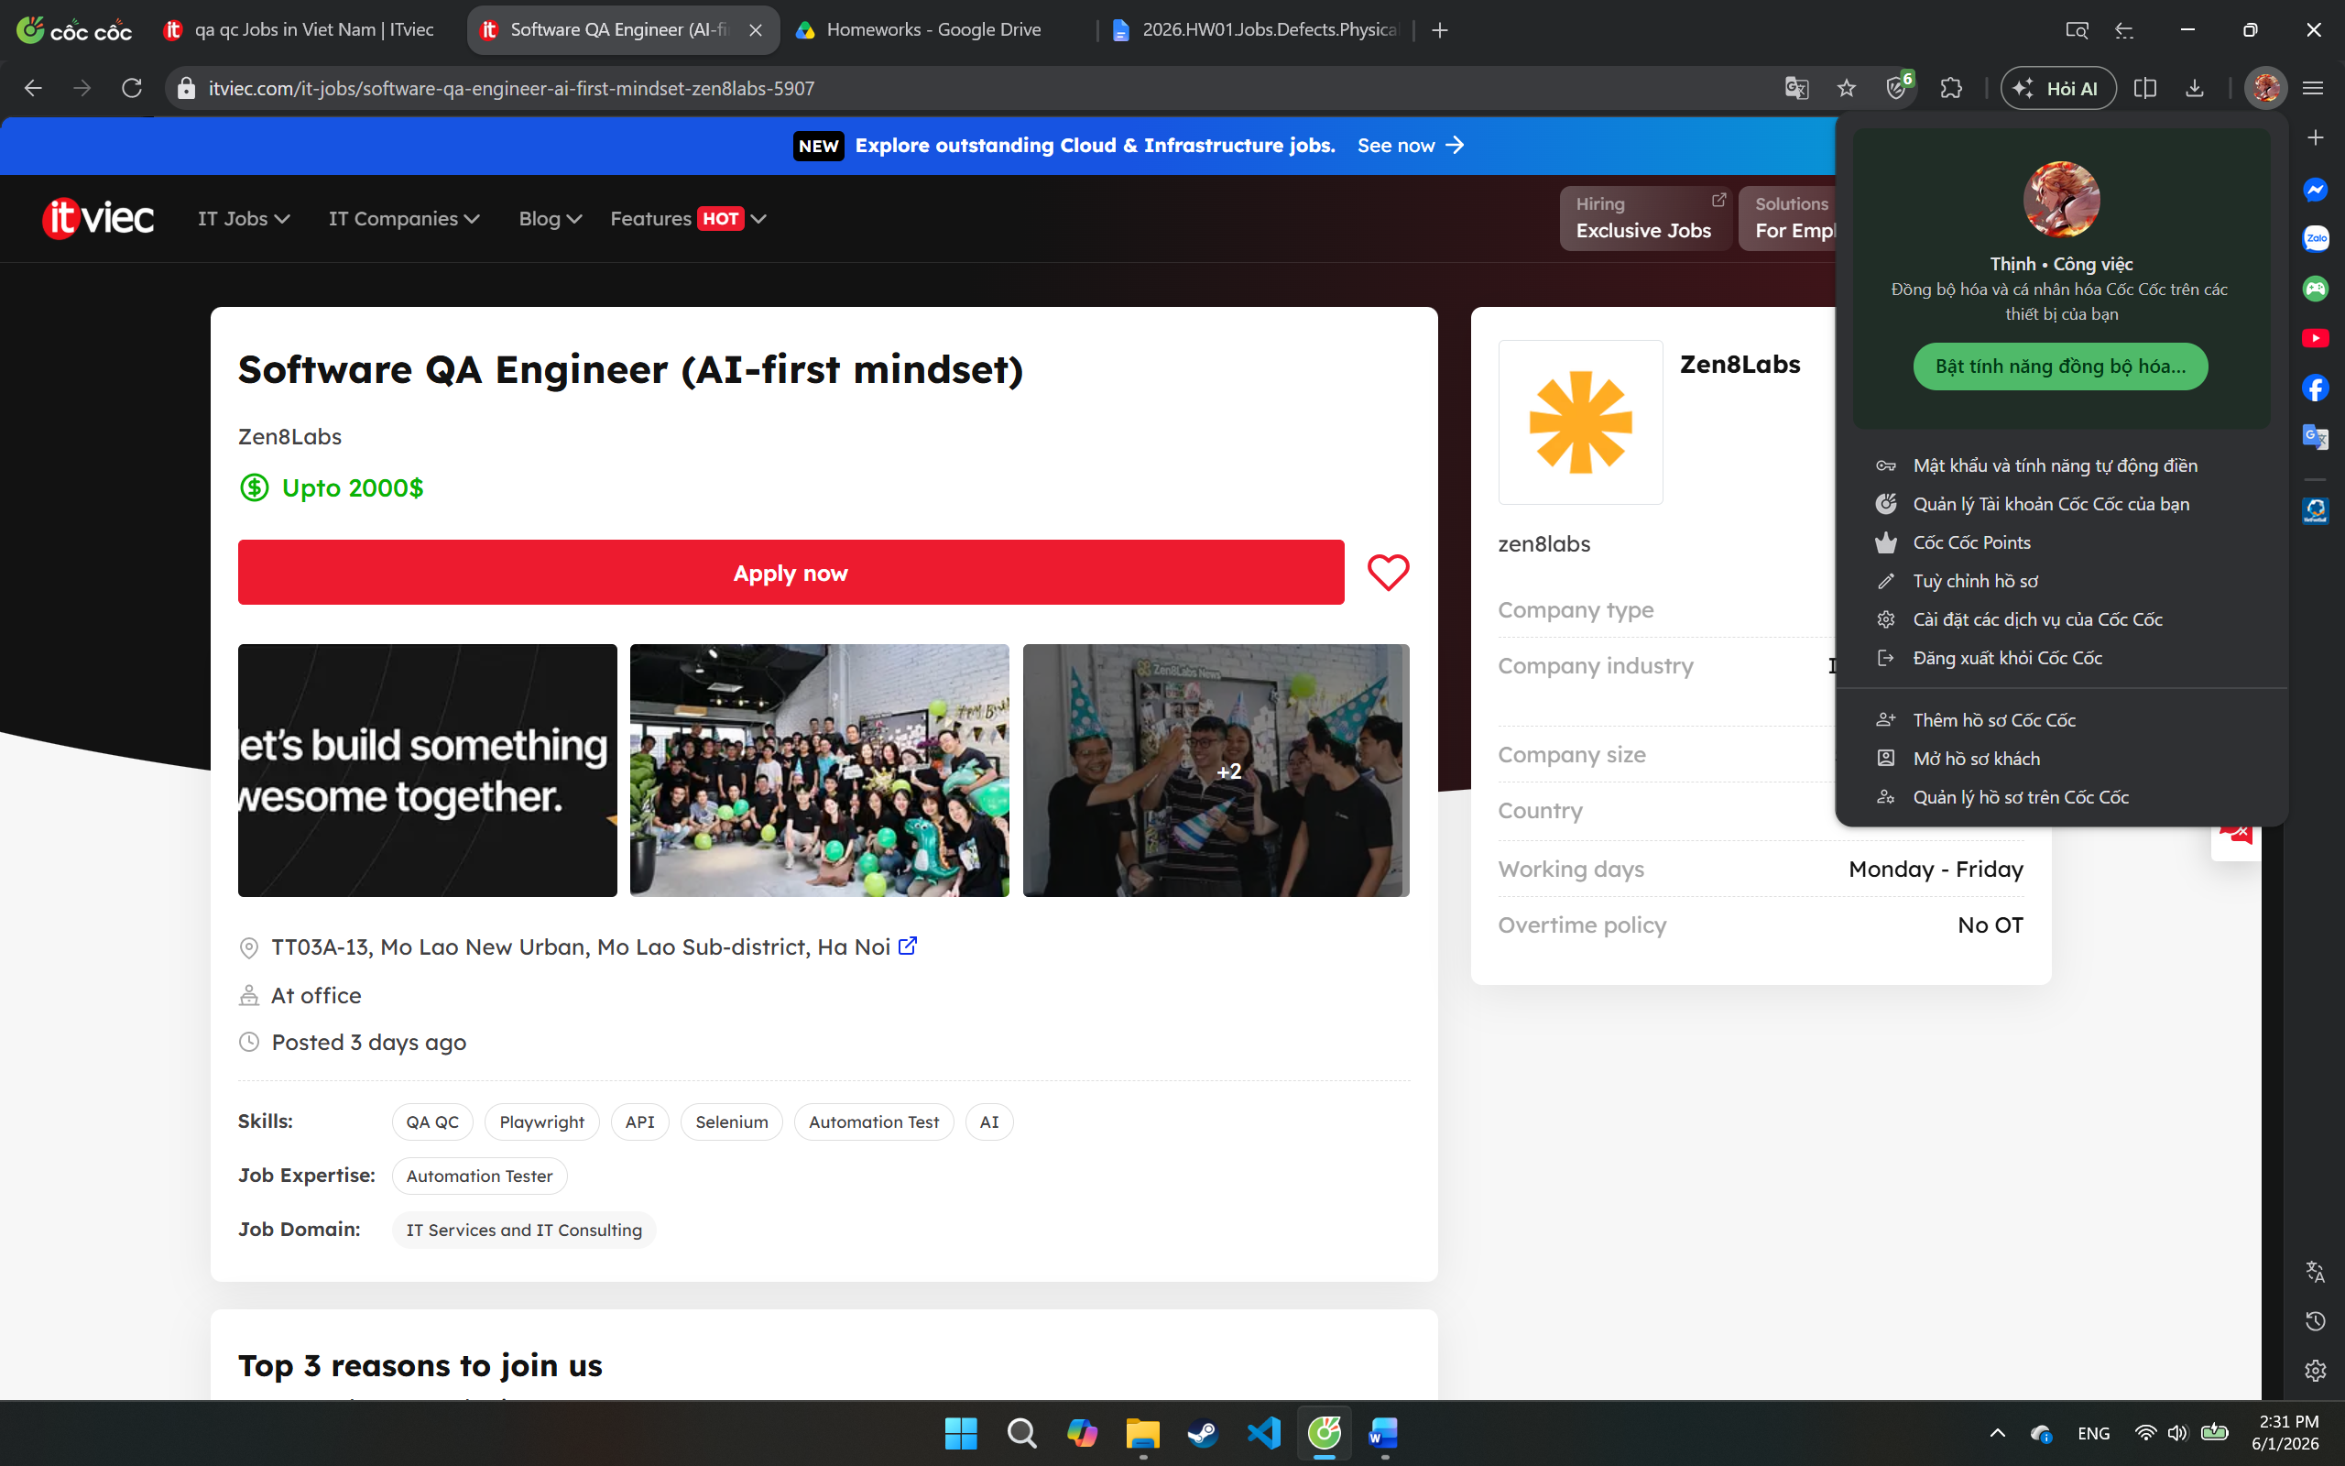
- Job description:
  - We are looking for a QA Engineer with an AI-first mindset who is passionate about ensuring software quality across complex, high-traffic, and highly integrated systems.
  - This role requires a strong hands-on testing mindset with the ability to leverage AI/Agentic AI tools to accelerate test analysis, generate and validate test scenarios, improve automation coverage, and enhance testing efficiency while still applying strong human judgment for complex system validation and exploratory testing, as well as to perform deep manual, exploration, integration, and system-level testing while also contributing to automation initiatives when appropriate.
  - Experience with embedded systems, industrial environments, or hardwareintegrated applications is preferred but not required.
  - Duties and Responsibilities:
    - Perform hands-on manual and exploration testing for complex workflows, integrations, edge cases, and production-like scenarios.
    - Apply AI/Agentic AI tools to assist in generating, validating, maintaining, and optimizing test plans, test cases, and regression suites.
    - Review and validate AI-generated test scenarios, automation scripts, and testing outcomes to ensure accuracy, completeness, and business relevance.
    - Leverage AI-assisted workflows to improve defect analysis, root-cause investigation, and test coverage efficiency.
    - Validate functionality across frontend, backend, APIs, databases, integrations, and system-level components.
    - Collaborate closely with developers, DevOps engineers, product owners, and system engineers to ensure product quality and stability.
    - Investigate defects thoroughly and use both traditional and AI-assisted approaches to identify root causes and quality risks.
    - Develop and maintain automated test scripts/frameworks for regression, smoke, API, and integration testing.
    - Continuously identify repetitive manual testing activities and transform them into scalable automated or AI-assisted testing workflows.
    - Support CI/CD pipelines and integrate automated testing into deployment workflows.
    - Participate in performance, reliability, stress, and scalability testing activities.
    - Evaluate and experiment with emerging AI testing tools, AI agents, and QA productivity solutions to improve engineering efficiency.
    - Monitor testing metrics, defect trends, and release quality indicators using datadriven approaches.
    - Continuously improve QA processes, testing strategies, and AI-driven quality engineering practices
- Required skill:
  - 4+ years of experience in software testing with strong manual testing expertise.
  - Experience testing complex, distributed, or high-traffic applications/systems.
  - Strong understanding of end-to-end testing, integration testing, regression testing, and exploratory testing.
  - Hands-on experience with automation testing tools/frameworks such as Selenium, Playwright, Cypress, Robot Framework, or similar.
  - Ability to write and maintain automation scripts using JavaScript, Java, Python, or similar languages.
  - Experience with API testing and backend validation.
  - Familiarity with Agile/Scrum methodologies and CI/CD environments.
  - Strong interest in applying AI/LLM/Agentic AI tools to improve software testing and QAworkflows.
  - Experience using AI-assisted development/testing tools such as Cursor, Claude, GitHub Copilot, ChatGPT, or similar platforms is highly preferred.
  - Experience with test management and defect tracking tools such as Jira, qTest, Xray, or TestRail.
  - Strong analytical thinking, troubleshooting, and communication skills.
  - Ability to work independently in fast-paced and complex environments
  - Desired qualification:
    - Experience with embedded systems, industrial software, IoT devices, or hardwareintegrated applications.
    - Experience with performance/load testing tools such as JMeter, k6, or Gatling.
    - Familiarity with Linux environments and shell scripting.
    - Experience building automation frameworks from scratch.
    - Knowledge of microservices or event-driven architectures.
    - Experience integrating AI capabilities into QA or engineering workflows.
    - ISTQB certification or equivalent
- Salary: Upto 2000$
- AI Impact Analysis: This position clearly demonstrates the shift from traditional QA toward AI-first quality engineering. The company expects testers to use AI and Agentic AI tools to generate, optimize, and maintain test assets while still relying on human expertise to validate AI-generated outputs. AI can significantly improve testing speed and coverage, but human testers remain essential for exploratory testing, edge-case discovery, business validation, and complex system assessment.
- QA Team Lead – Nakivo
- Link: https://itviec.com/it-jobs/qa-team-lead-nakivo-3715
- Screenshot:
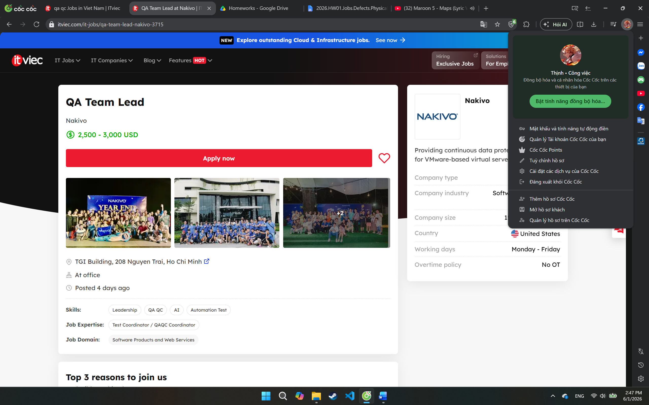
- Job description:
  - Quality Ownership
    - Own release quality for your product/team
    - Define testing scope based on risk, timelines, and business priorities
    - Ensure only production-ready features are released
    - Participate actively in planning, requirement reviews, and release discussions
    - Identify quality risks early and drive mitigation plans
  - Team Leadership
    - Lead and mentor QA engineers across manual and automation testing
    - Create a strong culture of accountability, ownership, and continuous improvement
    - Improve team efficiency and execution quality
  - Testing & Automation
    - Define and improve regression strategies
    - Drive automation for UI, API, and integration testing
    - Improve CI/CD quality workflows and release confidence
    - Optimize test execution time while maintaining meaningful coverage
    - Support exploratory, risk-based, and customer-focused testing approaches
  - Customer & Product Focus
    - Work closely with Product, DEV, and Support teams
    - Analyze production defects and customer feedback to improve test coverage
    - Drive root-cause analysis and defect prevention practices
    - Focus on customer-perceived quality, not only internal QA metrics
  - Process & Continuous Improvement
    - Help establish practical QA processes that teams actually follow
    - Track quality KPIs and testing effectiveness
    - Improve release readiness, test planning, and defect management
    - Introduce AI-assisted QA workflows where they provide real value
- Required skill:
  - Required Qualifications:
    - 6+ years of experience in software testing / quality engineering
    - 3+ years leading QA teams or acting as QA Lead
    - Strong hands-on experience with:
    - Test automation
    - Designing test matrices across multiple OS versions, hardware
    - configurations, and storage targets
    - Regression strategy
    - Experience reviewing requirements and identifying testing risks early
    - Strong troubleshooting and analytical skills
    - Experience mentoring junior and mid-level QA engineers
    - Comfortable working in fast-moving environments with evolving priorities
    - Good communication skills in English
  - Desired Qualifications:
    - Hands-on testing experience with backup/recovery products
    - Experience with cloud platforms, backup/storage products, virtualization, or
    - infrastructure-related software
    - Experience improving release quality and reducing defect leakage
    - Experience using AI tools (ChatGPT, Copilot, Cursor, Claude, etc.) to improve
    - QA workflows
    - Experience building automation frameworks or improving testing architecture
- Salary: 2,500 - 3,000 USD
- AI Impact Analysis: This position shows how QA leadership roles are evolving in the AI era. Besides managing testing processes and automation strategies, the QA Team Lead is expected to integrate AI tools such as ChatGPT, Copilot, Claude, and Cursor into quality workflows. AI can improve productivity, regression testing, and defect analysis, but human leadership remains essential for risk assessment, quality decisions, team management, customer-focused testing, and release governance.
- Senior QA Engineer (Tester/Business Analyst) - soxes AG
- Link: https://itviec.com/it-jobs/senior-qa-engineer-tester-business-analyst-soxes-ag-3239
- Screenshot:
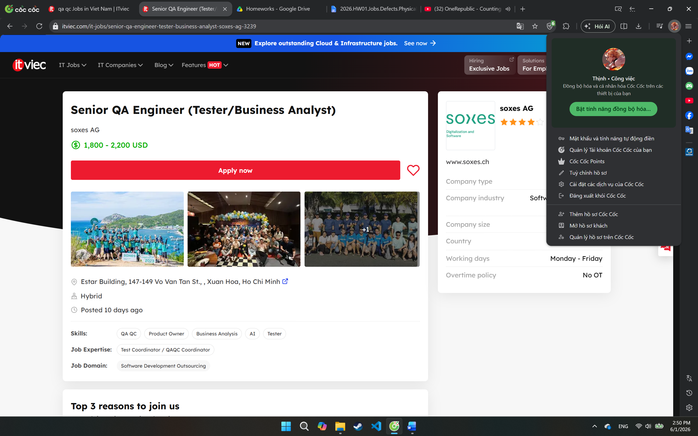
- Job description:
  - Job Overview
    - We are seeking an experienced and detail-oriented Senior Testing Engineer to ensure the quality, stability, and performance of our software products.
    - The ideal candidate should have strong expertise in manual testing and requirement analysis, along with basic hands-on experience using AI-assisted tools to improve testing efficiency and software quality processes.
  - Key Responsibilities
  - Technical Responsibilities
    - Analyze business and system requirements to ensure completeness and testability.
    - Collaborate with Product Owners, Business Analysts, and Developers to clarify requirements and expected behaviors.
    - Design, develop, execute, and maintain test plans, test cases, and testing documentation.
    - Perform functional, regression, integration, system, API, and performance testing.
    - Identify, document, track, and verify software defects.
    - Ensure software quality, reliability, scalability, and security standards are met.
    - Participate in release validation and production verification activities.
    - Utilize AI-assisted tools to improve QA productivity and testing efficiency.
    - Apply AI tools for:
      - Test case generation
      - Defect analysis
      - Test data preparation
      - Documentation support
    - Work with AI-assisted tools such as:
      - ChatGPT
      - GitHub Copilot
      - AI-based testing support tools
    - Provide recommendations for continuous improvement in QA processes and product quality.
- Required skill:
  - Experience & Skills
    - Minimum 5+ years of experience in software testing and quality assurance.
    - Strong experience in manual testing and requirement analysis.
    - Basic knowledge or experience with automation testing is a plus.
    - Experience using AI-assisted tools in software testing or daily work activities is preferred.
  - Familiarity with:
    - RESTful APIs
    - CI/CD pipelines
    - Git version control
    - Cloud platforms
  - Education: Bachelor’s degree in Computer Science, Information Technology, or a related technical field.
  - Language Skills: Strong English communication skills, with the ability to work effectively in an international environment and collaborate directly with overseas partners.
- Salary: 1,800 - 2,200 USD
- AI Impact Analysis: This position demonstrates how QA roles are expanding beyond traditional testing into requirement analysis and business validation. The company expects engineers to use AI-assisted tools to improve testing efficiency and quality processes, but human expertise is still required to understand business requirements, identify ambiguities, validate user expectations, and make quality decisions. AI can support testing activities, yet it cannot fully replace analytical thinking and stakeholder communication.
- Process Quality Assurance – SABITECH
- Link: https://itviec.com/it-jobs/process-quality-assurance-qa-qc-agile-scrum-jira-sabitech-cong-ty-co-phan-cong-nghe-sabi-1415
- Screenshot:
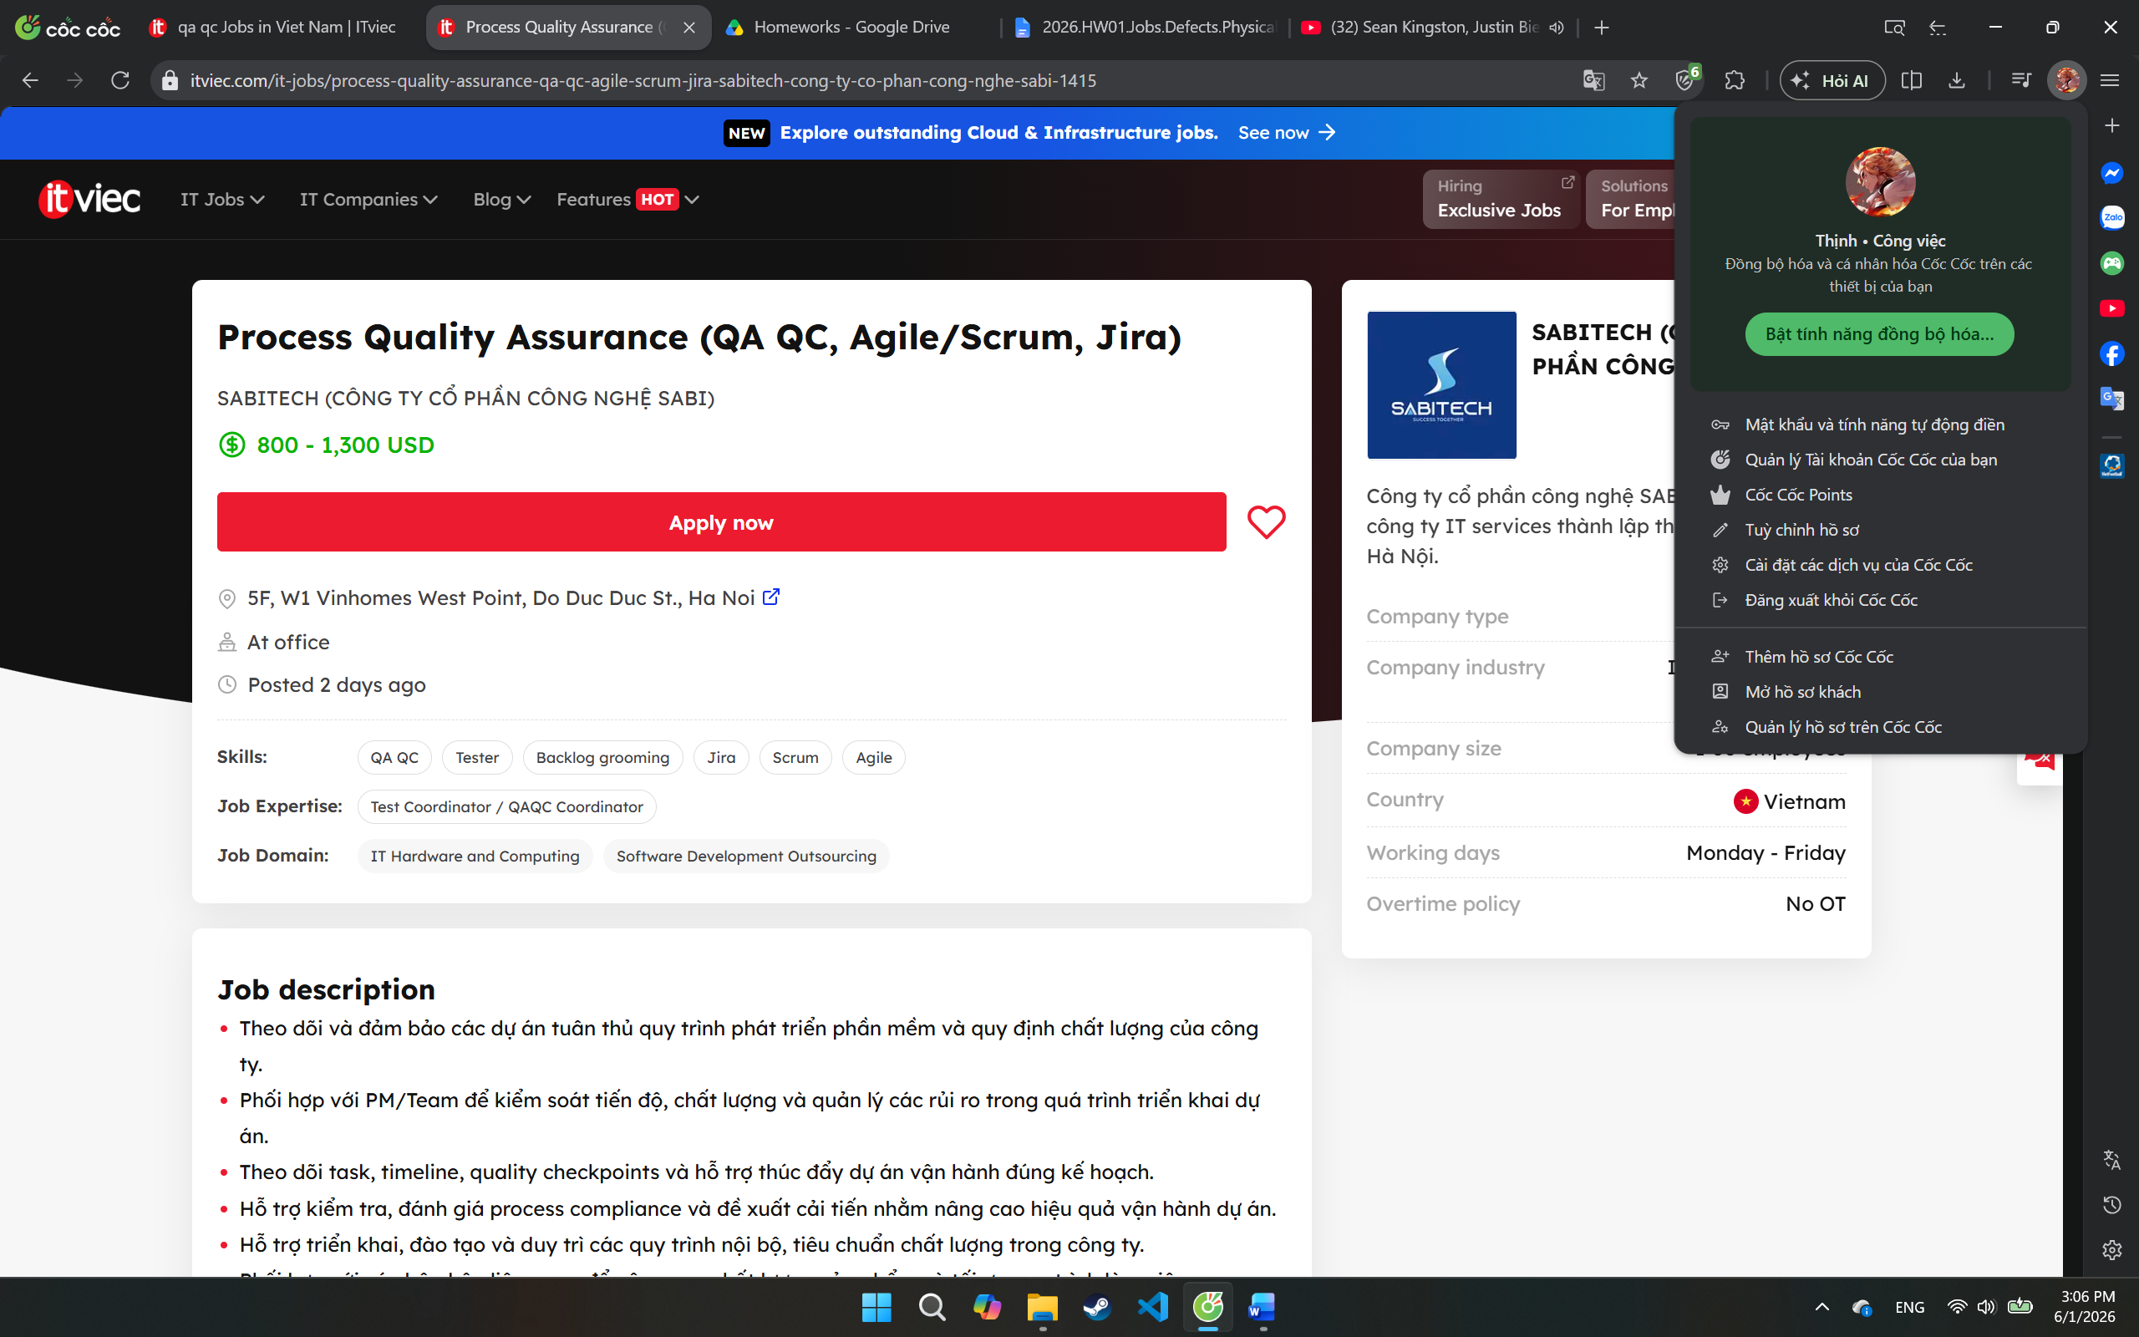
- Job description:
  - Theo dõi và đảm bảo các dự án tuân thủ quy trình phát triển phần mềm và quy định chất lượng của công ty.
  - Phối hợp với PM/Team để kiểm soát tiến độ, chất lượng và quản lý các rủi ro trong quá trình triển khai dự án.
  - Theo dõi task, timeline, quality checkpoints và hỗ trợ thúc đẩy dự án vận hành đúng kế hoạch.
  - Hỗ trợ kiểm tra, đánh giá process compliance và đề xuất cải tiến nhằm nâng cao hiệu quả vận hành dự án.
  - Hỗ trợ triển khai, đào tạo và duy trì các quy trình nội bộ, tiêu chuẩn chất lượng trong công ty.
  - Phối hợp với các bộ phận liên quan để nâng cao chất lượng sản phẩm và tối ưu quy trình làm việc.
- Required skill:
  - Có từ 1 năm kinh nghiệm ở vị trí PQA/QA/Project Coordinator trong công ty công nghệ hoặc IT outsourcing.
  - Hiểu quy trình phát triển phần mềm và mô hình Agile/Scrum.
  - Có kỹ năng theo dõi tiến độ, quản lý công việc, tổng hợp và phân tích dữ liệu báo cáo.
  - Kỹ năng giao tiếp, phối hợp và xử lý công việc tốt.
  - Có khả năng làm việc với nhiều team và phối hợp xử lý vấn đề hiệu quả.
  - Thành thạo Excel/Google Sheet; có kinh nghiệm sử dụng Backlog, Jira, Redmine hoặc các công cụ quản lý dự án là lợi thế.
  - Chủ động, cẩn thận, có tư duy hệ thống và tinh thần cải tiến quy trình.
  - Biết tiếng Nhật hoặc có kinh nghiệm làm việc với thị trường Nhật Bản là lợi thế.
- Salary: 800 - 1,300 USD
- AI Impact Analysis: This position demonstrates how quality assurance is expanding beyond software testing into process governance and Agile quality management. AI can assist in analyzing project metrics, monitoring Jira workflows, detecting process bottlenecks, and generating reports. However, human professionals are still required to evaluate team collaboration, assess process effectiveness, make improvement decisions, and ensure Agile practices are properly applied in real project environments.
- QC Engineer (Tester/QA QC) for Web - Evolus/PlanV
- Link: https://itviec.com/it-jobs/qc-engineer-tester-qa-qc-for-web-up-to-1500-evolus-planv-5225
- Screenshot:
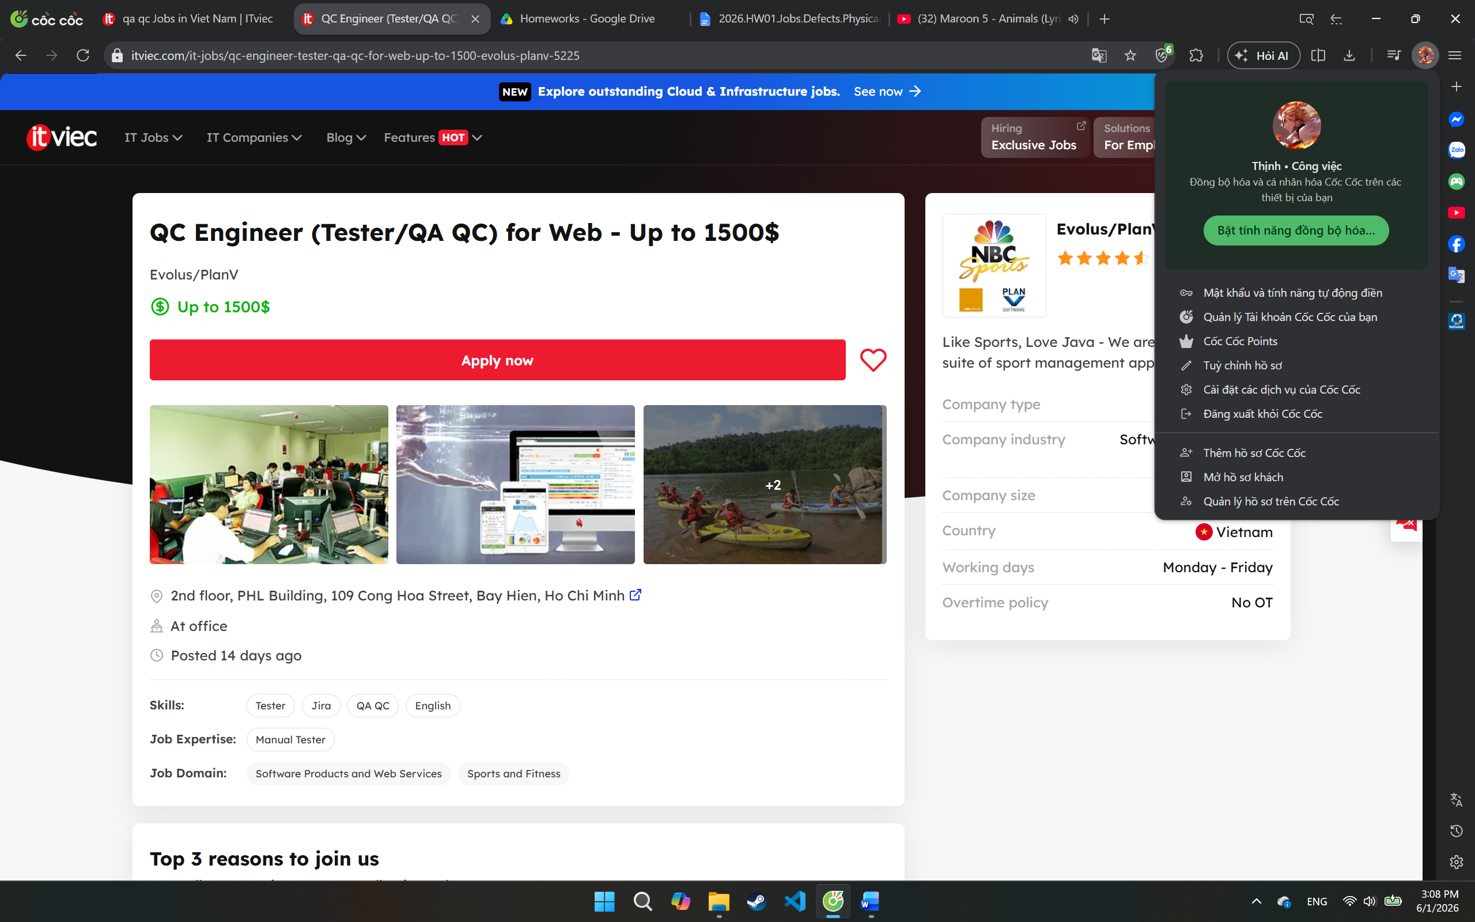
- Job description:
  - Participate in the development of exciting new server and client applications for sports team management that already have millions of users in the USA, UK and the EC. Work closely with top athletes and coaches from NBC Sports to create the next generation of applications to make sports teams perform far better. While NBC will help you better understand the details of competitive sports, our highly experienced engineering team will help you significantly improve your ability to develop world class enterprise applications. Your job will be to "own" a piece of the application, the size will depend on your experience. You will work closely with our USA based customer, our UI design, our senior technical team, QA, and the deployment team to do your job. We work at "Start-up Company" speed and you will learn and grow your skills very quickly.
- Required skill:
  - Technical requirements:
    - Firm knowledge in writing and executing test cases and test scripts
    - Minimum 2 years of experience in manual testing for enterprise web-based system
    - Good knowledge in Software Testing process, testing activities, testing types.
    - Experience in analyzing requirements, developing and executing test cases.
    - Strong problem-solving and analytical skills, with the ability to identify defects
    - Working with Issue Tracking Systems, such as JIRA is required
    - Strong English reading and writing skills
    - Cross-browser, cross-platform and responsive web testing experience is a plus
    - Performance or security testing is a plus
    - Having experience working with e-commerce systems is an advantage.
  - Behavioral requirements:
    - Carefulness and logic thinking
    - Able to work under pressure, hardworking, proactive, and responsible
    - Good communication and teamwork skills
    - Enjoy working in a fast paced team environment
    - Enjoy learning new technological approaches, and quickly applying these to your work
    - Love to exceed customer expectations
    - Self-motivated and self directed.
- Salary: Up to 1500$
- AI Impact Analysis: This position represents a traditional web quality assurance role focused on manual testing, requirement validation, and user experience verification. AI can assist with generating test cases, preparing documentation, and identifying common defects, but human testers remain essential for evaluating usability, understanding business requirements, validating user workflows, and discovering unexpected edge cases. Human judgment is still critical for ensuring software quality from an end-user perspective.
- Automation Tester (QA QC) – ABBANK
- Link: https://itviec.com/it-jobs/automation-tester-qa-qc-abbank-0039
- Screenshot:
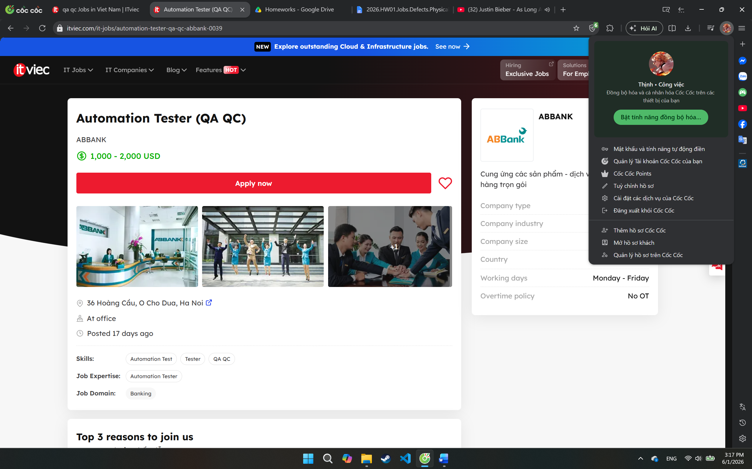
- Job description:
  - Xây dựng dụng cụ cho automation test và viết script cho các api/rest và application test.
  - Định nghĩa, phát triển, triển khai và duy trì script cho automation test
  - Quản lý phiên bản (source control) cho automation test script
  - Tham gia các cuộc họp về yêu cầu dự án để hiểu mục đích của dự án. Đóng góp thông tin về tính khả thi của dự án trên phương diện testing. Ước lượng thời gian testing cho dự án
  - Đưa ra phương án testing, phát triển các chiến lược automation test và các framework cho automation test…
  - Thiết kế test case và viết automation scripts.
  - Phối hợp với các thành viên khác trong nhóm để hiểu về mục tiêu của dự án, thu thập các yêu cầu liên quan đến automation, thiết kế automated test và giải quyết các vấn đề liên quan đến testing.
  - Phối hợp với nhóm Manual testing để đảm bảo phạm vi kiểm tra toàn diện.
  - Tham gia thực hiện Manual test khi cần thiết.
  - Luôn cập nhật các xu hướng và tiến bộ của ngành về các công cụ và kỹ thuật về automation testing.
- Required skill:
  - Trình độ Cử nhân trở lên chuyên ngành về Công nghệ thông tin, Khoa học máy tính hoặc các chuyên ngành liên quan.
  - Có trên 02 năm kinh nghiệm trong automation testing cho api/rest hoặc mobile hoặc web
  - Ưu tiên ứng viên có kinh nghiệm làm việc với Agile/Scrum
  - Thông thạo trong việc viết automation test script với các ngôn ngữ như Java, C#.net, Python, Javascript, etc..
  - Am hiểu về các giai đoạn trong việc kiểm thử phần mềm như: kiểm thử tính năng, kiểm thử tích hợp, kiểm thử tự động, kiểm thử white-box/black box, và kiểm thử load/performance;
  - Kinh nghiệm sử dụng các bộ công cụ, framework như Katalon, Postman, Rest Assured, SoapUI, Selenium Webdriver, Mobile automation test, Jmeter, Jenkins, etc là một lợi thế;
  - Kinh nghiệm quản lý phiên bản (version control) (như Git) và CI/CD
  - Đào tạo, mentoring/ coaching các nhân viên trong team và dự án về các quy trình test driven development, automation testing liên quan đến SIT, UAT, Compliance Test, Performance test etc.
  - Cẩn thận, tỉ mỉ, cần cù, nhanh nhẹn, có khả năng làm việc độc lập hoặc nhóm với cường độ cao.
  - Tinh thần không ngại thay đổi tool/ framework/ ngôn ngữ
- Salary: 1,000 - 2,000 USD
- AI Impact Analysis: This position reflects the increasing demand for automation-focused QA engineers in the banking industry. AI tools can assist with generating automation scripts, creating test data, and analyzing defects, helping improve testing efficiency and coverage. However, human testers are still required to design testing strategies, validate banking requirements, evaluate business risks, and ensure the reliability of critical financial systems.
- Chuyên Viên QC Phần Mềm (QC Executive) – Kingfoodmart
- Link: https://itviec.com/it-jobs/chuyen-vien-qc-phan-mem-qc-executive-kingfoodmart-0249
- Screenshot:
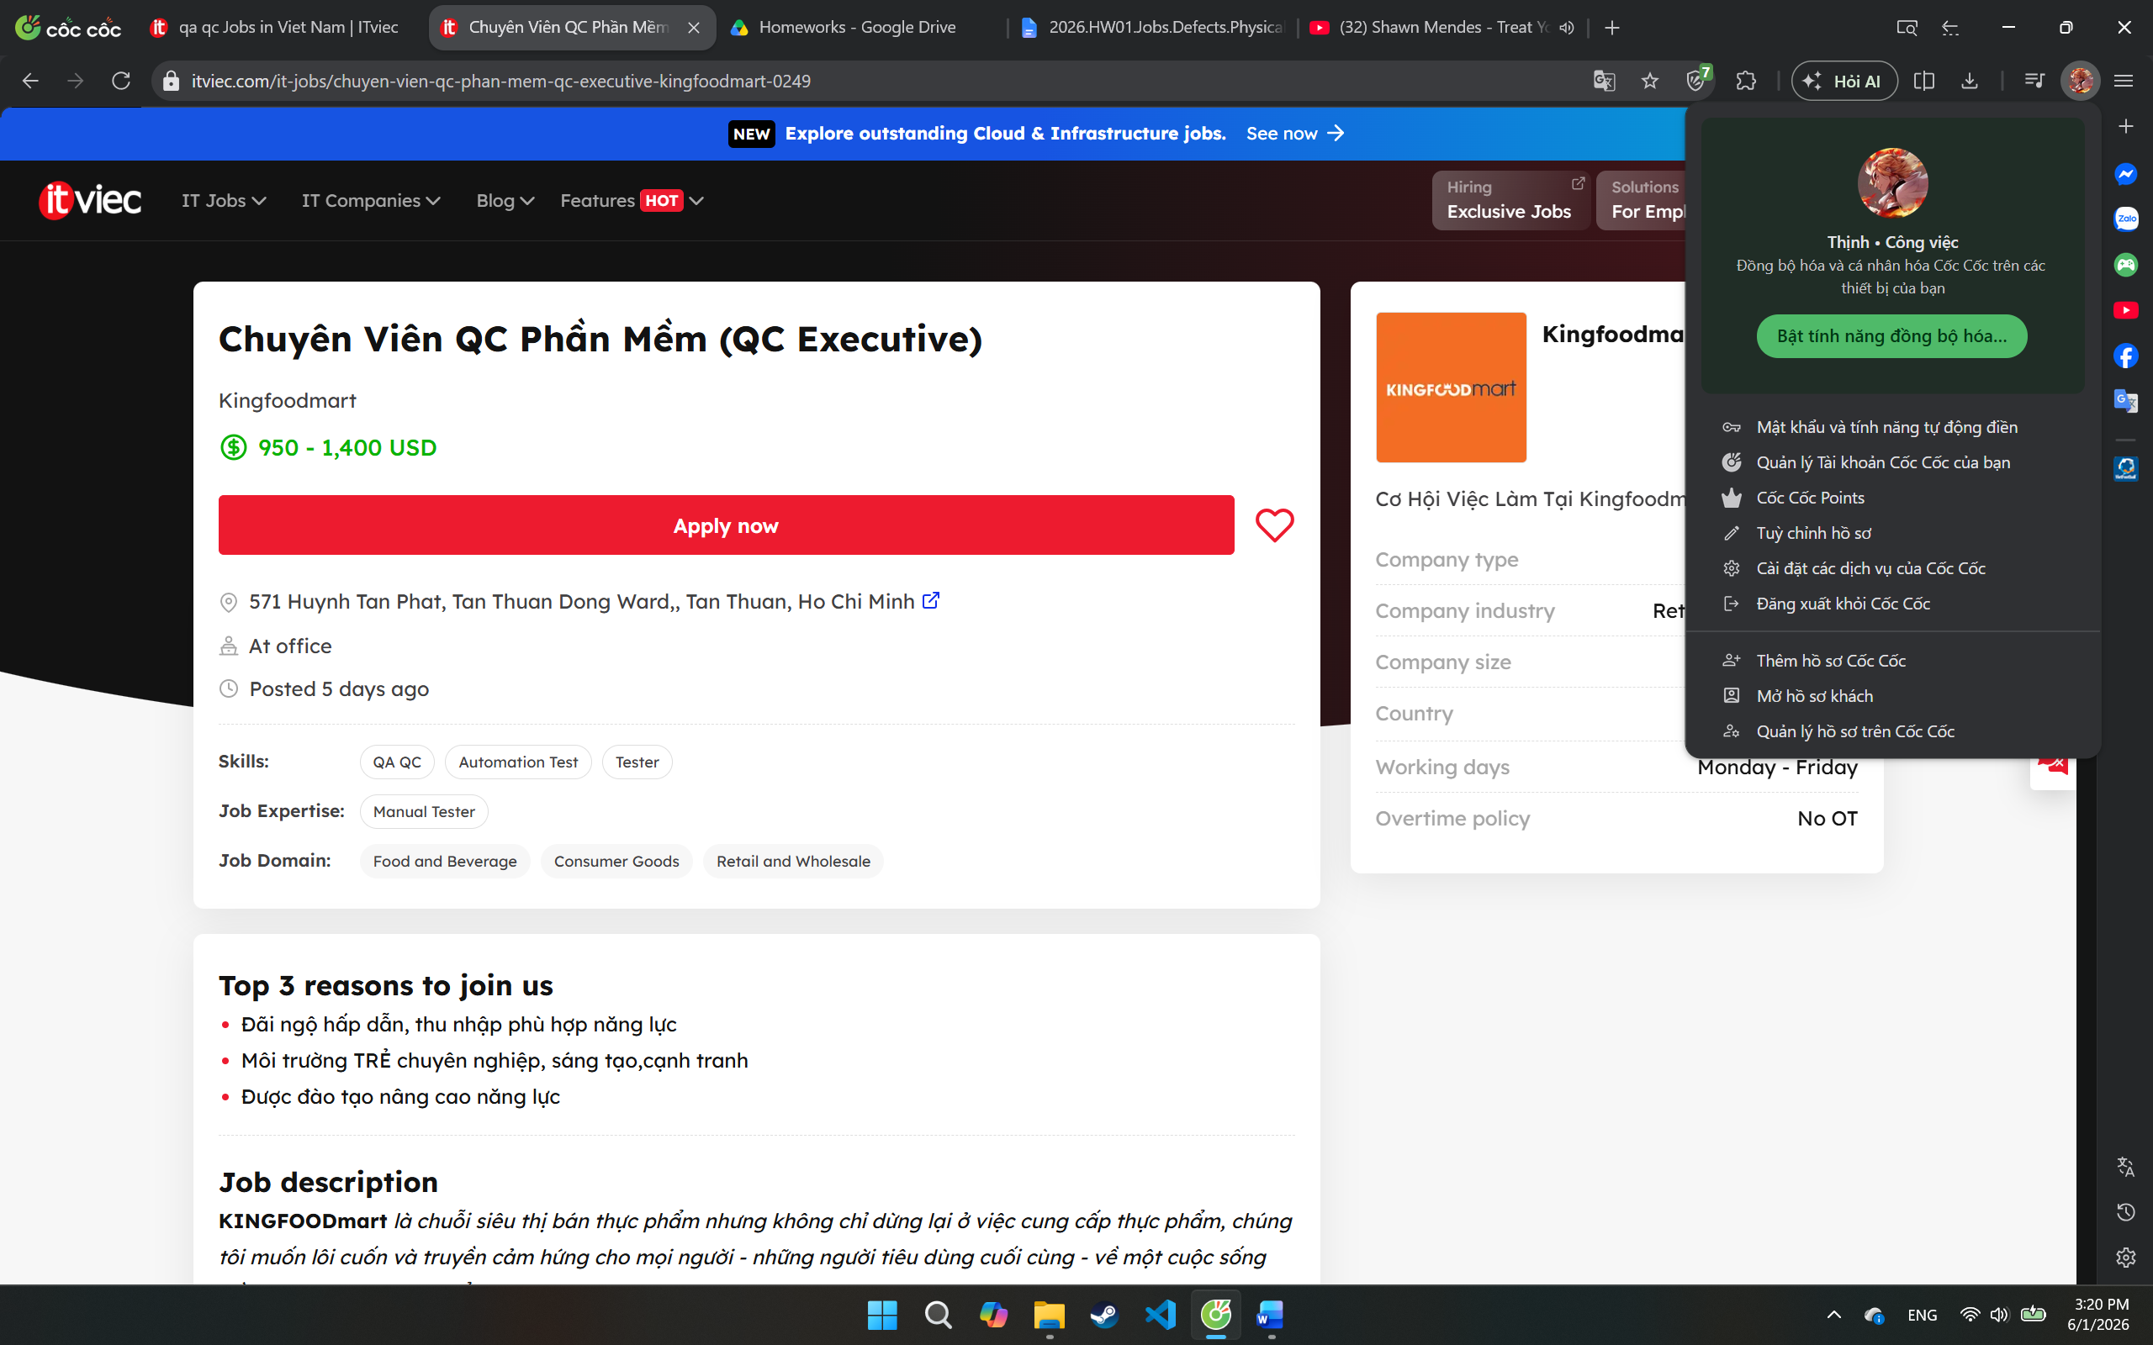
- Job description:
  - KINGFOODmart là chuỗi siêu thị bán thực phẩm nhưng không chỉ dừng lại ở việc cung cấp thực phẩm, chúng tôi muốn lôi cuốn và truyền cảm hứng cho mọi người - những người tiêu dùng cuối cùng - về một cuộc sống đầy sự thú vị thông qua ẩm thực. Chúng tôi hân hoan đón chào bạn gia nhập vào đội ngũ, với vai trò QC Executive
  - MÔ TẢ CÔNG VIỆC:
    - Lập kế hoạch kiểm tra, chuẩn bị test case chi tiết và tiến hành kiểm thử phần mềm đã được phát triển
    - Thực hiện kiểm tra, log lỗi và theo dõi tiến độ fix bug của team phát triển
    - Quản lý, giám sát và theo dõi vòng đời các vấn đề lỗi có thể phát sinh trong hệ thống
    - Kiểm soát chất lượng đảm bảo hệ thống/sản phẩm được tạo đúng như thiết kế đã thống nhất
    - Phối hợp chặt chẽ nhóm kỹ thuật (backend, web & mobile) để đảm bảo chất lượng sản phẩm đồng đều
    - Phối hợp với nhóm phát triển sản phẩm (product design) để hoàn thiện các tài liệu yêu cầu phát triển chi tiết
    - Chủ động hoàn thành công việc được giao với mức độ giám sát tối thiểu
- Required skill:
  - Có kinh nghiệm thực tế trong việc kiểm thử các hệ thống ERP (hoặc các hệ thống quản trị doanh nghiệp phức tạp tương đương).
  - Kỹ năng phân tích logic tốt, có khả năng dự đoán các tình huống, kịch bản (Edge cases) có thể gây lỗi hệ thống.
  - Nắm vững các kiến thức, quy trình và kỹ thuật kiểm thử phần mềm (Functional, Regression, Integration, API Testing,...).
  - Biết sử dụng các công cụ AI tối ưu hóa việc viết test case, tạo dữ liệu mẫu (mock data) hoặc hỗ trợ viết script test.
  - Kỹ năng viết bug, rõ ràng, lắng nghe và truyền đạt thông tin hiệu quả giữa các bên (Dev, Product, QA).
  - Chủ động cập nhật các xu hướng công nghệ, công cụ và quy trình kiểm thử mới để nâng cao hiệu suất công việc.
  - Có kinh nghiệm hoặc khả năng viết kịch bản kiểm thử tự động (Automation Test) sử dụng TypeScript với các công cụ Playwright (cho Web) và Appium (cho Mobile) là một lợi thế lớn.
  - Kỹ năng học hỏi nhanh và chủ động cập nhật các xu hướng công nghệ.
- Salary: 950 - 1,400 USD
- AI Impact Analysis: This position demonstrates how AI is becoming part of daily QA activities rather than a separate specialization. The company expects testers to use AI tools for generating test cases, mock data, and testing scripts to improve productivity. However, human testers remain essential for ERP validation, business workflow verification, edge-case discovery, and quality assessment of complex enterprise systems. AI can support testing efficiency, but it cannot fully replace analytical thinking and domain understanding.
QA/QC Role Mindmap Analysis (G9.1)
Prompt: Create a mindmap of QA/QC career roles in 2026 including AI-related positions.
Output:
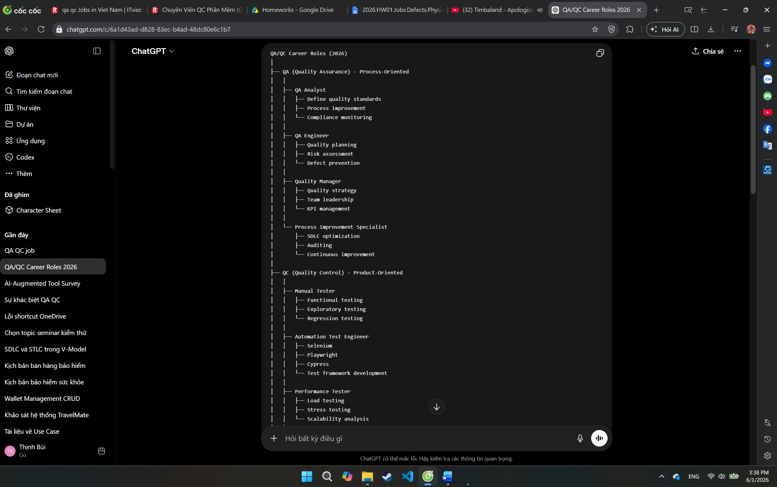
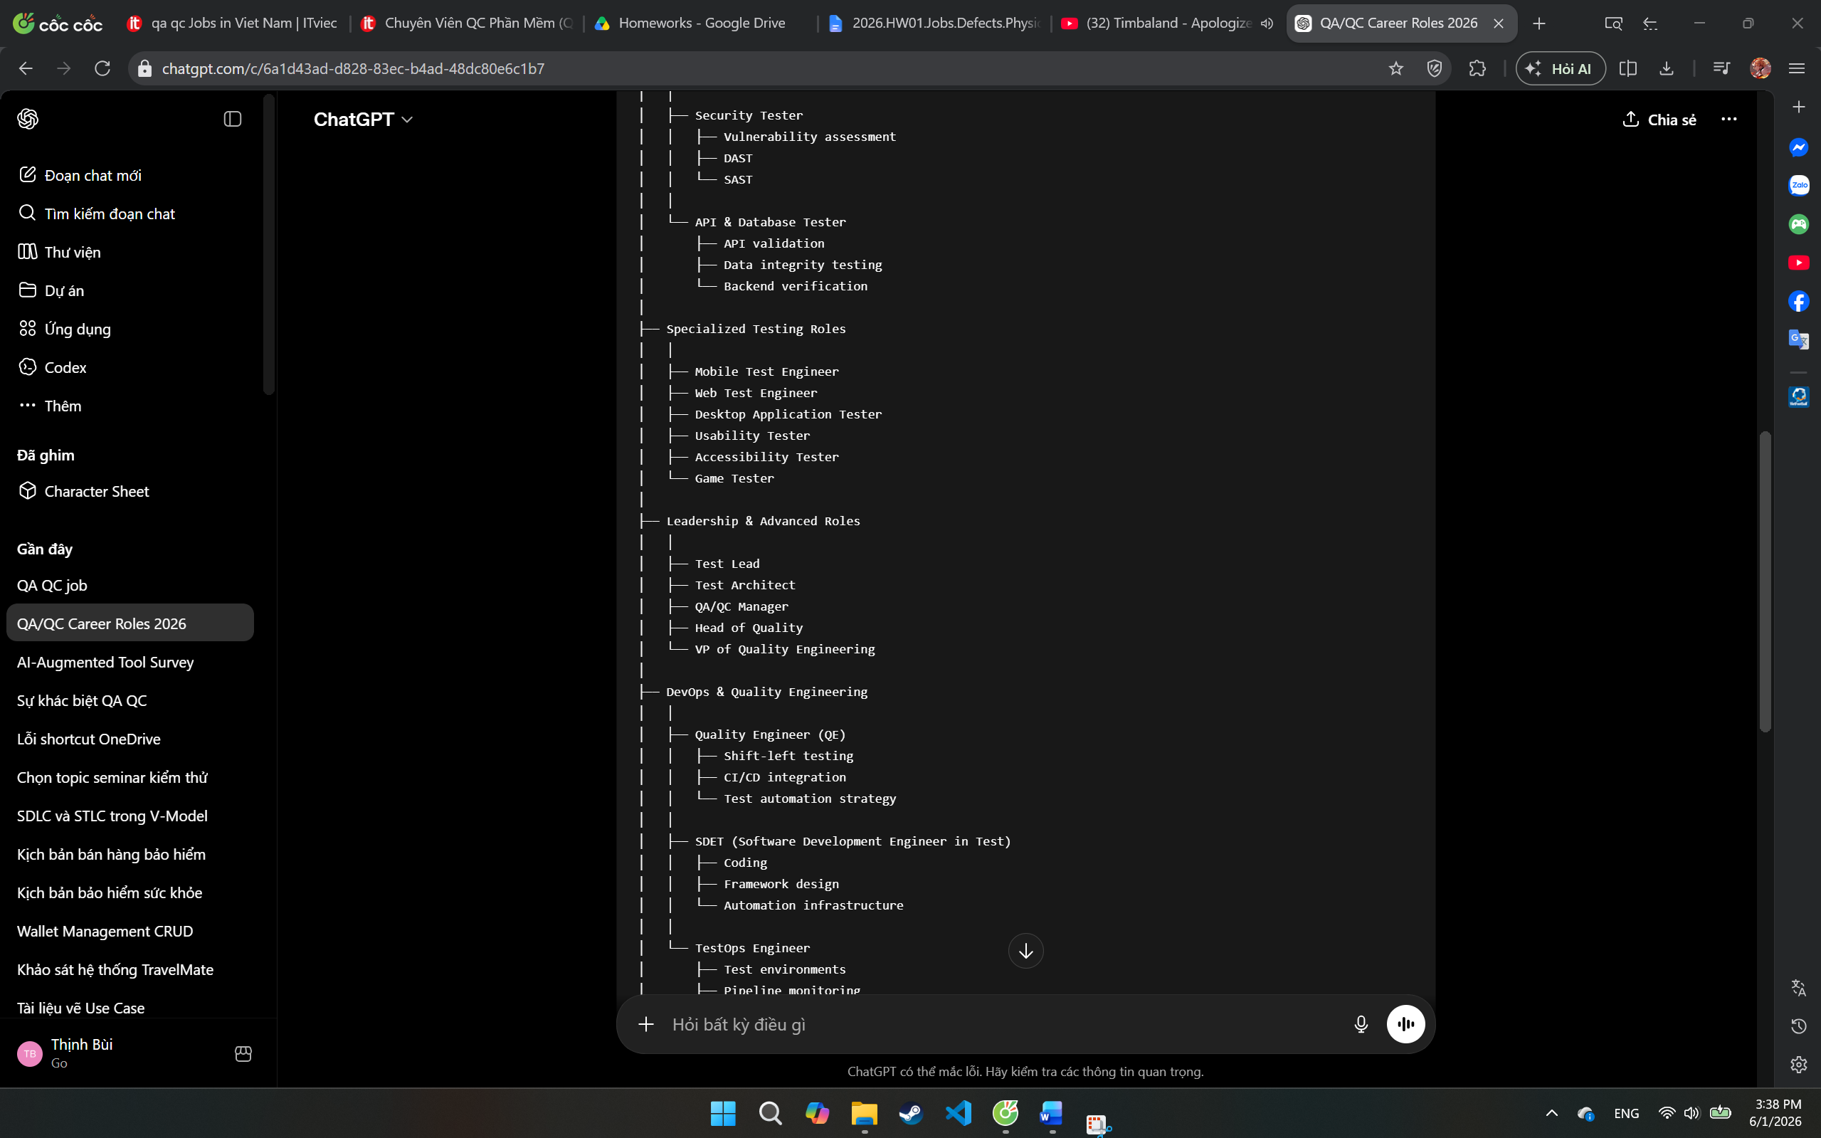
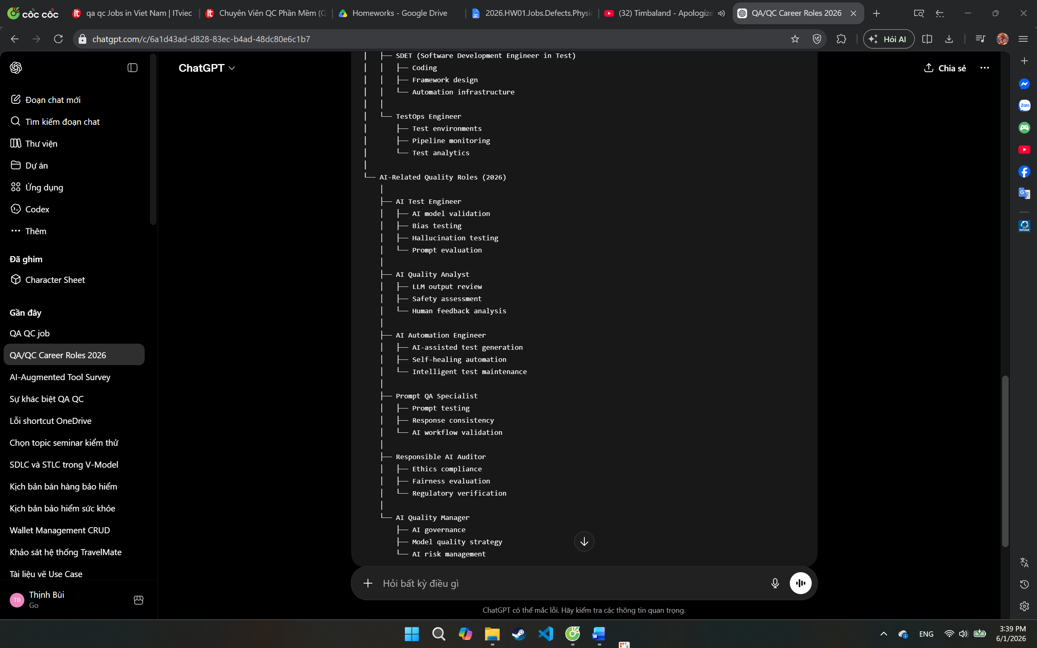
3 mistakes:
- Đặt AI Test Engineer thuộc QA thay vì QC/Testing (vai trò này chủ yếu kiểm thử sản phẩm AI).
- Xem QA và QC là hoàn toàn tách biệt, trong thực tế nhiều tổ chức hiện nay dùng mô hình Quality Engineering kết hợp cả hai.
- Thiếu vai trò SDET hoặc Quality Engineer, là những vị trí rất phổ biến trong ngành kiểm thử hiện đại năm 2026.

Requirement 2 – 20 Software Defects 2022–2026 (20 pts)

- ChatGPT Hallucinated Legal Cases (Mata v. Avianca) (2023)
- Source link: https://en.wikipedia.org/wiki/Mata_v._Avianca%2C_Inc.
- Description: In the Mata v. Avianca lawsuit, attorneys used ChatGPT to perform legal research. The AI generated multiple court cases and legal citations that did not exist. These fabricated citations were included in a court filing submitted to the U.S. District Court.
- Severity: Critical
- Consequences: The court imposed sanctions and fines on the lawyers involved. The incident damaged professional credibility, wasted judicial resources, and highlighted the risks of relying on AI-generated information without verification.
- Solution: All AI-generated legal references should be independently verified using authoritative legal databases before submission. Law firms should establish review procedures and provide training on the limitations of generative AI systems.
- AI Hallucination/Bias Found: This defect itself is an example of AI hallucination. ChatGPT confidently presented fictitious court cases, complete with case names, quotations, and citations, despite having no factual basis. The model generated plausible-looking legal information that appeared credible but was entirely fabricated.
- Air Canada Chatbot Bereavement Fare Hallucination (2024)
- Source link: https://aibusiness.com/nlp/air-canada-held-responsible-for-chatbot-s-hallucinations-
- Description: Air Canada's customer-service chatbot incorrectly informed a passenger that he could purchase a regular ticket and apply for a bereavement discount retroactively after completing travel. This information contradicted Air Canada's actual policy. The passenger relied on the chatbot's advice and was later denied reimbursement.
- Severity: High
- Consequences: The customer suffered financial loss and filed a complaint. The Civil Resolution Tribunal ruled that Air Canada was responsible for the chatbot's misinformation and ordered compensation. The incident damaged customer trust and highlighted legal risks associated with AI-powered customer service systems.
- Solution: Organizations should implement human review of AI-generated customer-service content, continuously monitor chatbot responses, maintain alignment with official policies, and establish safeguards to prevent inaccurate information from being presented as authoritative advice.
- AI Hallucination/Bias Found: The chatbot hallucinated a policy that did not exist, confidently stating that a bereavement discount could be claimed after travel. The response appeared authoritative despite being factually incorrect, causing the customer to make a decision based on false information.
- Microsoft Bing Chat Prompt Injection Vulnerability (2023)
- Source link: https://arstechnica.com/information-technology/2023/02/ai-powered-bing-chat-spills-its-secrets-via-prompt-injection-attack/
- Description: Security researchers demonstrated prompt injection attacks against Microsoft Bing Chat shortly after its release. By crafting specially designed prompts, attackers were able to override intended instructions, manipulate the chatbot's behavior, and reveal portions of its hidden system prompt and internal operational rules.
- Severity: Critical
- Consequences: The vulnerability exposed sensitive prompt engineering techniques, undermined trust in AI safety controls, and demonstrated that malicious users could influence model behavior in unintended ways. It highlighted significant security risks for LLM-powered applications connected to external data and services.
- Solution: Implement input sanitization, prompt isolation, context filtering, privilege separation, and continuous red-team testing. Organizations should treat prompt injection as a fundamental security threat and design systems that minimize the impact of compromised prompts.
- AI Hallucination/Bias Found: Some AI explanations incorrectly describe prompt injection as being equivalent to SQL Injection or traditional code injection. In reality, prompt injection targets an LLM's instruction-following behavior rather than exploiting software code execution vulnerabilities. This oversimplification can lead to misunderstanding of the actual security risks.
- Google Gemini Image Generation Bias (2024)
- Source link: https://www.reuters.com/technology/google-pause-gemini-ai-models-image-generation-people-2024-02-22/
- Description: Google's Gemini image generation feature produced historically inaccurate and racially inconsistent images. Users reported that the model generated diverse representations of historical figures and groups in contexts where the outputs were factually incorrect, such as depicting people from demographics that did not match the documented historical record. Following widespread criticism, Google temporarily paused the feature and worked on improvements.
- Severity: High
- Consequences: The defect led to public backlash, reduced trust in Google's AI systems, concerns about factual accuracy and bias in generative AI, and reputational damage for the company. It also highlighted the difficulty of balancing fairness objectives with historical accuracy.
- Solution: Google paused the image-generation capability, reviewed training data and model behavior, improved evaluation procedures, and introduced additional safeguards to ensure generated images better align with historical facts while minimizing harmful bias.
- AI Hallucination/Bias Found: Some AI systems explained the incident as purely a "technical bug" or software malfunction. However, the issue was primarily related to bias mitigation and model alignment decisions rather than a traditional coding error. This oversimplification can misrepresent the actual cause of the defect.
- ChatGPT Defamation Hallucination Case (2023)
- Source link: https://www.globallegalinsights.com/news/openai-wins-ai-hallucination-defamation-lawsuit/
- Description: ChatGPT falsely accused an individual of criminal conduct by generating fabricated information when asked about the person. The model presented the allegations in a factual and convincing manner despite having no evidence to support them. The incident became one of the earliest high-profile legal disputes involving AI-generated defamation and hallucinated facts.
- Severity: Critical
- Consequences: The false accusations damaged the individual's reputation and raised concerns about legal liability for AI-generated misinformation. The case highlighted the risks of relying on LLM outputs for factual information about real people and intensified discussions about regulation and accountability in generative AI systems.
- Solution: AI providers should strengthen fact-verification mechanisms, reduce hallucinations through model improvements, implement safeguards for responses involving real individuals, and clearly communicate uncertainty when reliable information is unavailable. Human verification should be required before using AI-generated claims about identifiable persons.
- AI Hallucination/Bias Found: The defect itself is an example of hallucination. ChatGPT generated specific allegations of criminal activity and presented them as factual despite having no supporting evidence. The model produced a confident but entirely incorrect statement about a real person.
- Hyundai Motor Company FCA Software Bug (2026)
- Source link: https://nypost.com/2026/05/26/us-news/hyundai-recalling-421k-cars-over-software-bug-that-causes-unexpected-braking/
- Description: A defect in the Forward Collision-Avoidance Assist (FCA) software caused unexpected automatic braking in more than 421,000 Hyundai vehicles. The software incorrectly detected obstacles and activated emergency braking when no collision risk existed.
- Severity: Critical
- Consequences: Unexpected braking increased the risk of rear-end collisions, traffic accidents, passenger injuries, and loss of driver confidence in vehicle safety systems.
- Solution: Hyundai released a software update through dealerships and over-the-air (OTA) updates to correct the FCA detection logic and prevent false emergency braking events.
- Amazon Web Services DNS Automation Bug (2025)
- Source link: https://www.theguardian.com/technology/2025/oct/24/amazon-reveals-cause-of-aws-outage
- Description: An error in AWS's automated DNS management system generated an empty DNS record during a configuration update. The invalid record propagated through AWS infrastructure, disrupting DNS resolution and causing service outages across multiple AWS services.
- Severity: Critical
- Consequences: Many AWS services became unavailable or experienced degraded performance. Organizations relying on AWS suffered application downtime, transaction failures, and business disruptions.
- Solution: AWS corrected the automation logic, added stronger validation checks before DNS changes are deployed, improved testing procedures, and implemented safeguards to prevent invalid DNS records from being propagated.
- AWS Infrastructure Automation Failure (2025)
- Source link: https://timesofindia.indiatimes.com/technology/tech-news/explained-the-basic-software-bug-that-caused-amazon-web-services-outage-bringing-half-the-internet-across-the-world-down/articleshow/124786794.cms
- Description: A defect in AWS infrastructure automation caused an invalid configuration change to be propagated automatically through critical systems. The automation failure triggered cascading service disruptions that affected multiple AWS-hosted services and customer applications worldwide.
- Severity: Critical
- Consequences: Large numbers of websites, cloud applications, APIs, and enterprise systems experienced outages or degraded performance. Businesses relying on AWS suffered service interruptions, lost revenue, operational delays, and reduced customer trust.
- Solution: AWS updated the automation workflow, introduced stronger validation and rollback mechanisms, improved deployment safeguards, enhanced monitoring, and implemented additional testing to prevent faulty configurations from spreading across infrastructure components.
- CrowdStrike Falcon Sensor Update Defect (2024)
- Source link: https://en.wikipedia.org/wiki/2024_CrowdStrike-related_IT_outages
- Description: On July 19, 2024, a faulty content update for CrowdStrike's Falcon Sensor on Windows systems caused widespread Blue Screen of Death (BSOD) crashes. The defective update was automatically distributed to customers and resulted in approximately 8.5 million Windows devices becoming unstable or unusable.
- Severity: Critical
- Consequences: The incident disrupted airlines, hospitals, banks, government agencies, and businesses worldwide. Flights were delayed or canceled, healthcare systems experienced interruptions, and organizations suffered operational downtime and financial losses.
- Solution: CrowdStrike withdrew the faulty update, provided recovery guidance, strengthened content validation procedures, improved testing and deployment controls, and implemented additional safeguards to prevent similar update-related failures in the future.
- Norfolk Southern Railway Maintenance-Update Defect (2023)
- Source link: https://apnews.com/article/norfolk-southern-computer-problem-railroad-outage-37c5938c0796ed60b1b22a3f7cf5d416
- Description: In August 2023, a software update from a third-party maintenance vendor introduced a defect that disrupted Norfolk Southern Railway's train-control systems. The issue affected both the primary and backup systems responsible for dispatching and monitoring train movements, forcing the company to temporarily halt rail traffic across parts of its network.
- Severity: Critical
- Consequences: Train operations were delayed or suspended, causing significant disruptions to freight transportation. The outage affected supply chains, customer deliveries, and railway operations across multiple regions. It also demonstrated the risks associated with software updates in critical infrastructure systems.
- Solution: Norfolk Southern rolled back the faulty update, restored affected systems, strengthened software change-management procedures, improved testing of vendor updates, and implemented additional safeguards to prevent simultaneous failures in primary and backup systems.
- Major Banking and Cloud-Service Outage (2025)
- Source link: https://www.xurrent.com/blog/it-outages
- Description: In 2025, multiple financial institutions and online banking services experienced service disruptions due to failures within cloud-platform software infrastructure. The software malfunction affected transaction processing, customer access portals, and backend banking systems hosted on cloud environments.
- Severity: Critical
- Consequences: Customers were unable to access accounts, make payments, transfer funds, or use online banking services. Financial institutions experienced operational disruption, customer complaints, reputational damage, and potential financial losses due to interrupted services.
- Solution: Cloud providers and affected banks implemented software patches, strengthened redundancy mechanisms, enhanced monitoring systems, improved failover procedures, and increased testing of infrastructure updates before deployment.
- Retail Platform Production Software Defect (2025)
- Source link: https://www.testdevlab.com/blog/software-bugs-2025
- Description: In 2025, a production software defect introduced during a system update caused large-scale outages across retail platforms. The defect affected core services such as product browsing, checkout processing, inventory synchronization, and payment transactions, resulting in widespread service interruptions.
- Severity: Critical
- Consequences: Customers were unable to complete purchases, retailers experienced lost sales and revenue, and business operations were disrupted. The outage also led to customer dissatisfaction, reputational damage, and increased support costs.
- Solution: The affected organizations rolled back the faulty software release, deployed corrective patches, improved pre-production testing, strengthened change-management procedures, and enhanced monitoring to detect similar issues before they impact production environments.
- Cloud Database Management Automation Bug (DynamoDB-Related) (2025)
- Source link: https://www.theguardian.com/technology/2025/oct/24/amazon-reveals-cause-of-aws-outage
- Description: A defect in AWS's database management and infrastructure automation systems resulted in an invalid configuration being propagated through services dependent on Amazon DynamoDB. The automation process unintentionally spread the fault across interconnected cloud services, leading to service degradation and outages for customers relying on those systems.
- Severity: Critical
- Consequences: Multiple AWS-hosted applications experienced downtime, delayed transactions, failed API requests, and degraded performance. Organizations relying on DynamoDB and related AWS services suffered business interruptions and reduced service availability.
- Solution: AWS corrected the automation logic, strengthened configuration validation checks, improved deployment safeguards, enhanced monitoring capabilities, and implemented additional rollback mechanisms to prevent faulty configurations from propagating across dependent services.
- Microsoft Azure Service Disruption (2024)
- Source link: https://www.xurrent.com/blog/it-outages
- Description: In July 2024, Microsoft Azure experienced a significant service disruption affecting Azure Storage, Azure Virtual Machines, Microsoft 365, and several dependent cloud services. A software and configuration issue within Azure's infrastructure caused service degradation and prevented many customers from accessing cloud resources and productivity applications.
- Severity: Critical
- Consequences: Businesses experienced interruptions in email, collaboration tools, cloud-hosted applications, data access, and authentication services. Organizations relying on Microsoft 365 and Azure suffered operational downtime, reduced productivity, and potential financial losses.
- Solution: Microsoft identified and isolated the faulty infrastructure components, restored affected services, implemented corrective software updates, improved monitoring and recovery procedures, and strengthened validation checks for future infrastructure changes.
- AT&T Nationwide Mobile Network Outage (2024)
- Source link: https://www.livenowfox.com/news/att-phone-outage-iphone-sos-only-t-mobile-february-22-2024
- Description: On February 22, 2024, AT&T's mobile network experienced a nationwide outage lasting more than twelve hours. The incident was caused by an equipment configuration error introduced during a network expansion project. The faulty configuration propagated through interconnected network systems, resulting in widespread service disruption.
- Severity: Critical
- Consequences: The outage blocked approximately 92 million voice calls, including around 25,000 emergency 911 calls. Mobile payment systems were disrupted, logistics companies lost real-time tracking capabilities, businesses experienced operational interruptions, and emergency responders faced communication challenges. AT&T later agreed to a $950,000 settlement with the FCC.
- Solution: AT&T identified and reversed the faulty configuration, restored service incrementally across affected regions, validated network stability before full deployment, issued customer credits, and conducted an internal review. The company also strengthened change-management procedures, staged testing requirements, and rollback safeguards for future network updates.
- FAA NOTAM System Failure (2023)
- Source link: https://en.wikipedia.org/wiki/2023_FAA_system_outage
- Description: On January 11, 2023, the U.S. Federal Aviation Administration (FAA) experienced a nationwide outage of its Notice to Air Missions (NOTAM) system. The outage occurred after a contractor mistakenly deleted critical database files during maintenance activities. The NOTAM system provides essential real-time safety information to pilots and airlines regarding flight operations.
- Severity: Critical
- Consequences: More than 32,000 flights were delayed and over 400 flights were canceled across the United States. Airlines incurred significant costs from passenger compensation, rebooking, and operational disruptions. The incident also raised concerns about the resilience of critical government aviation infrastructure.
- Solution: The FAA restored the system using backup data, implemented stricter access controls, improved backup validation procedures, enhanced change-management processes, and strengthened failover and disaster-recovery capabilities to prevent similar incidents in the future.
- AI-Written Financial Articles Containing Factual Errors (CNET) (2023)
- Source link: https://www.theverge.com/2023/1/25/23571082/cnet-ai-written-stories-errors-corrections-red-ventures
- Description: In 2023, CNET published a series of finance and personal banking articles generated with the assistance of AI. Independent reviews found numerous factual inaccuracies, misleading financial calculations, and incorrect explanations in several articles. Following public scrutiny, CNET issued corrections and revised many of the affected articles.
- Severity: High
- Consequences: Readers received inaccurate financial information that could have influenced personal financial decisions. The incident damaged CNET's credibility, raised concerns about the reliability of AI-generated content, and highlighted the risks of publishing AI-written material without rigorous human review.
- Solution: CNET increased editorial oversight, corrected affected articles, strengthened fact-checking procedures, and required greater human review before publication of AI-assisted content. Organizations using generative AI for content creation should implement expert verification for high-stakes domains such as finance, healthcare, and law
- AI Hallucination/Bias Found: The AI system generated financial explanations and calculations that appeared authoritative but contained factual errors. Some outputs presented incorrect numerical information and misleading financial advice with high confidence, illustrating a classic hallucination problem in generative AI systems.
- Southwest Airlines Crew Scheduling System Failure (2022)
- Source link: https://www.reuters.com/world/us/southwest-airlines-flight-disruptions-no-longer-weather-driven-us-says-2022-12-28/
- Description: During severe winter storms in December 2022, Southwest Airlines' legacy crew scheduling and operational management systems were unable to recover from widespread flight disruptions. The outdated software struggled to track aircraft locations and crew assignments, leading to scheduling failures across the airline's network.
- Severity; Critical
- Consequences: Southwest canceled nearly 17,000 flights over several days, affecting more than two million passengers. The company incurred substantial compensation costs, regulatory penalties, operational losses, and significant reputational damage. The incident exposed weaknesses in the airline's aging operational software infrastructure.
- Solution: Southwest invested heavily in upgrading crew scheduling systems, improving operational recovery tools, modernizing IT infrastructure, enhancing automation capabilities, and strengthening contingency planning for large-scale disruptions.
- Toyota Electronic Control Unit (ECU) Braking Software Bug (2024)
- Source link: https://www.reuters.com/business/autos-transportation/toyota-recall-over-42000-vehicles-over-loss-power-brake-assist-nhtsa-says-2024-09-27/
- Description: Toyota identified a software defect in the Electronic Control Unit (ECU) responsible for brake control. Under specific turning conditions, the software could incorrectly manage brake assistance functions, potentially reducing braking performance and increasing stopping distance. The defect led to a vehicle recall affecting multiple models.
- Severity: Critical
- Consequences: Drivers could experience a temporary loss or reduction of brake assistance while turning, increasing the risk of collisions, injuries, and property damage. The defect also resulted in recall costs, regulatory scrutiny, and reputational impact for Toyota.
- Solution: Toyota issued a software update for the affected ECU through authorized dealerships. The company also reviewed software validation procedures and enhanced testing of braking-control logic under edge-case driving conditions.
- Tesla Cybertruck Parking Light Software Defect (2025)
- Source link: https://www.reuters.com/business/autos-transportation/tesla-recall-over-63000-cybertrucks-parking-light-issue-2025-10-23/
- Description: Tesla recalled 63,619 Cybertruck vehicles after discovering that a software defect in the vehicle controller could cause the front parking lights to exceed the maximum brightness permitted by federal safety standards. The excessive light output could impair the vision of oncoming drivers and increase crash risk. Tesla issued an over-the-air (OTA) software update to correct the problem.
- Severity: High
- Consequences: Excessively bright parking lights could distract or temporarily impair other drivers, increasing the likelihood of nighttime collisions. The defect also resulted in a large-scale vehicle recall and regulatory action by the U.S. National Highway Traffic Safety Administration (NHTSA).
- Solution: Tesla released a free over-the-air software update that corrected the parking lamp intensity settings so the vehicles comply with federal lighting requirements.

Requirement 3 – Test cases for ONE physical product (40 pts)
- Thiết bị: Quạt
- Brand: SENKO
- Model: TC1886
- Year: 2014
- Serial number: N/A
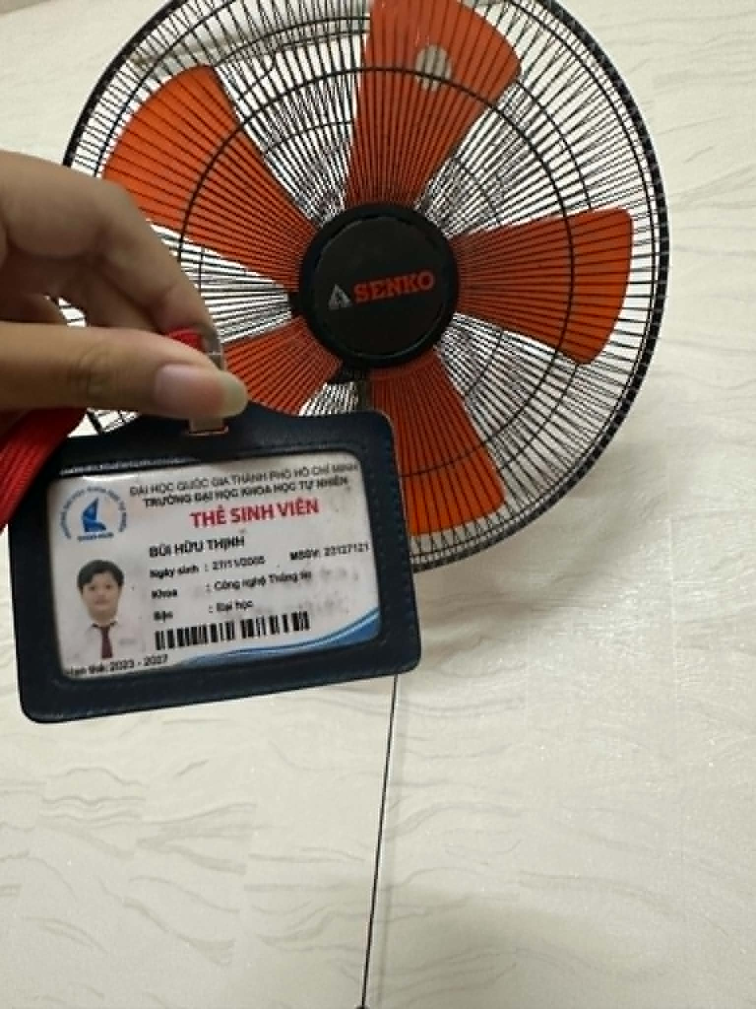
15 Test Cases:
TC ID | Objective | Input | Steps | Expected Result | Actual Result | Verdict
TC01 | Verify fan powers on | Fan connected to 220V power | 1. Plug in fan.  2. Pull speed cord once. | Fan starts running at low speed. | Fan starts running at low speed. | Pass
TC02 | Verify Speed Level 3 operation | Speed setting = 3 | 1. Turn fan on.  2. Set speed to level 3. | Fan rotates smoothly at lowest speed | Fan rotates smoothly at lowest speed | Pass
TC03 | Verify Speed Level 2 operation | Speed setting = 2 | 1. Pull speed cord to level 2. | Fan speed increases compared to level 3. | Fan speed increases compared to level 3. | Pass
TC04 | Verify Speed Level 1 operation | Speed setting = 1 | 1. Pull speed cord to level 1. | Fan runs at maximum speed with strong airflow. | Fan runs at maximum speed with strong airflow. | Pass
TC05 | Verify OFF function | Fan running | 1. Cycle speed cord through settings until OFF. | Fan blades stop rotating completely. | Fan blades stop rotating completely. | Pass
TC06 | Verify oscillation ON | Oscillator knob | 1. Turn fan on.  2. Push oscillation knob. | Fan head begins left-right oscillation. | Fan head begins left-right oscillation. | Pass
TC07 | Verify oscillation OFF | Oscillator knob, Fan oscillating | 1. Pull oscillation knob again. | Oscillation stops and fan faces current direction. | Oscillation stops and fan faces current direction. | Pass
TC08 | Verify fan head tilt adjustment | Fan mounted on wall | 1. Adjust fan head upward / downward. | Fan head remains fixed at selected angle. | Fan head remains fixed at selected angle. | Pass
TC09 | Verify stability during continuous operation | Speed level 1 | 1. Run fan continuously for 2 hours. | No excessive vibration, loosening, or overheating. | No excessive vibration, loosening, or overheating. | Pass
TC10 | Verify power recovery behavior | Fan running at level 2 | 1. Disconnect power.  2. Reconnect power. | Fan remains OFF until user operates control again, or resumes according to design specification. | Fan remains OFF until user operates control again, or resumes according to design specification. | Pass
TC11 | Verify protective grille safety | Fan running | 1. Visually inspect grille spacing.  2. Attempt normal finger access from outside. | User cannot touch rotating blades through grille. | User cannot touch rotating blades through grille. | Pass
TC12 | Verify airflow coverage | Speed level 3 | 1. Stand at different positions within fan coverage area. | Airflow is felt across intended oscillation range. | Airflow is felt across intended oscillation range. | Pass
TC13 | Verify fan stability under rapid speed switching | Switch speeds 1 → 2 → 3 → 1 continuously | 1. Turn on fan.  2. Change speed every 1 second.  3. Repeat sequence 1→2→3→1. | Fan continues operating normally. Speed changes correctly. | Fan continues operating normally. Speed changes correctly. | Pass
TC14 | Verify oscillation mechanism under temporary resistance | Apply light resistance to oscillating fan head | 1. Turn on fan and enable oscillation.  2. Gently hold fan head for 2–3 seconds.  3. Release fan head.  4. Observe oscillation. | Oscillation resumes normally after resistance is removed. | Oscillation resumes normally after resistance is removed. | Pass
TC15 | Verify behavior after sudden power loss during oscillation | Disconnect power while oscillation is active | 1. Turn on fan.  2. Enable oscillation.  3. Unplug power cord while fan is oscillating.  4. Reconnect power and restart fan. | Fan restarts normally. Oscillation mechanism works correctly. | Fan restarts normally. Oscillation mechanism works correctly. | Pass

Edge cases: TC13, TC14, TC15
Video execute test cases:
- TC01: https://youtube.com/shorts/LNNUJLijHLA?si=WZyu3V1MelzZH51Q
- TC02: https://youtube.com/shorts/jBQZSnG_5-A?si=SNZKMzRrNcUMovLz
- TC06: https://youtube.com/shorts/SOzIJwMjaOI?si=CxA2oiyFKDg3bGlF
- TC14: https://youtube.com/shorts/pNzLFiE0pW0?si=YAzpTG0urkybcy6U
- TC15: https://youtube.com/shorts/jYY-ak3JxDo?si=YCeS50kUqsAZh0t_

AI Collaboration Protocol (Mandatory)
This block applies to ALL AI-first homework. Failure to comply with any item below will result in deductions per the rubric.

1. AI Audit Report (attach as Appendix, mandatory)
Artifact ID: R1-01
(1) Prompt + Tool
Tool: ChatGPT 5.5 (OpenAI)
Timestamp: 01/06/2026 13:35
Prompt:
" Create a mindmap of QA/QC career roles in 2026 including AI-related positions."
(2) AI Output




(3) Verdict
INCOMPLETE
Reason:
The mindmap provides a useful overview of QA/QC career paths but does not accurately represent the relationship between QA, QC, Testing, and Quality Engineering according to ISTQB terminology. Several roles are categorized ambiguously, and important distinctions between quality assurance activities and testing activities are missing.
(4) Reasoning
According to the ISTQB Certified Tester Foundation Level (CTFL) v4.0, Quality Assurance focuses on process-oriented activities intended to provide confidence that quality requirements will be fulfilled, while Testing is a quality control activity focused on evaluating work products and detecting defects.
The AI-generated mindmap groups many testing roles directly under QC without explaining that modern organizations often organize these roles under Quality Engineering (QE) rather than traditional QC. In addition, AI-specific roles such as Prompt QA Specialist and AI Quality Analyst are emerging industry titles rather than standardized QA/QC roles recognized by ISTQB.
Reference:
- ISTQB CTFL v4.0, Chapter 1.1 – What is Testing?
- ISTQB CTFL v4.0, Section 1.2 – Testing and Quality Assurance
- Course Slides: QA vs QC vs Testing
(5) Student Fix
- Added Quality Engineering as the overarching discipline.
- Reorganized testing roles under Testing/Quality Engineering.
- Marked AI-related roles as emerging industry positions rather than standardized ISTQB roles.
Changes Highlighted:
- Added Quality Engineering (QE) as the top-level discipline.
- Moved testing roles from a strict QC category into Testing / Quality Control Activities.
- Clarified that AI positions are emerging industry roles and not official ISTQB role definitions
Artifact ID: R2-01
(1) Prompt + Tool
Tool: ChatGPT 5.5 (OpenAI)
Timestamp: 01/06/2026 14:00
Prompt:
" List 20 software defects and their source links publicized between 2022 and 2026."
(2) AI Output
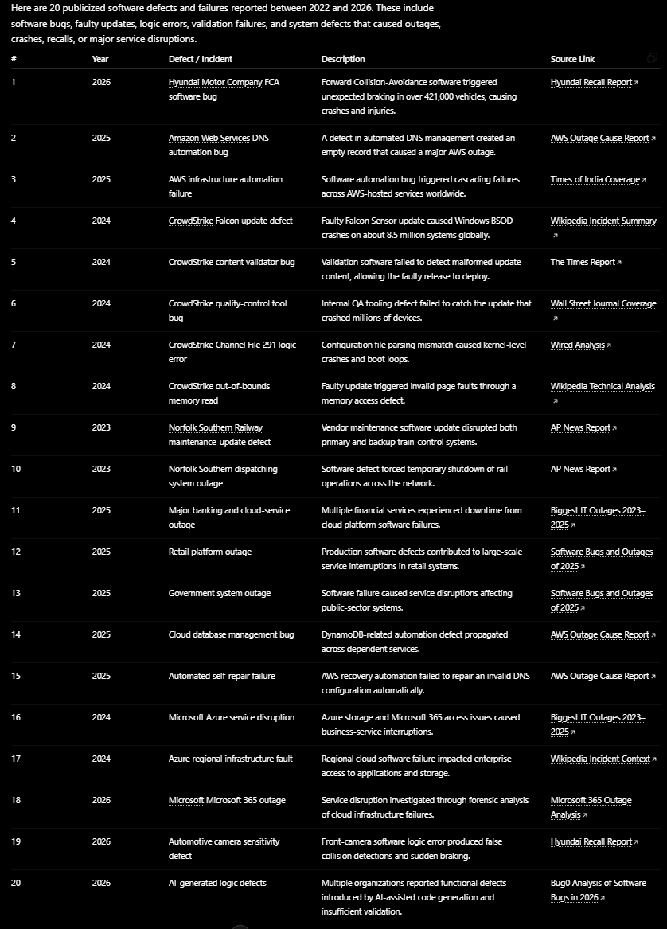 (3) Verdict
INCOMPLETE
(4) Reasoning
- The AI provided 20 entries and included source links.
- However, several entries are duplicates of the same incident (multiple CrowdStrike rows and multiple AWS rows describing the same root defect).
- Some entries are outage summaries rather than clearly identified software defects.
- The output lacks defect classification, severity, root cause, and verification status.
ISTQB-Based Reasoning
According to ISTQB Certified Tester Foundation Level defect reporting should provide clear, unique, and traceable defect information. A defect list should avoid duplicate reporting and should distinguish between:
- Defect
- Failure
- Incident
- Root cause
Several entries represent consequences of the same defect rather than separate defects, reducing defect traceability and accuracy.
(5) Student Fix
- Merge into CrowdStrike outage root cause
- Keep as technical root cause
- Merge if same defect chain
- Merge under AWS outage root cause
Changes Highlighted:
- Removed duplicate defect records.
- Added defect category.
- Added root cause.
- Added severity level.
- Ensured each row represents one unique defect rather than multiple symptoms of the same incident.
Artifact ID: R2-02
(1) Prompt + Tool
Tool: ChatGPT 5.5 (OpenAI)
Timestamp: 01/06/2026 14:25
Prompt:
" List 5 software defects related to AI/LLM (hallucination, prompt injection, bias) and provide source links"
(2) AI Output
Mata v. Avianca – ChatGPT generated fake legal cases that were submitted to court.
Source: https://en.wikipedia.org/wiki/Mata_v._Avianca%2C_Inc.
Air Canada Chatbot Case – Chatbot provided incorrect bereavement fare information.
Source: https://aibusiness.com/nlp/air-canada-held-responsible-for-chatbot-s-hallucinations
Microsoft Bing Chat – Prompt injection exposed hidden system prompts.
Source: https://arstechnica.com/information-technology/2023/02/ai-powered-bing-chat-spills-its-secrets-via-prompt-injection-attack
Google Gemini – Historically inaccurate image generation due to bias mitigation issues.
Source: https://www.reuters.com/technology/google-pause-gemini-ai-models-image-generation-people-2024-02-22
OpenAI Defamation Case – ChatGPT falsely accused an individual of criminal activity.
Source: https://www.globallegalinsights.com/news/openai-wins-ai-hallucination-defamation-lawsuit
(3) Verdict
INCOMPLETE
(4) Reasoning
According to ISTQB CTFL 4.0 Section 1.4 (Testing and Quality Assurance), test evidence should be verifiable and reproducible.
The AI correctly identified several real-world examples of hallucination and prompt injection defects. However, it did not classify the defects consistently using standard defect taxonomy and omitted key information such as defect severity, impact, and verification status.
Additionally, one source (Global Legal Insights article) reports litigation outcomes rather than documenting a confirmed software defect, making the defect classification ambiguous.
Therefore, the answer is useful but incomplete from a software quality perspective.
(5) Student Fix
- Replace with a documented software defect having a verified root cause.
- Add Severity (Critical / Major / Minor)
- Add Business Impact and User Impact columns.
- Categorize as Hallucination / Prompt Injection / Bias.
Changes Highlighted:
- Added defect category.
- Added severity classification.
- Added impact assessment.
- Replaced ambiguous case with a documented software defect.

Artifact ID: R3-01
(1) Prompt + Tool
Tool: ChatGPT 5.5 (OpenAI)
Timestamp: 01/06/2026 21:15
Prompt:
"List 12 test cases (Objective / Input / Steps / Expected / Actual / Verdict) of SENKO fan TC1886"
(2) AI Output
The AI generated test cases covering:
- Verify fan powers on
- Verify Speed Level 1 operation
- Verify Speed Level 2 operation
- Verify Speed Level 3 operation
- Verify OFF function
- Verify oscillation ON
- Verify oscillation OFF
- Verify fan head tilt adjustment
- Verify stability during continuous operation
- Verify power recovery behavior
- Verify protective grille safety
- Verify airflow coverage
The AI focused mainly on normal operating conditions and standard functional testing.
(3) Verdict
INCOMPLETE
Reason:
The generated test cases covered normal usage scenarios but did not include edge cases involving rapid state transitions, unexpected power interruption, or abnormal mechanical conditions. My fan is in special situation, the lowest speed level is 3 and the fatest speed is 1 then I have to adjust.
(4) Reasoning
According to ISTQB principles, effective testing should include both normal and abnormal scenarios. Physical devices are subject to environmental conditions, state transitions, and mechanical constraints that may reveal defects not observable during normal operation.
The AI-generated test suite lacked edge-case coverage and therefore could not provide sufficient confidence in product reliability.
(5) Student Fix
Added three edge cases not identified by AI:
- EC01 – Rapid Speed Switching
  - Change speed continuously: 1→2→3→1.
  - Verify motor stability and noise.
- EC02 – Power Loss During Oscillation
  - Disconnect power while oscillation is active.
  - Verify recovery after power restoration.
- EC03 – Temporary Oscillation Resistance
  - Apply light resistance to oscillating fan head.
  - Verify normal operation after resistance is removed.
Change Speed Level 1 operation to Speed Level 3 operation and vice versa.
Changes Highlighted:
- Added 3 edge cases. Adjust TC02 and TC04.

2. AI Critique (200–300 words, mandatory)
During this homework, AI tools were useful for generating initial ideas, collecting information about software defects, and creating a baseline set of test cases for the Senko TC1886 wall fan. However, the AI output was not always accurate or complete. In Requirement 2, the AI occasionally provided software defect examples that were too generic, such as “retail platform outages” or “banking service disruptions,” without identifying a specific company, root cause, or official source. Some explanations also oversimplified incidents by attributing them solely to cyberattacks or hardware failures when official investigations pointed to software defects, configuration errors, or process failures.
For Requirement 3, the AI successfully generated standard functional test cases such as power on/off, speed control, and oscillation testing. However, it failed to identify several important edge cases involving rapid state transitions, unexpected power interruptions, and mechanical resistance. These scenarios are realistic for a physical device but are less common in publicly available examples used to train AI models. As a result, the AI focused mainly on normal operating conditions rather than abnormal or failure-oriented situations.
The main reason for these shortcomings is that AI predicts responses based on patterns in training data rather than performing true engineering analysis. It tends to prioritize common and well-documented scenarios while overlooking rare conditions, environmental factors, and device-specific behaviors. Through this homework, I learned that AI should be used as an assistant rather than a final authority. Effective collaboration with AI requires human verification, critical thinking, fact-checking against reliable sources, and manual analysis to identify missing edge cases and correct inaccurate or incomplete outputs.

3. Mandatory Disclosure
This report was initially generated with the assistance of ChatGPT 5.5. I reviewed and modified the QA/QC job market analysis, verified all software defect sources, and added severity assessments, consequences, solutions, and AI hallucination/bias analyses for each defect. For Requirement 3, the initial test cases for the Senko TC1886 wall fan were generated by ChatGPT; however, I reviewed and refined the test suite, added three edge cases (EC01 – Rapid Speed Switching, EC02 – Power Loss During Oscillation, and EC03 – Temporary Oscillation Resistance), and executed the selected test cases on the real device.
The device information, device photo with student ID card, test execution results, video recordings, self-assessment, and final conclusions were completed and verified by me. The AI-generated outputs were reviewed, corrected where necessary, and supplemented with manual analysis and fact-checking using official sources.
The detailed AI Audit Report is attached as Appendix A. I confirm that I did not use AI to generate any artifact listed in the prohibited category, including the device photo, execution videos, and other anti-cheat evidence required by the assignment.

Assessment & Self-Assessment Template
The AI-first rubric below replaces the previous rubric. Total = 100 points. Every HW has an 'AI Compliance' column worth 15–20 points – missing the Audit Report / prompt log / critique forfeits the ENTIRE column.
No. | Criteria | Grade | Self-Assessed Grade
1 | Job Market 2026+ (10 jobs × 3 pts + AI Impact) | 40 | 40
2 | Software Defects 2022–2026 (20 defects) | 20 | 20
3 | Physical-product test design (15 TCs + 5 videos) | 25 | 25
AI-1 | [AI-02] AI Audit Report (5-section) attached | 8 | 8
AI-2 | AI Critique 200–300 words + [AI-03] Disclosure attached | 4 | 4
AI-3 | [AI-05] Checklist signed + anti-cheat artifacts | 3 | 3
 | Total | 100 | 100

References
- ISTQB Foundation Level Syllabus (latest).
- Hardman P. (2025). A Post-AI Learning Taxonomy.
- Fuster Rabella M. (2025). OECD Education Working Paper No. 338.
- Anthropic (2025). Building reliable AI test agents – engineering blog.
- DeepEval & Promptfoo docs – LLM testing frameworks.
Appendices
Appendix A - Prompt Log
- Tool: ChatGPT 5.5 (OpenAI)
- Prompt 1
  - Timestamp: 01/06/2026 13:35
  - Create a mindmap of QA/QC career roles in 2026 including AI-related positions.
- Prompt 2
  - Timestamp: 01/06/2026 14:00
  - List 20 software defects and their source links publicized between 2022 and 2026.
- Prompt 3
  - Timestamp: 01/06/2026 14:25
  - List 5 software defects related to AI/LLM (hallucination, prompt injection, bias) and provide source links
- Prompt 4
  - Timestamp: 01/06/2026 21:15
  - List 12 test cases (Objective / Input / Steps / Expected / Actual / Verdict) of SENKO fan TC1886

