**PROJECT:**TARGET SQL BUSINESS CASE

**NAME:**BHUVANESWARAN.S

**BATCH:**DSML OCT24(1)BEGINNER2

**CONTEXT:**

Target is a globally renowned brand and a prominent retailer in the United States. Target makes itself a preferred shopping destination by offering outstanding value, inspiration, innovation and an exceptional guest experience that no other retailer can deliver.

This particular business case focuses on the operations of Target in Brazil and provides insightful information about 100,000 orders placed between 2016 and 2018. The dataset offers a comprehensive view of various dimensions including the order status, price, payment and freight performance, customer location, product attributes, and customer reviews.

By analyzing this extensive dataset, it becomes possible to gain valuable insights into Target's operations in Brazil. The information can shed light on various aspects of the business, such as order processing, pricing strategies, payment and shipping efficiency, customer demographics, product characteristics, and customer satisfaction levels.

**DATASET SCHEMA:**

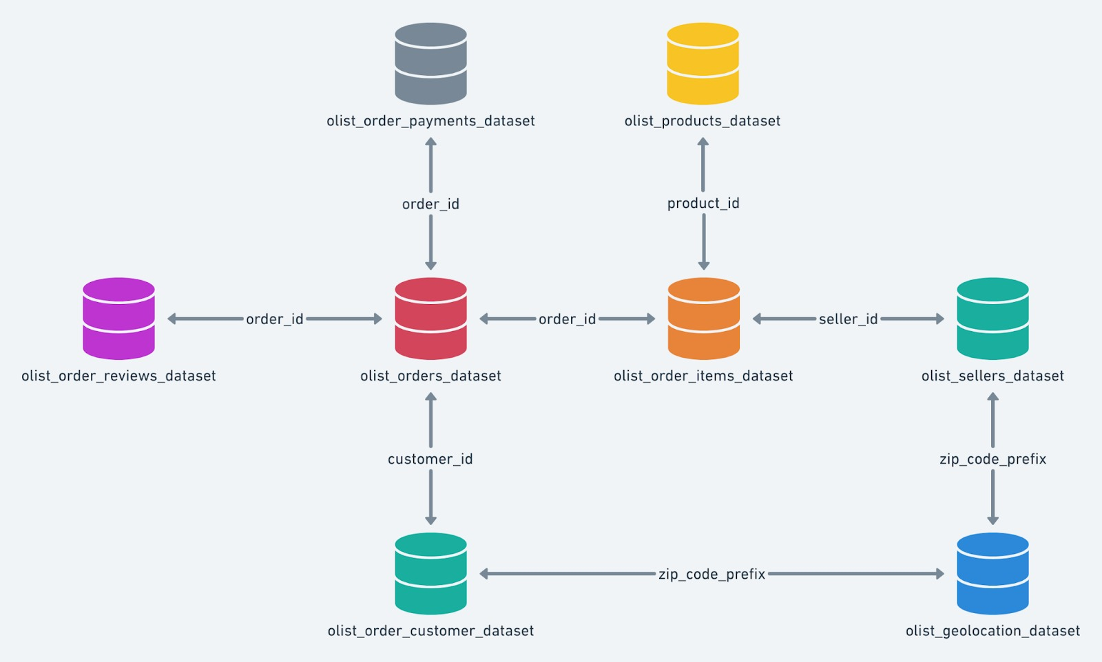

1. **Import the dataset and do usual exploratory analysis steps like checking the structure & characteristics of the dataset:**
2. Data type of all columns in the "customers" table?

**QUERY:**

select*

from  Ecommerce.orders

limit 10;

**OUTPUT:**

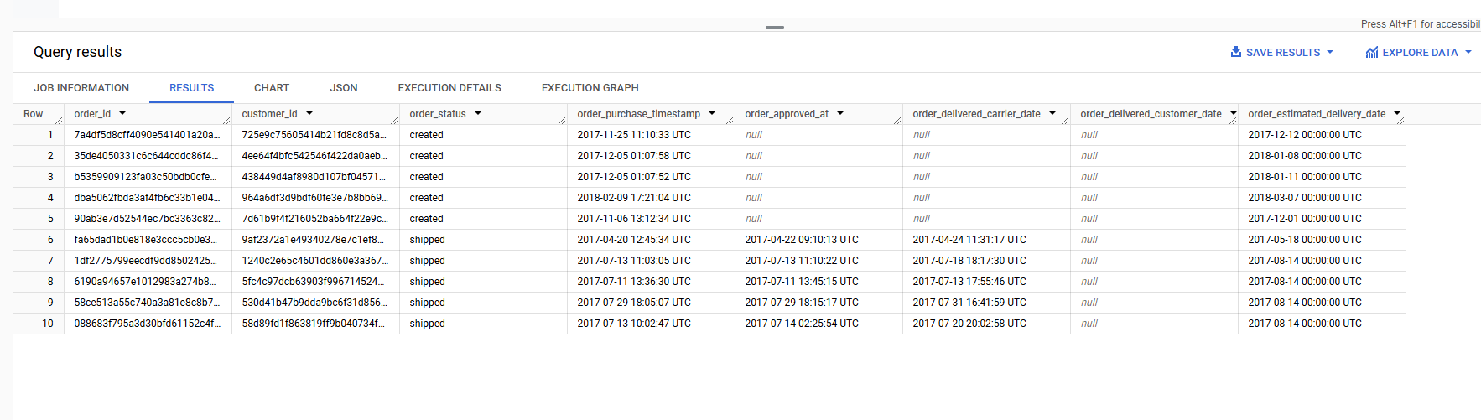

**INSIGHT:**

* These are the all columns of customers table within the “limit of 10”

|  |  |  |
| --- | --- | --- |
|  |  |  |

1. **Get the time range between which the orders were placed?**

**QUERY:**

select

 min(order_purchase_timestamp) as min_ ,

 max(order_purchase_timestamp) as max_

from `Ecommerce.orders`limit 10

**OUTPUT:**

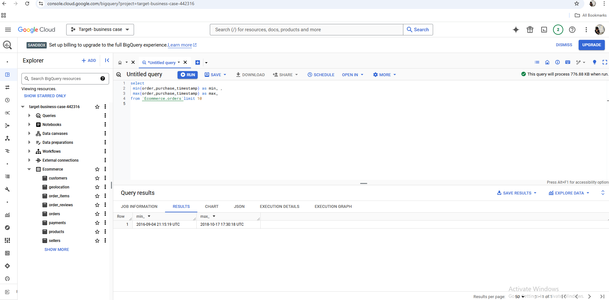

**INSIGHT:**

* Minumum time range of the order is = 2016-09-04 21:15:19 UTC
* Maximum time range of the order is= 2018-10-17 17:30:18 UTC

1. **Count the Cities & States of customers who ordered during the given period?**

**QUERY:**

select count(distinct customer_city)as unique_city,

 count(distinct customer_state)as unique_state,

 from `Ecommerce.customers`;

**OUTPUT:**

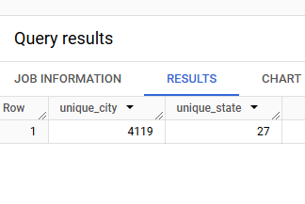

1. **In-depth Exploration:**
2. Is there a growing trend in the no. of orders placed over the past years?

**QUERY:**

SELECT

EXTRACT(YEAR FROM order_purchase_timestamp) AS order_year,

    COUNT(*) AS total_orders

FROM

   `Ecommerce.orders`

WHERE

    order_purchase_timestamp BETWEEN '2016-01-01' AND '2018-12-31'

GROUP BY

    EXTRACT(YEAR FROM order_purchase_timestamp)

ORDER BY

    order_year;

**OUTPUT:**

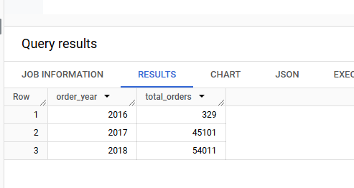

**INSIGHT:**

* This would indicate that the number of orders increased from 329 in 2016 to 54011 in 2018

**2.Can we see some kind of monthly seasonality in terms of the no. of orders being placed?**

**QUERY:**

SELECT

    EXTRACT(YEAR FROM order_purchase_timestamp) AS order_year,

    EXTRACT(MONTH FROM order_purchase_timestamp) AS order_month,

    COUNT(*) AS total_orders

FROM

    `Ecommerce.orders`

WHERE

    order_purchase_timestamp BETWEEN '2016-01-01' AND '2018-12-31'

GROUP BY

    EXTRACT(YEAR FROM order_purchase_timestamp),

    EXTRACT(MONTH FROM order_purchase_timestamp)

ORDER BY

    order_year, order_month;

**OUTPUT:**

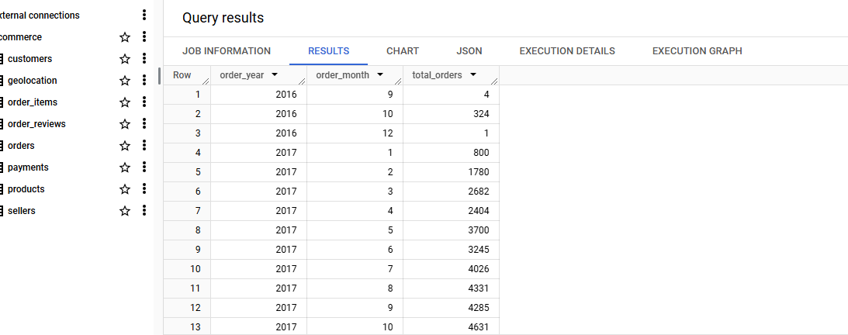

**INSIGHT:**

* This will shows the number of orders placed months of each years 2016 to 2018

**3** .During what time of the day, do the Brazilian customers mostly place their orders? (Dawn, Morning, Afternoon or Night)

0-6 hrs : Dawn

7-12 hrs : Mornings

13-18 hrs : Afternoon

19-23 hrs : Night

**QUERY:** SELECT

    CASE

        WHEN EXTRACT(HOUR FROM order_purchase_timestamp) BETWEEN 0 AND 6 THEN 'Dawn'

        WHEN EXTRACT(HOUR FROM order_purchase_timestamp) BETWEEN 7 AND 12 THEN 'Morning'

        WHEN EXTRACT(HOUR FROM order_purchase_timestamp) BETWEEN 13 AND 18 THEN 'Afternoon'

        WHEN EXTRACT(HOUR FROM order_purchase_timestamp) BETWEEN 19 AND 23 THEN 'Night'

    END AS time_of_day,

    COUNT(*) AS total_orders

FROM

    `Ecommerce.orders`

WHERE

    order_purchase_timestamp BETWEEN '2016-01-01' AND '2018-12-31'

GROUP BY

    time_of_day

ORDER BY

    CASE

        WHEN time_of_day = 'Dawn' THEN 1

        WHEN time_of_day = 'Morning' THEN 2

        WHEN time_of_day = 'Afternoon' THEN 3

        WHEN time_of_day = 'Night' THEN 4

    END;

**OUTPUT:**

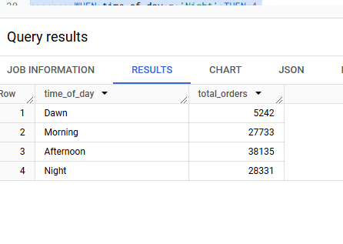

**INSIGHT:**

* This indicate the total no of orders (drawn,morning,afternoon,and night)

3).**Evolution of E-commerce orders in the Brazil region:**

**1.** Get the month on month no. of orders placed in each state.

**QUERY:**

SELECT

    EXTRACT(YEAR FROM o.order_purchase_timestamp) AS order_year,

    EXTRACT(MONTH FROM o.order_purchase_timestamp) AS order_month,

    c.customer_state AS state,

    COUNT(o.order_id) AS total_orders

FROM

    Ecommerce.orders o

JOIN

    Ecommerce.customers c

ON

    o.customer_id = c.customer_id

WHERE

    o.order_purchase_timestamp BETWEEN '2016-01-01' AND '2018-12-31'  -- Adjust the date range as needed

GROUP BY

    order_year, order_month, c.customer_state

ORDER BY

    order_year, order_month, c.customer_state;

**OUTPUT:**

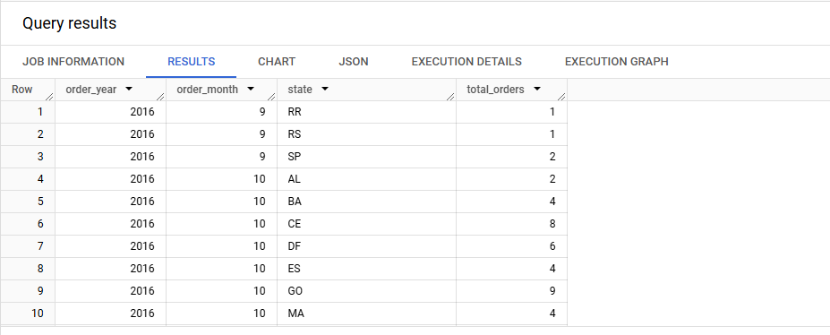

**INSIGHT:**

* You can modify the date range in the WHERE clause to analyze a different period.
* If you want to further analyze the data, you can add filters such as order_status or payment_type to focus on specific types of orders

**2 How are the customers distributed across all the states?**

**QUERY:**

SELECT

  customer_state,

  COUNT(DISTINCT customer_id) AS customer_count,

FROM

  `Ecommerce.customers`

  where customer_state is not null

GROUP BY

  customer_state

ORDER BY

  customer_count DESC;

**OUTPUT:**

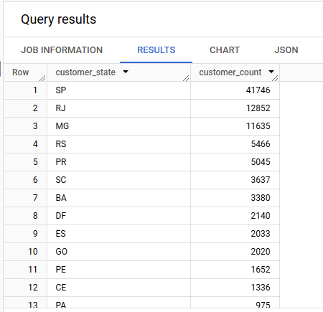

**INSIGHT:**

* the states where customer located (sp and rj)

**4).Impact on Economy: Analyze the money movement by e-commerce by looking at order prices, freight and others.**

**1. Get the % increase in the cost of orders from year 2017 to 2018 (include months between Jan to Aug only).**

**You can use the "payment_value" column in the payments table to get the cost of orders.**

**QUERY:**

WITH OrderCostByYear AS (

  -- Calculate the total payment value for each year, for months Jan-Aug

  SELECT

    EXTRACT(YEAR FROM o.order_purchase_timestamp) AS order_year,

    SUM(p.payment_value) AS total_payment_value

  FROM

    Ecommerce.orders o

  JOIN

    Ecommerce.payments p

  ON

    o.order_id = p.order_id

  WHERE

    EXTRACT(MONTH FROM o.order_purchase_timestamp) BETWEEN 1 AND 8  -- Months Jan-Aug

    AND EXTRACT(YEAR FROM o.order_purchase_timestamp) IN (2017, 2018)  -- Filter for 2017 and 2018

  GROUP BY

    order_year

)

SELECT

  t2017.total_payment_value AS total_payment_value_2017,

  t2018.total_payment_value AS total_payment_value_2018,

  ((t2018.total_payment_value - t2017.total_payment_value) / t2017.total_payment_value) * 100 AS percentage_increase

FROM

  OrderCostByYear t2017

JOIN

  OrderCostByYear t2018

ON

  t2017.order_year = 2017

AND

  t2018.order_year = 2018;

**OUTPUT:**

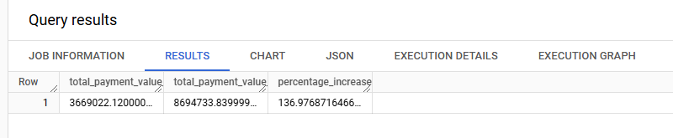

**INSIGHT:**

* Ensure that the payment_value column in the payments table is numeric and represents the total cost of the orders.
* The time range in the WHERE clause is specifically restricted to the months from January to August (months 1 through 8) for both years.

**2.Calculate the Total & Average value of order price for each state.**

**QUERY:**

SELECT c.customer_state AS state,

    SUM(p.payment_value) AS total_order_value,

    AVG(p.payment_value) AS avg_order_value

FROM

    Ecommerce.orders o

JOIN

    Ecommerce.payments p

ON

    o.order_id = p.order_id

JOIN

    Ecommerce.customers c

ON

    o.customer_id = c.customer_id

WHERE

    o.order_purchase_timestamp BETWEEN '2016-01-01' AND '2018-12-31'  -- Filter by date range if needed

GROUP BY

    c.customer_state

ORDER BY

    total_order_value DESC;

**OUTPUT:**

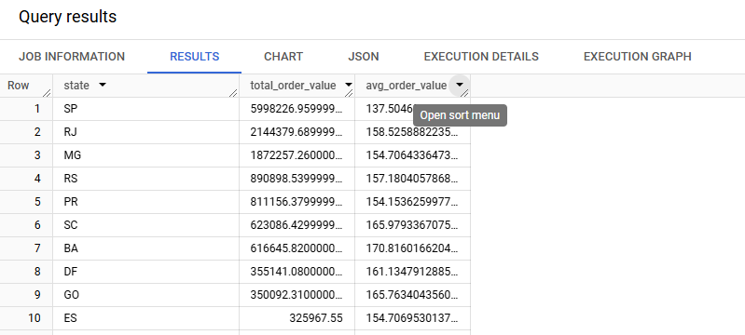

**INSIGHT:**

* total_order_value gives the sum of the payment_value for all orders in each state.
* avg_order_value calculates the average price of an order in each state.
* This analysis helps understand how each state contributes to the overall revenue and provides insights into pricing trends across different regions.

**3.Calculate the Total & Average value of order freight for each state.**

**QUERY:**

SELECT

    c.customer_state AS state,

    SUM(oi.freight_value) AS total_freight_value,

    AVG(oi.freight_value) AS avg_freight_value

FROM

    Ecommerce.orders o

JOIN

    Ecommerce.order_items oi

ON

    o.order_id = oi.order_id

JOIN

    Ecommerce.customers c

ON

    o.customer_id = c.customer_id

WHERE

    o.order_purchase_timestamp BETWEEN '2016-01-01' AND '2018-12-31'  -- Filter by date range if needed

GROUP BY

    c.customer_state

ORDER BY

    total_freight_value DESC;

**OUTPUT:**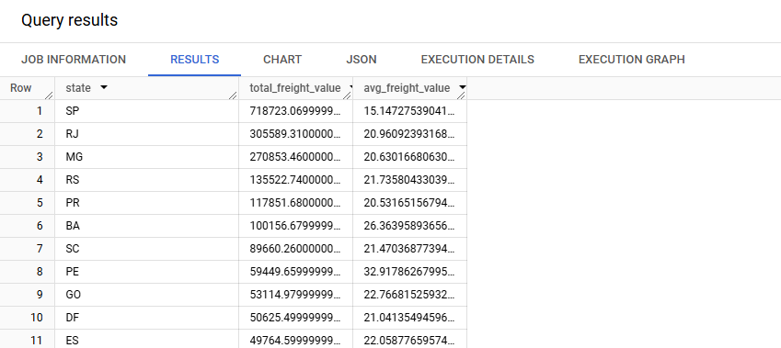

**INSIGHT:**

* Freight costs may vary depending on distance, order size, and other logistics factors. Analyzing freight costs by state can help identify regions where shipping costs are disproportionately high.
* If needed, you can also further break down the freight analysis by month or year to see trends in shipping costs over time.

**5).Analysis based on sales, freight and delivery time.**

**1.Find the no. of days taken to deliver each order from the order’s purchase date as delivery time.Also, calculate the difference (in days) between the estimated & actual delivery date of an order.Do this in a single query.You can calculate the delivery time and the difference between the estimated & actual delivery date using the given formula:time_to_deliver = order_delivered_customer_date - order_purchase_timestampdiff_estimated_delivery = order_delivered_customer_date - order_estimated_delivery_date.**

**QUERY:**

SELECT

    o.order_id,

    -- Calculate the delivery time (time taken to deliver the order)

    DATE_DIFF(o.order_delivered_customer_date, o.order_purchase_timestamp, DAY) AS time_to_deliver,

    -- Calculate the difference between the estimated and actual delivery date

    DATE_DIFF(o.order_delivered_customer_date, o.order_estimated_delivery_date, DAY) AS diff_estimated_delivery

FROM

    Ecommerce.orders o

WHERE

    o.order_delivered_customer_date IS NOT NULL  -- Ensure that delivered orders are considered

    AND o.order_purchase_timestamp IS NOT NULL  -- Ensure that purchase timestamp is available

    AND o.order_estimated_delivery_date IS NOT NULL  -- Ensure estimated delivery date is available

ORDER BY

    o.order_id;

**OUTPUT:**

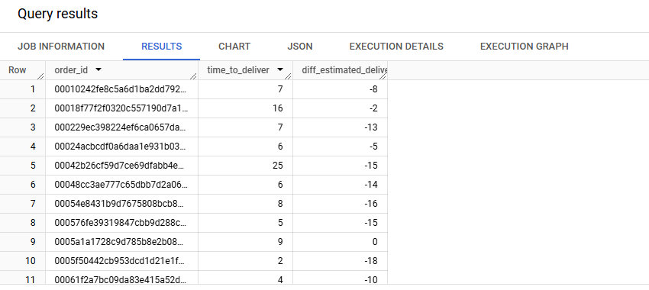

**INSIGHT:**

* If there are any NULL values in the date fields (like order_delivered_customer_date, order_purchase_timestamp, or order_estimated_delivery_date), the WHERE clause will filter those orders out, ensuring we only calculate the differences for orders with complete date information.
* You can adjust the sorting or add more filters (e.g., filtering by specific years or states) depending on the level of detail you want in your analysis.

**2.Find out the top 5 states with the highest & lowest average freight value.**

**QUERY:**

WITH FreightValuesByState AS (

  -- Calculate the average freight value for each state

  SELECT

    c.customer_state AS state,

    AVG(oi.freight_value) AS avg_freight_value

  FROM

    Ecommerce.orders o

  JOIN

    Ecommerce.order_items oi

  ON

    o.order_id = oi.order_id

  JOIN

    Ecommerce.customers c

  ON

    o.customer_id = c.customer_id

  WHERE

    o.order_purchase_timestamp BETWEEN '2016-01-01' AND '2018-12-31'  -- You can adjust the date range as needed

  GROUP BY

    c.customer_state

)

-- Top 5 states with highest average freight value

(SELECT state, avg_freight_value

FROM FreightValuesByState

ORDER BY avg_freight_value DESC

LIMIT 5)

UNION ALL

-- Top 5 states with lowest average freight value

(SELECT state, avg_freight_value

FROM FreightValuesByState

ORDER BY avg_freight_value ASC

LIMIT 5);

**OUTPUT:**

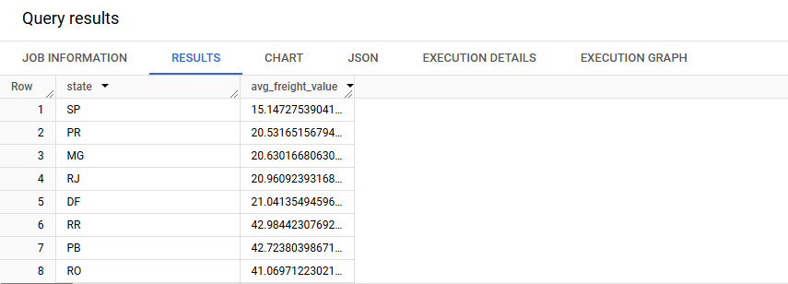

**INSIGHT:**

* Freight value may vary due to factors like distance, order size, or logistics complexities. Understanding these factors can help optimize shipping strategies.
* The date range used here (2016–2018) can be modified as per the analysis period.
* If there are any NULL or missing values in the freight data, they would not be included in the calculations as the query excludes such records by default.**3.Find out the top 5 states with the highest & lowest average delivery time.**

**QUERY:**

WITH DeliveryTimesByState AS (

  -- Calculate the average delivery time for each state

  SELECT

    c.customer_state AS state,

    AVG(DATE_DIFF(o.order_delivered_customer_date, o.order_purchase_timestamp, DAY)) AS avg_delivery_time

  FROM

    Ecommerce.orders o

  JOIN

    Ecommerce.customers c

  ON

    o.customer_id = c.customer_id

  WHERE

    o.order_delivered_customer_date IS NOT NULL  -- Ensure only delivered orders are considered

    AND o.order_purchase_timestamp IS NOT NULL  -- Ensure purchase timestamp is available

    AND o.order_delivered_customer_date IS NOT NULL  -- Ensure delivery date is available

  GROUP BY

    c.customer_state

)

-- Top 5 states with highest average delivery time

(SELECT state, avg_delivery_time

FROM DeliveryTimesByState

ORDER BY avg_delivery_time DESC

LIMIT 5

)

UNION ALL

-- Top 5 states with lowest average delivery time

(SELECT state, avg_delivery_time

FROM DeliveryTimesByState

ORDER BY avg_delivery_time ASC

LIMIT 5)

**OUTPUT:**

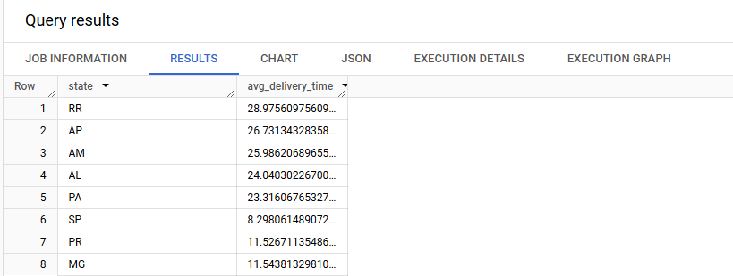

**INSIGHT:**

* The delivery time is only calculated for orders that have a valid purchase timestamp and delivery date.
* The estimated delivery date is not used in the calculation of the average delivery time, but the diff_estimated_delivery can be calculated separately if needed.
* You can modify the date range in the WHERE clause if you want to focus on a different period of time.

**4.Find out the top 5 states where the order delivery is really fast as compared to the estimated date of delivery.**

**You can use the difference between the averages of actual & estimated delivery date to figure out how fast the delivery was for each state.**

**QUERY:**

WITH DeliverySpeedByState AS (

  -- Calculate the average difference between actual and estimated delivery dates

  SELECT

    c.customer_state AS state,

    AVG(DATE_DIFF(o.order_delivered_customer_date, o.order_estimated_delivery_date, DAY)) AS avg_delivery_difference

  FROM

    Ecommerce.orders o

  JOIN

    Ecommerce.customers c

  ON

    o.customer_id = c.customer_id

  WHERE

    o.order_delivered_customer_date IS NOT NULL

    AND o.order_estimated_delivery_date IS NOT NULL

    AND o.order_purchase_timestamp IS NOT NULL

  GROUP BY

    c.customer_state

)

-- Top 5 states where the order delivery is faster (i.e., negative difference between actual and estimated delivery dates)

SELECT state, avg_delivery_difference

FROM DeliverySpeedByState

WHERE avg_delivery_difference < 0  -- Negative values indicate faster delivery

ORDER BY avg_delivery_difference ASC  -- Sort by the most negative values (fastest delivery)

LIMIT 5;

**OUTPUT:**

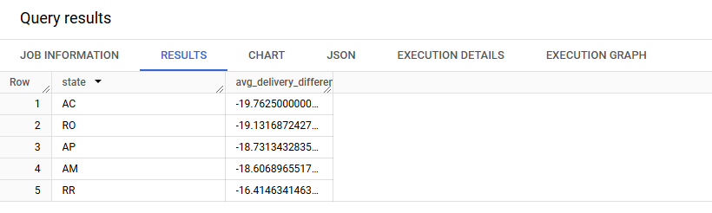

**INSIGHT:**

* This query only considers orders with both valid actual and estimated delivery dates.
* The date range used can be adjusted if needed, and additional filters (such as product category or shipping method) can be added to focus on specific types of orders.

**6).Analysis based on the payments:**

**1.Find the month on month no. of orders placed using different payment types.**

**QUERY:**

SELECT

    EXTRACT(YEAR FROM o.order_purchase_timestamp) AS order_year,

    EXTRACT(MONTH FROM o.order_purchase_timestamp) AS order_month,

    p.payment_type AS payment_type,

    COUNT(o.order_id) AS total_orders

FROM

    Ecommerce.orders o

JOIN

    Ecommerce.payments p

ON

    o.order_id = p.order_id

WHERE

    o.order_purchase_timestamp BETWEEN '2016-01-01' AND '2018-12-31'  -- You can adjust the date range as needed

GROUP BY

    order_year, order_month, payment_type

ORDER BY

    order_year, order_month, payment_type;

**OUTPUT:**

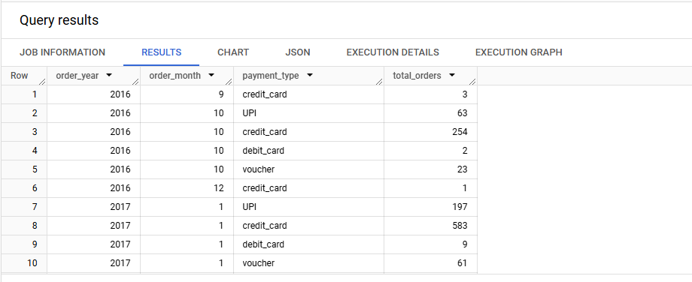

**INSIGHT:**

* If there are any null or missing payment types, they won't be included in the results, so ensure the data is clean.
* You can modify the date range in the WHERE clause to suit your needs.

**2.Find the no. of orders placed on the basis of the payment installments that have been paid.**

**QUERY:**

SELECT

    p.payment_installments AS installment_count,

    COUNT(o.order_id) AS total_orders

FROM

    Ecommerce.orders o

JOIN

    Ecommerce.payments p

ON

    o.order_id = p.order_id

WHERE

    p.payment_installments IS NOT NULL  -- Ensure there are installment details

GROUP BY

    p.payment_installments

ORDER BY

    installment_count;

**OUTPUT:**

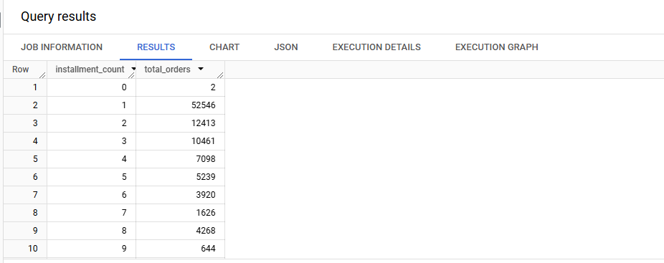

**INSIGHT:**

* Orders with NULL in the payment_installments field will be excluded from the results.
* If a customer selects EMI (Equated Monthly Installments), the number of installments will typically be greater than 1. A single payment (no installments) will be recorded as 1 in the payment_installments field.