CBOT – Computer Based Online Test

A PROJECT REPORT SUBMITTED TO INDIRA GANDHI NATIONAL OPEN UNIVERSITY IN
PARTIAL FULFILLMENT OF THE REQUIREMENTS FOR THE AWARD OF THE DEGREE OF

MASTER OF COMPUTER APPLICATIONS

SUBMITTED BY

BHUVANESWARAN A
012087184

UNDER THE GUIDANCE OF

MR. SURESH RAJA PERUMAL,
Systems Manager
CollabNet Software (P) Ltd., Chennai – 32.



SCHOOL OF COMPUTER AND INFORMATION SCIENCES
INDIRA GANDHI NATIONAL OPEN UNIVERSITY
MAIDAN GARHI, NEW DELHI - 110 068

2007

TABLE OF CONTENTS

1. PROJECT PROFORMA (original copy) 5
2. GUIDE BIO-DATA 7
3. CERTIFICATE OF ORIGINALITY 8
4. PROJECT SYNOPSIS 9
4.1. Introduction 9
4.2. Objective 11
4.3. Feasibility Study 12
4.3.1 Economical Feasibility 12
4.3.2 Technical Feasibility 12
4.3.3 Operational Feasibility 13
4.4. Analysis 13
4.4.1 DFD Diagram 14
4.4.2 Flow Chart 18
4.4.3 Project Description 21
4.4.4 Question Bank Preparation 21
4.4.5 Student Data Upload 22
4.4.6 CBOT Administration 22
4.4.7 CBOT Registration 23
4.4.8 CBOT 23
4.4.9 Evaluation 24
4.4.10 Project Details 25
4.4.11 List Views 25
5. PREFACE 26
6. ACKNOWLEDGEMENTS 28
7. INTRODUCTION 29
8. OBJECTIVE 32
9. SYSTEM ANALYSIS 33
9.1. Preliminary Investigation 34
9.2. Feasibility Study 35
9.2.1 Economical Feasibility 35
9.2.2 Technical Feasibility 35
9.2.3 Operational Feasibility 36
9.3. Project Planning 37
9.4. Project Scheduling 38
9.5. Software Requirements 39
9.6. Hardware Requirements 40
9.7. DFD Diagram 41
10. SYSTEM DESIGN 45
10.1. Project Description 46
10.1.1 CBOT Administration 46
Start Test 47
Re-Enable Test 47
10.1.2 Question Bank Preparation 48
Questions 49
Parsing Engine 50
Upload Engine 50
Validation 50
10.1.3 Candidate Data Upload 51
Upload Engine 52
Online Registration 52
Batch Allocation 53
Email notification 53
Synchronization 54
10.1.4 CBOT 54
Random Questions Generation 55
CBOT Details 55
Feedback 56
Project Details 56
Synchronization 57
Answer Sheet Generation 57
10.1.5 List View 58
Feedbacks List view 58
Candidates List view 59
Answer Sheet 59
10.1.6 Dynamic List view 59
10.2. Software Development (Source code) 60
10.2.1 PHP Libraries and scripts 60
inc/register.inc 60
inc/exam.inc 66
inc/dbi.inc 73
index.php 80
admin/main.php 81
10.2.2 Perl libraries and scripts 82
lib/Login_Gen.pm 83
lib/Calculate_Marks.pm 86
lib/Answer_Sheet.pm 97
bin/login_gen 110
bin/answer_sheet 112
10.3. Database Design 113
10.3.1 Table Definition 113
10.3.2 Functions in Procedural Language 116
10.4. Flow Charts 120
10.5. Optimization 124
10.6. Testing 126
11. COST ESTIMATION OF THE PROJECT 128
11.1. Software Cost 128
11.2. Hardware Cost 128
12. SYSTEM IMPLEMENTATION 129
12.1. Screen Shots 130
12.2. Validation Check 144
12.3. Future Scope of the Project 144
12.4. System Security 146
13. BIBLIOGRAPHY 147
14. REFERENCES 148
14.1. Websites 148

LIST OF FIGURES

Figure 1: Level 1 DFD Diagram 41
Figure 2: Level 2 DFD Diagram - 1 42
Figure 3: Level 2 DFD Diagram - 2 43
Figure 4: Level 2 DFD Diagram - 3 44
Figure 5: Flow chart: Question Bank Preparation 121
Figure 6: Flow chart: Registration & CBOT 122
Figure 7: Flow chart: CBOT Evaluation 123
Figure 8 Admin - Home Page 131
Figure 9 Admin - Enable Re-Test 132
Figure 10 Admin - Start Test 133
Figure 11 Admin - Validate Questions 134
Figure 12 Home Page 135
Figure 13 Login Page 136
Figure 14 Sample Questions 137
Figure 15 Instructions 138
Figure 16 Registration 139
Figure 17 Registration Response 140
Figure 18 CBOT Page 141
Figure 19 Algorithm 142
Figure 20 Feedback 143

PROJECT PROFORMA (original copy)

GUIDE BIO-DATA

Name : Suresh Raja Perumal

Designation : Systems Manager

Address : CollabNet Software (P) Ltd.,
The Lords, Block II,
5th Floor #1, 2,
North Extension Area,
Ekkatuthangal,
Guindy,Chennai – 32.

Age and Sex : 31 Years, Male

Educational Qualification : B.E.

Experience :

2000 – 2005 | Senior Systems Administrator,  Dicardia Inc.  San Carlos, CA, USA
2005 – Till Date | Systems Manager,  CollabNet Software (P) Ltd.  Chennai, India

Company Profile :

CollabNet is the leading provider of collaborative software development solutions.

Website : www.collab.net

CERTIFICATE OF ORIGINALITY

This is to certify that the Project Report entitled CBOT – Computer Based Online Test submitted to Indira Gandhi National Open University (IGNOU) in partial fulfillment of the requirement for the award of the degree of Master of Computer Applications (MCA), is an original work carried out by Mr.BHUVANESWARAN A, 012087184 under my guidance.

The matter embodied in this project is a genuine work done by the student and has not been submitted whether to this University or to any other University / Institute for the fulfillment of the requirement of any course of study.

Student Signature: ____________  Date: Sep 25 2007  Student Name and Address:  BHUVANESWARAN A  012087184  F5, Ashok Manor,  MC Nagar III Main Road,  Hastinapuram, Ch – 64 | Project Guide Signature: _______________  Date: Sep 25 2007  Project Guide Name and Address:  MR. SURESH RAJA PERUMAL  Systems Manager  CollabNet Software (P) Ltd.,  The Lords, Block II, 5th Floor,  North Extension Area,  Ekkatuthangal, Guindy, Chennai – 32.  Website: www.collab.net

PROJECT SYNOPSIS

Introduction

CBOT is a web based application to conduct online exams. The student details are entered in the system by the CBOT team. The login Id and Password would be sent to them through email. They are requested to login, confirm their details and choose any two subjects of their choice to take the CBOT.

Once they choose their subjects, they would be registered for the exam. The CBOT exam center would be alloted based on their college location. The CBOT venue, date & time would be intimated to them.

In the CBOT venue, all the registered candidates are allowed to take the test based on the subjects they have chosen. When they click 'Take Test' link, the questions are generated and the students would be able to take their test. Once they complete the exam, they can log out. The invigilator would request them to enter their feedbacks about the CBOT.

Later, the answers would be evaluated using the program. The students are short-listed based on the marks secured in the CBOT. Then the short-listed candidates would be invited to the next level of the interview.

The email would suggest the candidates to enter their project details online in the website. They are requested to enter their project details. They should also upload the soft copy of their project report.

The separate technical panel would conduct the technical interview. They would screen the candidates for their technical capability. They would again short-list the candidates for the next-level interview. The short-listed candidate details would be entered in the system. The email intimation would be sent to them requesting them to appear for the final interview.

The separate interview panel would conduct the final personal interview. They would short-list the candidates based on their performance. The short-listed candidate details would be entered in the system. The appointment order would be sent to them through the email. They would be requested to report at the branch office on a mentioned date.

Objective

Following are the Core Objective for this Project.

- Provision to generate Login Id and Password
- Provision to register candidate details
- Provision to allot CBOT venue date & time
- Provision to conduct online Test
- Provision to short-list candidates based on the marks obtained in the CBOT
- Provision to intimate the short-listed candidates
- Provision to enter the project details
- Provision to generate the answer sheet
- User Friendly Browser Interface
- SQL Complaint RDBMS

Feasibility Study

The feasibility study has been categorized into three sections. They are listed below.

- Economical Feasibility
- Technical Feasibility
- Operational Feasibility

Economical Feasibility

The solution which is fully customizable is required to address the issue. Moreover, since Linux is a free Operating System and most of the software tools are available for free under Linux, we adopted the method of developing an in-house software to address our need on Linux OS.

Technical Feasibility

Building CBOT project requires familiarity in Linux OS, Apache Web Server and PHP, PERL Scripting Language. Apache Web Server is proven to work efficiently with Linux OS. PHP is proven to work with Apache Web Server. So, this makes CBOT a technically feasible solution.

Operational Feasibility

Since, CBOT is a Web Based Application, the users can use the Web Browser to access the application. With the pleasing online test screen, fully configurable List views, Email Events & Email Contents provided in CBOT, maintenance is near to zero.

Analysis

This chapter provide details about system design that would be performed before the development of this Project work.

These details are modularized as sections and the details are presented in the context of the section heading.

DFD Diagram

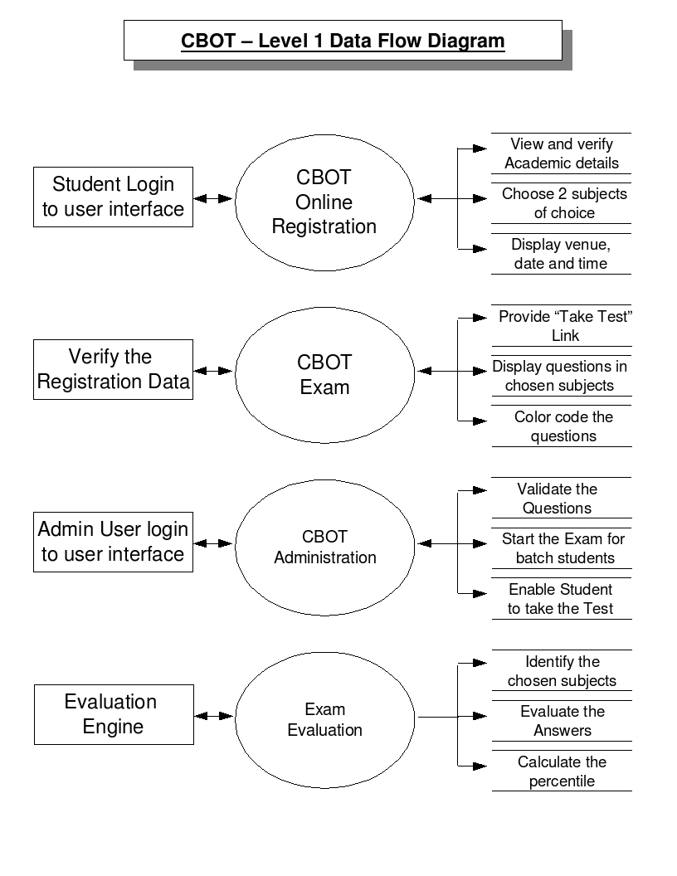

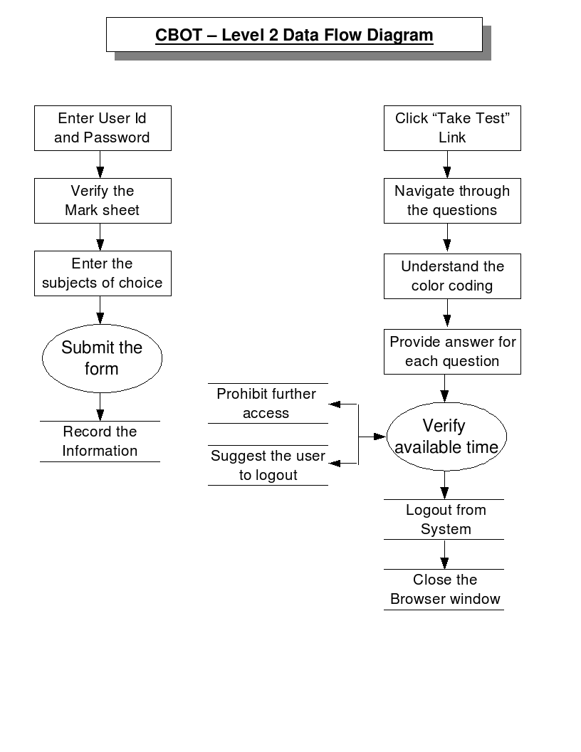

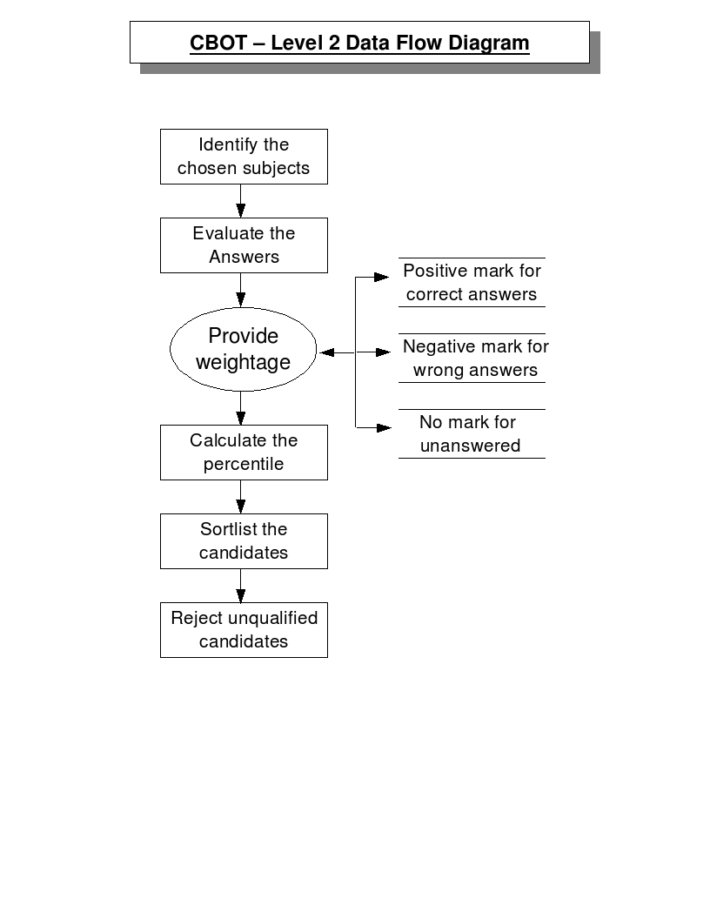
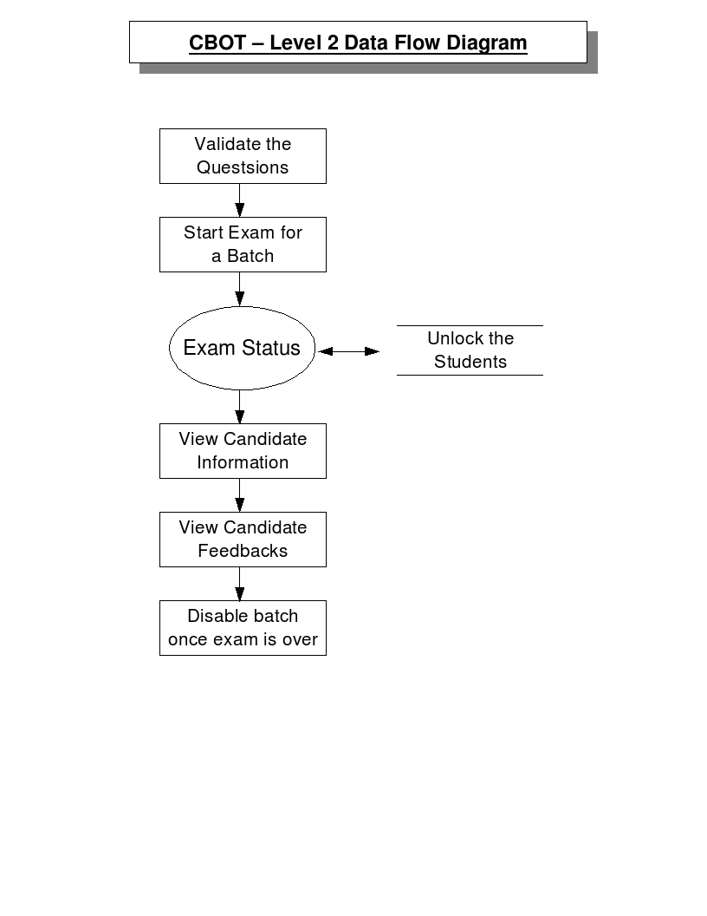

Flow Chart
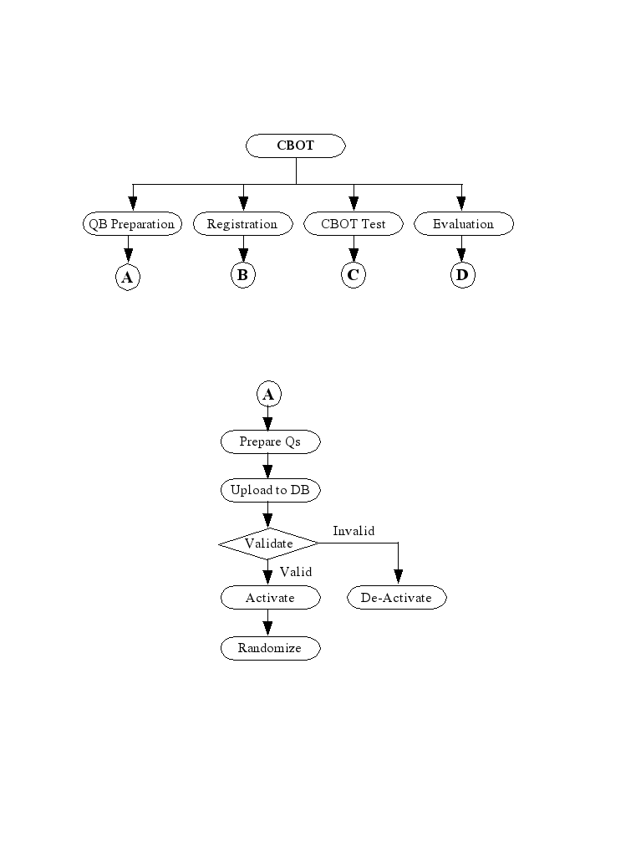
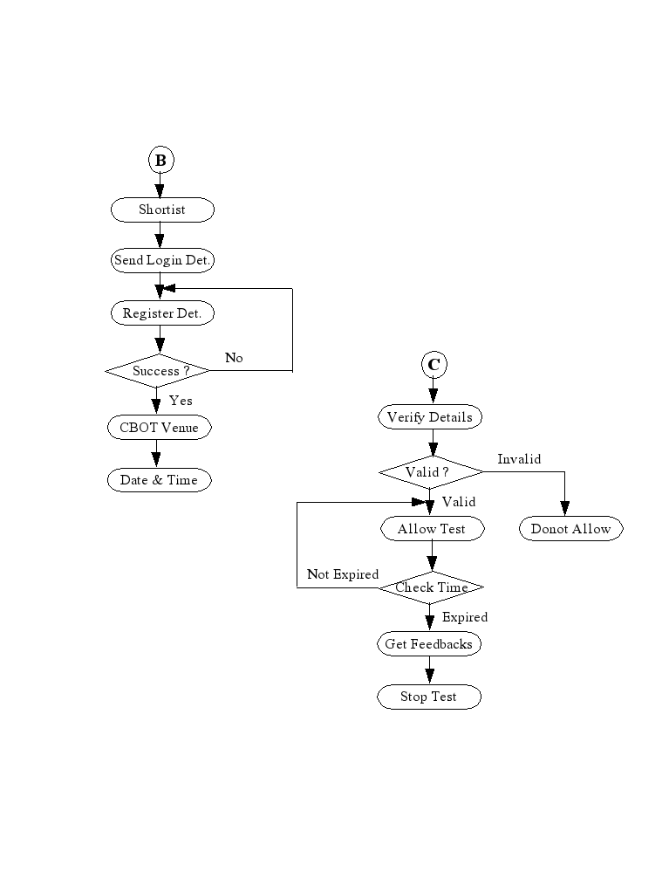
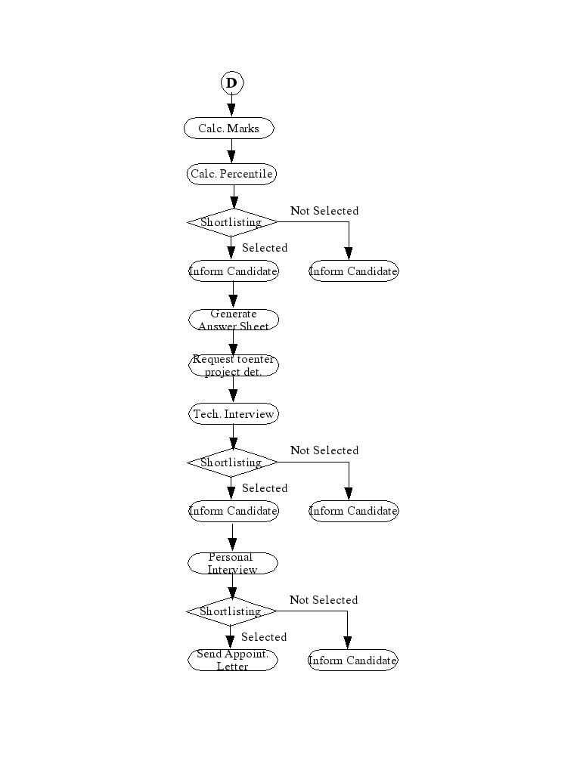

Project Description

The services offered by CBOT are categorized as below:

- Question Bank Preparation
- Student Data Upload
- CBOT Administration
- Online Registration
- CBOT
- Evaluation
- Project Details
- List views
- Email Intimations

Question Bank Preparation

As the CBOT would be conducted based on the subjects chosen by the candidate, separate team would be instructed to prepare the question bank. They would prepare the question bank and upload the details to the RDBMS.

Again, another team would validate the questions thus uploaded. Finally, all the validated questions would be used during the CBOT. The questions would be selected from the validated question bank.

Student Data Upload

Student details are collected from the colleges. The data would be prepared in the spreadsheet. The data thus prepared would be uploaded to the RDBMS using the upload engine. The students would be able to verify the data during CBOT registration.

CBOT Administration

Separate user accounts are created for the CBOT administrators. When they login to the system, they would be able to perform any of the following operations:

- Validate Questions
- Start the CBOT for the mentioned batch number
- Enable candidates to continue the CBOT
- View Candidate CBOT Details
- View Candidate Feedbacks

CBOT Registration

The students would be short-listed based on their academic marks. The Login Id and Password are generated for those candidates. The details would be intimated to them through email. They are requested to login to the website and perform CBOT registration.

During the registration, they are requested to verify their data. It includes, address details, mark details, etc. Once they verify their data, they are requested to choose two subjects of their choice. Thus CBOT would be conducted on the chosen subjects.

At the end of the registration, the CBOT venue, date & time would be calculated based on their college location. They would be alloted to the next available batch. They would be instructed to appear for the CBOT appropriately. Additionally, an email intimation would be sent to them confirming the CBOT details.

CBOT

The registered candidates would appear for the CBOT. They would be permitted to take the CBOT on their chosen subjects. Once their data is verified by the exam invigilator, they would be allowed to take CBOT. The invigilator would configure the system to start the test. The 'Take Test' link would appear in the home page of all the candidates.

Once they click this link, the exam would be started. The exam timer is started. The question no would be available as a link. The candidates can click the question no in order to view & answer that question. Various color coding is used in order to differentiate the various status of the questions. Various questions status would be:

- Not viewed as yet
- Viewed, but not answered
- Answered
- Current Question

The candidates are supposed to complete the test before the exam end time. Once the time is elapsed, they would not be able to proceed. They would be instructed to logout from the system.

Evaluation

Once the CBOT is over, their performance is evaluated. The CBOT evaluation engine would be run in order to calculate the marks obtained by the candidates. The separate recruitment team would use the CBOT data and short-list the candidates. They would be short-listed based on their academic and CBOT performance.

Once the short-listing process is over, the short-listed candidates are listed. The email intimation would be sent to them. They are requested to appear for the next round of interview on the mentioned date & time.

Project Details

Additionally, the short-listed candidates are requested to enter their academic project details in the website. They are requested to enter the details before the next interview date.

During the interview, the interview panel would use the project details entered by the candidates to evaluate the candidate.

List Views

The List views are to show the record wise details of CBOT data. The List view would show the details of all configured database records based on the SQL. The filter panel option would be available. The sort facility would be provided on all the fields. Various list views would be configured for the administrator who would conduct the CBOT.

PREFACE

The project aims at implementing a web based application for conducting Computer Based Online Test for the candidates in order to recruit them for the organization. It is implemented and put to use.

It is developed using Apache Web Server in Linux Operating System. The PHP scripting language is used for user interface. The PERL scripting language is used to perform back-end activities. It includes, parsing the questions in the XML file and updating the question bank database. The PERL scripting language is also used to send email notifications for the candidates.

The PostgreSQL RDBMS is used as the BACKEND. It is one of the powerful RDBMS available in open source.

All users access the CBOT using a web browser. The candidates can register their details, take the CBOT test and enter their project details. They can also view their exam status in the interface provided. The result is announced through an email notification for the candidates. In addition, the candidates can log in to the system to know the result.

The project exploits the advantages provided by PHP, PERL, PostgreSQL. These software are Open Source and freely downloadable, distributed under Various Free Software Licenses.

The Apache Web Server is the popular web server used in the Internet and it is freely available under the Apache license. The PHP scripting language is freely downloadable under GPL user license. Similarly, the PERL scripting language is available under PERL Artistic license and POSTGRESQL database is available under BSD license.

ACKNOWLEDGEMENTS

I wish to express my sincere gratitude to the following persons with whose help and encouragement, I have completed this project work successfully.

Mr. SURESH RAJA PERUMAL, System Administrator, CollabNet Software (P) Ltd., Chennai - 32 for his valuable guidance.

Ms. Gayathri SureshBabu, Systems Engineer, BK SYSTEMS (P) LTD., Chennai – 18 for her co-operation as the team member.

Ms. Mahalakshmi V, Systems Engineer, BK SYSTEMS (P) LTD., Chennai – 18 for her co-operation as the team member.

Finally, I express my sincere thanks to all those who have directly or indirectly rendered their help in successful completion of this project.

INTRODUCTION

The CBOT is a web based application to conduct exams online. The candidate details are entered in the system by the CBOT team. The Login id and Password are automatically generated and sent to the candidates through email. They are requested to login, confirm their details and choose any two subjects of their choice to take the CBOT.

Once they choose their subjects, they would be registered for the exam. The CBOT exam center is allocated based on their college location. The CBOT venue, date & time are intimated to them. The candidates are supposed to come to the CBOT venue on mentioned date and time.

In the CBOT venue, all the registered candidates are allowed to take the test based on the subjects they have chosen. When they click Take Test link, the questions are generated instantly and the candidates can attend the test. The question numbers with Hyperlink are displayed in the screen. When the candidate clicks the link, the question would be displayed. If it is an objective type question, the candidate can choose the correct answer. If it is the fill in the blanks type question, the candidate can enter the correct answer in the input box available.

Normally, the test duration is 90 minutes. The candidate should answer all the questions within this time. Once the test duration is complete, the candidate web session would be expired and he will not able to continue taking the test anymore.

Meanwhile, if there is an abnormal issue like power failure, the session time is started from where it was left. It is determined based on the time of last request from the candidate.

Once they complete the test, they can logout from the system. The user interface is provided to enter the feedback about the CBOT.

Later, the answers are evaluated using a script. The question bank database contains each question and associated answer. The script would verify the answer provided by the candidate with the correct one. The weightage is provided accordingly. The correct answer carries 2 marks. The wrong answer carries -1 mark. If it is not answered, it carries no mark.

The candidates are short-listed based on the marks obtained in the CBOT. Then the short-listed candidates are invited for the next level of the interview.

The email notification is sent to all selected candidates to appear for the next level of interview. The email would suggest the candidates to enter their project details in the CBOT website. Optionally, they should also upload the soft copy of their project report.

The separate technical panel would conduct the technical interview. They would screen the candidates for their technical capability. They would again short-list the candidates for the next-level of the interview. The short-listed candidate details are entered in the system. The email notification is sent to them requesting them to appear for the final interview.

The separate interview panel would conduct the final personal interview. They would short-list the candidates based on their performance. The short-listed candidate details are entered in the system. The appointment order would be sent to them through the email. They are requested to report at the branch office on a mentioned date.

OBJECTIVE

Following are the Core Objectives of this Project:

- Provision to generate Login Id and Password
- Provision to register candidate details
- Provision to perform various administration tasks
- Provision to synchronize the details
- Provision to allocate CBOT batch details
- Provision to allocate venue date & time
- Provision to conduct online Test
- Provision to short-list candidates based on the marks obtained in the CBOT
- Provision to send email notification to the candidates
- Provision to enter the project details
- Provision to generate the answer sheet
- Browser independent and Intuitive user interface
- SQL Complaint RDBMS
- Cost effective solution using Open source software

SYSTEM ANALYSIS

This chapter provide details about system analysis that has been performed before the development of this project work.

These details are modularized as sections and the details are presented in the context of the section heading.

Preliminary Investigation

When there is a request to develop a system to conduct online test, the development team had a discussion with the management team and the interview panel. They gave input and listed the expected result from the proposed system for conducting online tests. The input provided by them is based on their past experience. The team have recruited so many candidates before by conducting the test manually.

Based on the input a tentative work flow model is prepared and submitted to the team for perusal. We also analyzed the user interface for existing online systems which are used for conducting online tests.

Feasibility Study

The feasibility study has been categorized into three sections. They are listed below.

- Economical Feasibility
- Technical Feasibility
- Operational Feasibility

Economical Feasibility

The fully customizable solution is required to address the issue. The web based user interface should be provided, since the technology is proven and it is very easy to use.

Moreover, since Linux is a free OS and most of the software tools are available for free under Linux system, we adopted the method of developing an in-house software to address our need using Linux system.

Technical Feasibility

Building CBOT project requires familiarity in Linux system. It also requires expertise using Apache web server, PHP scripting language for web based interface and PERL scripting language for performing other back-end activities. The PHP scripting language is proven to work very well with Apache web server. So, this made the CBOT system a technically feasible solution.

Operational Feasibility

Since, CBOT is a browser independent web based application, users can use any web browser on any Operating System to access the application. With the pleasing online test screen, fully configurable List views, Email Events & Email Contents provided in CBOT, maintenance is almost near to zero.

Project Planning

The management team planned to have this project ready before they go for the recruitment drive. The project team is formed and the project requirement is spelled out. Depending on the work load for developers, the developers and testing engineers involved in other projects are leased to complete this project.

The estimated project duration is 30 days. Initial 5 days are allocated for preparing the System Requirement Specification (SRS) document and get it finalized discussing with the Management team. Next 15 days are allocated for development. It includes, Database Design, Pseudo code preparation, Flow chart, Coding and Developer testing. Final 10 days are allocated for testing the system with help from testing team.

Project Scheduling

The Project leader is responsible for delivering the project on time. He shared the work with rest of team members as follows:

He took the responsibility of the database design, UI design and implementation.

The Question bank preparation and to write the parsing engine is given to a developer. The complete responsibility is delegated to this developer to ensure the question bank database is filled before the CBOT.

The task of writing the upload engine for the question bank is given to another developer. The task of preparing the logo for question numbers to be displayed in the user interface is given to the same developer.

The freshers who are in training are requested to take a mock-up test before going live. They took the responsibility of testing the system and provide feedback for improving the system.

Software Requirements

Software required for CBOT are as follows:

- Linux OS (Redhat Distribution)
- PostgreSQL RDBMS
- APACHE Web Server with mod_php, mod_auth_pgsql support
- PHP Scripting Language
- PERL Scripting Language
- PERL Modules such as DBI, Data::ShowTable, FileHandle, etc

For accessing the CBOT Application, we need any of the browsers like,

- Internet Explorer 4.01 or above
- Netscape Navigator 4.07 or above
- Mozilla 7.0 or above
- Mozilla Firefox 1.0+

Hardware Requirements

The minimum hardware specification for the CBOT system are as follows:

- Pentium PIII 1.5Ghz
- 40GB HDD / CD Drive
- 512MB Ram

The CBOT website should be hosted with an ISP. So, the website is accessible anywhere for candidates to attend the test.

DFD Diagram

Figure 1: Level 1 DFD Diagram
Figure 2: Level 2 DFD Diagram - 1
Figure 3: Level 2 DFD Diagram - 2
Figure 4: Level 2 DFD Diagram - 3

SYSTEM DESIGN

This chapter provide details about system design that would be performed during the development of this project work.

These details are modularized as sections and the details are presented in the context of the section heading.

Project Description

The services offered by CBOT are categorized as below:

- CBOT Administration
- Question Bank Preparation
- Candidate Data Upload
- Online Registration
- CBOT
- Evaluation
- Project Details
- List views

CBOT Administration

The web based interface is provided to the CBOT Administrator to conduct and manage the CBOT. The Login Id and Password would be intimated to him. The interface is provided to change the password. He can login to the system to perform various administration tasks. He can perform various tasks before the test, during the test and after the test is completed.

Start Test

In the CBOT venue, the administrator should verify the data entered by the candidate in the CBOT system. If the validation is complete, the administrator can start the test at a predetermined time.

The interface to start the test officially is provided to him. He can select the CBOT venue, batch number for which he wish to start the CBOT. Finally, he can click submit in order to start the test for that batch of candidates.

Once he performs this operation, he can instruct the candidates to refresh the home page. A new link Take Test would appear in the home page. If the candidate clicks the link, the questions would be generated and displayed on the screen. The questions are generated in the subjects they have chosen to take the test.

The question numbers with Hyperlink are displayed in the screen. When the candidate clicks the link, the question would be displayed. If it is an objective type question, the candidate can choose the correct answer. If it is the fill in the blanks type question, the candidate can enter the correct answer in the input box available.

Re-Enable Test

When the candidates are taking the CBOT, there is a chance that the exam is terminated accidentally. It would be due to any of the following reasons:

- Power Shutdown
- Computer has hanged
- Browser is closed
- Internet connection is terminated

Due to the above or alike reasons, the candidate(s) might have to re-login to the system. In order to allow them continue their test, the interface is provided to the administrator to enable re-test for the particular candidate. If the administrator enables re-test, the candidate would be able to continue his test from where he have left.

The session timer would start from where it was left before. It is started from the time the candidate have sent the last request.

Question Bank Preparation

Before conducting the CBOT, the question bank for the chosen subjects has to be prepared. A separate technical team is formed to prepare the questions. Once they prepare the questions, they are uploaded to the CBOT database using the upload engine.

Questions

The technical team would prepare the objective type questions. The questions may belong to any of the following types:

- Single Selection
- Multi Selection
- Fill in the blanks

If the question belongs to single selection, there can be one number of possible answer. The candidate has to choose this answer.

If the question belongs to multi selection, there can be many possible answers. The candidate has to choose these answers.

If the question belongs to Fill in the blanks, the candidate has to input the correct answer.

The candidate should also write an algorithm for a given problem during the CBOT. It is mandatory irrespective of the subjects they have chosen.

Parsing Engine

Once the technical team prepares the questions, they can feed them to the parsing engine. The parsing engine would read the questions and convert it to the form which the Upload Engine might use to update to the database. The questions are feed in XML file format. The parsing engine is aware of the rules of the XML file. The file is parsed based on these rules and question details are updated in the database.

Upload Engine

The upload engine would get the data from the parsing engine. It would constructs necessary SQL to enter the question bank details into the database. Once the question bank details are entered into the database, they are displayed in the web interface. The question bank validation team would go through it and ratify them.

Validation

Once the questions are uploaded to the database, they are displayed in the web interface. The QB validation team would go through to activate them. They can view multiple questions and activate them. Alternatively, they can also view the questions one by one and activate them.

The validation team has the discretion to approve the selected questions relevant for the candidates who would be taking the test. They can make rest of questions as inactive. The inactive questions would be used while conducting the test for different set of candidates.

Once they activate the questions, they are added to the CBOT question bank. These questions would be used while conducting the CBOT. When the candidate clicks the Take Test button, 15 questions are generated from this question bank.

Candidate Data Upload

Before the CBOT, the HR team would collect the candidate details, short-list them based on various criterion like Academic performance, Project work and Experience.

The HR team would provide necessary information to the CBOT technical team. It is the responsibility of the technical team to make this information available in the CBOT system. The details are used for communicating with the candidate and to send email notification for them.

Upload Engine

The CBOT team would collect the information and pass the information to the CBOT Upload Engine. This engine would perform the validity check before updating the CBOT database.

Later, the data is used to send email notification to the candidates requesting them to register in CBOT website. The candidates are permitted to register the details up to 24 hrs before the time of CBOT.

Online Registration

On receipt of the email notification, the candidates would access the CBOT website to register the details. They are requested to login using their login id and password. If they have logged in using the correct login id and password, they would be permitted to register the information.

In the registration input form, they are requested to enter the following details:

- Contact details
- Academic Mark details
- Additional Details
- Any 2 CBOT subjects of their choice

Batch Allocation

After entering the registration information, they can click the Submit button. Once they click this button, the registration program would receive the data and update the details in the database.

The registration program would process the collected data and allocate the following details:

- CBOT Batch No
- Serial No
- CBOT Venue
- CBOT Date & Time

These details would be displayed in the registration response page.

Email notification

Once the registration is successful, an automated email notification is sent to the candidate. The details displayed in the response page are sent in the email. The candidates can use this information for future reference.

Synchronization

Once the registration is complete, the Administrator has to synchronize the registration to the business database, because, the CBOT would be conducted using the business database.

The Administrator can run the synchronization program to update the business database. Once the synchronization is complete, the registration data would be available in the business database.

CBOT

When the CBOT registration is over, the candidate is allowed to the take the test. The candidate is requested to report at the CBOT venue on a predefined date and time.

In the CBOT venue, the Administrator would verify the data entered in the CBOT system. If the validation is complete, the Administrator would start the test. The Administrator can click the Start Test button in his Login screen to start the test officially. Once he clicks the button, the candidates are requested to refresh the home page. The new link Take Test is displayed in the home page. The candidate can click this link to start the test.

Random Questions Generation

Once the candidate clicks the Take Test link, the questions are generated. In total, 15 questions are generated in each subject. The question numbers are displayed in all screen. The candidate can click the question number to view and provide an answer for the question.

The candidate can answer one question at a time. The questions are generated on a random order. All the candidates in the batch would get the same set of questions. But the order in which they appear are different.

CBOT Details

The candidate would be able to answer the questions one by one. The color coding is used in order to display various types of questions. They are:

- Current Question
- Answered Question
- Viewed, but not answered
- Not Viewed

The candidate can view any questions at any time. They would be able to re-answer the question any number of times.

Before the CBOT, the candidates have been instructed about the marks. The correct answer carries 2 marks. The wrong answer carries -1 mark. If it is not answered, it would carry 0 mark.

Once the candidate have completed his CBOT, he can logout from the system. Alternatively, if the CBOT time is expired, he would not be able to continue the test. He would be forced to logout from the system.

Feedback

Once the CBOT is over, the candidates are requested to enter their feedback about the CBOT. The user interface is provided for this purpose. They would enter their feedback and click the Submit button. When they click the Submit button, their feedback would be recorded in the system.

Project Details

Once the CBOT Is over, the performance of the candidates would be evaluated. The separate recruitment team would short-list the candidates based on various criterion. It includes the mark they obtained in this test, Mark secured in their diploma/degree semesters.

Finally, they would provide the short-listed candidate details to the CBOT technical team. The CBOT technical team would send the email notification to the short-listed candidates. They would be requested to appear for the Technical Interview on a mentioned date. It would send the email notification to the candidates who have not been short-listed as well.

In addition, the details would be posted in the website. The candidates can login to the system to check their status.

If the candidate is short-listed, he would be requested to enter their academic project details. The input form would be provided to them. They would enter the details. If they have the soft copy of their project, they would upload it to the system.

Synchronization

Once the candidates have entered their project details, the administrator has to synchronize the details to the business database. The project details would be part of the answer sheet. The Technical Interview panel would use the answer sheet while screening the candidates.

Answer Sheet Generation

Once the project details are synchronized to the business database, the answer sheet would be generated. The answer sheet would contain the following details:

- CBOT Performance
- Academic Details
- Contact Details
- College Details
- Project Details

List View

The list views are provided for the Administrators. The database records are shown in the list view. The following list views are configured for the Administrators:

- Feedbacks List view
- Candidates List view
- Answer Sheet

Feedbacks List view

Feedbacks List view would contain the details of the feedback entered by the candidates during the CBOT.

Candidates List view

Candidates List view would contain the details of all the candidates. The details include, college details, academic details, chosen subjects, etc.

Answer Sheet

Answer Sheet would contain the CBOT details of all the candidates. The details include, Marks Secured, Percentile Secured, Positive & Negative Marks, etc.

Dynamic List view

One more advantage of using the CBOT system is, it has a dynamic list view facility. The Administrator has the ability to define a new list view dynamically. He can define a pre-defined data structure for a intended list view. The data structure should contain following information:

- List view title
- SQL query
- Fields to display in Filter Panel
- Fields to provide sort facility
- Number of records to display in one screen
- Print PDF (Yes/No)

Software Development (Source code)

In this section we have included the source code for the project. The source code for couple of libraries and scripts are included in this section. Due to no of pages limitation, we are unable to attach the complete source code. For complete source code, please refer to the CD attached with this project report.

PHP Libraries and scripts

inc/register.inc

The PHP library to register the candidate information in CBOT system. The library is responsible to draw the register input form for the candidates. It also serves as a action page for the input form, updates the candidate information in the database and displays the response page. The error handling is also done by the same library.

<?php

function draw_register_form()
{
global $MISC, $TABLE, $BODY;
global $_REQUEST;

start_body($BODY, false);

$Form = array
(
"NAME" => "register",
"METHOD" => "POST",
"ACTION" => "main.php",
"TARGET" => "_self",
"onSubmit"=> "return validate_register_form(this);",
);

$TABLE["CPADDING"] = '3';
$TABLE["CSPACING"] = '1';
$TABLE["ALIGN"] = 'center';
$TABLE["WIDTH"] = '80%';
$Td_Class = 'white';
$Logo = $MISC["PRODUCT_LOGO"];

start_form($Form);
start_table($TABLE);
start_tr(); echo "<td class=$Td_Class colspan=2>";
draw_title('REG_FORM'); echo "</td>"; end_tr();

start_tr(); echo "<td class=$Td_Class colspan=2>";
draw_product_logo($Logo); echo "</td>"; end_tr();

start_tr(); echo "<td class=$Td_Class colspan=2>";
draw_user_header(); echo "</td>"; end_tr();

start_tr(); echo "<td class=$Td_Class colspan=2>";

$TABLE["WIDTH"] = '100%';
$TABLE["CPADDING"] = '3';
$TABLE["CSPACING"] = '0';

start_table($TABLE);

// start_tr();
// echo "<td class=$Td_Class colspan=2 align=right><font class=corporate><a href='./login.php?LOGOUT=1'>Logout</a></font></td>"; end_tr();
// end_tr();

start_tr();
echo "<td class=$Td_Class colspan=2>";
draw_register_input_form();
echo "</td>";
end_tr();

end_table(); echo "</td>"; end_tr();

start_tr();
echo "<TD ALIGN='CENTER' class='$Td_Class' colspan=2>";
echo "<INPUT TYPE='HIDDEN' NAME='REG' VALUE='1'></INPUT>";
echo "<INPUT TYPE='HIDDEN' NAME='RESP' VALUE='1'></INPUT>";
echo "<INPUT ALIGN='CENTER' TYPE='Submit' NAME='Submit' VALUE='Register'></INPUT>";
echo "<INPUT ALIGN='CENTER' TYPE='Reset' NAME='Clear' VALUE='Clear'></INPUT></td>";
end_tr();

echo "<tr><td align=center class=white>";
draw_copyright();
echo "</tr></td>";
end_table();
end_form();

end_body();
}

function draw_register_input_form()
{
global $REGISTER_FIELDS;
$Details = get_register_details (get_login());

list ($Name, $Dob, $Email, $AEmail, $College, $Branch, $Father, $Add1,
$Add2, $Add3, $Phone, $Sem1, $Sem2, $Sem3, $Sem4, $Sem5, $Sem6, $High,
$High_Outof, $Higher, $Higher_Outof) = $Details;

$Td_Class = 'white';
$TABLE["WIDTH"] = '100%';
$TABLE["CPADDING"] = '3';
$TABLE["CSPACING"] = '0';
$TABLE["BORDER"] = '0';

start_table($TABLE);

array_unshift ($REGISTER_FIELDS['NAME'], $Name);
array_unshift ($REGISTER_FIELDS['DOB'], $Dob);
array_unshift ($REGISTER_FIELDS['EMAIL'], $Email);
array_unshift ($REGISTER_FIELDS['AEMAIL'], $AEmail);
array_unshift ($REGISTER_FIELDS['COLLEGE'], $College);
array_unshift ($REGISTER_FIELDS['BRANCH'], $Branch);
array_unshift ($REGISTER_FIELDS['FATHER'], $Father);
array_unshift ($REGISTER_FIELDS['ADD1'], $Add1);
array_unshift ($REGISTER_FIELDS['ADD2'], $Add2);
array_unshift ($REGISTER_FIELDS['ADD3'], $Add3);
array_unshift ($REGISTER_FIELDS['PHONE'], $Phone);
array_unshift ($REGISTER_FIELDS['SEM1'], $Sem1);
array_unshift ($REGISTER_FIELDS['SEM2'], $Sem2);
array_unshift ($REGISTER_FIELDS['SEM3'], $Sem3);
array_unshift ($REGISTER_FIELDS['SEM4'], $Sem4);
array_unshift ($REGISTER_FIELDS['SEM5'], $Sem5);
array_unshift ($REGISTER_FIELDS['SEM6'], $Sem6);
array_unshift ($REGISTER_FIELDS['HIGH'], $High);
array_unshift ($REGISTER_FIELDS['HIGH_OUTOF'], $High_Outof);
array_unshift ($REGISTER_FIELDS['HIGHER'], $Higher);
array_unshift ($REGISTER_FIELDS['HIGHER_OUTOF'], $Higher_Outof);

$Mark = "*";
foreach ($REGISTER_FIELDS as $Field => $Array)
{
list ($Value, $Db_Field, $Label, $Input, $Mandatory, $Length) = $Array;

start_tr();
echo "<td class=$Td_Class align=right width=40% colspan=2><font class=corporate>$Label :</font></td>";
if ($Input == true)
{
echo "<td class=$Td_Class colspan=2><input type=textbox name='$Field' value='$Value' size=$Length maxlength='50'>";
if ($Mandatory == true)
{
echo "<font class=corporate>$Mark</font>";
}
echo "</td>";
}
else
{
echo "<td class=$Td_Class colspan=2><font class=label>&nbsp;$Value</font></td>";
}
end_tr();
}

start_tr();
echo "<td class=$Td_Class valign=top align=right width=40% colspan=2><font class=corporate>Selected Subjects:</font></td>";
echo "<td class=$Td_Class colspan=2><font class=label>";

$Subjects = array();
$Subjects = get_subjects_by_login_id (get_login());
Dprint ($Subjects);
if ($Subjects)
{
echo "<input type=hidden name='SUBJECT_EDIT' value=0>";
foreach ($Subjects as $Key => $Subject)
{
echo "$Subject<br>";
}
}
else
{
echo "<input type=hidden name='SUBJECT_EDIT' value=1>";
foreach (get_all_subjects() as $Key => $Subject)
{
echo "<input type=checkbox name='$Subject' value='1' onChange=\"validate_subjects(this); return false;\">&nbsp; <font class=corporate>$Subject</font><br>";
}
}

echo "</td>"; end_tr();

start_tr();
echo "<td class=$Td_Class valign=top align=left width=40% colspan=4><font class=corporate>All the fields marked as $Mark are Mandatory Fields</font></td>";
end_tr();

end_table();
}

function draw_register_resp()
{
global $MISC, $TABLE, $BODY;
global $_REQUEST, $REGISTER_FIELDS;

start_body($BODY, false);

$TABLE["CPADDING"] = '3';
$TABLE["CSPACING"] = '1';
$TABLE["ALIGN"] = 'center';
$TABLE["WIDTH"] = '80%';
$Td_Class = 'white';
$Logo = $MISC["PRODUCT_LOGO"];

start_table($TABLE);
start_tr(); echo "<td class=$Td_Class colspan=2>";
draw_title('REG_RESP'); echo "</td>"; end_tr();

start_tr(); echo "<td class=$Td_Class colspan=2>";
draw_product_logo($Logo); echo "</td>"; end_tr();

start_tr(); echo "<td class=$Td_Class colspan=2>";
draw_user_header(); echo "</td>"; end_tr();

start_tr(); echo "<td class=$Td_Class colspan=2>";

$TABLE["WIDTH"] = '100%';
$TABLE["CPADDING"] = '3';
$TABLE["CSPACING"] = '0';

start_table($TABLE);

// start_tr();
// echo "<td class=$Td_Class colspan=2 align=right><font class=corporate><a href='./login.php?LOGOUT=1'>Logout</a></font></td>"; end_tr();
// end_tr();

Dprint ($_REQUEST);
Dprint ("<br>");
Dprint ($REGISTER_FIELDS);
update_reg_details(get_login());
if ($_REQUEST["SUBJECT_EDIT"] == 1)
{
update_subject_details(get_login());
}

start_tr();
echo "<td class=$Td_Class colspan=2>";
draw_register_input_resp();
echo "</td>";
end_tr();

end_table(); echo "</td>"; end_tr();

echo "<tr><td align=center class=white>";
draw_copyright();
echo "</tr></td>";
end_table();

end_body();
}

function draw_register_input_resp()
{
global $REGISTER_FIELDS;
$Details = get_register_details (get_login());

list ($Name, $Dob, $Email, $AEmail, $College, $Branch, $Father, $Add1,
$Add2, $Add3, $Phone, $Sem1, $Sem2, $Sem3, $Sem4, $Sem5, $Sem6, $High,
$High_Outof, $Higher, $Higher_Outof) = $Details;

$Td_Class = 'white';
$TABLE["WIDTH"] = '100%';
$TABLE["CPADDING"] = '3';
$TABLE["CSPACING"] = '0';
$TABLE["BORDER"] = '0';

start_table($TABLE);

array_unshift ($REGISTER_FIELDS['NAME'], $Name);
array_unshift ($REGISTER_FIELDS['DOB'], $Dob);
array_unshift ($REGISTER_FIELDS['EMAIL'], $Email);
array_unshift ($REGISTER_FIELDS['AEMAIL'], $AEmail);
array_unshift ($REGISTER_FIELDS['COLLEGE'], $College);
array_unshift ($REGISTER_FIELDS['BRANCH'], $Branch);
array_unshift ($REGISTER_FIELDS['FATHER'], $Father);
array_unshift ($REGISTER_FIELDS['ADD1'], $Add1);
array_unshift ($REGISTER_FIELDS['ADD2'], $Add2);
array_unshift ($REGISTER_FIELDS['ADD3'], $Add3);
array_unshift ($REGISTER_FIELDS['PHONE'], $Phone);
array_unshift ($REGISTER_FIELDS['SEM1'], $Sem1);
array_unshift ($REGISTER_FIELDS['SEM2'], $Sem2);
array_unshift ($REGISTER_FIELDS['SEM3'], $Sem3);
array_unshift ($REGISTER_FIELDS['SEM4'], $Sem4);
array_unshift ($REGISTER_FIELDS['SEM5'], $Sem5);
array_unshift ($REGISTER_FIELDS['SEM6'], $Sem6);
array_unshift ($REGISTER_FIELDS['HIGH'], $High);
array_unshift ($REGISTER_FIELDS['HIGH_OUTOF'], $High_Outof);
array_unshift ($REGISTER_FIELDS['HIGHER'], $Higher);
array_unshift ($REGISTER_FIELDS['HIGHER_OUTOF'], $Higher_Outof);

foreach ($REGISTER_FIELDS as $Field => $Array)
{
list ($Value, $Db_Field, $Label, $Input, $Mandatory, $Length) = $Array;

start_tr();
echo "<td class=$Td_Class align=right width=40% colspan=2><font class=corporate>$Label :</font></td>";
echo "<td class=$Td_Class colspan=2><font class=label>&nbsp;$Value</font></td>";
end_tr();
}

start_tr();
echo "<td class=$Td_Class valign=top align=right width=40% colspan=2><font class=corporate>Selected Subjects:</font></td>";
echo "<td class=$Td_Class colspan=2><font class=label>";
foreach (get_subjects_by_login_id(get_login()) as $Key => $Subject)
{
echo "$Subject<br>";
}
echo "</td>"; end_tr();

start_tr();
echo "<td class=$Td_Class align=center width=40% colspan=4><a href='./main.php?REG=1'>Click here</a> <font class=corporate>if you wish to edit the above details</font></td>";
end_tr();

$Count = questions_count (get_login());

if ($Count > 0)
{
$Link = "./main.php?CONTINUE=1";
$Text = "Click Here to Continue your Exam";
}
else
{
$Link = "./main.php?EXAM=1";
$Text = "Click Here to Start your Exam";
}

start_tr();
echo "<td class=$Td_Class align=center width=40% colspan=4><a href='$Link'>$Text</a></td>";
end_tr();

end_table();
}

?>

inc/exam.inc

The library is responsible to display the exam form for the candidate during the test. The set of questions are identified for the batch and they are sorted in random order for each candidate and displayed in the user interface. The library is also responsible to keep track of expiry time.

<?php

function draw_exam_form()
{
global $MISC, $TABLE, $BODY;
global $_REQUEST;

start_body($BODY, false);

$Form = array
(
"NAME" => "exam",
"METHOD" => "POST",
"ACTION" => "main.php",
"TARGET" => "_self",
);

$TABLE["CPADDING"] = '3';
$TABLE["CSPACING"] = '1';
$TABLE["ALIGN"] = 'center';
$TABLE["WIDTH"] = '80%';

$Td_Class = 'white';
$Logo = $MISC["PRODUCT_LOGO"];

if ($_REQUEST["EXAM"] == true)
{
generate_questions();
if ($MISC["ALGORITHM"] == true)
{
generate_algorithm();
}
update_exam_start_time(get_login());
}
else if ($_REQUEST["SQ_NO"] == true)
{
$Sq_No = $_REQUEST["SQ_NO"];
$Value = $_REQUEST["A" . $Sq_No];
$Type = $_REQUEST["QTYPE"];

if ($Value == true || $Type == true)
{
if (strtoupper($Type) == 'MULTIPLE')
{
update_multi_answer_details (get_login(), $Sq_No);
}
else
{
update_answer_details (get_login(), $Sq_No, $Value, $Type);
}
}
}

if (!$_REQUEST["QNO"]) { $QNo = 1; }
else { $QNo = $_REQUEST["QNO"]; }

if ($_REQUEST["SUBJECT"])
{
$Subject = $_REQUEST["SUBJECT"];
}
else
{
$Subjects = get_subjects_by_login_id(get_login());
$Subject = $Subjects[0];
}

start_form($Form);
start_table($TABLE);
start_tr(); echo "<td class=$Td_Class colspan=2>";
draw_title('EXAM_FORM'); echo "</td>"; end_tr();

start_tr(); echo "<td class=$Td_Class colspan=2>";
draw_product_logo($Logo); echo "</td>"; end_tr();

start_tr(); echo "<td class=$Td_Class colspan=2>";
draw_user_header(); echo "</td>"; end_tr();

start_tr(); echo "<td class=$Td_Class colspan=2>";
$Remaining = draw_time_details(get_login()); echo "</td>"; end_tr();

start_tr();
echo "<td class=$Td_Class>"; draw_subject_links($Subject, $QNo); echo "</td>";
echo "<td class=$Td_Class>";
if ($MISC["ALGORITHM"] == true)
{
echo "<a href='./main.php?ALG=1'>Algorithm</a><br>";
}
echo "<a href='./login.php?LOGOUT=1'>Logout</a>";
echo "</td>";

end_tr();

start_tr(); echo "<td class=$Td_Class colspan=2>";

$TABLE["WIDTH"] = '100%';
$TABLE["CPADDING"] = '3';
$TABLE["CSPACING"] = '0';

start_table($TABLE);

// start_tr();
// echo "<td class=$Td_Class colspan=2 align=right><font class=corporate><a href='./login.php?LOGOUT=1'>Logout</a></font></td>"; end_tr();
// end_tr();

Dprint ("QNo :$QNo:<br>");
if ($Remaining > 0)
{
start_tr();
echo "<td class=$Td_Class colspan=2>";
if ($_REQUEST["ALG"])
{
$QNos = get_algorithm_nos (1, 1);
$QNo = $QNos[0];
Dprint ("Algorithm QNo :$QNo:<br>");

list ($Global_QNo, $Type) = draw_algorithm(get_login(), $QNo, $Remaining);
Dprint ("Global_QNo :$Global_QNo: Type :$Type:<br>");
}
else
{
list ($Global_QNo, $Type) = draw_question(get_login(), $Subject, $QNo, $Remaining);
Dprint ("Global_QNo :$Global_QNo: Type :$Type:<br>");
}

echo "</td>";
end_tr();

start_tr();
echo "<td class=$Td_Class colspan=2>";
draw_option($Global_QNo, $Type);
echo "</td>";
end_tr();
}
else
{
start_tr();
echo "<td class=$Td_Class colspan=2>";
draw_time_expiry_text();
echo "</td>";
end_tr();
}

end_table(); echo "</td>"; end_tr();

start_tr();
echo "<TD ALIGN='CENTER' class='$Td_Class' colspan=2>";
if ($QNo < $MISC["NOOF_QUESTIONS_PER_SUBJECT"])
{
$QNo = $QNo + 1;
}
else
{
$QNo = 1;
$Subjects = get_subjects_by_login_id(get_login());
if ($Subject == $Subjects[0]) { $Subject = $Subjects[1]; }
else { $Subject = $Subjects[0]; }
}
echo "<INPUT TYPE='HIDDEN' NAME='QNO' VALUE='$QNo'></INPUT>";
echo "<INPUT TYPE='HIDDEN' NAME='SUBJECT' VALUE='$Subject'></INPUT>";
echo "<INPUT ALIGN='CENTER' TYPE='Submit' NAME='Submit' VALUE='Submit'></INPUT>";
echo "<INPUT ALIGN='CENTER' TYPE='Reset' NAME='Clear' VALUE='Clear'></INPUT></td>";
end_tr();

echo "<tr><td align=center class=white colspan=2>";
draw_copyright();
echo "</tr></td>";
end_table();
end_form();

end_body();
}

function draw_time_expiry_text()
{
global $MISC;

$Mesg = $MISC["TIME_EXPIRY_MSG"];
echo "<font class='alert'>$Mesg<br></font>";
}

function generate_questions()
{
global $MISC;

$Noof_Qs = $MISC["NOOF_QUESTIONS_PER_SUBJECT"];
$Start = 1;
$End = $Noof_Qs;

foreach (get_subjects_by_login_id (get_login()) as $Key => $Subject)
{
srand ((float)microtime() * 10000000);
$Random_QNos[$Subject] = array();
$DB_Question_Nos[$Subject] = array();
$Question_Keys = array();
$DB_Question_Nos[$Subject] = get_question_nos($Subject, $Start, $End);

$Question_Keys = array_rand($DB_Question_Nos[$Subject], $Noof_Qs);

foreach ($Question_Keys as $Key => $Index)
{
$QNo = $DB_Question_Nos[$Subject][$Index];
insert_question_details (get_student_no(get_login()), $QNo, $Key + 1);
}
}
}

function generate_algorithm()
{
global $MISC;

$Noof_Qs = $MISC["NOOF_ALGORITHMS_PER_SUBJECT"];
$Start = 1; // This value has to be changed by the admin for each batch
$End = $Noof_Qs;

// srand ((float)microtime() * 10000000);
// $Random_QNos = array();
$DB_Question_Nos = array();
// $Question_Keys = array();
$DB_Question_Nos = get_algorithm_nos ($Start, $End);

// $Question_Keys = array_rand($DB_Question_Nos, $Noof_Qs);

$QNo = $DB_Question_Nos[0];
insert_algorithm_details (get_student_no(get_login()), $QNo, $Key + 1);
}

function draw_time_details($Login_Id)
{
global $TABLE, $MISC;

$Start_Epoch = get_exam_start_time($Login_Id);

$TABLE["WIDTH"] = '100%';
$TABLE["CPADDING"] = '0';
$TABLE["CSPACING"] = '0';

$Stime = convert_epoch_to_ts($Start_Epoch);
$Epoch = time();
$Ctime = convert_epoch_to_ts($Epoch);

$Total = $MISC["TOTAL_EXAM_DURATION"] * 60;
$Elapsed = $Epoch - $Start_Epoch;
$Remaining = $Total - $Elapsed;

$Total = select_duration($Total);
$Elapsed = select_duration($Elapsed);
$Remain_Sec= $Remaining;
$Remaining = select_duration($Remaining);

start_table($TABLE);
start_tr();
echo "<td class=white align='left' colspan=2><font class='corporate'>Start Time: &nbsp; </font> <font class='headdata'> $Stime </font></td>";
echo "<td class=white align='left' colspan=2><font class='corporate'>Current Time: &nbsp; </font><font class='headdata'> $Ctime </font></td>";
end_tr();

start_tr();
echo "<td class=white align='left' colspan=2><font class='corporate'>Total Time : &nbsp </font> <font class='headdata'> $Total </font></td>";
echo "<td class=white align='left'><font class='corporate'>Elapsed Time : &nbsp </font> <font class='headdata'> $Elapsed </font></td>";
echo "<td class=white align='left'><font class='corporate'>Remaining Time: &nbsp </font><font class='headdata'> $Remaining </font></td>";
end_tr();
end_table();
return $Remain_Sec;
}

function draw_subject_links($Curr_Sub, $QNo)
{
global $TABLE, $MISC;

$TABLE["WIDTH"] = '100%';
$TABLE["CPADDING"] = '2';
$TABLE["CSPACING"] = '1';

$Total = $MISC["NOOF_QUESTIONS_PER_SUBJECT"];
start_table($TABLE);
foreach (get_subjects_by_login_id(get_login()) as $Key => $Subject)
{
start_tr();
$Start = 1; $Count = 1;
Dprint ("Total :$Total: Start :$Start: Count :$Count:<br>");
echo "<td class=white align='right'><font class='headdata'>&nbsp;$Subject&nbsp;</font></td>";
echo "<td class=white align='left'>";
while ($Count <= $Total)
{
$Url = "./main.php?SUBJECT=$Subject&QNO=$Count";
if ($Count == $QNo && $Curr_Sub == $Subject) { $Class = 'clink'; }
else { $Class = 'alink'; }
echo "&nbsp;&nbsp;<a href='$Url'><font class='$Class'>$Count</font></a>&nbsp;";
$Count++;
}
echo "</td>";
end_tr();
}

end_table();
}

function draw_algorithm ($Login_Id, $QNo, $Remaining)
{
draw_time_alert ($Remaining);
list ($Global_QNo, $Type, $Question) = get_algorithm_name ($Login_Id, $QNo);

echo "<br><pre width=60>$Question</pre><br>";
return array ($Global_QNo, $Type);
}

function draw_question($Login_Id, $Subject, $QNo, $Remaining)
{
draw_time_alert($Remaining);
list ($Global_QNo, $Type, $Question) = get_question_name ($Login_Id, $Subject, $QNo);
echo "<br><pre width=90>$Question</pre><br>";
return array ($Global_QNo, $Type);
}

function draw_time_alert ($Remaining)
{
global $MISC;
$Alert = $MISC["ALERT_BEFORE"] * 60; //Seconds

if ($Remaining <= $Alert)
{
$Remaining = select_duration ($Remaining, "SQL, EUROPEAN");
$Remaining = preg_replace ("/@/", "", $Remaining);
echo "<font class='alert'>REMAINING Time: $Remaining</font>";
}
}

function draw_option ($Global_QNo, $Type)
{
$Options = get_options ($Global_QNo);
$Name = 'A' . $Global_QNo;

foreach ($Options as $Key => $Record)
{
list ($Option_No, $Option) = $Record;
if (strtoupper($Type) == 'SINGLE')
{
$Opt_Det = get_exam_option_details (get_login(), $Global_QNo);
list ($Old_Option, $Old_Value) = $Opt_Det[0];

if ($Option_No == $Old_Option) { $Checked = 'CHECKED'; }
else { $Checked = ''; }
echo "<input type=radio name='$Name' value='$Option_No' $Checked>$Option";
}
else if (strtoupper($Type) == 'MULTIPLE')
{
$Checked = '';
$Opt_Det = get_exam_option_details (get_login(), $Global_QNo);
$Name = 'A' . $Option_No;
foreach ($Opt_Det as $Key => $Opt_Rec)
{
list ($Old_Option, $Old_Value) = $Opt_Rec;
Dprint ("Option_No :$Option_No: Checked :$Checked:<br>");
if ($Option_No == $Old_Option) { $Checked = 'CHECKED'; break; }
else { $Checked = ''; }
}

echo "<input type=checkbox name='$Name' value='$Option_No' $Checked>$Option";
}
else if (strtoupper($Type) == 'INPUT')
{
$Opt_Det = get_exam_option_details (get_login(), $Global_QNo);
list ($Old_Option, $Old_Value) = $Opt_Det[0];

echo "<input type=textbox name='$Name' value='$Old_Value' size=10 maxlength=50>";
}
else if (strtoupper($Type) == 'ALGORITHM')
{
$Opt_Det = get_exam_option_details (get_login(), $Global_QNo);
list ($Old_Option, $Old_Value) = $Opt_Det[0];

echo "<textarea name='$Name' rows=5 cols=50>$Old_Value</textarea>";
}
echo "<br>";
}
echo "<input type='hidden' name='QTYPE' value='$Type'>";
echo "<input type='hidden' name='SQ_NO' value='$Global_QNo'>";
}

?>

inc/dbi.inc

This library is a generic database interface. It contains functions for performing various database operation including SELECT, UPDATE, and INSERT SQL commands. Almost all CBOT PHP scripts and libraries is dependent on this library for performing database operations.

<?php
include "logs.inc";

/////////////////////////////////////////////////////////////////////////////
// Dprint -- Debug Print
// Arguments
// Argument 1 => STRING
/////////////////////////////////////////////////////////////////////////////
function Dprint ($String)
{
global $GLOBALS;

if ($GLOBALS["DEBUG"]) { print_r ($String); print_r ("<p>"); }
return 0;
}

/////////////////////////////////////////////////////////////////////////////
// get_string() -- Translates Hash to literal string.
// Arguments
// Argument 1 => ARRAY
/////////////////////////////////////////////////////////////////////////////

function get_string($Array)
{
foreach ($Array as $Key => $Value)
{
$Data .= "$Key=$Value ";
}

// if ($Data != "") { $Array = $Data; }
return $Data;
}

/////////////////////////////////////////////////////////////////////////////
// connect_db() -- Connects to postgres database as per the declaration of
// global CONNECT_PARAMS. Once Connection is successful, that Handle is
// stored globally.
/////////////////////////////////////////////////////////////////////////////
function connect_db ()
{
global $CONNECT_PARAMS;
// global $Dbh;

$ConnData = get_string($CONNECT_PARAMS);
$Dbh = pg_connect($ConnData);

if ($Dbh) { Dprint ("Connection Successful<br>"); }

return $Dbh;
}

/////////////////////////////////////////////////////////////////////////////
// set_datestyle() Function is to set datestyle of the database
// to 'SQL, EUROPEAN'
// Arguments
// Argument 1 => Database Handler
/////////////////////////////////////////////////////////////////////////////
function set_datestyle($Dbh, $DateStyle = false)
{

if ($DateStyle)
{
$Sql = "SET DATESTYLE TO '$DateStyle'";
}
else
{
$Sql = "SET DATESTYLE TO 'sql, european'";
}

$Ret = pg_exec($Dbh, $Sql);
return $Ret;

}

/////////////////////////////////////////////////////////////////////////////
// begin() is to start transaction. But ason Thu Aug 8 14:24:38 IST 2002
// this function is never been used
// Arguments
// Argument 1 => Database Handler
/////////////////////////////////////////////////////////////////////////////
function begin($Dbh)
{
$Sql = "begin";
$Ret = pg_exec($Dbh, $Sql);
Dprint ("Transactions Began. :$Ret:<br>");
return $Ret;
}

/////////////////////////////////////////////////////////////////////////////
// commit() is to end/commit transaction. But ason
// Thu Aug 8 14:24:38 IST 2002 this function is never been used
// Arguments
// Argument 1 => Database Handler
/////////////////////////////////////////////////////////////////////////////
function commit($Dbh)
{
$Sql = "commit";
$Ret = pg_exec($Dbh, $Sql);
Dprint ("Transactions Committed. :$Ret:<br>");
return $Ret;
}

/////////////////////////////////////////////////////////////////////////////
// rollback() is to abort transaction. But ason Thu Aug 8 14:24:38 IST 2002
// this function is never been used
// Arguments
// Argument 1 => Database Handler
/////////////////////////////////////////////////////////////////////////////
function rollback($Dbh)
{
$Sql = "rollback";
$Ret = pg_exec($Dbh, $Sql);
Dprint ("Transactions Rolled Back. :$Ret:<br>");
return $Ret;
}

/////////////////////////////////////////////////////////////////////////////
// build_sql() -- Constructs a standard SQL, corresponding to the Hash Id
// been passed which is a key of global $MAIN_SQL_HASH.
// Only INSERT and SELECT SQL statements are handled sofar.
// Even in SELECT, WHERE conditions are yet to get implemented.
// Arguments
// Argument 1 => HASH ID
// Argument 2 => Data (mandatory for INSERT, optional for SELECT)
/////////////////////////////////////////////////////////////////////////////
function build_sql($Id, $Values = false, $Fieldno = false)
{
global $MAIN_SQL_HASH;

$Fields_Array = $MAIN_SQL_HASH[$Id]['FIELDS'];
$Statement = $MAIN_SQL_HASH[$Id]['STATEMENT'];
$Table = $MAIN_SQL_HASH[$Id]['TABLE'];

if ($Statement == 'INSERT')
{
$Total_Fields = count($Fields_Array);
$Sql = 'INSERT INTO '. $Table . '( ';
$i = 0;

foreach ($Fields_Array as $Lhs => $Rhs)
{
$i++;
if ($i == $Total_Fields)
{
$Sql .= "$Rhs ) VALUES ( ";
}
else
{
$Sql .= "$Rhs, ";
}
}

$Total_Fields = count($Values);
$i = 0;

foreach ($Values as $Value)
{
$i++;
if ($i == $Total_Fields)
{
$Sql .= "'$Value' )";
}
else
{
$Sql .= "'$Value', ";
}
}
}

elseif ($Statement == 'SELECT' or $Statement == 'SELECT DISTINCT')
{
if (is_int($Fieldno) == true)
{
$Field = $Fields_Array[$Fieldno];
$Sql = "$Statement $Field FROM $Table";
return $Sql;
}
else
{
$Total_Fields = count($Fields_Array);
$Sql = "$Statement ";

foreach ($Fields_Array as $Lhs => $Rhs)
{
if ($Fields_Array[$Total_Fields - 1] == $Rhs)
{
$Sql .= "$Rhs FROM $Table";
}
else
{
$Sql .= "$Rhs, ";
}
}
}
}

return $Sql;

}

/////////////////////////////////////////////////////////////////////////////
// parse_array() Function is to translate 2dim array to 1dim array
// Arguments
// Argument 1 => ARRAY
/////////////////////////////////////////////////////////////////////////////
function parse_array ($Arr)
{
$Data = Array ();
foreach ($Arr as $Key => $Element)
{
if (count($Element) <= 1)
{
foreach ($Element as $Key1 => $Value)
{
array_push($Data, $Value);
}
}
else
{
array_push ($Data, $Element);
}
}

return $Data;
}

/////////////////////////////////////////////////////////////////////////////
// execute_sql() -- Executes any damn postgres SQL
// Arguments
// Argument 1 => SQL
// Argument 2 => UNUSED
// Argument 3 => Database Handler(Optional)
/////////////////////////////////////////////////////////////////////////////
function execute_sql($Sql, $Date = false, $Dbh = false, $DateStyle = false)
{

Dprint ("Sql :$Sql:");
if ($Dbh == false)
{
$Dbh = connect_db();
$Disconnect = true;
}
else
{
$Disconnect = false;
}

set_datestyle($Dbh, $DateStyle);

$Statement = substr($Sql, 0, strpos($Sql, ' '));
$Ret = pg_exec($Dbh, $Sql);

if ($Ret == false)
{
lerror_log ("Sql :$Sql:");
lerror_log (pg_errormessage());
return false;
}
else
{
lsuccess_log ("Sql :$Sql:");
lsuccess_log ("Returned :" . pg_numrows($Ret) . ":");
}

if (strcasecmp($Statement, 'SELECT') == 0)
{
$numofrows = pg_numrows($Ret);
}
else
{
$numofrows = pg_cmdtuples($Ret);
if ($Disconnect == true) { disconnect_db($Dbh); }
return true;
}

for ($i = 0; $i < $numofrows; $i++)
{
$arr[$i] = pg_fetch_row ($Ret, $i);
}

if (!$arr) { $arr = 0; }
else { $arr = parse_array ($arr); }

if ($Disconnect == true) { disconnect_db($Dbh); }
return $arr;
}

/////////////////////////////////////////////////////////////////////////////
// insert_record() -- Executes any postgres INSERT SQL
// Arguments
// Argument 1 => SQL HASH ID
// Argument 2 => INSERT VALUES
/////////////////////////////////////////////////////////////////////////////
function insert_record ($Id, $Values)
{

$Sql = build_sql($Id, $Values);
$Arr = execute_sql($Sql);

if (!$Arr) { lerror_log(pg_errormessage()); }
else { return 'SUCCESS'; }

}

/////////////////////////////////////////////////////////////////////////////
// disconnect_db() -- Disconnects the database handler
// Arguments
// Argument 1 => Database Handler
/////////////////////////////////////////////////////////////////////////////
function disconnect_db ($Dbh)
{

$Ret = pg_close($Dbh);
Dprint ("Disconnect Successful<br>");
return $Ret;
}

?>

index.php

The main script which would be accessed from the user interface. Depending on the GET parameter passed, the function in appropriate library would be called.

<?php

$IPath = "./inc/";
include ($IPath . "bkinterview.inc");
include ($IPath . "home.inc");
include ($IPath . "register.inc");
include ($IPath . "exam.inc");
include ($IPath . "debug.inc");
include ($IPath . "html.inc");

$first_time = true ;
$JS_String = "" ;

$Stylesheet = $MISC["STYLESHEET"];
echo "<LINK REL='stylesheet' TYPE='text/css' HREF='$Stylesheet'>";

start_html($HTML);

if ($_REQUEST["REG"] == true)
{
if ($_REQUEST["RESP"] == true)
{
draw_register_resp();
}
else
{
draw_register_form();
}
}
else if ($_REQUEST["EXAM"] == true ||
$_REQUEST["SUBJECT"] == true ||
$_REQUEST["SQ_NO"] == true ||
$_REQUEST["ALG"] == true ||
$_REQUEST["CONTINUE"] == true)
{
draw_exam_form();
}
else
{
draw_home_page();
}
end_html($Copyright);

?>

admin/main.php

This script is the main interface for the Admin user. All Admin operations are performed from this script. The function call in appropriate library would be called, based on GET parameter passed in the URL.

<?php

$IPath = "./inc/";
include ($IPath . "bkinterview.inc");
include ($IPath . "home.inc");
include ($IPath . "test.inc");
include ($IPath . "debug.inc");
include ($IPath . "html.inc");

$first_time = true ;
$JS_String = "" ;

global $CUM; // Centralized User Management

if ($CUM == true)
{
session_register('AUTH');

$Loginid = get_login();
$Valid = Validate_User($Loginid);
}
else
{
session_register('LOGIN_DETAILS');
$Valid = Validate_User();
}

$Stylesheet = $MISC["STYLESHEET"];
echo "<LINK REL='stylesheet' TYPE='text/css' HREF='$Stylesheet'>";

if ($Valid == false || $Valid == 0)
{
//echo "<head><meta http-equiv=\"refresh\" content=\"0; ./login.php?ID=INVALID\"></head>";
echo "<font class=red>Invalid Login Id or Password. <a href=./index.php>Click Here</a> to login again.</font>";
exit;
}

start_html($HTML);

if ($_REQUEST["TEST"] == true)
{
if ($_REQUEST["RESP"] == true)
{
draw_start_test_resp();
}
else
{
draw_start_test_form();
}
}
else if ($_REQUEST["RETEST"] == true)
{
if ($_REQUEST["RESP"] == true)
{
draw_retest_resp();
}
else
{
draw_retest_form();
}
}
else if ($_REQUEST["EXAM"] == true ||
$_REQUEST["SUBJECT"] == true ||
$_REQUEST["SQ_NO"] == true ||
$_REQUEST["ALG"] == true ||
$_REQUEST["CONTINUE"] == true)
{
draw_exam_form();
}
else if ($_REQUEST["INSTRUCT"] == true)
{
draw_instruct_page ();
}
else
{
draw_admin_home_page();
}
end_html($Copyright);

?>

Perl libraries and scripts

lib/Login_Gen.pm

This is a perl Module for generating the Login Id for each candidate before the exam. The password is generated on a random basis and it is case-sensitive. The Login Id and Password details are sent to the candidate through email.

package Login_Gen;

use strict;
use Data::Dumper;
use POSIX qw (strftime);
use Symbol;

sub New
{
my ($Proto, $Obj_Handler) = @_;
my ($Class, $Self);

$Self = {};
$Class = ref($Proto) || $Proto;
bless($Self, $Class);

$Self->Initialise($Obj_Handler);
return $Self;
}

sub Initialise
{
my ($Pack, $Obj_Handler) = @_;
my ($Db_Wrapper);

$Pack->Objects($Obj_Handler);
$Pack->Connect_Db();
}

sub Objects
{
my ($Pack, $Handler) = @_;

if ($Handler) { $Pack->{'OBJ_HANDLER'} = $Handler; }
else { return $Pack->{'OBJ_HANDLER'}; }
}

sub Connect_Db
{
my $Pack = shift;
my ($Dbh);

$Dbh = $Pack->Objects->Db->Connect_Db(%main::REPORT_CONNECT_PARAMS);
$Pack->Report_Dbh($Dbh);
$Pack->Set_DateStyle($Dbh);
}

sub Dprint
{
if ($main::DEBUG)
{
print @_;
if ($main::STDIN)
{
print "Press <Enter> To Continue .. \n";
<STDIN>;
};
}
}

sub Set_DateStyle
{
my ($Pack, $Dbh) = @_;
my ($DateStyle, $Sql, $Ret, $Sth);

$DateStyle = "\"SQL,EUROPEAN\"";
$Sql = "SET DATESTYLE TO $DateStyle";

$Sth = $Dbh->prepare($Sql);
$Ret = $Sth->execute;

if ($Ret)
{
Dprint "DateStyle Successfully Set to $DateStyle in $Dbh\n";
}
else
{
Dprint "ERROR: DateStyle didn't Set Properly to $DateStyle in $Dbh \n";
}
}

sub Report_Dbh
{
my ($Pack, $Dbh) = @_;

if ($Dbh) { $Pack->{'REPORT_DBH'} = $Dbh; }
else { return $Pack->{'REPORT_DBH'}; }
}

sub Wrapper
{
my ($Pack, $Wrapper) = @_;
return $Pack->Objects->Wrapper();
}

sub Generate_Login_Ids
{
my $Pack = shift;
my ($Ret, $Sql, $Dbh);
my ($Count, $Student_No, $Login_Id, $Password, $Record, $Records);

$Dbh = $Pack->Report_Dbh();
$Sql = "select distinct sno from students where login_id is null or password is null";

Dprint "Sql :$Sql:\n";

($Ret, $Records) = $Pack->Objects->Db->FetchAll_ArrayRef($Dbh, $Sql);
Dprint "FetchAll_ArrayRef() returned :$Ret:\n";

if ($Ret == -1 || $Ret eq 'SERVER_DOWN') { return 'DB_ERROR'; }
elsif (!$Ret) { return 'NO_RECORDS'; }

Dprint Dumper $Records;

foreach $Record (@{$Records})
{
($Student_No) = @{$Record};

next if (!$Student_No);
$Login_Id = sprintf ("%s%04d", "s", 1000 + $Student_No);
$Password = $Pack->Generate_Random_String (6);
Dprint "No :$Student_No: Login Id :$Login_Id: Password :$Password:\n";

print "Setting login id and password for $Student_No ... ";
$Ret = $Pack->Update_Login_Password($Student_No, $Login_Id, $Password);
Dprint "Update_Login_Password() returned :$Ret:\n";

return $Ret if ($Ret ne 'SUCCESS');
print " done.\n";
}

$Count = @{$Records};
print "Login Id & Password are assigned to $Count students\n";
return 'SUCCESS';
}

sub Generate_Random_String
{
my ($Pack, $Length) = @_;
my ($String, @Chars);

$String = "";
@Chars = ('a' .. 'z', 'A' .. 'Z', '1' .. '9');
Dprint Dumper \@Chars;
foreach (1 .. $Length)
{
$String .= $Chars[rand @Chars];
}
return $String;
}

sub Update_Login_Password
{
my ($Pack, $Student_No, $Login_Id, $Password) = @_;
my ($Ret, $Sql, $Dbh);

$Dbh = $Pack->Report_Dbh();
$Sql = "update students set login_id = '$Login_Id', password = '$Password' where sno = '$Student_No'";

Dprint "Sql :$Sql:\n";

$Ret = $Pack->Objects->Db->Query_Execute($Dbh, $Sql);
Dprint "Query_Execute() returned :$Ret:\n";

if ($Ret == -1 || $Ret eq 'SERVER_DOWN') { return 'DB_ERROR'; }
elsif (!$Ret) { return 'NO_RECORDS'; }

return 'SUCCESS';
}

1;

lib/Calculate_Marks.pm

The perl library is used to calculate the marks obtained by the candidate. The Answers provided by the candidate is evaluated against the correct answer stored in the question bank and total score secured by the candidate is calculated.

package Calculate_Marks;

use strict;
use Data::Dumper;
use POSIX qw (strftime);
use Symbol;

$main::NO_ANSWER = 0.00;
$main::WRONG_ANSWER = -1.00;
#$main::CORRECT_ANSWER = '1.00'; Weightage is stored in database
sub New
{
my ($Proto, $Obj_Handler) = @_;
my ($Class, $Self);

$Self = {};
$Class = ref($Proto) || $Proto;
bless($Self, $Class);

$Self->Initialise($Obj_Handler);
return $Self;
}

sub Initialise
{
my ($Pack, $Obj_Handler) = @_;
my ($Db_Wrapper);

$Pack->Objects($Obj_Handler);
$Pack->Connect_Db();
}

sub Objects
{
my ($Pack, $Handler) = @_;

if ($Handler) { $Pack->{'OBJ_HANDLER'} = $Handler; }
else { return $Pack->{'OBJ_HANDLER'}; }
}

sub Connect_Db
{
my $Pack = shift;
my ($Dbh);

$Dbh = $Pack->Objects->Db->Connect_Db(%main::REPORT_CONNECT_PARAMS);
$Pack->Report_Dbh($Dbh);
$Pack->Set_DateStyle($Dbh);
}

sub Dprint
{
if ($main::DEBUG)
{
print @_;
if ($main::STDIN)
{
print "Press <Enter> To Continue .. \n";
<STDIN>;
};
}
}

sub Set_DateStyle
{
my ($Pack, $Dbh) = @_;
my ($DateStyle, $Sql, $Ret, $Sth);

$DateStyle = "\"SQL,EUROPEAN\"";
$Sql = "SET DATESTYLE TO $DateStyle";

$Sth = $Dbh->prepare($Sql);
$Ret = $Sth->execute;

if ($Ret)
{
Dprint "DateStyle Successfully Set to $DateStyle in $Dbh\n";
}
else
{
Dprint "ERROR: DateStyle didn't Set Properly to $DateStyle in $Dbh \n";
}
}

sub Report_Dbh
{
my ($Pack, $Dbh) = @_;

if ($Dbh) { $Pack->{'REPORT_DBH'} = $Dbh; }
else { return $Pack->{'REPORT_DBH'}; }
}

sub Wrapper
{
my ($Pack, $Wrapper) = @_;
return $Pack->Objects->Wrapper();
}

sub Calculate_Marks
{
my ($Pack, $Center, $Login_Id) = @_;
my ($Ret, $Sql, $Dbh, $Record, $Subject_Record, $Question_Record);
my ($Subject_Records, $Question_Records, $Records);
my ($Id, $No, $Type, $Weightage, $Subject, $Question, $Mark, $Total);
my ($Positive, $Negative);

$Dbh = $Pack->Report_Dbh();

$Pack->Set_Commit(0);

if ($Login_Id)
{
$Records->[0]->[0] = $Login_Id;
}
else
{
($Ret, $Records) = $Pack->Get_All_Students ($Center);
Dprint "Get_All_Students() returned :$Ret:\n";

return $Ret if ($Ret ne 'SUCCESS');
}

foreach $Record (@{$Records})
{
($Login_Id) = @{$Record};
next if (!$Login_Id);

$Pack->Login_Id($Login_Id);
Dprint "Login_Id :$Login_Id:\n";
($Ret, $Subject_Records) = $Pack->Get_All_Subjects();
Dprint "Get_All_Subjects() returned :$Ret:\n";

if ($Ret eq 'NO_RECORDS')
{
print "$Login_Id have not attended the exam\n";
next;
}
elsif ($Ret eq 'DB_ERROR') { return $Ret; }

foreach $Subject_Record (@{$Subject_Records})
{
($Subject) = @{$Subject_Record};
$Pack->Subject($Subject);

$Question_Records = [];
$Question_Record = [];
Dprint "Subject :$Subject:\n";
($Ret, $Question_Records) = $Pack->Get_All_Questions();
Dprint "Get_All_Questions() returned :$Ret:\n";

if ($Ret eq 'NO_RECORDS')
{
print "$Login_Id: have not attended the $Subject subject\n";
next;
}
elsif ($Ret eq 'DB_ERROR') { return $Ret; }

$Total = '0.00'; $Negative = '0.00'; $Positive = '0.00';
foreach $Question_Record (@{$Question_Records})
{
($Id, $No, $Type, $Weightage) = @{$Question_Record};
$Pack->Question_No($No);
$Pack->Type($Type);
$Pack->Weightage($Weightage);

Dprint "Id-No-Type-Weightage :$Id-$No-$Type-$Weightage:\n";
if (uc($Type) eq 'SINGLE')
{
$Mark = $Pack->Handle_Single ($Id);
}
if (uc($Type) eq 'INPUT')
{
$Mark = $Pack->Handle_Input ($Id);
}
elsif (uc($Type) eq 'MULTIPLE')
{
$Mark = $Pack->Handle_Multiple ($Id);
}
elsif (uc($Type) eq 'ALGORITHM')
{
$Mark = $Pack->Handle_Algorithm ($Id);
}

$Ret = $Pack->Update_Question_Mark_Details ($Id, $Mark);
Dprint "Update_Question_Mark_Details() returned :$Ret:\n";
if ($Mark == 0)
{
Dprint "$Login_Id, $Subject, $Id, $Mark: Zero Mark\n";
$Positive += $Mark;
}
elsif ($Mark > 0)
{
Dprint "$Login_Id, $Subject, $Id, $Mark: Positive Mark\n";
$Positive += $Mark;
}
else
{
Dprint "$Login_Id, $Subject, $Id, $Mark: Negative Mark\n";
$Negative += $Mark;
}
$Total += $Mark;

$Pack->Type('RESET');
$Pack->Question_No('RESET');
$Pack->Weightage('RESET');
}

$Ret = $Pack->Update_Mark_Details ($Positive, $Negative, $Total);
Dprint "Update_Mark_Details() returned :$Ret:\n";

if ($Ret eq 'SUCCESS') { $Pack->Commit(); }
else { $Pack->Rollback(); }

$Pack->Subject('RESET');
}
$Pack->Login_Id('RESET');
}
$Pack->Set_Commit(1);
}

sub Handle_Single
{
my ($Pack, $Id) = @_;
my ($Ret, $Sql, $Dbh, $Record, $Records);
my ($Mark, $Option_No, $Value, $Result);
my ($Correct, $Orig_Option_No, $Orig_Value);

$Dbh = $Pack->Report_Dbh();

($Ret, $Record) = $Pack->Get_Answer_Details($Id);
Dprint "Get_Answer_Details() returned :$Ret:\n";

return $Ret if ($Ret eq 'DB_ERROR');
if ($Ret eq 'NO_RECORDS')
{
print $Pack->Login_Id(), ": No answer for question id ->$Id<-\n";
$Mark = $main::NO_ANSWER;
}
else
{
Dprint Dumper $Record;
($Option_No, $Value, $Result) = @{$Record};
#$Answer = $Record->[3];

($Ret, $Record) = $Pack->Get_Orig_Answer_Details();
Dprint "Get_Orig_Answer_Details() returned :$Ret:\n";

Dprint Dumper $Record;
($Orig_Option_No, $Orig_Value) = @{$Record};

$Correct = 0;
if ($Option_No != $Orig_Option_No)
{
print $Pack->Login_Id(), ": Wrong answer for question id ->$Id<-\n";
$Mark = $main::WRONG_ANSWER;
}
else
{
print $Pack->Login_Id(), ": Correct answer for question id ->$Id<-\n";
$Mark = $Pack->Weightage();
$Correct = 1;
}

$Ret = $Pack->Update_Question_Result($Id, $Option_No, $Value, $Correct);
Dprint "Update_Question_Result() returned :$Ret:\n";
}
return $Mark;
}

sub Handle_Input
{
my ($Pack, $Id) = @_;
my ($Ret, $Sql, $Dbh, $Record, $Records);
my ($Mark, $Option_No, $Value, $Result);
my ($Correct, $Orig_Option_No, $Orig_Value);

$Dbh = $Pack->Report_Dbh();

($Ret, $Record) = $Pack->Get_Answer_Details($Id);
Dprint "Get_Answer_Details() returned :$Ret:\n";

return $Ret if ($Ret eq 'DB_ERROR');
if ($Ret eq 'NO_RECORDS')
{
print $Pack->Login_Id(), ": No answer for question id ->$Id<-\n";
$Mark = $main::NO_ANSWER;
}
else
{
Dprint Dumper $Record;
($Option_No, $Value) = @{$Record};
#$Answer = $Record->[3];

($Ret, $Record) = $Pack->Get_Orig_Answer_Details();
Dprint "Get_Orig_Answer_Details() returned :$Ret:\n";

Dprint Dumper $Record;
($Orig_Option_No, $Orig_Value) = @{$Record};

$Correct = 0;
if (!$Pack->Compare_Input_Data($Value, $Orig_Value))
{
print $Pack->Login_Id(), ": Wrong answer for question id ->$Id<-\n";
$Mark = $main::WRONG_ANSWER;
}
else
{
print $Pack->Login_Id(), ": Correct answer for question id ->$Id<-\n";
$Mark = $Pack->Weightage();
$Correct = 1;
}

$Ret = $Pack->Update_Question_Result($Id, $Option_No, $Value, $Correct);
Dprint "Update_Question_Result() returned :$Ret:\n";
}
return $Mark;
}

sub Handle_Input_Org
{
my ($Pack, $Id) = @_;
my ($Ret, $Sql, $Dbh, $Record, $Records);

return $Pack->Handle_Single($Id);
}

sub Handle_Multiple
{
my ($Pack, $Id) = @_;
my ($Ret, $Sql, $Dbh, $Record, $Records);

print "Multiple Choice Question is not handled\n";
}

sub Handle_Algorithm
{
my ($Pack, $Id) = @_;
my ($Ret, $Sql, $Dbh, $Record, $Records);

print "Algorithm is not handled\n";
return $main::NO_ANSWER;
}

sub Get_Answer_Details
{
my ($Pack, $Id) = @_;
my ($Ret, $Sql, $Dbh, $Record, $Records);

$Dbh = $Pack->Report_Dbh();

$Sql = "select distinct option_no, value from exam_options where exam_quest_id = '$Id'";
Dprint "Sql :$Sql:\n";

($Ret, $Records) = $Pack->Objects->Db->FetchAll_ArrayRef($Dbh, $Sql);
Dprint "FetchAll_ArrayRef() returned :$Ret:\n";

if ($Ret == -1 || $Ret eq 'SERVER_DOWN') { return 'DB_ERROR'; }
elsif (!$Ret) { return 'NO_RECORDS'; }

return ('SUCCESS', $Records->[0]);
}

sub Get_Orig_Answer_Details
{
my $Pack = shift;
my ($Ret, $No, $Sql, $Dbh, $Record, $Records);

$Dbh = $Pack->Report_Dbh();
$No = $Pack->Question_No();

$Sql = "select distinct option_no, option from all_options where question_no = '$No' and answer is true";
Dprint "Sql :$Sql:\n";

($Ret, $Records) = $Pack->Objects->Db->FetchAll_ArrayRef($Dbh, $Sql);
Dprint "FetchAll_ArrayRef() returned :$Ret:\n";

if ($Ret == -1 || $Ret eq 'SERVER_DOWN') { return 'DB_ERROR'; }
elsif (!$Ret) { return 'NO_RECORDS'; }

return ('SUCCESS', $Records->[0]);
}

sub Compare_Input_Data
{
my ($Pack, $Value, $Orig_Value) = @_;

$Value =~ s/^\s*|\s*$//g; $Orig_Value =~ s/^\s*|\s*$//g;

Dprint "Value :$Value: Orig_Value :$Orig_Value:\n";
if (uc($Value) eq uc($Orig_Value)) { return 1; }
else { return 0; }
}

sub Get_All_Subjects
{
my $Pack = shift;
my ($Ret, $Login_Id, $Sql, $Dbh, $Record, $Records);

$Login_Id = $Pack->Login_Id();
$Dbh = $Pack->Report_Dbh();

$Sql = "select distinct subject_name from exam_subjects where login_id = '$Login_Id'";
Dprint "Sql :$Sql:\n";
($Ret, $Records) = $Pack->Objects->Db->FetchAll_ArrayRef($Dbh, $Sql);
Dprint "FetchAll_ArrayRef() returned :$Ret:\n";

if ($Ret == -1 || $Ret eq 'SERVER_DOWN') { return 'DB_ERROR'; }
elsif (!$Ret) { return 'NO_RECORDS'; }

Dprint Dumper $Records;
return ('SUCCESS', $Records);
}

sub Get_All_Students
{
my ($Pack, $Center) = @_;
my ($Ret, $Sql, $Dbh, $Record, $Records);

$Dbh = $Pack->Report_Dbh();

$Sql = "select distinct login_id from students where exam_center = '$Center'";
Dprint "Sql :$Sql:\n";

($Ret, $Records) = $Pack->Objects->Db->FetchAll_ArrayRef($Dbh, $Sql);
Dprint "FetchAll_ArrayRef() returned :$Ret:\n";

if ($Ret == -1 || $Ret eq 'SERVER_DOWN') { return 'DB_ERROR'; }
elsif (!$Ret) { return 'NO_RECORDS'; }

Dprint Dumper $Records;

return ('SUCCESS', $Records);
}

sub Get_All_Questions
{
my $Pack = shift;
my ($Login_Id, $Subject);
my ($Ret, $Sql, $Dbh, $Record, $Records);

$Login_Id = $Pack->Login_Id();
$Subject = $Pack->Subject();
$Dbh = $Pack->Report_Dbh();

$Sql = "select distinct a.exam_quest_id, a.question_no, c.question_type, c.weightage from exam_details a, students b, all_questions c where a.student_no = b.sno and a.question_no = c.question_no and b.login_id = '$Login_Id' and c.subject = '$Subject'";
Dprint "Sql :$Sql:\n";
($Ret, $Records) = $Pack->Objects->Db->FetchAll_ArrayRef($Dbh, $Sql);
Dprint "FetchAll_ArrayRef() returned :$Ret:\n";

if ($Ret == -1 || $Ret eq 'SERVER_DOWN') { return 'DB_ERROR'; }
elsif (!$Ret) { return 'NO_RECORDS'; }

Dprint Dumper $Records;
return ('SUCCESS', $Records);
}

sub Update_Question_Result
{
my ($Pack, $Id, $Option_No, $Value, $Correct) = @_;
my ($Ret, $Type, $Sql, $Dbh);

$Type = $Pack->Type();
$Dbh = $Pack->Report_Dbh();

Dprint "Question_Result :$Type-$Id-$Option_No-$Value-$Correct:\n";
if ($Type eq 'INPUT')
{
$Sql = "update exam_options set result = '$Correct' where exam_quest_id = '$Id'";
}
else
{
$Sql = "update exam_options set result = '$Correct' where exam_quest_id = '$Id' and option_no = '$Option_No'";
}

Dprint "Sql :$Sql:\n";

$Ret = $Pack->Objects->Db->Query_Execute($Dbh, $Sql);
Dprint "Query_Execute() returned :$Ret:\n";

if ($Ret == -1 || $Ret eq 'SERVER_DOWN') { return 'DB_ERROR'; }
elsif (!$Ret) { return 'NO_RECORDS'; }

return 'SUCCESS';
}

sub Update_Question_Mark_Details
{
my ($Pack, $Id, $Mark) = @_;
my ($Ret, $Sql, $Dbh);

$Dbh = $Pack->Report_Dbh();
$Sql = "update exam_details set mark = '$Mark' where exam_quest_id = '$Id'";

Dprint "Sql :$Sql:\n";

$Ret = $Pack->Objects->Db->Query_Execute($Dbh, $Sql);
Dprint "Query_Execute() returned :$Ret:\n";

if ($Ret == -1 || $Ret eq 'SERVER_DOWN') { return 'DB_ERROR'; }
elsif (!$Ret) { return 'NO_RECORDS'; }

return 'SUCCESS';
}

sub Update_Mark_Details
{
my ($Pack, $Positive, $Negative, $Total) = @_;
my ($Login_Id, $Subject);
my ($Ret, $Sql, $Dbh);

$Login_Id = $Pack->Login_Id();
$Subject = $Pack->Subject();
$Dbh = $Pack->Report_Dbh();
$Sql = "update exam_subjects set positive = '$Positive', negative = '$Negative', scored_mark = '$Total' where login_id = '$Login_Id' and subject_name = '$Subject'";

Dprint "Sql :$Sql:\n";

$Ret = $Pack->Objects->Db->Query_Execute($Dbh, $Sql);
Dprint "Query_Execute() returned :$Ret:\n";

if ($Ret == -1 || $Ret eq 'SERVER_DOWN') { return 'DB_ERROR'; }
elsif (!$Ret) { return 'NO_RECORDS'; }

return 'SUCCESS';
}

sub Commit
{
my $Pack = shift;
if (!ref($Pack->Report_Dbh()))
{
die "Invalid dbh.\n";
}
$Pack->Objects->Db->Commit($Pack->Report_Dbh());
print "Transactions committed.\n";
}

sub Rollback
{
my $Pack = shift;
$Pack->Objects->Db->Rollback($Pack->Report_Dbh());
print "Transactions rolled back.\n";
}

sub Set_Commit
{
my ($Pack, $Flag) = @_;

if ($Flag)
{
Dprint "Closing transactions\n";
}
else
{
Dprint "Opening transactions\n";
}
$Pack->Objects->Db->Set_Commit($Pack->Report_Dbh(), $Flag);
}

sub Weightage
{
my ($Pack, $Weightage) = @_;

if ($Weightage eq 'RESET') { $Pack->{'WEIGHTAGE'} = ''; }
elsif ($Weightage) { $Pack->{'WEIGHTAGE'} = $Weightage; }
else { return $Pack->{'WEIGHTAGE'}; }
}

sub Question_No
{
my ($Pack, $Question_No) = @_;

if ($Question_No eq 'RESET') { $Pack->{'QUESTION_NO'} = ''; }
elsif ($Question_No) { $Pack->{'QUESTION_NO'} = $Question_No; }
else { return $Pack->{'QUESTION_NO'}; }
}

sub Type
{
my ($Pack, $Type) = @_;

if ($Type eq 'RESET') { $Pack->{'TYPE'} = ''; }
elsif ($Type) { $Pack->{'TYPE'} = $Type; }
else { return $Pack->{'TYPE'}; }
}

sub Login_Id
{
my ($Pack, $Login_Id) = @_;

if ($Login_Id eq 'RESET') { $Pack->{'LOGIN_ID'} = ''; }
elsif ($Login_Id) { $Pack->{'LOGIN_ID'} = $Login_Id; }
else { return $Pack->{'LOGIN_ID'}; }
}

sub Subject
{
my ($Pack, $Subject) = @_;

if ($Subject eq 'RESET') { $Pack->{'SUBJECT'} = ''; }
elsif ($Subject) { $Pack->{'SUBJECT'} = $Subject; }
else { return $Pack->{'SUBJECT'}; }
}

1;

lib/Answer_Sheet.pm

This library is responsible to generate the Answer sheet for each candidate. It is a report which contains, the question, answer, mark secured by each candidate. It also contains total marks secured by the candidate. The report can be used by the Interviewing panel for questioning the candidate during next round of interview.

package Answer_Sheet;

use strict;
use Data::Dumper;
use POSIX qw (strftime);
use Symbol;

$Answer_Sheet::ANSWER_SHEET_DIR = "/home/bhuvan/Rec_Report/log/asheet/";
sub New
{
my ($Proto, $Obj_Handler) = @_;
my ($Class, $Self);

$Self = {};
$Class = ref($Proto) || $Proto;
bless($Self, $Class);

$Self->Initialise($Obj_Handler);
return $Self;
}

sub Initialise
{
my ($Pack, $Obj_Handler) = @_;
my ($Db_Wrapper);

$Pack->Objects($Obj_Handler);
$Pack->Connect_Db();
}

sub Objects
{
my ($Pack, $Handler) = @_;

if ($Handler) { $Pack->{'OBJ_HANDLER'} = $Handler; }
else { return $Pack->{'OBJ_HANDLER'}; }
}

sub Connect_Db
{
my $Pack = shift;
my ($Dbh);

$Dbh = $Pack->Objects->Db->Connect_Db(%main::REPORT_CONNECT_PARAMS);
$Pack->Report_Dbh($Dbh);
$Pack->Set_DateStyle($Dbh);
}

sub Dprint
{
if ($main::DEBUG)
{
print @_;
if ($main::STDIN)
{
print "Press <Enter> To Continue .. \n";
<STDIN>;
};
}
}

sub Set_DateStyle
{
my ($Pack, $Dbh) = @_;
my ($DateStyle, $Sql, $Ret, $Sth);

$DateStyle = "\"SQL,EUROPEAN\"";
$Sql = "SET DATESTYLE TO $DateStyle";

$Sth = $Dbh->prepare($Sql);
$Ret = $Sth->execute;

if ($Ret)
{
Dprint "DateStyle Successfully Set to $DateStyle in $Dbh\n";
}
else
{
Dprint "ERROR: DateStyle didn't Set Properly to $DateStyle in $Dbh \n";
}
}

sub Report_Dbh
{
my ($Pack, $Dbh) = @_;

if ($Dbh) { $Pack->{'REPORT_DBH'} = $Dbh; }
else { return $Pack->{'REPORT_DBH'}; }
}

sub Wrapper
{
my ($Pack, $Wrapper) = @_;
return $Pack->Objects->Wrapper();
}

sub Generate_Answer_Sheet
{
my ($Pack, $Login_Id) = @_;
my ($Ret, $Sql, $Dbh);
my ($Subject, $Id, $Serial, $Type, $Question, $Mark);
my ($Option_No, $Option, $Correct_Answer, $Answer, $Result, $Record, $Records);
my ($Question_Record, $Question_Records, $Login_Record, $Login_Records);
my ($No, $Options, $Option_Record, $Option_Records);

$Dbh = $Pack->Report_Dbh();

if ($Login_Id)
{
$Login_Records->[0]->[0] = $Login_Id;
}
else
{
($Ret, $Login_Records) = $Pack->Get_Selected_Candidate_Details();
Dprint "Get_Selected_Candidate_Details() returned :$Ret:\n";
return $Ret if ($Ret ne 'SUCCESS');
}

Dprint Dumper $Login_Records;
foreach $Login_Record (@{$Login_Records})
{
($Login_Id) = @{$Login_Record};

($Ret, $Records) = $Pack->Get_All_Subjects($Login_Id);
Dprint "Get_All_Subjects() returned :$Ret:\n";
if ($Ret ne 'SUCCESS')
{
print "$Login_Id: Invalid Login Id or Candidate have not taken the test\n";
return $Ret;
}

Dprint Dumper $Records;

$Pack->Login_Id($Login_Id);
$Pack->Answer_Sheet('RESET');

$Ret = $Pack->Add_Student_Details();
Dprint "Add_Student_Details() returned :$Ret:\n";
if ($Ret ne 'SUCCESS')
{
print "$Login_Id: Invalid Login Id or Candidate have not taken the test\n";
return $Ret;
}

$Ret = $Pack->Add_Mark_Details();
Dprint "Add_Mark_Details() returned :$Ret:\n";
if ($Ret ne 'SUCCESS')
{
print "$Login_Id: Invalid Login Id or Candidate have not taken the test\n";
return $Ret;
}

$Ret = $Pack->Add_Project_Details();
Dprint "Add_Project_Details() returned :$Ret:\n";
if ($Ret ne 'SUCCESS')
{
print "$Login_Id: Invalid Login Id or Candidate have not taken the test\n";
return $Ret;
}

foreach $Record (@{$Records})
{
($Subject) = @{$Record};

next if (!$Subject);
$Pack->Subject($Subject);
#$Pack->Open_File();

#$Pack->Write_File ("Subject : $Subject\n");
$Pack->Append_Answer_Sheet("----------\nSubject : $Subject\n");

print "Generating for $Login_Id, $Subject ... ";
($Ret, $Question_Records) = $Pack->Get_All_Questions();
Dprint "Get_All_Questions() returned :$Ret:\n";
next if ($Ret ne 'SUCCESS');

Dprint Dumper $Question_Records;
foreach $Question_Record (@{$Question_Records})
{
($Id, $Serial, $Type, $Question, $Mark) = @{$Question_Record};
#$Pack->Write_File ("Question No : $Serial\n");
$Pack->Append_Answer_Sheet("Question No : $Serial\n");

($Ret, $Option_Records) = $Pack->Get_All_Options($Id);
Dprint "Get_All_Options() returned :$Ret:\n";

Dprint Dumper $Option_Records;
$Options = ""; $No = 1;
foreach $Option_Record (@{$Option_Records})
{
($Option_No, $Option, $Answer) = @{$Option_Record};
next if ($Type eq 'INPUT' || $Type eq 'ALGORITHM');

$Options .= "$No) $Option\n";
$No++;
if ($Answer)
{
$Correct_Answer = $Option;
}
}

($Ret, $Answer) = $Pack->Get_Candidate_Option($Type, $Id);
Dprint "Get_Candidate_Option() returned :$Ret:\n";

$Result = "$Question\n$Options\nCORRECT ANSWER: $Correct_Answer\nCANDIDATE CHOICE: $Answer\nMARK SECURED: $Mark\n========\n";
#$Pack->Write_File("$Result");
$Pack->Append_Answer_Sheet("$Result");
}
print " done.\n";

#$Pack->Close_File();
$Pack->Subject('RESET');
}

$Ret = $Pack->Update_Answer_Sheet();
Dprint "Update_Answer_Sheet() returned :$Ret:\n";
$Pack->Login_Id('RESET');
}
return $Ret;
}

sub Generate_Report_For_Personal_Interview
{
my ($Pack, $Login_Id) = @_;
my ($Ret, $Sql, $Dbh);
my ($Subject, $Id, $Serial, $Type, $Question, $Mark);
my ($Option_No, $Option, $Correct_Answer, $Answer, $Result, $Record, $Records);
my ($Question_Record, $Question_Records, $Login_Record, $Login_Records);
my ($No, $Options, $Option_Record, $Option_Records);

$Dbh = $Pack->Report_Dbh();

if ($Login_Id)
{
$Login_Records->[0]->[0] = $Login_Id;
}
else
{
($Ret, $Login_Records) = $Pack->Get_Selected_Candidate_Details();
Dprint "Get_Selected_Candidate_Details() returned :$Ret:\n";
return $Ret if ($Ret ne 'SUCCESS');
}

Dprint Dumper $Login_Records;
foreach $Login_Record (@{$Login_Records})
{
($Login_Id) = @{$Login_Record};

($Ret, $Records) = $Pack->Get_All_Subjects($Login_Id);
Dprint "Get_All_Subjects() returned :$Ret:\n";
if ($Ret ne 'SUCCESS')
{
print "$Login_Id: Invalid Login Id or Candidate have not taken the test\n";
return $Ret;
}

Dprint Dumper $Records;

$Pack->Login_Id($Login_Id);
$Pack->Answer_Sheet('RESET');

$Ret = $Pack->Add_Student_Details();
Dprint "Add_Student_Details() returned :$Ret:\n";
if ($Ret ne 'SUCCESS')
{
print "$Login_Id: Invalid Login Id or Candidate have not taken the test\n";
return $Ret;
}

$Ret = $Pack->Add_Mark_Details();
Dprint "Add_Mark_Details() returned :$Ret:\n";
if ($Ret ne 'SUCCESS')
{
print "$Login_Id: Invalid Login Id or Candidate have not taken the test\n";
return $Ret;
}

$Ret = $Pack->Add_Project_Details();
Dprint "Add_Project_Details() returned :$Ret:\n";
if ($Ret ne 'SUCCESS')
{
print "$Login_Id: Invalid Login Id or Candidate have not taken the test\n";
return $Ret;
}

foreach $Record (@{$Records})
{
($Subject) = @{$Record};

next if (!$Subject);
$Pack->Subject($Subject);
#$Pack->Open_File();

#$Pack->Write_File ("Subject : $Subject\n");
$Pack->Append_Answer_Sheet("----------\nSubject : $Subject\n");

print "Generating for $Login_Id, $Subject ... ";
($Ret, $Question_Records) = $Pack->Get_All_Questions();
Dprint "Get_All_Questions() returned :$Ret:\n";
next if ($Ret ne 'SUCCESS');

Dprint Dumper $Question_Records;
foreach $Question_Record (@{$Question_Records})
{
($Id, $Serial, $Type, $Question, $Mark) = @{$Question_Record};
#$Pack->Write_File ("Question No : $Serial\n");
$Pack->Append_Answer_Sheet("Question No : $Serial\n");

($Ret, $Option_Records) = $Pack->Get_All_Options($Id);
Dprint "Get_All_Options() returned :$Ret:\n";

Dprint Dumper $Option_Records;
$Options = ""; $No = 1;
foreach $Option_Record (@{$Option_Records})
{
($Option_No, $Option, $Answer) = @{$Option_Record};
next if ($Type eq 'INPUT' || $Type eq 'ALGORITHM');

$Options .= "$No) $Option\n";
$No++;
if ($Answer)
{
$Correct_Answer = $Option;
}
}

($Ret, $Answer) = $Pack->Get_Candidate_Option($Type, $Id);
Dprint "Get_Candidate_Option() returned :$Ret:\n";

$Result = "$Question\n$Options\nCORRECT ANSWER: $Correct_Answer\nCANDIDATE CHOICE: $Answer\nMARK SECURED: $Mark\n========\n";
#$Pack->Write_File("$Result");
$Pack->Append_Answer_Sheet("$Result");
}
print " done.\n";

#$Pack->Close_File();
$Pack->Subject('RESET');
}

$Ret = $Pack->Update_Answer_Sheet();
Dprint "Update_Answer_Sheet() returned :$Ret:\n";
$Pack->Login_Id('RESET');
}
return $Ret;
}

sub Get_Selected_Candidate_Details
{
my $Pack = shift;
my ($Ret, $Sql, $Dbh, $Records);

$Dbh = $Pack->Report_Dbh();

# Candidates who have been selected for technical interview
# The status of those candidates are set as 2.
$Sql = "select distinct login_id from students where status = 2";
Dprint "Sql :$Sql:\n";

($Ret, $Records) = $Pack->Objects->Db->FetchAll_ArrayRef($Dbh, $Sql);
Dprint "FetchAll_ArrayRef() returned :$Ret:\n";

if ($Ret == -1 || $Ret eq 'SERVER_DOWN') { return 'DB_ERROR'; }
elsif (!$Ret) { return 'NO_RECORDS'; }

return ('SUCCESS', $Records);
}

sub Get_All_Subjects
{
my ($Pack, $Login_Id) = @_;
my ($Ret, $Sql, $Dbh, $Records);

$Dbh = $Pack->Report_Dbh();

$Sql = "select distinct subject_name from exam_subjects where login_id = '$Login_Id'";
Dprint "Sql :$Sql:\n";

($Ret, $Records) = $Pack->Objects->Db->FetchAll_ArrayRef($Dbh, $Sql);
Dprint "FetchAll_ArrayRef() returned :$Ret:\n";

if ($Ret == -1 || $Ret eq 'SERVER_DOWN') { return 'DB_ERROR'; }
elsif (!$Ret) { return 'NO_RECORDS'; }

return ('SUCCESS', $Records);
}

sub Add_Student_Details
{
my $Pack = shift;
my ($Ret, $Sql, $Dbh);
my ($Record, $Records);
my ($Line, $Field, $Login_Id, $HashRef);

$Pack->Answer_Sheet($Pack->Answer_Sheet . "\nPERSONAL DETAILS\n================\n\n");
$Dbh = $Pack->Report_Dbh();
$Login_Id = $Pack->Login_Id();
$Sql = "select login_id, password, student_name, father_name, college_name, stu_address1, stu_address2, stu_address3, feedbacks, remarks from students where login_id = '$Login_Id'";

Dprint "Sql :$Sql:\n";

($Ret, $Records) = $Pack->Objects->Db->FetchAll_HashRef($Dbh, $Sql);
Dprint "FetchAll_ArrayRef() returned :$Ret:\n";

if ($Ret == -1 || $Ret eq 'SERVER_DOWN') { return 'DB_ERROR'; }
elsif (!$Ret) { return 'NO_RECORDS'; }

foreach $HashRef (@{$Records})
{
foreach $Field (keys %{$HashRef})
{
$Line = sprintf ("%-20s:%-20s\n", $Field, $HashRef->{$Field});
$Pack->Answer_Sheet($Pack->Answer_Sheet . $Line);
}
}
return 'SUCCESS';
}

sub Add_Mark_Details
{
my $Pack = shift;
my ($Ret, $Sql, $Dbh);
my ($Record, $Records);
my ($Line, $Field, $Login_Id, $HashRef);

$Pack->Answer_Sheet($Pack->Answer_Sheet . "\nCBOT & ACADEMIC DETAILS\n=======================\n\n");
$Dbh = $Pack->Report_Dbh();
$Login_Id = $Pack->Login_Id();
$Sql = "select * from students_sl2 where \"Login Id\" = '$Login_Id'";

Dprint "Sql :$Sql:\n";

($Ret, $Records) = $Pack->Objects->Db->FetchAll_HashRef($Dbh, $Sql);
Dprint "FetchAll_ArrayRef() returned :$Ret:\n";

if ($Ret == -1 || $Ret eq 'SERVER_DOWN') { return 'DB_ERROR'; }
elsif (!$Ret) { return 'NO_RECORDS'; }

foreach $HashRef (@{$Records})
{
foreach $Field (keys %{$HashRef})
{
$Line = sprintf ("%-20s:%-20s\n", $Field, $HashRef->{$Field});
$Pack->Answer_Sheet($Pack->Answer_Sheet . $Line);
}
}
return 'SUCCESS';
}

sub Add_Project_Details
{
my $Pack = shift;
my ($Ret, $Sql, $Dbh);
my ($Record, $Records, $Fields, @Fields);
my ($Line, $Field, $Login_Id, $HashRef);

@Fields =
(
'tech_int_date',
'tech_int_time',
'tech_int_venue',
'pro_name',
'pro_noof_people',
'pro_duration',
'pro_names_of_people',
'pro_synopsis',
'pro_os',
'pro_language',
'pro_database',
'pro_source_code',
'pro_project_report',
'pro_implemented_for',
'pro_put_to_use',
'pro_noof_lines_of_code'
);

$Fields = join (', ', @Fields);

$Dbh = $Pack->Report_Dbh();
$Login_Id = $Pack->Login_Id();
$Sql = "select $Fields from students where login_id = '$Login_Id'";

Dprint "Sql :$Sql:\n";

($Ret, $Records) = $Pack->Objects->Db->FetchAll_HashRef($Dbh, $Sql);
Dprint "FetchAll_ArrayRef() returned :$Ret:\n";

if ($Ret == -1 || $Ret eq 'SERVER_DOWN') { return 'DB_ERROR'; }
elsif (!$Ret) { return 'NO_RECORDS'; }

$Pack->Answer_Sheet($Pack->Answer_Sheet . "\nPROJECT DETAILS\n===============\n\n");
foreach $HashRef (@{$Records})
{
foreach $Field (keys %{$HashRef})
{
$Line = sprintf ("%-20s:%-20s\n", $Field, $HashRef->{$Field});
$Pack->Answer_Sheet($Pack->Answer_Sheet . $Line);
}
}
return 'SUCCESS';
}

sub Update_Answer_Sheet
{
my $Pack = shift;
my ($Ret, $Sql, $Dbh, $Records);
my ($Login_Id, $Answer_Sheet);

$Login_Id = $Pack->Login_Id();
$Dbh = $Pack->Report_Dbh();
$Answer_Sheet = quotemeta($Pack->Answer_Sheet());

$Sql = "update students set answer_sheet = '$Answer_Sheet' where login_id = '$Login_Id'";
$Ret = $Pack->Objects->Db->Query_Execute($Dbh, $Sql);
Dprint "Query_Execute() returned :$Ret:\n";

if ($Ret == -1 || $Ret eq 'SERVER_DOWN') { return 'DB_ERROR'; }
elsif (!$Ret) { return 'NO_RECORDS'; }

return 'SUCCESS';
}

sub Get_All_Questions
{
my ($Pack, $Id) = @_;
my ($Ret, $Sql, $Dbh, $Records);
my ($Login_Id, $Subject);

$Login_Id = $Pack->Login_Id();
$Subject = $Pack->Subject();
$Dbh = $Pack->Report_Dbh();

$Sql = "select distinct a.exam_quest_id, a.serial_no, b.question_type, b.question, a.mark from exam_details a, all_questions b, students c where a.question_no = b.question_no and a.student_no = c.sno and c.login_id = '$Login_Id' and b.subject = '$Subject' order by a.serial_no asc";
Dprint "Sql :$Sql:\n";

($Ret, $Records) = $Pack->Objects->Db->FetchAll_ArrayRef($Dbh, $Sql);
Dprint "FetchAll_ArrayRef() returned :$Ret:\n";

if ($Ret == -1 || $Ret eq 'SERVER_DOWN') { return 'DB_ERROR'; }
elsif (!$Ret) { return 'NO_RECORDS'; }

return ('SUCCESS', $Records);
}

sub Get_All_Options
{
my ($Pack, $Id) = @_;
my ($Ret, $Sql, $Dbh, $Records);

$Dbh = $Pack->Report_Dbh();

$Sql = "select distinct a.option_no, a.option, a.answer from all_options a, exam_details b where a.question_no = b.question_no and b.exam_quest_id = '$Id'";
Dprint "Sql :$Sql:\n";

($Ret, $Records) = $Pack->Objects->Db->FetchAll_ArrayRef($Dbh, $Sql);
Dprint "FetchAll_ArrayRef() returned :$Ret:\n";

if ($Ret == -1 || $Ret eq 'SERVER_DOWN') { return 'DB_ERROR'; }
elsif (!$Ret) { return 'NO_RECORDS'; }

return ('SUCCESS', $Records);
}

sub Get_Candidate_Option
{
my ($Pack, $Type, $Id) = @_;
my ($Ret, $Sql, $Dbh, $Records);

$Dbh = $Pack->Report_Dbh();

if ($Type eq 'INPUT' or $Type eq 'ALGORITHM')
{
$Sql = "select distinct value from exam_options where exam_quest_id = '$Id'";
}
else
{
$Sql = "select distinct a.option from all_options a, exam_options b where a.option_no = b.option_no and exam_quest_id = '$Id'";
}

Dprint "Sql :$Sql:\n";

($Ret, $Records) = $Pack->Objects->Db->FetchAll_ArrayRef($Dbh, $Sql);
Dprint "FetchAll_ArrayRef() returned :$Ret:\n";

if ($Ret == -1 || $Ret eq 'SERVER_DOWN') { return 'DB_ERROR'; }
elsif (!$Ret) { return 'NO_RECORDS'; }

return ('SUCCESS', $Records->[0]->[0]);
}

sub Open_File
{
my $Pack = shift;
my ($Filename, $Fh, $College, $PIN);

$Filename = $Answer_Sheet::ANSWER_SHEET_DIR . $Pack->Login_Id() . "_" . sprintf ("%04s", substr($Pack->Subject(), 0, 3)) . ".txt";
Dprint "Filename :$Filename:\n";

$Fh = gensym();
if (!open ($Fh, ">$Filename"))
{
print "$Filename: $!";
exit -1;
}
$Pack->{'FH'} = $Fh;
}

sub Close_File
{
my $Pack = shift;

close ($Pack->{'FH'});
$Pack->{'FH'} = undef;
}

sub Write_File
{
my ($Pack, $String) = @_;
my ($Fh);

$Fh = $Pack->{'FH'} || return -1;
print $Fh $String;
return 1;
}

sub Append_Answer_Sheet
{
my ($Pack, $String) = @_;

$Pack->Answer_Sheet($Pack->Answer_Sheet() . $String);
return 1;
}

sub Draw_Header
{
my $Pack = shift;

select ($Pack->{'FH'});
printf ("\n\n\n");
printf ("\n\n\n\n");
printf (" NAME OF THE COLLEGE : %s\n", $Pack->{'COLLEGE'});
printf (" PLACE : %s, %s\n", $Pack->{'DISTRICT'}, $Pack->{'PIN'});
printf ("\n");

$~ = "RECORD_HEADER";
write;
select (STDOUT);
format RECORD_HEADER =
+-----+------------------------------+-------------------------------+------+
| No. | Student Name | Father's Name | Dept.|
+-----+------------------------------+-------------------------------+------+
.
}

sub Draw_Tail
{
my $Pack = shift;

select ($Pack->{'FH'});
$~ = "RECORD_TAIL";
write;
select (STDOUT);
format RECORD_TAIL =
+-----+------------------------------+-------------------------------+------+

.
}

sub Draw_Record
{
my ($Pack, $No, $Student, $Father, $Branch) = @_;

select ($Pack->{'FH'});

$~ = "RECORD";
write;

select (STDOUT);
format RECORD =
|^>>. | ^<<<<<<<<<<<<<<<<<<<<<<<<<<<~| ^<<<<<<<<<<<<<<<<<<<<<<<<<<<<~| @||| |
$No, $Student, $Father, $Branch
| | ^<<<<<<<<<<<<<<<<<<<<<<<<<<<~| ^<<<<<<<<<<<<<<<<<<<<<<<<<<<<~| |
$Student, $Father
.
}

sub Login_Id
{
my ($Pack, $Login_Id) = @_;

if ($Login_Id eq 'RESET') { $Pack->{'LOGIN_ID'} = ''; }
elsif ($Login_Id) { $Pack->{'LOGIN_ID'} = $Login_Id; }
else { return $Pack->{'LOGIN_ID'}; }
}

sub Subject
{
my ($Pack, $Subject) = @_;

if ($Subject eq 'RESET') { $Pack->{'SUBJECT'} = ''; }
elsif ($Subject) { $Pack->{'SUBJECT'} = $Subject; }
else { return $Pack->{'SUBJECT'}; }
}

sub Answer_Sheet
{
my ($Pack, $Answer_Sheet) = @_;

if ($Answer_Sheet eq 'RESET') { $Pack->{'ANSWER_SHEET'} = ''; }
elsif ($Answer_Sheet) { $Pack->{'ANSWER_SHEET'} = $Answer_Sheet; }
else { return $Pack->{'ANSWER_SHEET'}; }
}

1;

bin/login_gen

This is a perl script associated with lib/Login_Gen.pm Module. The user can run this script to generate the Login Id and password for each candidate.

#!/usr/bin/perl -I/home/bhuvan/Rec_Report/lib

$| = 1;

sub ObjHandler;

sub Usage
{
exit;
}

BEGIN
{
$SIG{'INT'} = sub { exit(); };
$SIG{'TERM'} = sub { exit(); };
$SIG{'QUIT'} = sub { exit(); };
}

END { }

require 5.005;
use strict;

use Dbi::Db_Lib;
use Db_Wrapper;

use Objects;
use Login_Gen;
use Globals;
use Data::Dumper;

$main::DEBUG = '0';
$main::STDIN = '0';

Create_Objects();
my $Ret = ObjHandler->Login_Gen->Generate_Login_Ids();
print "Generate_Login() returned :$Ret:\n";
if ($Ret eq 'NO_RECORDS')
{
print "Login Id and Password has been assigned to all users already!\n";
}

sub Create_Objects
{
print STDERR "Creating Objects ... \n";
$main::Objects = Objects->New();

$main::Db_Lib = Dbi::Db_Lib->New(\%main::SQL_DEBUG_HASH);
ObjHandler->RegisterObject($main::Db_Lib, 'Db');

$main::Db_Wrapper = Db_Wrapper->New($main::Objects);
ObjHandler->RegisterObject($main::Db_Wrapper, 'Wrapper');

$main::Login_Gen = Login_Gen->New($main::Objects);
ObjHandler->RegisterObject($main::Login_Gen, 'Login_Gen');

print STDERR "Done\n";
}

sub ObjHandler
{
return $main::Objects;
}

bin/answer_sheet

This is a perl script associated with lib/Answer_Sheet.pm Module. The user can run this script to generate Answer sheet report for each candidate. The report can be used by the Interview panel for questioning the candidate during next round of interview.

#!/usr/bin/perl -I/home/bhuvan/Rec_Report/lib

$| = 1;

sub ObjHandler;

sub Usage
{
exit;
}

BEGIN
{
$SIG{'INT'} = sub { exit(); };
$SIG{'TERM'} = sub { exit(); };
$SIG{'QUIT'} = sub { exit(); };
}

END { }

require 5.005;
use strict;

use Dbi::Db_Lib;
use Db_Wrapper;

use Objects;
use Answer_Sheet;
use Globals;
use Data::Dumper;

$main::DEBUG = '1';
$main::STDIN = '0';

my $Login_Id = shift;

if (!$Login_Id)
{
Usage();
print "Press <Enter> to Update Answer Sheet of all selected candidates ... ";
<STDIN>;
}

Create_Objects();
my $Ret = ObjHandler->Answer_Sheet->Generate_Answer_Sheet($Login_Id);
print "Generate_Answer_Sheet() returned :$Ret:\n";

sub Create_Objects
{
print STDERR "Creating Objects ... \n";
$main::Objects = Objects->New();

$main::Db_Lib = Dbi::Db_Lib->New(\%main::SQL_DEBUG_HASH);
ObjHandler->RegisterObject($main::Db_Lib, 'Db');

$main::Db_Wrapper = Db_Wrapper->New($main::Objects);
ObjHandler->RegisterObject($main::Db_Wrapper, 'Wrapper');

$main::Answer_Sheet = Answer_Sheet->New($main::Objects);
ObjHandler->RegisterObject($main::Answer_Sheet, 'Answer_Sheet');

print STDERR "Done\n";
}

sub ObjHandler
{
return $main::Objects;
}

sub Usage
{
print "Usage: $0 [ login_Id ]\n";
}

Database Design

Table Definition

CREATE TABLE recruitment (
sno serial NOT NULL,
college_name text,
category text,
address1 text,
address2 text,
address3 text,
principal_name text,
hod_name text,
std_code text,
telephone1 text,
telephone2 text,
tele_ext text,
student_name text,
branch_name text,
father_name text,
dob date,
stu_address1 text,
stu_address2 text,
stu_address3 text,
stu_phone text,
sem1_mark numeric(6,2),
sem2_mark numeric(6,2),
sem3_mark numeric(6,2),
sem4_mark numeric(6,2),
sem5_mark numeric(6,2),
sem6_mark numeric(6,2),
dip_percent numeric(6,2),
tenth_mark numeric(6,2),
tenth_percent numeric(6,2),
twelveth_mark numeric(6,2),
twelveth_percent numeric(6,2),
exam_center text
);

CREATE VIEW college_report AS
SELECT DISTINCT recruitment.college_name, recruitment.address2,
count(*) AS count FROM recruitment GROUP BY
recruitment.college_name, recruitment.address2 ORDER BY
recruitment.address2 DESC, recruitment.college_name, count(*);

CREATE VIEW region_rep AS
SELECT recruitment.address2, count(*) AS count FROM recruitment
GROUP BY recruitment.address2;

CREATE TABLE college_det (
serial_no integer,
college_name text,
grade text,
address1 text,
address2 text,
address3 text
);

CREATE VIEW pin_rep AS
SELECT recruitment.address3, count(*) AS count FROM recruitment
GROUP BY recruitment.address3 ORDER BY recruitment.address3;

CREATE TABLE all_questions (
question_no serial NOT NULL,
question text,
question_type text,
subject text,
active boolean DEFAULT 't',
ctime timestamp without time zone DEFAULT now(),
mtime timestamp without time zone,
"level" integer,
weightage numeric(6,2) DEFAULT 1,
subject_quest_id integer,
prepared_by text,
qcomment text,
approved_by text,
approved_on timestamp without time zone
);

CREATE TABLE all_options (
option_no serial NOT NULL,
question_no integer,
"option" text,
answer boolean DEFAULT 'f',
ctime timestamp without time zone DEFAULT now(),
mtime timestamp without time zone
);

CREATE TABLE exam_details (
exam_quest_id serial NOT NULL,
student_no integer,
question_no integer,
mark numeric(6,2),
ctime timestamp without time zone DEFAULT now(),
mtime timestamp without time zone,
serial_no integer NOT NULL,
answered_ts timestamp without time zone,
status integer DEFAULT 0
);

CREATE TABLE exam_options (
exam_quest_id integer,
option_no integer,
value text,
result boolean,
ctime timestamp without time zone DEFAULT now(),
mtime timestamp without time zone
);

CREATE TABLE algorithms (
algorithm_no serial NOT NULL,
algorithm_question text,
subject text,
ctime timestamp without time zone DEFAULT now(),
mtime timestamp without time zone
);

CREATE TABLE exam_algorithms (
algorithm_no integer,
student_no integer,
algorithm_answer text,
ctime timestamp without time zone DEFAULT now(),
mtime timestamp without time zone
);

CREATE TABLE batch_details (
batch_no integer,
exam_center text,
exam_venue text,
exam_date date,
exam_time text,
total_candidates integer,
reg_candidates integer
);

CREATE TABLE users (
login_id text NOT NULL,
"password" text,
user_name text,
group_name text
);

CREATE TABLE program_errors (
error_id serial NOT NULL,
program text,
sql text,
placeholders text,
error_msg text,
fixed boolean DEFAULT 'f',
ctime timestamp without time zone DEFAULT now()
);

CREATE TABLE subjects (
subject_name text NOT NULL,
subject_desc text,
ctime timestamp without time zone DEFAULT now(),
mtime timestamp without time zone,
active boolean DEFAULT 't'
);

CREATE TABLE exam_subjects (
login_id text,
subject_name text,
exam_start_ts timestamp without time zone,
exam_end_ts timestamp without time zone,
ctime timestamp without time zone DEFAULT now(),
mtime timestamp without time zone,
total_mark numeric(6,2),
scored_mark numeric(6,2)
);

Functions in Procedural Language

CREATE FUNCTION fhr () RETURNS "trigger"
AS 'declare

lrecord record;
lall_questions record;
lexam_options record;

ltype text;
lweightage numeric (6,2);
lmark numeric (6,2);

lright int;
lgiven_count int;
lright_count int;

begin

if (tg_relname = ''exam_options'') then
if (tg_op = ''INSERT'') then
if (tg_when = ''BEFORE'') then
if (new.option_no is null) then
select into lrecord option from all_options where
upper(option) = upper (new.value);
else
select into lrecord option_no from all_options where
option_no = new.option_no and answer is true;
end if;

if found then new.result = true;
else new.result = false;
end if;

return new;

elsif (tg_when = ''AFTER'') then

lmark = 0.00;
select into lall_questions question_type, weightage from
all_questions a, exam_details b, exam_options c where
a.question_no = b.question_no and b.exam_quest_id =
c.exam_quest_id and c.exam_quest_id = new.exam_quest_id;

if not found then return new; end if;

ltype = lall_questions.question_type;
lweightage = lall_questions.weightage;

if (upper(ltype) = ''ALGORITHM'') then
return new;
elsif (upper (ltype) = ''SINGLE'' or
upper (ltype) = ''INPUT'') then

if (new.result = true) then lmark = lweightage; end if;

elsif (upper (ltype) = ''MULTIPLE'') then

lright = 0;
select into lright_count count(a.*) from all_options a,
exam_details b where a.question_no = b.question_no and
b.exam_quest_id = new.exam_quest_id and a.answer is true;

select into lgiven_count count(*) from exam_options where
exam_quest_id = new.exam_quest_id;

raise notice ''lright_count %, lgiven_count %'', lright_count,
lgiven_count;
if (lgiven_count <= lright_count) then
for lexam_options in select * from exam_options where
exam_quest_id = new.exam_quest_id loop

raise notice ''quest_id %, option %'', new.exam_quest_id,
lexam_options.option_no;
if lexam_options.result is true then lright = lright + 1; end if;

end loop;
lmark = lweightage * lright/lright_count;
end if;

end if;

update exam_details set mark = lmark where exam_quest_id =
new.exam_quest_id;

end if;
end if;
end if;

return new;
end;'
LANGUAGE plpgsql;

CREATE FUNCTION calculate_marks () RETURNS boolean
AS 'declare

lrecord record;
lsum_marks numeric (6,2);
lsum_weightage numeric (6,2);

begin

for lrecord in select * from exam_subjects loop

select into lsum_weightage sum(a.weightage) from all_questions a,
exam_details b, students c where a.question_no = b.question_no and
b.student_no = c.sno and a.subject = lrecord.subject_name and
c.login_id = lrecord.login_id and a.question_type != ''ALGORITHM'';

if lrecord.total_mark is null then
update exam_subjects set total_mark = lsum_weightage where
subject_name = lrecord.subject_name and login_id =
lrecord.login_id;
end if;

select into lsum_marks sum(b.mark) from all_questions a,
exam_details b, students c where a.question_no = b.question_no and
b.student_no = c.sno and a.subject = lrecord.subject_name and
c.login_id = lrecord.login_id;

if (lrecord.scored_mark != lsum_marks) or lrecord.scored_mark is
null then
update exam_subjects set scored_mark = lsum_marks where
subject_name = lrecord.subject_name and login_id = lrecord.login_id;
end if;
end loop;
return true;
end;'
LANGUAGE plpgsql;

Flow Charts

Flowcharts are used to represent the implementation visually. Flowcharts are the first steps before starting the actual coding for the application. Once the System Design has been completed, we have to draw flow charts, which must explain the Input/Output with all the possible error conditions.

The Flow Chart must have the definite step for each block it represents. Later these flow charts are converted as pseudo code, which is a preliminary for the actual coding. In this Project, the flow charts are drawn to explain the major modules of the project.

This section contains flow charts for the following major modules

- Question Bank Preparation
- Registration
- CBOT
- Evaluation

Figure 5: Flow chart: Question Bank Preparation

Figure 6: Flow chart: Registration & CBOT

Figure 7: Flow chart: CBOT Evaluation

Optimization

The System Design has been evaluated in order to optimize the Design with respect to the Resource Usage and Process Live Time.

Since this is a Web based Project, the Web Server (APACHE) is optimized with the use of mod_php module. The mod_php module is loaded only once for one APACHE Server and it will be always in memory. When there is a request from the user, the mod_php starts executing the requested PHP script.

The other method, which would take drastic amount of memory and the execution, is running a Standalone PHP for every request for executing the Script. This method would take considerable amount of timing and the Memory to load the PHP first, and then it starts processing the actual script. By using mod_php we have optimized this area.

There is one more area in which the system takes considerable time and the memory with regard to the database connections.

There are two ways in which the Apache can handle the database connections. They are ,

- Persistent Connection
- Non-Persistent Connection

In Persistent connection, the Apache always keeps the live connectivity for the Database. This will help us to reduce the memory and time for connecting to the database for each and every request, which deals with the database connections. The Non-Persistent connection always makes the connection to the database whenever there is a request from the PHP Script.

We have used persistent database connections in APACHE to avoid frequent database connection and saved considerable amount of time.

The Apache Web Server has been optimized with the Industry standards with respect to Security, Process Management and Memory Management.

On the database front, many indexes are created on student table and question bank table to improve the performance of the SELECT queries.

Testing

The System Designed has gone through the testing phase with the help of the test cases prepared by the testing team. The test cases are prepared for all components of the CBOT system. The test case is a set of specific test factor values in which one allowed value is associated with each of the test factors. The test case would contain following entities:

- Test case Id
- Name of Test case
- Description
- Test procedure
- Expected Result

The CBOT components for which the test cases prepared are as follows:

  - Question Bank Preparation
  - Candidate Data Upload
  - CBOT Administration
  - Online Registration
  - CBOT
  - Evaluation
  - Project Details
  - List views

The individuals in the testing team are requested to test each component in the CBOT system and provide the test case result. They have been given the list of test cases associated with the component. They did the testing and got back with the test result.

COST ESTIMATION OF THE PROJECT

The cost associated for this project implementation has been classified under the following sections.

- Software Cost
- Hardware Cost

Software Cost

As mentioned earlier, CBOT is developed using Free Software. So, there is no direct or indirect cost associated with purchasing software being used for the development and implementation of the project.

Hardware Cost

The project has been developed and tested using the existing infrastructure i.e. Computer, Accessories etc at the organization. There is no direct cost involved for the development of this project.

SYSTEM IMPLEMENTATION

Till now, we described the system analysis and the system design. Once the problem is analyzed and a suitable solution is proposed and designed, the system is implemented as per the design.

This chapter provides the screen shots of the implemented system. This chapter also contains the future scope of the project.

Screen Shots

This section contains the screen shots of the CBOT implementation.
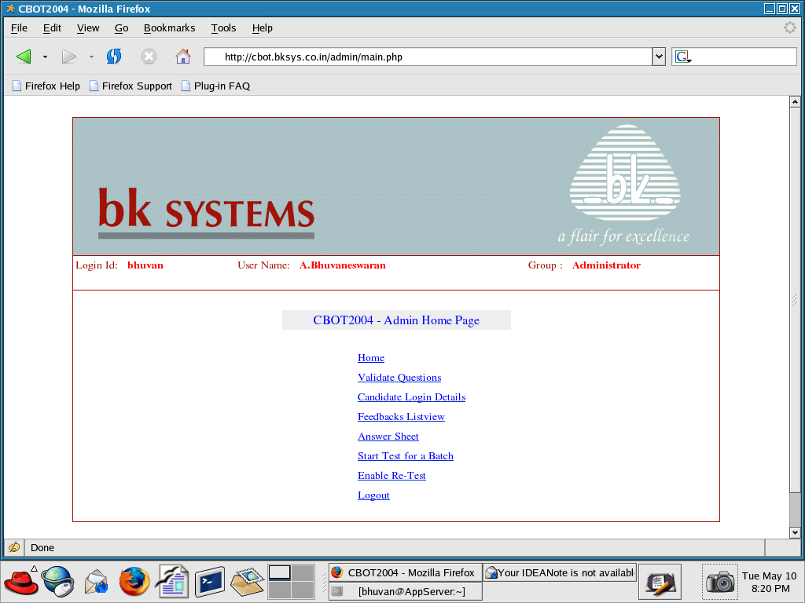Figure 8 Admin - Home Page
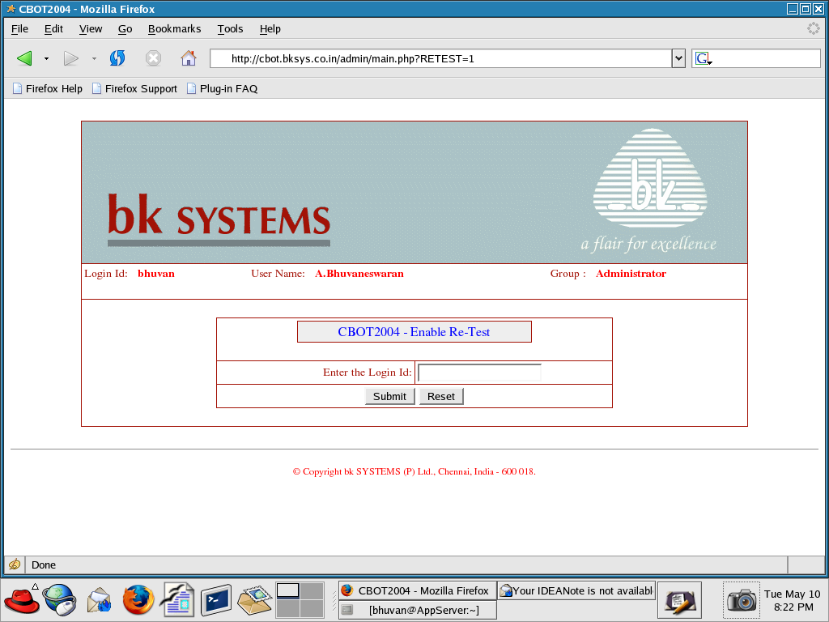Figure 9 Admin - Enable Re-Test
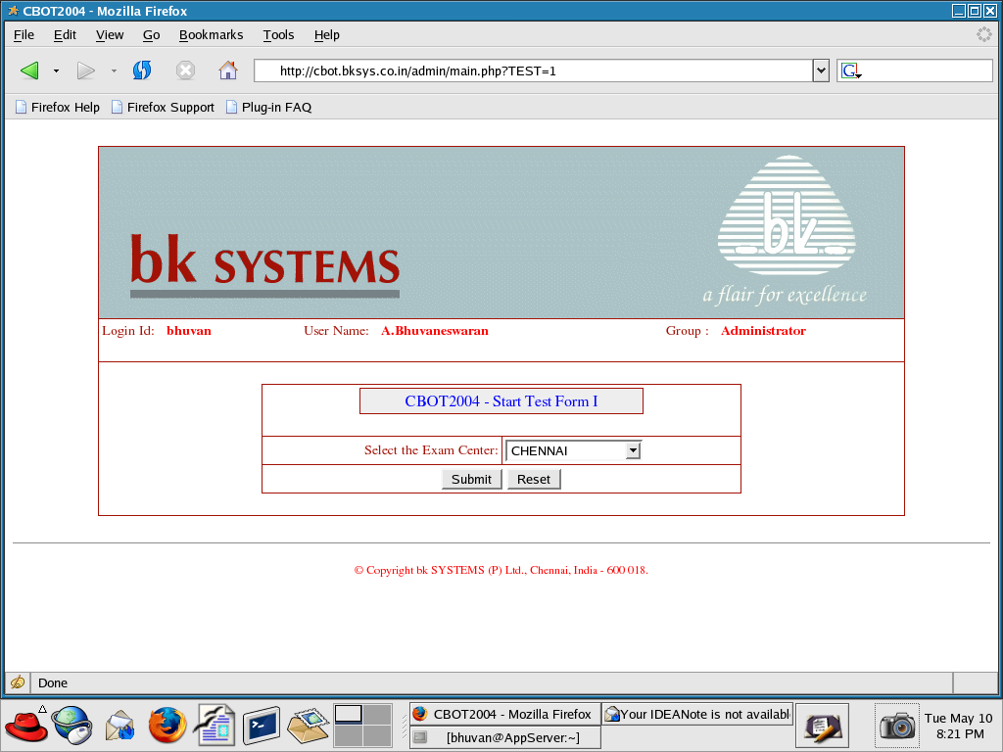Figure 10 Admin - Start Test
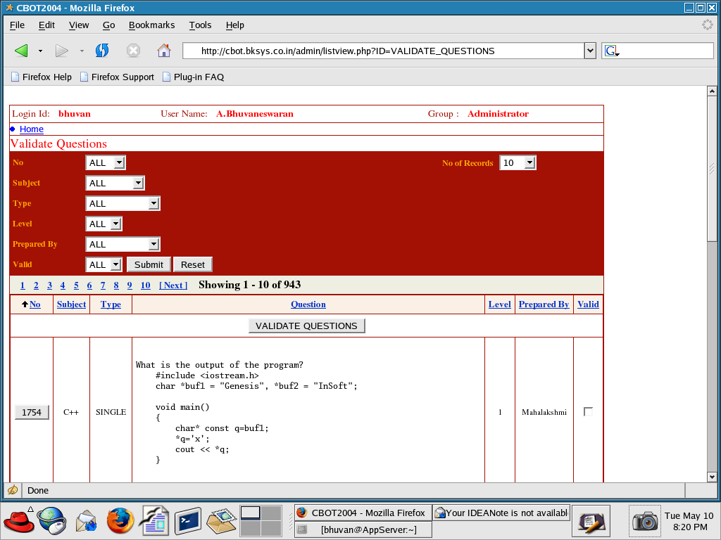Figure 11 Admin - Validate Questions
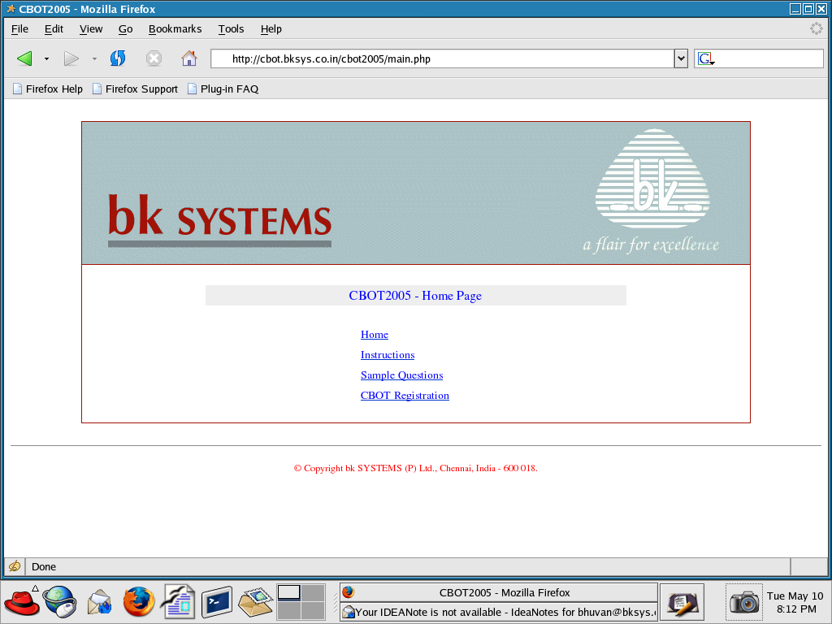Figure 12 Home Page
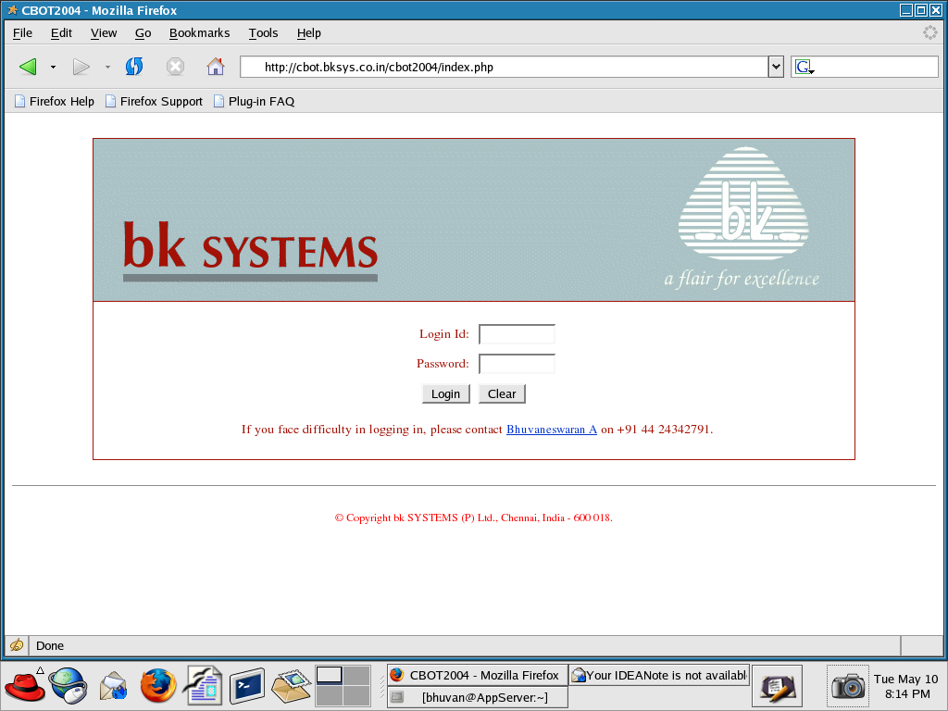Figure 13 Login Page
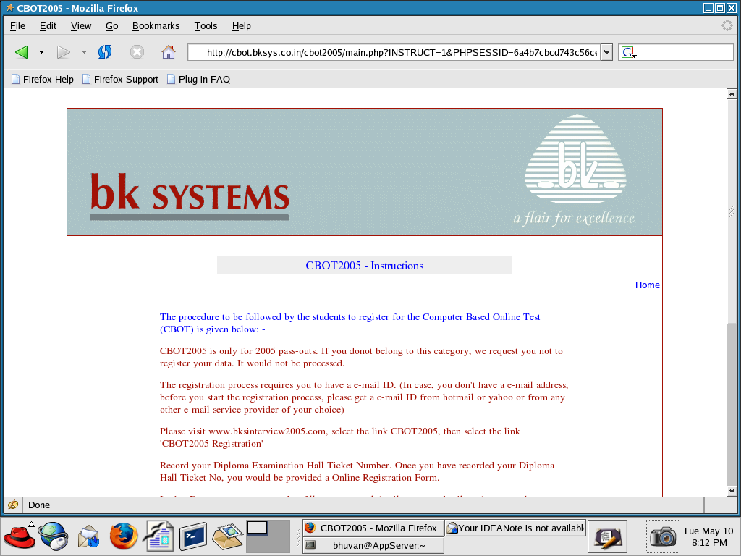Figure 15 Instructions
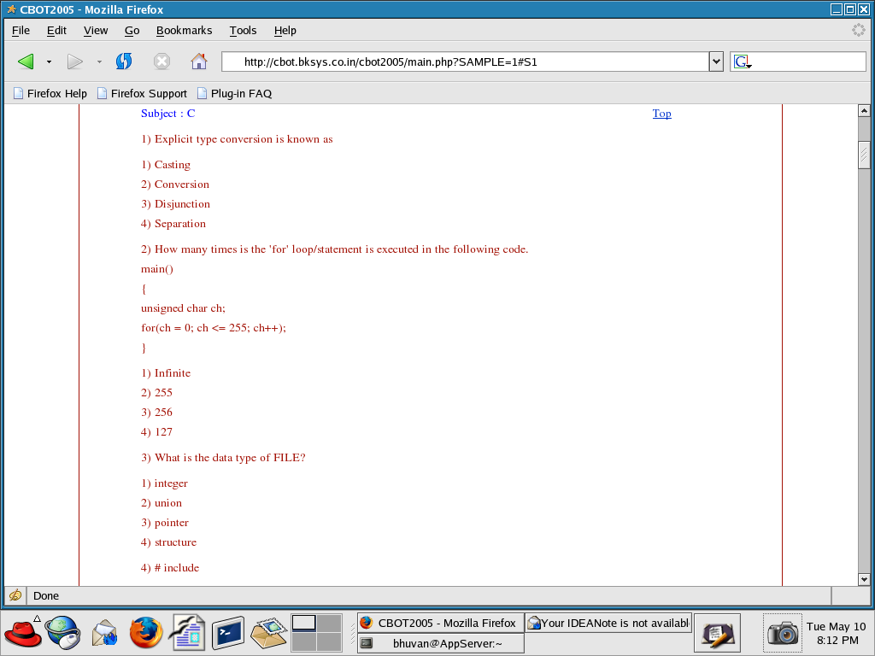Figure 14 Sample Questions

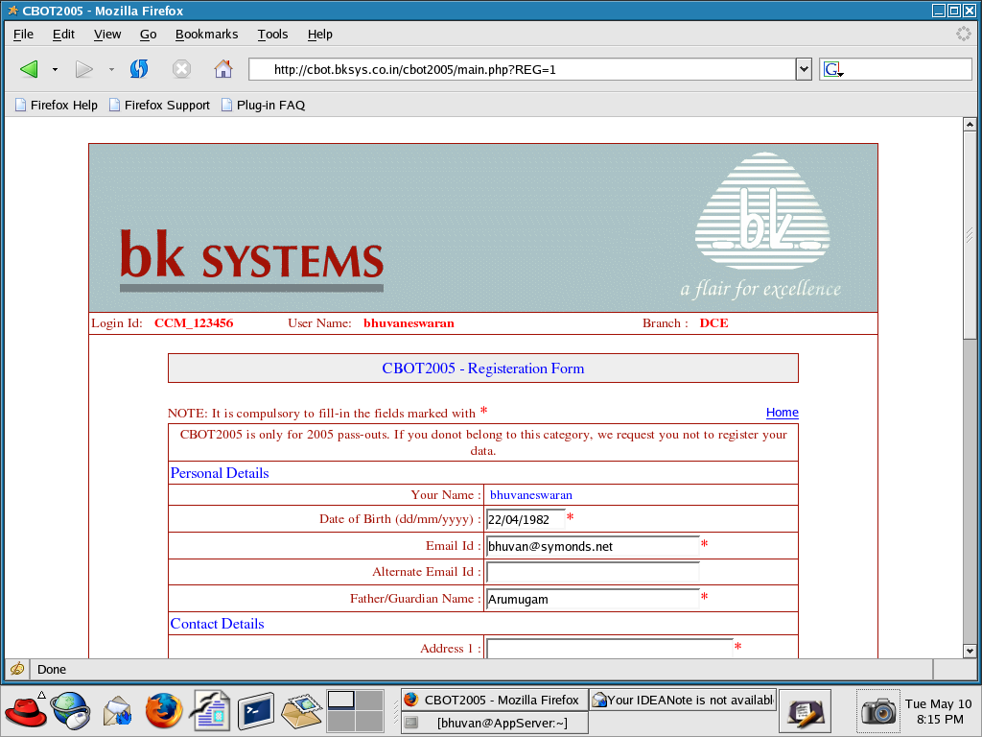Figure 16 Registration
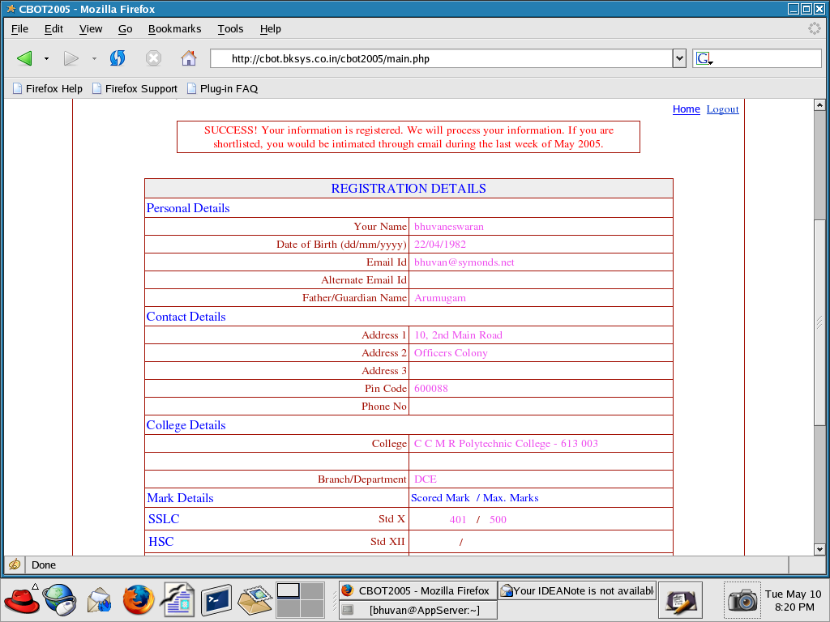Figure 17 Registration Response
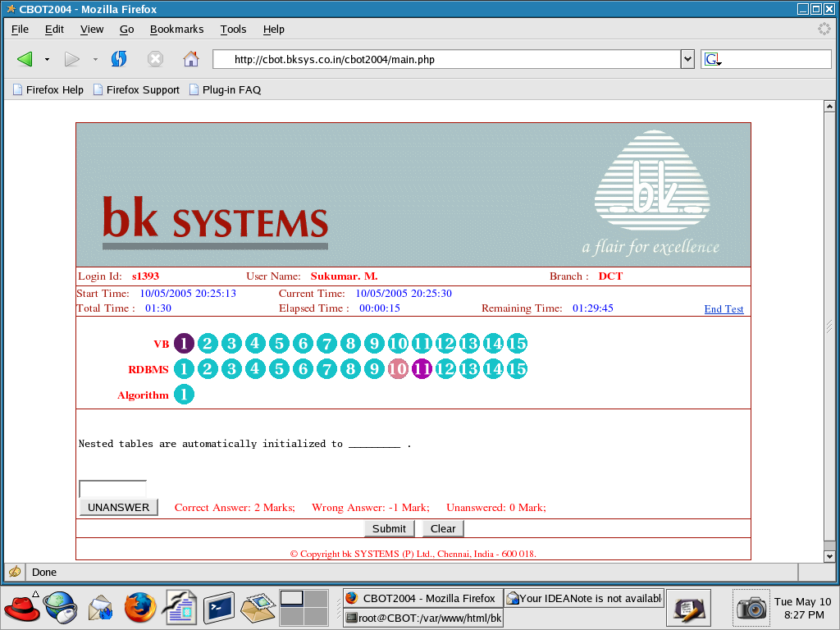Figure 18 CBOT Page
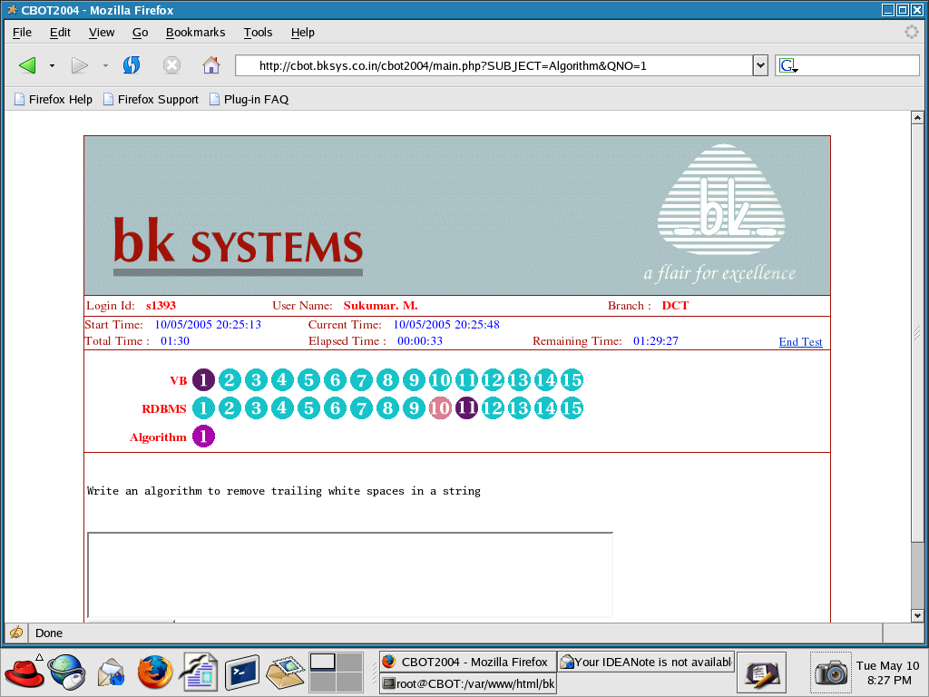Figure 19 Algorithm
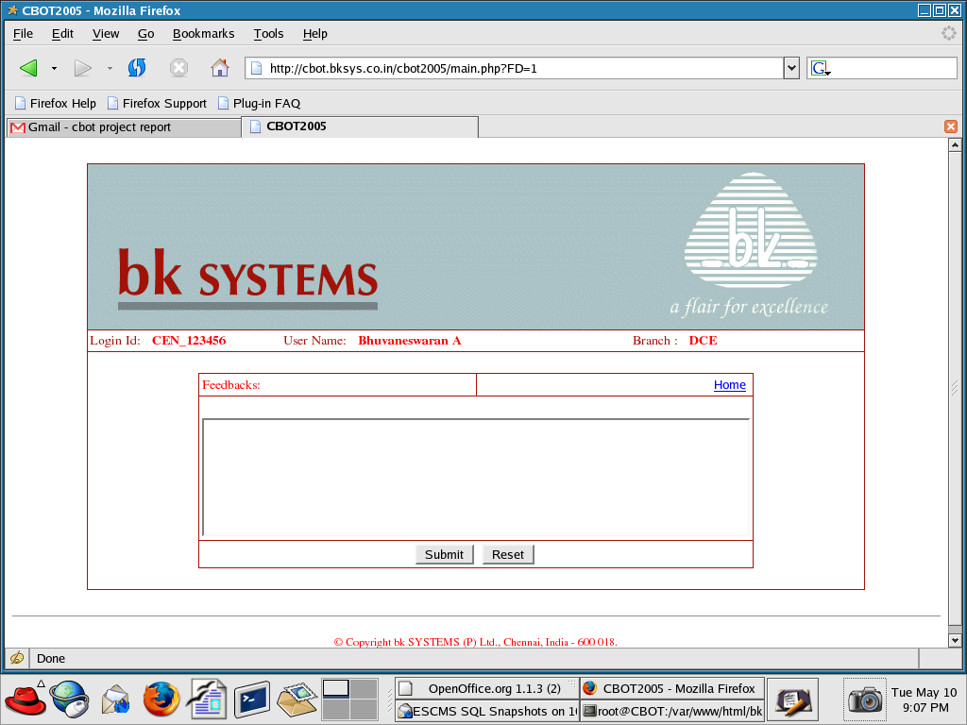Figure 20 Feedback

Validation Check

The final testing is done with the help of engineers in BK SYSTEMS (P) LTD., Chennai - 18. The testing has been done on the Redhat Linux 7.3 Distribution with the following environment.

- Web Server: APACHE ver. 1.3.22
- Scripting Languages: PHP 4.1.2, Perl ver. 5.6.0
- Database : PostgreSQL ver 7.3.4

The testing was done using Linux Operating System with the Mozilla Firefox 1.0 Web Browser. It has been validated that the candidates are able to register their details and take the CBOT. It has also been validated that the administrator are able to perform their activities.

By implementing this project, we are exposed to the latest cutting edge technology in Linux Operating System that includes the learning of APACHE, PHP and PERL with PostgreSQL databases.

Future Scope of the Project

Currently, the CBOT is used to conduct the test for the diploma candidates only. It can be enhanced to conduct the test for the UG and PG candidates.

Currently, there is no interface to upload the prepared questions. The web interface can be provided to enter the questions.

Currently, there is no provision for the candidates to take the mock test. An interface can be provided to the candidates to take the mock test anytime before the CBOT.

Currently, the exam remaining time is refreshed only when the candidate hit the submit button. It can be enhanced to display the remaining time using the stop watch.

Currently, the online help facility is not provided to the candidates during the CBOT. An online help can be provided to the candidates during the CBOT.

System Security

CBOT is the User Authentication based application. Authenticated Users can only access the system. Unauthorized access to the system is prohibited.

BIBLIOGRAPHY

- Programming Perl – Second Edition

    - by Larry Wall, Tom Christiansen & Randal L. Schwartz, O’Reilly & Associates

- PostgreSQL - Introduction and Concepts

    - by Bruce Momjian available at http://postgresql.org

- PHP Manual

    - by Stig Sæther Bakken, Alexander Aulbach, Egon Schmid, Jim Winstead, Lars Torben Wilson, Rasmus Lerdorf, Andrei Zmievski, Jouni Ahto available at http://www.php.net

- Apache – The Definitive Guide Second Edition

- By Ben Laurie and Peter Laurie, O’Reilly

REFERENCES

Websites

- http://www.php.net for PHP References.
- http://www.techdocs.postgresql.org for POSTGRESQL References.
- http://www.cpan.org for PERL modules.
- http://www.apache.org for Apache Web Server.

