SELECT * FROM order_processing.customer;

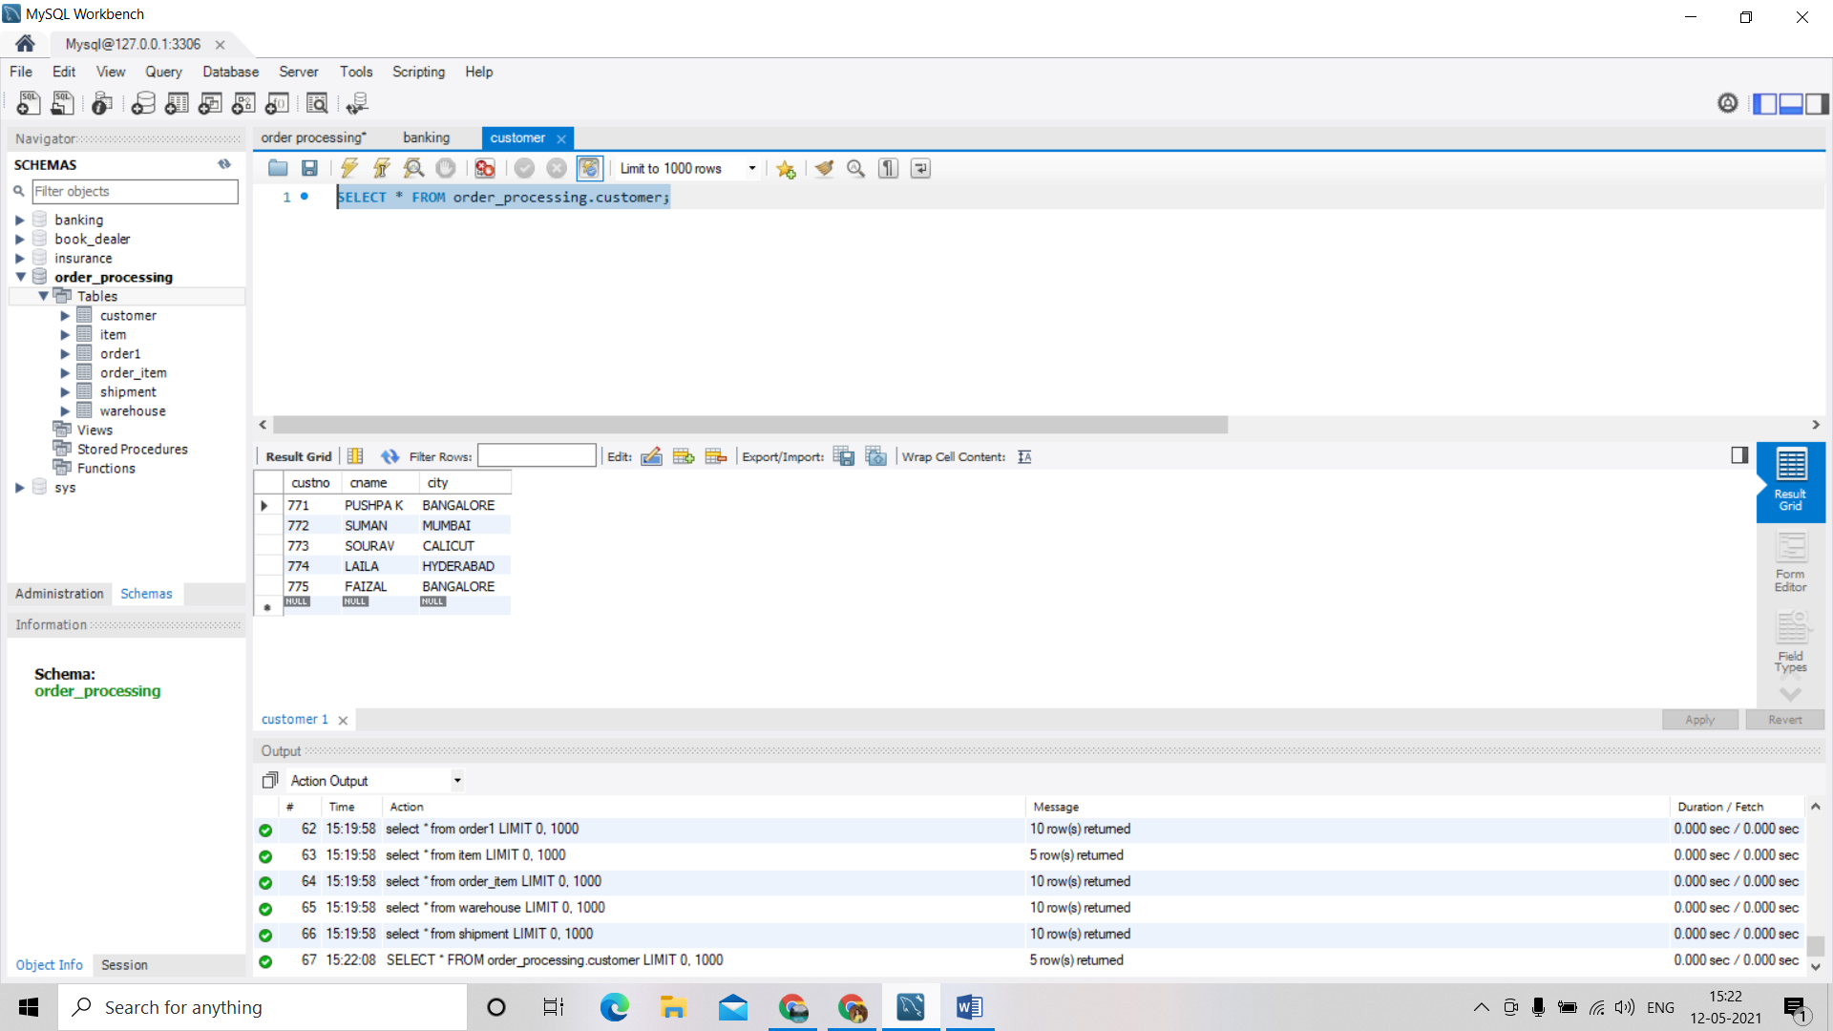

SELECT * FROM order_processing.item;

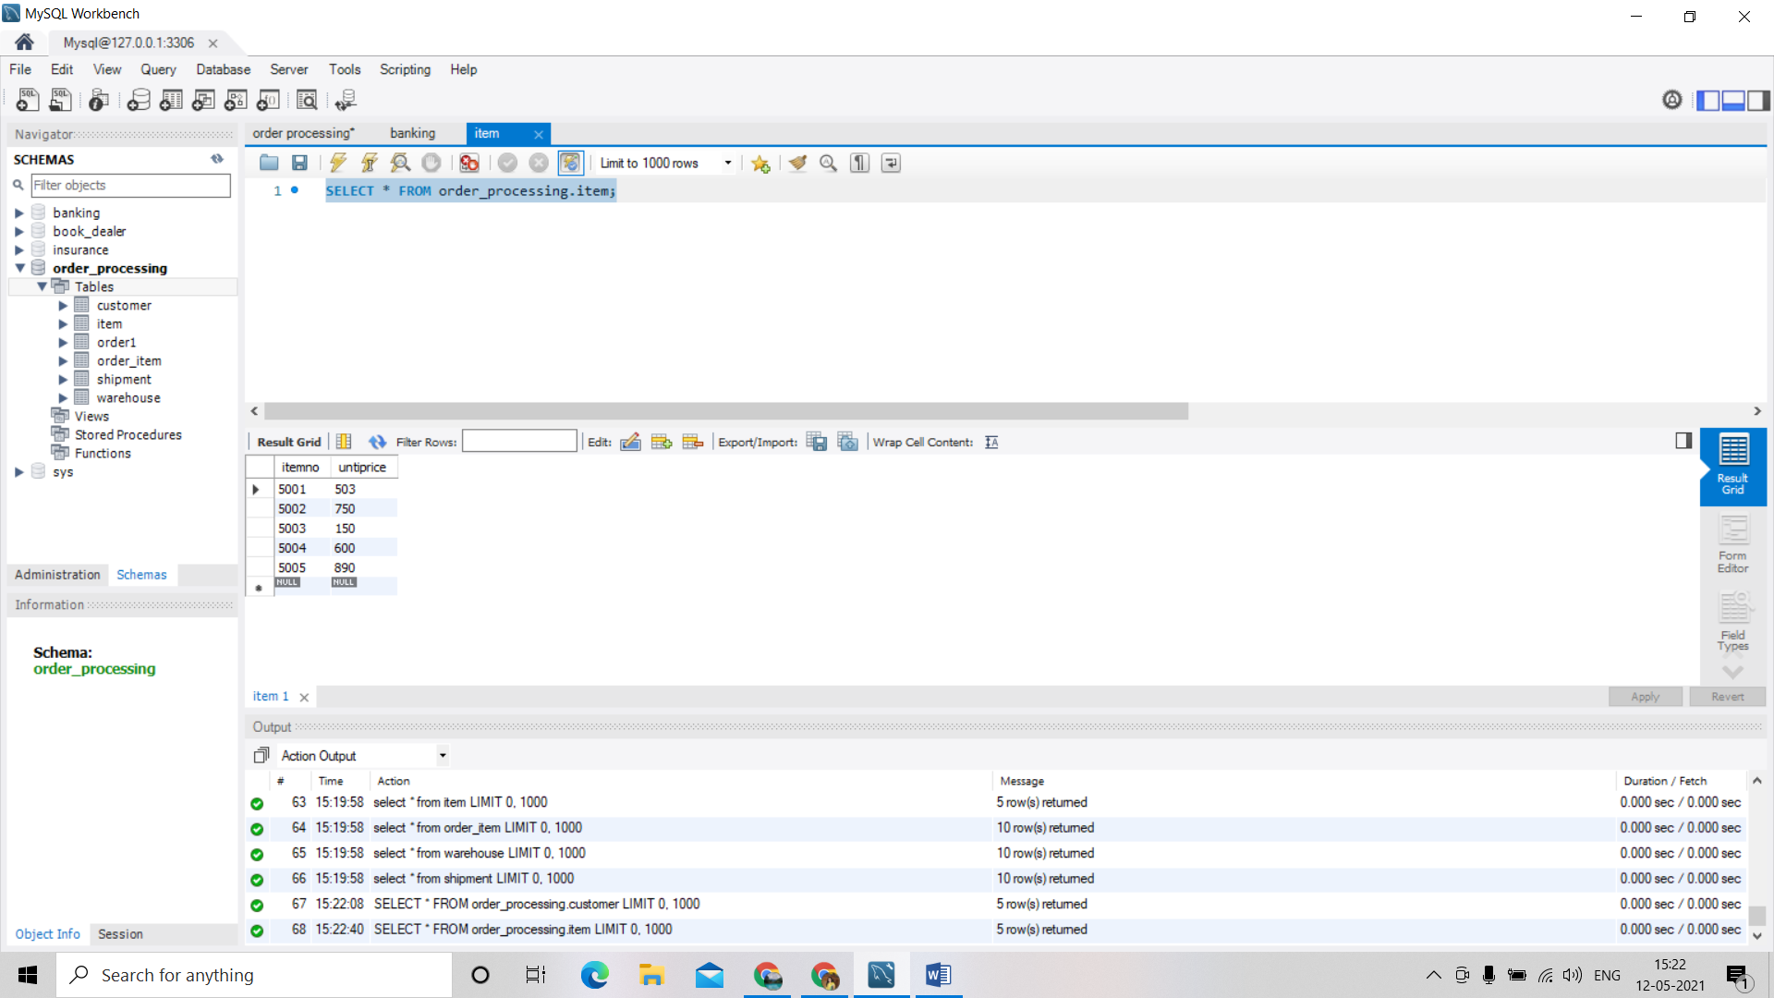

SELECT * FROM order_processing.order1;

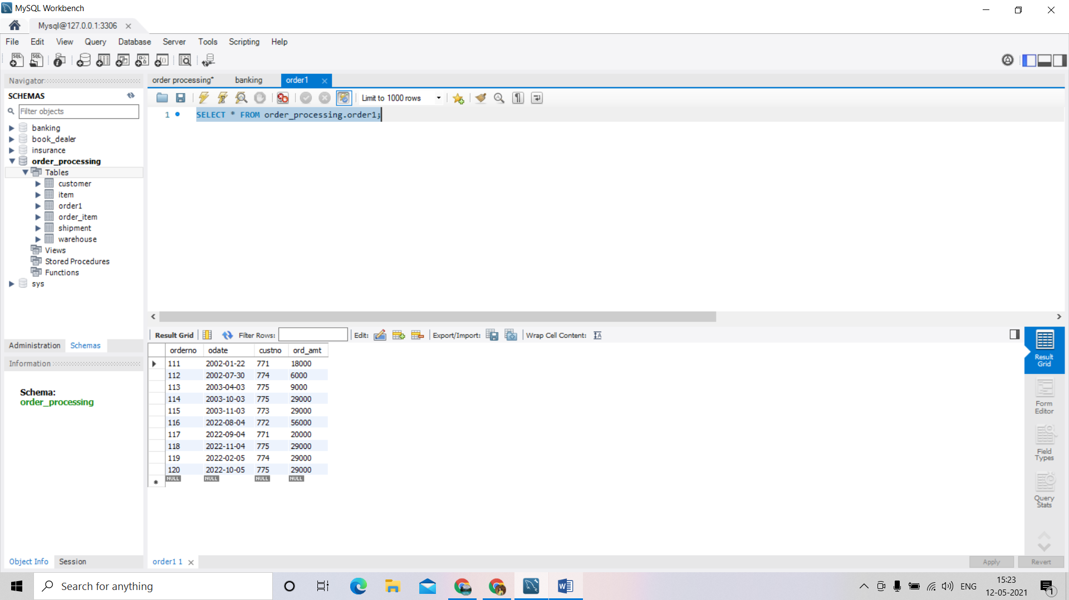

SELECT * FROM order_processing.order_item; 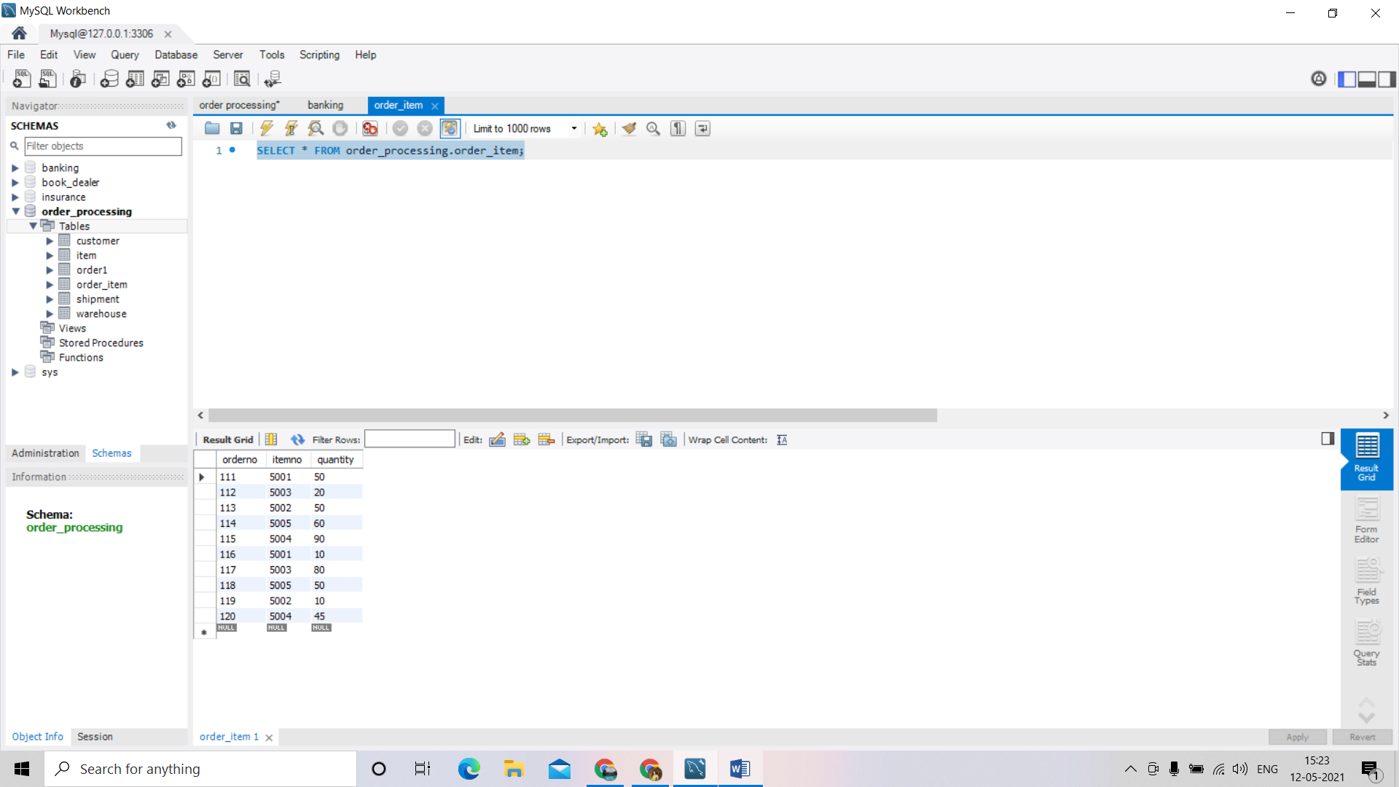

SELECT * FROM order_processing.shipment;

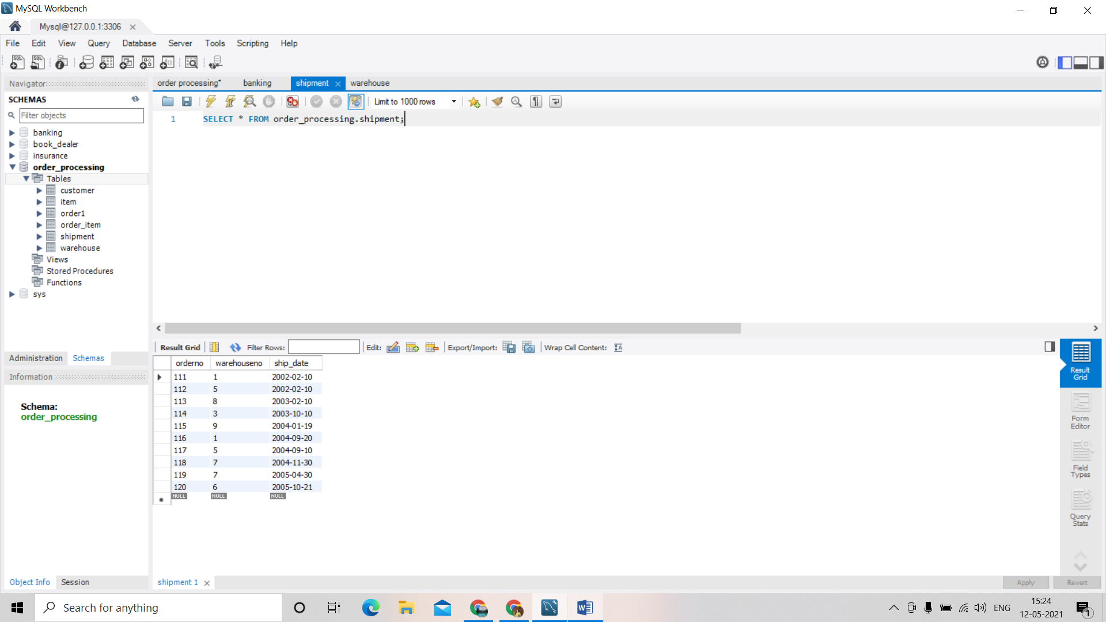

SELECT * FROM order_processing.warehouse;

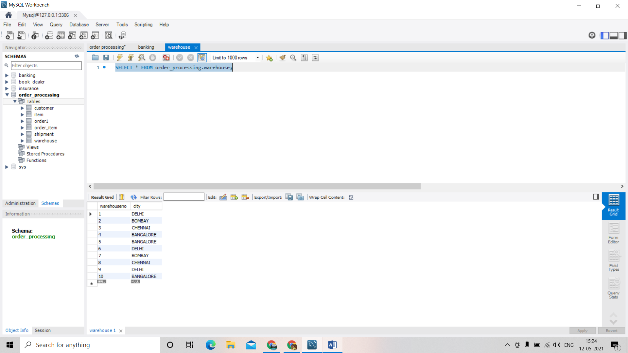

QUERY 1.

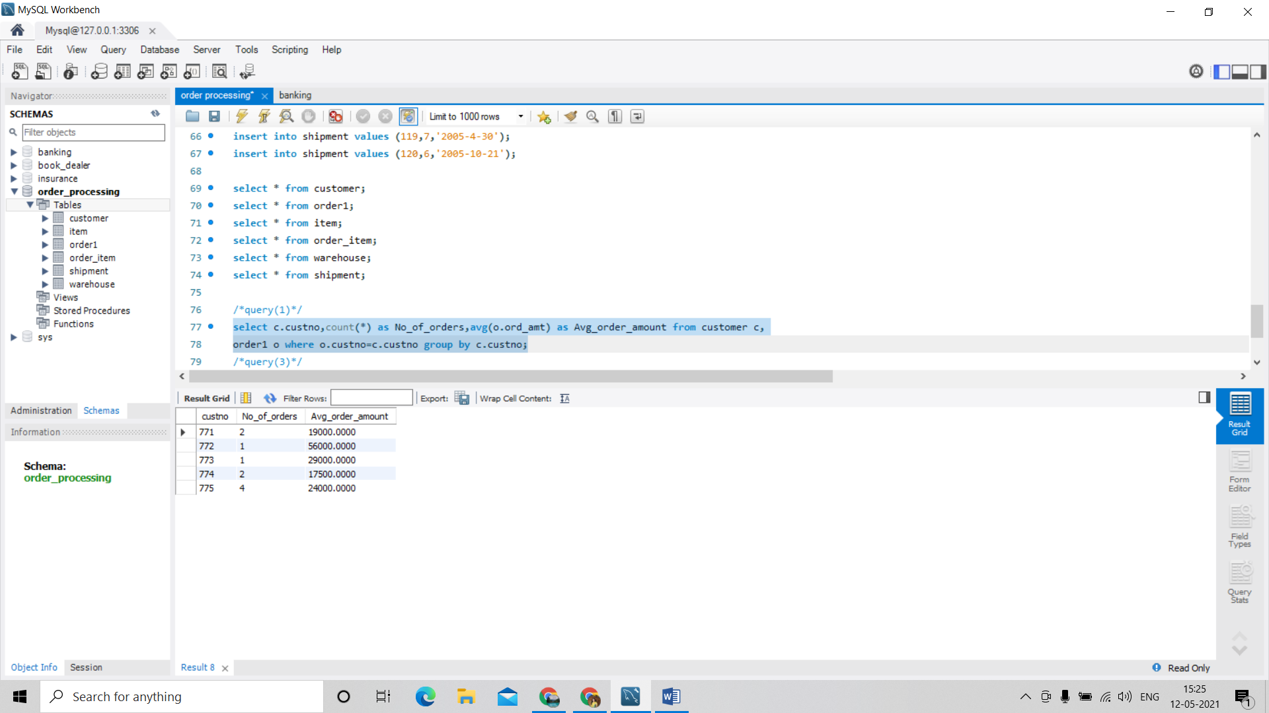

QUERY 2.

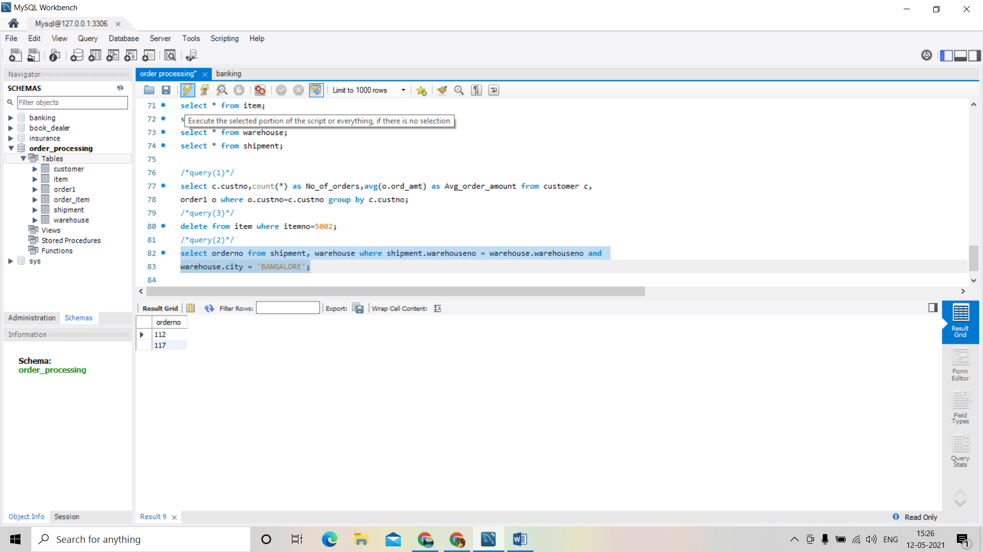

QUERY 3.

