**MEPCO SCHLENK ENGINEERING COLLEGE, SIVAKASI**

**DEPARTMENT OF AI&DS**

**19AD602 – FULL STACK DEVELOPMENT**

**Exercise 3**

1. Create a table consisting of Hexadecimal colour code values. Write a program to use mouseover and mouseout events for changing the content of the table cells colour to the corresponding colour of the Hexadecimal colour code.

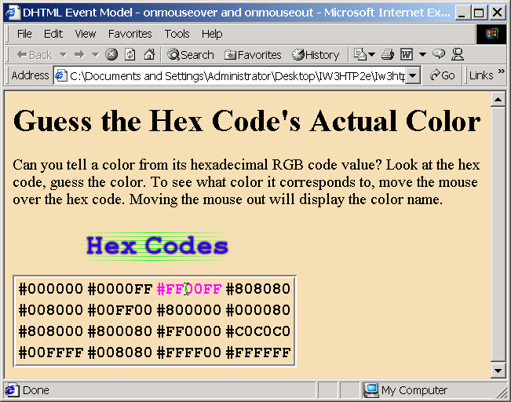

2. Design a dropdown menu as shown in the figure in a web page.

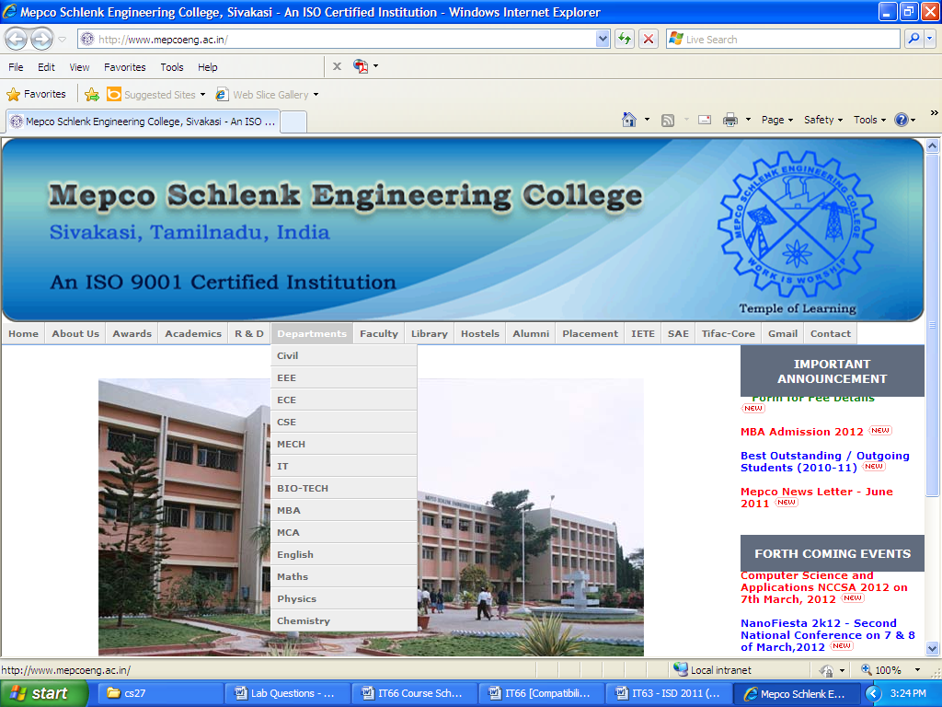

3. Write a Javascript function that will deal with pop-up-blocking browsers to detect whether pop-up was blocked or not. Test this function with some HTML page which will redirect to an error page informing that pop-up was disabled.

4. Write a Web page that enables the user to play the game of 15. There is a 4-by-4 board (implemented as a HTML table) for a total of 16 slots. One of the slots is empty. The other slots are occupied by 15 titles, randomly numbered from 1 through 15. Any tile next to the currently empty slot can be moved into the currently empty slot by clicking on the title. Your program create the board with the tiles out of order. The user’s goal is to arrange the tiles in sequential order row by row. Using the Document Object Model and the **onclick** event, write a script that allows the user to swap the positions of the open position and an adjacent tile. [hint: The **onclick** event should be specified for each table cell.