**EXERCISE-11**

**WEBPACK**

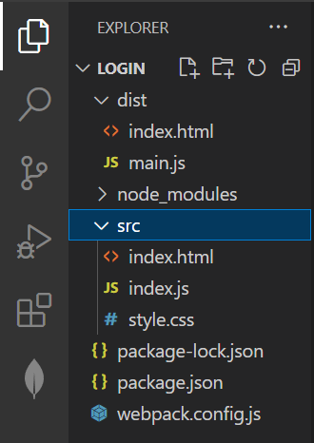

**EXERCISE – 12**

**BINDING NODEJS AND REACT**

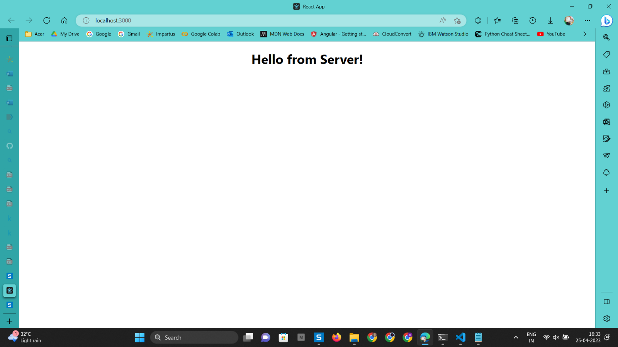

**EXERCISE – 9**

**TYPESCRIPT**

**Queue**

**Bank Account**

**Product**

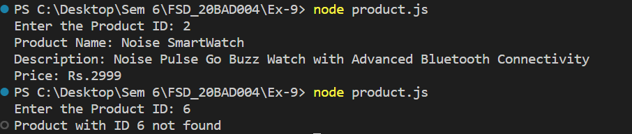



**EXERCISE – 13**

**DOCKER**

