**EXERCISE-10**

**REACT STATE AND COMPONENTS**

**SIMPLE COUNTER APP:**

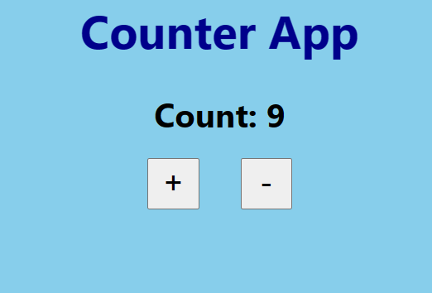

**BOOK SHOP FILTER SEARCH:**

