**EXERCISE-4:**

Applied CRUD operations

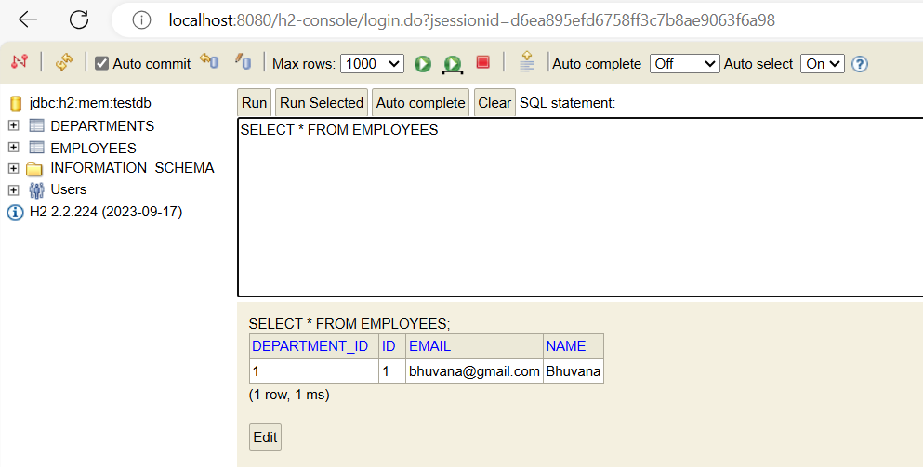

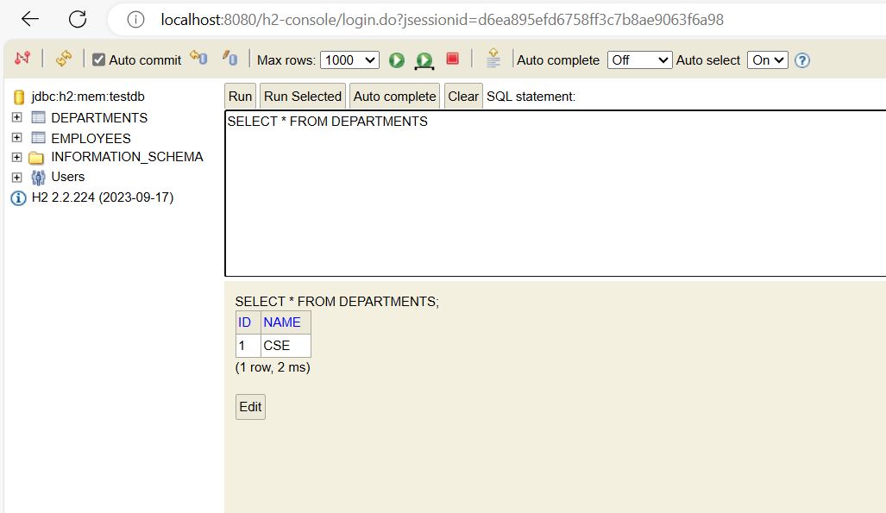

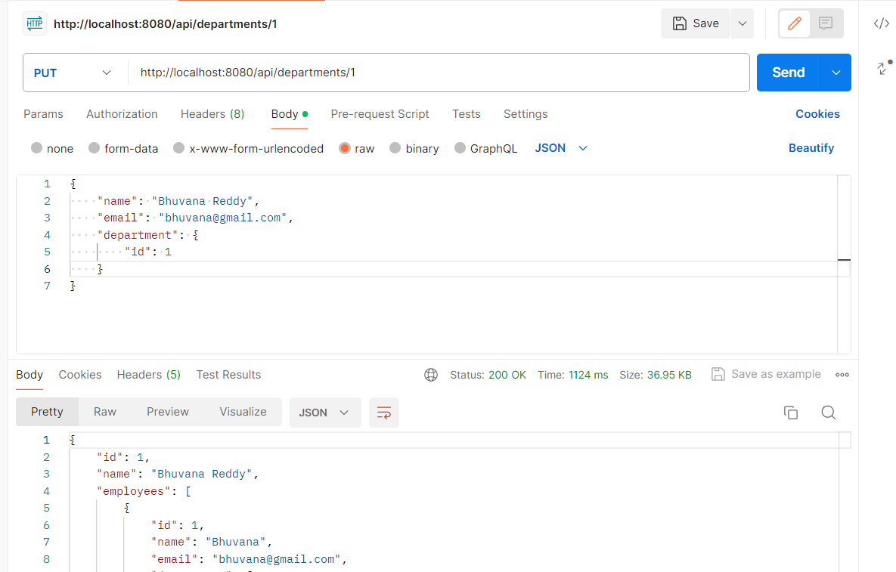

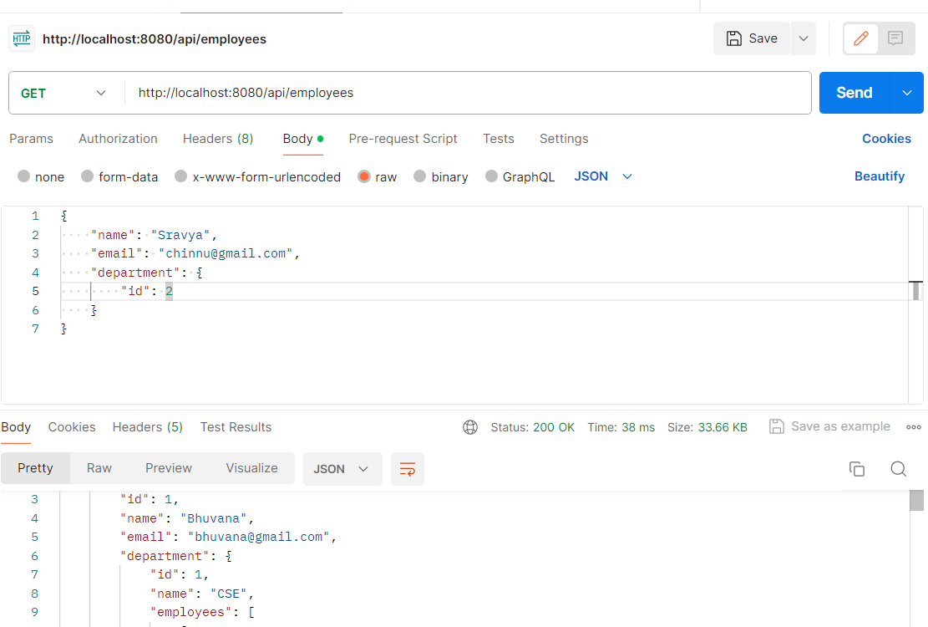

**End Points:**

**Employees**: http://localhost:8080/api/employees

**Departments**: http://localhost:8080/api/departments