AICTE | IBM SkillsBuild
Data Analytics with AI Internship 2026

PROJECT REPORT
HR Employee Attrition: Analytics and Risk Prediction
Using Python, Data Visualisation and Machine Learning

Submitted by
Bhuvaneshwari K
B.Tech Information Technology

Abstract
Employee attrition is costly for organisations because every departure brings recruitment expense, lost productivity and lost knowledge. This project analyses the IBM HR Analytics Employee Attrition dataset of 1,470 employees to understand why people leave and to predict who is most likely to leave next.
The data was cleaned, enriched with engineered features (age, tenure and income bands) and explored through descriptive analytics and visualisation. Two machine learning models, Logistic Regression and Random Forest, were trained and compared. The Random Forest was then used to give every employee a 0 to 100 risk score and to rank the main drivers of attrition.
The analysis found an overall attrition rate of 16.1%, with attrition concentrated among employees who work overtime, young employees, Sales Representatives, single employees and low-income employees. The report closes with practical retention strategies for HR teams.

1. Introduction
Attrition is the rate at which employees leave an organisation. High attrition in specific roles or groups signals problems with workload, pay, growth or work-life balance. Data analytics lets HR teams move from reacting to resignations to anticipating them.

1.1 Problem Statement
Understand the factors that influence employee attrition in the IBM HR dataset, build a model that predicts attrition risk, and recommend data-backed actions to improve retention.

1.2 Objectives
- Clean and prepare the HR dataset for analysis.
- Identify the key factors associated with employee attrition through exploratory data analysis.
- Build and evaluate machine learning models to predict attrition.
- Score active employees by risk level so HR can prioritise retention efforts.
- Recommend retention strategies based on the findings.

2. Dataset Description
The IBM HR Analytics Employee Attrition and Performance dataset is a publicly available dataset on Kaggle, created by IBM data scientists. It contains 1,470 employee records and 35 attributes, with no missing values and no duplicate rows. Three columns (EmployeeCount, Over18, StandardHours) hold a single constant value and were removed.

Feature group | Examples
Demographics | Age, Gender, MaritalStatus, Education, EducationField, DistanceFromHome
Job details | Department, JobRole, JobLevel, BusinessTravel, OverTime
Compensation | MonthlyIncome, HourlyRate, DailyRate, PercentSalaryHike, StockOptionLevel
Experience | TotalWorkingYears, YearsAtCompany, YearsInCurrentRole, YearsSinceLastPromotion, NumCompaniesWorked
Satisfaction | JobSatisfaction, EnvironmentSatisfaction, RelationshipSatisfaction, WorkLifeBalance, JobInvolvement
Target | Attrition (Yes / No)

Source: https://www.kaggle.com/datasets/pavansubhasht/ibm-hr-analytics-attrition-dataset

3. Methodology
- Data loading and inspection: checked shape, data types, missing values and duplicates.
- Data cleaning: removed constant columns that carry no information.
- Feature engineering: created a binary attrition flag, Age Band, Tenure Band and Income Band.
- Exploratory data analysis: compared attrition rates across categories and examined income, satisfaction and tenure patterns.
- Modelling: one-hot encoded categorical variables, split data 75/25 with stratification, and trained Logistic Regression and Random Forest with class weighting.
- Evaluation: measured accuracy, precision, recall, F1 score and ROC-AUC, using a decision threshold of 0.35.
- Risk scoring and insights: scored every employee, ranked drivers by feature importance and derived recommendations.

3.1 Tools and Technologies
Tool | Purpose
Python 3 | Programming language
Pandas, NumPy | Data manipulation and numerical computing
Matplotlib, Seaborn | Data visualisation
Scikit-learn | Machine learning models and evaluation
Jupyter Notebook | Development environment and documentation

4. Exploratory Data Analysis

4.1 Overall Attrition
Of the 1,470 employees, 237 have left, giving an attrition rate of 16.1%. The dataset is therefore imbalanced: only about one in six employees is a leaver, which influences how the model must be evaluated.
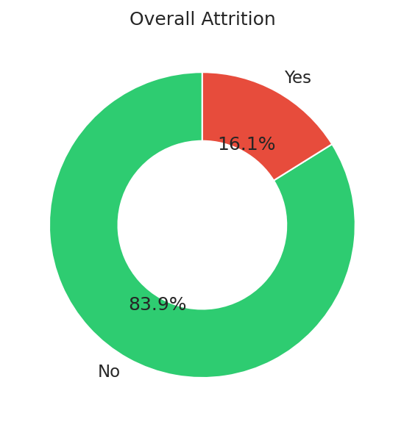
Figure 1: Overall attrition split

4.2 Attrition by Category
Figure 2 compares attrition rates across six dimensions. The red dashed line marks the company average. Overtime, young age, single status and frequent travel stand out clearly above average.
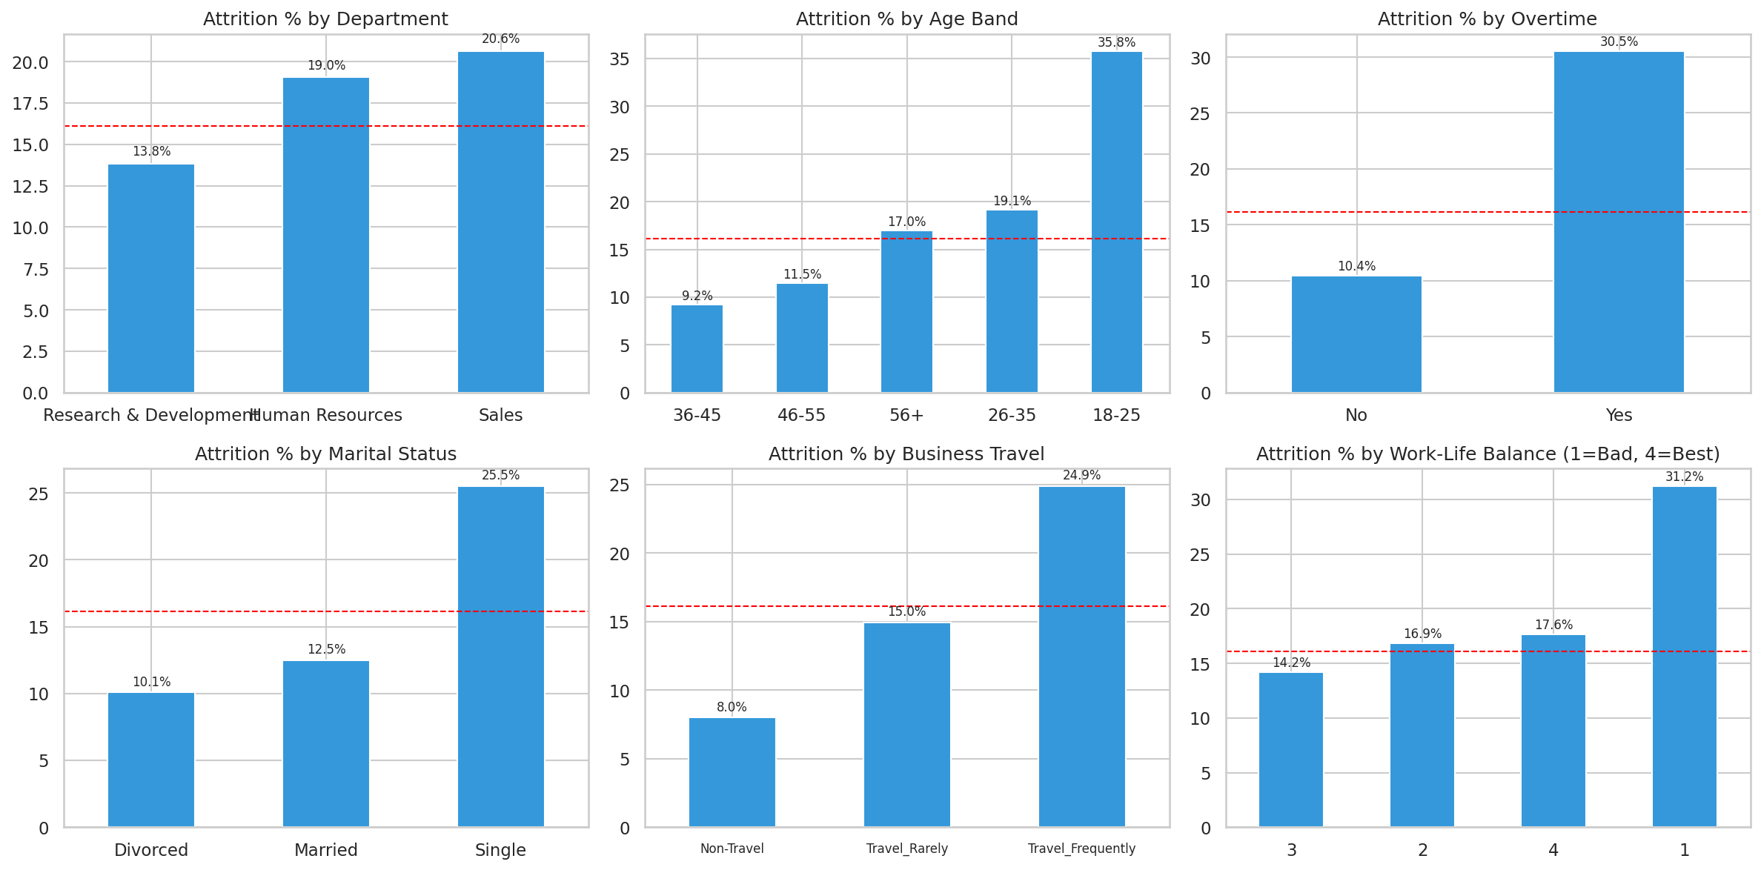
Figure 2: Attrition rate by department, age, overtime, marital status, travel and work-life balance

4.3 Attrition by Job Role
Sales Representatives have the highest attrition at 39.8%, far above the company average, followed by Laboratory Technicians at 23.9%. Research Directors (2.5%), Managers (4.9%) and Healthcare Representatives (6.9%) show the lowest rates.
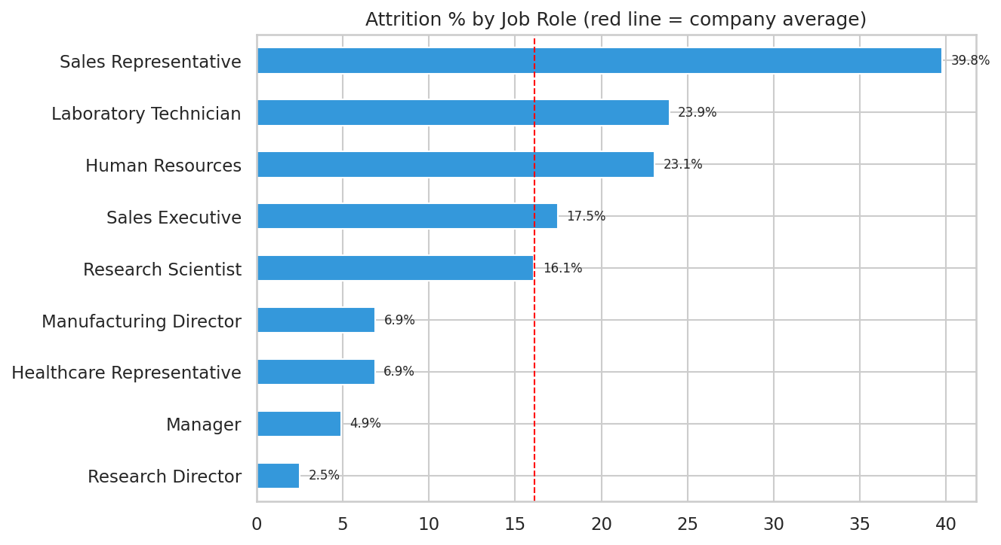
Figure 3: Attrition rate by job role

4.4 Income, Satisfaction and Tenure
Employees who left earn a noticeably lower median monthly income ($3,202) than those who stayed ($5,204). Lower job satisfaction is associated with higher attrition, and leavers are concentrated in the first few years at the company.
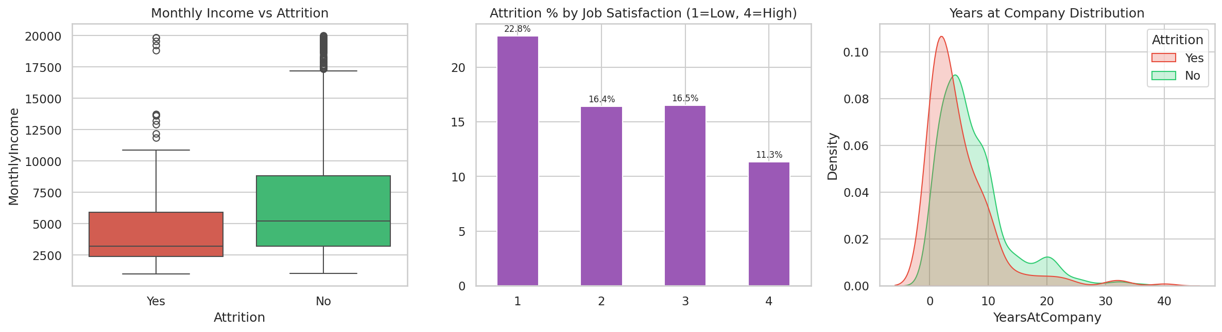
Figure 4: Income, job satisfaction and tenure versus attrition

4.5 Job Level and Tenure Heatmap
The heatmap shows that attrition is highest among junior employees (Job Level 1) with short tenure, which identifies the early-career window as the most vulnerable period.
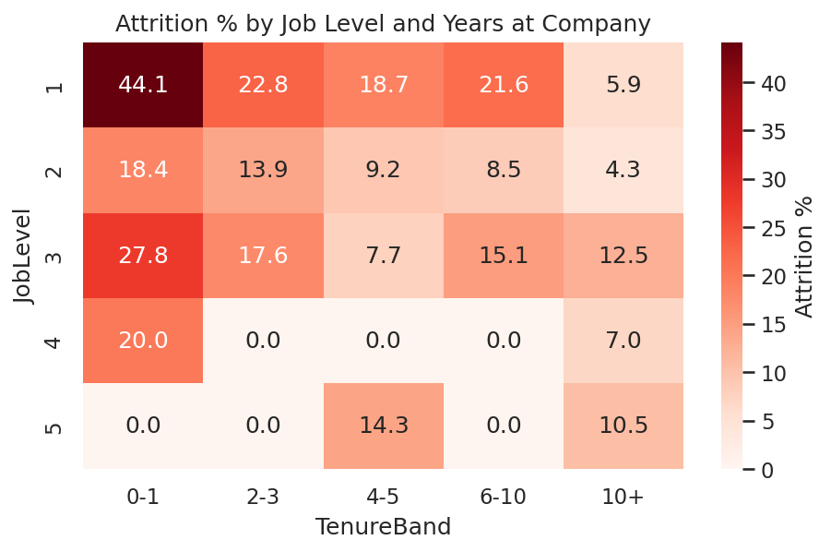
Figure 5: Attrition rate (%) by job level and years at company

4.6 Correlation with Attrition
All numeric correlations with attrition are weak (between -0.17 and +0.08), which shows that no single numeric variable explains attrition on its own. The strongest negative relationships are with total working years, job level, years in current role, monthly income and age: more experienced and better-paid employees are less likely to leave. Distance from home is the strongest positive relationship. Categorical factors such as overtime are not included in this chart and are covered in Section 4.2.
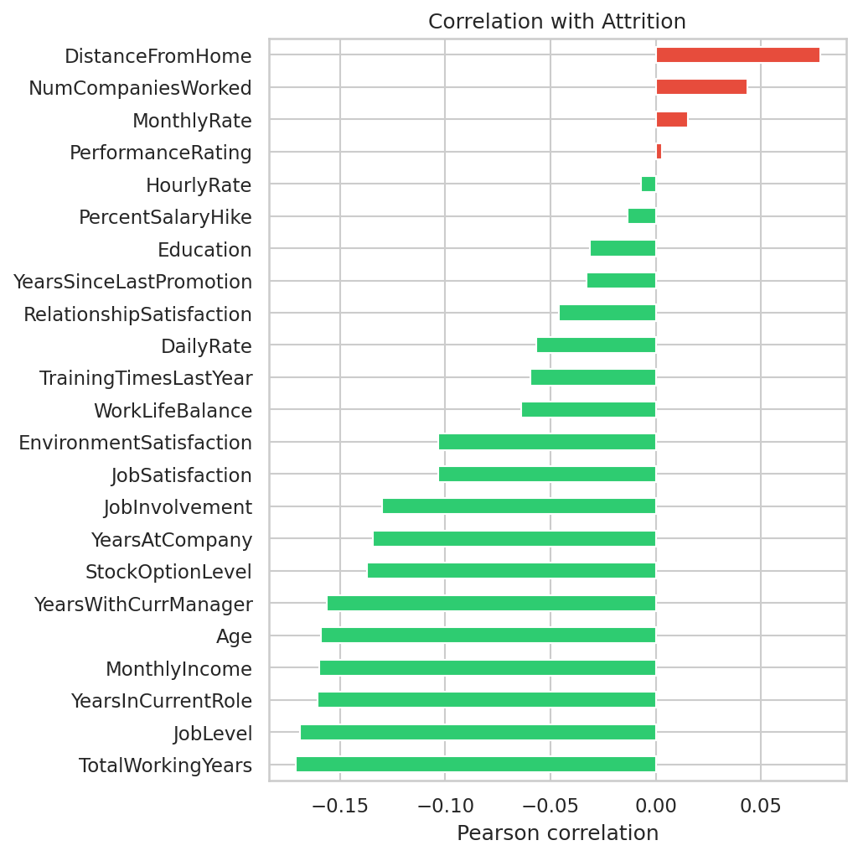
Figure 6: Correlation of numeric features with attrition

5. Machine Learning Model

5.1 Approach
Attrition prediction is a binary classification problem. Because only 16% of employees are leavers, a model that always predicts 'stayed' would reach 84% accuracy yet be useless. The models were therefore trained with balanced class weights and judged on recall, F1 and ROC-AUC in addition to accuracy. The decision threshold was lowered from 0.5 to 0.35 so the models catch more potential leavers.

5.2 Model Comparison

Model | Accuracy | Precision | Recall | F1 | ROC-AUC
Logistic Regression | 0.731 | 0.351 | 0.797 | 0.487 | 0.808
Random Forest | 0.812 | 0.439 | 0.610 | 0.511 | 0.772

Logistic Regression achieves the best ROC-AUC (0.808) and the highest recall (79.7%), so it identifies the most leavers. Random Forest achieves higher accuracy, precision and F1. Random Forest was used for risk scoring and feature importance because it captures non-linear relationships and provides importance values directly.
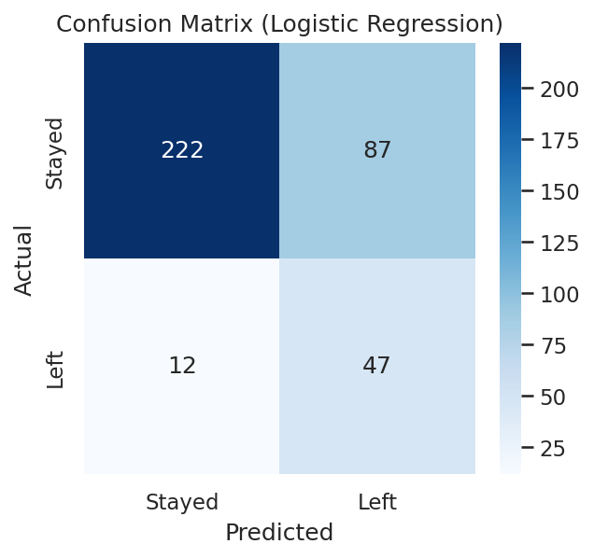
Figure 7: Confusion matrix of the best model by ROC-AUC (Logistic Regression)

5.3 Key Drivers of Attrition
The Random Forest ranks monthly income, age, overtime, years at company and total working years among the strongest predictors of attrition. These agree with the patterns found in the exploratory analysis.
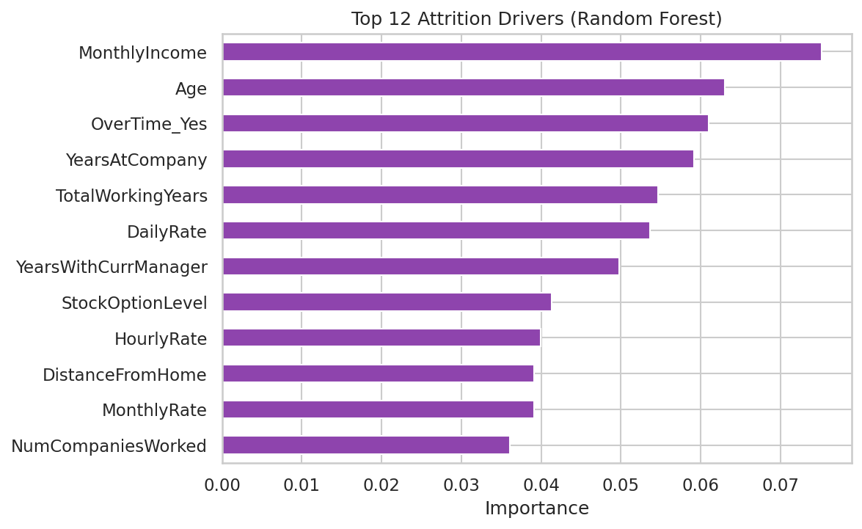
Figure 8: Top 12 attrition drivers (Random Forest feature importance)

5.4 Employee Risk Scoring
Each employee received a risk score from 0 to 100. Active employees were grouped into High (above 60), Medium (30 to 60) and Low (below 30) risk. Of 1,233 active employees, 12 are High risk, 160 are Medium risk and 1,061 are Low risk. The highest-risk employees are young Sales Representatives and Laboratory Technicians with low income and short tenure.
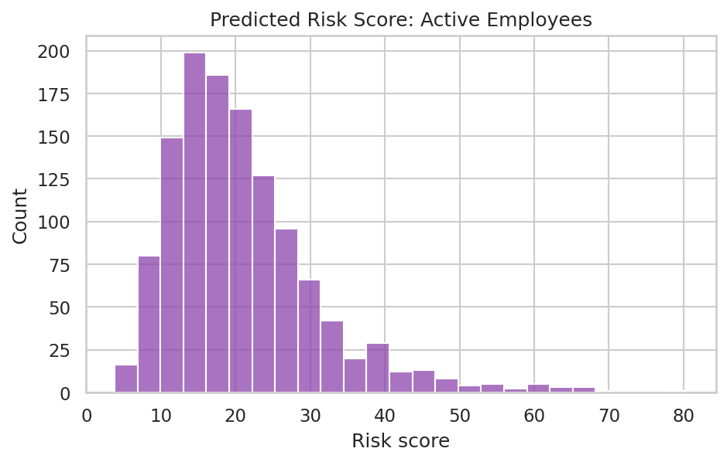
Figure 9: Distribution of predicted risk scores for active employees

6. Key Insights
# | Finding
1 | Overall attrition rate is 16.1% (237 of 1,470 employees).
2 | Overtime employees leave at 30.5% versus 10.4% without overtime, about 2.9 times higher.
3 | Sales Representatives have the highest role-level attrition at 39.8%.
4 | Employees aged 18 to 25 have the highest age-band attrition at 35.8%.
5 | Single employees leave at 25.5% versus 12.5% for married employees.
6 | Median monthly income of leavers is $3,202 versus $5,204 for stayers.
7 | Frequent business travellers leave at 24.9% versus 8.0% for non-travellers.
8 | Attrition is concentrated at Job Level 1 in the first few years of tenure.

7. Recommendations
- Control overtime. Rebalance workloads, hire for peak periods and cap overtime hours to reduce the strongest attrition driver.
- Support early-career employees. Provide mentoring, structured onboarding and clear promotion paths for Job Level 1 employees in their first three years.
- Review compensation. Benchmark pay for high-attrition roles such as Sales Representatives and Laboratory Technicians.
- Manage business travel. Reduce frequent travel where possible or offer time-off and travel allowances.
- Act on the risk list. Hold stay-interviews with employees flagged High risk and address their concerns early.
- Monitor satisfaction. Run quarterly pulse surveys on job satisfaction and work-life balance and track the trend.

8. Conclusion and Limitations
This project shows that employee attrition is not random. It is concentrated in identifiable groups defined by workload, age, role, pay and tenure. Combining descriptive analytics with a predictive model gives HR both an explanation of why people leave and an early-warning list of who may leave next, so retention effort can be targeted where it matters most.
Limitations: the dataset is a single snapshot created by IBM data scientists and may not reflect any real organisation. Model precision is moderate (below 45%), so risk scores should start conversations rather than drive individual decisions. Future work could add time-based data, hyperparameter tuning, SHAP-based explanations and a deployed dashboard.

9. References
- IBM HR Analytics Employee Attrition and Performance dataset, Kaggle: https://www.kaggle.com/datasets/pavansubhasht/ibm-hr-analytics-attrition-dataset
- Scikit-learn documentation: https://scikit-learn.org
- Pandas documentation: https://pandas.pydata.org
- Seaborn documentation: https://seaborn.pydata.org

