PROGRAM ASSESSMENT REPORT

MASTER OF SCIENCE IN COMPUTER SCIENCE AND SOFTWARE ENGINEERING
The Master of Science degree may be earned under a thesis or non-thesis option. The MS (non-thesis) degree requires a minimum of 33 graduate semester credit hours. All courses in the degree must be taken for a grade. The three required 7000-level courses are COMP7270, COMP7300, and COMP7500. Students may take up to three (3) credit hours of COMP7930 Directed Study. Students may take three (3) credit hours of COMP7980 Master of Science Capstone Engineering Project, which is a graded course.

COMP 7270 | Advanced Topics in Algorithms | 3
COMP 7300 | Advanced Computer Architecture | 3
COMP 7500 | Advanced Topics in Operating Systems | 3
Select 18 Credits in COMP 6000-89 | 99 | 18
Select 6 Credits in @ 6000-8999 |  | 6
Total |  | 33

The Master of Science degree (thesis option) requires a minimum of 30 graduate semester credit hours. All courses in the degree must be taken for a grade; the exception is COMP 7990 Research and Thesis, which is offered in incomplete/complete format. The three required 7000-level courses are COMP 7270, COMP 7300, and COMP 7500. Students may take up to three (3) credit hours of COMP7930/6 Directed Study. A thesis is required for the MS-CSSE degree (i.e., thesis option). A written proposal supporting the thesis project must be approved by a student’s supervisory committee, which is comprised of at least three faculty members. One member of the committee is designated as the major professor (a.k.a., advisor). Students must pass a comprehensive oral examination at the conclusion of their studies. All students with the thesis option are required to submit the Master’s Final Examination Form to the graduate school.

COMP 7270 | Advanced Topics in Algorithms | 3
COMP 7300 | Advanced Computer Architecture | 3
COMP 7500 | Advanced Topics in Operating Systems | 3
COMP 7990 | Research and Thesis | 6
Select 9 Credits in COMP 6000-899 | 9 | 9
Select 6 Credits in @ 6000-8999 |  | 6
Total |  | 30

For questions on the assessment report, please email Dr. Xiao Qin (xqin@auburn.edu)

Student Learning Outcomes
The vision of the Master of Science in Computer Science and Software Engineering (MS-CSSE) program at Auburn University is to offer a unique opportunity for Master’s students to develop cutting-edge and in-depth knowledge of computer science and software engineering disciplines. We cater to Master’s students with an outstanding aptitude and strong analytic skills for software design and development.

Specificity of Outcomes
There are four student learning outcomes (SLO 1-4) defined to implement our MS-CSSE program vision.
- SLO 1: Students will demonstrate proficiency in core knowledge in algorithms, computer architecture, and operating systems.
- SLO 2: Students will be able to implement and test software solutions to problems.
- SLO 3: Students will apply reasoning and technical skills to solve problems in at least one area of research.
- SLO 4: Students will effectively communicate with non-technical and technical audiences during software lifecycles.

Comprehensive Outcomes
The four student learning outcomes (SLOs) listed in Section 1 represent the culmination of all coursework related to the MS-CSSE program. These outcomes represent skills and capabilities that should be fully developed over the course of each MS-CSSE student’s education. Although the program offers a broad education allowing MS-CSSE students to improve research and teaching skills in computer science and software engineering disciplines, these SLOs represent the skills and capacities required in careers as computer scientists, researchers, and engineers.

The CSSE faculty measures the SLOs according to the proficiency guidelines offered by the Association of Computing Machinery (ACM), which is the world’s largest professional organization for educational and scientific computing. In the past decade, ACM has produced a series of recommendations for university-level graduate Computer Science programs. The MS-CSSE program has adopted the ACM recommendations as its education objectives to train well-prepared master’s students. In addition, these four SLOs are in alignment with disciplinary standards set by IEEE Computer Society, Computing Research Association (CRA), and those professionals represented by ACM and IEEE.
The initial version of the SLOs was created by the CSSE graduate programs committee (5 members) through a series of discussion sessions and meetings held between April 2017 to June 2017. In May 2020, the graduate programs committee revised the SLOs; the number of SLOs was cut back from 20 down to 5. The previous version of 20 SLOs makes the program too complicated to assess. We intend to keep the current version unchanged for the next five years. The new SLOs were approved by the CSSE faculty in June 2020. The SLOs will be re-evaluated, reviewed, and ratified in the year 2025.

Communicating Student Learning Outcomes
  - Faculty
The graduate programs committee was directly involved in the development of the program vision and student learning outcomes. A copy of this assessment report will be disseminated to newly hired faculty

and adjunct faculty members during the orientation week or the beginning of their first academic semester. We have made all the assessment reports available on the department’s shared drive to be accessed by all the CSSE faculty and staff members.

  - Students
We have provided newly admitted MS-CSSE students with a copy of the program vision and student learning outcomes in their orientation meeting organized by the Graduate Program Officer. The orientation meetings are held at the beginning of the first semester of the program. MS-CSSE Students are introduced about the program assessment methods used by the graduate program committee. The student learning outcomes are posted on the departmental website to disseminate the SLOs information to current and prospective MS-CSSE students.

Curriculum Map

Curriculum Map for the MS-CSSE program
The following table is a curriculum map that visually depicts the alignment between the MS-CSSE student learning outcomes (SLOs) and the courses offered from the Fall’12 to Spring’20 semesters. In each cell of the curriculum map, a letter indicates how a course relates to a student learning outcome. Letters “I”, “R”, and “E” designate courses in the program “introduce”, “reinforce”, or “emphasize” the corresponding learning outcomes. We assign weights to represent the contributions of the graduate courses to each of the four SLOs. The weights for “introduce”, “reinforce”, or “emphasize” are 0.33, 0.66, and 1.0, respectively.

Contribution | Weight | Notation
- Introduce: | 0.33 | I
- Reinforce: | 0.66 | R
- Emphasize: | 1.0 | E

The curriculum map was reviewed and approved by the CSSE faculty in June 2020. The graduate programs committee intends to keep the curriculum maps unchanged in the next five years unless one or more learning outcomes are updated before June 2025. We will revisit and update this curriculum map in the spring 2025 semester.

The Curriculum Map of the MS-CSSE Program

Course Outcomes | SLO 1 | SLO 2 | SLO 3 | SLO 4
6000 Web Application Development |  | E |  | E
6120 Database Systems I | E | E | I | R
6120 Database Systems I (Summer) | I | E | R | E
6130 Data Mining | E | I | R | E
6320 Design and Analysis of Computer Networks | R | R | E
6340 Network Quality Assurance and Simulation | I | R | E
6350 Digital Forensics | I | I | E | I
6360 Wireless and Mobile Networks | E | R | R | I

6370 Computer and Network Security | I |  | E
6400 Foundation of Computer Graphics |  | R | E
6520 Network and Operating Sys Admin |  |  | E
6530 Cloud Computing |  | E | I
6600 Artificial Intelligence | R |  | E
6620 User Interface Design and Evaluation |  | R | E | R
6630 Machine Learning | R | R | R | R
6660 Intro to Evolutionary Comp | R | R | E | R
6700 Software Process |  | E
6710 Software Quality Assurance | R | E | E | E
6970 Special Topics: Comp Intel. & Adversarial ML | R | R | E | R
6970 Special Topics: Game Design for Social Change | E | I | E | E
6970 Special Topics: Cybersecurity Threats&CounterM | E | E | E | E
6970 Special Topics: Cyber Physical Systems Security |  |  | I | I
6970 Special Topics: Computational Biology |  | R | E | E
6970 Special Topics: Computer Security at the Fringes |  |  | E
6970 Special Topics: Deep Learning | R | R | E | R
6970 Special Topics: Game Design and Development | R | E | I
6970 Special Topics: Information Retrieval |  | R | I | I
6970 Special Topics: Security in Wireless Networks | E | R | I | I
6970 Special Topics: Software Analytics |  | E | E | R
6970 Special Topics: iOS Development | E | R |  | R
7120 Database Systems II |  |  | E | E
7270 Advanced Topics in Algorithms | E | E | E | E
7300 Advanced Computer Architecture | E | R | E | R
7330 Topics in Parallel and Distributed Computing |  | R | E | I
7370 Advanced Computer and Network Security | E | E | E | E
7500 Advanced Topics in Operating Systems | E | R | I | I
7620 Human Computer Interaction |  | I | E | I
7700 Software Architecture |  | E
7720 Software Re-Engineering | I |  |  | I
7950 Introduction Graduate Study Computer Science |  |  |  | I
7970 Natural Language Processing |  | E | R | R
7930 Directed Study | R | R | E | E
7990 Research and Thesis | R | R | E | E
Weights | 19.25 | 26.20 | 30.61 | 21.90

Measurement

Outcome-Measure Alignment
All the student learning outcomes are assessed using a combination of pre-tests and post-tests, quizzes, midterm and final exams, written assignments, programming assignments, course projects, or presentations. A handful of rubrics have been developed to assess homework and project assignments (e.g., written communication, oral communication, projects).
The outcome-measure alignment is listed in the table below. Notation: QZ - Quiz, PE – Pre-test, ME – Midterm Exams, FE – Final Exams, WA – Written Assignments, PA -Programming Assignments, PT – Presentations, PJ – Projects, QF – Qualifying Exam, PD – Proposal Defense, FD – Final Defense, ID – Indirect, SV – Survey.

The outcome-measure alignment for the MS-CSSE Program

Outcomes | QZ | PE | ME | FE | WA | PA | PJ | PT | QF | PD | FD | ID | SV
SLO 1 | X |  | X | X | X | X |  |  | X
SLO 2 |  | X | X | X |  |  | X
SLO 3 |  |  |  |  | X |  | X | X |  | X | X
SLO 4 |  |  |  |  |  |  | X |  |  | X | X | X | X

Direct Measures
Each student learning outcome has a list of direct measurements. Direct measures, requiring master’s students to demonstrate their knowledge and skills, will provide tangible, visible and self-explanatory evidence of what our graduate students have and have not learned as a result of graduate courses and the master’s program. In this section, we elaborate on various ways of measuring actual student behaviors.

- Authentic Course-Embedded Measures
  - Exams
  - Quizzes
  - Oral Presentations
  - Assignments
  - Projects.
- Exit Exams: Final Oral Examination (Final Thesis Defense).

  - Authentic Course-Embedded Measures
This type of direct measures includes exams, tests, quizzes, oral presentations, quizzes, assignments. We believe the direct measures in this category are most effective because the measures are course-embedded, which means the work accomplished by our Ph.D. students are actually work that counts towards a grade. Our Ph.D. students are likely to take the learning activity more
seriously if associated with grades. We directly gauge student knowledge and skills by the virtue of authentic and part of already existing student work. The disadvantage of this method is two- fold: it is immensely time-consuming, and it is difficult to collect data to forge an annual

assessment report. For this reason, we also rely on the following direct measures of student learning.

  - Exit Exams: Final Thesis and Project Defense
The final oral examination (also referred to as final thesis or project defense) takes place at the conclusion of a master’s thesis research or capstone engineering project. The examination will be administered by the candidate's advisory committee in accordance with the Auburn University Bulletin. Before this examination can be taken, the student must have satisfied all the other course requirements for the master’s degree.

The final exams are open to the public. Master’s students should give an abstract of the thesis or capstone project to the departmental secretary at least one business day in advance of the examination for dissemination to the CSSE graduate student body.

Data Collection
CSSE graduate faculty members have taught a total of 33 graduate-level courses in the academic year 2021- 2022. At the end of the spring 2022 semester, the director of graduate programs (GPO) designed a course- level data collection form shared on the Google Spreadsheet. After the data-collection requests were sent to the instructors, the data collection spreadsheet was collaboratively updated by the CSSE graduate faculty. The response rate is higher than 90%.

For all the four student learning outcomes, individual faculty members collect data for the graduate courses, usually in a wide variety of forms, including quizzes, exams, assignments, course projects, and presentations. The examinations consist of a series of questions administered in class at the end of the semester. The quiz and exam answers are reviewed by the faculty members and reported to the assessment coordinator.

In each graduate course, the faculty member aligned at least one of the direct measures - exams, tests, quizzes, oral presentations, quizzes, and assignments - to at least one of the four student learning outcomes. For each direct measure in a graduate course, student performance ratings are categorized in five camps depending on score ranges:

Direct Measure Rating | Score Range | Notation
- Outstanding Mastery: | [90, 100] | OM
- Above Satisfactory Mastery: | [80, 90) | AM
- Satisfactory Mastery: | [70, 80) | SM
- Partial Mastery: | [60, 70) | PM
- Minimal or no evidence of Mastery: | [0, 60) | MM

The table below includes all relevant information with regards to how the direct assessment was conducted and the rationale for choosing specific measurement methods.

The Detailed Information on Direct Assessment Methods

Learning Outcomes | SLO 1 | SLO 2 | SLO 3 | SLO4
Direct Measure Description | Exams and Quizzes | Programming Assignment and Projects | Assignment and Projects | Presentations and Written Reports
Samples | All students enrolled in COMP 7270, 7300, 7500,  6120, 6320, 6360 | All students enrolled in COMP 6000, 6120, 6530,  6700, 7370, 7700 | All students enrolled in COMP 6320, 6340, 6370,  6600, 6620, 6970 | All students enrolled in COMP 6120, 6130, 6970,  7120, 7370, 7970
When | Final exam week; fall and spring semesters | Last week of fall, spring, and summer semesters | Last week of fall and spring semesters | Presentation weeks of fall and spring semesters
Where | Final Week and In-Class or Canvas | Canvas | Canvas | Canvas
How | Faculty or GTA graded | Faculty or GTA graded | Faculty or GTA graded | Faculty or GTA graded
Desired Results | The class average should be rated as “Outstanding Mastery” | The class average should be rated as “Outstanding Mastery” | The class average should be rated as “Outstanding Mastery” | The class average should be rated as “Outstanding Mastery”

Each course’s score is derived from the above direct measures. Importantly, the enrollment of a course is treated as the course weight during the data aggregation process, meaning that a course with high enrollment contributes to the final SLO scores more significantly than those with low enrollments. Recall that the curriculum map articulated in Section 4 on page 3 indicates that each course has impacts on one or more SLOs. Such impacts are measured in terms of “introduce” (I), “reinforce” (R), or “emphasize” (E). To aggregate course-level data, we assign 1.00, 0.66, and 0.33 to “introduce” (I), “reinforce” (R), or “emphasize” (E) in the curriculum map. We apply this assignment strategy because a course that “emphasize” on a SLO offers more pronounced contributions than another course rated as “introduce”.

Oral and written communication skills (SLO 4) are assessed throughout course projects, directed studies, research and thesis, starting with the introductory course. The rubrics are used to assess both written and oral communication skills during software development lifecycles. The faculty members complete the rubric distributed to students to improve their communication performance. All scores for written reports and presentations are collected by the assessment coordinator at the end of each semester.
Student capabilities to carry out real-world projects (SLO 2) are assessed through class projects (e.g., COMP 6710, COMP 7120, COMP 7330, and COMP 7980). A rubric for each course project is provided to help identify areas where students’ capability needs improvement.

All MS-CSSE students complete either a project or a thesis. A student’s supervisor completes a performance evaluation form to assess the student’s communication, research, and software development skills. The survey is provided as a google document, which is completed either offline or online. To offer feedback to MS-CSSE students, evaluations are completed at mid-semester with results reported to the student. Final evaluations are completed at the end of each semester collected by the assessment coordinator.

Results

Reporting Results
  - Assessment Results of the Four SLOs
Recall that in each graduate course, the faculty member aligned at least one of the direct measures - exams, tests, quizzes, oral presentations, quizzes, and assignments - to at least one of the four student learning outcomes. Given direct measures in the graduate courses, the instructors rated student performance in the following five categories depending on score ranges.

Direct Measure Rating | Score Range | Notation
- Outstanding Mastery: | [90, 100] | OM
- Above Satisfactory Mastery: | [80, 90) | AM
- Satisfactory Mastery: | [70, 80) | SM
- Partial Mastery: | [60, 70) | PM
- Minimal or no evidence of Mastery: | [0, 60) | MM

The score of each course is mapped to the four SLOs according to the curriculum map delineated in Section 4 on page 3. The SLO scores contributed by each graduate course are listed in the table below. It is noteworthy that all the scores recorded in the following table are automatically derived from the curriculum map coupled with the above course-level direct measurement data.
The direct measurement data, the collection method of which are articulated in Sections 5 and 6, are summarized in the following table.

The Direct Measurement Data for the MS-CSSE Program (Part 4-1)
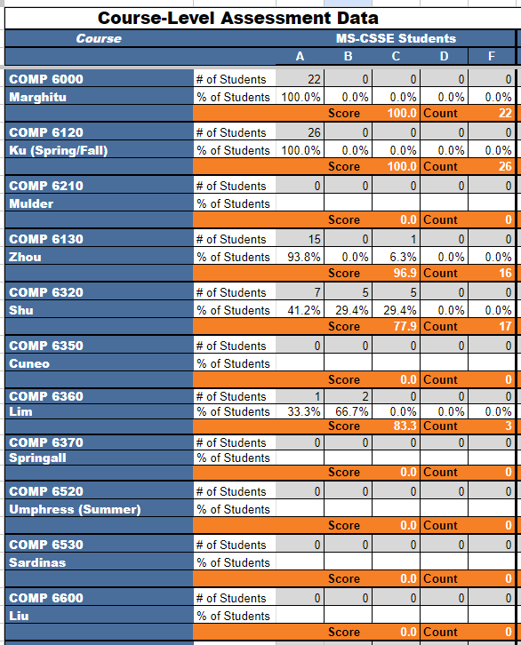

The Direct Measurement Data for the MS-CSSE Program (Part 4-2)

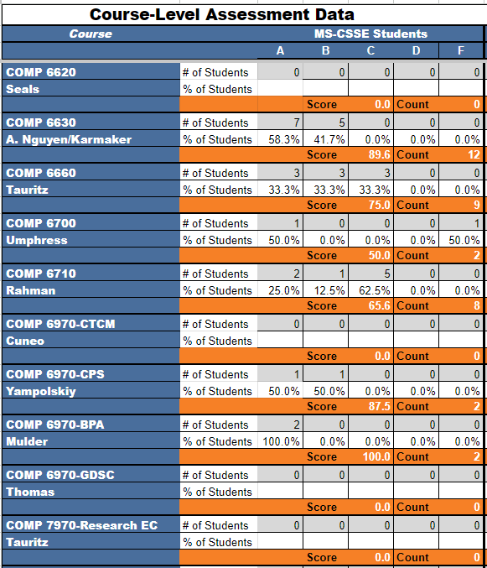

The Direct Measurement Data for the MS-CSSE Program (Part 4-3)
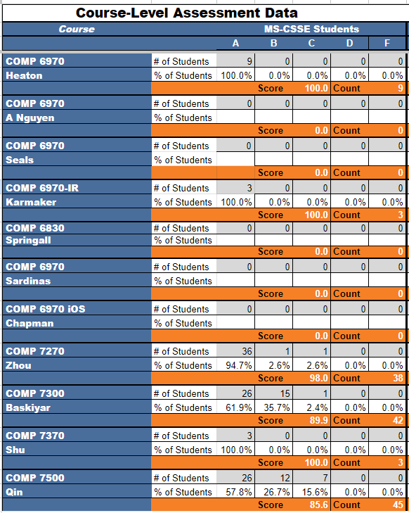

The Direct Measurement Data for the MS-CSSE Program (Part 4-4)
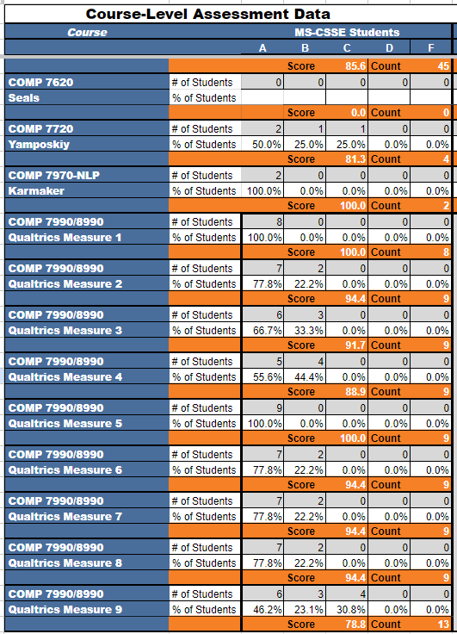

It is noteworthy that we present the direct measured data collected at the level of lecture-based courses. The assessment data from directed study, capstone engineering project, and thesis research were also collected in the fall 2021 and spring 2022 semesters. The results of the thesis defense can be found in Section 8.2 on page 8. Each SLO metric is evaluated on the scale from 100 to 0, where a score in [100, 90] is Exemplary, (90, 80) is Proficient, (80, 70) is Acceptable, and (70, 0) is Deficient. The following table summarizes the SLO results derived from the direct measurement methods.

The SLO Results Derived from the Direct Measurement Data (Part 1-5)
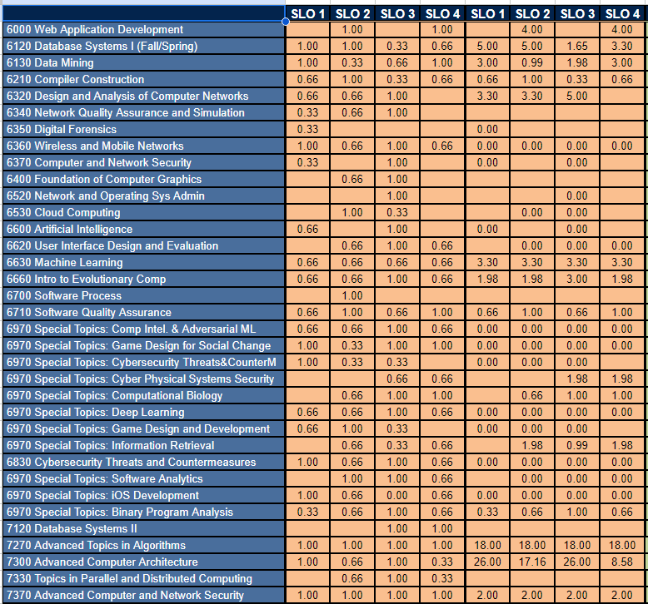

The SLO Results Derived from the Direct Measurement Data (Part 2-5)
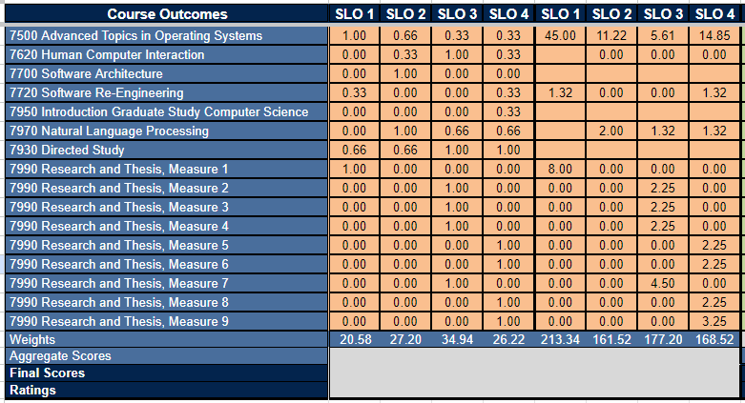

The SLO Results Derived from the Direct Measurement Data (Part 3-5)
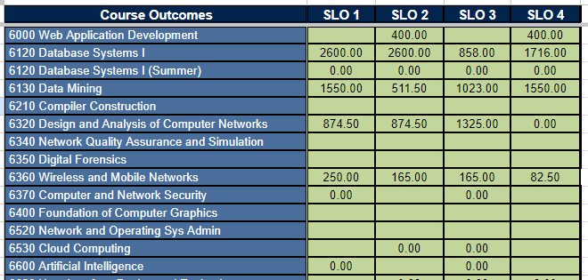

The SLO Results Derived from the Direct Measurement Data (Part 4-5)
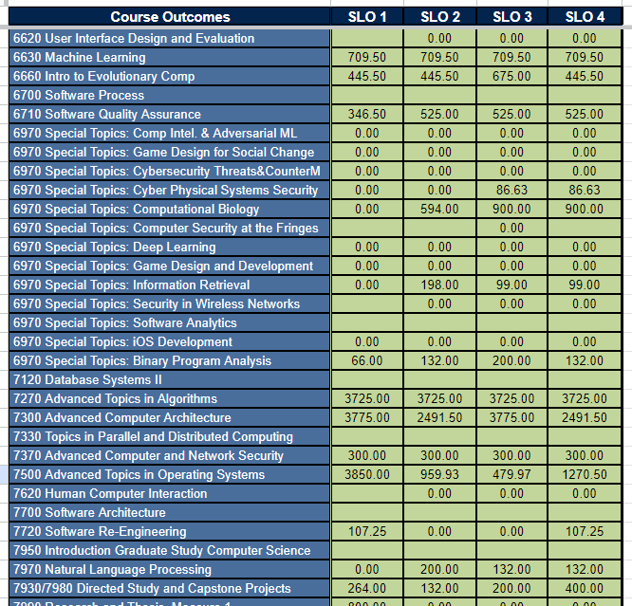

The SLO Results Derived from the Direct Measurement Data (Part 5-5)
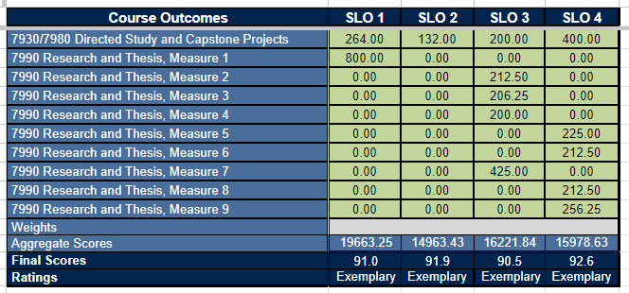

  - Assessment Results of Thesis Final Defense

- - Each MS (Thesis Option) student is expected to demonstrate mastery of the basic principles of at least one of the disciplines of CSSE. Please assess this student using the following scale
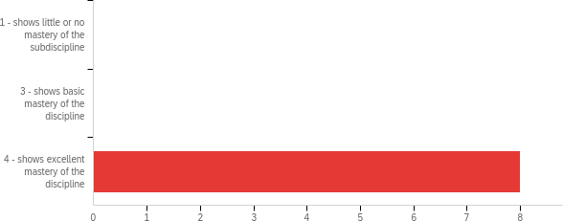

# | Field | Minimum | Maximum | Mean | Std Deviation | Variance | Count
1 | Each MS (Thesis Option) student is expected to demonstrate mastery of the basic principles of at least one of the disciplines of CSSE. Please assess this student  using the following scale | 4.00 | 4.00 | 4.00 | 0.00 | 0.00 | 8

# | Answer | % | Count
1 | 1 - shows little or no mastery of the subdiscipline | 0.00% | 0
3 | 3 - shows basic mastery of the discipline | 0.00% | 0
4 | 4 - shows excellent mastery of the discipline | 100.00% | 8
 | Total | 100% | 8

- - Each MS (Thesis Option) student is expected to perform cutting-edge research in at least one area of specialty. Please assess this candidate using the following scale:
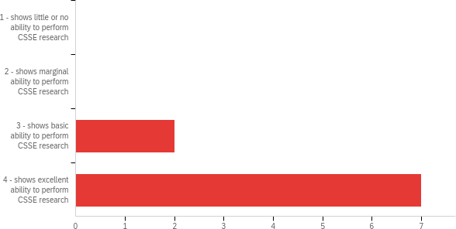

# | Field | Minimum | Maximum | Mean | Std Deviation | Variance | Count
1 | Each MS (Thesis Option) student is expected to perform cutting- edge research in at least one area of specialty. Please assess this candidate using the  following scale: | 3.00 | 4.00 | 3.78 | 0.42 | 0.17 | 9

# | Answer | % | Count
1 | 1 - shows little or no ability to perform CSSE research | 0.00% | 0
2 | 2 - shows marginal ability to perform CSSE research | 0.00% | 0
3 | 3 - shows basic ability to perform CSSE research | 22.22% | 2
4 | 4 - shows excellent ability to perform CSSE research | 77.78% | 7
 | Total | 100% | 9

- - Content: appropriate, complete, concise, and logically organized; problem, approach and results clear; appropriate use of time.
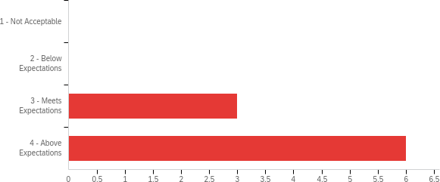

# | Field | Minimum | Maximum | Mean | Std Deviation | Variance | Count
1 | Content: appropriate, complete, concise, and logically organized; problem, approach and results clear; appropriate use of time. | 3.00 | 4.00 | 3.67 | 0.47 | 0.22 | 9

# | Answer | % | Count
1 | 1 - Not Acceptable | 0.00% | 0
2 | 2 - Below Expectations | 0.00% | 0
3 | 3 - Meets Expectations | 33.33% | 3
4 | 4 - Above Expectations | 66.67% | 6
 | Total | 100% | 9

- - Visual aids: readable & clear, concise wording, effective use of graphics, appropriate amount of information.
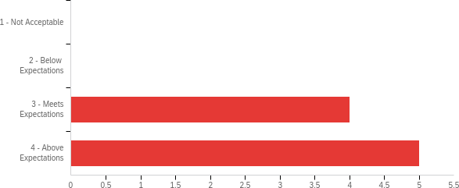

# | Field | Minimum | Maximum | Mean | Std Deviation | Variance | Count
1 | Visual aids: readable &amp; clear, concise wording, effective use of graphics, appropriate amount of information. | 3.00 | 4.00 | 3.56 | 0.50 | 0.25 | 9

# | Answer | % | Count
1 | 1 - Not Acceptable | 0.00% | 0
2 | 2 - Below Expectations | 0.00% | 0
3 | 3 - Meets Expectations | 44.44% | 4
4 | 4 - Above Expectations | 55.56% | 5
 | Total | 100% | 9

- - Presenter: appears well-prepared, vocabulary technically correct and audience appropriate.
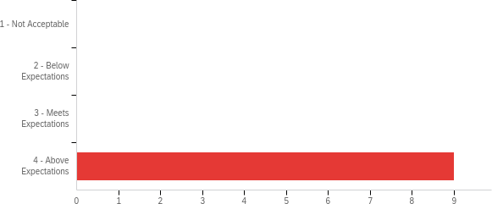

# | Field | Minimum | Maximum | Mean | Std Deviation | Variance | Count
1 | Presenter: appears well- prepared, vocabulary technically  correct and audience  appropriate. | 4.00 | 4.00 | 4.00 | 0.00 | 0.00 | 9

# | Answer | % | Count
1 | 1 - Not Acceptable | 0.00% | 0
2 | 2 - Below Expectations | 0.00% | 0
3 | 3 - Meets Expectations | 0.00% | 0
4 | 4 - Above Expectations | 100.00% | 9
 | Total | 100% | 9

- - Presentation mechanics: good voice volume, enunciation, speed; free of hesitations, distracting mannerisms; good poise, eye contact.
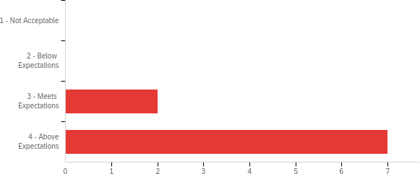

# | Field | Minimum | Maximum | Mean | Std Deviation | Variance | Count
1 | Presentation mechanics: good voice volume, enunciation, speed; free of hesitations, distracting mannerisms; good  poise, eye contact. | 3.00 | 4.00 | 3.78 | 0.42 | 0.17 | 9

# | Answer | % | Count
1 | 1 - Not Acceptable | 0.00% | 0
2 | 2 - Below Expectations | 0.00% | 0
3 | 3 - Meets Expectations | 22.22% | 2
4 | 4 - Above Expectations | 77.78% | 7
 | Total | 100% | 9

- - Responses to questions and comments: appropriate, direct, and complete
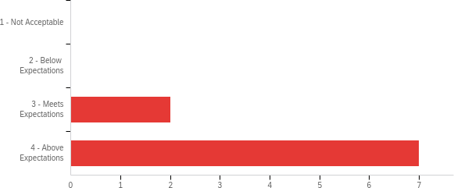

# | Field | Minimum | Maximum | Mean | Std Deviation | Variance | Count
1 | Responses to questions and comments: appropriate, direct,  and complete | 3.00 | 4.00 | 3.78 | 0.42 | 0.17 | 9

# | Answer | % | Count
1 | 1 - Not Acceptable | 0.00% | 0
2 | 2 - Below Expectations | 0.00% | 0
3 | 3 - Meets Expectations | 22.22% | 2
4 | 4 - Above Expectations | 77.78% | 7
 | Total | 100% | 9

- - Quality of English: good grammatical form, voice, tense, punctuation. Concise presentation
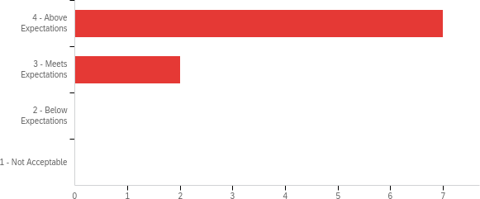

# | Field | Minimum | Maximum | Mean | Std Deviation | Variance | Count
1 | Quality of English: good grammatical form, voice, tense,  punctuation. Concise  presentation | 1.00 | 2.00 | 1.22 | 0.42 | 0.17 | 9

# | Answer | % | Count
1 | 4 - Above Expectations | 77.78% | 7
2 | 3 - Meets Expectations | 22.22% | 2
3 | 2 - Below Expectations | 0.00% | 0
4 | 1 - Not Acceptable | 0.00% | 0
 | Total | 100% | 9

- - Technical writing content: good organization; clear description of problem, state-of-the art, technical approach, and results; clear figures and tables; relevant and timely references
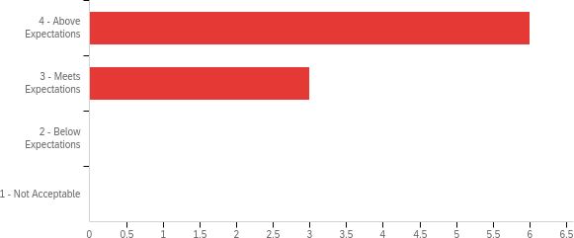

# | Field | Minimum | Maximum | Mean | Std Deviation | Variance | Count
1 | Technical writing content: good organization; clear description of problem, state-of-the art, technical approach, and results; clear figures and tables; relevant  and timely references | 1.00 | 2.00 | 1.33 | 0.47 | 0.22 | 9

# | Answer | % | Count
1 | 4 - Above Expectations | 66.67% | 6
2 | 3 - Meets Expectations | 33.33% | 3
3 | 2 - Below Expectations | 0.00% | 0
4 | 1 - Not Acceptable | 0.00% | 0
 | Total | 100% | 9

Interpreting Results



Communicating Results
The program outcomes were shared with the CSSE faculty through an email announcement. The program outcomes have been posted on the CSSE graduate programs website in September 2020 after the 2019- 2020 report was submitted. This latest annual assessment report was shared with the CSSE faculty members through the graduate faculty mailing list on Thursday, June 15, 2023, in the summer 2023 semester. After we incorporated the faculty’s comments on this report, the assessment report is submitted to the Office of Academic Assessment. In additional, the assessment report was submitted to Dr. Fergus and Dr. Auad, the Associate Deans who oversee program assessment and graduate studies in the Samuel Ginn College of Engineering. The final version of this assessment report will be shared, distributed, and discussed during a faculty meeting scheduled in the first week of the fall 2023 semester.

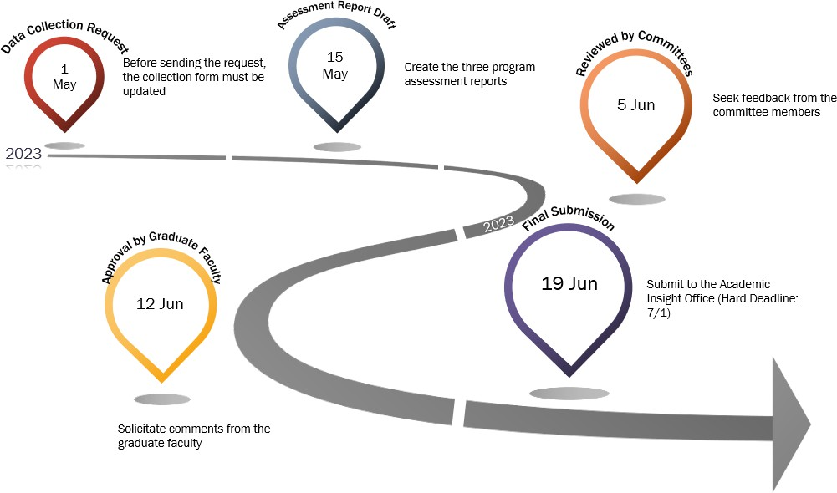

The above infographic sketches the timeline of the entire assessment procedure, including data collection, data analysis, assessment report writing, graduate programs committee review, CSSE graduate faculty approval, and final report submission. The procedure starts at the beginning of May, and the annual assessment report is submitted in the third week of June.
A vast majority of the CSSE graduate faculty members participated in the assessment procedure such as data collection. The graduate programs committee thoroughly reviewed this report before the CSSE graduate faculty approved the assessment report. To facilitate efficient communication, we provide the graduate faculty with a summary of the key findings from the report.
The detailed milestones, deadlines, and description of each activity are tabulated in the table below.

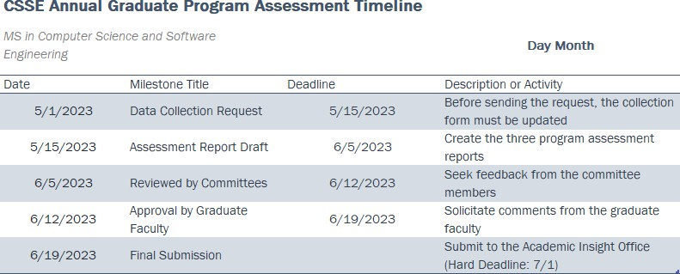

Use of Results

Purposeful Reflection
  - A Consistent and Ongoing Process
The graduate programs committee consists of five professors: Dr. Biaz, Dr. Ku, Dr. Baskiyar, Dr. Kandah, and Dr. Qin, who are committee to arrange a minimum of three meetings per year to evaluate and improve the Ph.D. program. Please note that Dr. Umphress retired last year, and Dr. Kandah – the chair of the Cybersecurity curriculum committee in the CSSE Department – is a new member serving on the CSSE graduate programs committee. The recommendations made by the graduate programs committee will be further reviewed by the CSSE graduate faculty in the first faculty meeting scheduled in the fall 2023 semester. In some cases, departmental policies will be forged to streamline the management of the Ph.D. program and doctoral students. The graduate faculty always offers insightful feedback to the graduate programs committee to brush up on proposed policies and strategies. In case of disagreements occur among graduate faculty members, the department chair – Dr. Narayanan – will collaborate with Dr. Hendrix, associate chair of the department, to spearhead a resolution through tradeoffs for the disagreements.

  - Implementation of the Above Process
During the graduate programs committee meeting held on June 15, the committee members concurred that the SLO 3 measure is still noticeably lower than those of the other SLOs. The graduate programs committee proposed plan to focus on novel approaches to strengthening MS-CSSE students’ reasoning and technical skills to solve problems in at least one area of research. By and large, the MS-CSSE program in Computer Science and Software Engineering is rated at the proficient level. The CSSE graduate faculty will continue improving both the curriculum as well as the opportunities for extracurricular activities. We look forward to future faculty development accompanied by the constructive and insightful feedback offered by the Office of Academic Insight on this graduate program assessment report.

  - COMP 7930 Directed Studies and COMP 7980 Capstone Projects
During the graduate programs committee meeting held on June 15, the committee members concurred that the SLO 3 measure is still noticeably below its peers. The data collected from COMP 6120, 7930, and 7980 were not available when we initially wrote the report containing the following assessment results. Surprisingly, after we incorporated the data gleaned from COMP 6120/7930/7980, all the SLO measures - especially SLO 2-3 measures - are immensely boosted from the proficient rating to the exemplary ones. We conclude that these three courses play a pivotal role in program assessment procedure. We will, in the future, ensure that assessment data is collected from these three important courses.

Direct measurement before incorporating the COMP 6120, 7930, 7980 data
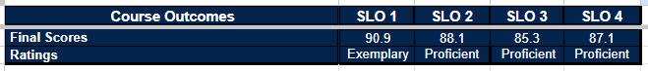

Direct measurement after incorporating the COMP 6120, 7930, and 7980 data
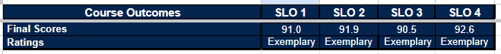

Action Plan

Courses Performing well

AP

Courses Needing Support

AP1

Trends

AP2

