1. INTRODUCTION
   1. Overview

An infographic is a collection of imagery ,data visualization like pie charts

And bar graphs ,and minimal text that gives an easy- to -understand overview

Of a topic.

* 1. PURPOSE

With canva you can creat posters ,infographics ,documents ,graphics ,etc…

In a very simple way.

1. Problem Defenition and design Thinking
   1. Empathy map

Paste the empathy map screenshot.

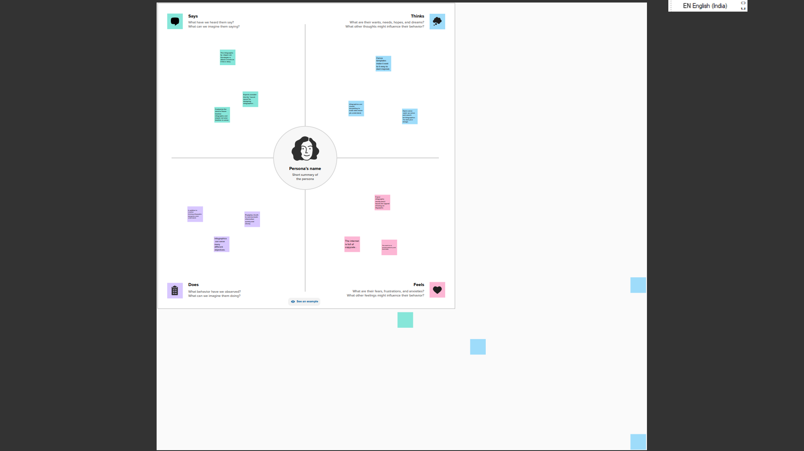

* 1. Ideation &brainstorming map

Paste the ideation & brainstorming map screenshot

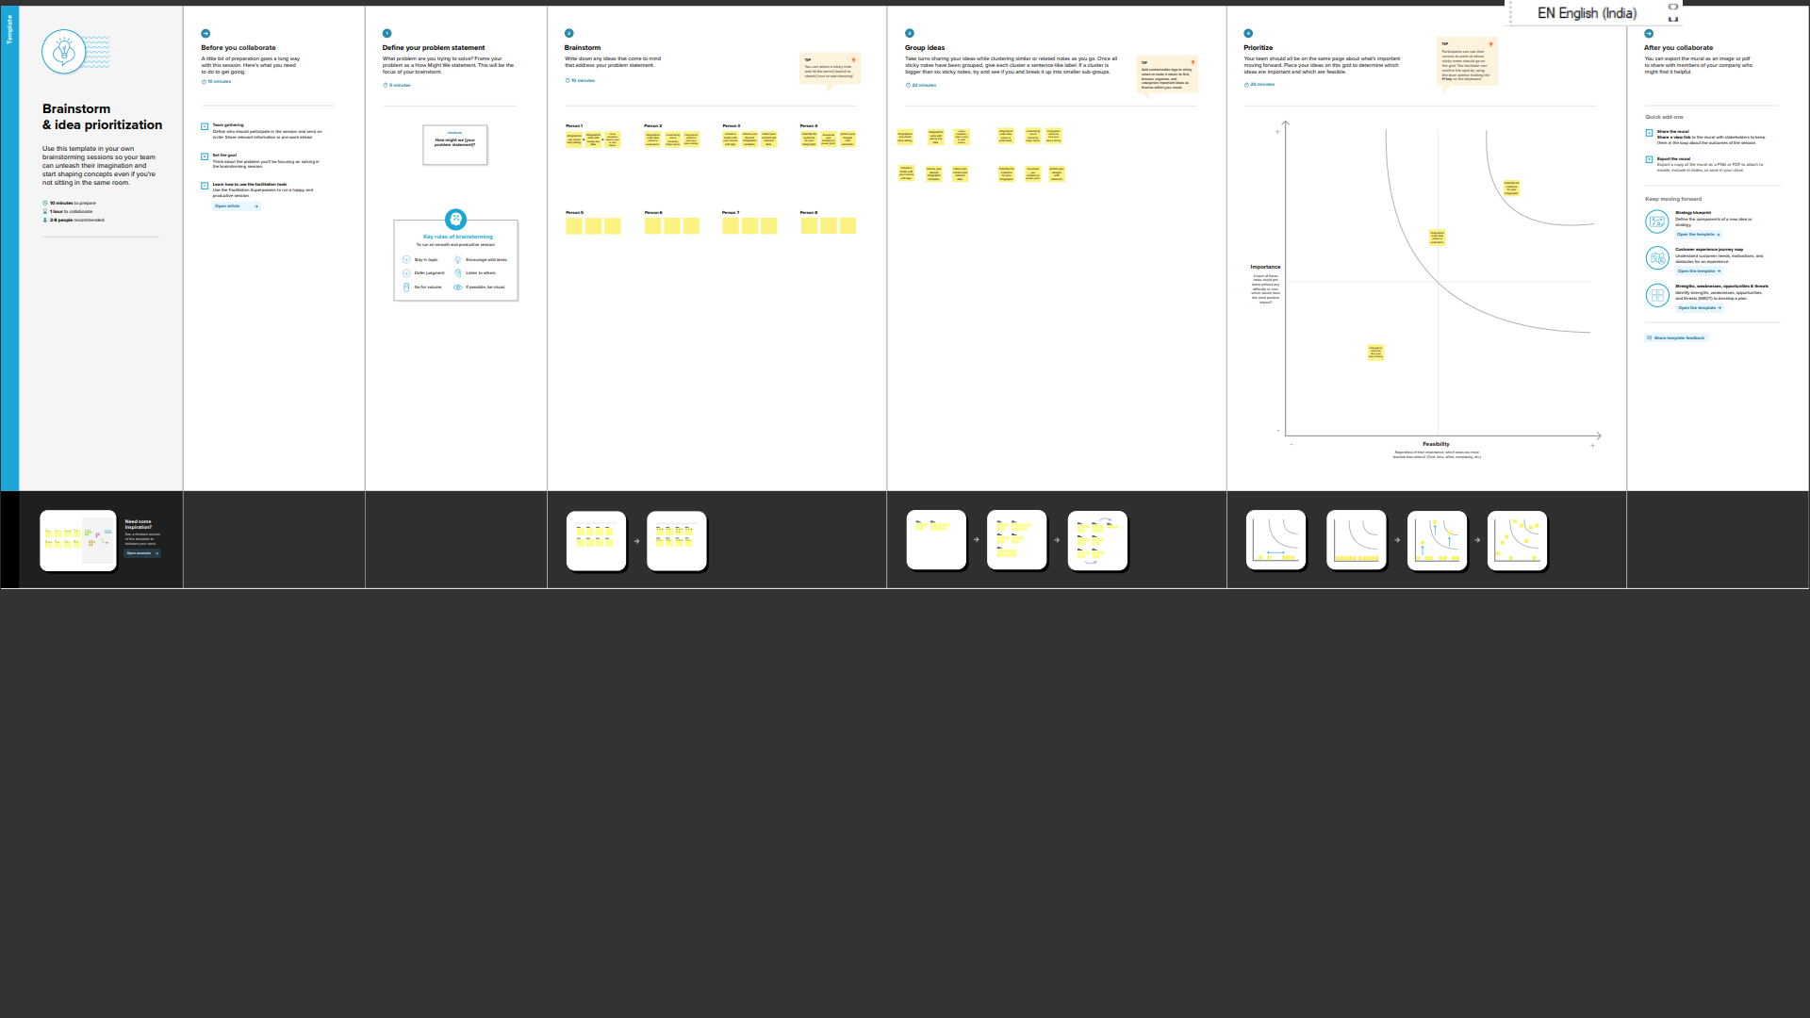

1. RESULT

Final findings (out put) of the project along with the screenshots.

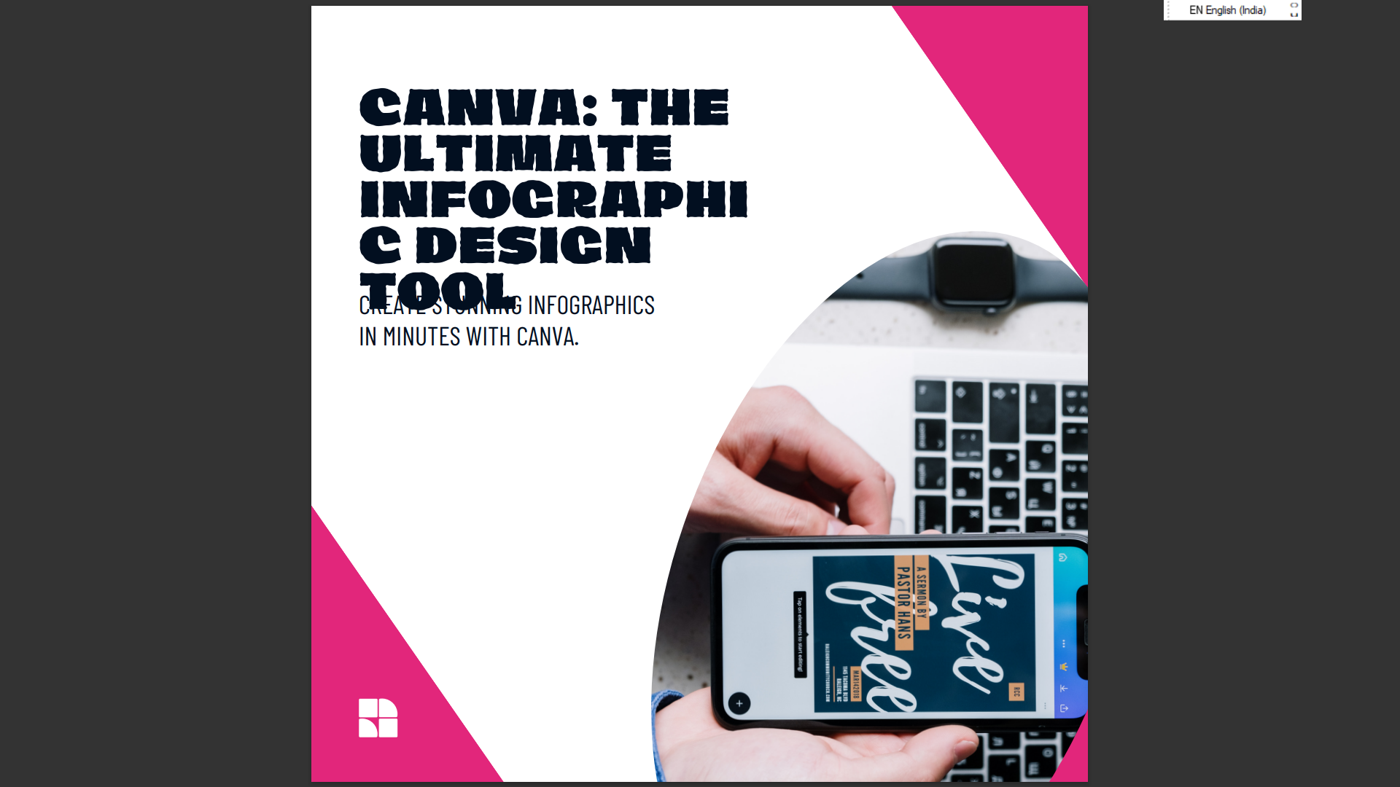

4 ADVANTAGES&DISADVANTAGES

1. offers a professional look
2. Even a non-designer can become a designer using canva.
3. Limitation of number of temolates.
4. Free version is limited.
5. Cannot download the “raw”file to your computer.
6. Canva is budjet-friendly.