• data.csv(text/csv) - 230 bytes, last modified: 3/26/2026 - 100% done
Saving data.csv to data (1).csv
First 5 rows:
Name Age Marks City
0 Amit 20 85 Hyderabad
1 Sneha 21 90 Chennai
2 Rahul 19 70 Bangalore
3 Priya 22 88 Mumbai
4 Kiran 20 60 Delhi

Last 5 rows:
Name Age Marks City
5 Anjali 21 95 Pune
6 Vikram 23 75 Hyderabad
7 Neha 20 82 Chennai
8 Arjun 22 77 Bangalore
9 Divya 21 89 Mumbai

Data Info:
<class 'pandas.core.frame.DataFrame'>
RangeIndex: 10 entries, 0 to 9
Data columns (total 4 columns):
# Column Non-Null Count Dtype
--- ------ -------------- -----
0 Name 10 non-null object
1 Age 10 non-null int64
2 Marks 10 non-null int64
3 City 10 non-null object
dtypes: int64(2), object(2)
memory usage: 452.0+ bytes
None

Summary Statistics:
Age Marks
count 10.000000 10.000000
mean 20.900000 81.100000
std 1.197219 10.650509
min 19.000000 60.000000
25% 20.000000 75.500000
50% 21.000000 83.500000
75% 21.750000 88.750000
max 23.000000 95.000000

Missing Values:
Name 0
Age 0
Marks 0
City 0
dtype: int64

Students with Marks > 80:
Name Age Marks City
0 Amit 20 85 Hyderabad
1 Sneha 21 90 Chennai
3 Priya 22 88 Mumbai
5 Anjali 21 95 Pune
7 Neha 20 82 Chennai
9 Divya 21 89 Mumbai

Selected Columns (Name & Marks):
Name Marks
0 Amit 85
1 Sneha 90
2 Rahul 70
3 Priya 88
4 Kiran 60
5 Anjali 95
6 Vikram 75
7 Neha 82
8 Arjun 77
9 Divya 89
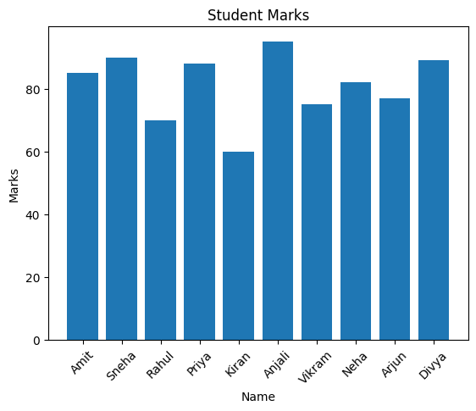

✅ Task Completed Successfully!

