Mean,Median,Mode
Data source
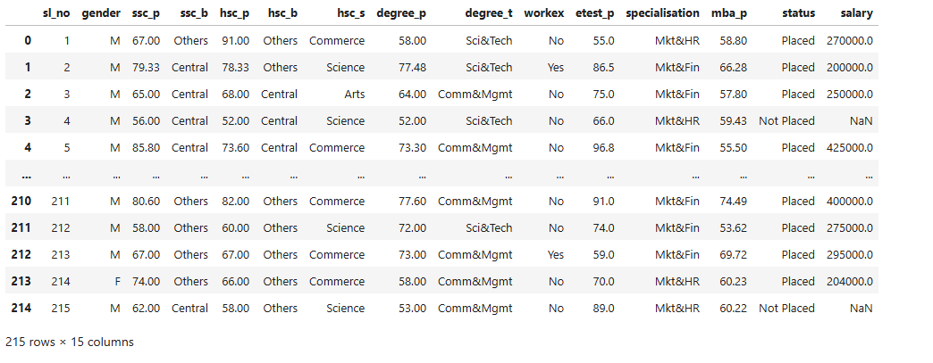

For the above data source, we had arrived below statistics.
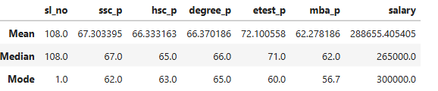

Employee’s average entrance test percentage is ’72.1%’
Middle point of entrance test percentage is 71%
Employee’s repeated scored entrance score is 60%.

Percentile
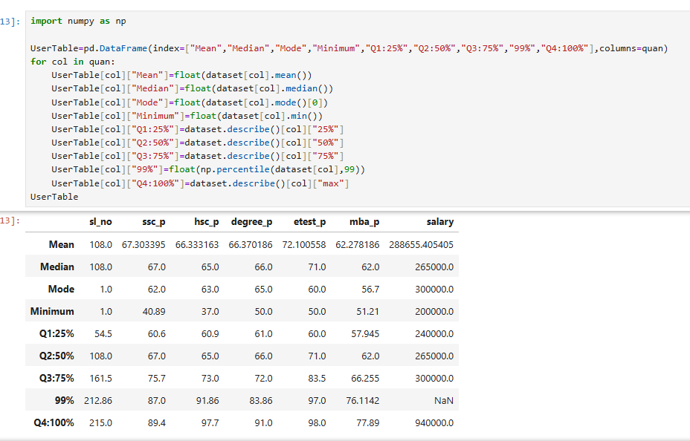
SSLC Passing score statistics analysis.
Out of 215 employees, lowest 25 % of employee’s SSC pass score fall between 40.89-60.6 Mark
Out of 215 employees, 50 % of employee’s SSC pass score fall between 40.89-67.0 Mark
Out of 215 employees, lowest 75 % of employee’s SSC pass score fall between 40.89-75.7 Mark
Out of 215 employees, 99 % of employee’s SSC pass score fall between 40.89-87.0 Mark
Out of 215 employees, ALL employee’s SSC pass score falls between 40.89-89.4 Mark
Out of 215 employees, Middle 50% of employee’s SSC pass score fall between 60.6-75.7 Mark
Out of 215 employees, highest 25% of employee’s SSC pass score fall between 75.70-89.4 Mark
Out of 215 employees, highest 75 % of employee’s SSC pass score fall between 60.6-89.4 Mark
Out of 215 employees, highest 1% of employee’s SSC pass score fall between 87.0-89.4 Mark

IQR
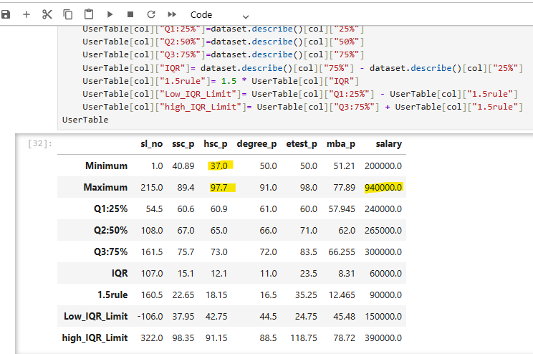
Based on the outcome I could able to find below outliers.
Data field | Lesser Outlier | Greater Outlier
Hsc_p | Yes | Yes
Salary | No | Yes

