**IOT_PHASE 4**

**(SMART WATER FOUNTAINS)**

**TEAM NAME: proj_228481_Team_1**

**TEAM MEMBERS:**

1. **S.BHUVANASRI**
2. **M.DEEPIKA**
3. **K.KIRUTHIKA**
4. **N.SELVAMEENA**
5. **M.SHOFIYA**

**INTRODUCTION:**

The purpose of a smart water fountain project is to provide efficient, convenient, and hygienic access to drinking water while promoting water conservation and sustainability. This report outlines the components used the setup and functionality of the system.

**HARDWARE COMPONENTS:**

Hardware components Used :

1)Raspberry Pi

2)LED

3)Resistor(300 ohm)

4) HC-SR04 ultrasonic distance sensor

5)bipolar stepper motor

**USES OF THE COMPONENTS IN SMART WATER FOUNTAIN PROJECT:**

Here we can see the some specific uses of these components in a smart water fountain project:

1. **Raspberry Pi:**

* Controller: Use the Raspberry Pi as the central controller to manage the various components of the smart water fountain.
* IOT Connectivity: Enable remote control and monitoring of the fountain using Wi-Fi or other IOT protocols.
* Data Logging: Collect data on fountain operation and water levels for analysis and maintenance.

2. **LED (Light Emitting Diode):**

* Illumination: Use LEDs to add decorative and dynamic lighting effects to the water fountain.
* Status Indicators: Employ LEDs as indicators for system status, such as power, water level, or mode.

3. **HC-SR04 Ultrasonic Distance Sensor:**

* Water Level Sensing: Utilize the ultrasonic sensor to measure and monitor the water level in the fountain basin.
* Overflow Prevention: Implement an alert or shutdown mechanism to prevent overflows by detecting high water levels.

4. **Bipolar Stepper Motor:**

* Water Jet Control: Use the stepper motor to control the direction and angle of water jets, creating dynamic water patterns.
* Fountain Nozzle Adjustment: Adjust the position of fountain nozzles for different water displays and effects.

5. **Resistor (300 Ohm):**

* LED Current Limiting: Connect resistors in series with LEDs to limit the current and protect the LEDs in the fountain lighting system.
* Voltage Division: Use resistors in voltage divider circuits to interface with sensors or devices.

In a smart water fountain project, these components help automate and enhance the functionality and aesthetics of the fountain, providing features such as dynamic lighting, water level monitoring, and control over water patterns.

**STIMULATION DESIGN IN WOKWI :**

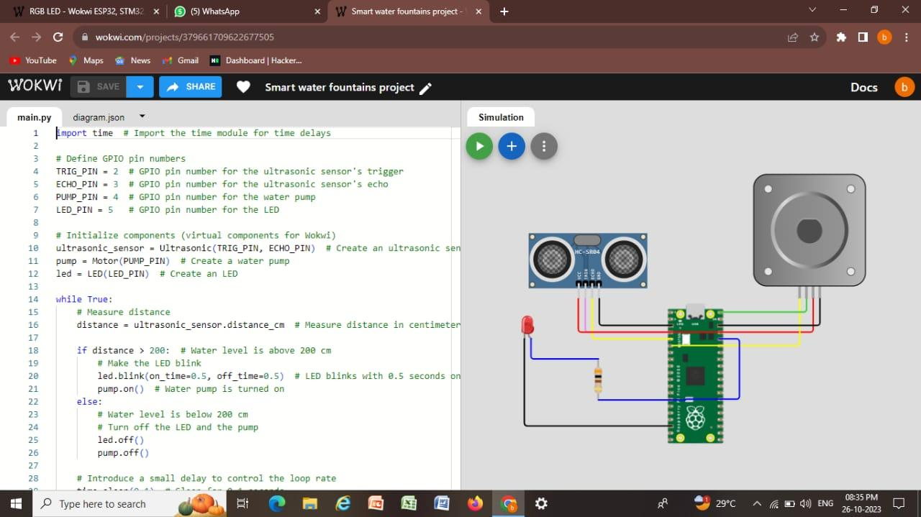

**OUTPUT:**

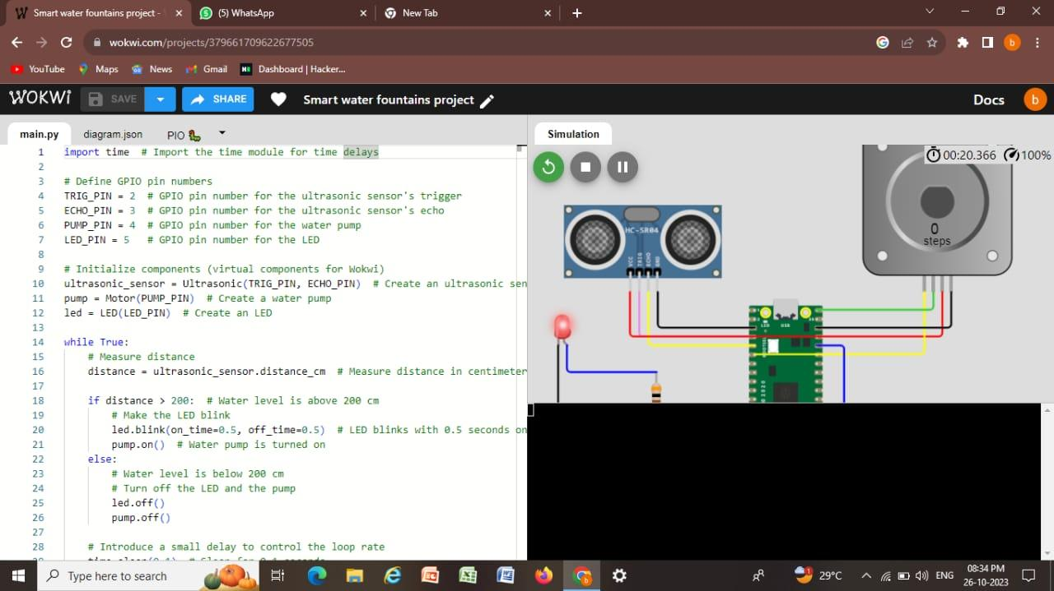

**STIMULATION CODE:**

Import time # Import the time module for time delays

# Define GPIO pin numbers

TRIG_PIN = 2 # GPIO pin number for the ultrasonic sensor’s trigger

ECHO_PIN = 3 # GPIO pin number for the ultrasonic sensor’s echo

PUMP_PIN = 4 # GPIO pin number for the water pump

LED_PIN = 5 # GPIO pin number for the LED

# Initialize components (virtual components for Wokwi)

Ultrasonic_sensor = Ultrasonic(TRIG_PIN, ECHO_PIN) # Create an ultrasonic sensor

Pump = Motor(PUMP_PIN) # Create a water pump

Led = LED(LED_PIN) # Create an LED

While True:

# Measure distance

Distance = ultrasonic_sensor.distance_cm # Measure distance in centimeters

If distance > 200: # Water level is above 200 cm

# Make the LED blink

Led.blink(on_time=0.5, off_time=0.5) # LED blinks with 0.5 seconds on and off time

Pump.on() # Water pump is turned on

Else:

# Water level is below 200 cm

# Turn off the LED and the pump

Led.off()

Pump.off()

# Introduce a small delay to control the loop rate

Time.sleep(0.1) # Sleep for 0.1 seconds

**STIMULATION CODE LINK:**

https://wokwi.com/projects/379661709622677505

**WEB CODE:**

<!DOCTYPE html>

<html>

<head>

<title>Water Fountain Status</title>

<link rel=”stylesheet” type=”text/css” href=”style.css”>

</head>

<body>

<header>

<h1>Water Fountain Status</h1>

</header>

<section class=”status”>

<h2>Current Status</h2>

<p id=”flowRate”>Flow Rate: <span id=”flowValue”>0</span> GPM</p>

</section>

<section class=”alerts”>

<h2>Alerts</h2>

<ul id=”alertList”>

<!—Alerts will be displayed here 🡪

</ul>

</section>

<script src=”script.js”></script>

</body>

</html>

Body {

Font-family: Arial, sans-serif;

}

Header {

Background-color: #3498db;

Color: #fff;

Text-align: center;

Padding: 20px;

}

Section {

Margin: 20px;

Padding: 10px;

Border: 1px solid #ccc;

Border-radius: 5px;

}

H2 {

Color: #3498db;

}

Ul {

List-style: none;

}

// Simulate real-time data (replace with actual data source)

Function generateRandomData() {

Return {

flowRate: (Math.random() * 10).toFixed(2), // Random flow rate between 0 and 10 GPM

alerts: Math.random() < 0.2 ? [“Malfunction detected”] : [],

};

}

Function updateData() {

Const data = generateRandomData();

// Update flow rate

Const flowValue = document.getElementById(“flowValue”);

flowValue.textContent = data.flowRate;

// Update alerts

Const alertList = document.getElementById(“alertList”);

alertList.innerHTML = “”;

data.alerts.forEach((alert) => {

const li = document.createElement(“li”);

li.textContent = alert;

alertList.appendChild(li);

});

}

// Update data every 5 seconds (adjust as needed)

setInterval(updateData, 5000);

// Initial data update

updateData();

**OUTPUT:**

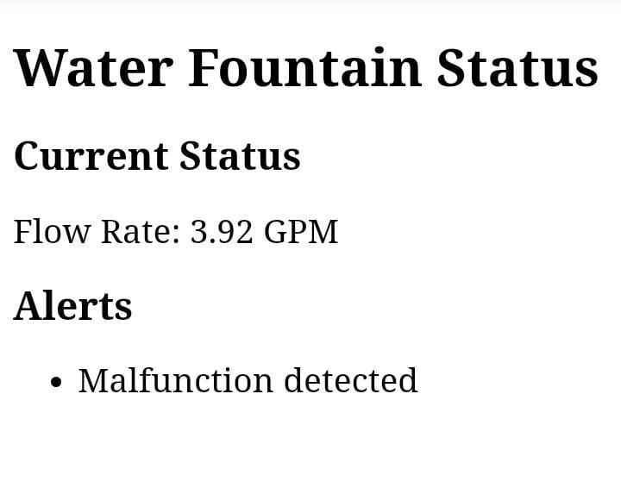

**CONCLUSION:**

* The main purpose of a smart water fountain project is to enhance water conservation and reduce waste through efficient and controlled water dispensing.
* This project is to reduce water wastage by implementing controls and sensors that can adjust the flow rate based on user demand and detect and prevent leaks to conserve water effectively.