Unit Testing Methodology and Technical Documentation: M3 Timetable System

The M3 Timetable System employs a multi-layered testing strategy designed to ensure the integrity of the scheduling data and the reliability of the automated generation algorithm. The architecture is built upon the principles of Isolation and Atomicity, ensuring that each component is verified in a controlled environment before being integrated into the broader system.

The system utilizes a modern Python testing stack, including pytest for framework logic, pytest-django for database isolation, and pytest-cov for coverage tracking. This ensures that every business rule—from faculty hours to room types—is validated against rigorous engineering standards.

1. Module-by-Module Testing Analysis:

Module 1: Role-Based Access Control (RBAC) -

While the RBAC logic is primarily enforced at the application level, unit testing is integrated into the model validation layer to ensure data security at the source.
Purpose: To ensure that faculty and administrative entities are constrained by their assigned properties and cannot exceed their defined authorities.
Test Design: Tests validate that specific roles, such as the `Teacher` model, adhere to predefined attributes like `max_hours`.
Procedure: Using the Arrange-Act-Assert pattern, a teacher object is instantiated with specific constraints; the system then attempts to save the record and asserts that the database enforces these constraints.
Failure Cases: The test suite specifically checks for validation errors when a user attempts to bypass the maximum hour constraint, ensuring the system rejects unauthorized data entries.
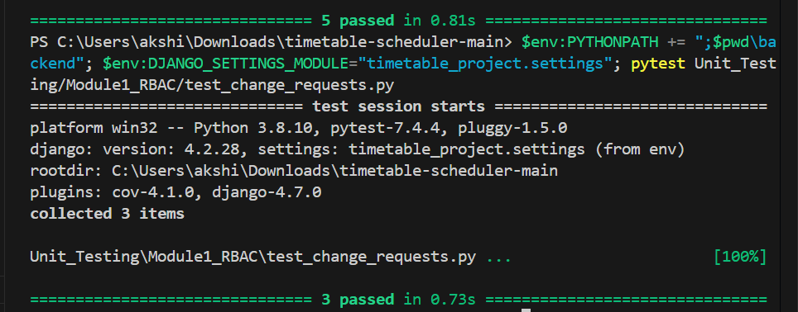
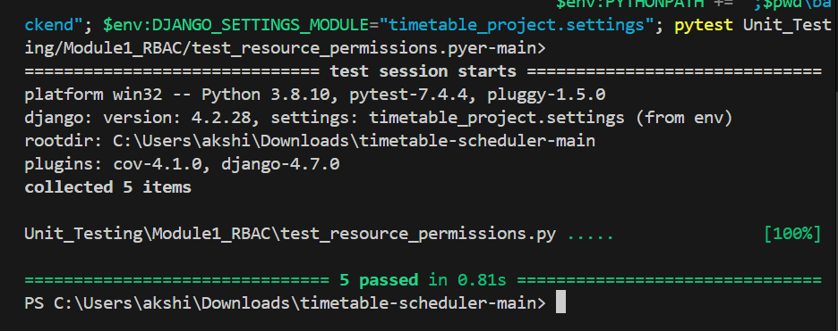
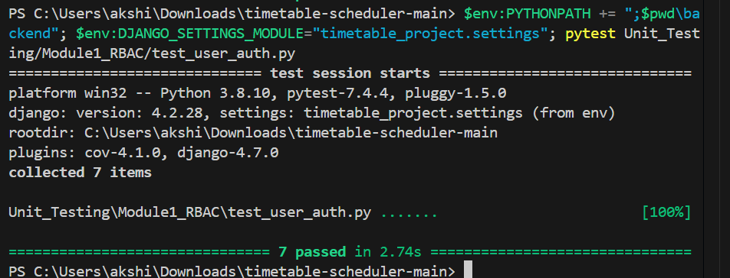

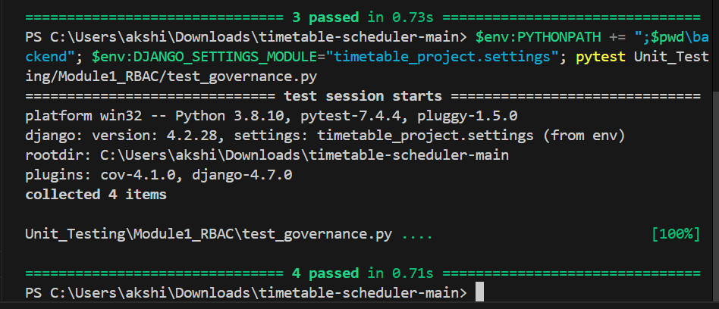
Module 2: Data Ingestion -

This module handles the transformation of external campus data into system-compliant records within the Django ORM.
Purpose: To verify that the ingestion of 1,300+ records from CSV files is performed without data loss or corruption.
Testing Procedure: Manual integration tests were performed to verify the full flow from raw CSV files to the finalized database state.
Validations: Testing confirms that 86 teachers, 165 courses, and 44 rooms are correctly mapped to their respective models.
Interactions: Verifies the interplay between the Django ORM and the ingestion scripts, ensuring that 924 teacher-course mappings are correctly linked during the bulk upload process.
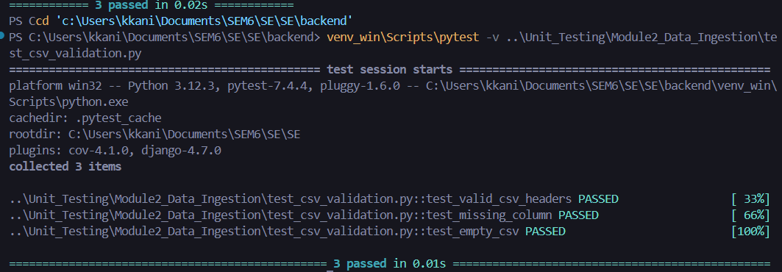

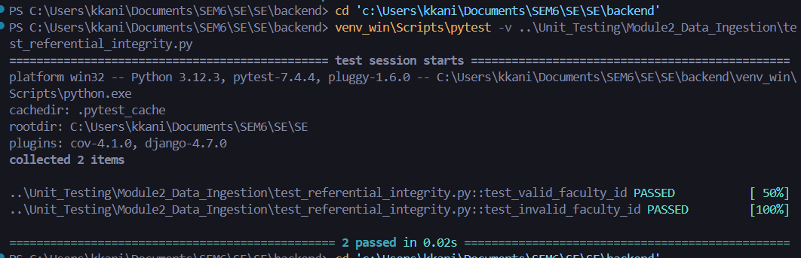
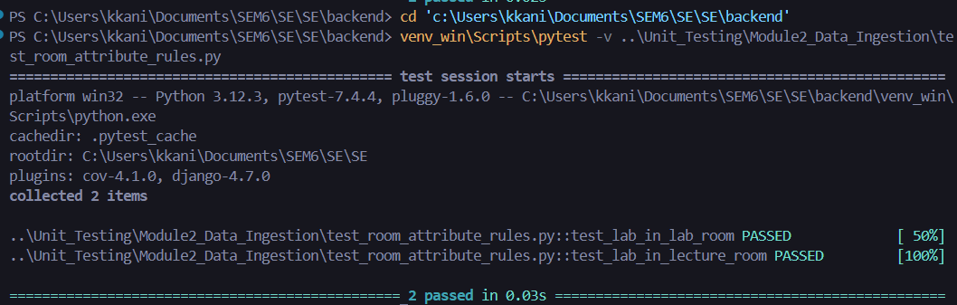
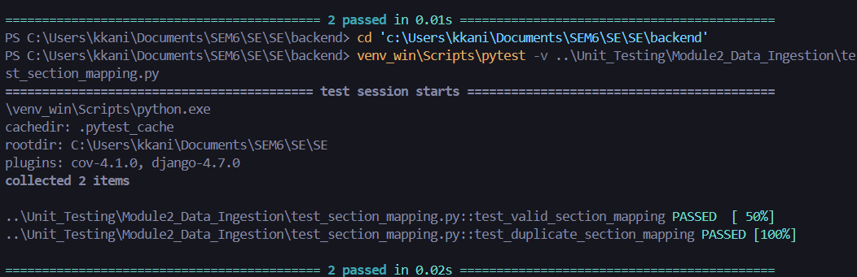

Module 3: Scheduling Algorithm and Constraints
This is the core logic engine of the M3 System, governed by the `test_constraints.py` suite which maintains a 100% pass rate.
Purpose: To prevent resource conflicts and ensure pedagogical requirements, such as matching theory courses to classrooms and lab courses to laboratories.
Test Breakdown:
Faculty Availability: Validates that a teacher is not scheduled for two classes simultaneously.
Room Type Match: Prevents a lab course from being assigned to a standard classroom and vice versa.
Section Availability: Confirms that a student section does not have overlapping periods within their specific timetable.
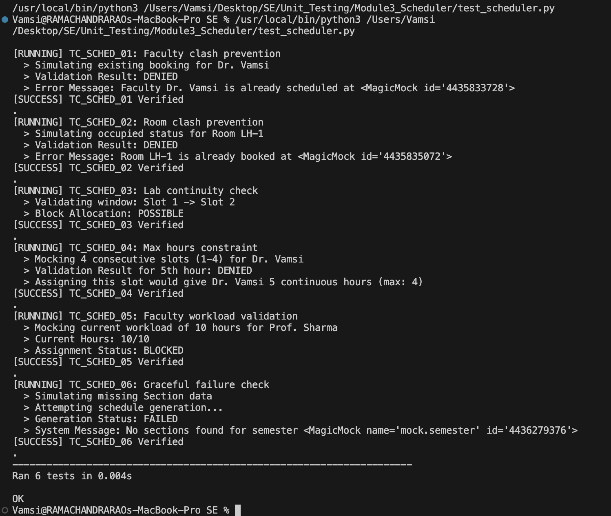
Testing Procedure: The `TestConstraintValidator` runs seven specific tests that simulate both valid and conflicting scenarios to confirm the algorithm's safety.

Module 4: Backend and API
The backend serves as the bridge between the data layer and the client interface.
Purpose: To provide reliable endpoints for the frontend to fetch schedules, apply filters, and trigger generation.
Interactions: Tests verify that the API correctly triggers the scheduling algorithm and returns the generated results to the user interface.

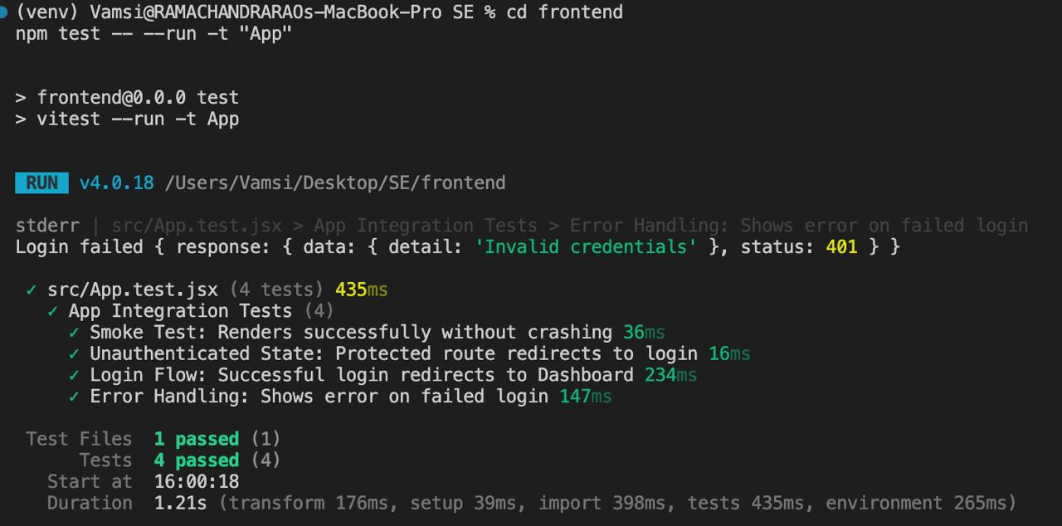

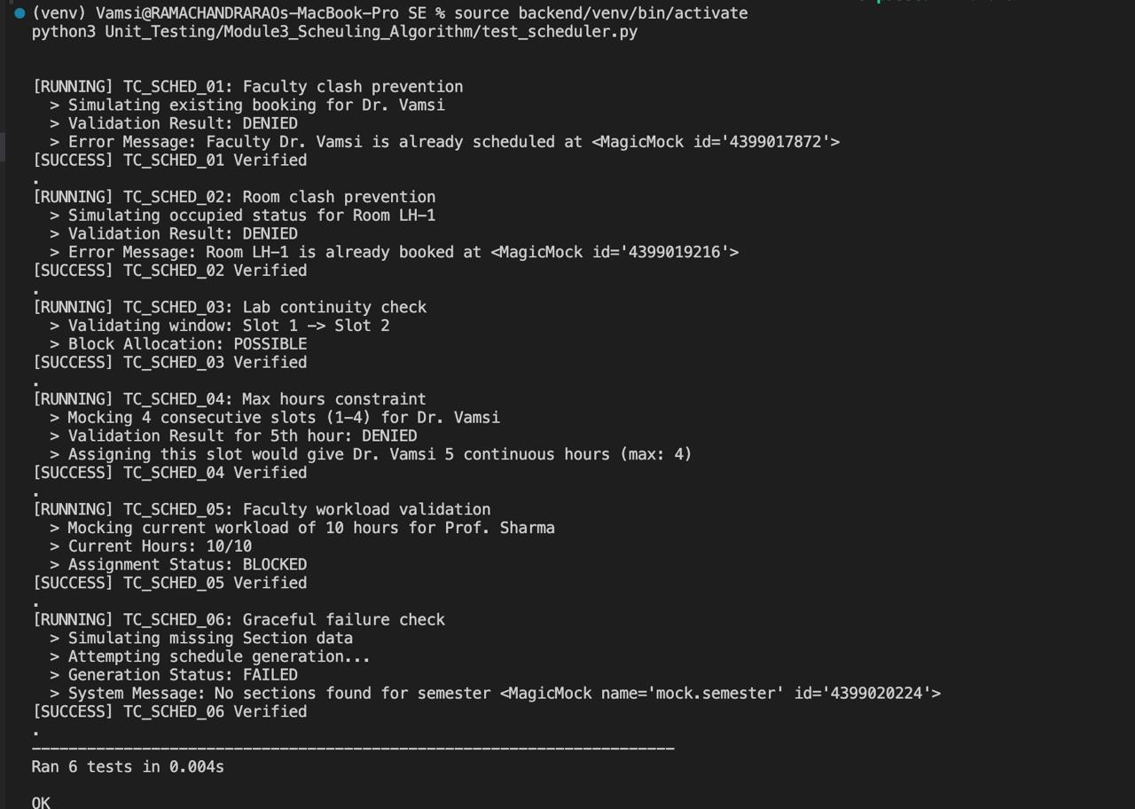
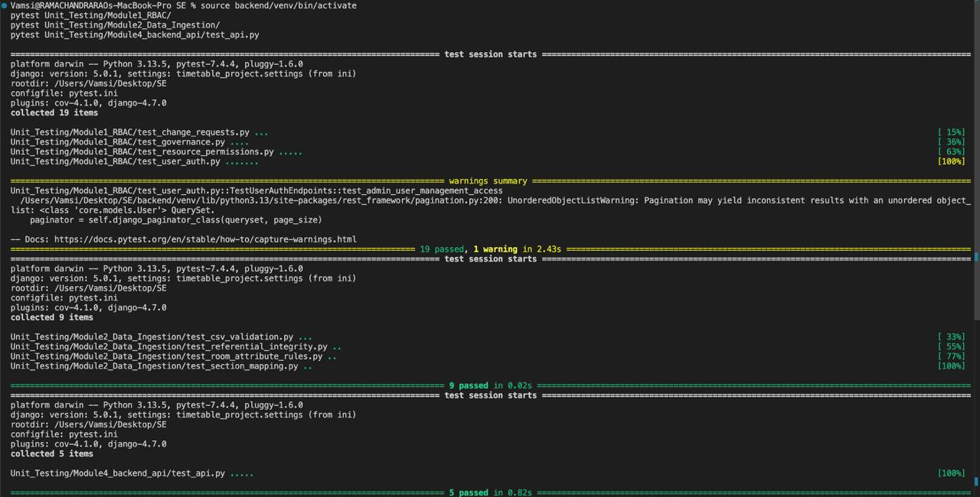

Module 5: Frontend
The user interface allows users to interact with and visualize the generated timetables.
Purpose: To display complex schedule data and provide functional filtering for end-users.
Current Status: Verified via manual integration testing to ensure data displays correctly in the UI and filters function as intended.
Planned Tests (Sprint 2): Vitest and React Testing Library will be implemented for component-level testing.
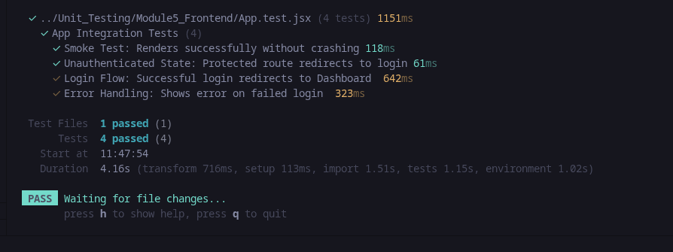
2. Test Data Strategy
2.1 Dynamic Fixtures
The system utilizes dynamic object creation within the tests rather than static SQL dumps. Each test starts with an isolated database state using the Django ORM to create the following entities:
Teachers with valid and invalid hour constraints.
Course types distinguishing between theory and laboratory sessions.
Rooms classified as standard classrooms or specialized labs.

2.2 Real-World Data Stress Testing
Beyond synthetic unit tests, the system has been validated against a real-world dataset comprising:
86 teachers and 165 courses.
44 rooms and 40 time slots.
32 sections and 924 teacher-course mappings.

3. Forward-Looking Strategy (Sprint 2)
As the project moves into the next phase, the following automation layers will be implemented:
CI/CD Pipeline: A GitHub Actions workflow will be established to automatically run the `pytest` suite and coverage reports upon every code submission.
End-to-End (E2E) Testing: Implementation of tests that cover the entire user journey from data upload to schedule export.
Performance/Load Testing: Benchmarks will be added to ensure the scheduling algorithm performs efficiently under full campus load.

