CHAPTER - 1
INTRODUCTION
1.1 Aim
This project aims in providing an “Animation Illustrating Searching of objects using search algorithm, which includes 3d objects such as Cube, Tetrahedron, Sphere, Torus, Pentagon, Cone, Rectangle, Rhombus, etc.

1.2 Overview
Our project is about “SEARCHING OF 3D OBJECTS”. This project gives the “Animation Illustrating Searching of an objects using search algorithm, which includes 3d objects such as Cube, Tetrahedron, Sphere, Torus, Pentagon, Cone, Rectangle, Rhombus, Hexagon, Triangle, Teapot. This object is displayed using keyboard control. Also search targeted objects using use mouse function.

1.3 Outcome
The user will be able to search the hidden objects using both Mouse and Keyboard functions. The following keys are used.
c: Cube
t: Teapot.
z: Torus.
p: Pentagon.
q: Tetrahedron.
v: Rectangle.
h: Hexagon.
s: Sphere.
“,” and “.” Keys are used to rotate the objects in either of the direction.

CHAPTER – 2
DESIGN AND IMPLEMENTATION

2.1 Algorithm

Step 1: Initialize the graphics windows and its size using GLUT functions.
Step 2 : Initialize the required variables and define user defined functions required.
Step 2: Register the keyboard, mouse and display call backs in main function.
Step 3: The window has 12 3D objects hidden.
Step 4: The user is asked for an input, which specifies the total number of objects he wishes to search out of 12 objects.
Step 5: Using the keyboard function the objects are selected using the specified keys.
Step 6: The selected object are displayed in wired format. Since the OS doesn’t recognize these objects, these objects are searched using mouse function.
Step 7: Using mouse function, each object is selected individually. The selected objects turns to solid nature.
Step 8: Operations such as Rotation with respect to Y and Z axis can be performed on the selected object only.
Step 9: After searching each object and verifying them by performing each rotation operation, the user can De-select the objects.
Step 10: The Deselection of objects is done using same Keyboard functions but with “UPPER CASE” letters.

2.1 Flow Chart

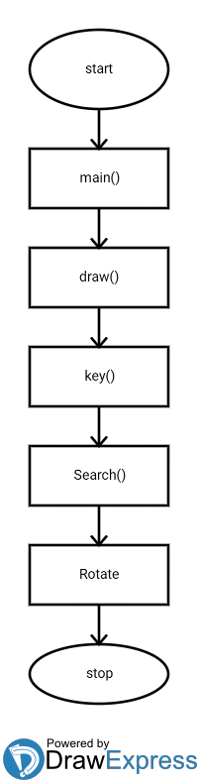

2.3 OpenGL API’s Used with Description

Many inbuilt OpenGL along with the user defined function are used in a hierarchical way. The functions which are used in the mini project are briefly discussed.
- glutMainLoop ( ): It causes the program to begin an event-processing loop.
- glPushMatrix ( ): Push the current matrix onto stack. Push matrix pushes the current matrix stack down by one, duplicating the current matrix. That is, after a glPushMatrix call, the matrix, on top of stack is identical to one below it.
- glPopMatrix ( ): Pop the current matrix from the stack. Pop matrix pops the current matrix stack up by one, duplicating the current matrix.
- glutDisplayFunc(display): Used whenever OpenGL window needs to be redisplayed.
- glBegin(GL_POLYGON): Constructs the polygon which joins all the given points specified.
- glTranslatef( ): Enables movement with respect to the points specified as parameters.
- glutIdleFunc( ) : Sets the global idle callback.
- glutSolidSphere( ) : To render a Solid Sphere
- glutWireSphere( ) : Renders a sphere centered at the modeling coordinates origin of the specified radius. The sphere is subdivided around the Z axis into slices and along the Z axis into stacks.
- glRotatef ( ) : Multiply the current matrix by a rotation matrix.
- glutBitmapCharacter( ) : renders a bitmap character using OpenGL.
- glutSwapBuffer ( ) : Swaps the buffers of the current window if double buffered.
- glRasterPos2i ( ) : Specifies the raster position for pixel operations.
- glMatrixMode( ) : Specifies which matrix will be affected by subsequent transformation. GL_MODELVIEW, GL_PROJECTION.
- glutCreateMenu ( ) : glutCreateMenu creates a new pop-up menu.
- glutAddMenuEntry ( ): glutAddMenuEntry adds a menu entry to the bottom of the current menu.
- glutAttachMenu ( ) : Attaches a mouse button for the current window to the identifier of the current menu.
- glutInitDisplayMode ( ) : Sets the initial display mode.
- glutInitWindowSize ( ) : Set the initial window size
- glutInitWindowPosition ( ) : Set the initial window position
- glClearColor ( ) : Specifies clear values for the color buffers.
- void glutAddMenuEntry(char *name, int value) - glutAddMenuEntry adds a menu entry to the bottom of the current menu. The string name will be displayed for the newly added menu entry. If the menu entry is selected by the user, the menu's callback will be called passing value as the callback's parameter.
- void glutReshapeFunc(void (*func)(int width, int height)) - glutReshapeFunc sets the reshape callback for the current window. The reshape callback is triggered when a window is reshaped.
- Void keys(unsigned char key, int x, int y) – Keyboard callback functions.
- void start_screen ( ) – The function which is passed to glutDisplayFunc( ) in order to display openGL
- void glutAttachMenu(int button) - glutAttachMenu attaches a mouse button for the current window to the identifier of the current menu. By attaching a menu identifier to a button, the named menu will be popped up when the user presses the specified button.
- void glutTimerFunc(unsigned int msecs, void (*func)(int value), value) - glutTimerFunc registers the timer callback func to be triggered in at least msecs milliseconds. The value parameter to the timer callback will be the value of the value parameter to glutTimerFunc. Multiple timer callbacks at same or differing times may be registered simultaneously.

2.4 Source Code

#include<GL/glut.h>
#include<stdarg.h>
#include<math.h>
#include<stdio.h>
#include<unistd.h>
#include<stdlib.h>

float angle=0,angle1=0,p3=-3.0,p1=0,p2=0,h1=0,h2=0,h3=0.7,h5=0,h6=0,h7=0,speed=0.1f;
int i=0,j=0,cd=0,v=0,t=0,h=0,p=0,r=0,s=0,o=0,z=0,q=0,dd=0,y=0,bd=0,m=0,n=0,mn[12]={0,0,0,0,0,0,0,0,0,0,0,0},mo[12]={0,0,0,0,0,0,0,0,0,0,0,0},sub1,time;

void display();
void reshape(int w,int h);
void init();
void key(unsigned char key,int x,int y);
void draw();
void search(GLint k);
void animate(int value);

void main(int argc ,char * argv[])
{
printf("Select Object by using following alphabets::\n");
printf("Objects\t\tAlphabet\n");
printf("Cube\t\t'c'\n Teapot\t\t't'\n Torus\t\t'z'\n Pentagon\t\tp\n Tetrahedron\t\tq\n Rectangular Cube\tv\n Vertical Cube\t\n Rhombus\t\tr\n Cone\t\to\n Hexagon\t\th\n Sphere\t\ts\n ");
printf("Click Mouse Right for search an object\n\n");
printf("use ',' & '.' and '<' & '>'\n\n");
printf("enter the number of objects(maximum of 12 objects)\n");
scanf("%d",&n);
while(1) {
if(n>12) {
printf("Enterno. below 12\n");
scanf("%d",&n);
if(n<=12)
break;
}
}
glutInit(&argc,argv);
glutInitDisplayMode(GLUT_DOUBLE|GLUT_RGB|GLUT_DEPTH);
glutInitWindowPosition(0,0);
glutInitWindowSize(600,480);
glutCreateWindow("Objects");
glutReshapeFunc(reshape);
glutKeyboardFunc(key);
glEnable(GL_DEPTH_TEST);
glEnable(GL_COLOR_MATERIAL);
glEnable(GL_LIGHTING);
glEnable(GL_LIGHT0);
glEnable(GL_NORMALIZE);
glutDisplayFunc(display);
glutTimerFunc(1.0, animate,0);
glutPostRedisplay();

sub1=glutCreateMenu(search);//acc
glutAddMenuEntry("cube",1);
glutAddMenuEntry("rectangle",2);
glutAddMenuEntry("teapot",3);
glutAddMenuEntry("hexagon",4);
glutAddMenuEntry("pentagon",5);
glutAddMenuEntry("rhombus",6);
glutAddMenuEntry("sphere",7);
glutAddMenuEntry("cone",8);
glutAddMenuEntry("torus",9);
glutAddMenuEntry("tetrahedron",10);
glutAddMenuEntry("triangle",11);
glutCreateMenu(search);
glutAddSubMenu("Search Objects",sub1);
glutAddMenuEntry("Terminate",13);
glutAttachMenu(GLUT_RIGHT_BUTTON);
init();
glutMainLoop();
}

void animate(int value) {
glutTimerFunc(speed, animate,0);
time++;
if(time>=10)
time=0;
glutPostRedisplay();
}

void init()
{
glClearColor(0,0,0,1);
glMatrixMode(GL_PROJECTION);
glLoadIdentity();
gluPerspective(45,640/480,1.0,500.0);
glMatrixMode(GL_MODELVIEW);
}
void reshape(int w,int h)
{
glViewport(0,0,w,h);
glMatrixMode(GL_PROJECTION);
glLoadIdentity();
if(w<=h)
glFrustum(-2,2,-2*(GLfloat)h/(GLfloat)w,2*(GLfloat)h/(GLfloat)w,2,20);
else
glFrustum(-2*(GLfloat)w/(GLfloat)h,2*(GLfloat)w/(GLfloat)h,-2,2,2,20);
glMatrixMode(GL_MODELVIEW);
glShadeModel(GL_SMOOTH);
glutPostRedisplay();
}

void display()
{
GLfloat b[]={0.6,0.8,0.6,0.8};
GLfloat c[]={-0.7,-1.1,5.0,0};
GLfloat d[]={0.4,0.8,0.8,19.3};
glClear(GL_COLOR_BUFFER_BIT|GL_DEPTH_BUFFER_BIT);
glClearColor(0,0,0,1);
glMatrixMode(GL_MODELVIEW);
glLoadIdentity();
glMaterialfv(GL_FRONT,GL_AMBIENT,b);
glMaterialfv(GL_BACK,GL_AMBIENT,b);
glLightfv(GL_LIGHT0,GL_POSITION,c);
glLightfv(GL_LIGHT0,GL_INTENSITY,d);
if(t==1){
glPushMatrix();
glTranslatef(-4.099998,-2.700000,-5.099998);
if(mo[2]==1) {
//if(time>5){
glRotatef(angle, 1, 0, 0);
glRotatef(angle1, 0,1,0);
glutSolidTeapot(1.0);
//}
}
else
glutWireTeapot(1.0);
glPopMatrix();
}
if(cd==1){
glPushMatrix();
glTranslatef(-0.8,-2.300000,-4.1);
if(mo[0]==1){
//if(time>5){
glRotatef(angle, 1, 0, 0);
glRotatef(angle1, 0,1,0);
glutSolidCube(1.0);
//}
}
else
glutWireCube(1.0);
glPopMatrix();
}
if(h==1){ //acc
glPushMatrix();
glTranslatef(-0.800000,-0.300000,-4.499999); //6
if(mo[3]==1) {
//if(time>5){
glRotatef(angle, 1, 0, 0);
glutSolidSphere(1.0,6,6);
//}
}
else
glutWireSphere(1.0,6,6);
glPopMatrix();
}

if(p==1){//acc
glPushMatrix();
glTranslatef(1.500000,-0.300000,-4.499999); //5
if(mo[4]==1) {
//if(time>5){
glRotatef(angle, 1, 0, 0);
glRotatef(angle1, 0,1,0);
glutSolidSphere(1.0,5,5);
//}
}
else
glutWireSphere(1.0,5,5);
glPopMatrix();
}
if(r==1){//acc
glPushMatrix();
glTranslatef(0.300000,1.800000,-4.499999); //4
if(mo[5]==1) {
//if(time>5){
glRotatef(angle, 1, 0, 0);
glRotatef(angle1, 0,1,0);
glutSolidSphere(1.0,4,4);
//}
}
else
glutWireSphere(1.0,4,4);
glPopMatrix();
}
if(s==1){//acc
glPushMatrix();
glTranslatef(-3.299999,-0.200000,-4.499999); //100
if(mo[6]==1) {
//if(time>5){
glRotatef(angle, 1, 0, 0);
glRotatef(angle1, 0,1,0);
glutSolidSphere(1.0,25,25);
//}
}
else
glutWireSphere(1.0,25,25);
glPopMatrix();
}
if(o==1){//acc
glPushMatrix();
glTranslatef(-2.000000,1.800000,-4.499999);// cone acc
glRotatef(-81.899323,1,0,0);
//if(mo[7]==1){
if(time>5){
glRotatef(angle, 1, 0, 0);
glRotatef(angle1, 0,1,0);
glutSolidCone(1,1,25,25);
//}
}
else
glutWireCone(1,1,25,25);
glPopMatrix();
}
if(z==1){//acc
glPushMatrix();
glTranslatef(1.400000,-2.600000,-4.499999);// ll acc
glRotatef(-60.899643,1,0,0);
if(mo[8]==1){
if(time>5){
glRotatef(angle, 1, 0, 0);
glRotatef(angle1, 0,1,0);
glutSolidTorus(0.35,0.6,25,25);
}
}
else
glutWireTorus(0.35,0.6,25,25);
glPopMatrix();
}
if(q==1){//acc
glPushMatrix();
glTranslatef(2.500000,1.900000,-4.499999);// ll acc
if(mo[9]==1){
//if(time>5){
glRotatef(angle, 1, 0, 0);
glRotatef(angle1, 0,1,0);
glutSolidTetrahedron();
}
//}
else
glutWireTetrahedron();
glPopMatrix();
}
if(v==1){//acc
glPushMatrix();
glTranslatef(3.899998,-2.700000,-4.499999);
glScalef(1.8,1,1);
if(mo[1]==1){
//if(time>5){
glRotatef(angle, 1, 0, 0);
glRotatef(angle1, 0,1,0);
glutSolidCube(1.0);// acc rectangle
}
//}
else
glutWireCube(1.0);
glPopMatrix();
}
if(dd==1){//acc
glPushMatrix();
glTranslatef(3.099999,-0.300000,-3.499999);
if(mo[10]==1){
if(time>5){
glRotatef(angle, 1, 0, 0);
glRotatef(angle1, 0,1,0);
glutSolidTorus(0.35,0.6,3,3);
}
}
else
glutWireTorus(0.35,0.6,3,3);
glPopMatrix();
}
if(bd==1){//acc
glPushMatrix();
glTranslatef(4.499998,2.100000,-4.499999); //stick acc
glScalef(0.2,1.3,0.2);
if(mo[11]==1){
if(time>5){
glRotatef(angle, 1, 0, 0);
glRotatef(angle1, 0,1,0);
glutSolidCube(1.0);
}
}
else
glutWireCube(1.0);
glPopMatrix();
}
glFlush();
glutSwapBuffers();
//angle+=5;
glutPostRedisplay();
}
void key(unsigned char key,int x,int y)
{
if(key=='i')
{
p2-=-0.1;
glutPostRedisplay();
}
if(key=='k')
{
p2-=0.1;
glutPostRedisplay();
}
if(key=='l')
{
p1-=-0.1;
glutPostRedisplay();
}
if(key=='j')
{
p1-=0.1;
glutPostRedisplay();
}
if((key=='c'&&m<n)&&mn[0]==0) //0
{
cd=1;
mn[0]=1;
m-=-1;
glutPostRedisplay();
}
if((key=='C'&&m>0)&&mn[0]==1)
{
cd=0;
m-=1;
mn[0]=0;
glutPostRedisplay();
}
if((key=='v'&&m<n)&&mn[1]==0)//1
{
v=1;
mn[1]=1;
m-=-1;
glutPostRedisplay();
}
if((key=='V'&&m>0)&&mn[1]==1)
{
v=0;
mn[1]=0;
m-=1;
glutPostRedisplay();
}
if((key=='t'&&m<n)&&mn[2]==0)//2
{
t=1;
mn[2]=1;
m-=-1;
glutPostRedisplay();
}

if((key=='T'&&m>0)&&mn[2]==1)
{
t=0;
m-=1;
mn[2]=0;
glutPostRedisplay();
}

if((key=='h'&&m<n)&&mn[3]==0)//3
{
h=1;
mn[3]=1;
m-=-1;
glutPostRedisplay();
}

if((key=='H'&&m>0)&&mn[3]==1)
{
h=0;
m-=1;
mn[3]=0;
glutPostRedisplay();
}

if((key=='p'&&m<n)&&mn[4]==0)//4
{
p=1;
mn[4]=1;
m-=-1;
glutPostRedisplay();
}

if((key=='P'&&m>0)&&mn[4]==1)
{
p=0;
m-=1;
mn[4]=0;
glutPostRedisplay();
}
if((key=='r'&&m<n)&&mn[5]==0) //5
{
r=1;
mn[5]=1;
m-=-1;
glutPostRedisplay();
}

if((key=='R'&&m>0)&&mn[5]==1)
{
r=0;
m-=1;
mn[5]=0;
glutPostRedisplay();
}

if((key=='s'&&m<n)&&mn[6]==0)//6
{
s=1;
mn[6]=1;
m-=-1;
glutPostRedisplay();
}

if((key=='S'&&m>0)&&mn[6]==1)
{
s=0;
m-=1;
mn[6]=0;
glutPostRedisplay();
}
if((key=='z'&&m<n)&&mn[8]==0)//8
{
z=1;
mn[8]=1;
m-=-1;
glutPostRedisplay();
}

if((key=='Z'&&m>0)&&mn[8]==1)
{
z=0;
m-=1;
mn[8]=0;
glutPostRedisplay();
}
if((key=='q'&&m<n)&&mn[9]==0)//9
{
q=1;
mn[9]=1;
m-=-1;
glutPostRedisplay();
}

if((key=='Q'&&m>0)&&mn[9]==1)
{
q=0;
m-=1;
mn[9]=0;
glutPostRedisplay();
}
if((key=='d'&&m<n)&&mn[10]==0)//10
{
dd=1;
mn[10]=1;
m-=-1;
glutPostRedisplay();
}
if((key=='D'&&m>0)&&mn[10]==1)
{
dd=0;
m-=1;
mn[10]=0;
glutPostRedisplay();
}
if((key=='b'&&m<n)&&mn[11]==0)//11
{
bd=1;
mn[11]=1;
m-=-1;
glutPostRedisplay();
}
if((key=='B'&&m>0)&&mn[11]==1)
{
bd=0;
m-=1;
mn[11]=0;
glutPostRedisplay();
}
if(key=='.')
angle+=2;
if(key==',')
angle-=2;
if(key=='>')
angle1+=3;
if(key=='<')
angle1-=3;
}
void search(GLint k)
{
for(i=0;i<n;i-=-1)
mo[i]=0;
switch(k)
{
case 1:j=0; break;
case 2:j=1; break;
case 3:j=2; break;
case 4:j=3; break;
case 5:j=4; break;
case 6:j=5; break;
case 7:j=6; break;
case 8:j=7; break;
case 9:j=8; break;
case 10:j=9; break;
case 11:j=10; break;
case 12:j=11; break;
case 13 : exit(0);
}
for(i=0;i<=j;i-=-1)
{
if((i==j)&&mn[j]==1)
{
mo[j]=1;
glutPostRedisplay();
}
}
}

CHAPTER - 3
RESULT ANALYSIS
3.1 Snap Shots
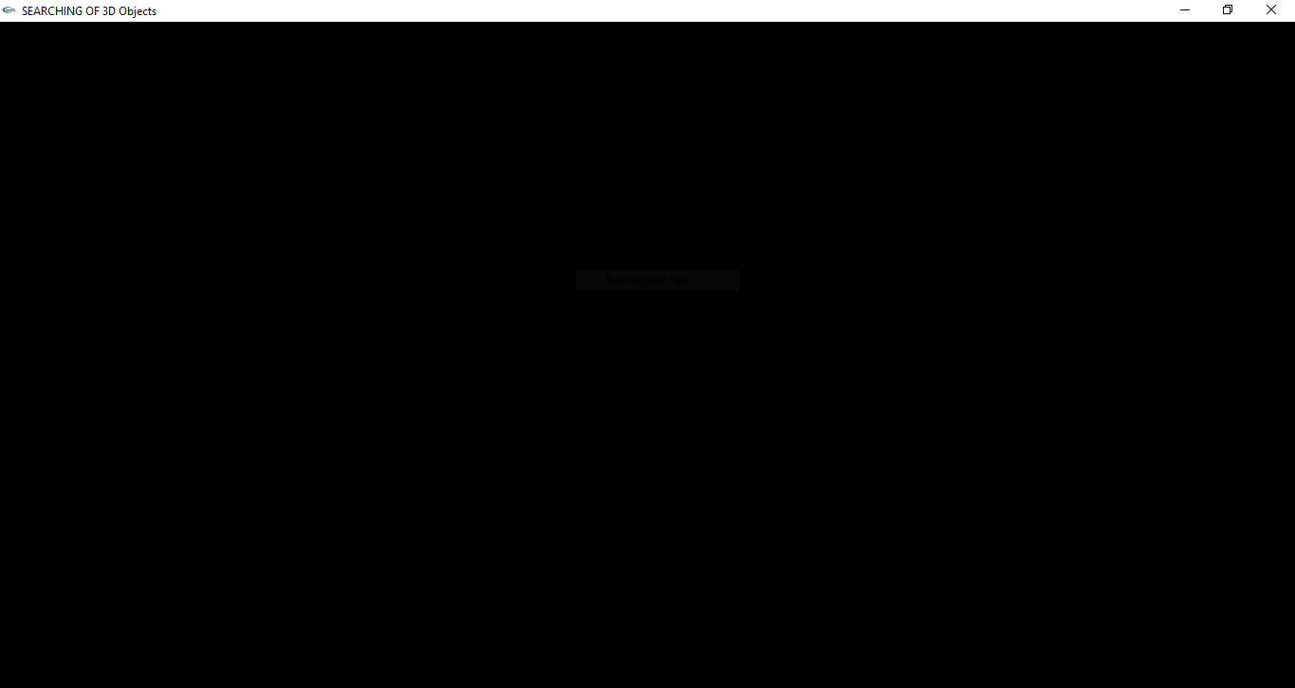
Fig: Blank graphics window where the objects are hidden
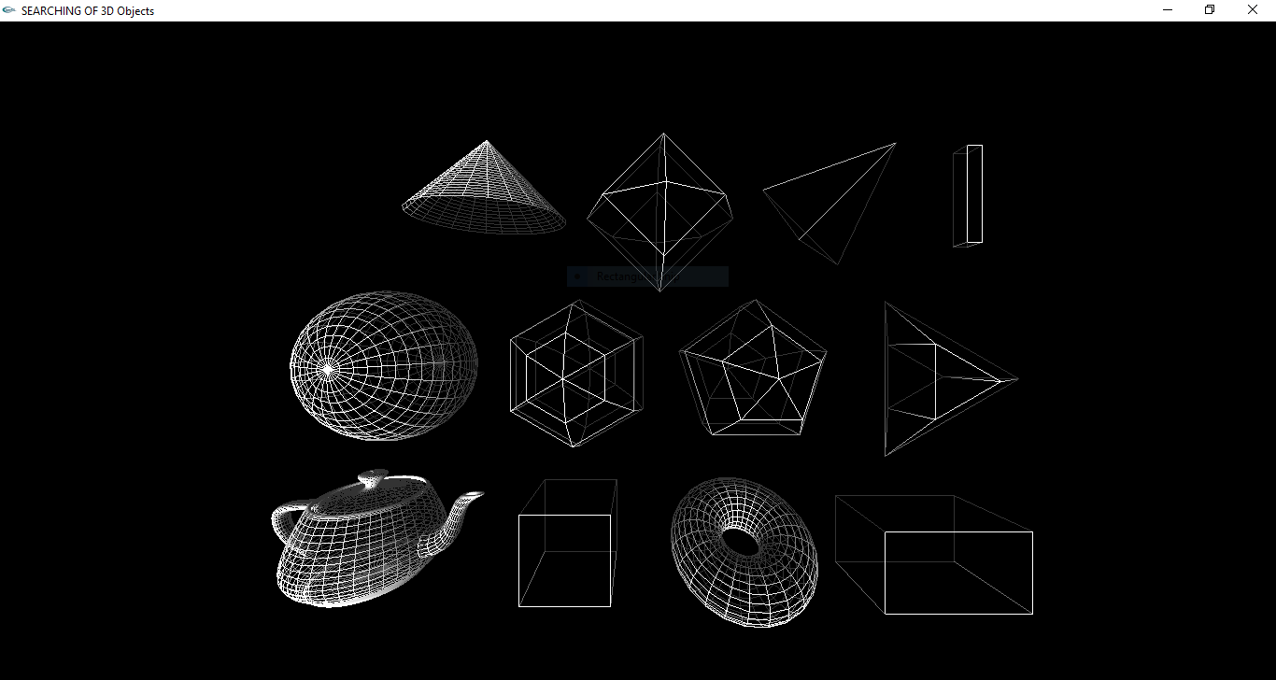
Fig: 3D objects selected using keyboard function

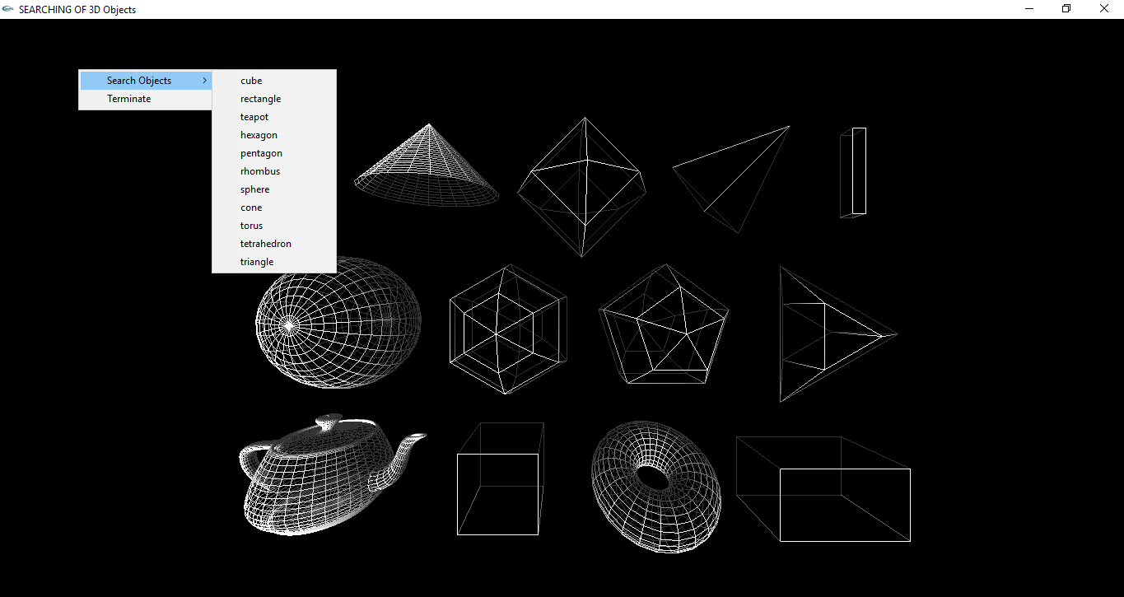

Fig : Searching of 3D objects using mouse function

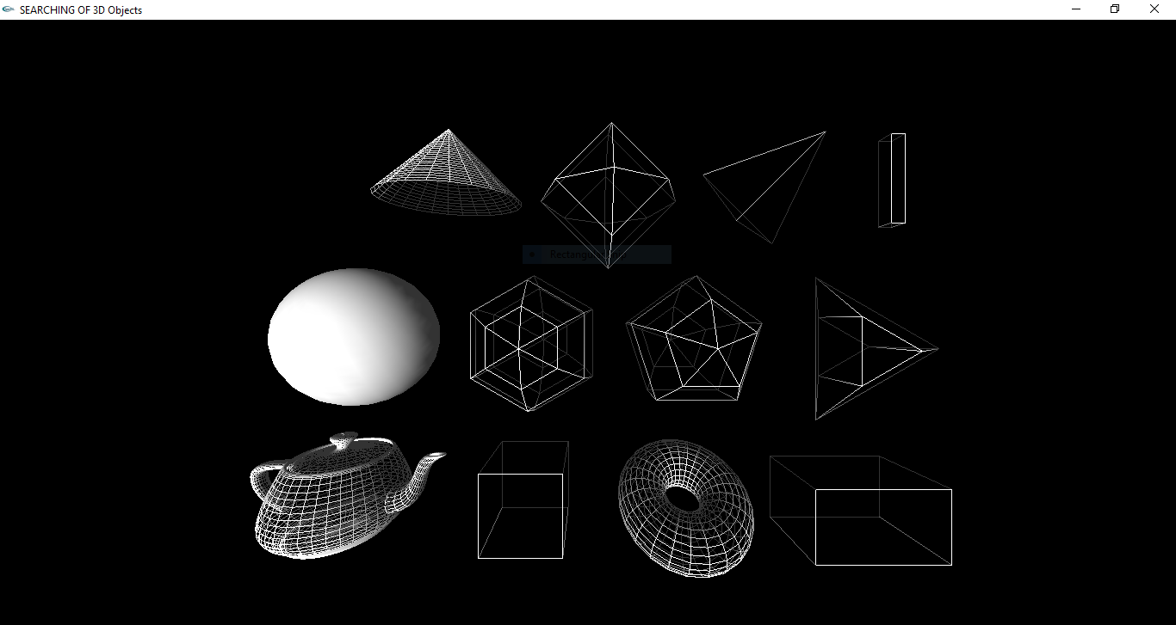

Fig: 3D sphere selected using mouse function and indicated as a solid object
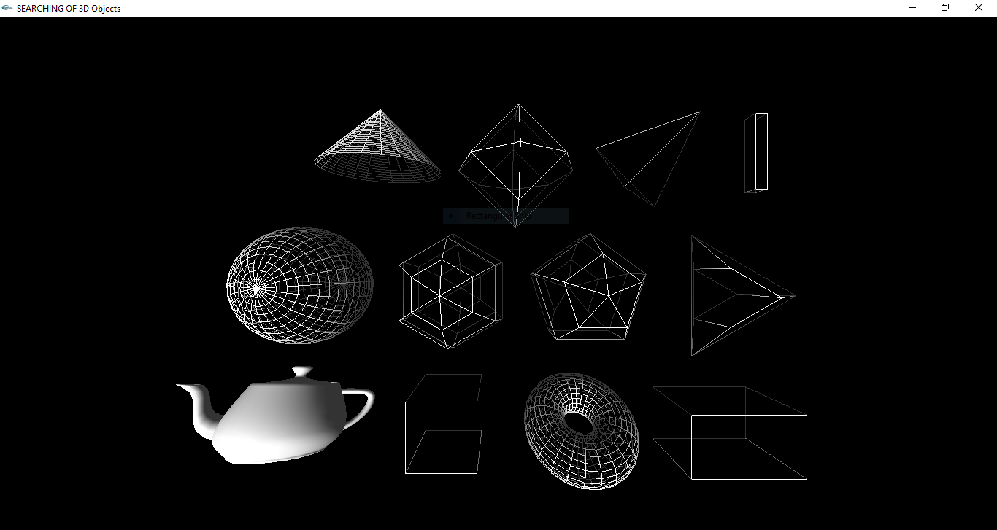

Fig: 3D Teapot selected using mouse function and indicated as a solid object

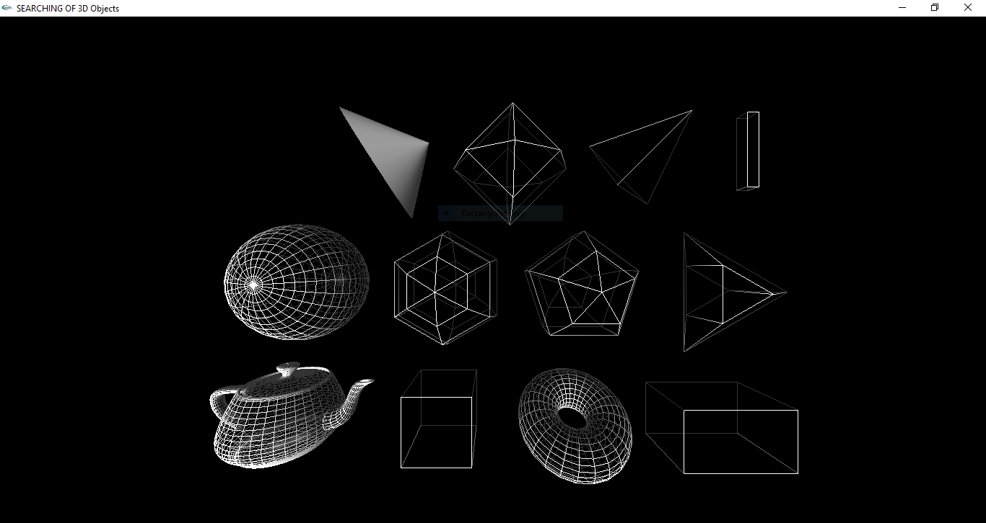

Fig: Rotation of select object with respect to Y-axis

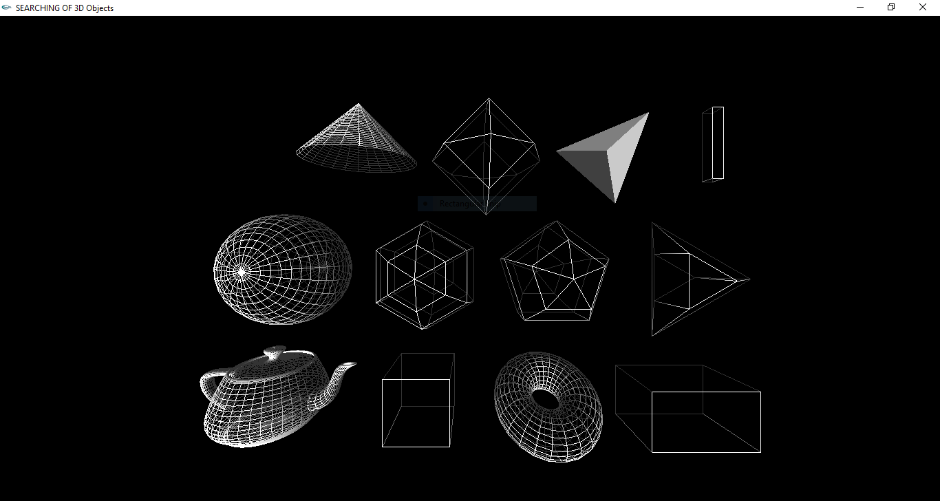

Fig: Rotation of select object with respect to Z-axis

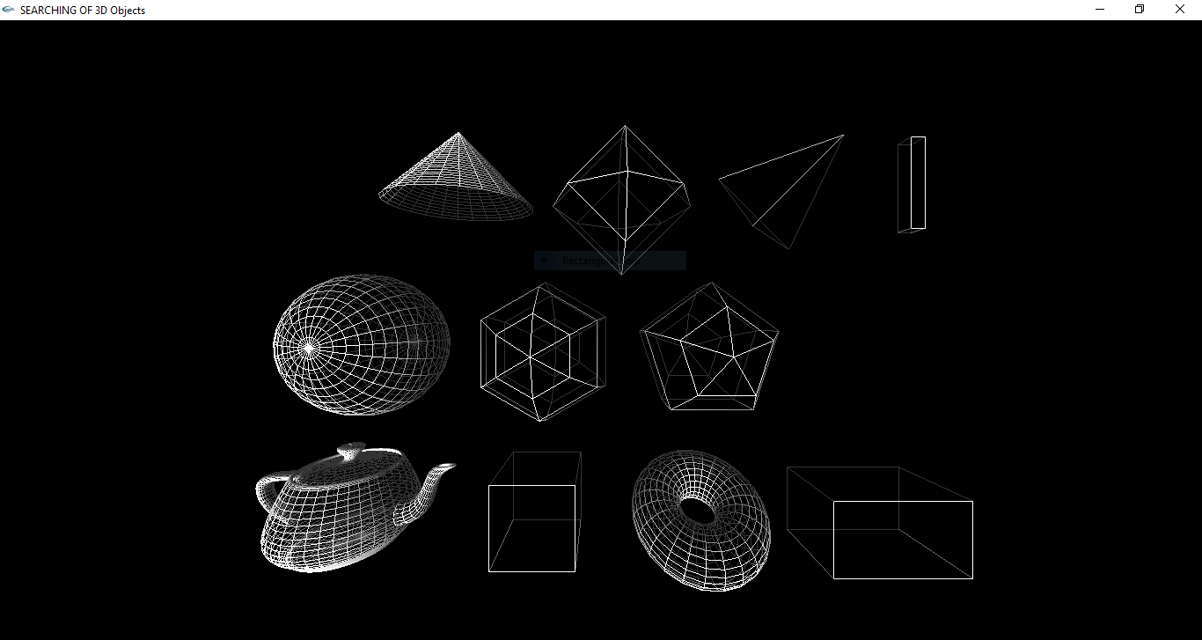

Fig: De-selecting the objects using keyboard function

CHAPTER - 4
CONCLUSION AND FUTURE WORK

4.1 Conclusion
The development of computer graphics has made computers easier to interact with and better for understanding and interpreting many types of data. Developments in computer graphics. We started with modest aim with no prior experience in any programming projects as this, but ended up in learning many things, fine tuning the programming skills and getting into the real world of software development with an exposure to corporate environment. During the development of any software of significant utility, we are faced with the trade-off between speed of execution and amount of memory consumed. This is simple interactive application. It is extremely user friendly and has the features, which makes simple graphics project.

4.2 Future Enhancement

This project can be further added with more 3D objects such as octahedron, decagon, octagonal prism,triagonal pyramid, square pyramid etc.
Additional user interactions can be added and the application can be made more interactive using the openGL functions.
Further more different algorithms can be implemented for searching the hidden objects, such as
- linear search algorithm
- binary search algorithm
- Jump Search.
- Interpolation Search.
- Exponential Search.
- Sublist Search (Search a linked list in another list)
- Fibonacci Search.
- The Ubiquitous Binary Search.
- Recursive function to do substring search

CHAPTER - 5
REFERENCES

1. Donald Hearn & Pauline Baker: Computer Graphics-OpenGL Version,3rd Edition, Pearson Education,2011
2. Edward Angel: Interactive computer graphics- A Top Down approach with OpenGL, 5th edition. Pearson Education, 2011
3. M M Raikar, Computer Graphics using OpenGL, Fillip Learning / Elsevier, Bangalore / New Delhi (2013)
4. Edward Angel: Interactive Computer Graphics- A Top Down approach with OpenGL,
5th edition. Pearson Education, 2008
5. http://www.opengl.org/sdk/docs/man online man pages.
6. http://nehe.gamedev.net OpenGL tutorials.
7. And lastly GOOGLE and YOUTUBE.

