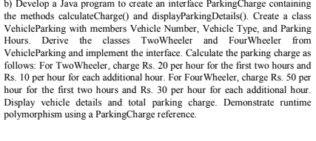

interface ParkingCharge {
double calculateCharge();
void displayParkingDetails();
}
class VehicleParking {
String vehicleNumber;
String vehicleType;
int parkingHours;
public VehicleParking(String vehicleNumber, String vehicleType, int parkingHours) {
this.vehicleNumber = vehicleNumber;
this.vehicleType = vehicleType;
this.parkingHours = parkingHours;
}
}
class TwoWheeler extends VehicleParking implements ParkingCharge {
public TwoWheeler(String vehicleNumber, int parkingHours) {
super(vehicleNumber, "Two Wheeler", parkingHours);
}
public double calculateCharge() {
if (parkingHours <= 2) {
return parkingHours * 20.0;
} else {
return (2 * 20.0) + ((parkingHours - 2) * 10.0);
}
}
public void displayParkingDetails() {
System.out.println("Vehicle Number: " + vehicleNumber);
System.out.println("Vehicle Type: " + vehicleType);
System.out.println("Parking Hours: " + parkingHours + " hrs");
System.out.println("Total Parking Charge: Rs. " + calculateCharge());
System.out.println("-----------------------------------");
}
}
class FourWheeler extends VehicleParking implements ParkingCharge {
public FourWheeler(String vehicleNumber, int parkingHours) {
super(vehicleNumber, "Four Wheeler", parkingHours);
}
public double calculateCharge() {
if (parkingHours <= 2) {
return parkingHours * 50.0;
} else {
return (2 * 50.0) + ((parkingHours - 2) * 30.0);
}
}
public void displayParkingDetails() {
System.out.println("Vehicle Number: " + vehicleNumber);
System.out.println("Vehicle Type: " + vehicleType);
System.out.println("Parking Hours: " + parkingHours + " hrs");
System.out.println("Total Parking Charge: Rs. " + calculateCharge());
System.out.println("-----------------------------------");
System.out.println("Name: Bhuvanesh R");
System.out.println("USN : 1BM26CS573-T");
}
}
public class ParkingManagementSystem {
public static void main(String[] args) {
ParkingCharge parkingRef;
parkingRef = new TwoWheeler("KA-01-AB-1234", 5);
parkingRef.displayParkingDetails();
parkingRef = new FourWheeler("KA-05-CD-5678", 4);
parkingRef.displayParkingDetails();
}
}

OUTPUT :-

