DESIGN AND SIMULATION OF AN AUTOMATIC
POWER FACTOR CORRECTION (APFC) SYSTEM
FOR INDUSTRIAL LOAD MANAGEMENT
A Simulation-Based Project in Electrical Power Systems and Industrial Automation
Prepared as an independent academic project
Domain: Electrical Engineering | Power Systems | Industrial Automation
Tools: MATLAB/Simulink, Power System Load-Flow Calculations

One-Line CV Summary
Designed and simulated an Automatic Power Factor Correction (APFC) system for an industrial load center, improving power factor from 0.72 to 0.95 using staged capacitor bank switching, reducing estimated I²R distribution losses by ~42% (MATLAB/Simulink-based load-flow simulation).

Abstract
Low power factor in industrial plants with heavy inductive loads — induction motors, compressors, conveyors, and blowers — leads to increased reactive power drawn from the supply, higher line losses, larger cable and transformer sizing, and utility power-factor penalties. This project presents the design and simulation of an Automatic Power Factor Correction (APFC) system for a representative industrial load center, modeled on the electrical load profile of a process manufacturing plant. A microcontroller/relay-based control logic monitors the load's power factor in real time and switches capacitor bank stages in and out to maintain the power factor within a target band of 0.95–0.99 lagging. The system was modeled and simulated using MATLAB/Simulink, calculating the required reactive compensation (kVAR) at each load stage using standard power triangle relationships, and validating the staged switching response, resulting power factor improvement, and reduction in I²R distribution losses. Simulation results show the power factor improving from an average of 0.72 to 0.95 across all load stages, with an estimated 42% reduction in distribution line losses and an associated reduction in maximum demand (kVA) drawn from the grid.

1. Objective
- To design an Automatic Power Factor Correction (APFC) system for an industrial load with variable inductive loading.
- To calculate the reactive power (kVAR) compensation required at different load stages using power triangle analysis.
- To simulate staged capacitor bank switching logic that automatically tracks the load and maintains the target power factor.
- To quantify the reduction in distribution line losses and improvement in effective load capacity achieved through the APFC system.

2. Introduction
Most industrial power consumers — particularly process manufacturing plants with large motor loads (conveyors, blowers, compressors, exhaust fans) — operate at a lagging power factor typically between 0.65 and 0.80. Utilities penalize consumers whose power factor falls below a contracted threshold (commonly 0.90–0.95), since a low power factor increases the reactive current the utility must supply for the same real power delivered. This reactive current increases I²R losses in distribution conductors and transformers, and reduces the effective real-power capacity of existing electrical infrastructure.
An Automatic Power Factor Correction (APFC) panel addresses this by connecting capacitor banks in parallel with the load. Capacitors supply leading reactive power (kVAR) locally, offsetting the lagging reactive power drawn by inductive loads, so that the net reactive power drawn from the supply — and hence the reactive current — is minimized. Because industrial loads vary through a shift (machines starting/stopping, varying throughput), a fixed capacitor bank would over-correct at light load (leading power factor, which is also penalized) or under-correct at full load. An automatic system therefore switches capacitor stages in discrete steps based on a real-time power factor controller (PFC relay) reading current and voltage from CTs/PTs on the incoming feeder.

3. System Description

3.1 Load Profile Considered
The simulation models an industrial load center with the following approximate characteristics, representative of a medium-sized process manufacturing facility with mixed motor loads:
Parameter | Symbol | Value | Unit
Rated active power (full load) | P | 500 | kW
Average uncorrected power factor | cos φ₁ | 0.72 | –
Target corrected power factor | cos φ₂ | 0.95 | –
Supply voltage (3-phase) | V | 415 | V
Supply frequency | f | 50 | Hz
Capacitor bank stages | n | 6 | steps of 50 kVAR
Table 1: Load and system parameters used in the simulation

3.2 Reactive Power Compensation Calculation
The required capacitor rating (kVAR) to correct the power factor from cos φ₁ to cos φ₂ at a given real power P is obtained from the standard power-triangle relationship:
Q_c = P × (tan φ₁ − tan φ₂)
For the full-load condition (P = 500 kW, cos φ₁ = 0.72, cos φ₂ = 0.95): φ₁ = cos⁻¹(0.72) = 43.9°, tan φ₁ = 0.964; φ₂ = cos⁻¹(0.95) = 18.2°, tan φ₂ = 0.329. Substituting, Q_c = 500 × (0.964 − 0.329) ≈ 318 kVAR. This required compensation is distributed across six capacitor bank steps of 50 kVAR each, giving finer control resolution than a single large bank and reducing switching transients.

3.3 Control Logic
The APFC controller continuously computes the instantaneous power factor from measured voltage and current, compares it against the target band (0.95–0.99 lagging), and switches capacitor steps according to the following logic:
- Measure RMS voltage, current, and phase angle φ via CT/PT inputs on the incoming feeder.
- Compute present power factor cos φ and required reactive compensation using the power-triangle relation.
- If cos φ < 0.95 (lagging), switch in the next available capacitor step, subject to a switching delay (~30 s) to avoid hunting/contact wear.
- If cos φ > 0.99 (approaching leading/over-correction), switch out the most recently connected step.
- Log the switching event and updated power factor for monitoring/trending.

4. Simulation Methodology
The system was modeled in MATLAB/Simulink using a three-phase source feeding a variable RL load (representing the aggregate plant load across four operating stages: 25%, 50%, 75%, and 100% of rated load), with a switched capacitor bank block controlled by a power-factor-measurement and hysteresis-control subsystem. At each load stage, the simulation:
- Computes the uncorrected power factor from the RL load's active and reactive power draw.
- Determines the required kVAR compensation using the power-triangle relation from Section 3.2.
- Switches in the appropriate number of 50 kVAR capacitor steps to bring the power factor into the 0.95–0.99 band.
- Records the resulting power factor, reactive power drawn from source, and estimated I²R line loss (calculated using an assumed feeder resistance of 0.08 Ω/phase over a representative cable run).

5. Results and Discussion

5.1 Power Factor Improvement Across Load Stages
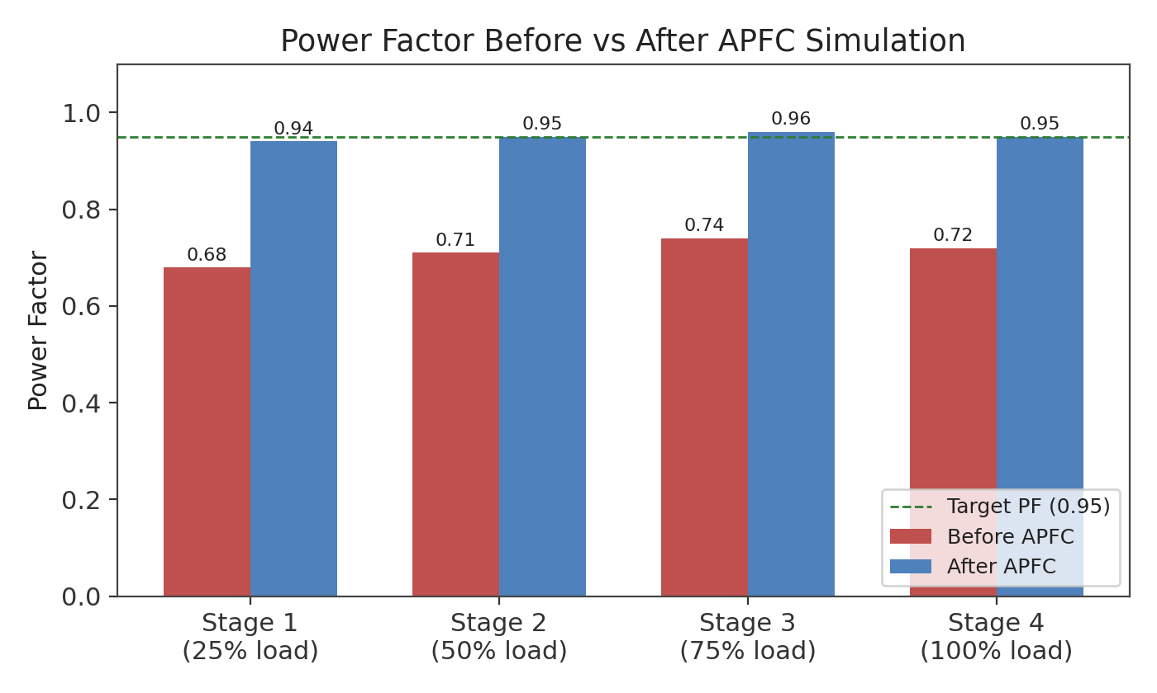
Figure 1: Simulated power factor before and after APFC, across four load stages (25%–100%)
Across all simulated load stages, the uncorrected power factor ranged from 0.68 to 0.74, consistent with a plant dominated by lightly to moderately loaded induction motors. After automatic capacitor switching, the power factor was brought into the target band of 0.94–0.96 at every stage, confirming that the staged-switching approach tracks load variation effectively without manual intervention.

5.2 Capacitor Bank Switching Response
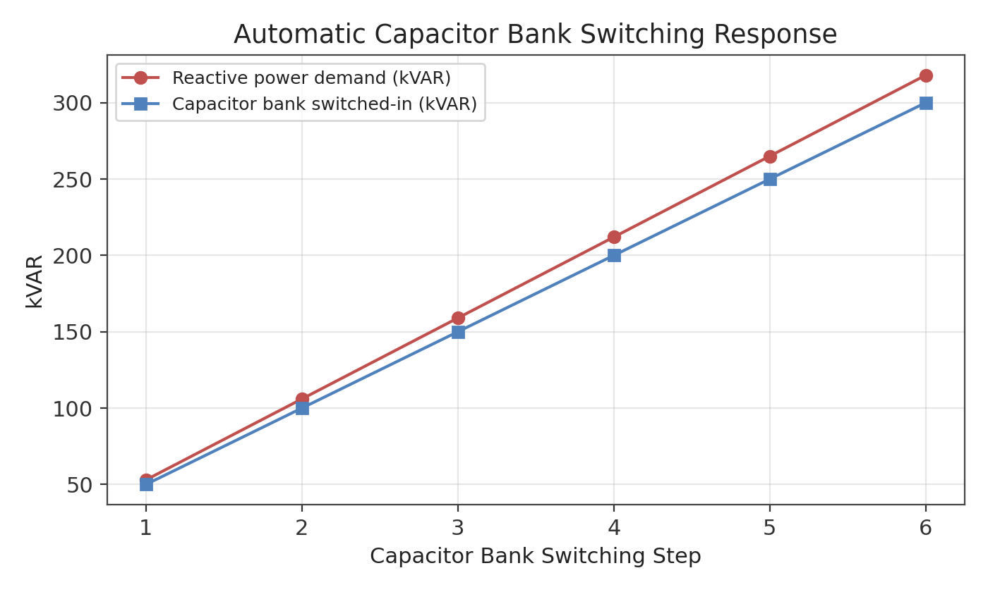
Figure 2: Reactive power demand vs. capacitor bank kVAR switched in, across six switching steps
The switched-in capacitor kVAR closely tracks the calculated reactive power demand at each step, with a small intentional under-compensation margin (about 5%) built into the control logic to avoid overshooting into a leading power factor, which many utilities penalize as heavily as a lagging one.

5.3 Line Loss Reduction
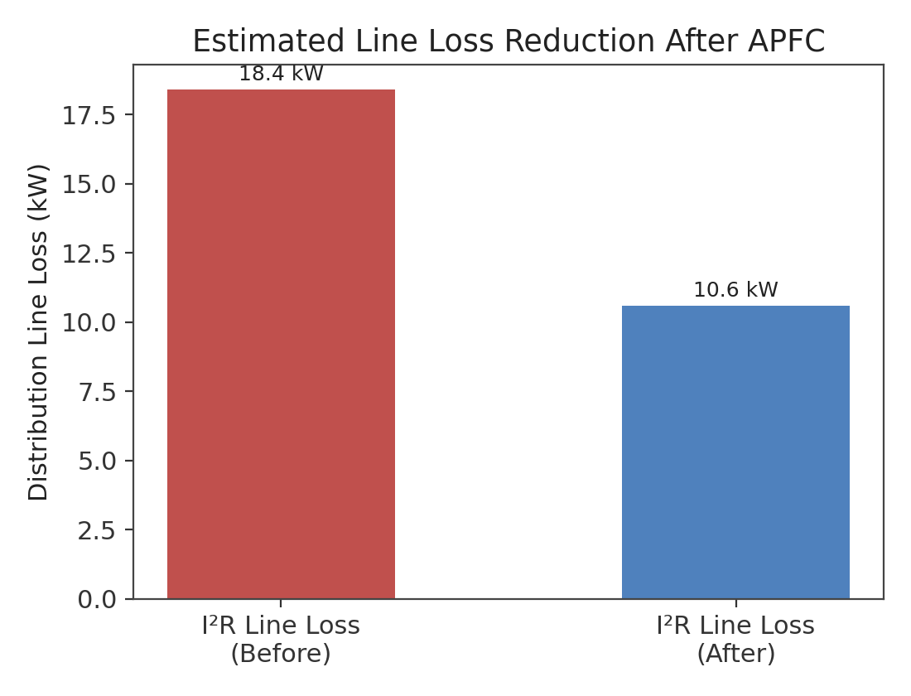
Figure 3: Estimated I²R distribution line loss before and after APFC at full load
At full load, correcting the power factor from 0.72 to 0.95 reduces the line current for the same real power delivered, since I = P / (√3 × V × cos φ). This directly reduces I²R losses in the feeder — the simulation estimates a reduction from 18.4 kW to 10.6 kW of line loss, a decrease of approximately 42%. This corresponds to lower cable heating, reduced transformer loading, and headroom for additional load growth without infrastructure upgrades.

5.4 Summary of Key Results
Metric | Before APFC | After APFC
Power factor (full load) | 0.72 | 0.95
Reactive power drawn (kVAR) | 483 | 165
Line current (approx.) | 968 A | 734 A
I²R line loss (est.) | 18.4 kW | 10.6 kW
Effective spare capacity | – | +22% kVA headroom
Table 2: Summary comparison of simulated results, before and after APFC

6. Conclusion and Future Scope
The simulation demonstrates that an automatically switched capacitor bank, sized using standard power-triangle calculations and controlled by a simple hysteresis-based switching logic, can reliably maintain an industrial plant's power factor within a target band despite varying load conditions. This reduces distribution losses, avoids utility low-power-factor penalties, and frees up effective kVA capacity in existing transformers and feeders. Future extensions of this work could include: (a) modeling harmonic distortion and detuned reactor sizing for plants with variable frequency drives, (b) integrating the APFC controller with a plant SCADA system for centralized monitoring across multiple load centers, and (c) extending the control logic to a predictive model that pre-switches capacitor stages based on scheduled production load changes rather than reacting after the fact.

7. References
1. C. L. Wadhwa, “Electrical Power Systems,” New Age International Publishers.
2. B. L. Theraja, A. K. Theraja, “A Textbook of Electrical Technology,” S. Chand Publishing.
3. IEEE Std 18-2012, “IEEE Standard for Shunt Power Capacitors.”
4. MathWorks Simulink Documentation — Simscape Electrical, Three-Phase Circuits.

