

Flattrade Broking Private Limited

SOP - Active Directory (AD) User, Computers and Group Policy Management Procedure

Version History

Version | Description | Author | Date of Revision
V1 | Active Directory | Bhuvaneshwar G

Approval History

Version | Approved By | Department | Date of Approval

Table of Contents

1. Scope 3
2. References 3
3. Process Description 3
4. Purpose 4
5. IT Tools 4
6. Business Impact 5
7. High Level Process Diagram 6
8. Entry Criteria 7
9. Process 7
15
10. Exit Criteria 15
11. Measure of quality 15
12. Dependent Process 15

Scope
This SOP outlines the step-by-step process for creating, modifying, disabling, and deleting user accounts in Active Directory (AD), creating and managing Group Policies, and adding both Windows and Linux computers to the AD domain using the organization’s standard domain-joining procedures..

References
User Account - Manual user account creation
Group policy - Group policy mangement

Process Description

User creation -
- Create the user account in Active Directory (AD) with the required details.
- Assign the user to the correct Organizational Unit (OU).
- Add the user to the appropriate security groups based on their role.

Group Policy Creation -
- Open the Group Policy Management Console (GPMC).
- Create a new Group Policy Object (GPO) with a suitable name.
- Configure the required settings inside the GPO (e.g. wallpaper lock).
- Link the GPO to the appropriate Organizational Unit (OU).
- Update Group Policy on the target systems using gpupdate /force.
- Verify that the policy is applied successfully on user or computer systems.

Adding Windows and Linux Systems to Active Directory

Windows
- Update network adapter settings to use the organization’s DNS server.
- Join the computer to the designated AD domain via system properties.

Linux
- Execute the join-ad.sh script to join the computer to the AD domain.
- The script applies required configurations and registers the system in AD.

Purpose
- AD stores and manages information about all users and devices on the network.
- Its hierarchical structure makes management easier for administrators.
- Administrators can apply security policies to many computers at once, saving time and improving security.

IT Tools
- Active Directory Users and Computers (ADUC) – for managing user and device accounts.
- Group Policy Management Console (GPMC) – for creating and managing Group Policies.

Applications and Tasks
S.no | Task | Application
 | Create, modify and disable the user accounts | Active Directory Users and Computers (ADUC)
 | Manage security groups and permissions | Group Policy Management Console (GPMC)

Roles and Tasks
S.no | Task | Roles
1. | The IT Infra team is responsible for creating, updating, and disabling user accounts in AD. | IT support
2. | The IT Infra team is responsible for managing group memberships and access permissions, as well as resetting passwords . | IT support

Business Impact
- Implementing Active Directory (AD) enables centralized and secure user management, reducing administrative effort, minimizing manual configuration changes, and ensuring consistent access control across all systems.

- Integration with AD supports regulatory and organizational compliance by enforcing standardized security policies, improving audit readiness, and reducing the likelihood of compliance gaps.

High Level Process Diagram
- User Account -
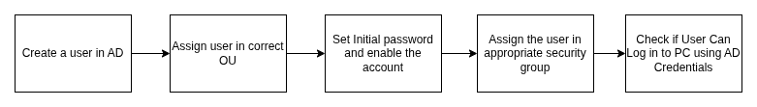
- Group policy -

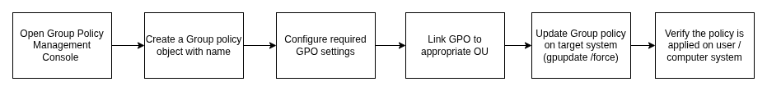

Entry Criteria
- When a new employee joins the company, the IT support team will create the user account in Active Directory and place the account in the appropriate Organizational Unit (OU) based on the employee’s department.

Process

Creating User account
Step 1 : Create the user account in Active Directory (AD) with the required details.
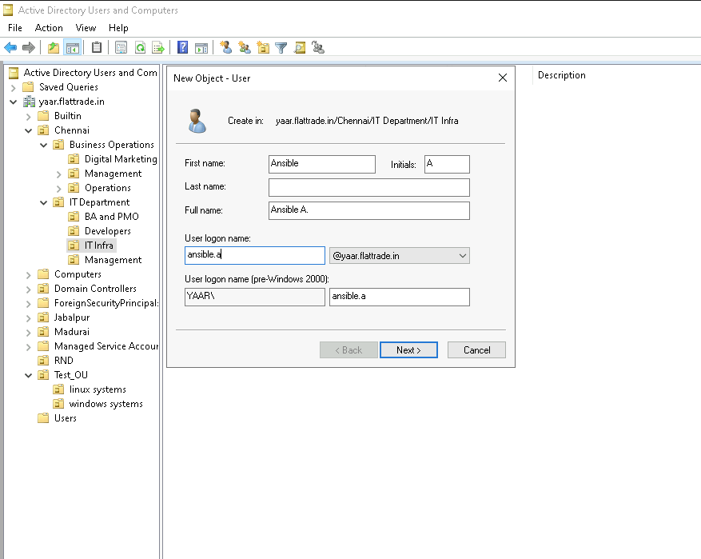

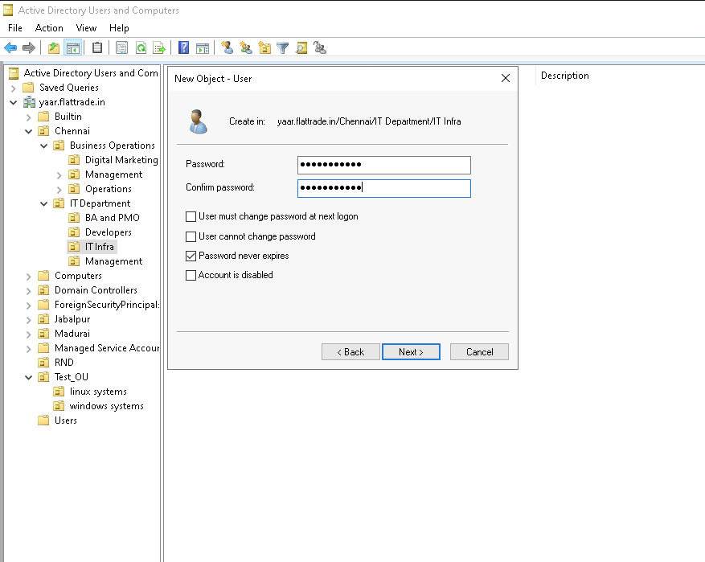

- Open Active Directory Users and Computers (ADUC) from the Domain Controller
- Right-click the OU and select New → User.
- Enter the required user information:
- First Name
- Last Name
- Intial
- User Logon Name
- Click Next to proceed.
- Password can be set by the user
- Select the appropriate options such as password never expires
- Click Finish to create the user object in AD.

Step 2 : Assign the User to the Correct Organizational Unit (OU)

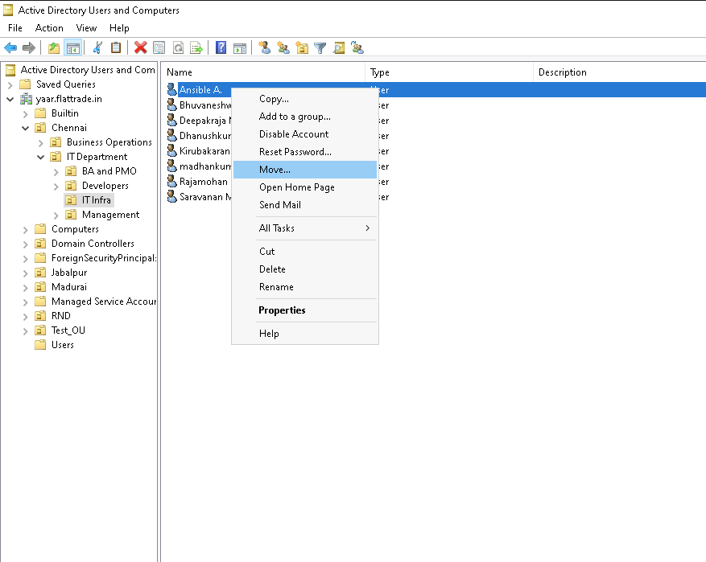
- Identify the correct OU based on department
- Right-click the newly created user object and select Move.
- Choose the appropriate OU from the directory tree.
- Confirm the move to ensure the user inherits the correct Group Policies (GPOs) and departmental configurations.

Step 3 : Add the user to the appropriate security groups based on their role.
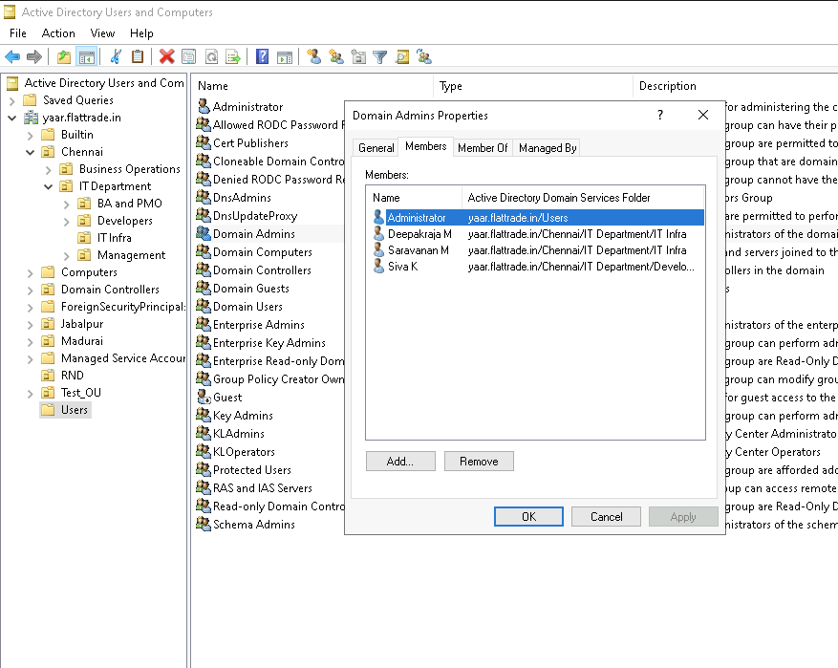

- All new users are created as standard users with default permissions.
- Only authorized personnel (IT support) are granted access to critical systems.

Group Policy

Step 1 : Open the Group Policy Management Console (GPMC).
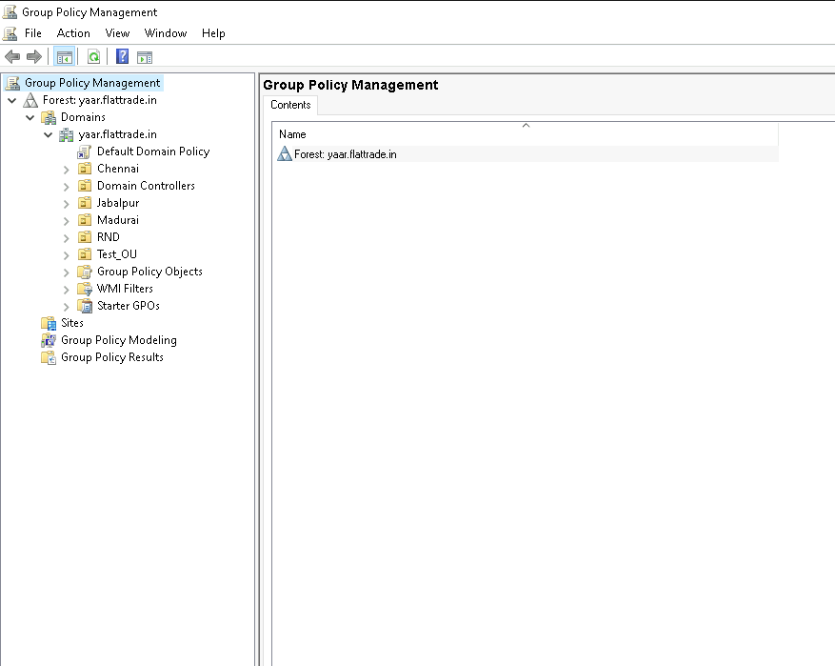

- Log in to a domain-joined system with Administrative privileges.
- open it from Server Manager → Tools → Group Policy Management.
- Confirm that you can view the domain structure and existing GPOs.

Step 2 : Create a new Group Policy Object (GPO) with a suitable name.

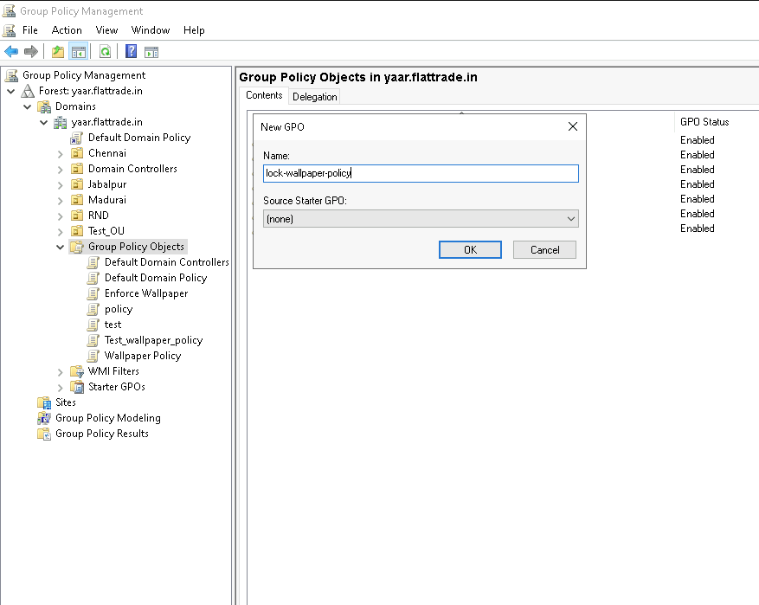

- In the Group Policy Management Console, expand the domain.
- Right-click Group Policy Objects → New.
- Enter a meaningful name for the GPO (e.g., Wallpaper-Lock-Policy)
- Click OK to create the policy object.

Step 3 : Configure Required Settings in the GPO

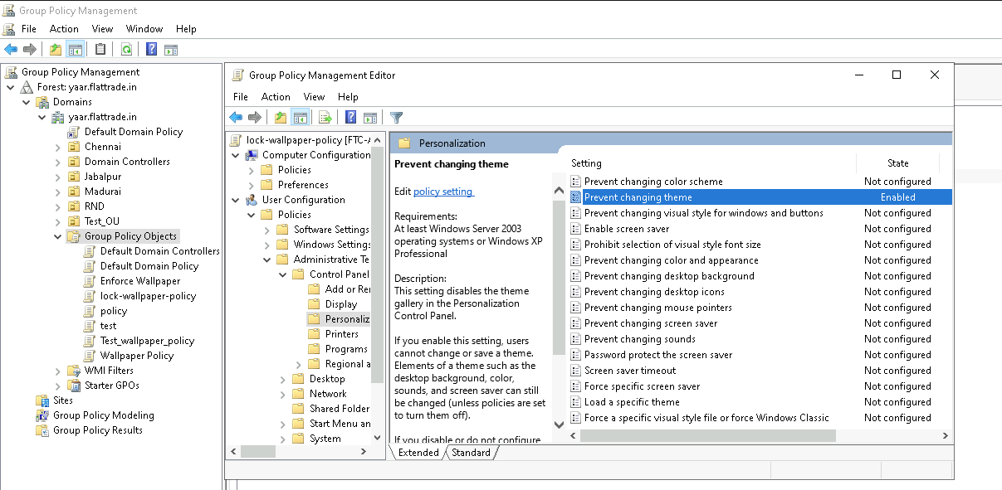

- Right-click the newly created GPO → select Edit.
- The Group Policy Management Editor opens.
- Navigate to the required path depending on the policy type, for example:
User Configuration → Policies → Administrative Templates → Control panel → Personalization→ Prevent changing theme (for wallpaper lock)
- Enable the specific policy setting
- Apply and close the editor once configurations are complete.

Step 4 : Link the GPO to the Appropriate Organizational Unit (OU)

- In GPMC, locate the target OU where the policy should apply.
- Right-click the OU → Link an Existing GPO.
- Select the GPO you created and click OK.
- Verify that the GPO is now listed under the OU’s Linked Group Policy Objects.

Step 5 : Verify Policy Application

- Log in to a target system and check if the new policy is applied (e.g., wallpaper is locked).
- Use the command gpresult /r to check detailed policy results:
- Confirm the correct GPO shows under applied policies.

Adding Windows and Linux Systems to Active Directory

Windows
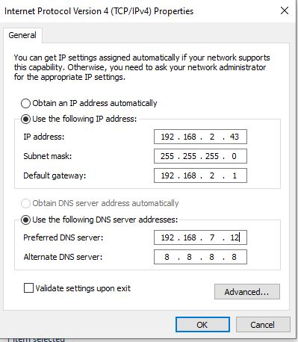

- Open Control Panel → Network and Sharing Center → Change Adapter Settings, right-click the active connection, select Properties, disable IPv6, and set the IPv4 DNS to 192.168.7.12 with an alternate of 8.8.8.8

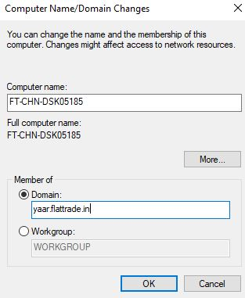

- Go to Settings → System → About → Advanced System Settings → Computer Name → Change, and update the domain name to join the AD domain.

Linux
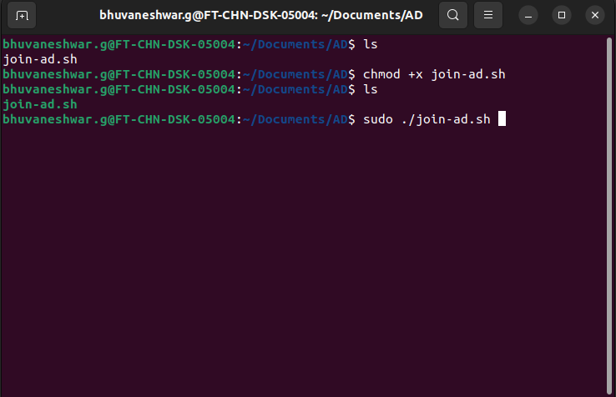

- Ensure the join-ad.sh script is executable by running chmod +x join-ad.sh (the file will appear in green when executable), and then execute it using ./join-ad.sh to join the Linux system to the AD domain.

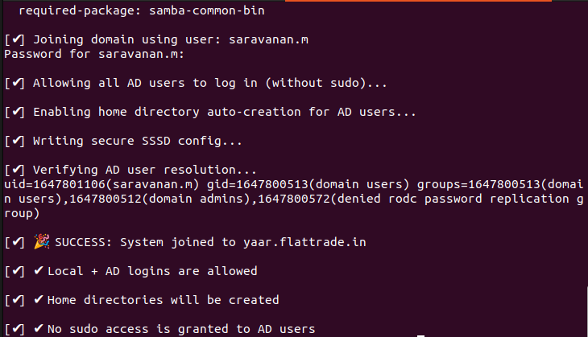

- An Admin user prompt will appear, and you can enter the AD admin password to complete the domain join.

Exit Criteria
- The Active Directory change is successfully completed and verified, with all required updates applied, tested, and documented without any errors.

Error Handling
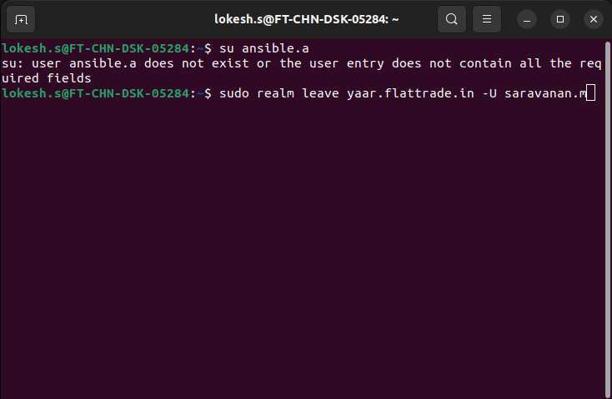

Issue:
While switching the Active Directory (AD) user on a Linux system, the user change may fail with the error message “ user does not exist or the user entry does not contain all the required fields “.

Solution:

- Log in as the root user (or switch to root using sudo su -).
- Remove the system from the AD domain using the following command:
sudo realm leave yaar.flattrade.in -U saravanan.m
- enter the Active Directory (AD) admin user password to authorize the domain leave operation.
- Re-run the join-ad script to rejoin the system to the AD domain
- After successful domain join, verify that the required AD user is switched and accessible.

Outcomes

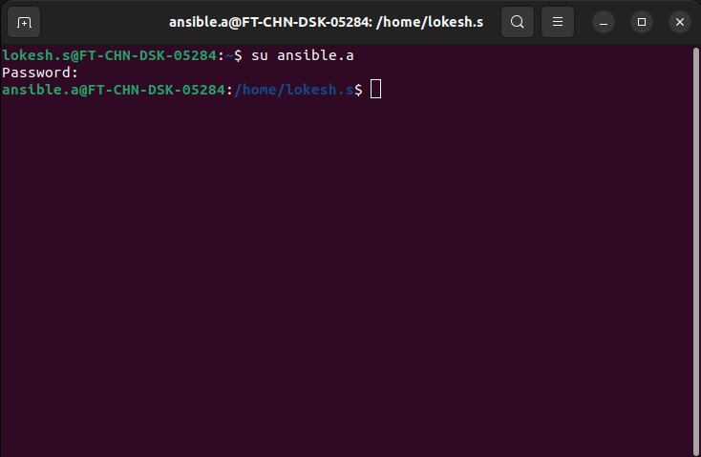

- The system is cleanly removed and rejoined to the AD domain, and the correct AD user is successfully applied.

Mesure of quality
N/A

Dependent Process
N/A

