**03-04-2022 Cryptography And Network Security 2019103604**

**R.Aadharsh**

1)Finding Passwords in executables using GDB:

C-Code:

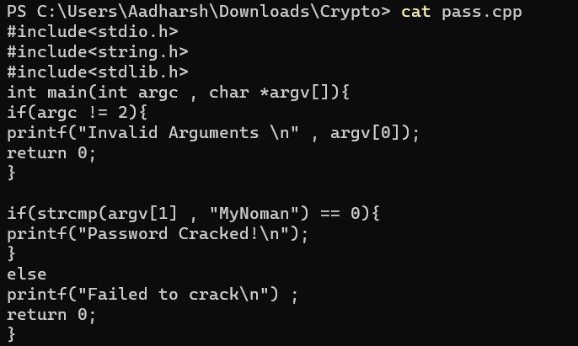

Output:

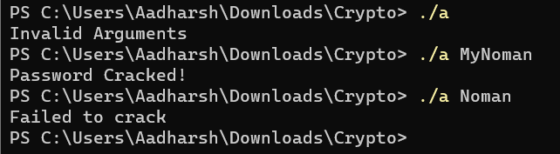

Ways to crack the password:

a)Use stings command :

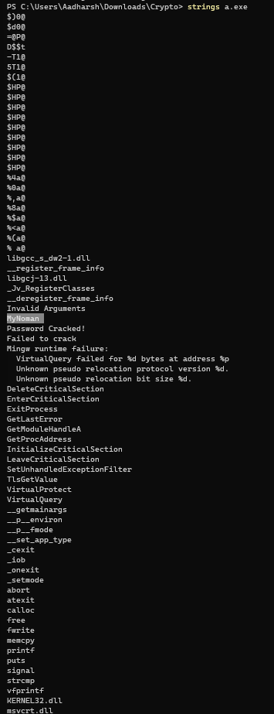

b)Using GDB:

Assume that the coder didn’t expose the password and used the hexadecimal sum as the password

Code:

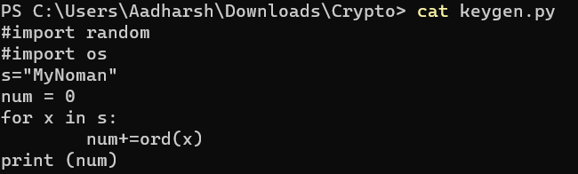



C code:

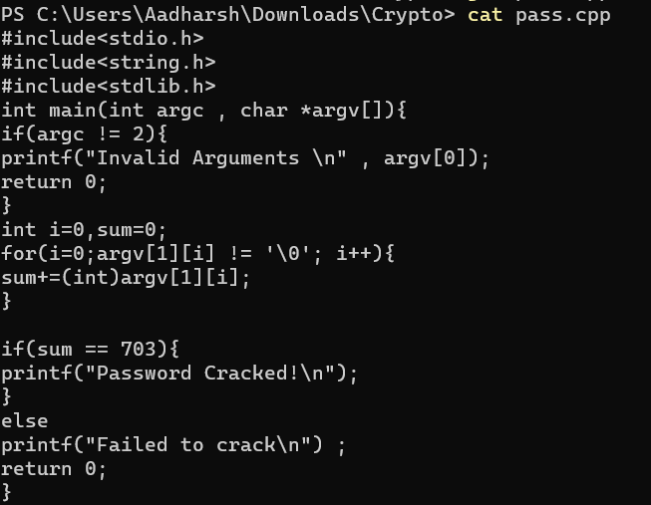

O/P:

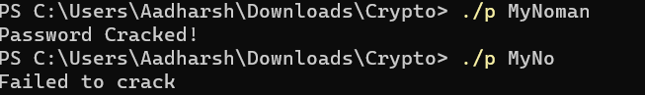

Using Strings wont work here because the password was nowhere exposed by the coder

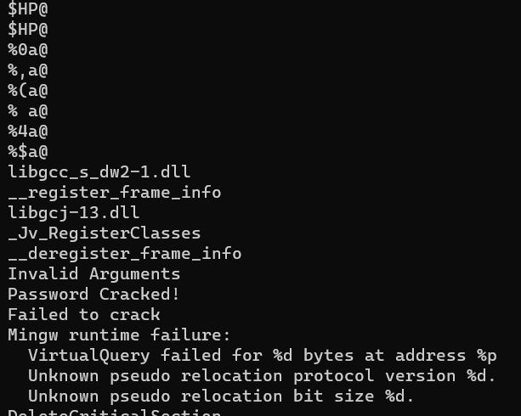

Exploitation:

Disassembling the main:

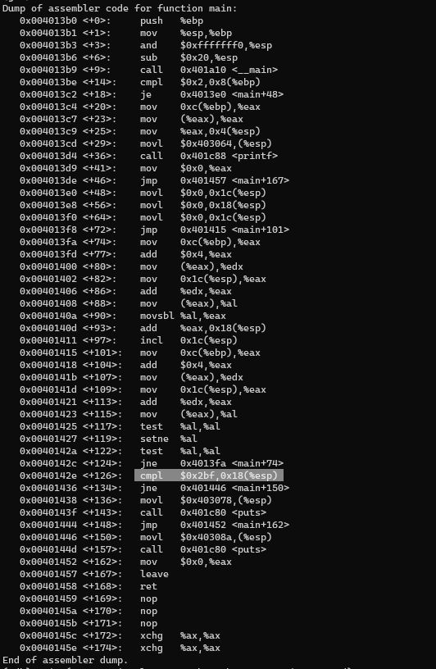

Searching if there are any comparisions done to validate the password and when found finding the equalent hexadecimal value

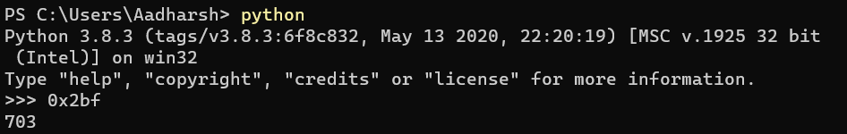

Creating a python program to get the different combinations that give a hexadecimal sum of 703

Python Program :

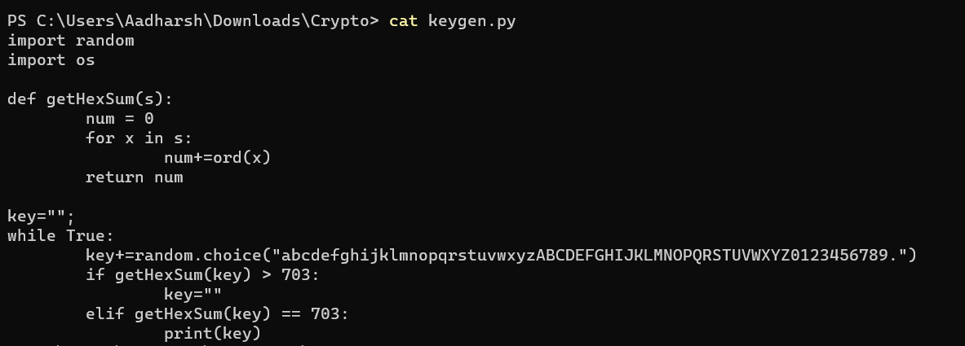

O/P:

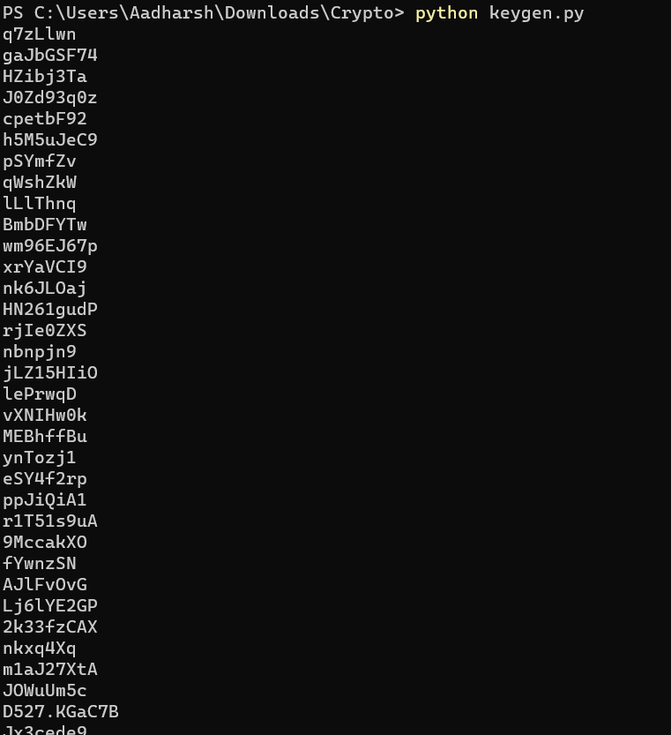

So from here choosing one string as password should crack the password



2)