ASSIGNMENT – 3

RETURN ORIENTED PROGRAMMING

SUBJECT NAME: CRYPTOGRAPHY AND NETWORK SECURITY
SUBJECT CODE: CS6008
MODULE: 3

NAME | BHUVANESHWAR S
REG.NO | 2019103513
DATE | 05/04/2022

AIM:
To implement a return oriented programming.

TOOLS INVOLVED:
- ROPgadget
- GCC
- Python 2
- Linux Based Operating System - Ubuntu

PROBLEM DESCRIPTIONS:
Return oriented programming is a technique of stack smashing where the attacker uses a chain of already present executable codes already present in process’s memory. The executable code instructions are called gadgets. Each gadgets return to another gadget until the desired effect is achieved.

INPUT:
Getting an input from files which contain addresses of gadgets.

OUTPUT:
To get the address of ‘/bin/sh’ and load the return address of hello program with this address, so that we end up with a running shell.

SCREENSHOT:

FILENAME: hello.c
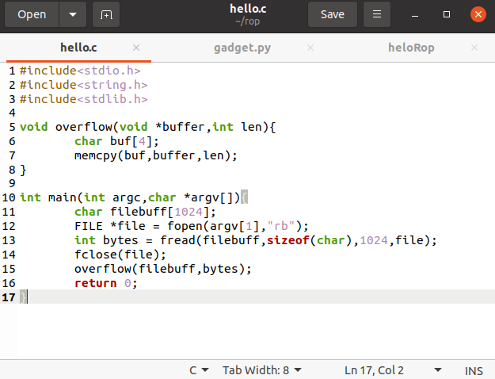

Here the code, which copy the characters from the files.
We first begin by compiling hello.c code with the following command: gcc -fno-stack-protector -static hello.c -o hello

Where,
-fno-stack-protector : disables stack protection
-static : link a program statically, to prevent address randomization

ROPgadget libraries used to find all the gadget from the executable binary files (hello) and put into the “heloRop”.

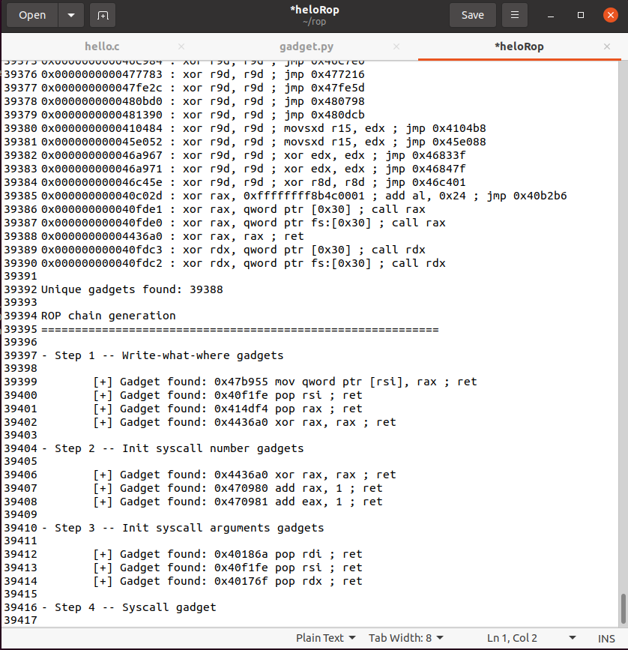

39388 gadget are found from the executable binary files. Now we need to spawn a shell from the Executable binary files. So we have to select particular gadget and enter into the python files to write the corresponding bytes of the address to the text files.

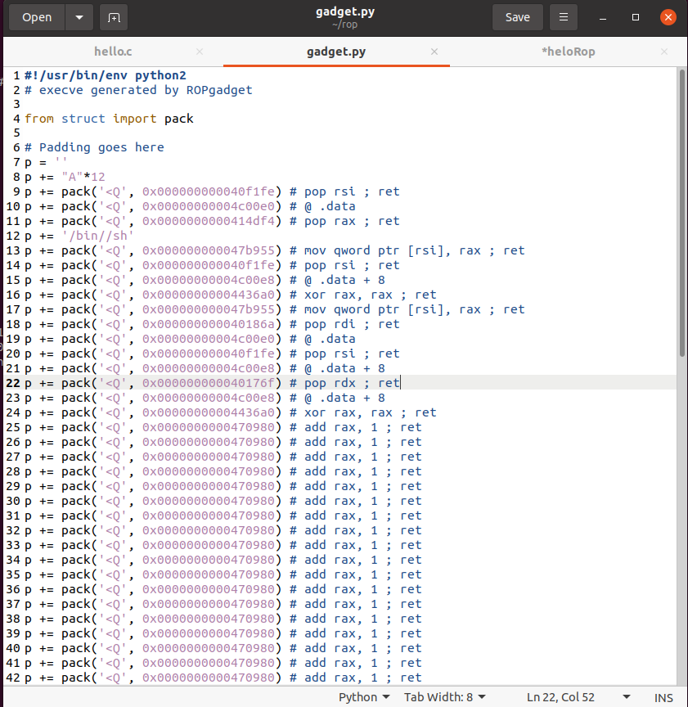

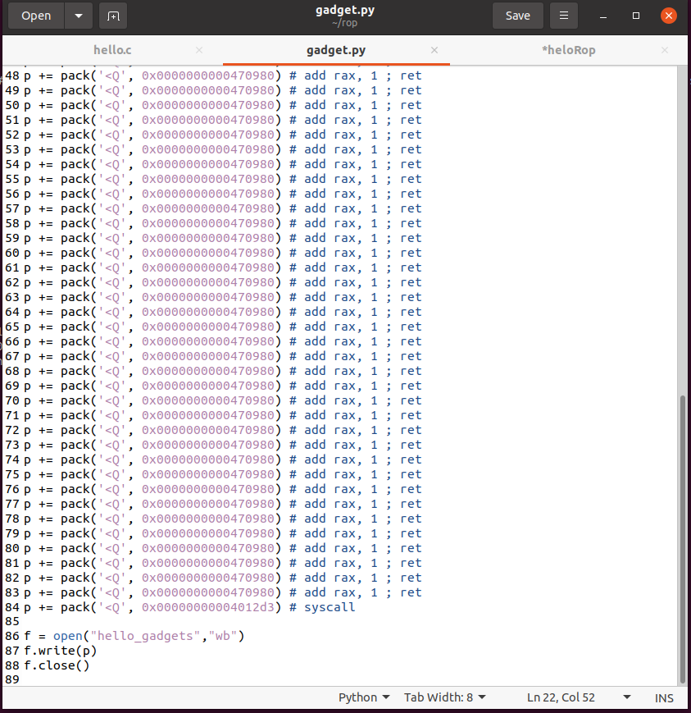

Now we run the python scripts (gadget.py), the hello_gadgets (vulnerable) files is created which address of gadgets to spawn a shell.
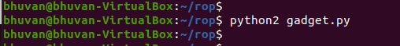

Run the executive binary files with the vulnerable files (hello_gadgets)

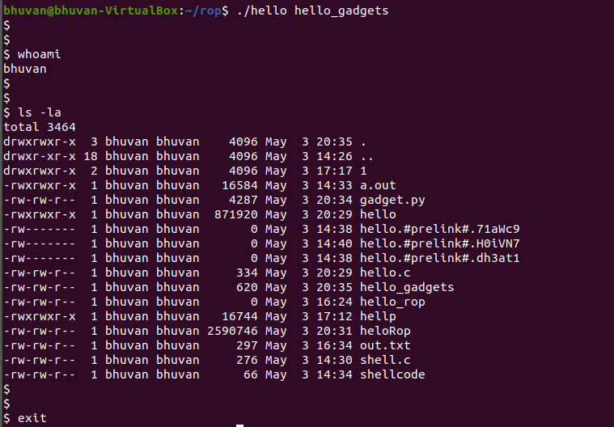

Hence the shell is spawned the attacker can control (or attack) / get an particular information from a entire system. We can see list of files and also see username of the current user.

